DOCKER-02
- Create a tomcat container on 8080 and deploy sample application in tomcat.
First we can check docker server is running or not
Systemctl status docker
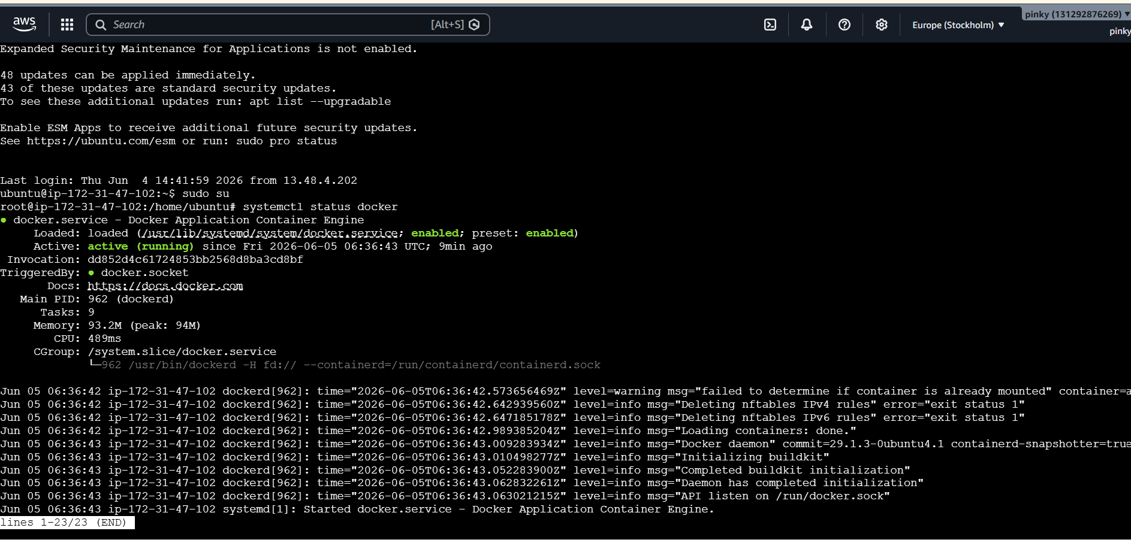
To pull the tomcat image from the Docker Hub, use the command 'docker pull tomcat:latest'. Once the image is successfully downloaded,
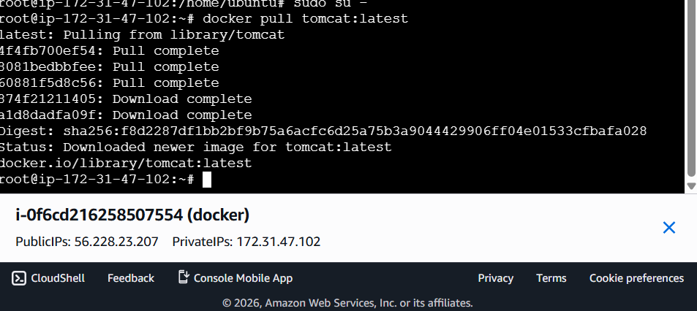
We can check image is download or not
Give the command docker images
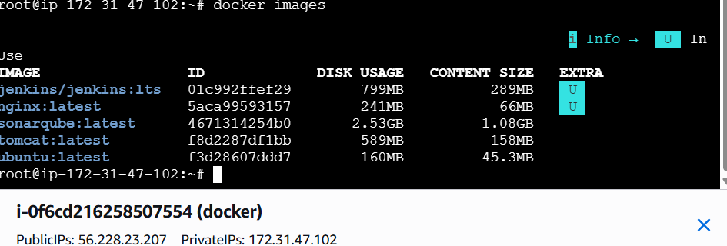
To run the image on port
docker run -itd -p 8080:8080 tomcat:latest
What happened:
-i → Interactive
-t → Terminal
-d → Run in background
-p 8080:8080 → Map server port to container port
tomcat → Image name

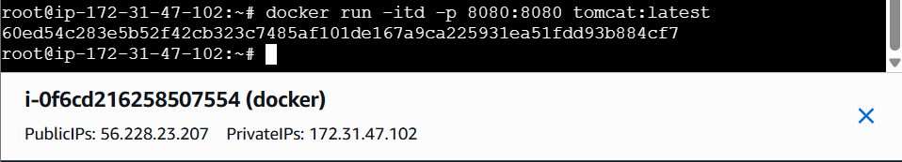
Verify the browser copy the ip add give 8080
What happened:
Browser showed 404 Not Found.
Why->Default Tomcat page is disabled.No application was deployed yet.
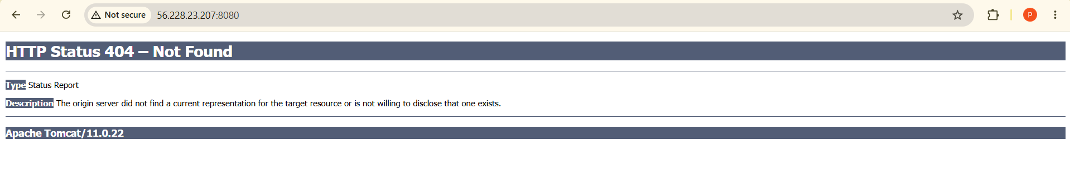
Check Running Containers
Use this command--> docker ps -a

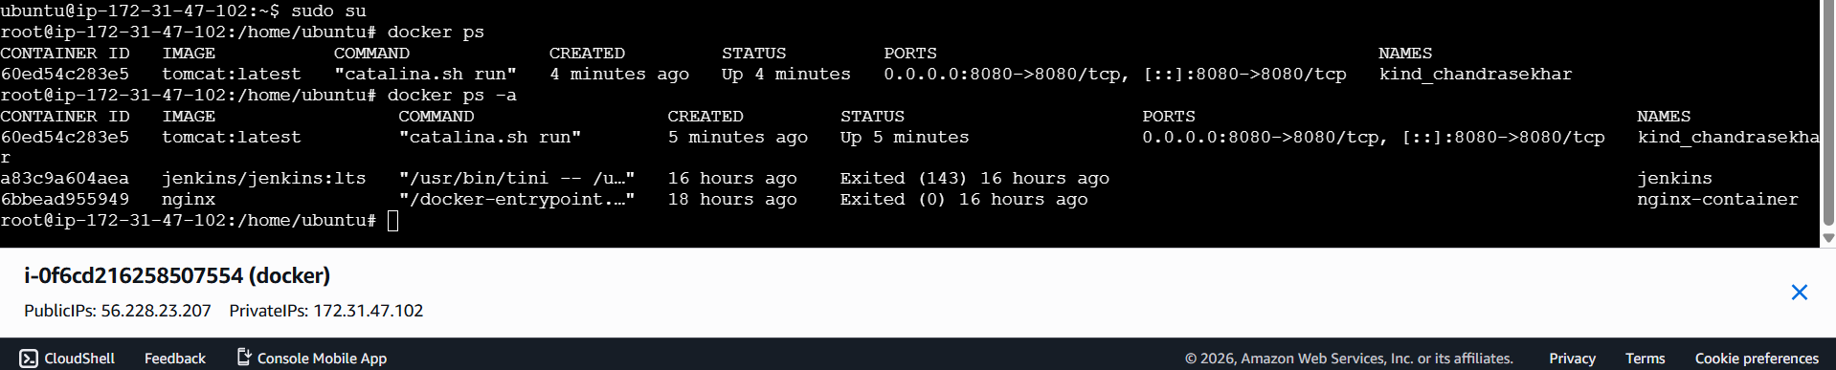
Enter Tomcat Container
docker exec -it <container_id> /bin/bash

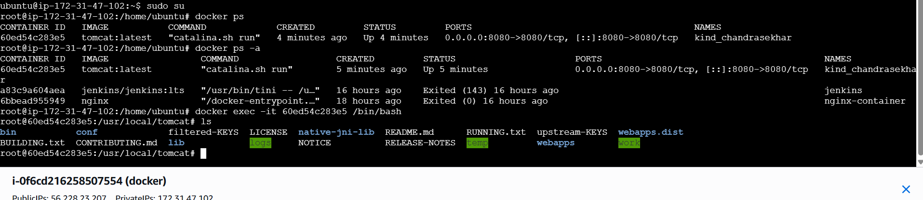
To deploy sample war file we need to update the packages and install wget for that we will use
Commandapt updatecd webappsgo to do in webapps

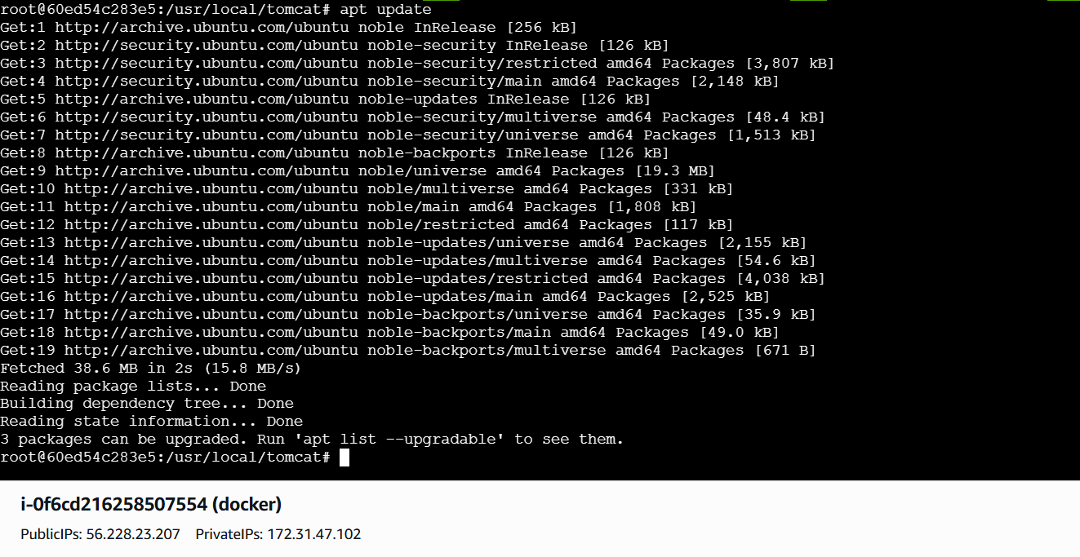
Wget weblink Sample.war has been deployed in webapps Now lets check in browser using ipaddress:8080/sample

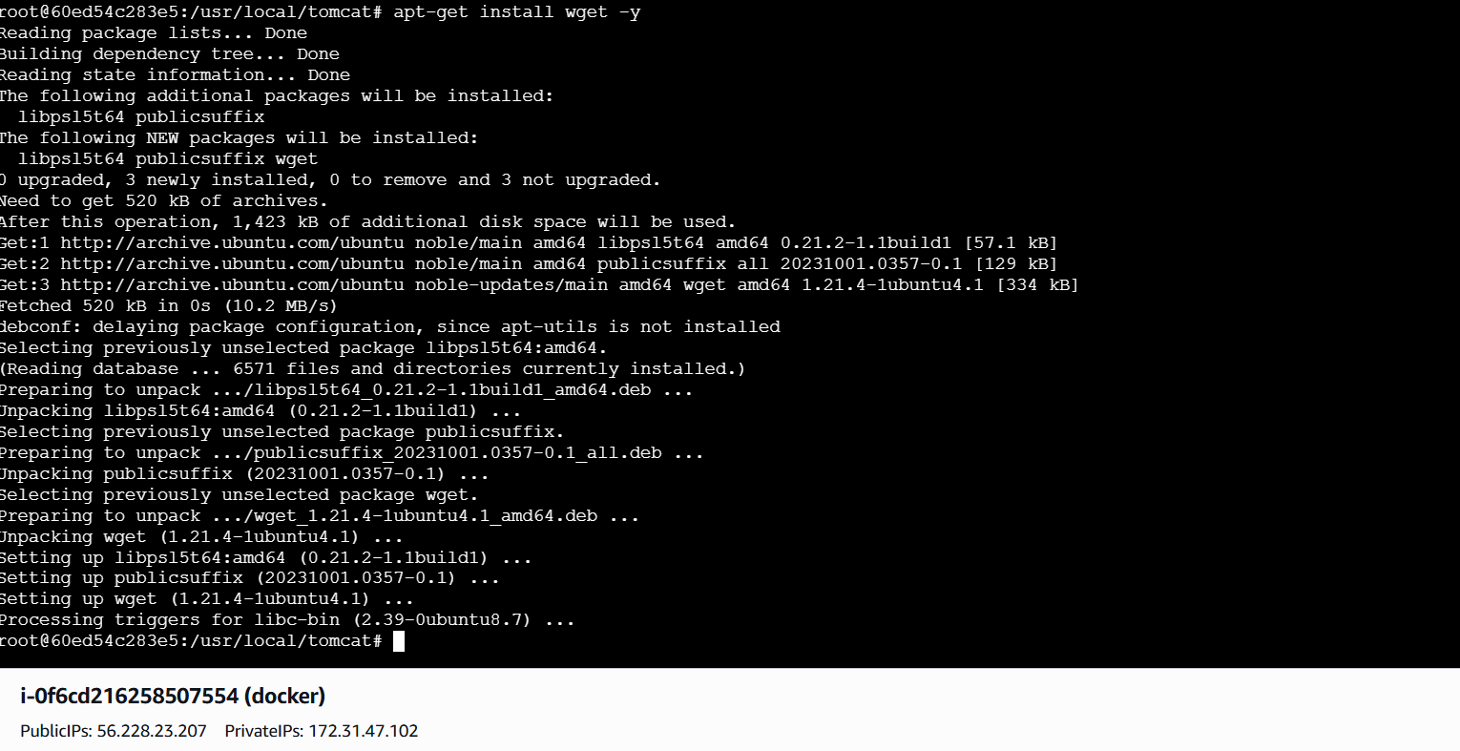
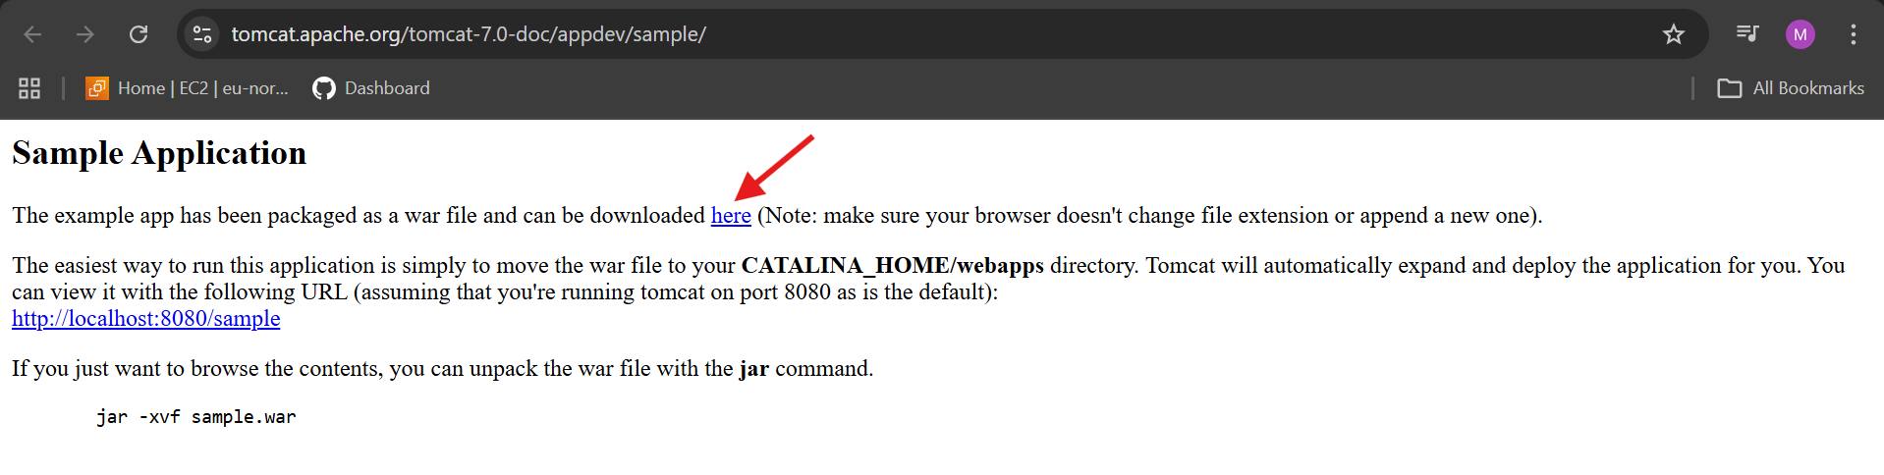
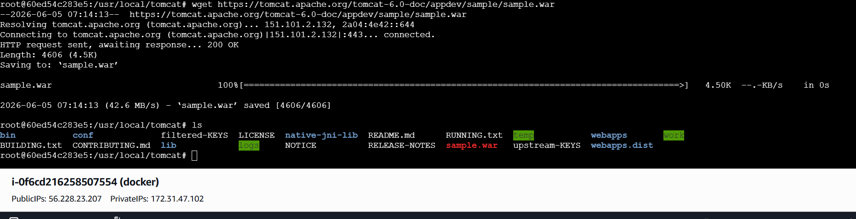
I am not download inside the webapps then I want to move sample.war to webapps

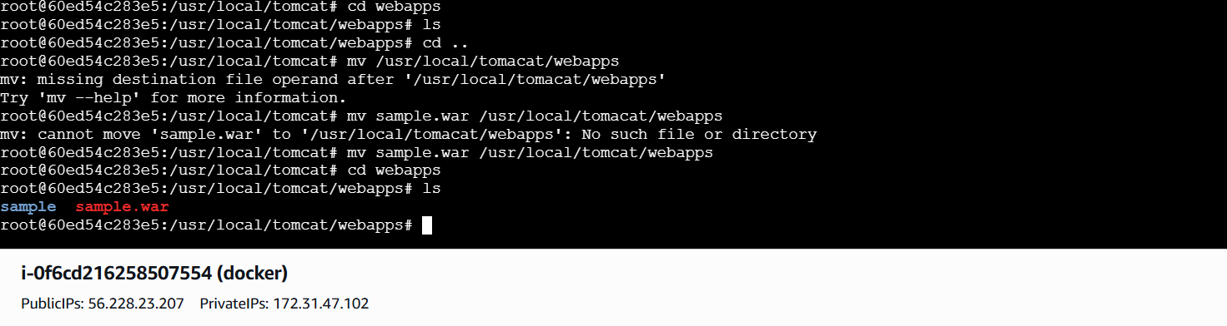

- Create volume and deploy tomcat container on port 8081.
Lets create volume by using command
docker volume create deployment
And check if it has been created or not by using docker volume ls

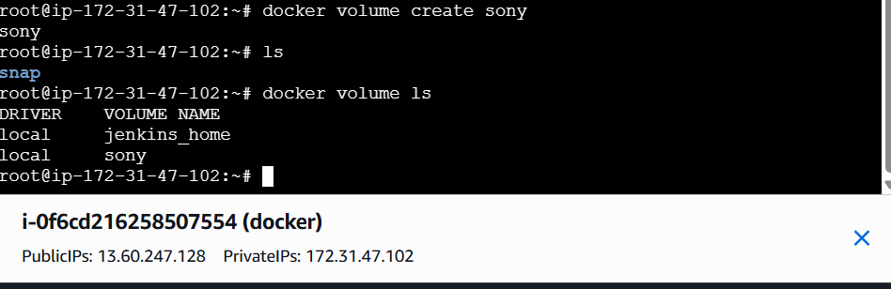
Now lets go to the folder
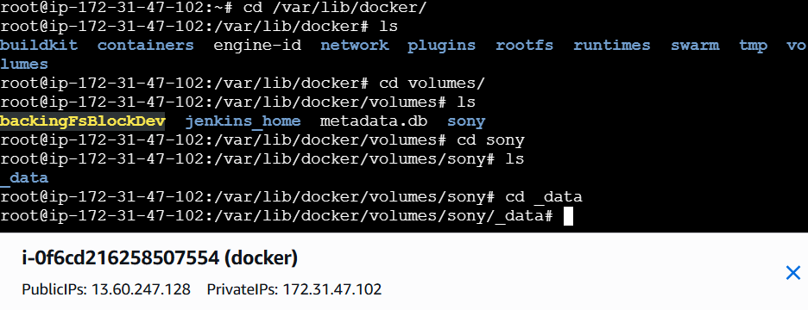
Now lets deploy a sample war file using wget

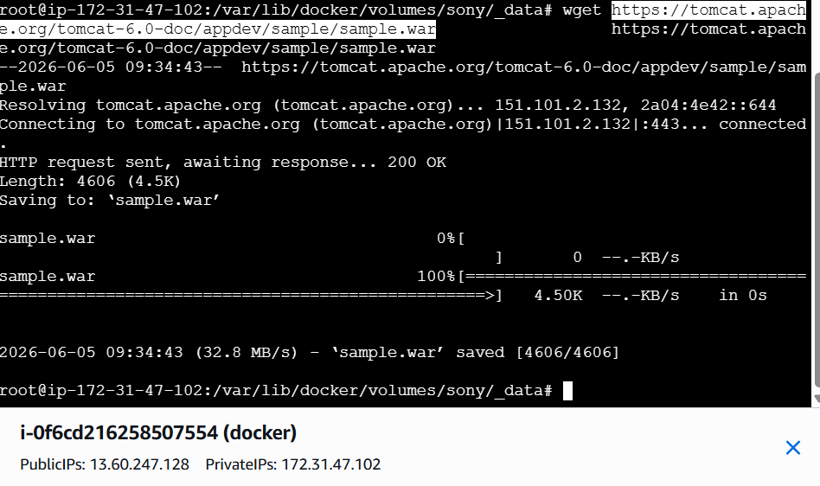
Now lets run the image using command
docker run -itd -p 8081:8080 -v
/var/lib/docker/volumes/deployment/_data:/usr/local/tomcat/webapps tomcat:latest
Lets verify the browser
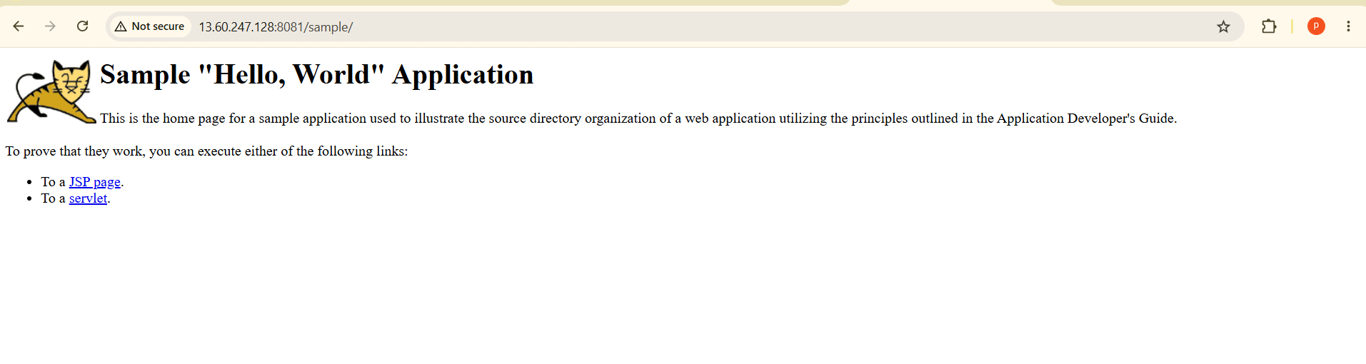
- Limit the nginx container to 500 MB.
First we can pull the nginx by using
Docker pull nginx:latest
Check the image are download are not
Docker images
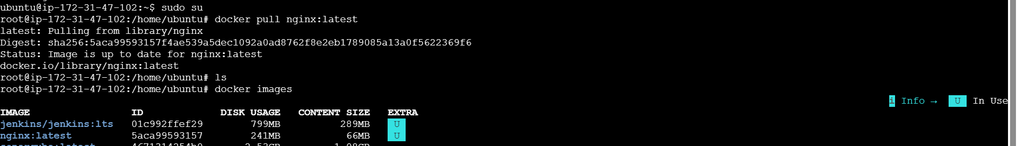
Run Nginx Container with 500 MB Memory Limit
docker run -d → Run in detached mode
--name nginx-500mb → Container name
-p 80:80 → Map host port 80 to container port 80
--memory="500m" → Limit container memory to 500 MB
nginx:latest

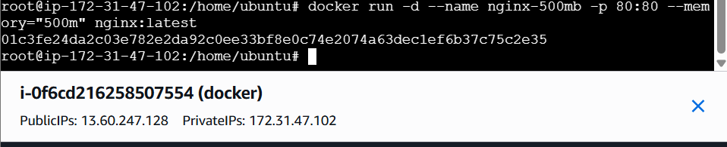
Verify Memory Limit
docker inspect nginx-500mb

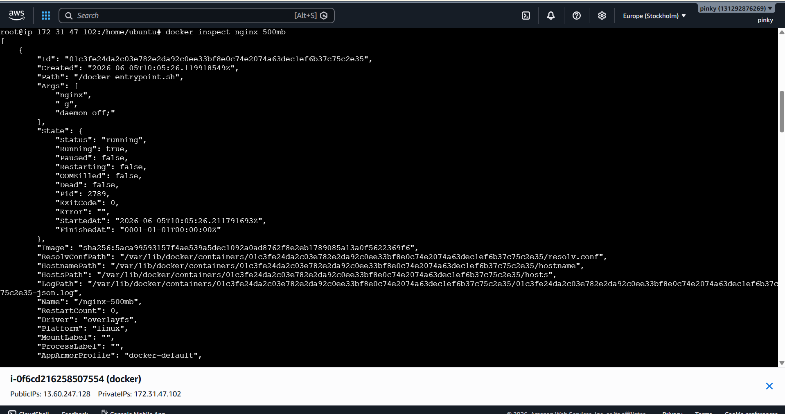
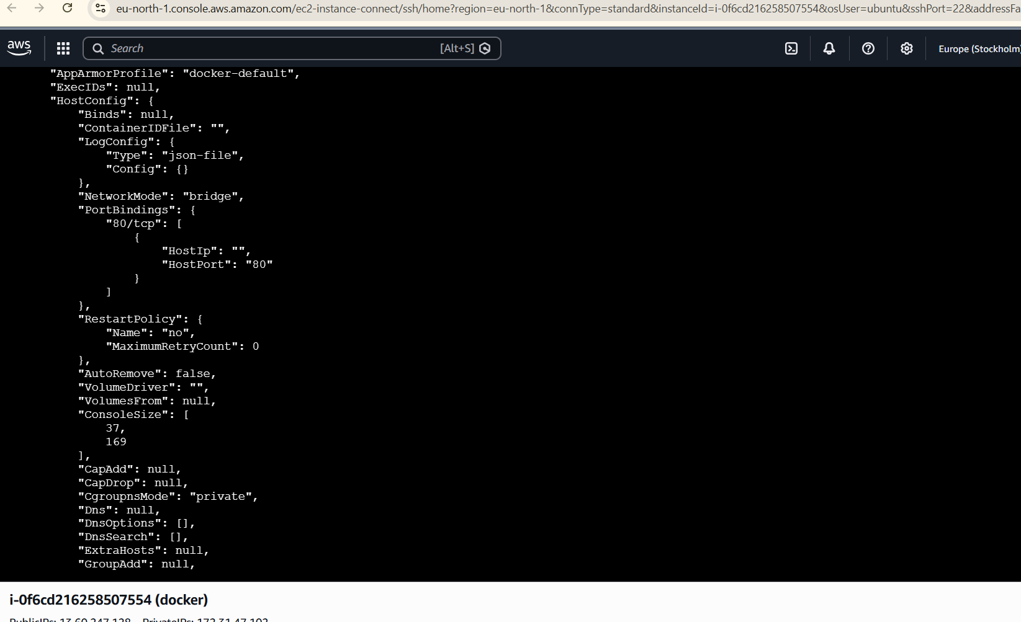
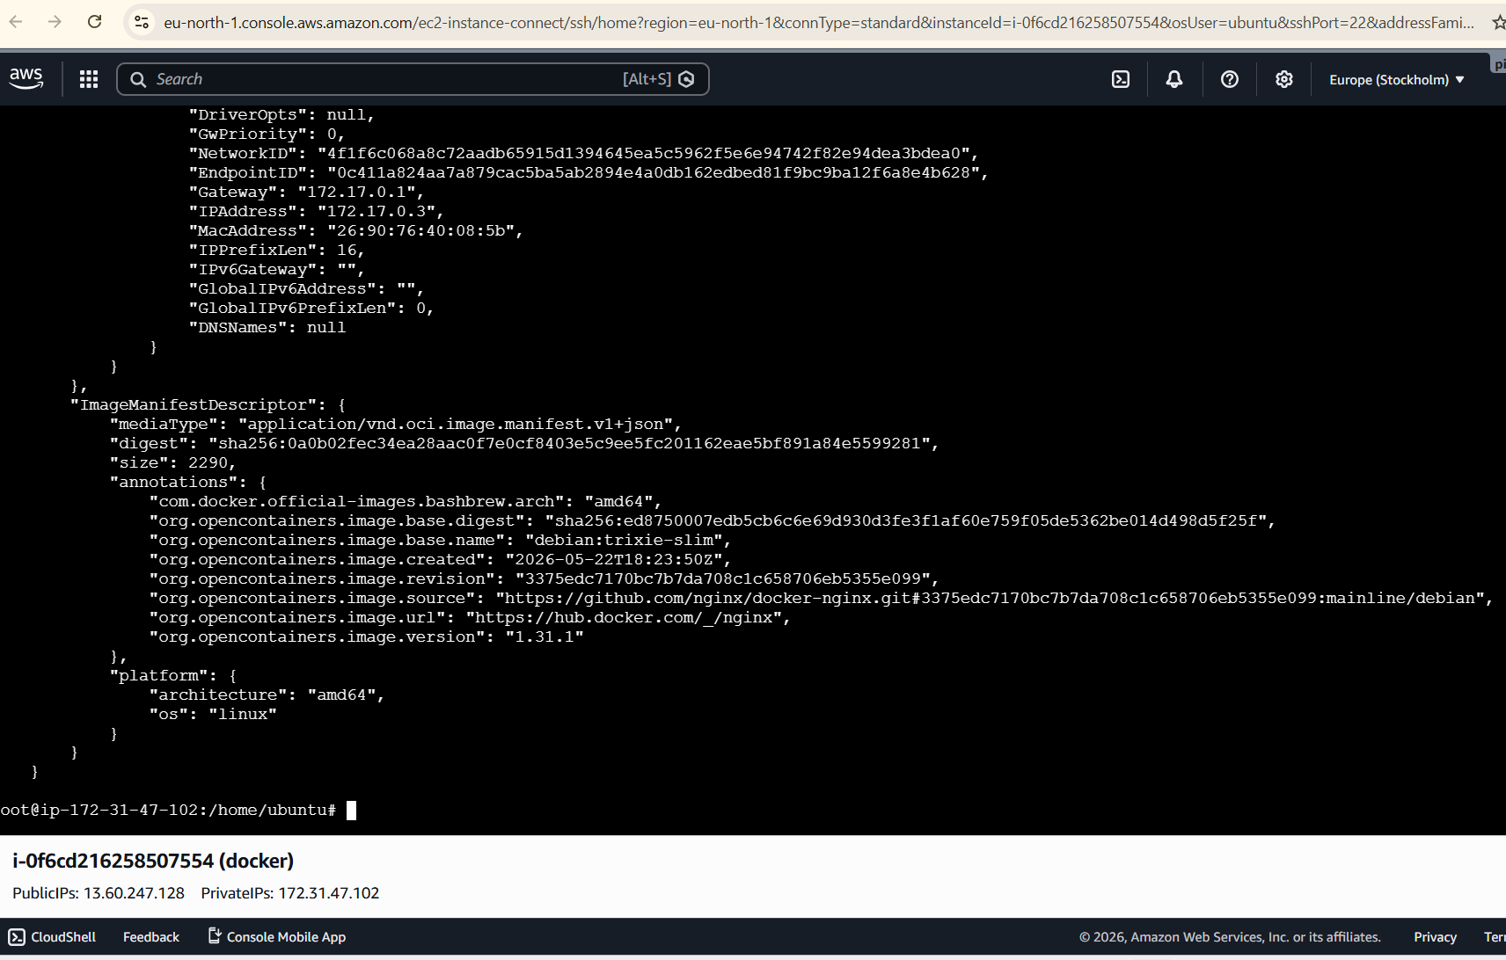
docker stats nginx-500mb

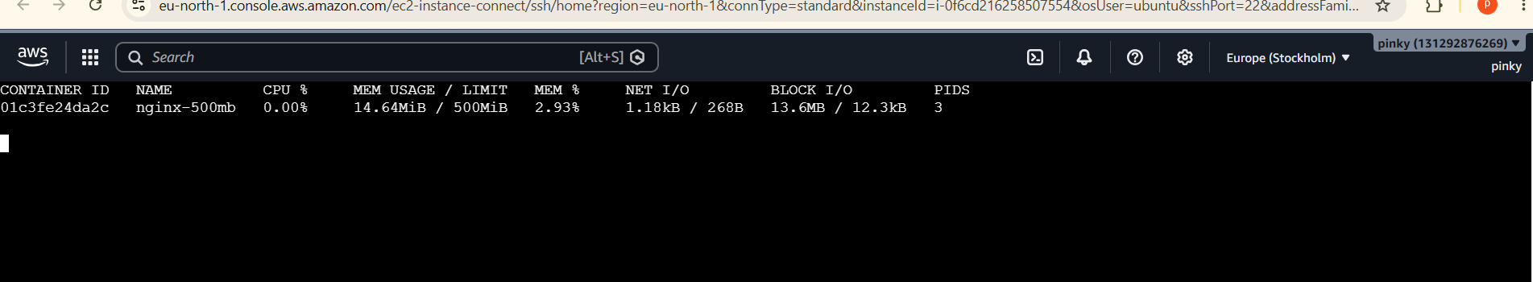
Verify the browser
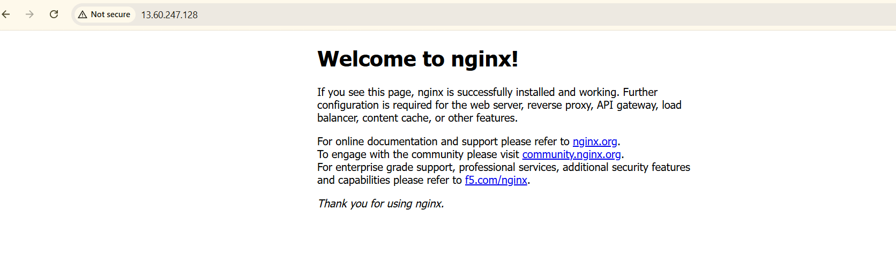
- Create a sample docker file using below instructions.
  - Base module as amazonlinux:latest
  - Maintainer you name
  - Install nginx
  - COPY one index.html file to image
  - Expose on port 80
  - Command to start the nginx container
First we can create one index.html
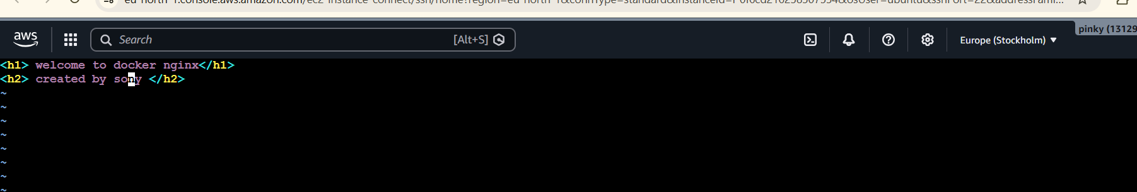
Then create dockerfile

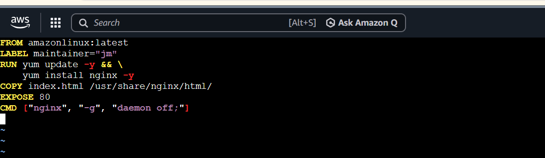
Lets build that file by using this commands
Docker build -t sony:v1 .
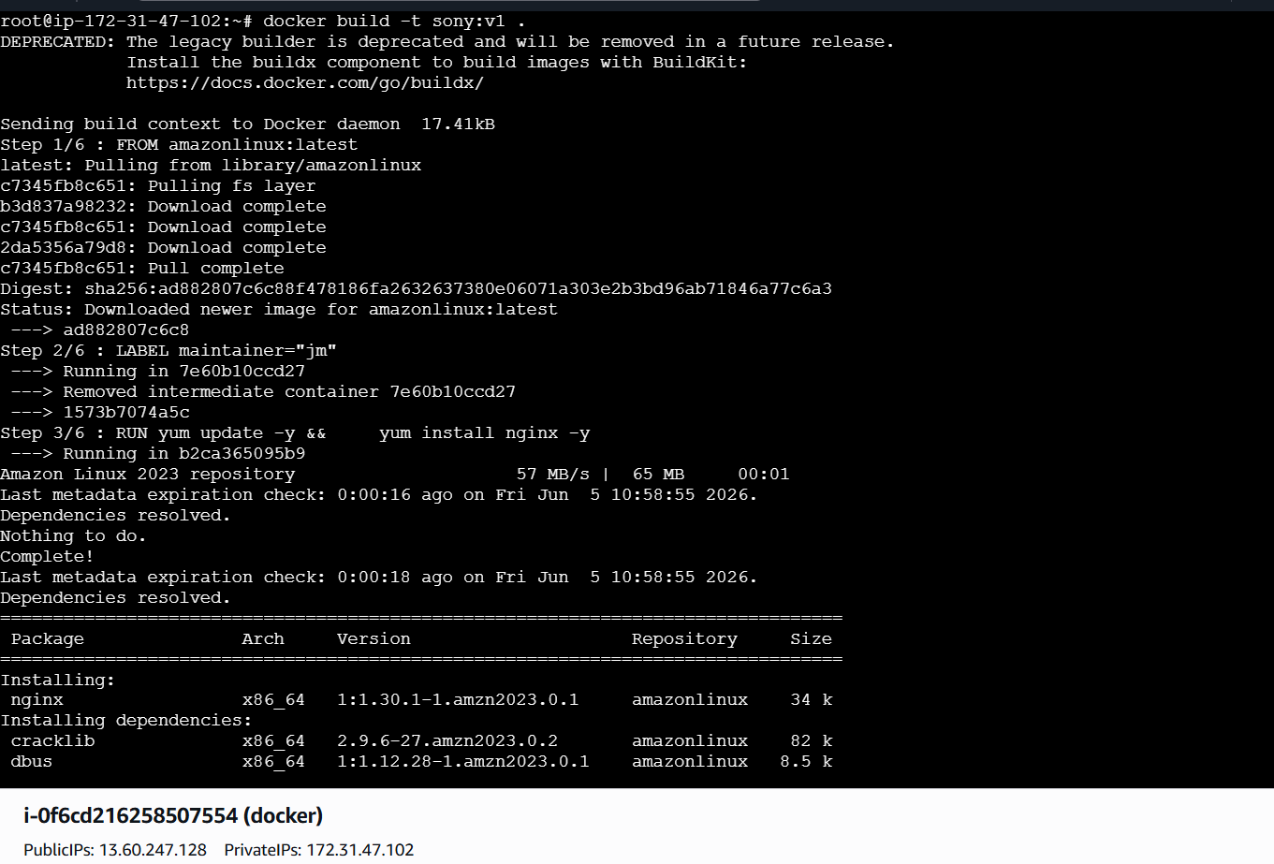
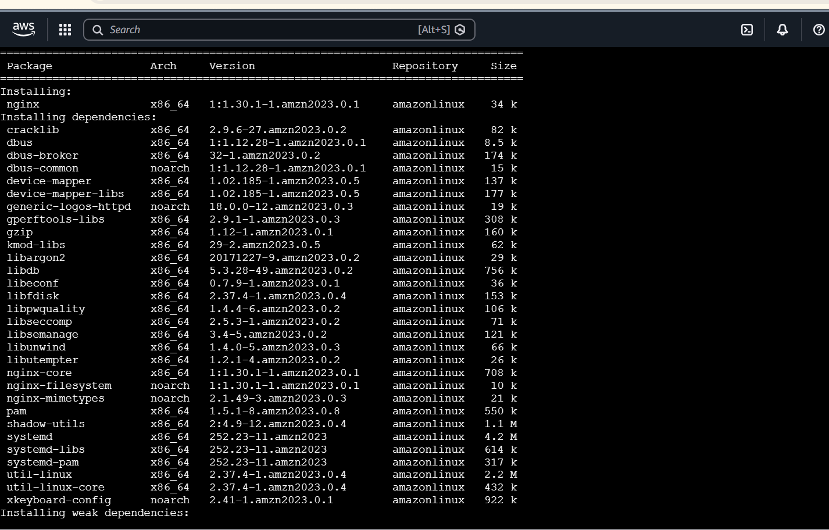
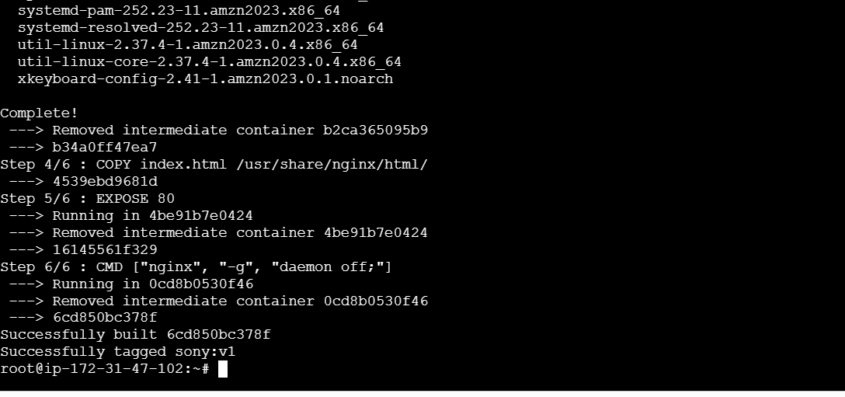
After build we can run then file
docker run -d \
--name nginx \
-p 8082:80 \
Sony:v1
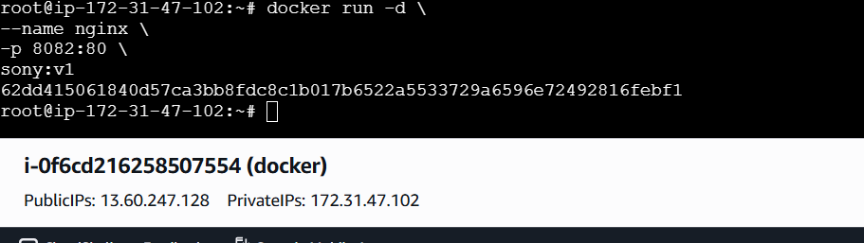
To check the image is download or not
Dokcke images
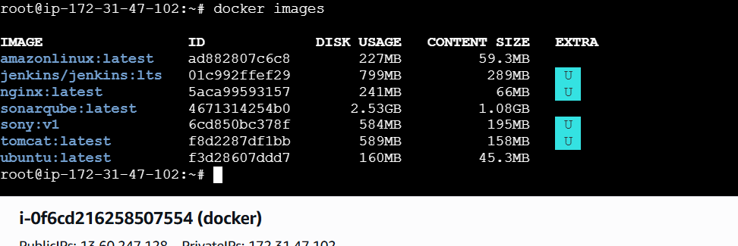
Verify the browser
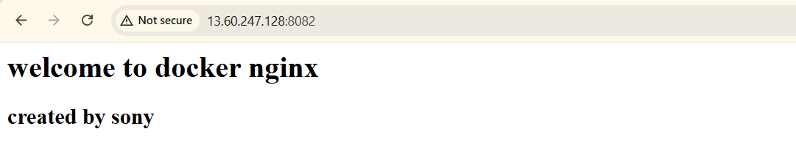

- Push image to Docker hub
We can check the images are avaible
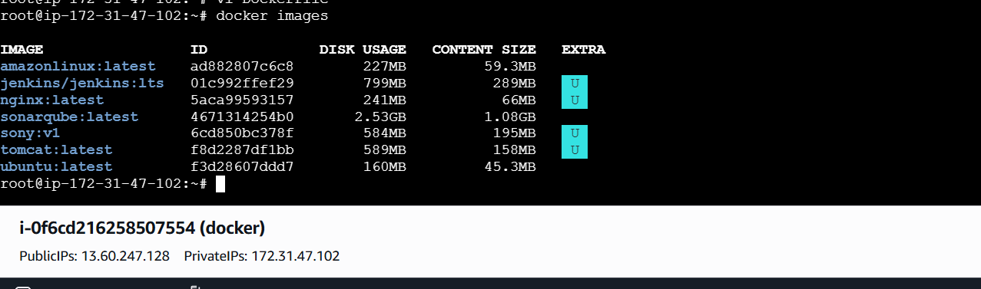
Lets go to google
Open Docker Hub Dashboard
considered site:
https://hub.docker.com
logged into Docker Hub.
Opened Repositories section

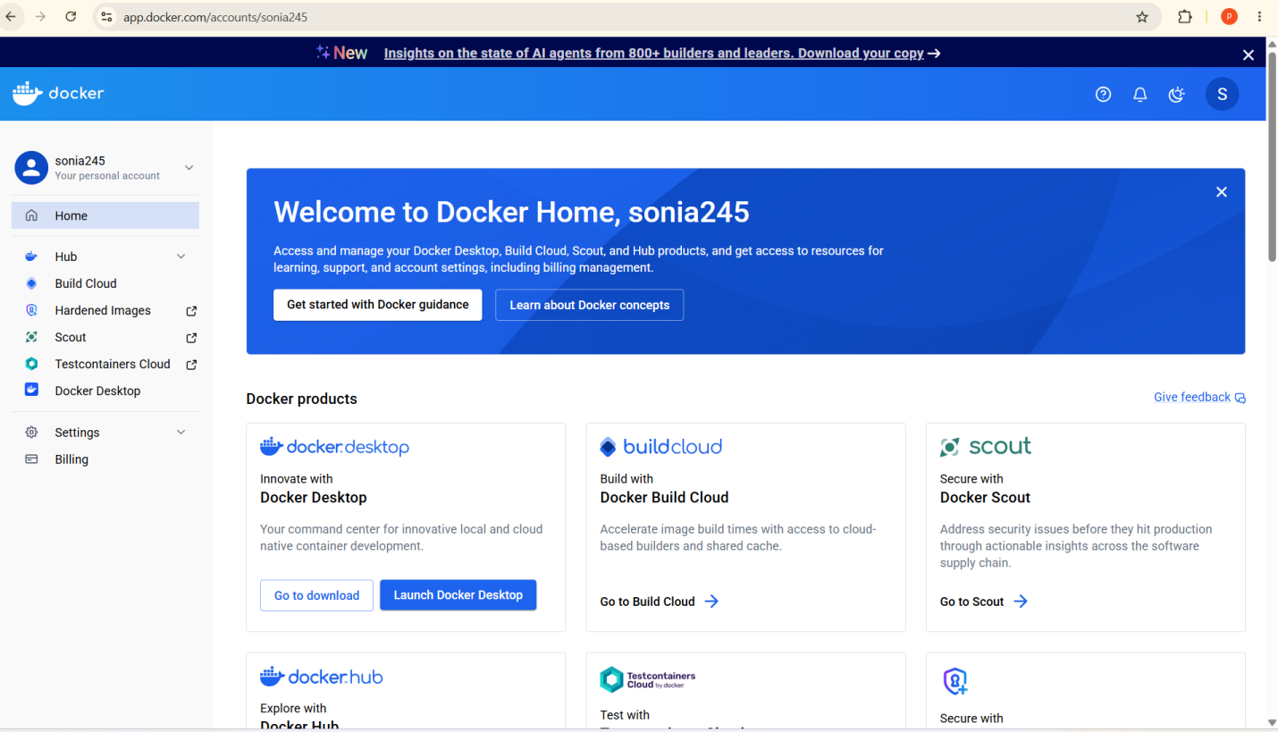
Create the one repository
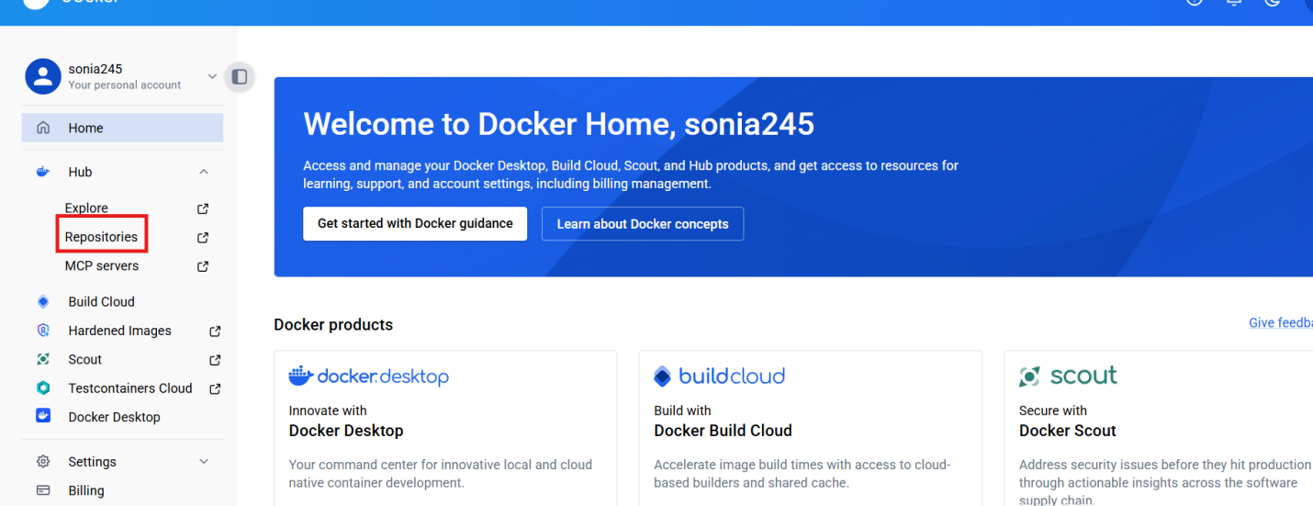
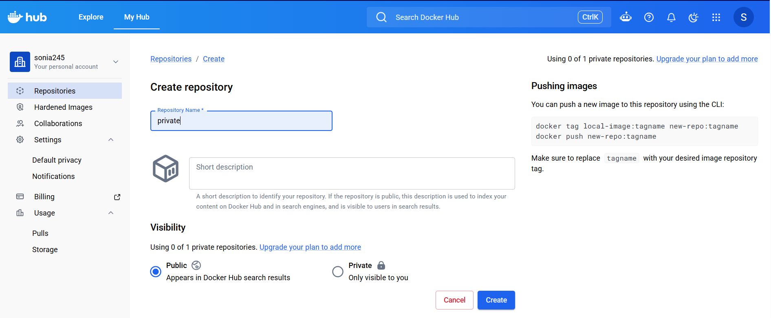
Go to server login the
Login to Docker Hub from Server
Docker login
Copy thr url link

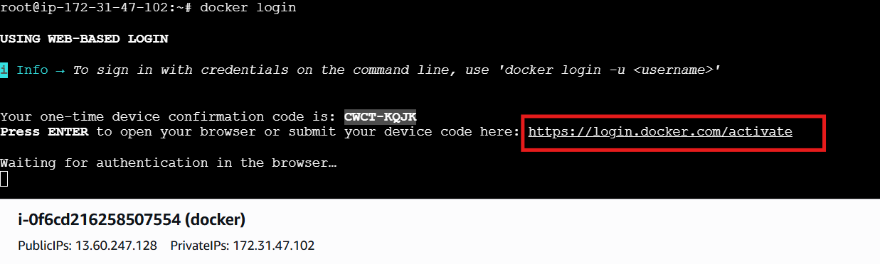

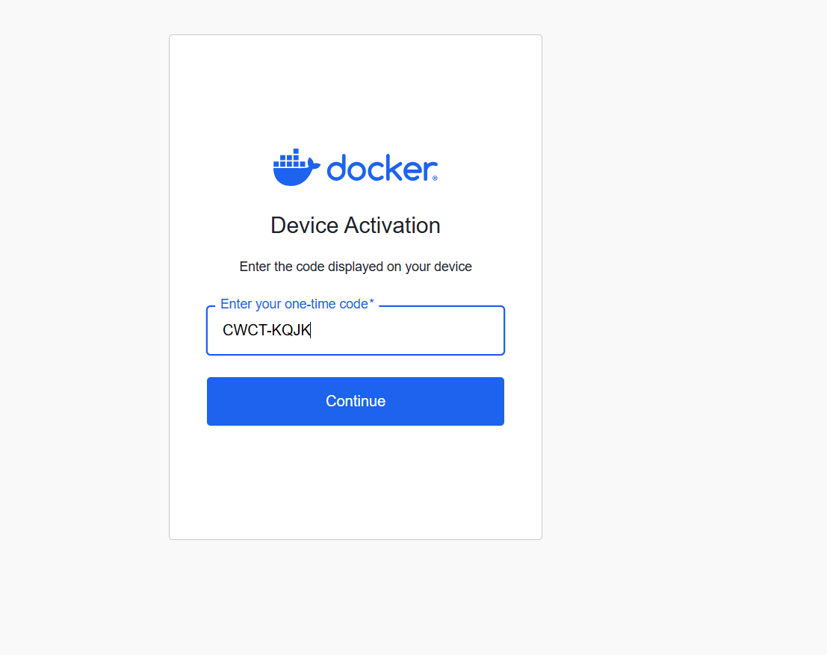
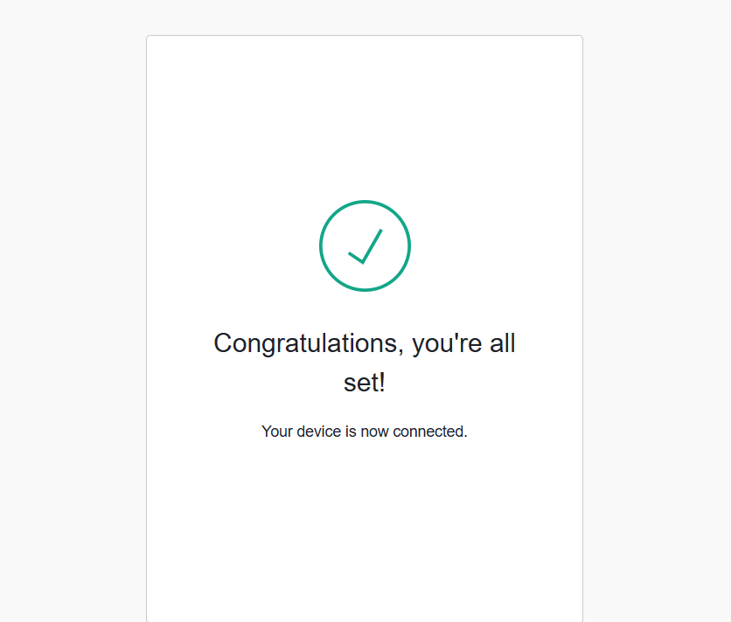
Tag Image for Docker Hub
docker tag sony:v1 sonia245/sony:v1

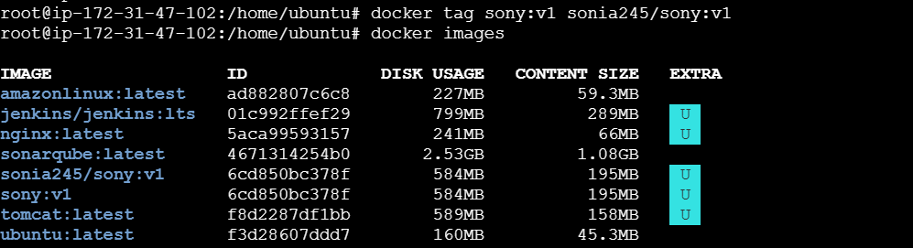
push Image to Docker Hub
docker push sonia245/sont:v1
Uploaded image to Docker Hub.

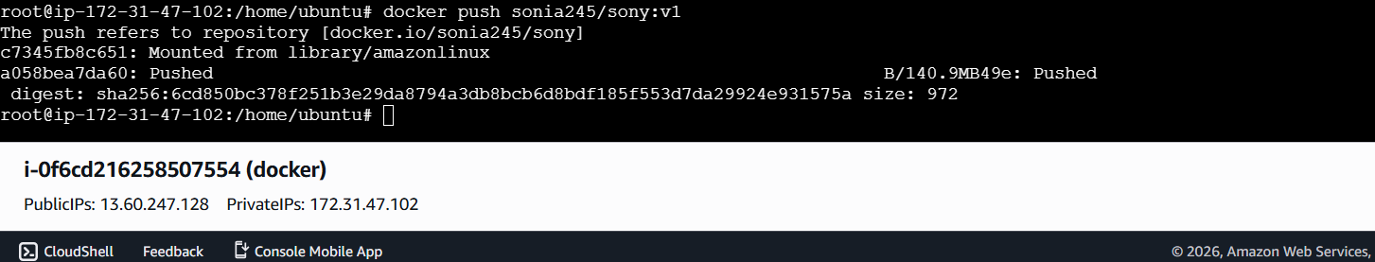
Verify the docker hub
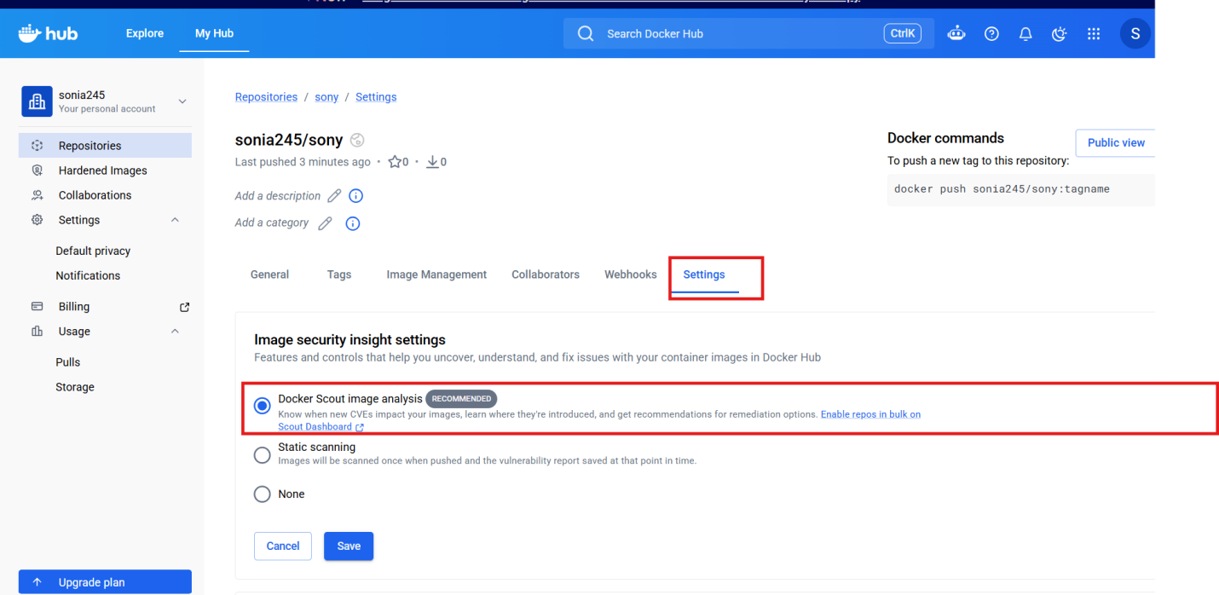
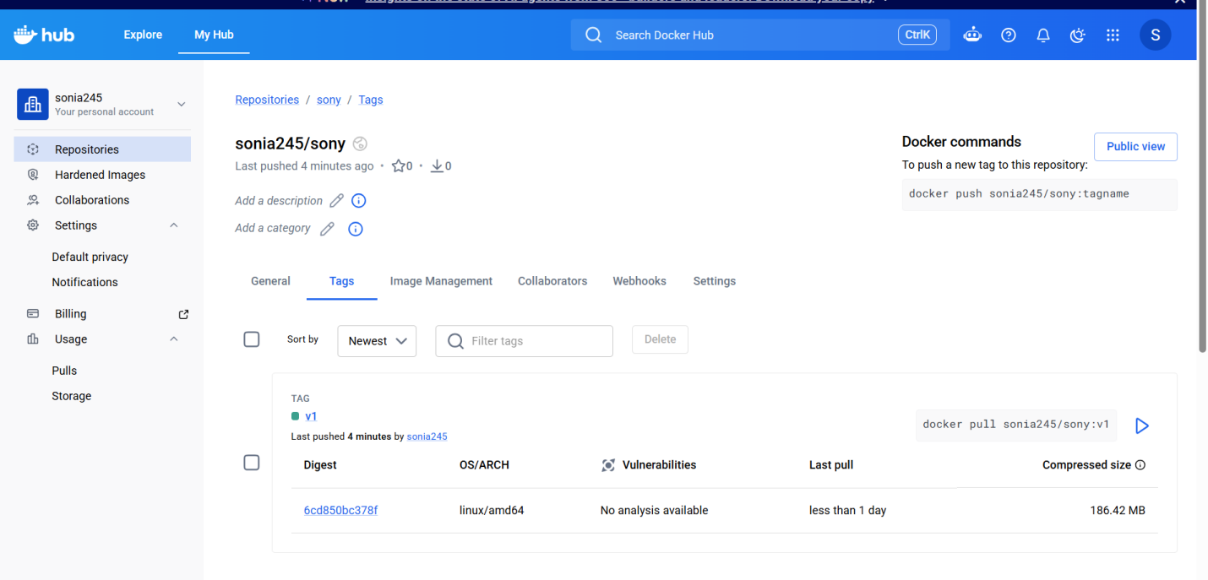

- push image to AWS ECR
Update the package
Sudo apt update
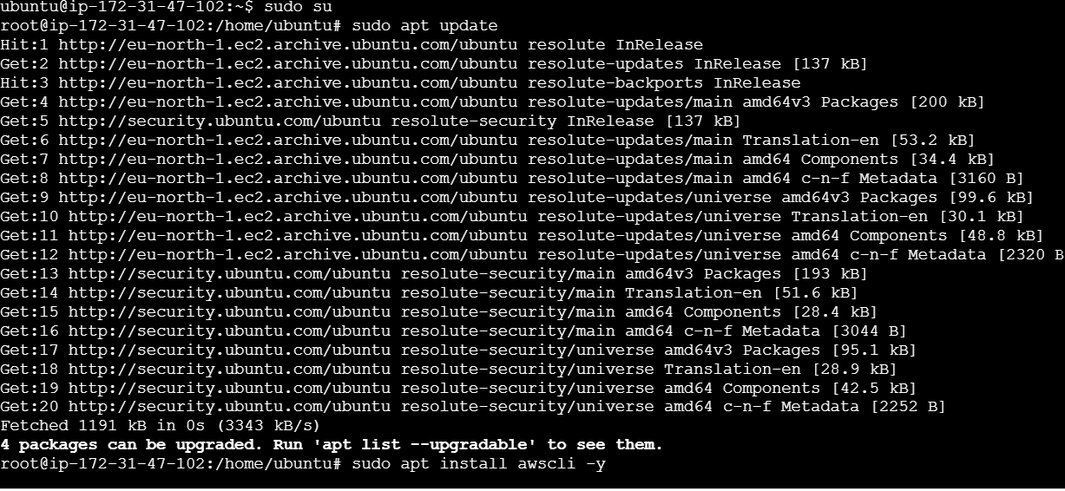
Install awscli
Sudo spt install awscli -y
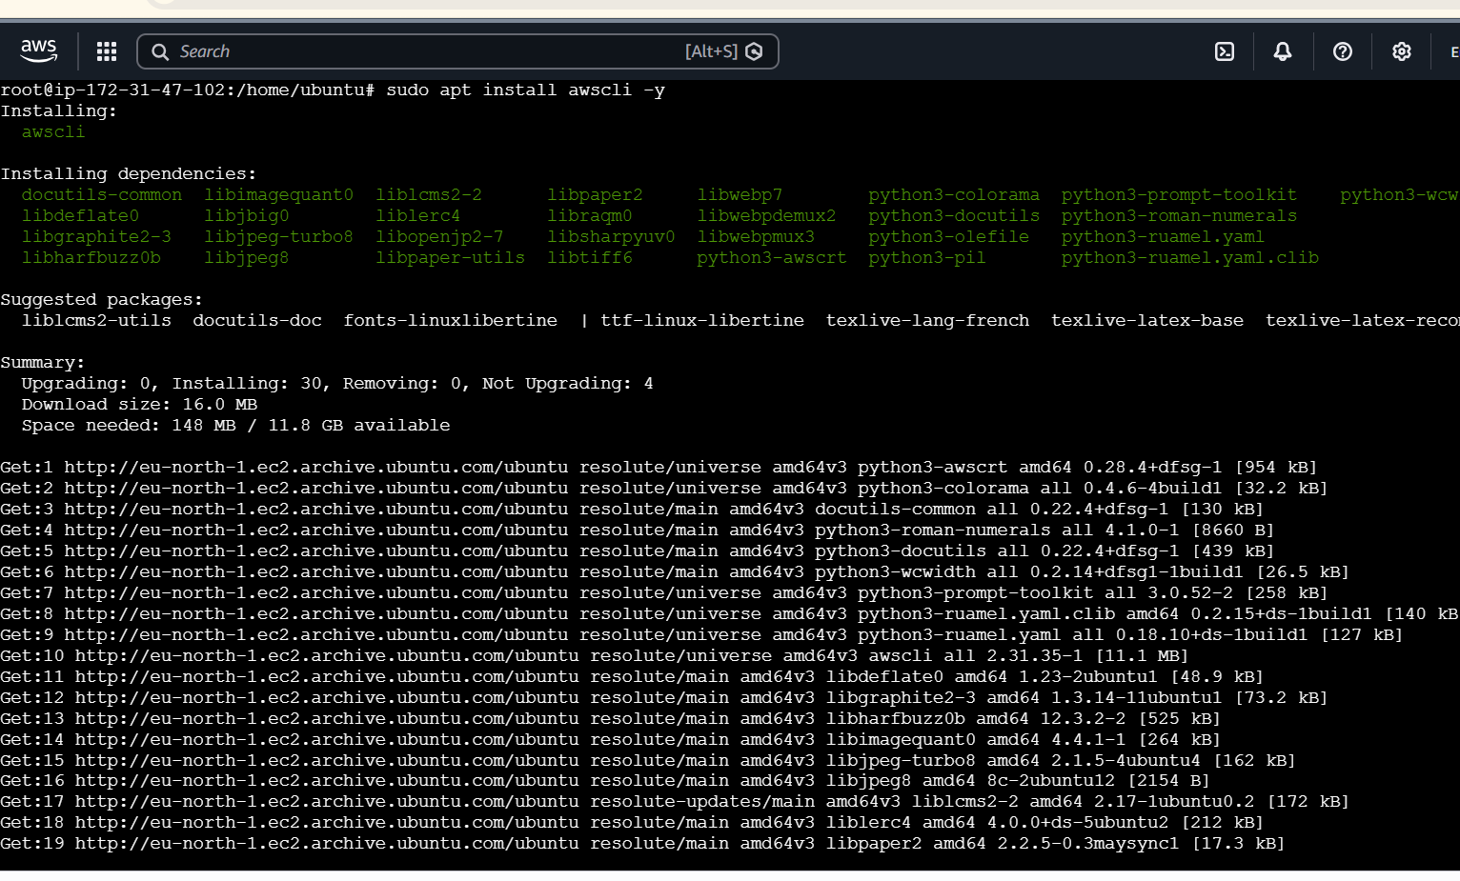
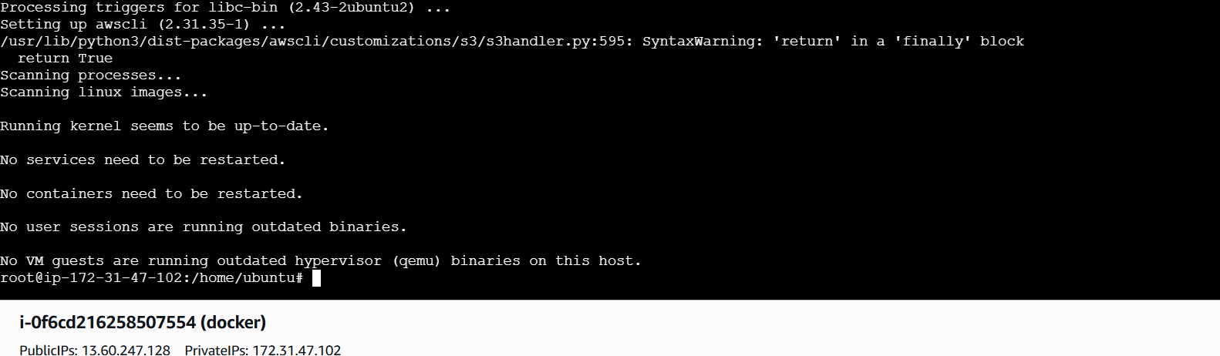
Check aws veesion
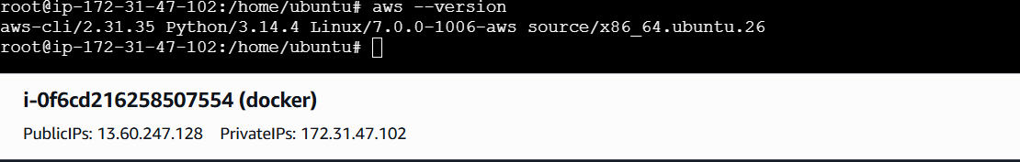
aws configure

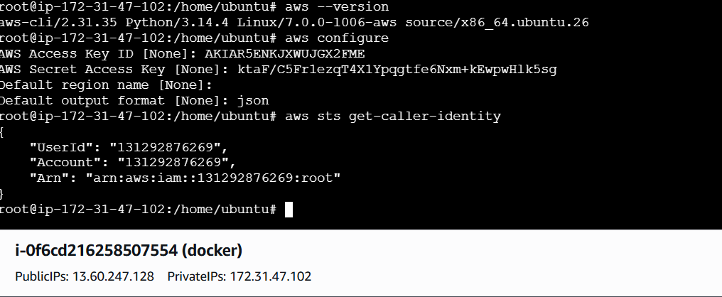
Login using the below command
aws ecr get-login-password --region us-east-1 | docker login --username AWS --password-stdin 131292876269.dkr.ecr.us-east-1.amazonaws.com

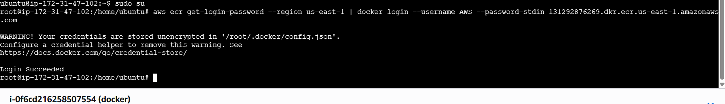
Go to ecr service create a repository
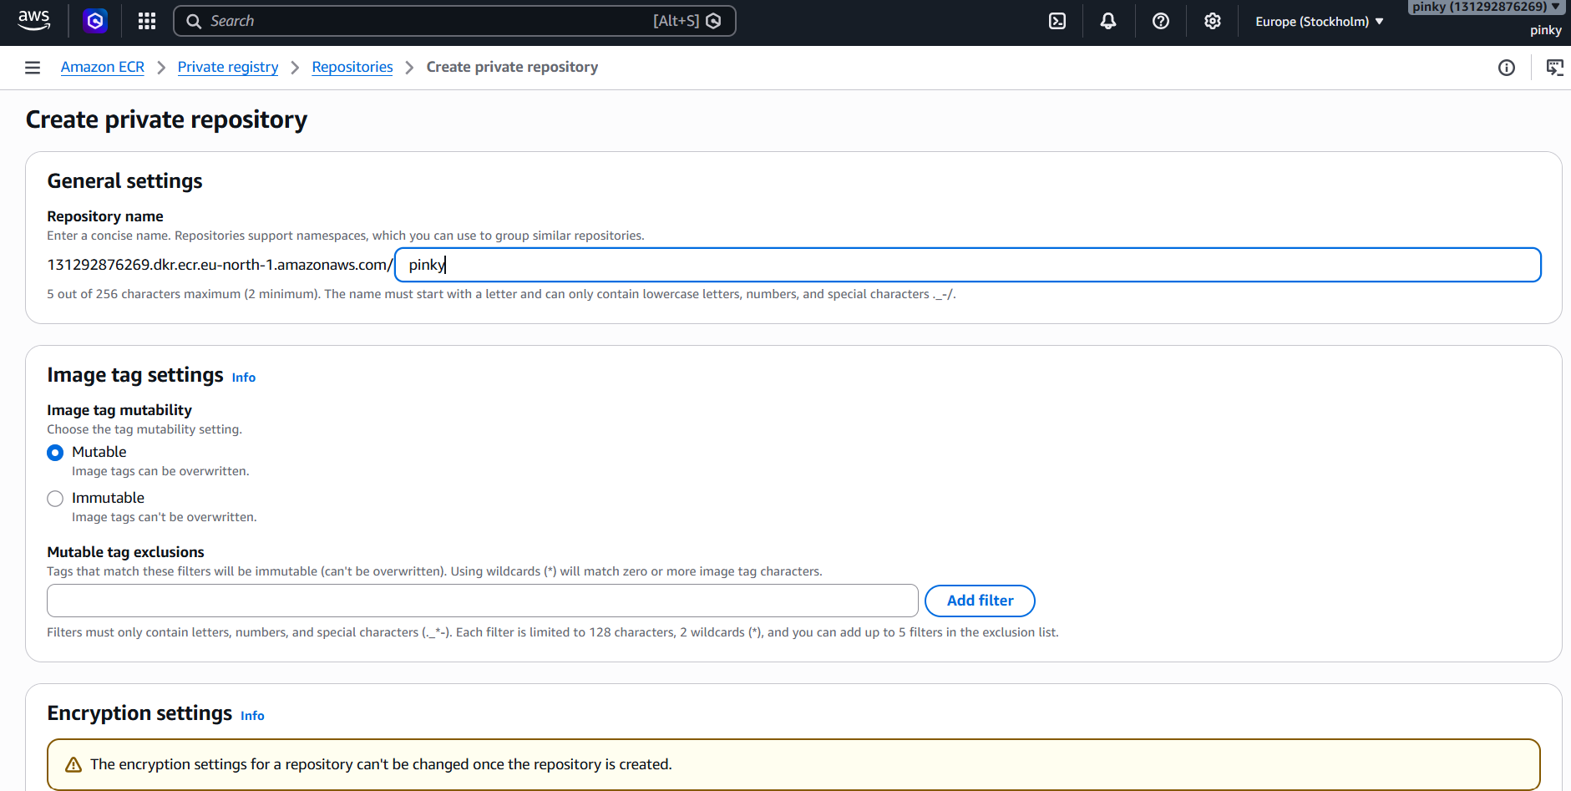
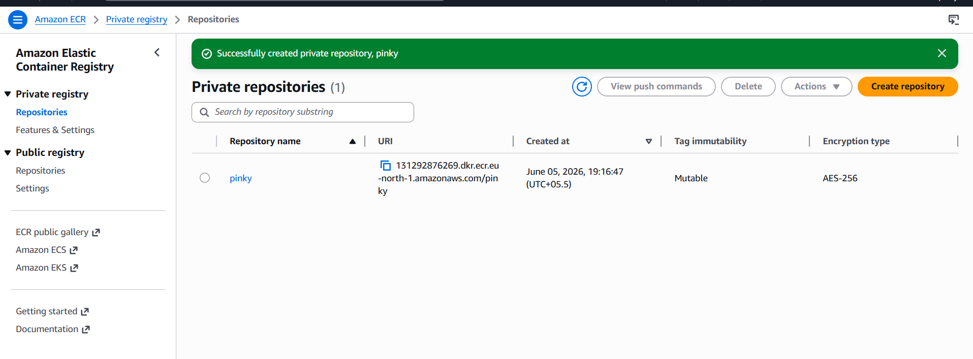
Now lets rename our image to repo name by using command
docker tag sony:v1 131292876269.dkr.ecr.us-east-1.amazonaws.com/sony:v1

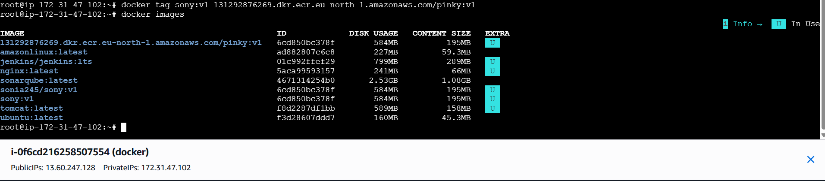
Check Docker images
Now lets push to our ECR repo by using command
docker push 131292876269.dkr.ecr.us-east-1.amazonaws.com/sony:v1

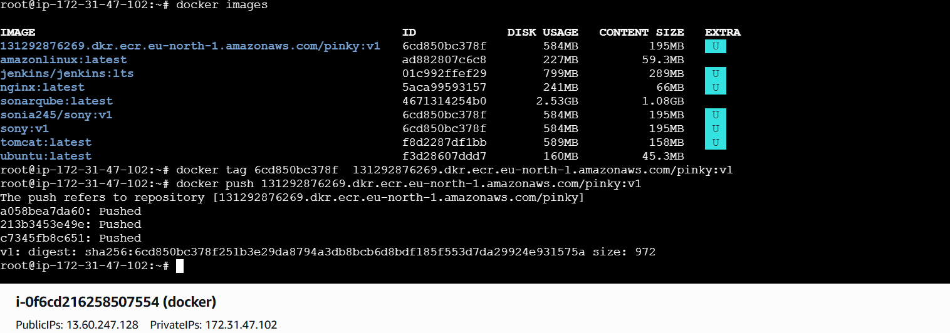
Lets check in the AWS ECR
It has been pushed successfully

