**Assignment Description**

I create the Webpage for book. The name of the book is “RICH DAD OR POOR DAD”

I create a folder🡪

Many files available are:-

Index.html- when I open the file in the browser file look like

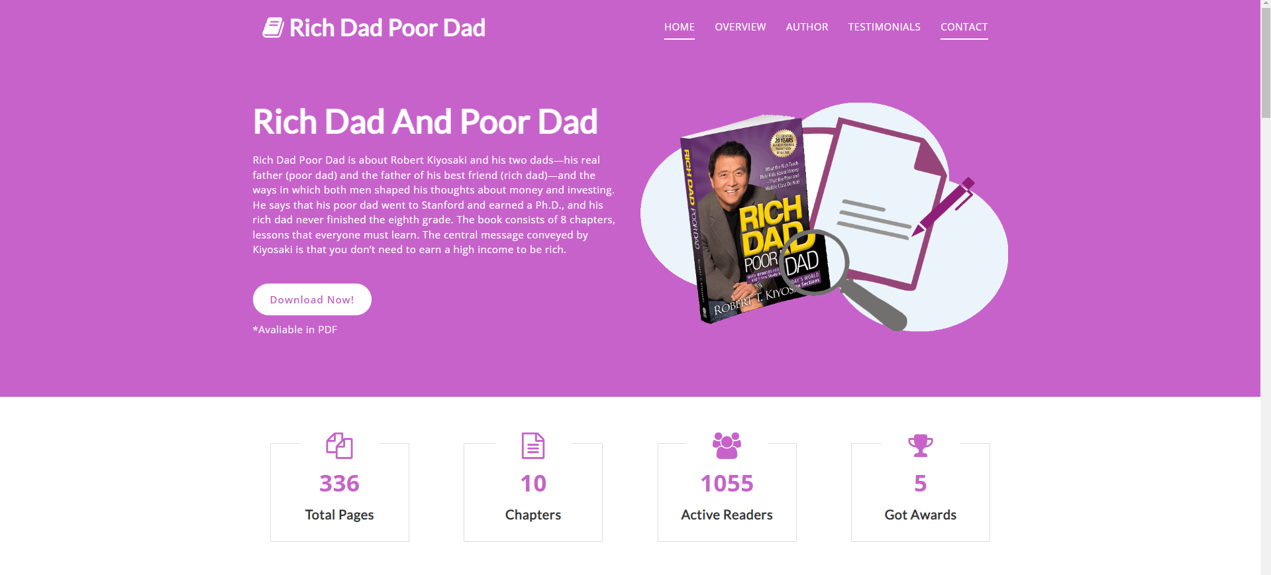

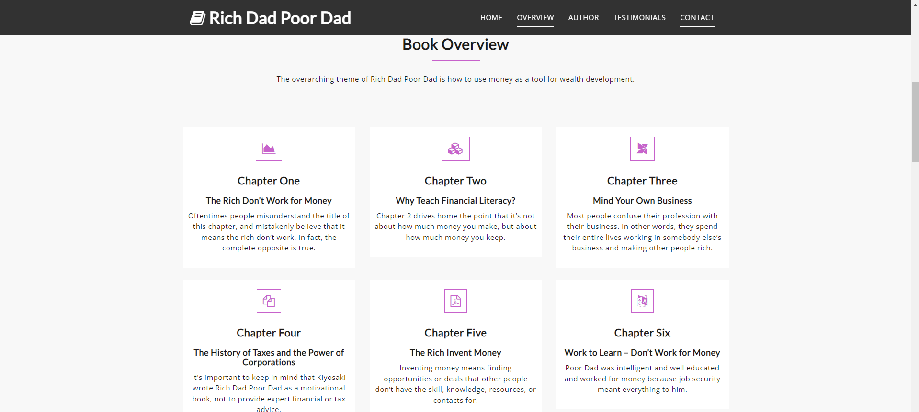

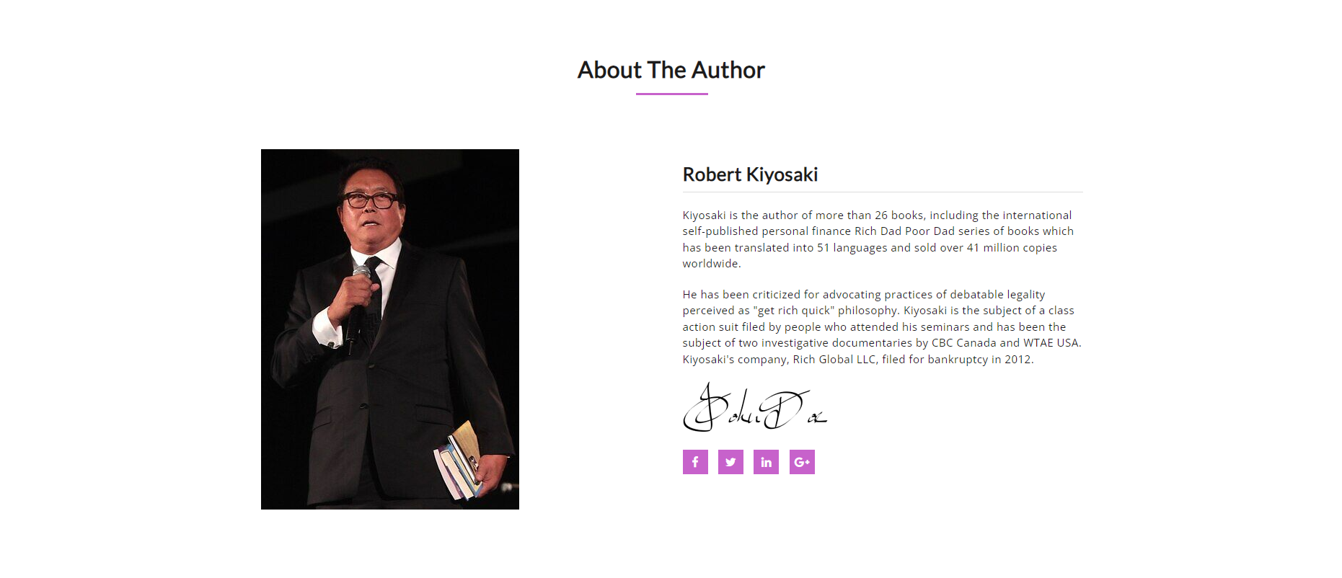

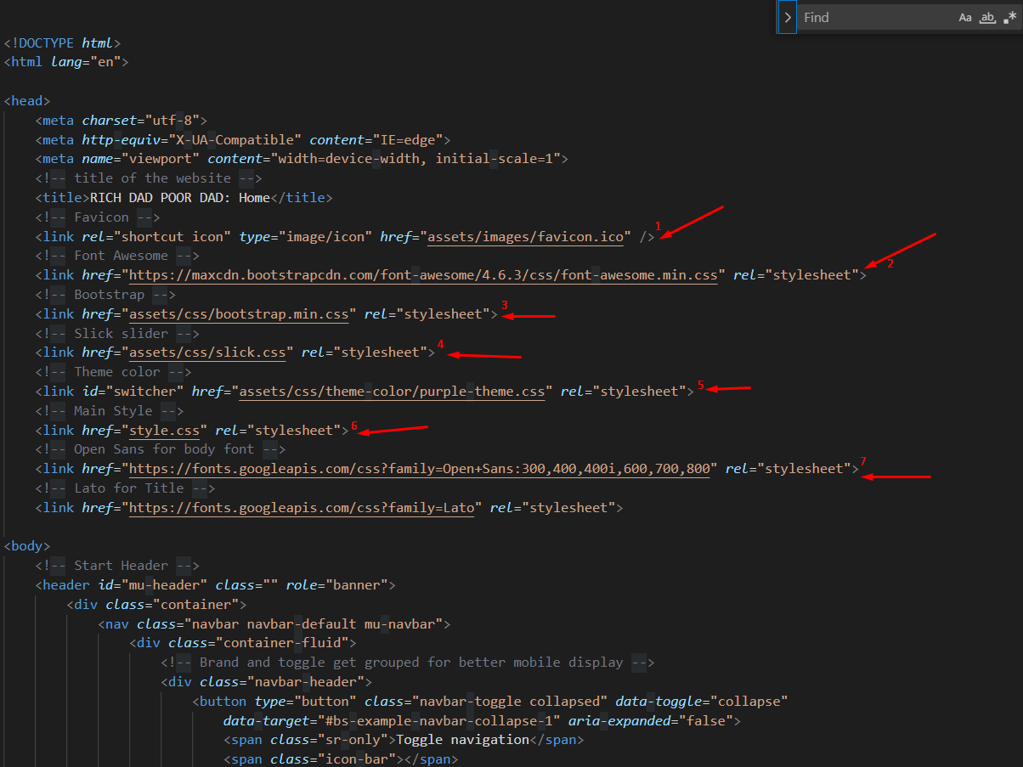

1:-

FIRST LINK FOR FAVICON

2 link: - FOR BOOTSTRAP

3 link:-IN THE ASSETS FOLDER PUT THE CSS

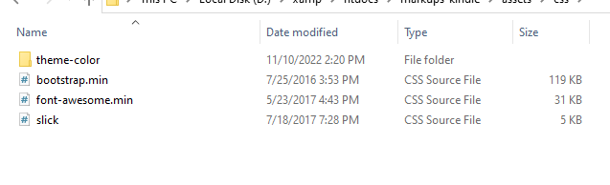

Images folder:-

**Images** folder contain he images

SCHEMA.ORG-

Schema.org provides a collection of shared vocabularies Ibmasters can use to mark up their pages in ways that can be understood by the major search engines: Google, Microsoft, Yandex and Yahoo!

You use the **schema.org** vocabulary along with the **Microdata, RDFa** . ,or **JSON-LD** formats to add information to your Ib content. This guide will help get you up to speed with Microdata and schema.org so that you can start adding markup to your Ib pages.

IN THE FAQ, I USE THE FAQ SCHEMA

**Link for the File**

<index.html>