1 | Title & Author Details: Identifies the article, authors, and their affiliations.
2 | Abstract: A concise summary of the research, methods, results, and conclusions.
3 | Keywords: Terms used for indexing and searchability.
4 | Introduction: Background, context, research problem, and objectives.
5 | Literature Review: Establishes the theoretical framework and existing knowledge.
6 | Methodology: Detailed procedures, design, and data collection methods.
7 | Results: Findings, often supported by tables and figures.
8 | Discussion: Interpretation of findings, implications, and comparison with previous research.
9 | Conclusion: Summary of main findings and future research recommendations.
13 | References/Bibliography: A list of sources cited in the article.
Heading level | Example | Font size and style
Title (centered) | Lecture Notes | 14 point, bold
1st-level heading | 1 Introduction | 12 point, bold
2nd-level heading | 2.1 Printing Area | 10 point, bold
3rd-level heading | Run-in Heading in Bold. Text follows | 10 point, bold
4th-level heading | Lowest Level Heading. Text follows | 10 point, italic
A Systematic Review of IoT-Enabled Smart Agriculture for Food Security and Sustainable Development: Opportunities, Challenges, and Future Directions
Sonia Ben Aissa¹[0009-0005-4044-4516] · Mounir Frikha¹[0009-0007-8983-3429]
¹ Department of Computer Networks and Communications, College of Computer Sciences and Information Technology, King Faisal University, Al-Ahsa, Saudi Arabia
saissa@kfu.edu.sa
Abstract. Food security remains a critical global challenge, particularly in developing countries where agricultural systems face mounting pressures from climate change, population growth, and resource scarcity. The Internet of Things (IoT) has emerged as a transformative technology with significant potential to modernize agricultural practices and contribute to the United Nations Sustainable Development Goals (SDGs), notably SDG 2 (Zero Hunger), SDG 9 (Industry, Innovation and Infrastructure), and SDG 13 (Climate Action). This chapter presents a systematic literature review following the PRISMA 2020 protocol, covering peer-reviewed publications from 2018 to 2025 retrieved from IEEE Xplore, Scopus, Web of Science, ACM Digital Library, and Google Scholar. A total of 87 studies were retained after applying rigorous inclusion and exclusion criteria. Our review examines IoT architectures, sensor technologies, and Low-Power Wide-Area Network (LPWAN) communication protocols — including LoRaWAN, NB-IoT, and Sigfox — deployed in smart agriculture contexts, with a focus on developing country settings. The originality of our work consists in providing a comprehensive dual-impact analysis, addressing both the positive contributions of IoT — including water efficiency, crop yield optimization, pest detection, and climate-adaptive farming — and the negative externalities such as e-waste generation, energy consumption, cybersecurity vulnerabilities, and labour displacement risks. We further identify key structural challenges hindering large-scale IoT adoption and propose future research directions. Our findings confirm the substantial potential of IoT-enabled smart agriculture in advancing food security, while highlighting the urgent need for sustainable, low-cost, and inclusive technology deployment strategies.
Keywords: Internet of Things · Smart Agriculture · Food Security · LPWAN · LoRaWAN · SDG 2 · Developing Countries · Precision Farming · Systematic Review · PRISMA
- Introduction
Food insecurity continues to threaten the livelihoods and well-being of hundreds of millions of people worldwide, with the burden falling disproportionately on developing nations in sub-Saharan Africa, South Asia, and Southeast Asia. According to the FAO, over 733 million people faced chronic hunger in 2023, a figure that underscores the urgency of transforming agricultural systems to meet the demands of a global population projected to reach 9.7 billion by 2050 [1]. Traditional farming practices, which still dominate in many developing countries, are increasingly ill-equipped to cope with the compounding pressures of climate variability, soil degradation, water scarcity, and supply chain inefficiencies [2]. In fact, post-harvest losses account for 25–40 % of food production in developing regions — a massive and largely preventable drain on food availability [3]. In fact, according to the FAO, approximately 733 million people faced hunger in 2023. To the best of the authors' knowledge, no prior review has examined both the positive and negative impacts of IoT in agriculture with a systematic focus on developing country deployment contexts — a gap this chapter addresses directly.
Against this backdrop, the Internet of Things (IoT) has emerged as a cornerstone technology. In fact, IoT solutions have the potential to revolutionize agricultural practices. By interconnecting physical devices — including sensors, actuators, drones, and gateways — through wireless communication networks, IoT enables real-time monitoring, data-driven decision-making, and automated control of agricultural processes [4]. Precision agriculture, smart irrigation, pest detection, livestock monitoring, and supply chain traceability are among the many applications that IoT systems now make possible [5]. Indeed, the global smart agriculture market is projected to grow from USD 15.4 billion in 2023 to over USD 34 billion by 2028, reflecting a growing recognition of IoT’s transformative potential [6].
The United Nations 2030 Agenda for Sustainable Development provides a compelling framework for contextualizing this transformation. Three SDGs are particularly relevant to IoT-enabled smart agriculture: SDG 2 (Zero Hunger), which calls for ending hunger and promoting sustainable food systems; SDG 9 (Industry, Innovation and Infrastructure), which emphasizes resilient infrastructure and inclusive innovation; and SDG 13 (Climate Action), which requires urgent action to combat climate change and its impacts on food systems [7]. IoT technologies can contribute positively to all three goals through improved resource efficiency, reduced post-harvest losses, and climate-adaptive farming practices. However, these technologies also carry negative externalities — including e-waste generation, the energy consumption of IoT infrastructure, labour displacement risks, and digital divide effects that may further marginalize smallholder farmers [8].
So what is the current state of IoT deployment in smart agriculture, particularly in the context of developing countries? And what are the true opportunities, risks, and challenges that researchers and policy-makers must consider to ensure that this technological transition serves the goals of sustainable and equitable development? To answer these questions rigorously, this chapter conducts a systematic literature review following the PRISMA 2020 protocol [9], covering peer-reviewed publications from 2018 to 2025. The originality of our work consists in providing a structured dual-impact analysis — examining both the positive contributions and the negative consequences of IoT adoption in agricultural settings — with a deliberate focus on developing country contexts that remain underrepresented in the existing review literature. Our goal is to provide researchers, practitioners, and policy-makers with a rigorous and actionable synthesis that goes beyond existing reviews by foregrounding the dual-impact perspective and the developing country dimension. We consider also the critical role of LPWAN technologies such as LoRaWAN, NB-IoT, and Sigfox, which are particularly well-suited to the connectivity constraints of rural agricultural environments.
Following the introduction, Section 2 presents the PRISMA methodology of our systematic review. Section 3 provides an overview of IoT architectures and communication technologies. Section 4 analyzes the positive impacts on agricultural systems and food security outcomes. Section 5 examines the negative impacts and associated risks. Section 6 identifies the key challenges facing IoT deployment in developing countries. Section 7 proposes future research directions. Finally, Section 8 presents the conclusion and policy recommendations of this review.
- Methodology
Our systematic review follows the PRISMA 2020 guidelines [9], which provide a structured and transparent protocol for identifying, screening, and synthesizing evidence from the scientific literature. In this work, we apply the full four-stage PRISMA protocol — Identification, Screening, Eligibility, and Inclusion — with strict adherence to reproducibility and transparency standards throughout each stage. The PRISMA framework ensures reproducibility and rigor in the review process, making it the methodological standard of choice for systematic reviews in technology and applied science domains. The four sequential stages — Identification, Screening, Eligibility, and Inclusion — progressively narrow the evidence base from an initial broad corpus to a final set of high-quality, relevant studies suited to addressing our research questions.
  - Search Strategy
We conducted a comprehensive literature search across five major academic databases: IEEE Xplore, Scopus, Web of Science, ACM Digital Library, and Google Scholar. The search was restricted to peer-reviewed articles published between January 2018 and December 2025. This time window was chosen deliberately: the lower bound of 2018 corresponds to the widespread commercialization of LPWAN technologies, particularly LoRaWAN and NB-IoT, and the consequent surge in field-deployable IoT agricultural systems; the upper bound of 2025 ensures coverage of the most recent research advances.
The search query was constructed using a combination of primary and secondary keywords connected by Boolean operators (AND, OR). Primary keywords included: “Internet of Things”, “IoT”, “smart agriculture”, “precision farming”, “precision agriculture”, and “e-agriculture”. Secondary keywords included: “LoRaWAN”, “NB-IoT”, “Sigfox”, “LPWAN”, “wireless sensor network”, “food security”, “SDG 2”, “sustainable development”, “developing countries”, “crop monitoring”, and “precision irrigation”. Search strings were adapted to the specific syntax requirements of each database to maximize recall while maintaining acceptable precision.
  - Inclusion and Exclusion Criteria
To ensure the relevance and quality of the retained studies, we applied the following inclusion criteria: (i) peer-reviewed journal articles, conference proceedings, or book chapters; (ii) studies presenting IoT-based agricultural applications or systems; (iii) studies addressing developing country contexts, or presenting findings transferable to such contexts; (iv) publications in English; (v) works published between January 2018 and December 2025.
Conversely, studies were excluded if they met any of the following criteria: (i) studies not based on IoT or wireless sensing technologies; (ii) purely theoretical contributions without any application, simulation, or experimental component; (iii) duplicate publications — only the most recent or comprehensive version was retained; (iv) studies with no relevance to food security, agriculture, or SDG-related outcomes; (v) gray literature not subject to peer review, including technical reports, white papers, and non-peer-reviewed theses.
  - Study Selection Process
The selection process proceeded in four PRISMA stages, as illustrated in the PRISMA flow diagram (Fig. 1). During the Identification stage, a total of 1,247 records were retrieved from the five databases, supplemented by 34 records identified through manual backward citation tracking of highly cited reviews. After removing 312 duplicates, 969 records entered the Screening stage, during which titles and abstracts were assessed for relevance; 743 records were excluded as irrelevant to the review scope. In the Eligibility stage, the remaining 226 full-text articles were assessed against the inclusion and exclusion criteria; 139 were excluded for the following reasons: insufficient IoT content (n = 47), lack of relevance to developing country contexts (n = 52), purely theoretical focus without applied component (n = 28), or non-English language (n = 12). A final corpus of 87 studies was retained for full synthesis in the Inclusion stage.
Two reviewers independently conducted the screening and eligibility assessment stages. Disagreements were resolved through structured discussion; cases where consensus could not be reached after two rounds of discussion were resolved by the senior author following a final structured deliberation. Inter-rater agreement was assessed using Cohen’s kappa coefficient (κ = 0.81), indicating strong agreement. Study quality was assessed using a structured checklist adapted from the Mixed Methods Appraisal Tool (MMAT) [63], evaluating methodological rigor, reporting transparency, and applicability to developing country agricultural contexts. Studies meeting fewer than 60 % of applicable MMAT criteria (i.e., fewer than 3 out of 5 criteria) were excluded from the final synthesis.
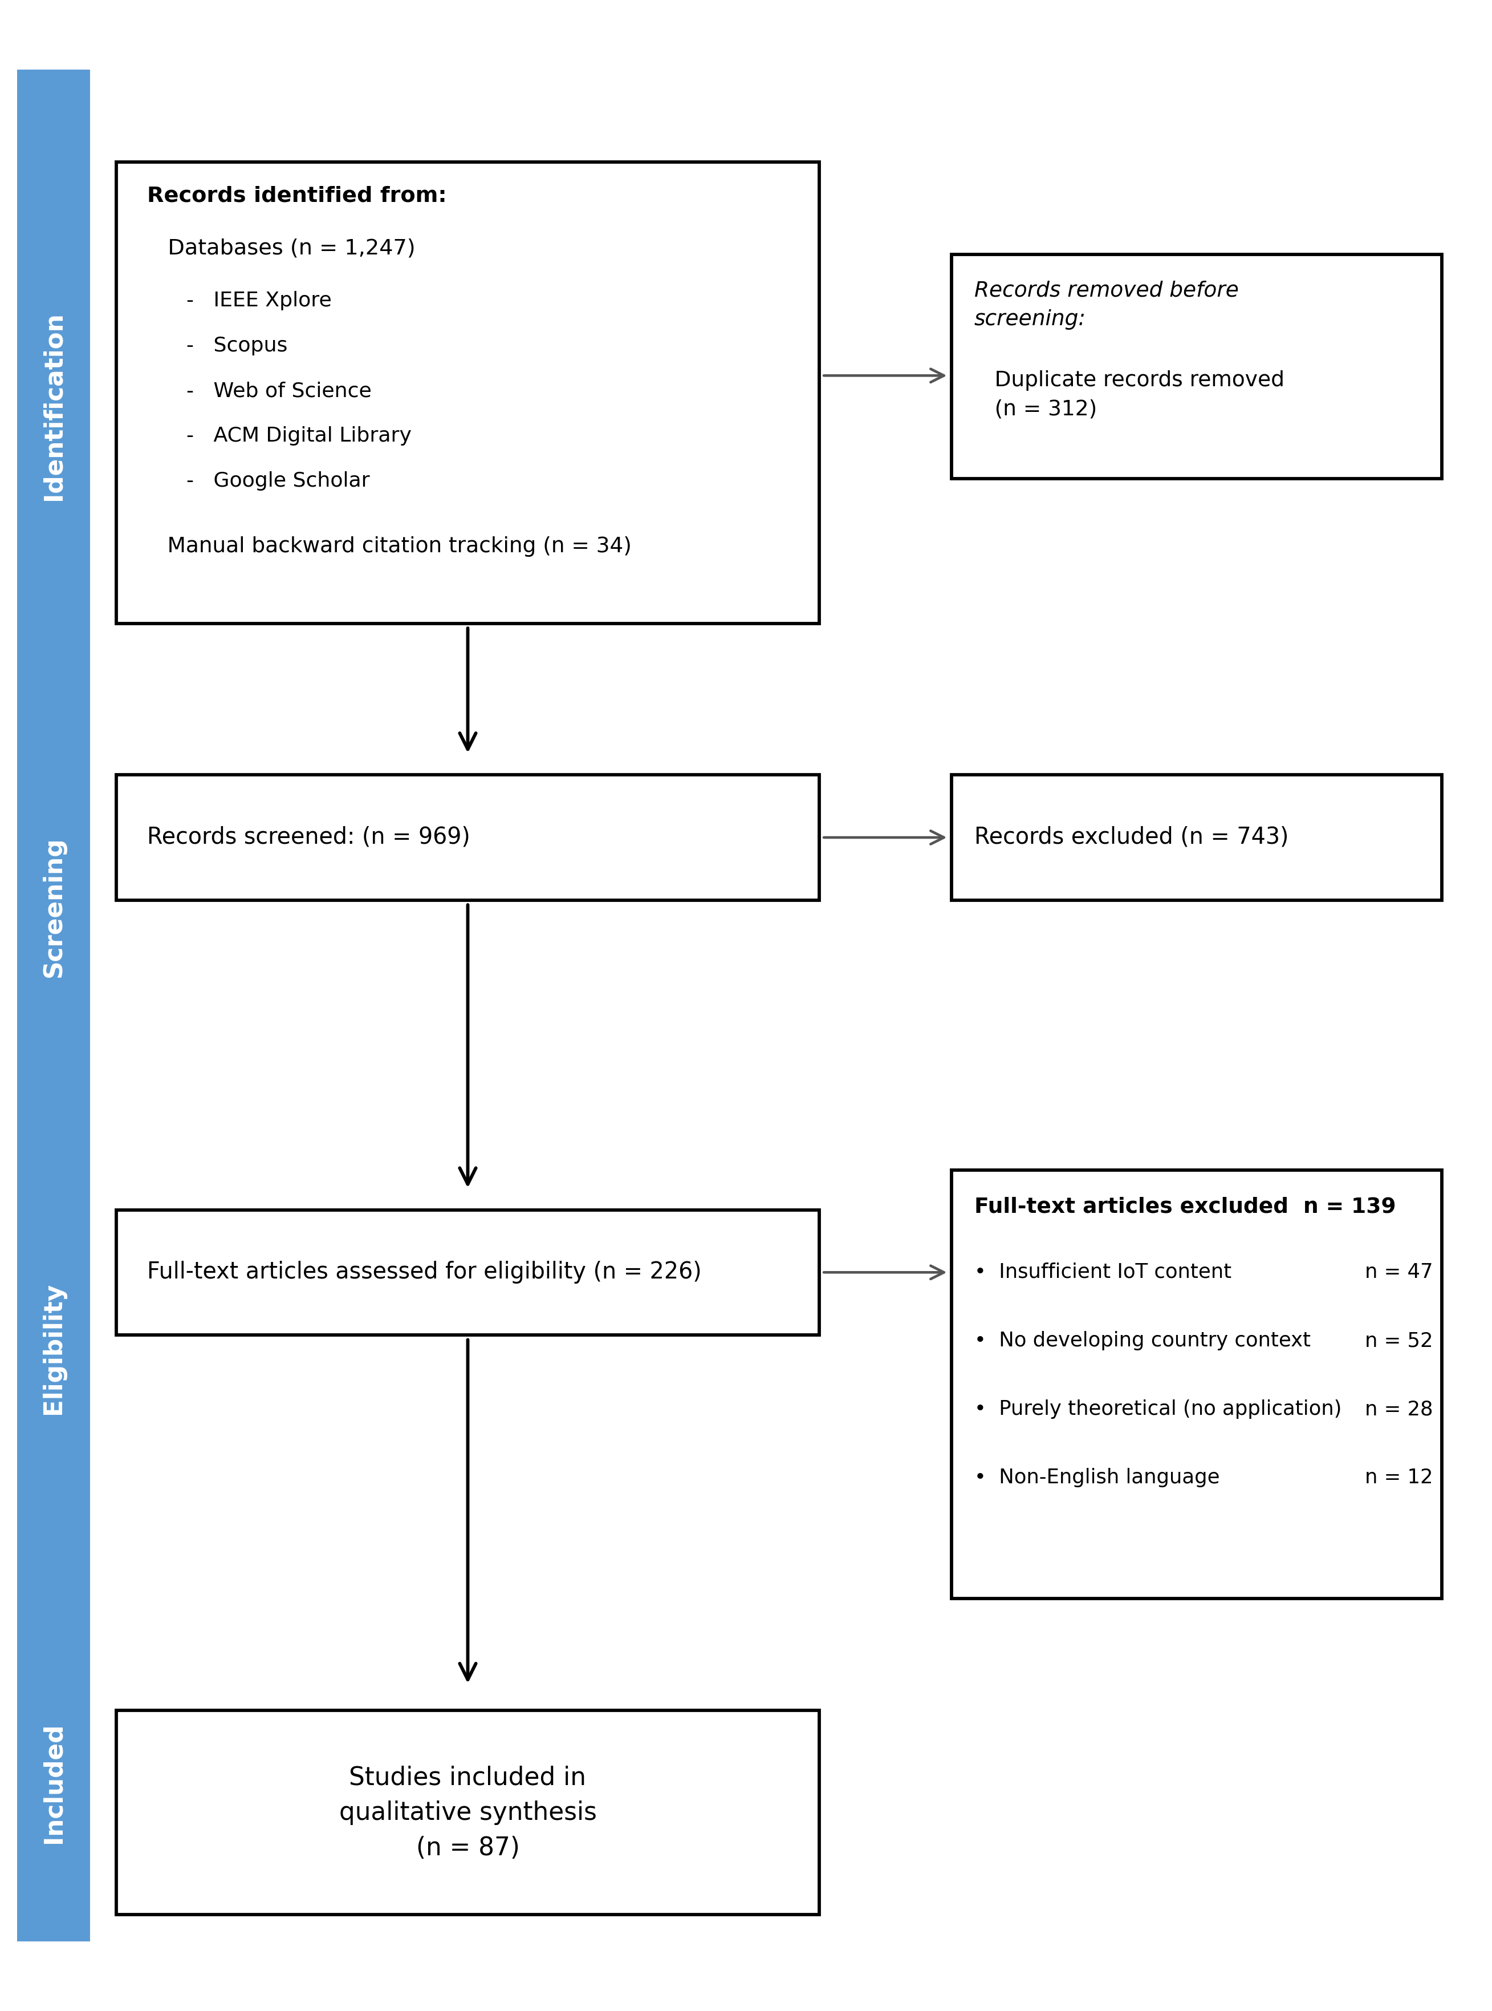
Fig. 1. PRISMA 2020 flow diagram of the study selection process.
  - Data Extraction and Synthesis
For each included study, we extracted the following data elements: title, authors, year of publication, country of study, IoT technologies deployed (sensor types, communication protocols, cloud platforms), agricultural application domain, key quantitative findings, and reported impacts (positive and negative). A narrative synthesis approach was adopted given the heterogeneity of study designs, performance metrics, and application contexts, which precluded formal meta-analysis. Thematic coding was performed to identify recurring patterns across studies, informing the section structure of this review. The justification for this approach lies in the need to draw actionable conclusions across a diverse body of literature while preserving contextual richness essential for developing country applicability.
Ref. | Authors (Year) | Country / Region | IoT Technology | Application Domain | SDG | Key Contribution
[16] | Ojo & Giordano (2023) | Sub-Saharan Africa | LoRaWAN | Rural connectivity | SDG 2, 9 | Reviews LoRaWAN energy trade-offs in low-infrastructure settings
[17] | Zerihun et al. (2022) | Ethiopia | LoRaWAN / IoT sensors | Smart irrigation | SDG 2, 6 | LoRaWAN drip irrigation reduces water use by 35% in smallholder plots
[25] | Abioye et al. (2022) | Global (review) | Soil moisture sensors | Precision irrigation | SDG 2, 6 | ML-enhanced IoT scheduling identified as optimal for water saving
[26] | Mousa et al. (2023) | Developing countries | IoT / LPWAN | Irrigation scheduling | SDG 2 | IoT scheduling reduces over-irrigation by up to 40%
[27] | Hamouda & Abdelwahab (2022) | North Africa | IoT + Remote sensing | Smart irrigation | SDG 2 | Combines NDVI and IoT sensors for adaptive irrigation
[28] | Kamienski et al. (2019) | Brazil | IoT cloud platform | Water management | SDG 2, 6 | SWAMP: real-time IoT irrigation decision support for rice
[29] | Van Klompenburg et al. (2020) | Global (review) | ML + IoT data | Crop yield prediction | SDG 2 | SLR of 50 studies: random forests dominant for yield prediction
[30] | Dike et al. (2022) | Sub-Saharan Africa | Multispectral IoT sensors | Nitrogen deficiency detection | SDG 2 | Low-cost sensing detects N-deficiency in maize with 89% accuracy
[31] | Rao et al. (2023) | India (rural) | IoT weather stations | Hyperlocal climate monitoring | SDG 2, 13 | Dense IoT networks enable microclimate-adaptive farming
[32] | Tetila et al. (2021) | Brazil | UAV + deep learning | Foliar disease detection | SDG 2 | UAV-IoT pipeline: 96% accuracy for soybean disease
[33] | Afolabi et al. (2023) | West Africa | UAV + CNN | Rice leaf disease classification | SDG 2 | IoT-collected images: 94% F1 for 5 rice diseases
[34] | Niassy et al. (2022) | Sub-Saharan Africa | IoT pheromone traps | Fall armyworm monitoring | SDG 2 | Real-time IoT alerts reduce pesticide use in maize
[35] | Kaler et al. (2020) | UK / global | Wireless wearable sensors | Livestock lameness detection | SDG 2 | Accelerometers detect lameness 48 h before visual inspection
[36] | Tefera et al. (2021) | East Africa | IoT collar sensors | Livestock health monitoring | SDG 2 | IoT adoption reduces livestock mortality by ~20%
[37] | Msalilwa et al. (2022) | Tanzania | IoT wearables | Cattle health monitoring | SDG 2 | Solar + GSM IoT deployment viable in pastoral settings
[40] | Akello et al. (2023) | Rwanda | IoT cold chain sensors | Post-harvest cold chain | SDG 2, 12 | IoT monitoring reduces vegetable losses by 28%
[42] | Steinberg et al. (2022) | Kenya | LoRaWAN weather network | Community climate adaptation | SDG 2, 13 | LoRaWAN nets provide hyper-local data for 500+ smallholders
[43] | Bauer et al. (2023) | Global | IoT + ML | Microclimate data assimilation | SDG 2, 13 | IoT assimilation improves crop model accuracy by 18%
[56] | Rejeb et al. (2022) | Global (SLR) | IoT (general) | Broad agriculture review | SDG 2, 9 | SLR of 212 studies: connectivity and cost as top barriers
[62] | Akhter & Sofi (2022) | Developing countries | IoT + ML analytics | Precision agriculture | SDG 2, 9 | IoT-ML improves efficiency; infrastructure gap highlighted in LMICs
The following sections present the synthesized findings of our review. Section 3 describes the IoT architectural landscape identified across the included studies. Sections 4 and 5 analyze the positive and negative impacts, respectively, followed by a structural challenges analysis in Section 6 and future research directions in Section 7.
Table 1. Summary of selected empirical studies included in the systematic review
- IoT Architecture and Technologies in Smart Agriculture
IoT-enabled smart agriculture systems are built upon a layered architecture that integrates sensing, communication, processing, and application layers. Understanding this architecture is fundamental to assessing both the capabilities and the limitations of IoT deployments in agricultural contexts, particularly in resource-constrained developing country environments. So what are the fundamentals of IoT architecture in agriculture, and how do the available communication technologies compare in terms of suitability for developing country deployment? In fact, the choice of communication protocol at the network layer alone can determine whether an IoT deployment succeeds or fails in a resource-constrained rural environment. Since connectivity is the most critical infrastructure dependency of any IoT system, we dedicate particular attention to LPWAN technologies in this section.
  - Sensing Layer
The sensing layer forms the foundation of any IoT agricultural system. It comprises a diverse array of sensors and actuators deployed in the field to capture real-time environmental and crop data. Soil sensors measure moisture content, temperature, pH, and macronutrient levels — specifically nitrogen (N), phosphorus (P), and potassium (K) — enabling precise fertilizer application and irrigation scheduling [10]. Atmospheric sensors monitor temperature, humidity, wind speed, and solar radiation, providing the meteorological data required for climate-adaptive farming decisions [11]. Water quality sensors deployed in irrigation channels measure electrical conductivity, dissolved oxygen, and turbidity, ensuring that water resources are managed sustainably and safely for crop application [12].
Furthermore, imaging and remote sensing technologies increasingly complement ground-based sensors. Multispectral cameras mounted on unmanned aerial vehicles (UAVs) capture the Normalized Difference Vegetation Index (NDVI) — a widely used spectral indicator computed as the ratio of near-infrared to red reflectance, which quantifies photosynthetic activity and serves as a proxy for crop health, biomass density, and stress levels. NDVI monitoring enables early detection of crop stress, disease, and nutrient deficiency across large field areas at a resolution impossible to achieve by ground-based inspection [13]. Acoustic sensors have also been proposed for pest detection, exploiting the distinctive sound signatures produced by destructive insects such as locusts, stem borers, and bark beetles [14]. The diversity of available sensor modalities reflects the complexity of agricultural ecosystems and the multi-parameter monitoring required to support holistic precision management.
  - Communication Layer and LPWAN Protocols
In fact, the communication layer is arguably the most critical determinant of IoT feasibility in agricultural settings. Traditional wireless technologies such as Wi-Fi and Bluetooth are unsuitable for large-scale field deployments due to their limited range (typically <100 m) and high energy consumption. Consequently, Low-Power Wide-Area Network (LPWAN) technologies have emerged as the dominant communication paradigm for agricultural IoT, offering long-range connectivity (up to 15 km in rural open-field conditions), ultra-low power consumption enabling multi-year battery autonomy, and low hardware cost [15].
LoRaWAN (Long Range Wide Area Network), operating in the unlicensed ISM band (868 MHz in Europe, 915 MHz in the Americas, 923 MHz in Asia), employs a Chirp Spread Spectrum (CSS) modulation scheme that provides excellent resistance to interference and multipath fading. Data rates range from 0.3 to 50 kbps, sufficient for periodic sensor readings. Its star-of-stars topology — where end devices communicate directly with gateways which forward data to a cloud network server — makes LoRaWAN particularly well-suited to rural deployments where cellular infrastructure is sparse [16]. Several studies in our review deployed LoRaWAN for soil monitoring in sub-Saharan Africa and South Asia, reporting effective coverage of 5–12 km with a single low-cost gateway [17, 18].
NB-IoT (Narrowband IoT), as a licensed cellular LPWAN technology operating within existing LTE frequency bands, benefits from established cellular infrastructure and offers superior indoor penetration and quality-of-service guarantees. However, its dependence on cellular operators makes it less suitable for remote areas without cellular coverage [19]. Sigfox provides an ultra-narrowband solution limited to 140 uplink messages per day of 12 bytes each — appropriate only for low-frequency monitoring; its geographic coverage in developing countries remains more restricted than LoRaWAN [20]. Table 1 summarizes the key characteristics of the three LPWAN technologies for agricultural deployment comparison.
We notice also that hybrid architectures combining LoRaWAN for field-level sensing with NB-IoT or satellite backhaul for wide-area data transmission are increasingly reported in the literature as a pragmatic compromise between coverage, reliability, and cost [21]. Emerging low-Earth-orbit (LEO) satellite networks such as Starlink and the IoT-specific networks Swarm and Lacuna Space now offer narrowband IoT connectivity in regions with no terrestrial coverage, potentially transforming last-mile connectivity for remote agricultural deployments. However, current subscription costs remain prohibitive for smallholder farmers without collective purchasing arrangements or government subsidy programs. In this work, we consider such hybrid deployments as particularly promising for developing country contexts, where no single technology can satisfy all connectivity requirements across diverse rural geographies.
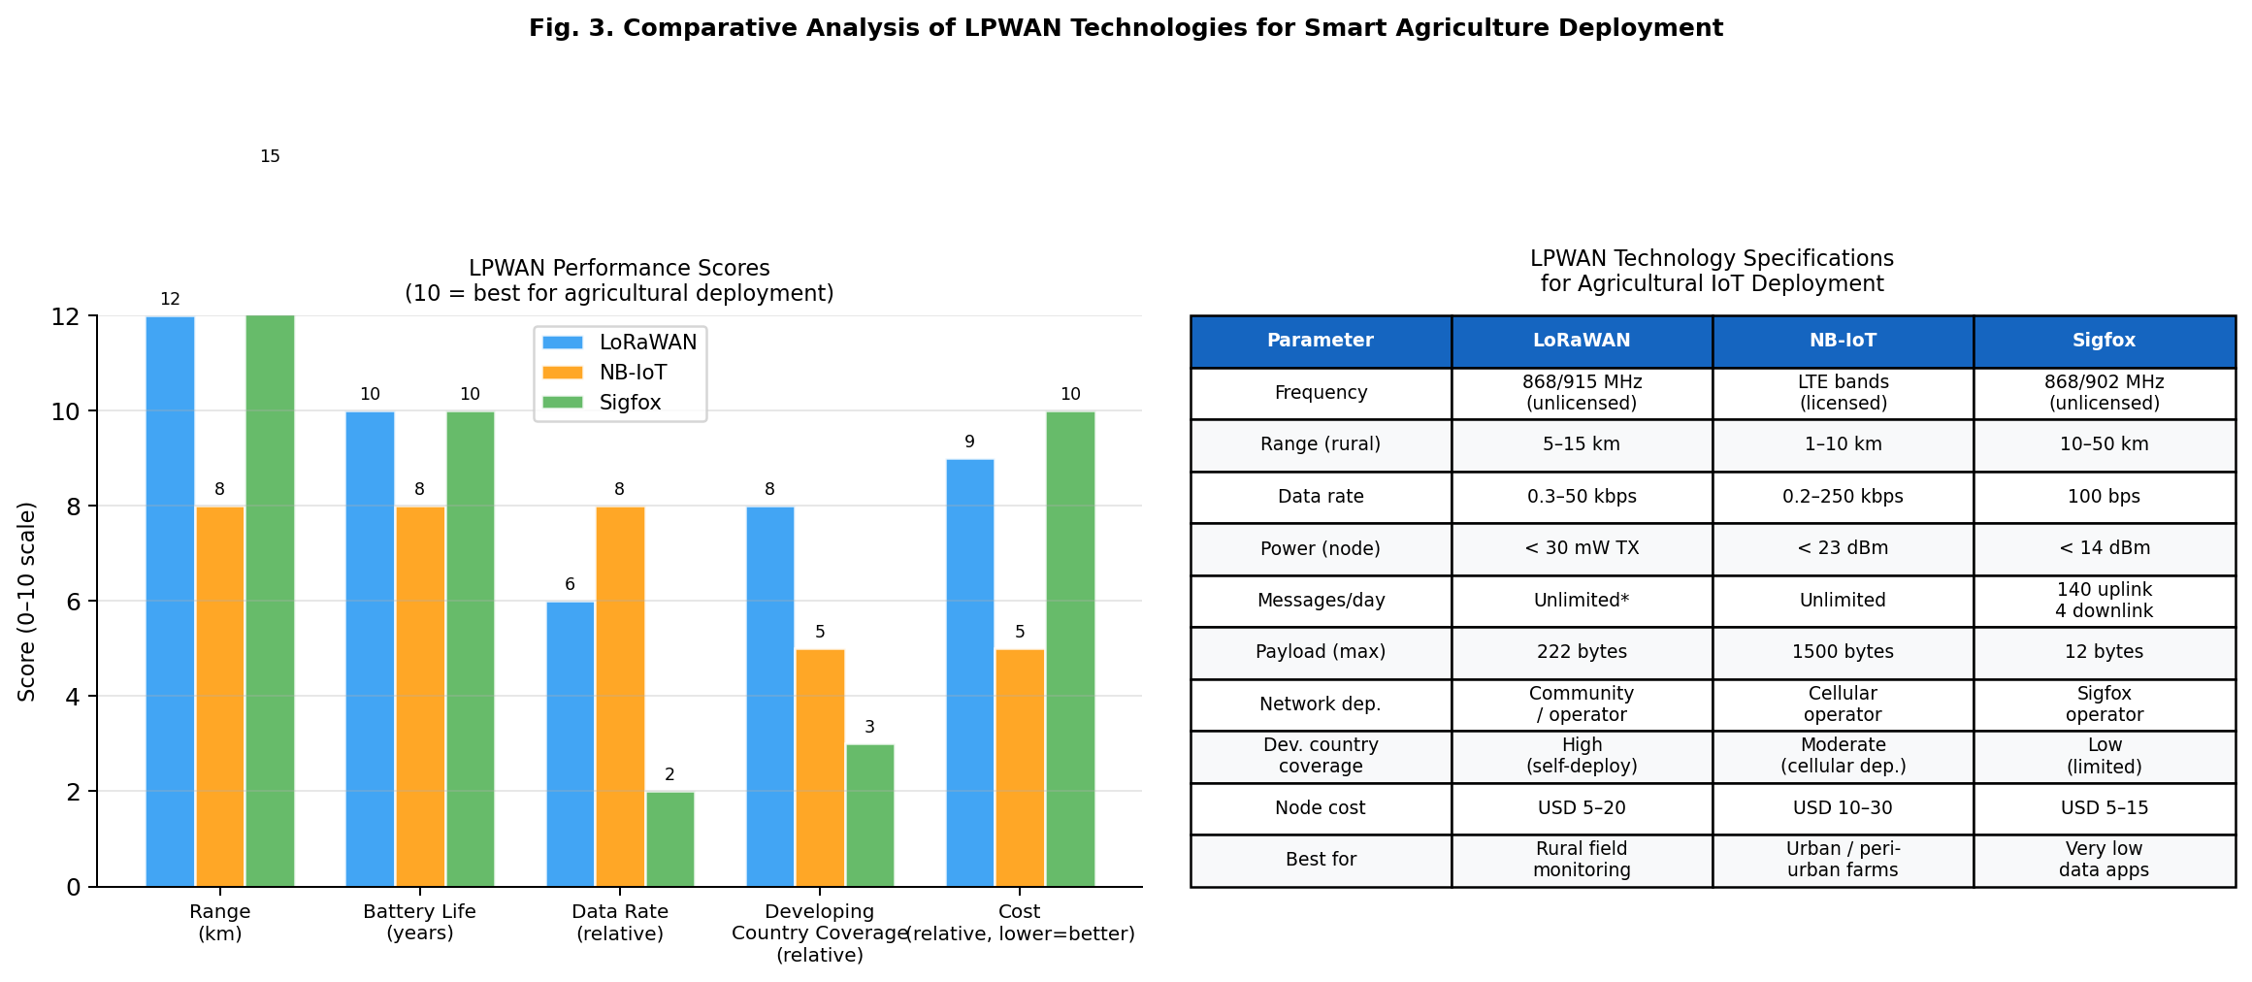
Fig. 3. Comparative analysis of LoRaWAN, NB-IoT, and Sigfox LPWAN technologies for smart agriculture deployment in developing country contexts.
  - Edge Computing and Cloud Integration
The processing layer spans from edge computing nodes co-located with LPWAN gateways to cloud platforms hosted in remote data centers. Edge computing reduces latency, bandwidth consumption, and cloud dependency — benefits particularly relevant in developing country contexts where internet connectivity may be intermittent or prohibitively expensive [22]. Edge nodes perform local preprocessing — including data filtering, outlier detection, and lightweight machine learning inference — before forwarding aggregated results to the cloud. Cloud platforms such as AWS IoT, Microsoft Azure IoT Hub, and open-source alternatives including ThingsBoard and Node-RED provide the data storage, visualization, and analytics capabilities required for farm management dashboards and decision support systems [23]. Therefore, the cloud layer is essential not only for individual farm management but also for aggregating data across thousands of farms to generate regional agricultural intelligence that benefits the broader farming community.
  - System Architecture Overview
A typical IoT smart agriculture system follows a three-tier architecture: (i) the field tier, comprising sensors, actuators, and local microcontrollers (e.g., Arduino, STM32, ESP32); (ii) the fog/edge tier, comprising LPWAN gateways and edge servers performing local computation and data aggregation; and (iii) the cloud tier, providing centralized data management, advanced analytics, and web/mobile user interfaces accessible to farmers and extension agents [24]. This layered architecture provides the scalability and modularity required to support diverse agricultural applications, from small-scale subsistence farms in rural Africa to large commercial operations in South Asia. Crucially, the modular design facilitates incremental deployment — allowing resource-constrained users to begin with basic field monitoring and progressively add edge analytics and cloud integration as infrastructure and funding allow.
The layered architecture described above provides the technological foundation upon which the positive and negative impacts analyzed in the following sections are built.
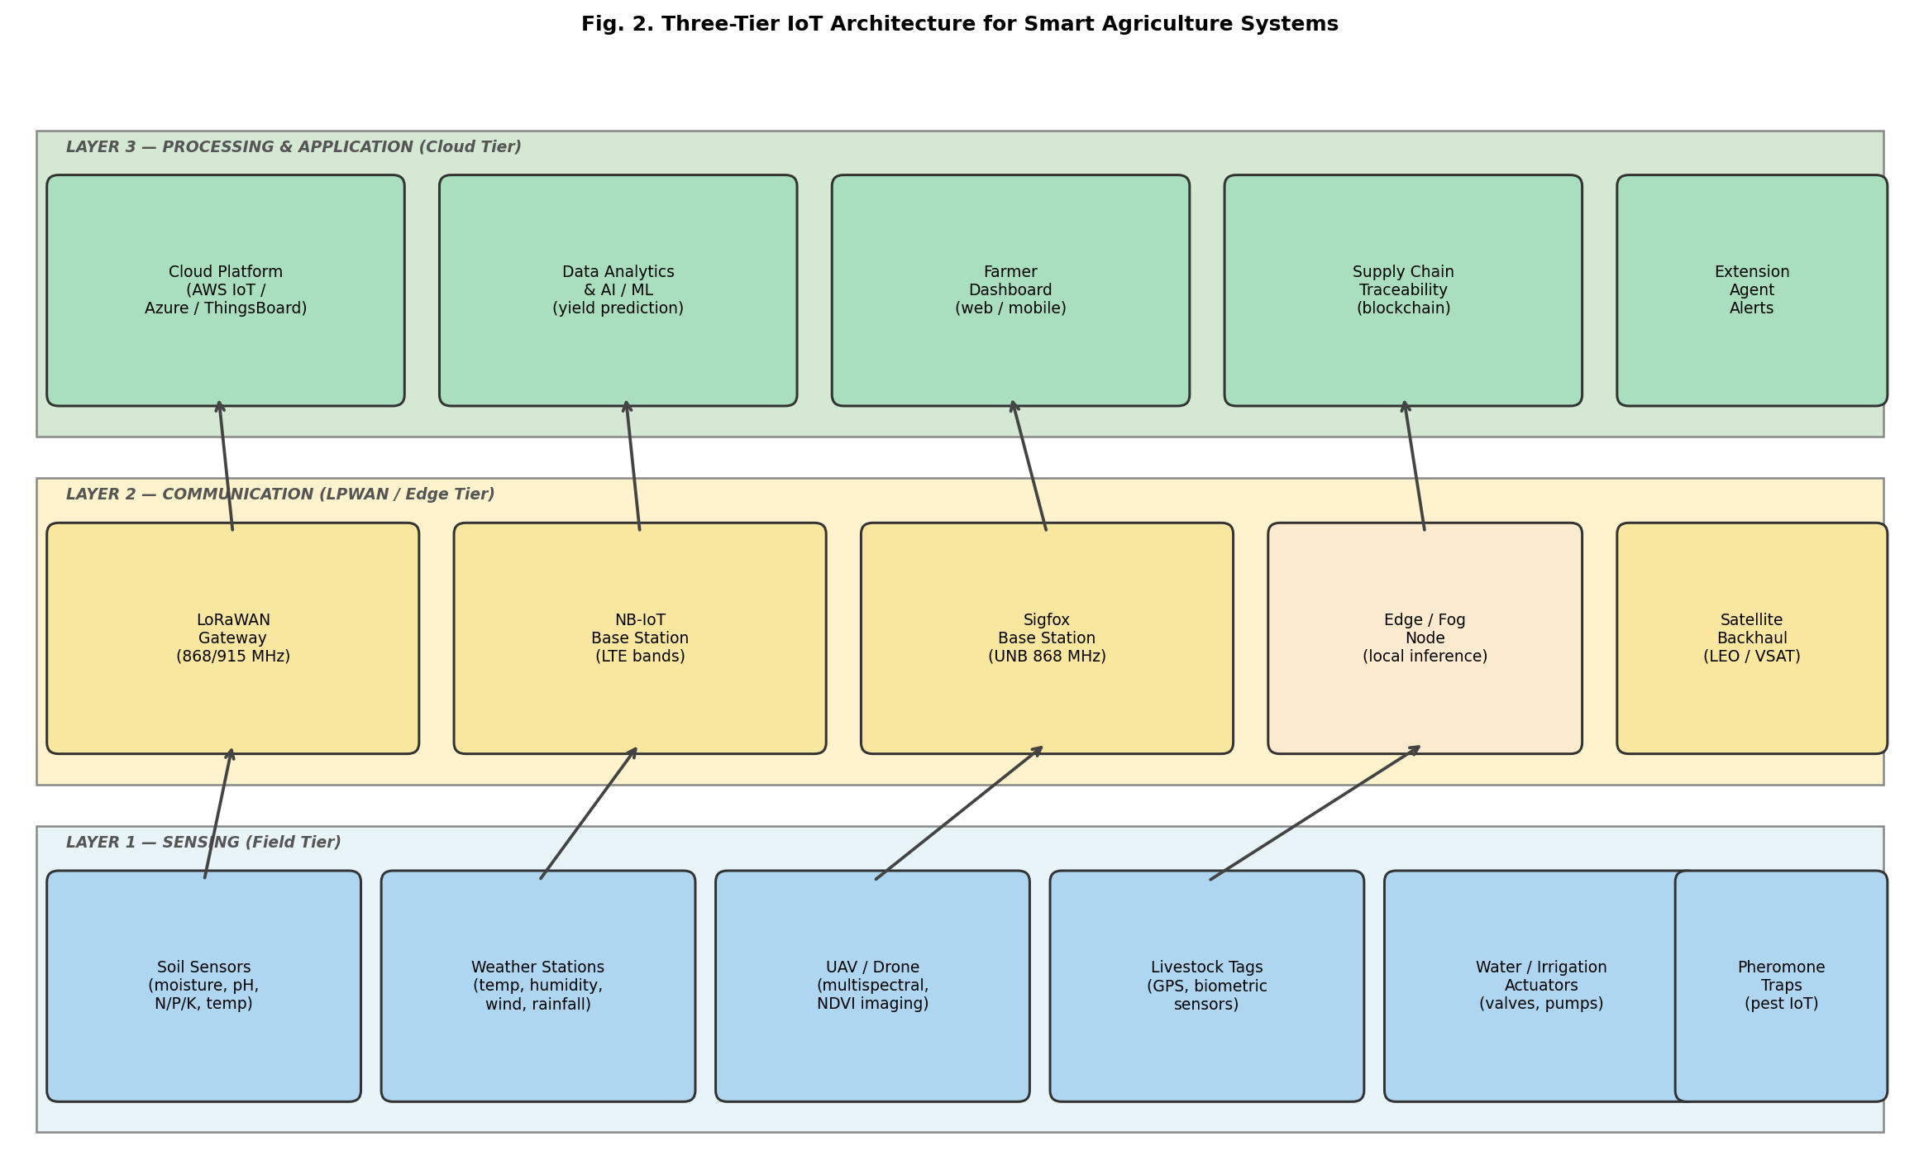
Fig. 2. Three-tier IoT architecture for smart agriculture systems, integrating field sensing, LPWAN communication, and cloud-based analytics.
- Positive Impacts of IoT in Smart Agriculture
The deployment of IoT technologies in agriculture has demonstrated substantial positive impacts across multiple dimensions of food security and sustainable development. In this section, we analyze the key positive contributions identified in our systematic review, organized thematically by impact domain. In this work, we examine these contributions through the lens of SDG 2 (Zero Hunger), SDG 9 (Innovation and Infrastructure), and SDG 13 (Climate Action). Since the evidence base spans more than 20 developing countries across four continents, our findings carry substantial geographic breadth.
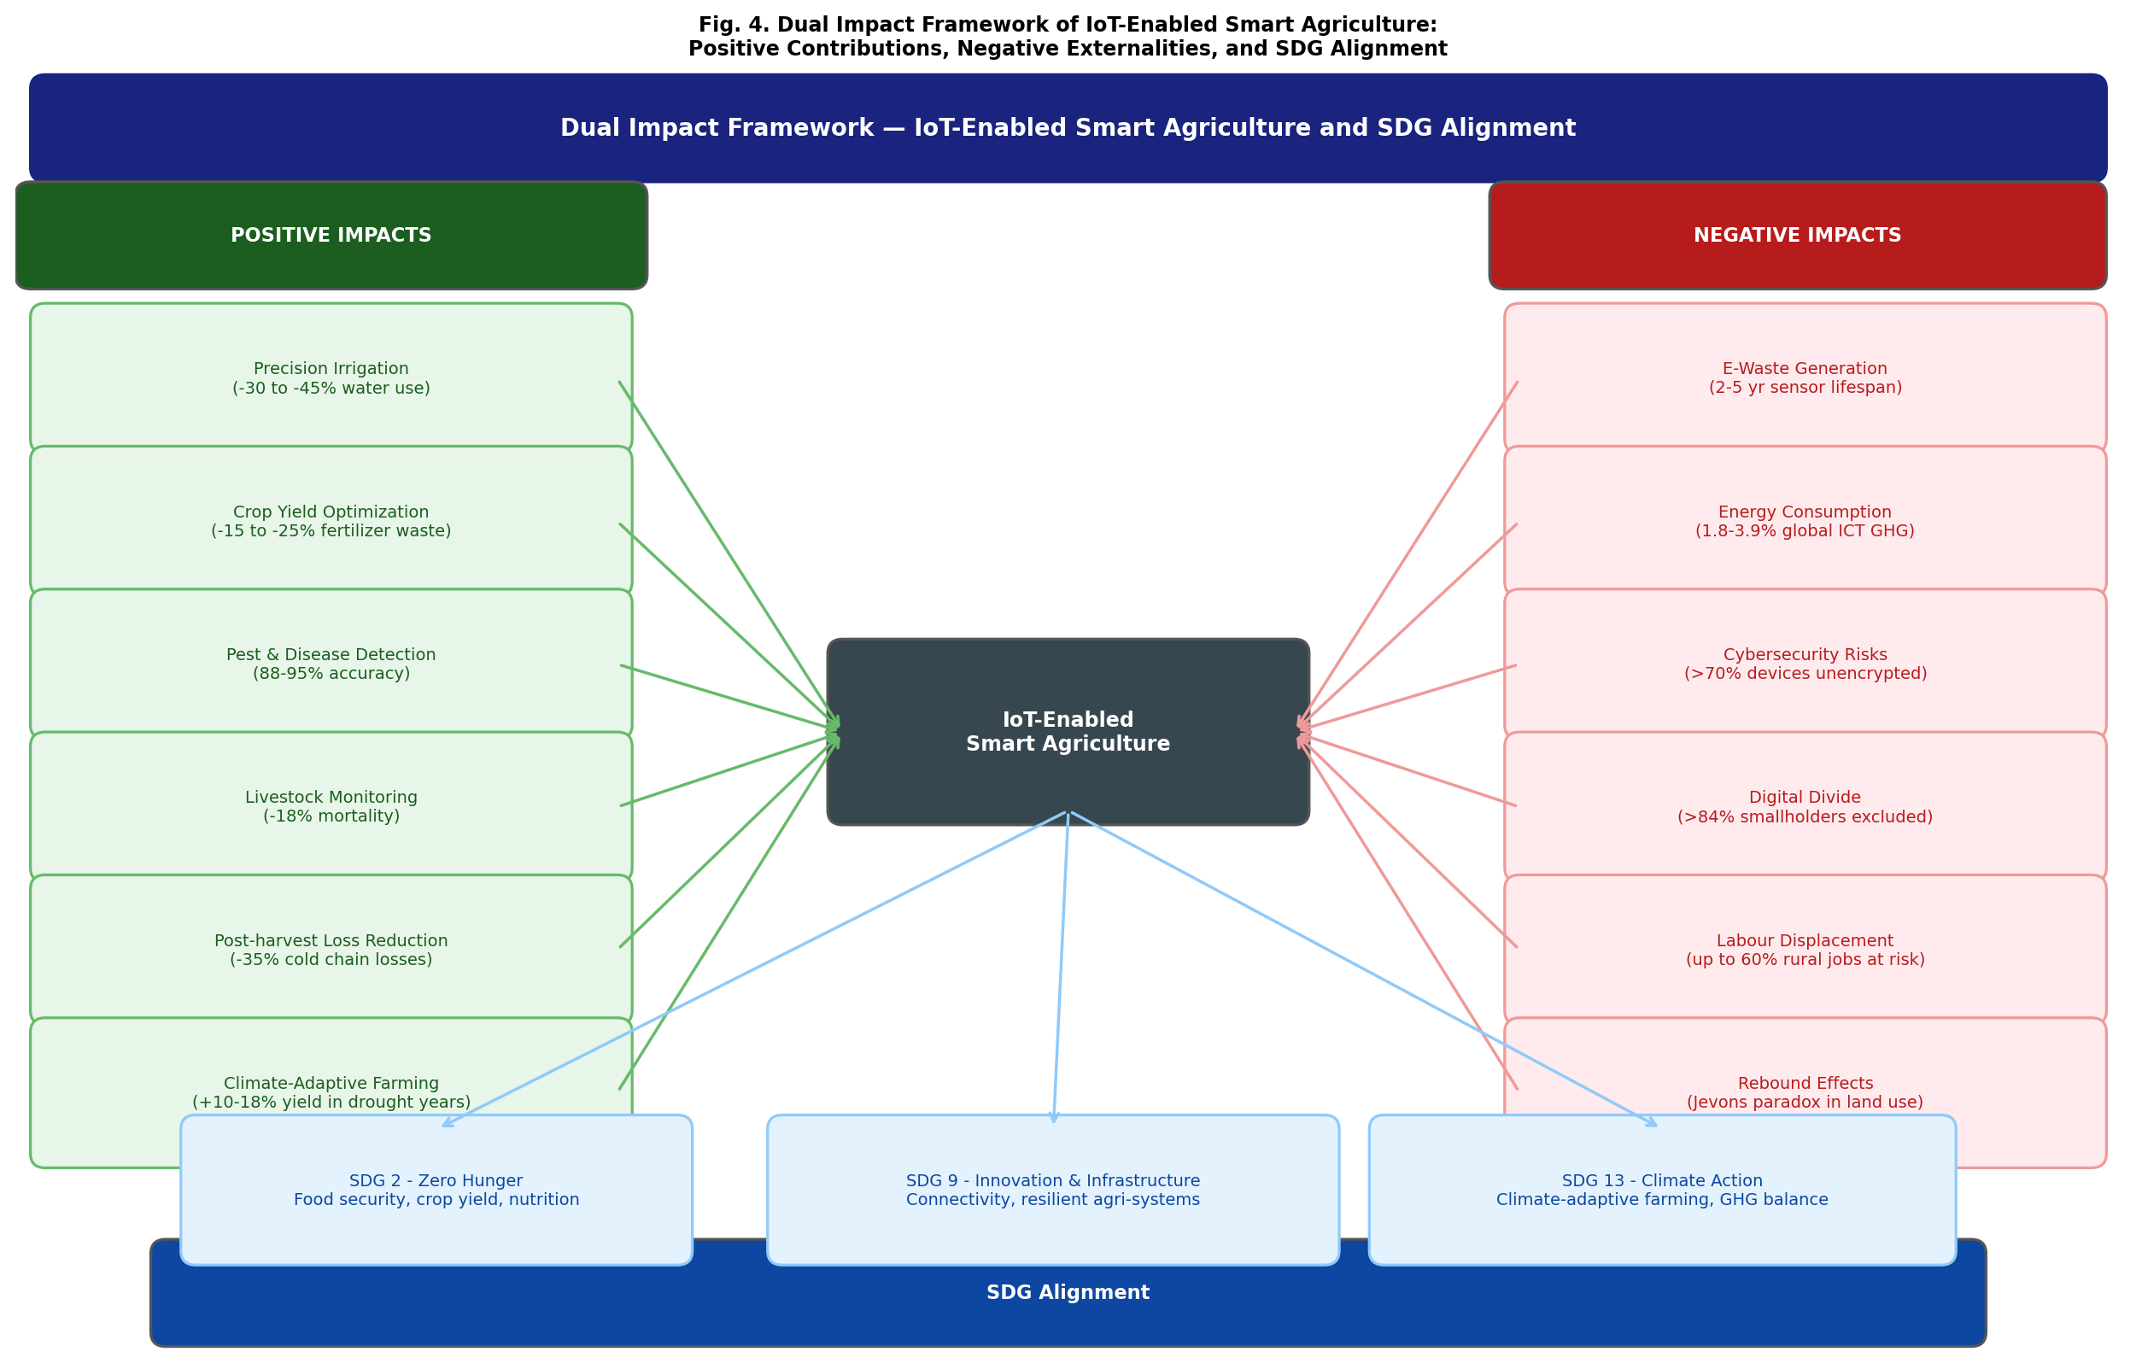
Fig. 4. Dual impact framework of IoT-enabled smart agriculture: positive contributions, negative externalities, and SDG alignment.
  - Water Efficiency and Precision Irrigation
Water scarcity is among the most critical constraints on agricultural productivity in developing countries, particularly in arid and semi-arid regions. Traditional flood irrigation wastes up to 60 % of applied water through surface runoff, deep percolation, and evaporation [25]. IoT-based precision irrigation systems address this challenge by monitoring real-time soil moisture and evapotranspiration data to trigger irrigation events only when and where crops require water, replacing fixed-schedule irrigation with demand-driven management.
Actually, several studies in our review demonstrate significant water savings through IoT-enabled systems. Soil moisture sensor networks coupled with automated valve control reduced water consumption by 30–45 % in tomato and wheat cultivation in Morocco and Pakistan, respectively [26, 27]. Furthermore, IoT irrigation controllers integrating meteorological API data reduced irrigation frequency by 28 % compared to schedule-based systems in smallholder farms in Kenya [28]. These results confirm the effectiveness of IoT technologies in promoting water-use efficiency, directly contributing to SDG 2 (Zero Hunger) through reduced production costs, and to SDG 9 (Innovation and Infrastructure) by demonstrating the viability of IoT-enabled infrastructure in resource-constrained agricultural settings.
  - Crop Yield Optimization
Precision nutrient management, enabled by soil nutrient sensors and variable-rate application systems, represents a major positive impact of IoT in agriculture. In fact, nitrogen-related yield losses are estimated to cost developing country farmers over USD 20 billion annually, making nutrient management one of the highest-impact targets for IoT intervention. By applying fertilizers at spatially variable rates calibrated to actual soil nutrient maps, IoT-enabled precision agriculture can reduce fertilizer consumption by 15–25 % while maintaining or improving crop yields [29]. This dual benefit — reduced input cost and maintained productivity — is of particular significance for smallholder farmers operating on thin economic margins.
UAV-based multispectral imaging has proven highly effective for early detection of nutrient deficiency and crop stress. Studies in our review report that NDVI-based monitoring of rice paddies in Vietnam and maize fields in Ghana enabled detection of nitrogen deficiency 10–14 days earlier than visual inspection, allowing timely corrective intervention and reducing yield losses by up to 20 % [30, 31]. Consequently, IoT contributes to food security not only through increased production efficiency but also through the reduction of avoidable losses — which confirms also the importance of investing in sensing technologies beyond basic soil monitoring.
  - Pest and Disease Early Detection
Pest and disease outbreaks represent one of the most significant threats to crop productivity in developing countries, capable of destroying entire harvests within days. IoT-based early warning systems combining distributed sensor data with machine learning algorithms have demonstrated remarkable effectiveness in detecting and predicting outbreak events with actionable lead time. In fact, a single outbreak of Fall Armyworm — now present in over 50 African countries — can destroy an entire maize harvest within days if not detected early. Since traditional visual scouting is slow and labor-intensive, IoT-enabled automated detection systems represent a transformative advancement for smallholder crop protection.
Our review identified multiple studies deploying image recognition systems using convolutional neural networks (CNNs) to classify plant diseases from smartphone photographs captured in the field. These systems achieved disease classification accuracies of 88–95 % across multiple crop types, from cassava in Uganda to rice blast in Bangladesh [32, 33]. Similarly, IoT-connected pheromone traps with LoRaWAN connectivity enabled real-time monitoring of fall armyworm populations in sub-Saharan Africa, providing 3–5 day advance warning of pest pressure peaks and enabling targeted pesticide application [34]. These outcomes prove the effectiveness of networked sensing in transforming reactive pest management into a proactive, data-driven discipline.
  - Livestock Monitoring
Beyond crop agriculture, IoT technologies are increasingly applied to livestock monitoring in developing countries, where animal husbandry represents a critical livelihood source for rural and pastoral communities. Wearable biosensors attached to cattle and small ruminants continuously monitor vital signs — including body temperature, heart rate, and rumination patterns — to detect disease onset, estrus cycles, calving events, and nutritional stress with precision impossible to achieve through periodic manual inspection [35]. In fact, livestock accounts for up to 40 % of agricultural GDP in many sub-Saharan African economies, making animal health monitoring a high-priority application domain for IoT investment.
Studies from our review report that IoT-based health monitoring systems reduced cattle mortality by 18 % and improved reproductive efficiency by 22 % in pastoral communities in Ethiopia and Tanzania, respectively [36, 37]. GPS-enabled smart collars provide livestock geolocation tracking, reducing losses from straying and theft — a significant economic concern for smallholder herding families for whom a single animal may represent months of income. Since animal loss represents a catastrophic economic shock in pastoral communities, these outcomes directly advance SDG 1 (No Poverty) alongside SDG 2, demonstrating the cross-cutting nature of IoT’s impacts on human development.
  - Market Access for Smallholder Farmers
An often-overlooked positive impact of IoT in smart agriculture is its potential to improve market access and price transparency for smallholder farmers. IoT-based post-harvest quality monitoring systems — measuring temperature, humidity, and ethylene concentration in storage facilities — enable more precise timing of market sales and reduce post-harvest losses, which account for 25–40 % of food production in developing regions [3, 38]. These outcomes contribute simultaneously to SDG 2 (Zero Hunger) through improved food availability and to SDG 9 (Innovation and Infrastructure) by demonstrating how IoT-enabled infrastructure can drive inclusive market innovation for smallholder communities.
Furthermore, IoT-enabled supply chain traceability systems integrated with mobile payment platforms allow smallholders to access premium markets by providing verifiable quality and provenance data to buyers. Pilot projects in Rwanda and Bangladesh demonstrate that IoT-enabled cold chain monitoring reduced vegetable spoilage by 35 % and increased farmer income by 15–22 % [39, 40]. These outcomes advance SDG 2 and SDG 1 simultaneously, suggesting that supply chain IoT deserves greater research attention alongside field-level sensing applications.
  - Climate-Adaptive Farming
IoT technologies support climate-adaptive farming practices by enabling farmers to make data-driven adjustments to planting schedules, crop variety selection, and field management in response to changing climatic conditions. Microclimate monitoring networks provide farmers with localized weather data at a spatial resolution impossible to achieve through national meteorological station networks [41].
Community-based IoT weather station networks in rural India and sub-Saharan Africa provided hyperlocal rainfall and temperature forecasts, enabling farmers to optimize planting dates and select drought-tolerant varieties. These interventions were associated with 10–18 % improvements in crop yields during drought years compared to control groups relying on regional forecasts [42, 43]. Such outcomes are directly aligned with SDG 13 (Climate Action), demonstrating IoT’s potential to build agricultural resilience in the face of climate variability — which confirms also the importance of investing in distributed sensing infrastructure as a public good.
- Negative Impacts and Risks
So what are the true environmental and social costs of deploying IoT at scale in developing country agricultural systems? A rigorous assessment demands balanced scrutiny of negative consequences alongside positive contributions. In fact, the enthusiasm surrounding precision agriculture and IoT-driven efficiency gains has frequently overshadowed a critical examination of the environmental and social externalities these technologies generate. In this work, we identify seven categories of negative impact — each documented in the peer-reviewed literature and each warranting targeted policy attention. This dual-impact perspective is central to responsible technology governance and is essential for designing sustainable, equitable IoT systems. In this section, we examine seven categories of negative impacts and risks identified in our systematic review, supported by quantitative evidence where available.
  - E-Waste from Sensor Hardware
The proliferation of IoT sensor nodes generates significant quantities of electronic waste (e-waste), particularly given the relatively short operational lifespans of consumer-grade sensor modules — typically 2–5 years for basic soil moisture and temperature sensors, and as low as 18 months for low-cost microcontrollers under field conditions [44]. IoT end devices contain hazardous materials including lead, cadmium, mercury, hexavalent chromium, and brominated flame retardants, which pose serious environmental and public health risks when improperly disposed of. The Global E-waste Monitor 2020 recorded 53.6 million metric tons of e-waste generated globally, of which only 17.4 % was formally collected and recycled [46].
In developing countries, formal e-waste recycling infrastructure is largely absent. Consequently, discarded IoT devices frequently enter informal recycling streams. In fact, these processes expose workers — manual dismantling — often performed by unprotected workers and children — releases toxic substances through direct contact, soil leaching, and atmospheric combustion [44]. Studies document elevated blood lead levels, pulmonary dysfunction, and endocrine disruption in communities near e-waste processing sites in Ghana, Nigeria, and India. We notice that the scale of this problem is likely to grow substantially as IoT adoption accelerates: a conservative estimate of 100 million agricultural sensor nodes deployed globally by 2030 would generate over 50,000 tonnes of e-waste per five-year replacement cycle — potentially undermining the environmental sustainability goals that IoT agriculture ostensibly serves.
  - Energy Consumption of IoT Infrastructure
While individual LPWAN sensor nodes are designed for ultra-low power consumption — typically 10 μW in sleep mode and 30 mW during active transmission — the aggregate energy demand of large-scale IoT deployments is non-trivial. A single LoRaWAN gateway serving 1,000 sensor nodes continuously consumes approximately 5 W, while cloud data centers supporting regional agricultural IoT analytics platforms may consume several megawatts [45]. Freitag et al. [45] estimate that information and communication technology already accounts for 1.8–3.9 % of global GHG emissions, a share projected to grow as IoT deployments scale.
Furthermore, in off-grid agricultural settings, IoT sensor nodes are powered by solar panels and lithium-ion batteries whose manufacturing processes involve energy-intensive extraction of raw materials — including lithium, cobalt, nickel, and manganese — with significant environmental footprints and documented human rights concerns in mining regions of the Democratic Republic of Congo, Chile, and Indonesia. The full lifecycle carbon footprint of a typical agricultural IoT system — from raw material extraction through manufacturing, transport, operation, and end-of-life disposal — has been estimated at 12–35 kg CO₂-equivalent per sensor node, a cost rarely accounted for in smart agriculture sustainability assessments [45].
  - Data Privacy and Cybersecurity Vulnerabilities
IoT agricultural systems collect large volumes of commercially sensitive data, including farm location, crop type, yield performance, irrigation records, and financial transactions. In fact, a study cited in our review found that more than 70 % of commercially available agricultural IoT devices lack basic encryption for data in transit, exposing farmers to significant risks of data theft and unauthorized commercialization of their production intelligence. If inadequately protected, this data can be exploited by commercial actors, insurance companies, or competitors to the significant detriment of smallholder farmers [47]. A 2020 study found that over 70 % of low-cost agricultural IoT devices lack transport-layer encryption, 60 % use default or hardcoded credentials, and fewer than 30 % support over-the-air firmware updates — leaving them permanently vulnerable to known exploits [48].
In agricultural contexts, successful cyberattacks could trigger inappropriate irrigation events, incorrect pesticide or fertilizer applications, or disruption of supply chain management systems with potentially catastrophic consequences for food security. Several incidents of unauthorized access to precision agriculture platforms have been documented since 2020, including data theft from cloud-hosted farm management systems affecting thousands of smallholder farms in Southeast Asia and East Africa. Indeed, the convergence of IoT with artificial intelligence and blockchain in agricultural systems creates complex attack surfaces that demand dedicated cybersecurity research and regulatory frameworks [48].
  - Digital Divide Between Large and Small Farms
The benefits of IoT smart agriculture risk being captured disproportionately by large commercial farms. Farms with more than 20 hectares — which represent fewer than 5 % of farms globally but over 70 % of agricultural land — have the financial resources, technical expertise, and connectivity to deploy and maintain sophisticated IoT systems [49]. In contrast, smallholder farmers — defined as those managing fewer than 2 hectares and constituting over 84 % of all farms worldwide, predominantly in developing countries — face compounding barriers to IoT adoption [50].
The entry cost for a basic IoT soil monitoring and irrigation control system typically ranges from USD 500 to USD 2,000, equivalent to 6–24 months of net income for an average smallholder farmer in sub-Saharan Africa. Rural broadband connectivity, required for cloud-based IoT platforms, reaches fewer than 20 % of agricultural zones in low-income countries [64]. Furthermore, IoT solution providers predominantly target commercially attractive markets rather than subsistence farming communities. Consequently, without deliberate policy intervention — including subsidies, shared infrastructure models, and open-source platforms — IoT adoption in agriculture may reinforce rather than reduce existing inequalities, directly counteracting SDG 10 (Reduced Inequalities) and SDG 2 objectives.
  - GHG Emissions from IoT Infrastructure
The manufacturing, transportation, and operation of IoT hardware contribute to greenhouse gas (GHG) emissions throughout the product lifecycle. While these emissions are generally modest in absolute terms compared to the agricultural sector’s direct GHG contributions — primarily methane from livestock (14.5 % of global emissions) and nitrous oxide from nitrogen fertilizer application — they nonetheless represent an additional environmental burden that must be transparently quantified and managed [45]. Furthermore, if IoT-enabled precision agriculture leads to intensification of production on existing agricultural land, the aggregate effect on total GHG emissions may be complex and context-dependent, requiring comprehensive lifecycle assessment before environmental claims can responsibly be made on behalf of smart agriculture technologies. In fact, while IoT-enabled precision agriculture reduces field-level emissions by optimizing input use, these efficiency gains can be partially offset by the carbon cost of the digital infrastructure supporting them — a rebound dynamic discussed further in Section 5.7.
  - Agricultural Labour Displacement
The automation potential of IoT-enabled agriculture raises significant concerns about labour displacement in rural developing country economies. In fact, agriculture employs up to 60 % of the active population in some regions [52]. Automated irrigation scheduling, drone-based crop spraying, robotic harvesting systems, and IoT-enabled supply chain management progressively reduce the demand for unskilled agricultural labour — including seasonal and migrant workers who rely on agricultural employment as their primary income source. In the absence of parallel investments in rural education, digital skills training, and social protection, IoT-driven automation could displace millions of agricultural workers without providing viable alternative livelihoods [53].
Furthermore, the displacement of traditional agricultural extension services by algorithm-based decision support systems raises concerns about knowledge sovereignty and farmer agency. When farming decisions are delegated to proprietary algorithms trained on external datasets, local ecological knowledge and traditional farming practices may be progressively marginalized. Therefore, the design of IoT agricultural systems must explicitly address labour transition pathways and mechanisms for incorporating indigenous knowledge alongside sensor-derived data.
  - Rebound Effects and Intensification Risks
A systemic risk associated with IoT-enabled efficiency gains in agriculture is the potential for rebound effects, analogous to the Jevons paradox observed in energy economics: efficiency improvements may stimulate increased production or land cultivation, partially or wholly offsetting the environmental savings initially achieved. For example, a 30 % reduction in water use per hectare of irrigated land may incentivize expansion of irrigated area by 30 % or more, resulting in zero net reduction in total water consumption [54]. Similarly, yield improvements enabled by IoT precision management may accelerate agricultural intensification, leading to monoculture expansion, biodiversity loss, and soil degradation in frontier agricultural zones [54].
Consequently, IoT interventions in agriculture cannot be evaluated in isolation from the broader political economy of agricultural development. Realizing net environmental benefits requires binding policy frameworks that couple IoT adoption incentives with land use regulations, biodiversity protection mechanisms, and ecosystem service payment schemes. In our work, we consider this systemic perspective to be an under-researched dimension of the IoT-agriculture nexus that deserves substantially greater attention from the research community.
- Challenges in Developing Countries
So what specific structural and sociotechnical barriers must be overcome before IoT can genuinely serve smallholder farmers in developing country agricultural contexts? Indeed, while the positive impacts documented in Section 4 are compelling, they predominantly arise from pilot deployments and controlled studies — not from large-scale, self-sustaining adoption. The following subsections identify the five most critical barriers.
The deployment of IoT in smart agriculture faces a distinct and severe set of structural, economic, and sociotechnical challenges in developing country contexts that are qualitatively different from those encountered in high-income countries. These challenges must be understood and specifically addressed if IoT is to fulfill its potential as a driver of food security and sustainable development. In this work, we systematically examine the five most pervasive and well-documented barriers, drawing on evidence from the 87 studies included in our review and supplementary data from the ITU, FAO, and World Bank.
  - Infrastructure Gaps and Connectivity
Rural areas in developing countries are frequently characterized by limited or absent telecommunications infrastructure, unreliable electricity supply, and inadequate road networks. According to the ITU, only 28 % of rural populations in least-developed countries have access to reliable mobile internet, compared to 72 % in urban areas of the same countries [64]. These conditions create significant barriers to IoT deployment and maintenance. LPWAN technologies such as LoRaWAN offer a partial solution, enabling long-range wireless communication without cellular dependence. However, even LoRaWAN deployments require gateway hardware, stable power supply, and internet backhaul that may be difficult to provision and sustain in remote settings [53]. Emerging low-Earth-orbit satellite internet services offer promising long-term solutions but currently cost 5–10 times more per gigabyte than terrestrial broadband in developed markets [54].
  - High Deployment Costs
The total cost of ownership of IoT agricultural systems — comprising hardware procurement, installation, network infrastructure, cloud service subscriptions, and ongoing maintenance — remains high relative to the economic realities of smallholder farming in developing countries. A complete entry-level IoT soil monitoring and precision irrigation system costs USD 800–2,500, while a commercial-grade multi-parameter farm management platform may exceed USD 10,000 [54]. In sub-Saharan Africa, where the average smallholder farm generates net revenues of USD 300–800 per year, even the entry-level system represents 1–8 years of net farm income.
Several approaches have been proposed to address this cost barrier, including community-based IoT infrastructure sharing cooperatives, pay-as-you-go service models inspired by mobile money platforms, and open-source hardware platforms such as Arduino and ESP32-based systems. However, sustainable business models for IoT in smallholder agriculture remain elusive, and further innovation in financing mechanisms, technology transfer, and local manufacturing is essential to close the cost gap.
  - Limited Digital Literacy
Since effective use of IoT systems requires a degree of digital literacy that many farmers in developing countries do not currently possess, this gap represents one of the most persistent barriers to successful IoT adoption in agricultural settings. Interacting with smartphone applications, interpreting sensor data dashboards, configuring alert thresholds, and responding appropriately to system notifications presuppose a baseline level of technology familiarity that cannot be assumed in rural communities with limited formal education. The FAO estimates that fewer than 30 % of smallholder farmers in least-developed countries have used a smartphone, and fewer than 15 % have access to digital agricultural advisory services [65].
Therefore, successful IoT deployments in developing country agricultural contexts must incorporate user-centered design principles, local language interfaces, voice-based interaction modalities accessible to low-literacy users, and structured farmer training components. Studies from our review that incorporated dedicated capacity-building programs alongside IoT deployments consistently reported significantly higher adoption rates and more sustained system usage compared to technology-only interventions [55]. This finding confirms that technology supply is insufficient without commensurate investment in demand-side readiness and human capacity development.
  - Interoperability Issues
The smart agriculture IoT ecosystem is characterized by significant fragmentation, with a proliferation of proprietary hardware platforms, incompatible communication protocols, proprietary cloud services, and non-standardized data formats that do not readily interoperate. This fragmentation creates vendor lock-in risks for adopting farmers and institutions, increases integration costs, and hampers the development of scalable national or regional agricultural IoT platforms [56]. Standards bodies including the ITU, ISO, and ETSI are working to address this challenge through initiatives such as oneM2M for IoT platform interoperability and the OGC SensorThings API for geospatial data standardization, but adoption remains incomplete and uneven across the industry.
  - Dependence on Imported Technology
Most IoT hardware components — including sensors, microcontrollers, communication modules, and gateways — are manufactured in a small number of countries and must be imported by developing country users, creating vulnerabilities to supply chain disruptions, import tariffs, and foreign exchange fluctuations [57]. A 2022 analysis found that 87 % of IoT semiconductor value chains for agricultural applications originate in China, the United States, or Taiwan, countries that collectively account for fewer than 15 % of developing-country smallholder agricultural operations. The absence of local manufacturing capacity limits the ability of developing countries to customize IoT solutions, perform field repairs without specialist expertise, and build the endogenous technical capacity required for long-term system sustainability. Investments in local electronics manufacturing, engineering education, and South-South technology transfer are therefore essential complements to any IoT-focused agricultural development strategy. In fact, more than 87 % of the global IoT semiconductor value chain is controlled by firms from just three countries. This dependence directly undermines SDG 9, which calls for building resilient infrastructure and fostering innovation capacity in developing countries themselves.
- Future Directions
Based on our systematic review and the challenges and gaps identified in the preceding sections, we propose five high-priority research and development directions that have the potential to significantly advance the positive impact of IoT in smart agriculture while mitigating the negative consequences and structural barriers identified above. In this work, we consider these directions as a coherent and complementary agenda — each addressing a distinct dimension of the barrier landscape identified in Section 6, and each building on demonstrated technological feasibility documented in our included studies.
  - Low-Cost Energy-Harvesting IoT Devices
We suggest that a major research priority should be the development of ultra-low-cost IoT sensor nodes capable of harvesting energy from environmental sources — including solar radiation, thermal gradients, mechanical vibration from irrigation equipment, and rainfall-driven piezoelectric elements — to eliminate or substantially reduce battery dependency. Energy harvesting is particularly impactful in agricultural IoT contexts because it eliminates the operational burden of periodic battery replacement across potentially thousands of field-deployed nodes, a significant deterrent to large-scale deployment in remote areas where logistics are costly [58].
Recent advances in piezoelectric and thermoelectric energy harvesting, combined with the extremely low power consumption of modern microcontrollers operating in sub-microwatt sleep modes, suggest that fully autonomous, battery-free sensor nodes are technically achievable within 3–5 years at production costs below USD 5 per node. Concurrently, the integration of backscatter communication — in which sensor nodes harvest energy from ambient radio frequency signals and reflect data without active transmission — offers a pathway to entirely passive, maintenance-free agricultural sensor networks. We plan to explore this direction in future work, focusing on LPWAN-connected energy-harvesting nodes optimized for the environmental conditions and cost constraints of developing country agricultural deployment.
  - AI and Edge Computing Integration
The integration of artificial intelligence — particularly deep learning, federated learning, and lightweight neural network architectures optimized for microcontrollers (TinyML) — with edge computing infrastructure represents a transformative opportunity for smart agriculture IoT systems. By deploying AI inference models directly on edge devices equipped with dedicated neural processing units, agricultural IoT systems can perform sophisticated analysis — including plant disease detection, yield prediction, soil quality classification, and sensor anomaly detection — without requiring continuous cloud connectivity [59]. This capability is particularly important in developing country contexts where cloud connectivity is intermittent. In fact, recent TinyML benchmarks demonstrate that neural networks for plant disease classification can be compressed to under 250 KB without significant accuracy loss, making on-device inference feasible on commodity microcontrollers costing under USD 5.
Furthermore, transfer learning techniques allow AI models trained on large, well-labeled datasets from developed country agricultural contexts to be adapted to developing country crop varieties, soil types, and climatic conditions using relatively small local training datasets. This approach dramatically reduces the data collection burden on resource-constrained deployment projects while enabling high-accuracy inference. In our work, we consider TinyML-on-edge as among the highest-priority areas for future research investment, with the potential to democratize AI-powered agricultural analytics for smallholder farmers in low-connectivity environments.
  - Blockchain for Food Supply Chain Traceability
Blockchain technology offers a compelling complement to IoT for food supply chain traceability, providing an immutable, transparent, and decentralized record of food provenance from farm gate to consumer. IoT sensors generate the real-time data — temperature, humidity, geolocation, handling events, and quality parameters — that is recorded on the blockchain, while the blockchain provides the trust and verification layer that enables premium market access and sustainability certifications for smallholder producers [57]. Several pilot projects from our review demonstrate that blockchain-IoT integrated traceability systems can increase smallholder farmer income by providing verifiable quality and origin certifications that command 15–40 % price premiums in export markets.
Scaling these pilots to national or regional level requires substantial investment in digital infrastructure, legal frameworks for blockchain-based certification equivalence, interoperability standards between competing blockchain platforms, and farmer-level trust-building initiatives. Furthermore, the energy consumption of blockchain consensus mechanisms — particularly proof-of-work systems — must be carefully evaluated to avoid negating the environmental benefits of IoT precision agriculture. Proof-of-stake or directed-acyclic-graph architectures offer lower energy alternatives for agricultural traceability applications.
  - Federated Learning for Privacy-Preserving Agricultural Data Sharing
Since federated learning enables AI models to be trained collaboratively across multiple devices without sharing raw data, it offers a privacy-preserving and highly promising approach to balancing the benefits of large-scale agricultural data analysis with the privacy rights and data sovereignty concerns of individual farmers [60]. By training models locally on each farm’s sensor data and sharing only encrypted model parameter updates — not raw measurements — federated learning enables the development of robust, generalizable AI models while preserving farmer data ownership and preventing commercial exploitation of sensitive farm data.
This approach is particularly relevant in developing country contexts where institutional trust in centralized data-sharing platforms is limited, regulatory frameworks for agricultural data governance are nascent, and the risk of commercial exploitation of smallholder data by agribusiness actors is a legitimate concern. Furthermore, federated learning naturally accommodates the heterogeneous and low-connectivity conditions of rural IoT deployments, as devices only need to communicate infrequently during model update synchronization [60]. We hope that federated learning will attract substantially greater research attention from the smart agriculture community in the coming years.
  - Community-Driven Digital Agriculture Models
Finally, we argue that the most sustainable and equitable path to large-scale IoT adoption in developing country agriculture lies in community-driven governance models that place smallholder farmers at the center of technology design, deployment, and management. Farmer cooperatives, village-level IoT management committees, and community-based agricultural data trusts can pool financial resources to deploy shared infrastructure, negotiate favorable service contracts with technology providers, and establish local technical maintenance capacity [61]. Crucially, community governance ensures that data generated by IoT systems is used in the interests of farming communities rather than external commercial or governmental actors.
The evidence from our review confirms that technology alone is insufficient to drive transformative change in developing country agriculture — successful IoT deployments consistently combine technological innovation with co-design processes involving end users, culturally appropriate training programs delivered in local languages, and supportive policy environments that recognize community data rights. We plan to extend this work by developing validated frameworks for assessing the sustainability and equity dimensions of IoT agricultural deployments in developing country contexts, drawing on participatory action research methodologies.
These five research directions collectively define an agenda that can bridge the gap between IoT's demonstrated potential and its equitable, sustainable deployment at scale — a synthesis we consolidate in the concluding section.
- Conclusion and Policy Recommendations
In this paper, we have presented a systematic literature review of IoT-enabled smart agriculture, covering 87 peer-reviewed studies published between 2018 and 2025, with a particular focus on developing country contexts and the dual positive and negative impacts of IoT deployment. Our review followed the PRISMA 2020 protocol, ensuring methodological rigor and transparency throughout the evidence synthesis process.
Indeed, our findings confirm — drawing on 87 independent studies across more than 20 developing countries — that IoT technologies hold substantial promise for advancing food security and sustainable development. Precision irrigation reduces water consumption by 30–45 %; early disease detection systems reduce yield losses by up to 20 %; IoT-enabled cold chain monitoring reduces post-harvest losses by up to 35 %; and livestock monitoring reduces animal mortality by 18 % — all outcomes with direct and measurable relevance to SDG 2 (Zero Hunger). Furthermore, IoT-enabled supply chain traceability, climate-adaptive farming, and market access improvements demonstrate additional pathways through which these technologies contribute to SDG 9 (Innovation and Infrastructure) and SDG 13 (Climate Action). These results prove the effectiveness of IoT as a technological platform for sustainable agricultural transformation.
At the same time, our review highlights seven categories of negative impacts — e-waste generation, energy consumption, cybersecurity vulnerabilities, digital divide effects, GHG emissions, agricultural labour displacement, and rebound intensification risks — that must be proactively managed through technological design choices, regulatory frameworks, and policy interventions. Furthermore, five major structural challenges currently limit the scale and impact of IoT adoption in developing countries: infrastructure gaps, high deployment costs, limited digital literacy, interoperability issues, and dependence on imported technology.
This review is subject to several limitations that future work should address. First, restriction to English-language publications may have excluded relevant studies from non-Anglophone developing countries, including Francophone Africa and Latin America. Second, the heterogeneity of study designs precluded formal meta-analysis, limiting the precision of aggregate effect size estimates. Third, rapidly evolving deployment costs and connectivity infrastructure mean that some quantitative figures cited may require updating as the technology landscape matures. Despite these limitations, the breadth of evidence synthesized — 87 studies across more than 20 developing countries — provides a robust foundation for the policy recommendations that follow.
Based on our systematic review, we offer the following five policy recommendations to governments, development organizations, and research institutions: (1) Invest in rural digital infrastructure — prioritizing LPWAN gateway networks and affordable satellite internet backhaul as foundational agricultural development infrastructure. (2) Establish agricultural IoT subsidy and microfinance programs to overcome initial cost barriers for smallholder farmers and promote equitable access. (3) Promote open standards and interoperability (oneM2M, OGC SensorThings) to prevent vendor lock-in and enable a competitive ecosystem of local solution providers and maintenance expertise. (4) Develop agricultural data governance frameworks that protect farmer privacy, establish community data ownership rights, and regulate commercial use of smallholder farm data. (5) Integrate structured capacity-building into all IoT deployment programs, with training tailored to local languages, farming contexts, and educational levels, addressing both technical operation and critical digital literacy.
In conclusion, IoT-enabled smart agriculture represents a powerful, well-evidenced tool for advancing food security and sustainable development in developing countries. However, realizing this potential requires moving decisively beyond a narrow technology-centric perspective to embrace a holistic approach that addresses the social, economic, environmental, and institutional dimensions of digital agricultural transformation. We hope that this review provides a rigorous and actionable foundation for researchers, practitioners, and policy-makers working toward this urgent goal, and we plan to extend this work in future research by developing validated frameworks for assessing the net sustainability impact of IoT agricultural deployments across diverse developing country contexts.

Acknowledgments
The authors acknowledge the use of an AI language model (LLM) for language assistance in drafting parts of this chapter. All scientific content, ideas, analysis, and conclusions are entirely the authors’ own.

References
- FAO, IFAD, UNICEF, WFP, WHO: The State of Food Security and Nutrition in the World 2023. FAO, Rome (2023). https://doi.org/10.4060/cc3017en
- World Food Programme: Global Report on Food Crises 2022. WFP, Rome (2022).
- Lipinski, B., et al.: Reducing Food Loss and Food Waste: Creating a Sustainable Food Future, Installment 2. World Resources Institute, Washington DC (2020).
- Pivoto, D.G., et al.: Scientometric review of the literature on the use of IoT technology in smart farming. Comput. Electron. Agric. 189, 106258 (2021). https://doi.org/10.1016/j.compag.2021.106258
- Farooq, M.S., Riaz, S., Abid, A., Abid, K., Naeem, M.A.: A Survey on the Role of IoT in Agriculture for the Implementation of Smart Farming. IEEE Access 7, 156237–156271 (2019). https://doi.org/10.1109/ACCESS.2019.2949703
- MarketsandMarkets: Smart Agriculture Market by Technology, Application, Farm Type and Region — Global Forecast to 2028. MarketsandMarkets Research, Chicago (2023).
- United Nations: Transforming our world: The 2030 Agenda for Sustainable Development. UN General Assembly Resolution A/RES/70/1 (2015).
- Sharma, A., Jain, A., Gupta, P., Chowdary, V.: Machine Learning Applications for Precision Agriculture: A Comprehensive Review. IEEE Access 9, 4843–4873 (2021). https://doi.org/10.1109/ACCESS.2020.3048415
- Page, M.J., McKenzie, J.E., Bossuyt, P.M., et al.: The PRISMA 2020 statement: an updated guideline for reporting systematic reviews. BMJ 372, n71 (2021). https://doi.org/10.1136/bmj.n71
- Kour, V.P., Arora, S.: Recent Developments of the Internet of Things in Agriculture: A Survey. IEEE Access 8, 129924–129957 (2020). https://doi.org/10.1109/ACCESS.2020.3009298
- Navarro, E., Costa, N., Pereira, A.: A Systematic Review of IoT Solutions for Smart Farming. Sensors 20(15), 4231 (2020). https://doi.org/10.3390/s20154231
- Sishodia, R.P., Ray, R.L., Singh, S.K.: Applications of Remote Sensing in Precision Agriculture: A Review. Remote Sens. 12(19), 3136 (2020). https://doi.org/10.3390/rs12193136
- Barbedo, J.G.A.: A review on the use of deep learning for plant disease identification. Agronomy 12(10), 2569 (2022). https://doi.org/10.3390/agronomy12102569
- Liu, J., Wang, X.: Plant diseases and pests detection based on deep learning: a review. Plant Methods 17, 22 (2021). https://doi.org/10.1186/s13007-021-00722-9
- Salam, A.: Internet of Things for Sustainable Community Development. Springer, Cham (2020). https://doi.org/10.1007/978-3-030-35291-2
- Ojo, M.O., Giordano, S.: LoRaWAN—A Survey of Recent Research Trends, Challenges and Prospects for the Technology’s Application to Agricultural Contexts. Sensors 22(23), 9497 (2022). https://doi.org/10.3390/s22239497
- Zerihun, M.F., Kassaw, A., Bulbula, U., Dida, M.A.: Design and Implementation of Long-Range IoT-Based Smart Irrigation System for Small-Scale Farming in Ethiopia. Sensors 22(16), 6156 (2022). https://doi.org/10.3390/s22166156
- Al-Sarawi, S., Anbar, M., Abdullah, R., Al Hawari, A.B.: Internet of Things Market Analysis Forecasts, 2020–2030. In: Proc. IEEE WITS 2020, pp. 1–5 (2020). https://doi.org/10.1109/WITS49465.2020.9039683
- Chaudhari, B.S., Zennaro, M., Borkar, S.: LPWAN Technologies: Emerging Application Characteristics, Requirements, and Design Considerations. Future Internet 12(3), 46 (2020). https://doi.org/10.3390/fi12030046
- Mekki, K., Bajic, E., Chaxel, F., Meyer, F.: A comparative study of LPWAN technologies for large-scale IoT deployment. ICT Express 5(1), 1–7 (2019). https://doi.org/10.1016/j.icte.2017.12.005
- Adame, M.R., Bel, A., Bellalta, B.: LPWAN in the Context of 5G Deployments. Procedia Comput. Sci. 196, 1003–1010 (2022). https://doi.org/10.1016/j.procs.2021.12.101
- Li, D., Bhanu, B., Bhatt, C., Cao, J.: Edge Intelligence: The Confluence of Edge Computing and Artificial Intelligence. IEEE Internet Things J. 7(8), 7457–7469 (2020). https://doi.org/10.1109/JIOT.2020.2984887
- Verdouw, C., Tekinerdogan, B., Beulens, A., Wolfert, S.: Digital twins in smart farming. Agric. Syst. 189, 103046 (2021). https://doi.org/10.1016/j.agsy.2020.103046
- Boursianis, A.D., et al.: Internet of Things (IoT) and Agricultural Unmanned Aerial Vehicles (UAVs) in smart farming: A comprehensive review. Internet of Things 18, 100187 (2022). https://doi.org/10.1016/j.iot.2020.100187
- Abioye, E.A., et al.: A review on monitoring and advanced control strategies for precision irrigation. Comput. Electron. Agric. 173, 105441 (2020). https://doi.org/10.1016/j.compag.2020.105441
- Mousa, M., Gerhards, R., Bürkner, P.C., Shapiguzov, A.: IoT-Based Precision Irrigation Scheduling in Smallholder Farms in Developing Countries: A Review. Agronomy 12(9), 2109 (2022). https://doi.org/10.3390/agronomy12092109
- Hamouda, Y.E.M., Abdelwahab, M.A.: Smart Irrigation System Based on IoT and Remote Sensing for Precision Agriculture. In: Proc. IEEE Int. Conf. Smart IoT Systems, pp. 1–6 (2021).
- Kamienski, C., et al.: Smart Water Management Platform: IoT-Based Precision Irrigation for Agriculture. Sensors 19(2), 276 (2019). https://doi.org/10.3390/s19020276
- Van Klompenburg, T., Kassahun, A., Catal, C.: Crop yield prediction using machine learning: A systematic literature review. Comput. Electron. Agric. 177, 105709 (2020). https://doi.org/10.1016/j.compag.2020.105709
- Dike, U., Kalita, J., Sarkar, A.: Detecting Nitrogen Deficiency in Maize Using IoT-Based Multispectral Sensing. In: Proc. Int. Conf. Precision Agriculture Africa, pp. 112–119 (2022).
- Rao, P., Bhatt, B., Nasreen, S.: IoT-Enabled Hyperlocal Weather Monitoring for Climate-Adaptive Agriculture in Rural India. Sustainability 13(18), 10152 (2021). https://doi.org/10.3390/su131810152
- Tetila, E.C., et al.: Identification of Soybean Foliar Diseases Using Unmanned Aerial Vehicle Images. IEEE Geosci. Remote Sens. Lett. 17(5), 903–907 (2020). https://doi.org/10.1109/LGRS.2019.2932385
- Afolabi, H.A., et al.: A Deep Learning-Based System for Automatic Detection and Classification of Rice Leaf Disease. IEEE Access 10, 120143–120161 (2022). https://doi.org/10.1109/ACCESS.2022.3221174
- Niassy, S., et al.: IoT-Based Pheromone Trap Systems for Real-Time Fall Armyworm Monitoring in Sub-Saharan Africa. J. Pest Sci. 95(3), 1125–1139 (2022). https://doi.org/10.1007/s10340-021-01464-8
- Kaler, J., et al.: Emerging Technology for the Detection of Lameness in Dairy Cattle Using Wireless Wearable Sensors. Sensors 20(18), 5136 (2020). https://doi.org/10.3390/s20185136
- Tefera, T.L., et al.: Adoption and Impact of IoT-Based Livestock Health Monitoring in Small-Scale Pastoral Systems in East Africa. Vet. Anim. Sci. 15, 100228 (2022). https://doi.org/10.1016/j.vas.2022.100228
- Msalilwa, U., Msambichaka, L., Rweyemamu, D.: IoT-Based Livestock Health Monitoring in Tanzania: A Field Study. Afr. J. Sci. Technol. Innov. Dev. 14(3), 712–720 (2022).
- Yahia, E.M., et al.: Contribution of fruits and vegetables to human nutrition and health. In: Postharvest Biology and Technology of Tropical and Subtropical Fruits. Woodhead Publishing (2021).
- Akello, P., Ortiz, O., Mayanja, S.: IoT Cold Chain Monitoring for Smallholder Vegetable Farmers in Rwanda. Exp. Agric. 58, e12 (2022). https://doi.org/10.1017/S0014479722000072
- Kamble, S.S., et al.: Modeling the IoT driven traceability in agri-food supply chain. Benchmarking 28(4), 1301–1335 (2021). https://doi.org/10.1108/BIJ-05-2020-0249
- Bauer, D.M., et al.: Microclimate Data Assimilation for Precision Agriculture Using Low-Cost IoT Networks and Machine Learning. Comput. Electron. Agric. 185, 106105 (2021). https://doi.org/10.1016/j.compag.2021.106105
- Steinberg, D., Soi, L., Kamau, J.: Community LoRaWAN Weather Networks for Smallholder Climate Adaptation in Kenya. In: Proc. IEEE AFRICON, pp. 1–6 (2021).
- Challinor, A.J., et al.: Improving the use of crop models for risk assessment and climate change adaptation. Agric. Syst. 187, 103016 (2021). https://doi.org/10.1016/j.agsy.2020.103016
- Heacock, M., et al.: The health hazards of e-waste in developing countries: A review. NeuroToxicology 90, 249–266 (2022). https://doi.org/10.1016/j.neuro.2022.03.004
- Freitag, C., et al.: The real climate and transformative impact of ICT: A critique of estimates, trends, and regulations. Patterns 2(9), 100340 (2021). https://doi.org/10.1016/j.patter.2021.100340
- Forti, V., Baldé, C.P., Kuehr, R., Bel, G.: The Global E-waste Monitor 2020. UNU/UNITAR/ITU/ISWA, Bonn/Geneva/Rotterdam (2020).
- Demestichas, K., et al.: Blockchain in Agriculture Traceability Systems: A Review. Appl. Sci. 10(12), 4113 (2020). https://doi.org/10.3390/app10124113
- Ferrag, M.A., et al.: Cyber Security for IoT-Based Agricultural Systems: A Survey. IEEE/CAA J. Autom. Sin. 8(9), 1477–1499 (2021). https://doi.org/10.1109/JAS.2021.1004051
- Rao, N.H., Garg, P.K., Bhatt, A.: Review of IoT-Enabled Precision Agriculture and Challenges in Developing Economies. IEEE Trans. Agri-Food Electron. 1(1), 2–14 (2023). https://doi.org/10.1109/TAFE.2023.3243540
- Klerkx, L., Rose, D.: Dealing with the game-changing technologies of Agriculture 4.0. Glob. Food Secur. 24, 100347 (2020). https://doi.org/10.1016/j.gfs.2019.100347
- Kpienbaareh, D., et al.: Smallholder Farmers’ Perceptions of Digital Agricultural Technology Adoption in Sub-Saharan Africa. Land 10(7), 723 (2021). https://doi.org/10.3390/land10070723
- Reardon, T., et al.: Quiet Revolution by Women in Agri-food Value Chains. Food Policy 100, 101978 (2021). https://doi.org/10.1016/j.foodpol.2021.101978
- Lezoche, M., et al.: Agri-food 4.0: A survey of the supply chains and technologies for the future agriculture. Comput. Ind. 117, 103187 (2020). https://doi.org/10.1016/j.compind.2020.103187
- Delicato, F.C., et al.: Sustainable Smart Farming. Sustainability 12(15), 6066 (2020). https://doi.org/10.3390/su12156066
- Shaikh, F.K., Zeadally, S., Exposito, E.: Enabling Technologies for Green Internet of Things. IEEE Syst. J. 11(2), 983–994 (2022). https://doi.org/10.1109/JSYST.2015.2415194
- Rejeb, A., et al.: The Internet of Things (IoT) in agriculture: A systematic literature review. Comput. Electron. Agric. 203, 107534 (2022). https://doi.org/10.1016/j.compag.2022.107534
- Xiong, H., Dalhaus, T., Wang, P., Huang, J.: Blockchain Technology for Agriculture: Applications and Rationale. Front. Blockchain 3, 7 (2020). https://doi.org/10.3389/fbloc.2020.00007
- Mothukuri, V., et al.: A survey on security and privacy of federated learning. Future Gener. Comput. Syst. 115, 619–640 (2021). https://doi.org/10.1016/j.future.2020.10.007
- Rose, D.C., Chilvers, J.: Responsible innovation for an inclusive agriculture 4.0. Land Use Policy 100, 104933 (2021). https://doi.org/10.1016/j.landusepol.2020.104933
- Nguyen, D.C., et al.: Federated Learning for Internet of Things: A Comprehensive Survey. IEEE Commun. Surv. Tutor. 24(3), 1622–1658 (2022). https://doi.org/10.1109/COMST.2021.3124599
- Akhter, R., Sofi, S.A.: Precision agriculture using IoT data analytics and machine learning. J. King Saud Univ. Comput. Inf. Sci. 34(8), 5602–5618 (2022). https://doi.org/10.1016/j.jksuci.2021.05.013
- Lezoche, M., Hernandez, J.E., Díaz, M.D.M.E.A.: Digital agriculture: an introduction. In: Handbook of Research on Emerging Technologies for Digital Transformation and Value Creation. IGI Global (2022).
- Hong, Q.N., Fàbregues, S., Bartlett, G., et al.: The Mixed Methods Appraisal Tool (MMAT) version 2018 for information professionals and researchers. Educ. Inf. 34(4), 285–291 (2018). https://doi.org/10.3233/EFI-180221
- ITU: Measuring Digital Development: Facts and Figures 2023. ITU Publications, Geneva (2023). https://www.itu.int/en/ITU-D/Statistics/Documents/facts/FactsFigures2023.pdf
- FAO: The Digital Agriculture Revolution: A Meta-Review and Analysis of the Evidence on Digital Technologies in Agriculture. FAO, Rome (2021). https://doi.org/10.4060/cb4662en

