Sonia Ndonga

Report CA

Creative Coding 2

Table of Contents

Introduction 1

Useful Programming algorithms, methods and approaches when taken into my code 1

Map Function 1

Array 2

For Loops (Statement) 2

If Statement (Conditional) 3

Function Parameters 3

Reference: 4

# Introduction

My Creative Coding CA is based on Charts and how to be used as a graphical representation for data visualisation and implemented through code. The purpose of the chart is to be able to display and demonstrate depending on the topic of choice. To be able to visualize my data visualisation, I used P5.js to be able to draw the graph and to input data when plotting a specific chart.

# Useful Programming algorithms, methods and approaches when taken into my code

## Map Function

The map function is used when you want to iterate an array and calling a function in an element of an array. I used the map function when I called a new variable and used this.data to be able to modify the total from the sketch.js

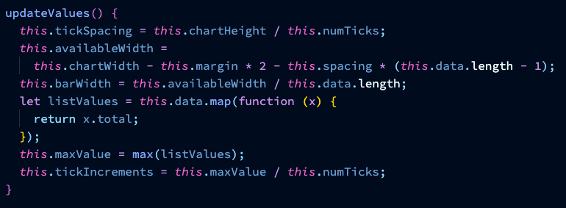

Figure : Map() Function

## Array

An Array is a data type that is stored in a memory. I used an Array when I got a unique data type list of objects and used them in an Array of objects that can be used at a later stage in the code.

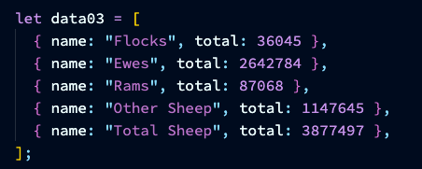

Figure : Array of Objects

## For Loops (Statement)

For loops is a type of loop that used for expressions such as initialization, conditions and expressions to implement a block of code. In the drawHorizontalLines() function, I initialized the for loop with the let i = 0; for which the loop beings at 0. Then, I set the condition to be i <= this.numTicks ; if i is less or equal to this.numTicks, then the loop will continue to run. The expression of i ++ increments the count of each iteration through the loop. This will output the horizontal line with its stroke, strokeWeight and line.

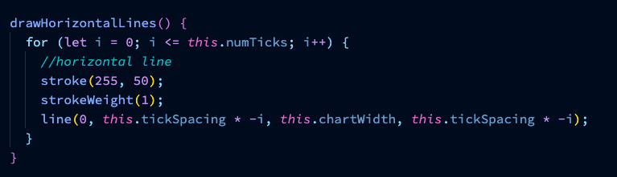

Figure : For Loop

## If Statement (Conditional)

If Statement (Conditional) : executes a specific action in which the outcome is true or false. For the if statement, I used this.showLabels and this.rotateLabels if the statement is true then this.rotateLabel will rotate to vertical but if the statement is false then the condition fails then the code will execute to the else statement which will remain horizontal.

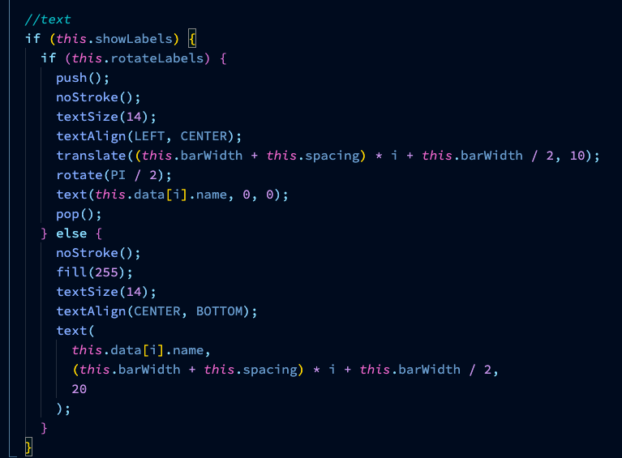

Figure : If & Else Statement (Conditions)

## Function Parameters

Function Parameters : A Functions is a block of code the returns a value. Parameters are inputs that can be passed into a function and act like a local variable. In the scaleData function I used a single parameter of num in the parentheses. Inside of the scaleData function I returned using map and defined num to use it to convert the String into an Array.

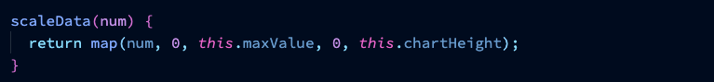

Figure : Function Parameters

# Reference:

<https://p5js.org/reference/> - P5.js References

<https://data.gov.ie/showcase/irish-sheep-census> - Data.gov.ie : Irish Sheep Census

<https://irish-sheep-census.firebaseapp.com/> - Data Visualisation for Irish Sheep Census

<https://github.com/> - GitHub Website