Sonia Nigam

Assignment 4

**Problem 1**

**A)** Mean number of common reviewed movies: 18.8076608736

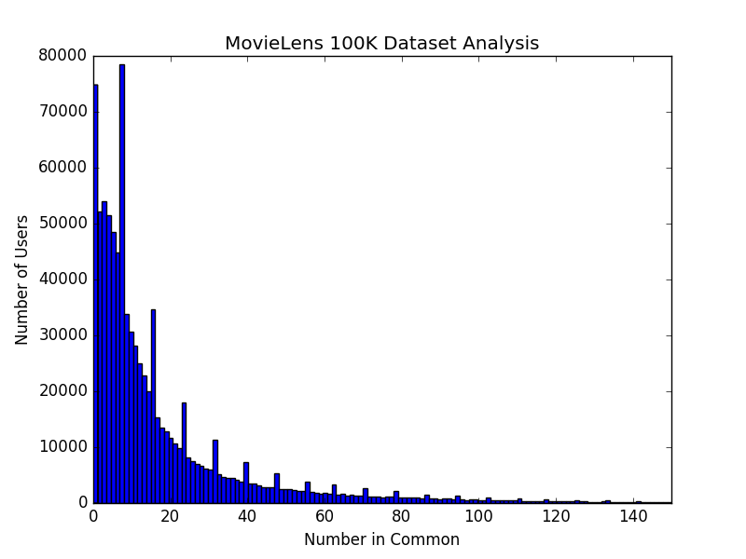Median number of common reviewed movies: 10.0

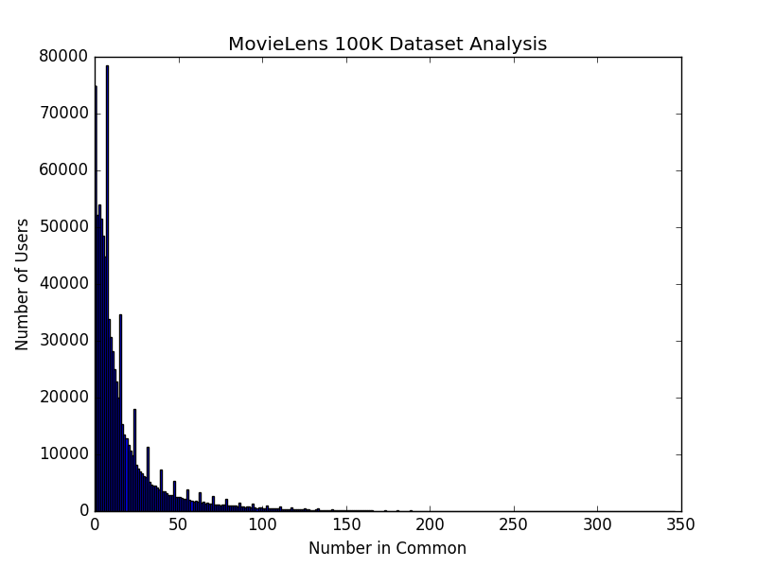

The above numbers and graphs were generated from code found in the file understanding_data.py. To run this file, enter in command line: “python understanding_data.py u.data”.

I created two histograms. The first histogram constrains the x-axis such that it focuses on the concentrated lower end of the distribution. I did this because I think it creates a more telling visual of the data, and is easier to read. The second histogram has an x-axis that goes up to 350, because there are 346 unique common quantities, and this graph covers the entire distribution. Because the right end of the distribution consists of outliers, where one given pair had a high number of common reviews, it is hard to see this data representation on the large-scale graph. That being said, it does more accurately represent the entire data representation, so I thought it was important to include it.

When designing both histograms, I set it such that the number of bins is the same as the number of individual common quantities. Meaning, each bar represents a distinct number of common movie reviews between a pair of users, and the height of the bar represents how many pairs of users had that same common quantity. I did this such that no quantities were aggregated, and that the histogram would accurately represent the distribution.

**B)** 141 movies have the minimum number of reviews (1 review). 1 movie has the maximum number of reviews (583). I think this distribution follows the general notion of Zipf’s law. There are 1,682 movies, thus the film with the maximum number of reviews is ranked 1,682nd in the frequency table. According to the law, there should be 1,682 times more movies ranked first in the frequency table. In this case, there are 141 films with the minimum number of reviews, and only one film with the maximum number of reviews. Thus, this data distribution follows the skewed trend where higher ranked terms (more reviews) have fewer occurrences (fewer movies), but does not follow the law to the exact numerical definition. This trend can be very clearly seen in the plotted graph below.

Movie 50 had the maximum number of reviews with: 583 reviews

The following movies had the minimum number of reviews with: 1 review

['1653', '1655', '1621', '1627', '1626', '1625', '1624', '1579', '1343', '1507', '1505', '1618', '1619', '1616', '1614', '1613', '1363', '1543', '1548', '1601', '1603', '1604', '1606', '1156', '1557', '1525', '1526', '814', '1492', '1493', '1494', '1498', '1122', '1235', '1236', '1482', '1486', '1130', '1572', '1571', '1570', '1577', '1576', '1575', '1574', '830', '1582', '1583', '1580', '1581', '1586', '1373', '1584', '1457', '1458', '1587', '1595', '1596', '1593', '1599', '1447', '1452', '1453', '857', '852', '1476', '1309', '1559', '1681', '1680', '1682', '1461', '1460', '1310', '1533', '1536', '1678', '1679', '1674', '1675', '1676', '1677', '1670', '1671', '1673', '677', '1414', '1320', '1325', '1329', '1520', '711', '1669', '1668', '1667', '1666', '1665', '1663', '1661', '1660', '599', '1546', '1339', '1352', '1659', '1650', '1651', '1657', '1654', '1633', '1349', '1348', '1340', '1341', '1645', '1647', '1641', '1640', '1649', '1648', '1515', '1510', '1563', '1564', '1566', '1567', '1630', '1632', '1634', '1635', '1636', '1637', '1638', '1366', '1568', '1569', '1561', '1562', '1565', '1201', '1364']

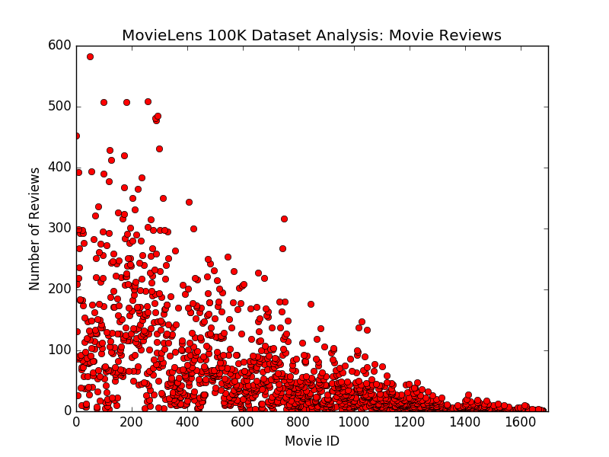

The above numbers and graphs were generated from code found in the file understanding_data.py. To run this file, enter in command line: “python understanding_data.py u.data”.

**Problem Two**

**A)** I think approach A is a more suitable solution to the issue posed by missing reviews. Users are only allowed to rate a movie from 1-5. Meaning, if the rating is set to be 0, it clearly represents a missing rating. In turn, if a user has rated a movie and another user has not, Manhattan Distance will always appropriately count this difference when measuring the distance between two users. With approach B, a missing rating will be substituted with the mean. There is a chance that this average rating is the same number as the rating of the user who actually rated the film. In turn, Manhattan Distance would mistakenly consider this as a similarity between two users, when in reality that does not accurately represent how they viewed the film. Approach B does not correctly distinguish unrated films from the pool of data, and in turn could consider erroneous similarities. Moreover, it is important to note when users have both chosen not to rate a given film, as it is telling of their profile. Approach A will correctly account for when users have both not rated a given movie, for they will both be 0.

For example, imagine the following two users rating 5 movies.

1) 1 1 3 1

2) 1 1

In this scenario, we are going to compare user 1 and user 2. With Approach A, user1 and user2’s missing reviews would be substituted with 0s and would appear like below.

1) 1 1 3 1 0

2) 1 0 1 0 0

In turn, the Manhattan Distance would be 1+1+1 = 3. This correctly captures the similarity that they did not review the fifth film. It also captures two key differences where user1 reviewed the film and user2 did not.

With Approach B, user1 and user2’s missing reviews would be substituted with the mean rating, and would appear like below.

1) 1 1 3 1 1.5

2) 1 1 1 1 1

In turn, the Manhattan Distance would be 1+1 = 2. Because user2’s substituted mean rating matched user1’s rating in both cases, the algorithm interpreted these comparisons as two similarities and did not account for them in the distance. This method does not clearly distinguish unrated films, and the means of substitution can be mistaken as a matched rating. Moreover, both users were missing the 5th review, and had different substituted means. Though it truly was a similarity that they did not review a given film, this was counted as a difference within the distance.

In conclusion, Approach A ensures that unrated films have a unique numeric value; as a result, there cannot be false matches between user ratings when one user’s substitution matches the other’s true rating, and false mismatches when two users have different substituted means. As a result, this is a more accurate approach to calculating Manhattan Distance.

**B)**