**Question 1**

Implemented in *gmm_est.py*

**Question 2**

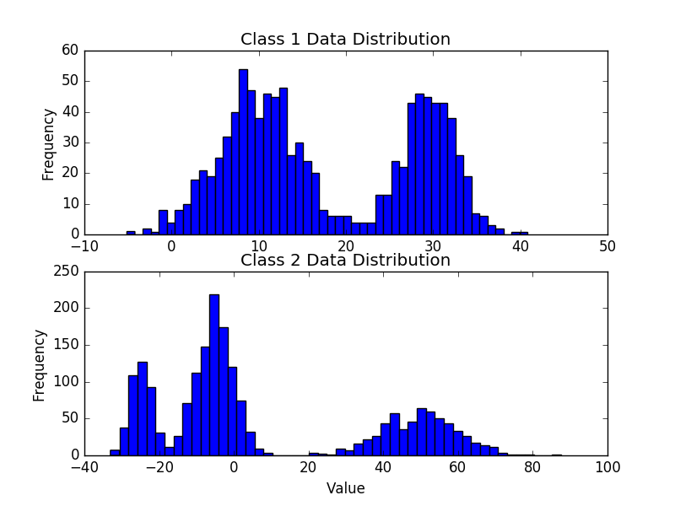

I plotted the above graph in order to discern the appropriate number of Gaussian components and parameter initializations. With this, I used the following values:

**Class 1**

mu_init: [10, 30]

sigmasqinit: [7, 5]

wt_init: [.6, .4]

**Class 2**

mu_init: [-30, -10, 50]

sigmasqinit: [10, 13, 15]

wt_init: [.2, .5, .3]

**Final GMM Parameters for Class 1**

mu = [9.7748859236586476, 29.582587182965749]

sigma^2 = [21.922804563645315, 9.7837696128028284]

w = [0.59765463038822264, 0.40234536961263107]

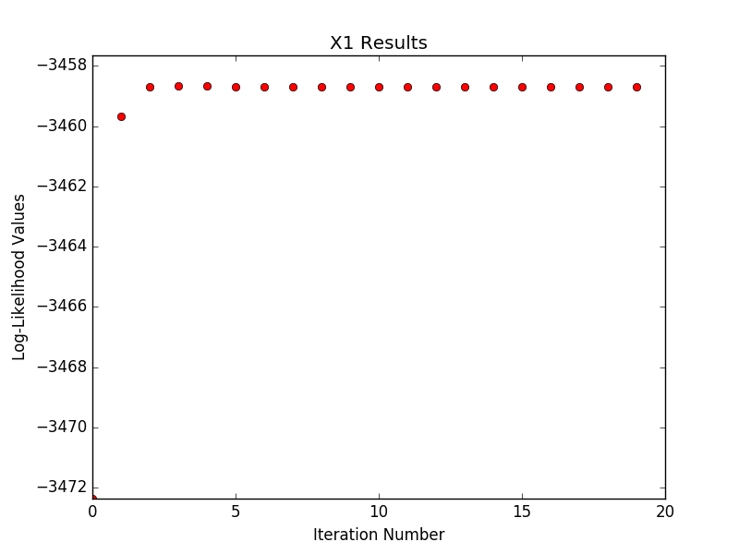

**Final GMM Parameters for Class 2**

mu = [-24.822751728709839, -5.0601582832398666, 49.62444471952756]

sigma^2 = [7.9473354076752969, 23.322661814417472, 100.02433750441168]

w = [0.20364945852681876, 0.49884302379613926, 0.29750751767685851]

