**Problem One**

A. Implemented using n = 3

I chose n=3 in order to balance the variance within both the training and testing sets. Because 30 data points is not that large of a sample, I wanted to ensure that both training and testing had a sufficient number of data points to provide a grounded statistic.

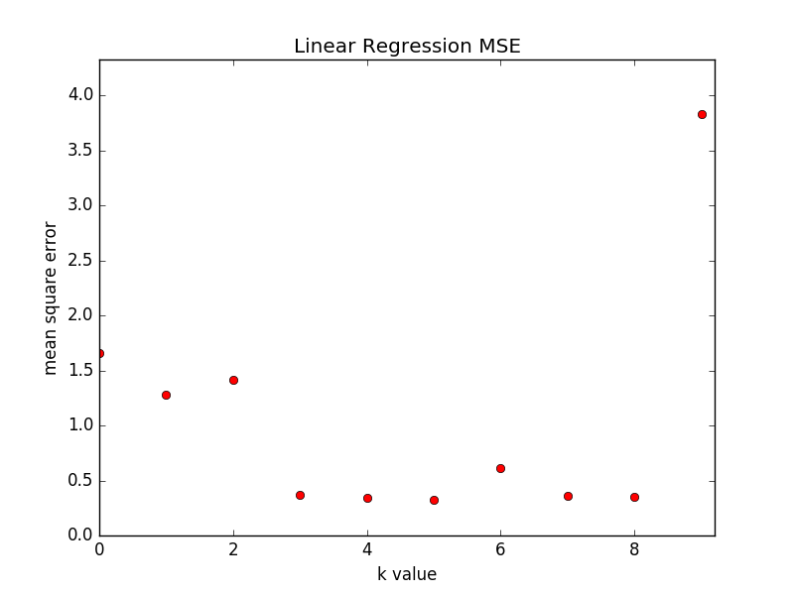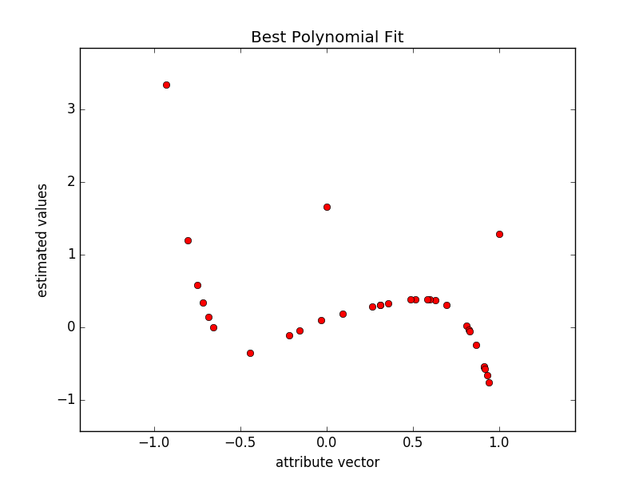

B. The k that yielded the best result was 5 with the lowest error rate 0.325665168273.

C. NOT SURE FOLLOW UP

**Problem Two**

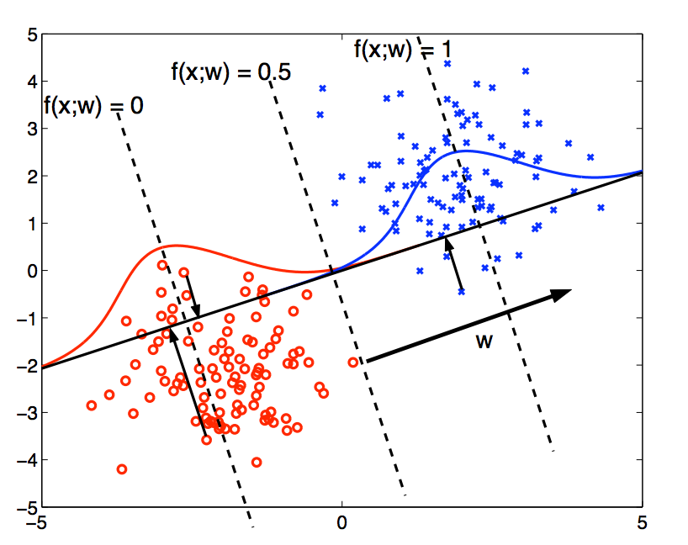A. Regression can be utilized in order to classify data. Classification implies that the resulting variable is casted as a class. In turn, the way to classify using regression is that you label each class a number, formulate a best-fit regression line, and then round all output to their closest label number. For the sake of this explanation, we will assume we are in a binary system such that the outputted variable must be classified as a 0 or 1. Regression results in a continuous variable. Meaning, a value will be plugged into a polynomial function that will return a label that is not necessarily 0 or 1. In order to deal with this continuity, one must leverage a decision boundary. A decision boundary will indicate whether or not the input should be classified as 0 or 1 based on the outputted value. If there are several classes, the best approach is often to round the resulting number to the closest number associated to a given label. In a binary space, An example of a decision boundary is if f(x,w) > .5 then it will be classified as 1, otherwise it will be classified as 0.

Source: <http://www.ai.mit.edu/courses/6.867-f04/lectures/lecture-5-ho.pdf>

In the above graph, the decision boundary is based on .5. When the polynomial produces values greater than .5, the input is classified as “blue”, otherwise it is classified as “red”. Another concept would be if 1=dog, 2=cat, and 3=mouse. If the regression outputs 2.7, it would be classified as a mouse, but if it outputs .2 it is classified as a dog. In the end, classification via regression takes results of a best-fit function and essentially casts them in the class with the closest associated numeric label.

B. The regression algorithm is dependent on the relationship between inputs and estimated values. If there isn’t a strong correlation between the two values, then this approach will be highly compromised. Similarly, if there are a few outliers, they will greatly affect the best-fit function, and in turn compromise the regression estimation accuracy. The following graph clearly demonstrates this notion. With all of the data (on the left) the best-fit function takes the outliers into account, which alters the slope away from the trend of the majority of data points. When the outliers are taken out, the best-fit function estimates values much more accurately. In turn, being at the will of outliers is a weakness of classification via regression.

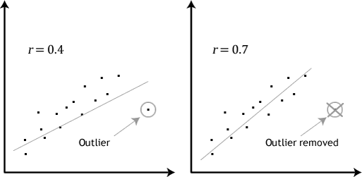Source: <https://statistics.laerd.com/statistical-guides/pearson-correlation-coefficient-statistical-guide-2.php>

**Problem Three**

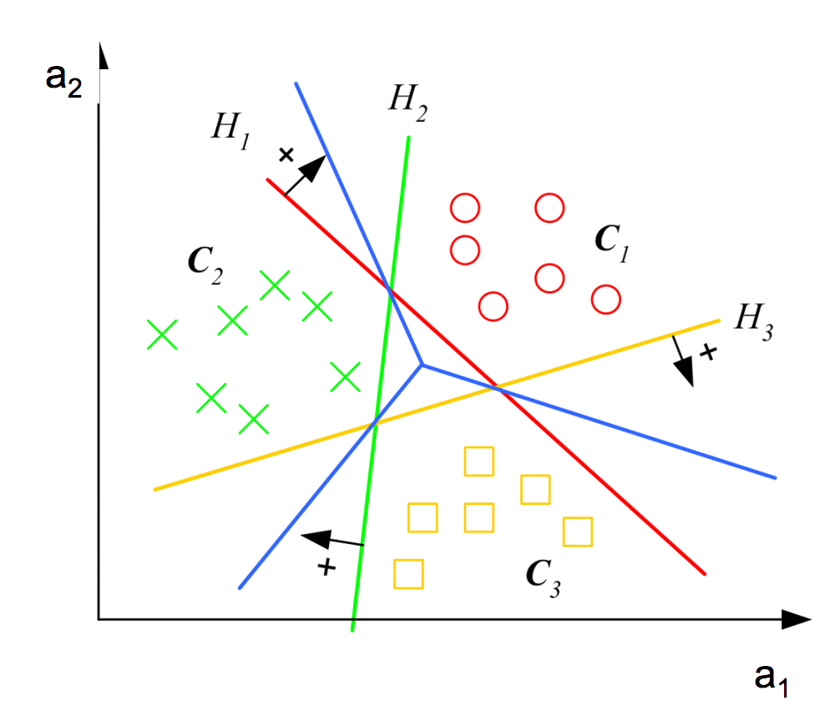A. When there are more than 3 classes to be distinguished, LDA is more accurate in cases where the data cannot be separated linearly. In ordered to be separated linearly, there must be singly connected convex regions. When this is not the case, the data can still be separated using n discriminant functions, in turn separating the space into n convex regions. An example of an instance where data is not linearly separable, but can be separated under the LDA model is as follows.

Source: Class Linear Discriminants Lecture Slides

B. The LDA method assumes that classes are normally distributed, Gaussian, and are linear combinations of features. Thus, the method’s effectiveness is rooted in the assumption that classes share a covariance matrix.

C. NEED TO DO

D. NEED TO DO

**Problem Four**

A. It took 2 epochs to correctly classify X1.

The parameter vector is: [1. 0, 6.5756]

B. It took 3 epochs to correctly classify X2.

The parameter vector is: [0.0, 0.91136866]