Human Takeover Guide
Team — Standard Operating Procedure
The Fertility Solution | June 2026

Overview
The AI assistant handles most conversations automatically. However, certain situations require a human touch — either because the message is sensitive, the lead has asked for a person, or the topic is outside what the AI should address.
When any of these situations arise, the system automatically flags the conversation and pauses the AI. At that point, you take over.

Golden rule
Once you are in a conversation, it is yours. You complete it manually. The AI will not come back unless specifically re-enabled — which is not part of the current process.

1 When Does a Conversation Come to You?
There are two types of triggers that hand a conversation over to the VA team:

A. The lead asks for a human
If the lead says anything like the phrases below, the AI immediately stops and flags the conversation for you:
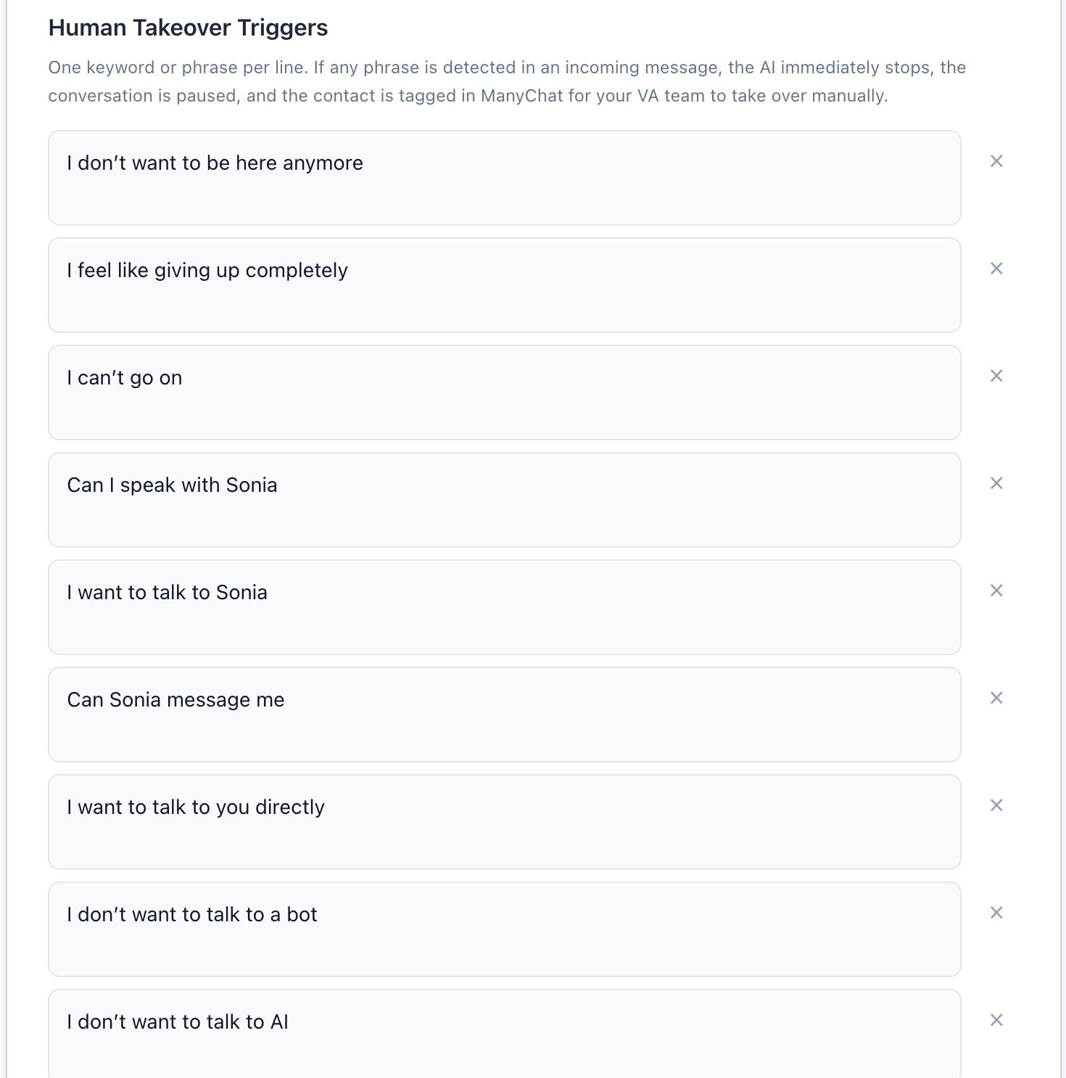

B. A sensitive or medical topic comes up
If the lead mentions any topic on the medical sensitivity list
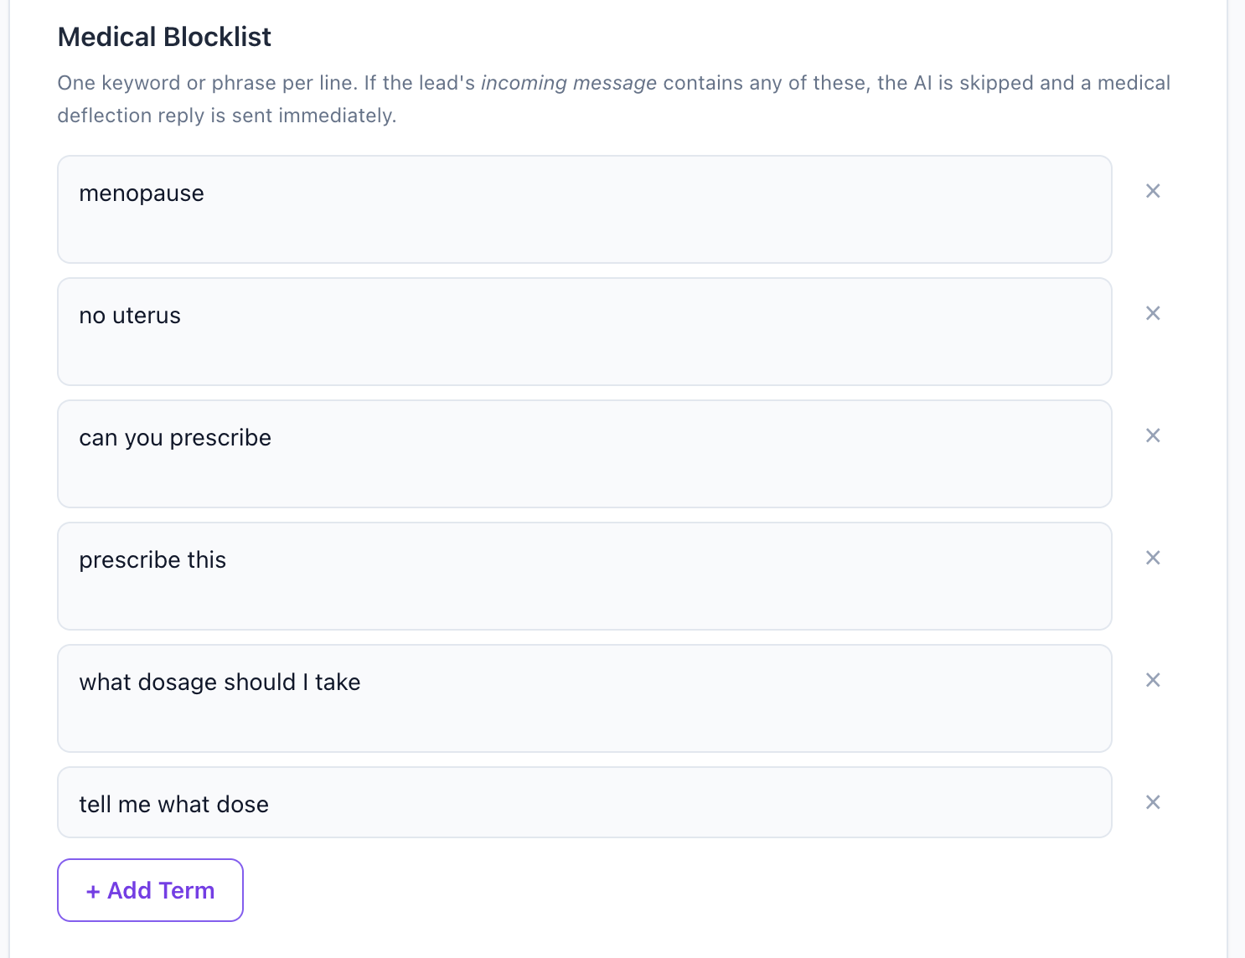
the AI sends a predefined message and then immediately hands the conversation to you.
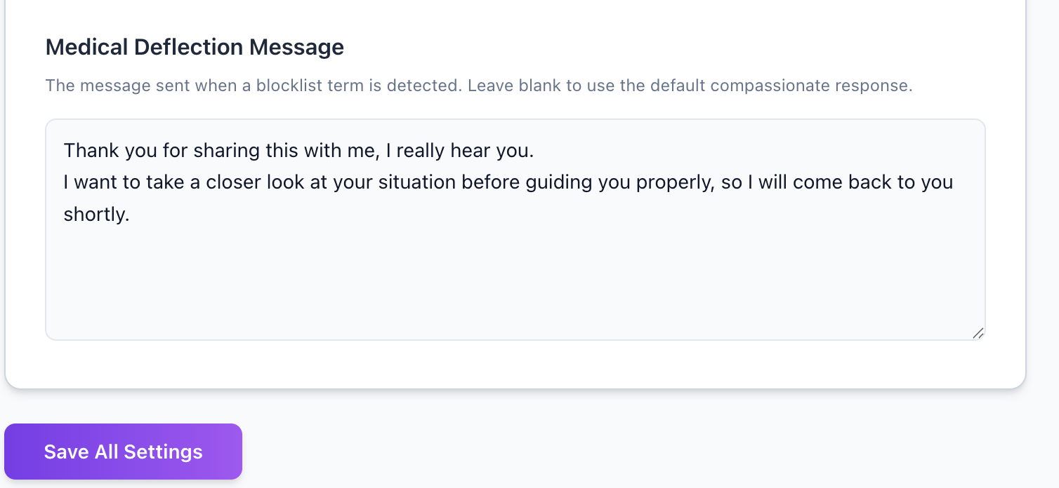
Both are fully configurable.
In both cases, the same thing happens automatically:
The AI pauses. A tag is added to the contact in ManyChat.

2 How Do You Know It’s Your Turn?
You will see a tag appear on the contact in ManyChat. This is your signal to open the conversation and take over.
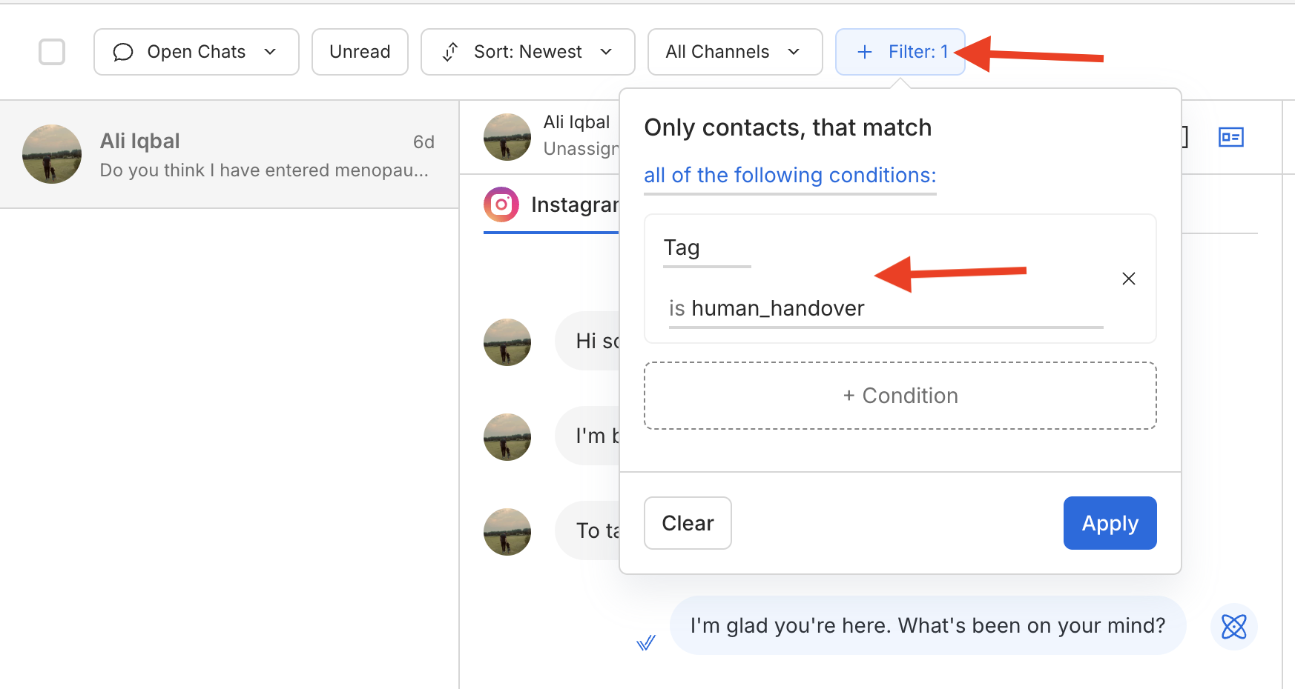
When you open the conversation you will be able to read the full chat history so you can understand exactly what has been discussed before stepping in.

3 What Do You Do Once You’re In?
1 | Read the conversation history — understand where the lead is, what they have shared, and why the AI handed off.

2 | Respond as yourself — warmly, personally, and in line with Sonia’s brand voice. You do not need to explain that you are a human

3 | Handle the conversation to completion — whether that means answering a question, offering the booking link, or simply listening and supporting.

4 When Is a Conversation Finished?
You can consider a conversation complete when one of the following has happened:
- The lead has booked a call with Sonia
- The lead has clearly said they are not interested
- You have answered the question or concern that triggered the handover
- The lead has gone quiet for 48 hours after your follow-up

Once the conversation is complete, simply leave it. No further action in the system is needed.

5 What You Should Not Do
- Do not give medical advice or diagnoses.
- Do not promise outcomes (“you will get pregnant”, “the programme guarantees...”).
- Do not re-enable the AI for a conversation you have taken over.
- Do not leave a conversation unacknowledged for more than a few hours during working hours.

6 Quick Reference

Situation | Who handles it | Outcome
Normal lead qualification | AI | AI continues automatically
Lead asks for a human | VA takes over | VA completes conversation
Medical or emotional topic | VA takes over | VA completes conversation
Complaint or refund request | VA takes over | VA (and Sonia if needed) completes conversation
Lead booked and enrolled | Sonia | Conversation closed, AI stays off
7 Important Link
1. Admin Dashboard
https://jellyfish-app-qwns9.ondigitalocean.app/admin/config#safety
Password: password123
2. Demo Video
https://www.loom.com/share/a50e7d42301541df9885fac8baccd38d
For questions, contact iftikharasjad@gmail.com. | Document version: June 2026

