SAT Datashare — Production endpoint verification
Experience API | Production | All eight GET endpoints working
Date: 24 September 2026
Layer tested: Exp (production_exp_url)
Result: All endpoints returned HTTP 200 with mapped payload data.

Summary
# | Endpoint | HTTP status | Result
1 | GET /api/v1/Invoice | 200 OK | Working as expected
2 | GET /api/v1/Order | 200 OK | Working as expected
3 | GET /api/v1/Product | 200 OK | Working as expected
4 | GET /api/v1/Route | 200 OK | Working as expected
5 | GET /api/v1/SalesRep | 200 OK | Working as expected
6 | GET /api/v1/Customer | 200 OK | Working as expected
7 | GET /api/v1/Stock | 200 OK | Working as expected
8 | GET /api/v1/Warehouse | 200 OK | Working as expected

1) Invoice
Endpoint | GET /api/v1/Invoice
Query parameters | fromDate, toDate, pageNumber
HTTP status | 200 OK
Result | Working as expected
Screenshot
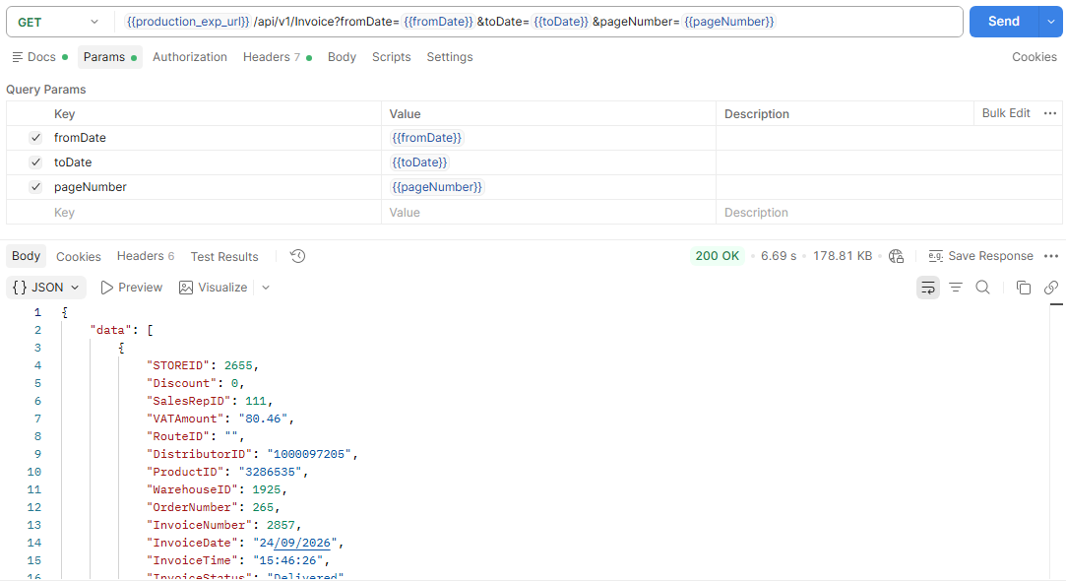
Working as expected. Returns mapped invoice rows. DistributorID is 1000097205, InvoiceStatus is Delivered, VATAmount is 2 decimals.

2) Order
Endpoint | GET /api/v1/Order
Query parameters | fromDate, toDate, pageNumber
HTTP status | 200 OK
Result | Working as expected
Screenshot
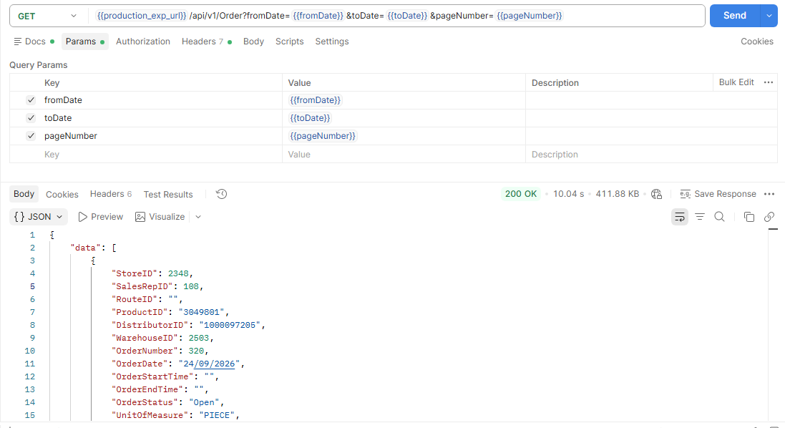
Working as expected. Returns mapped order rows. DistributorID is 1000097205. OrderDate is populated from ENTRY_TIME.

3) Product
Endpoint | GET /api/v1/Product
Query parameters | none
HTTP status | 200 OK
Result | Working as expected
Screenshot
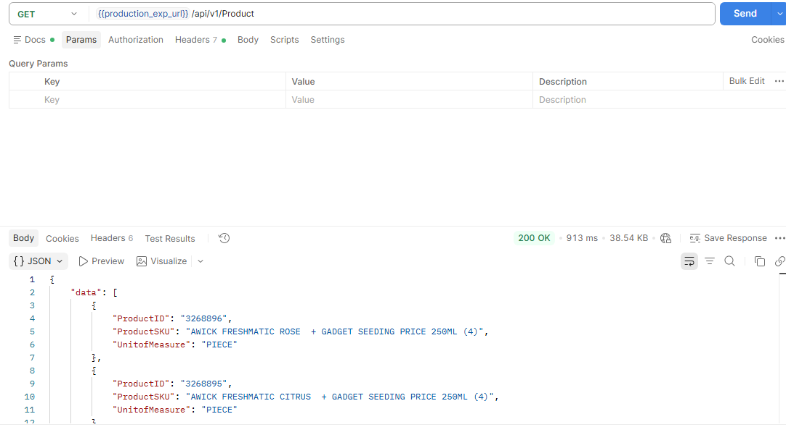
Working as expected. Returns only ProductID, ProductSKU, and UnitofMeasure.

4) Route
Endpoint | GET /api/v1/Route
Query parameters | none
HTTP status | 200 OK
Result | Working as expected
Screenshot
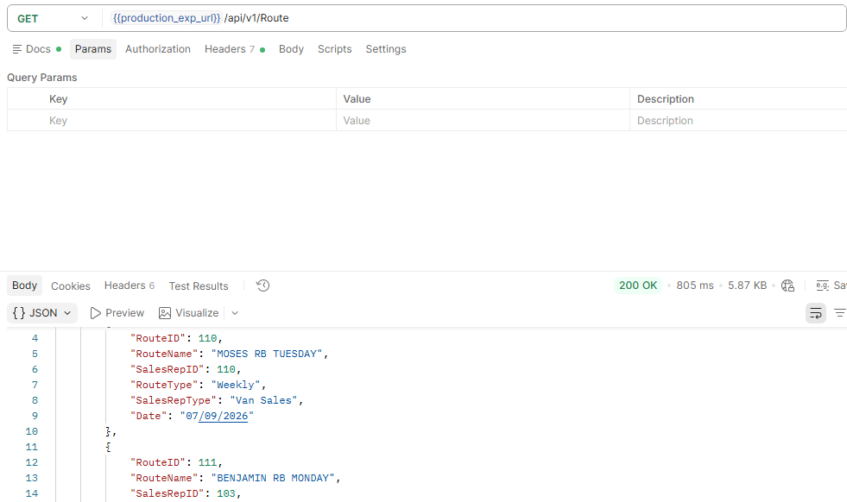
Working as expected. Returns RouteID, RouteName, SalesRepID, RouteType, SalesRepType, and Date.

5) SalesRep
Endpoint | GET /api/v1/SalesRep
Query parameters | none
HTTP status | 200 OK
Result | Working as expected
Screenshot
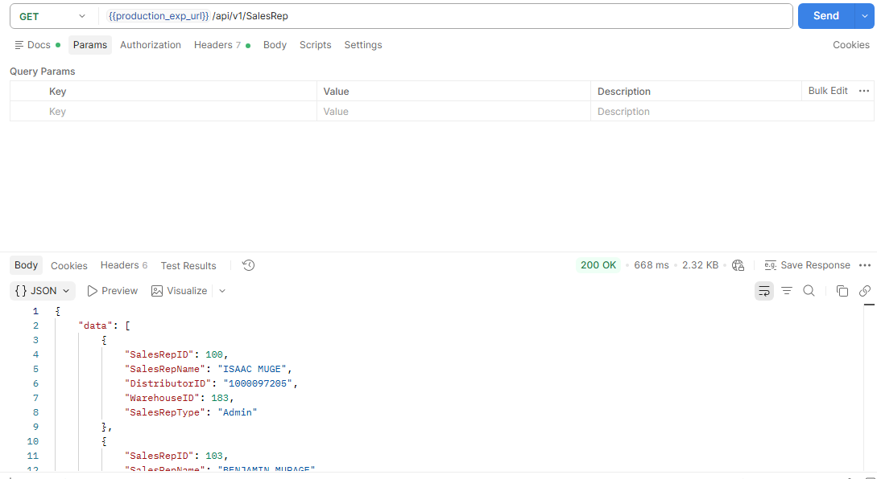
Working as expected. Returns SalesRepID, SalesRepName, DistributorID 1000097205, WarehouseID, and SalesRepType.

6) Customer
Endpoint | GET /api/v1/Customer
Query parameters | fromDate, toDate, pageNumber
HTTP status | 200 OK
Result | Working as expected
Screenshot
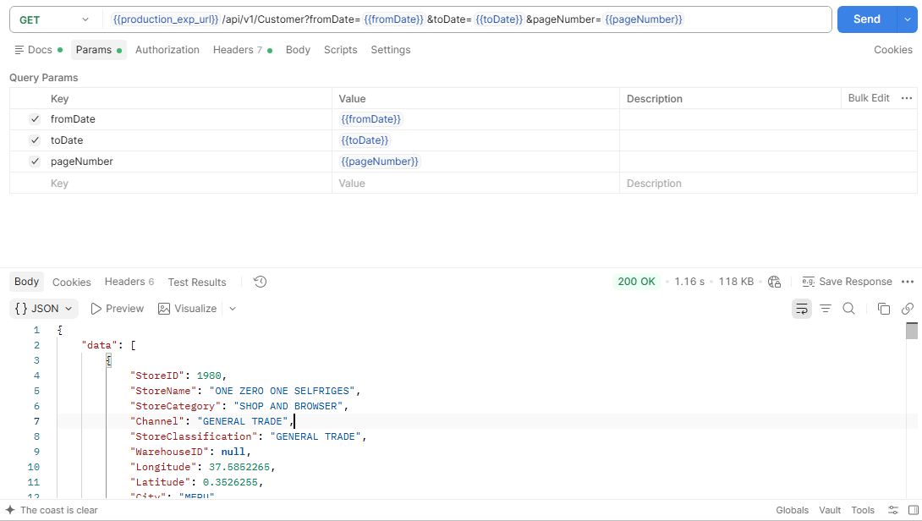
Working as expected. Returns store fields. WarehouseID is null as agreed.

7) Stock
Endpoint | GET /api/v1/Stock
Query parameters | pageNumber
HTTP status | 200 OK
Result | Working as expected
Screenshot
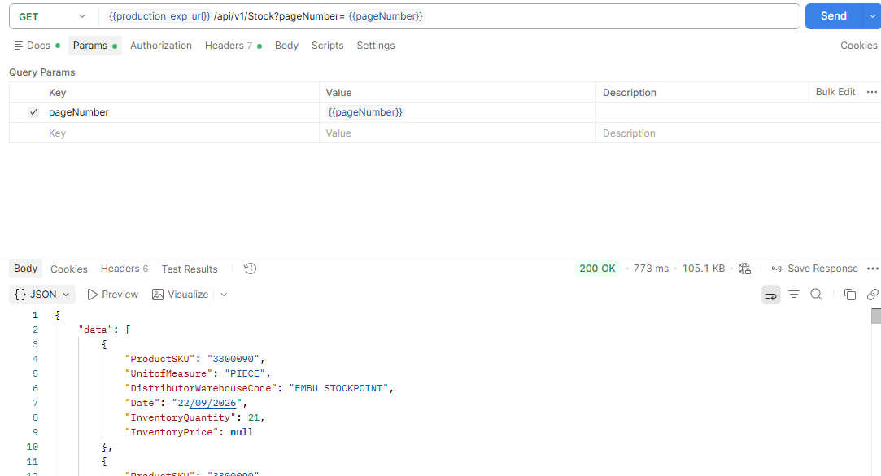
Working as expected. Returns ProductSKU, UnitofMeasure, DistributorWarehouseCode, Date, and InventoryQuantity. InventoryPrice is null as agreed.

8) Warehouse
Endpoint | GET /api/v1/Warehouse
Query parameters | none
HTTP status | 200 OK
Result | Working as expected
Screenshot
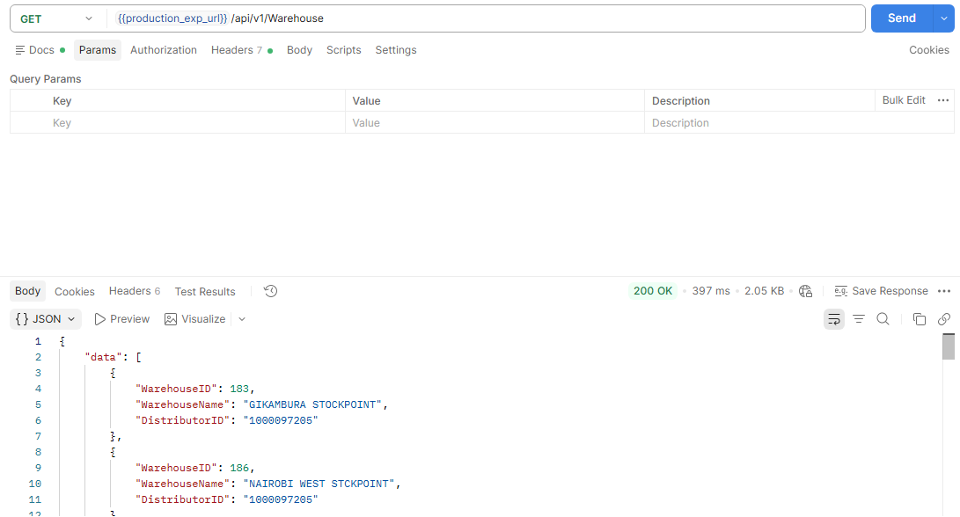
Working as expected. Returns WarehouseID, WarehouseName, and DistributorID 1000097205.

