

R & POwerBi aSSIGNMENT

By Sonia Shah



February 27, 2024

Contents

**Task 1 – Load the data/Install Package/Import library /Check data types3**

**Task 2- Clean the data/Check and remove the missing values/Remove data which not required4**

**Task 3 - Exploratory Data Analysis/Basic Charts in R  6**

**Task 4 – Export Data 7**

**Task 5 - Create Power BI Dashboard  8**

#Task 1 - U Load the data / Install Package / import library / check data types

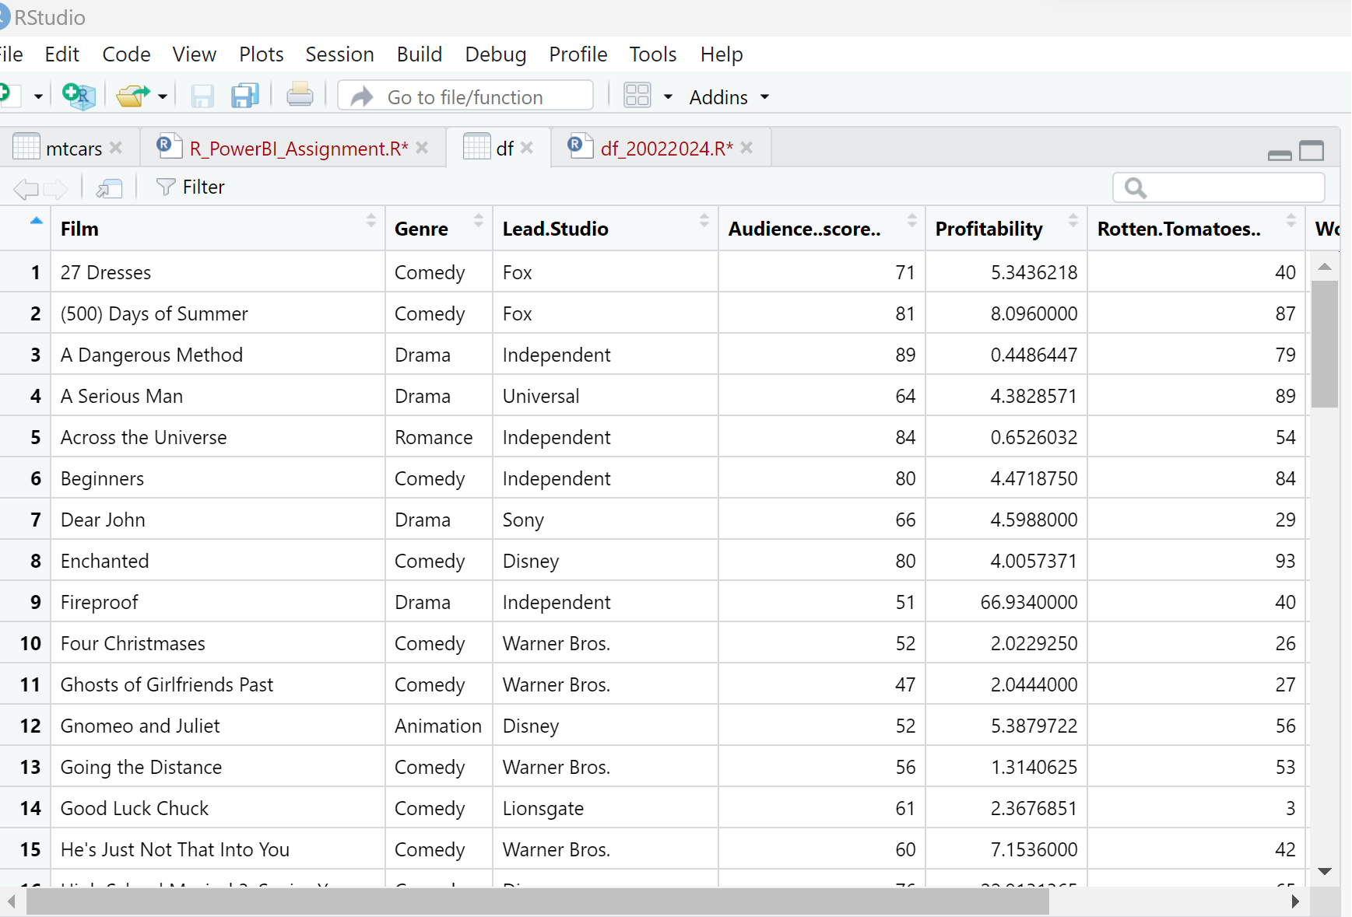

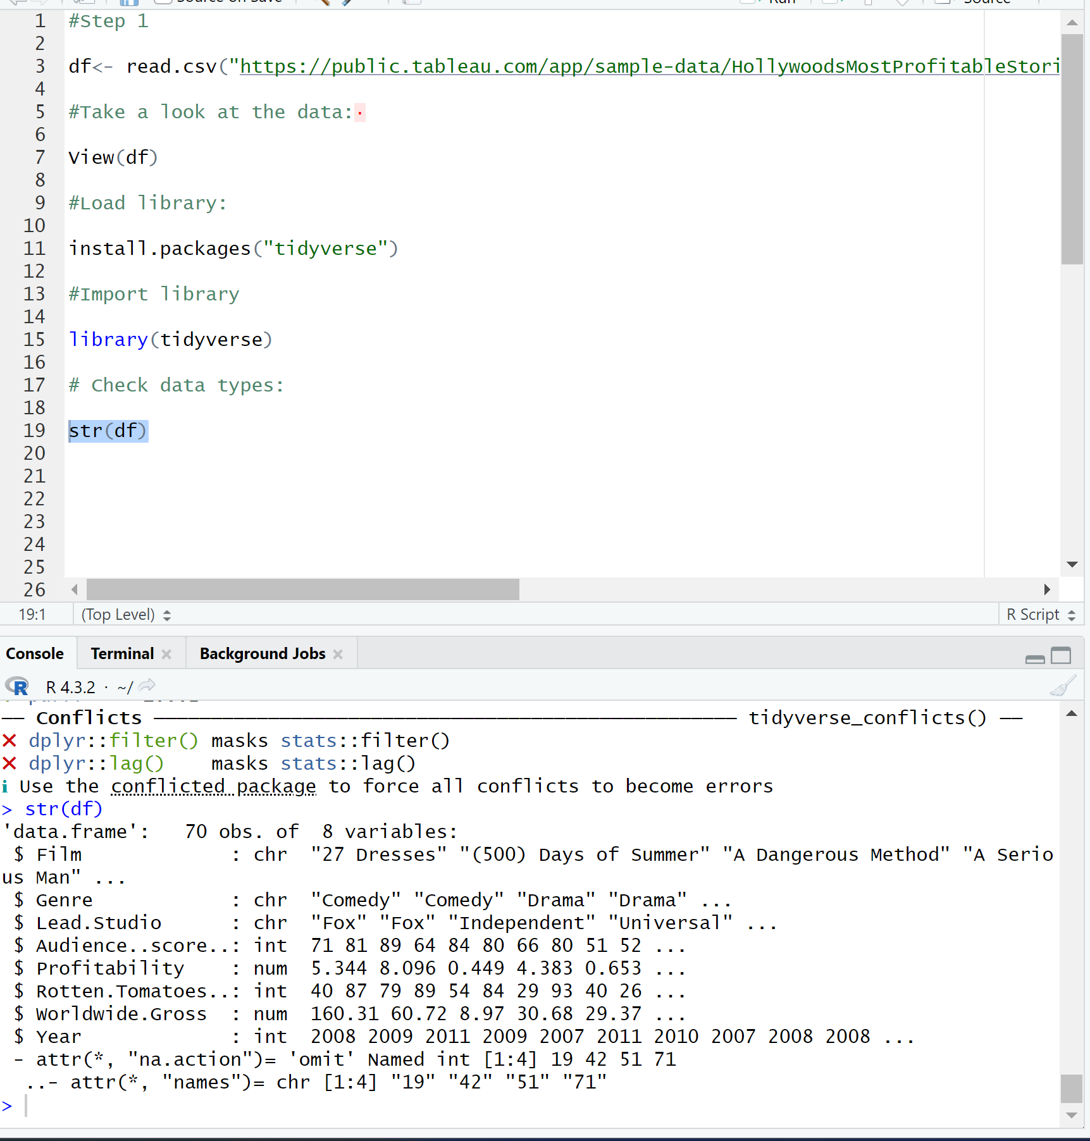

#Task 2 - Clean the data/Check and remove the missing values/Remove data which not required

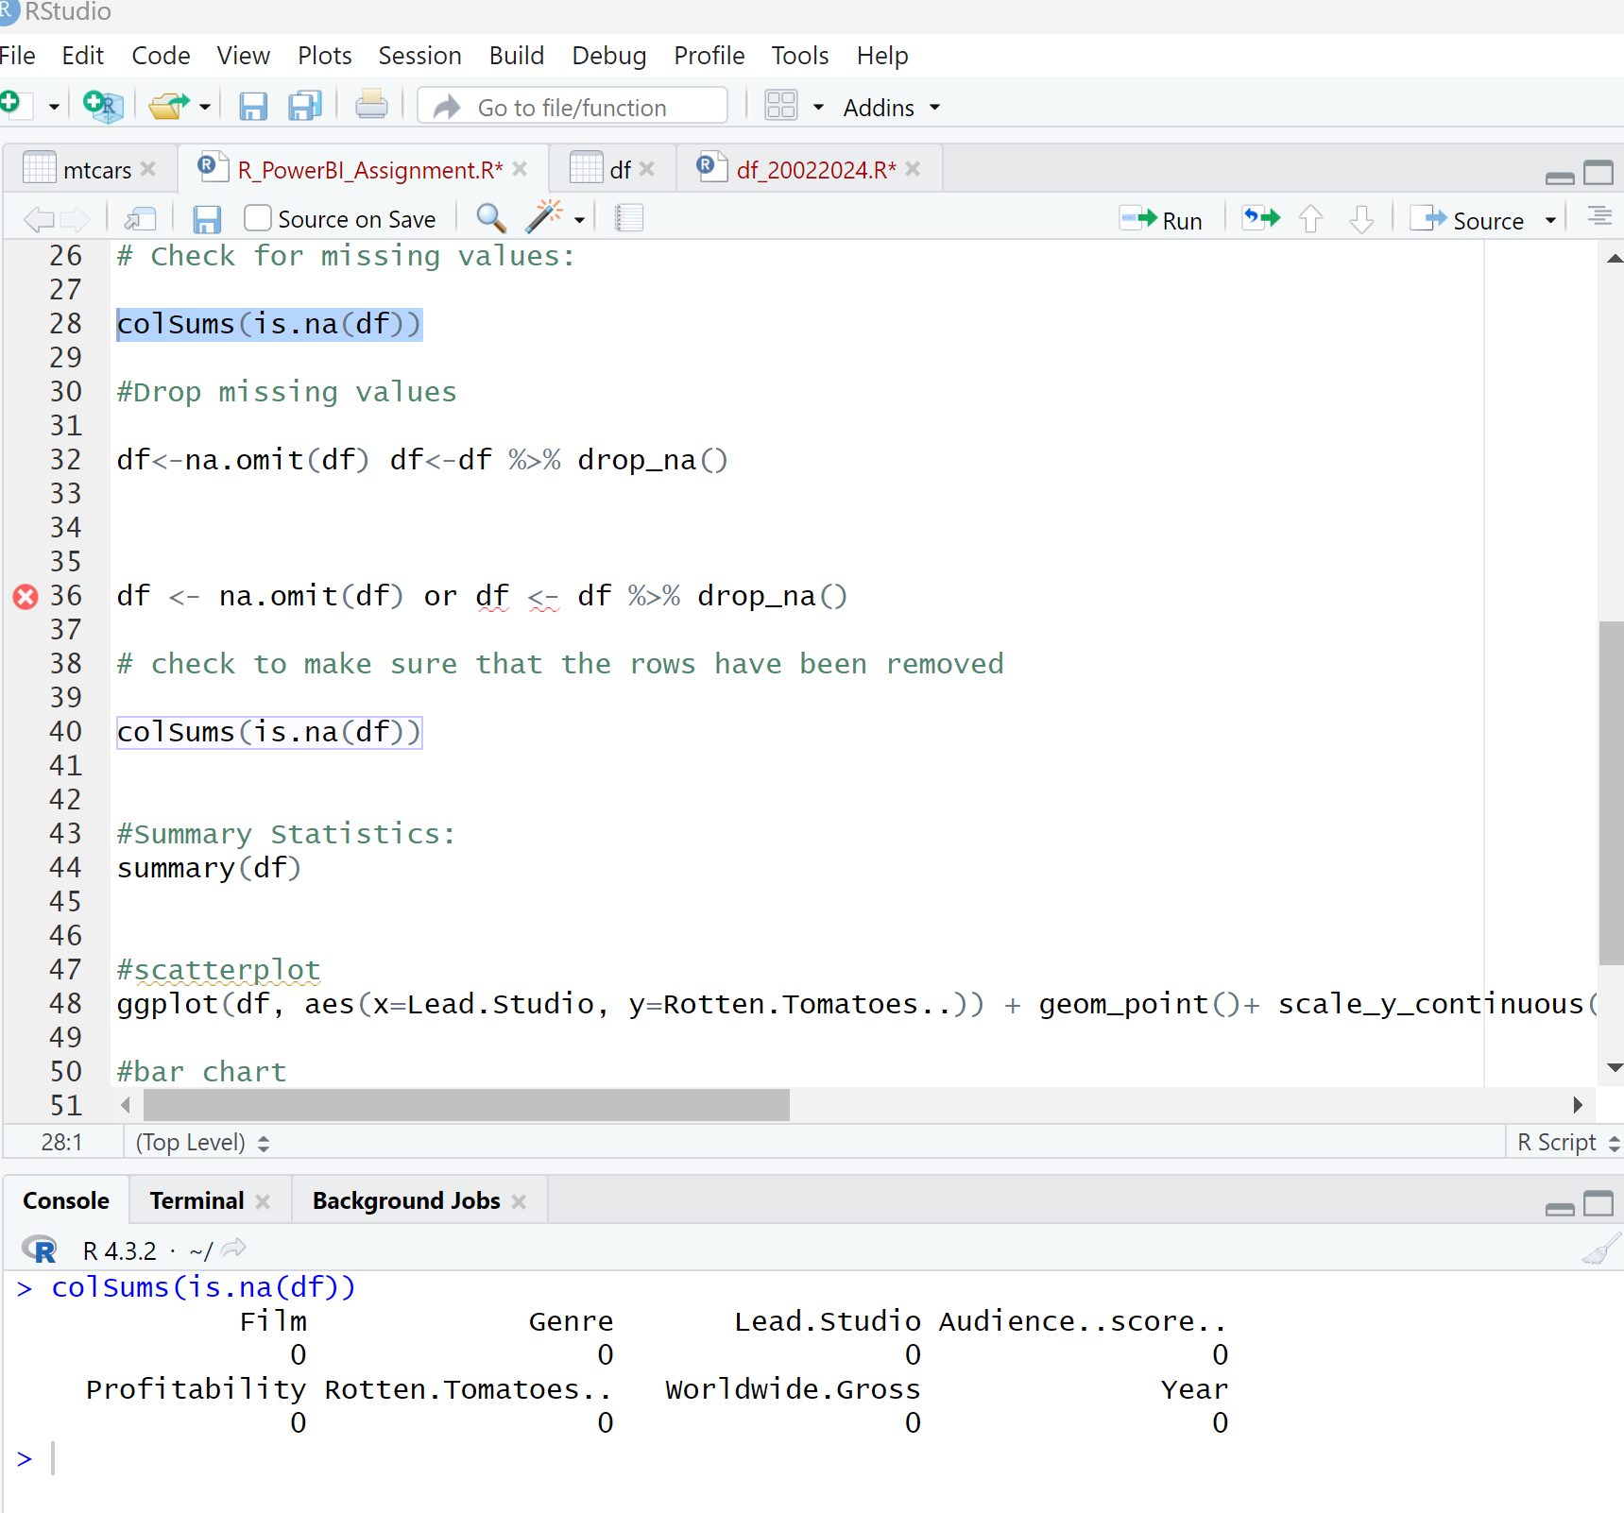

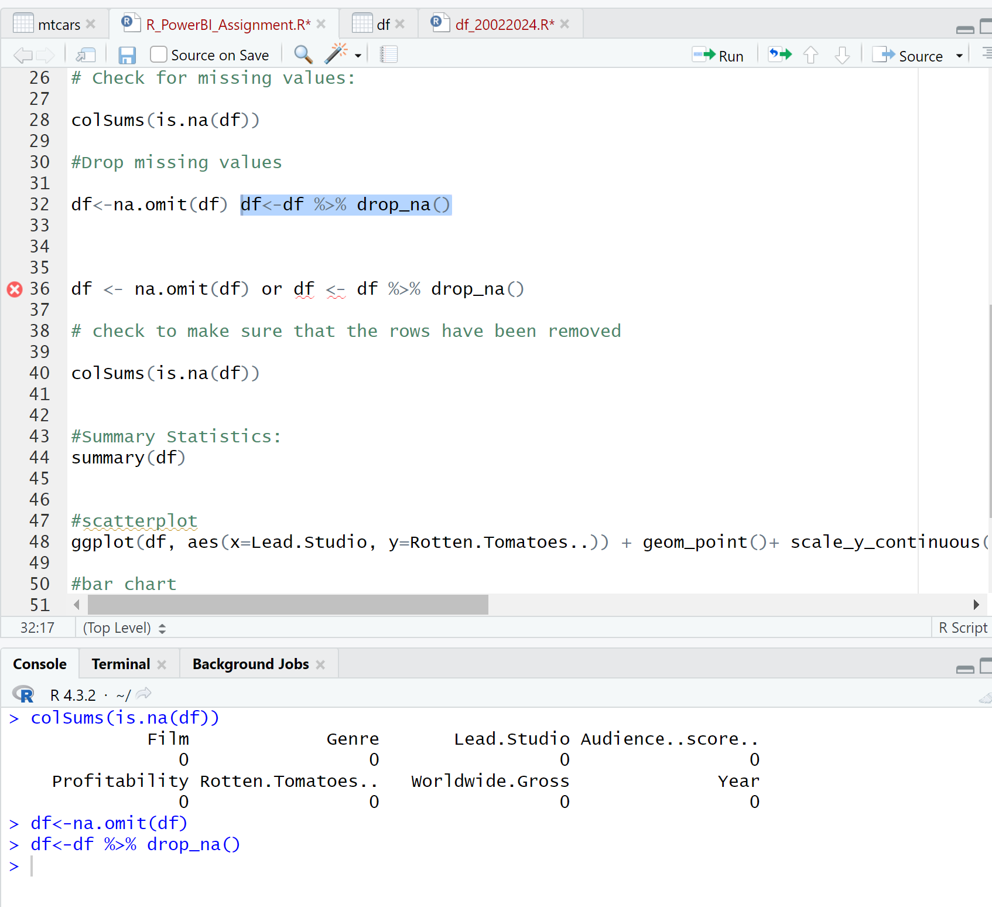

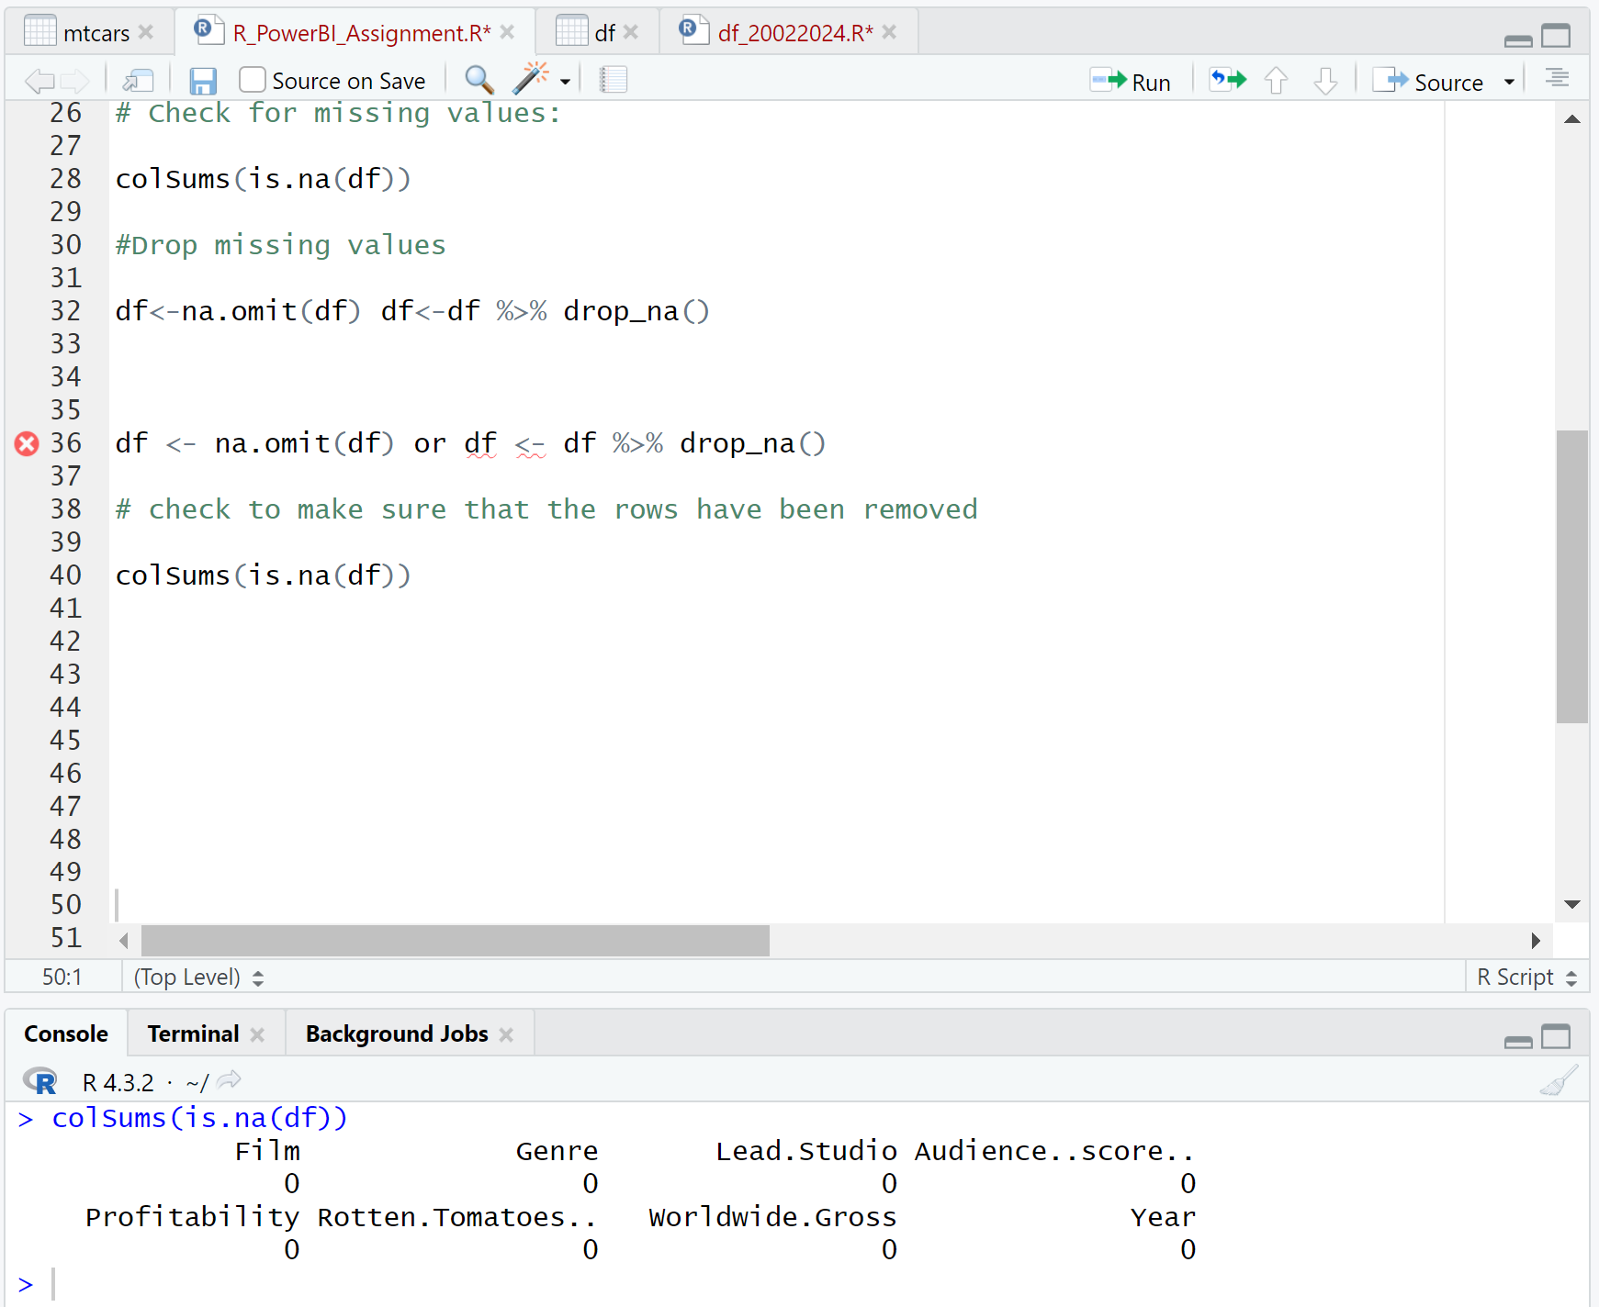

#Task 3 - Exploratory Data Analysis/Basic Charts in R  ​

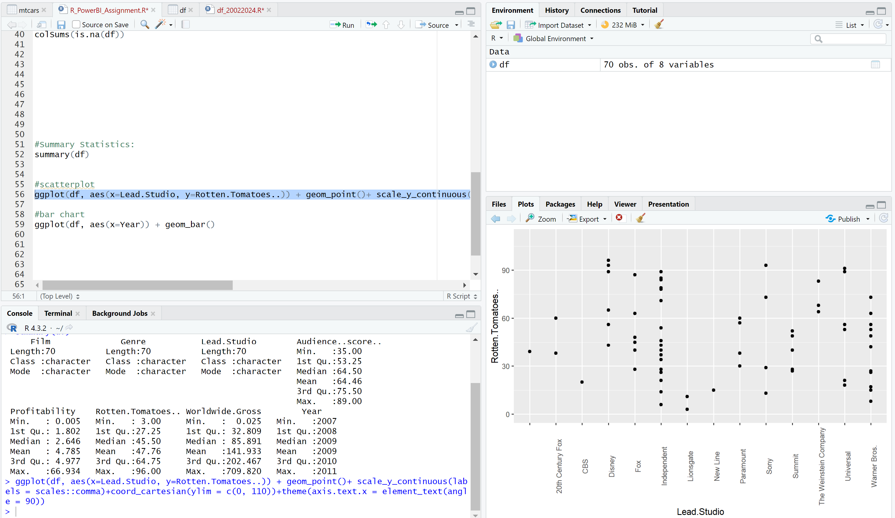

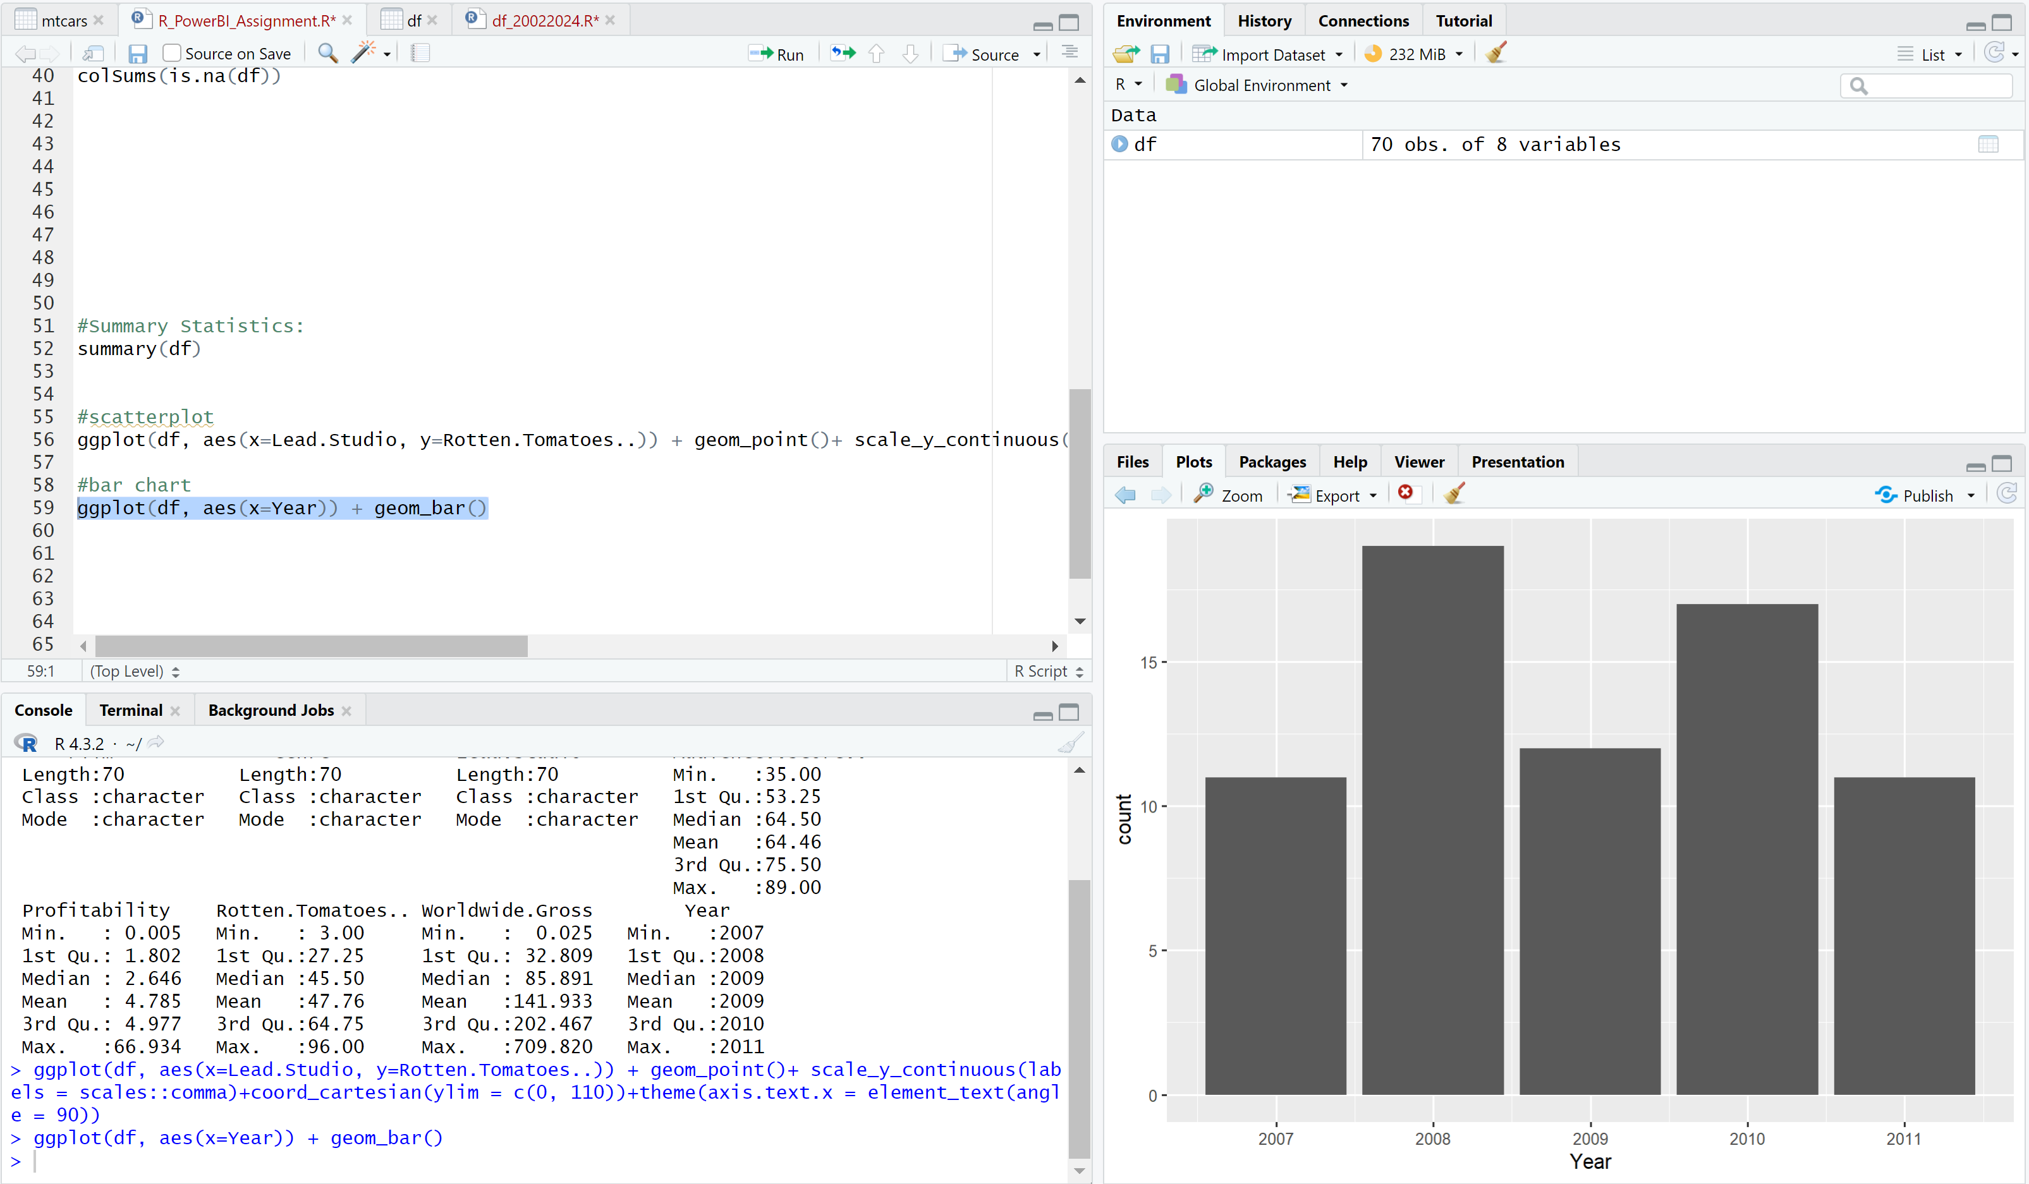

#Task 4 – Export Clean Data.

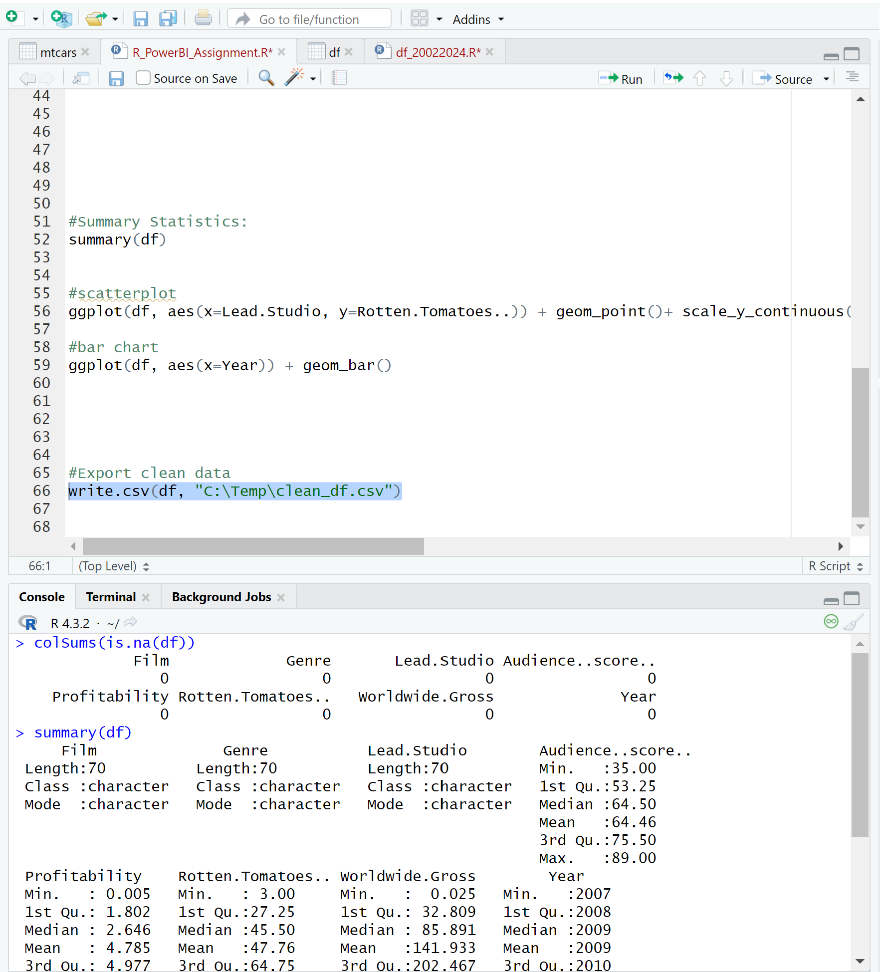 ​

#Task 5 – Create Power BI Dashboard

