GOVIND SINGH

About Me

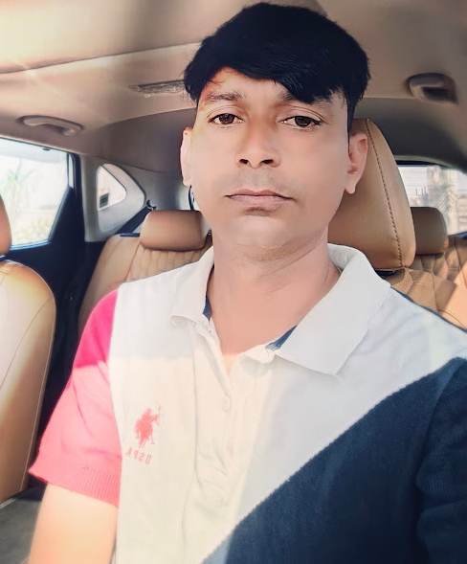

17 Years experience

+91.9929555155

January 04, 1987
Bijoliya,Rajasthan

stonekota@gmail.com

Objective:-

Seeking a challenging career where can utilize my academic and analytical knowledge. Significantly contribute to growth of the organization with hard work and dedication. To Contribute and render the best of my services for the growth of the service Industry with my talent and abilities.

Assets:-

Self confidence, excellent communication skill, Keenness to work, awareness for responsibilities, ability to work calmly under pressure and in harmony with colleagues, imaginative and inquiring state of mind.

Educational Qualification :-
cation :-Professional Qualification :-Professional Qualification :-

Examination | Year Of Passing | Board / University
B.A. | 2007 | MLV COLLAGE BHILWARA
Sr. Secondary | 2005 | Board Of Sec. Edu.Raj.Ajmer
Secondary | 2003 | Board Of Sec. Edu.Raj.Ajmer

Skills

- Operating System :- Window 98 & Window XP , Windows 7 Windows 10

- Office Management :- MS Office ( WORLD, EXCEL,POWERPOINT,ACCESS)

- Office :- Internet Marketing ( Sales)

Personal Details / Skills :-

Can work under pressure.

Good interpersonal skills.
Self driven to do things.
Aggressive Professional nature.nternet

Work Experience :-

- Worked with Unimax India Pvt. Ltd. As a Superviser ( 2 Years ).
- Worked Regatta Universal Exports As a Supervisor (1.5 Years).
- Worked with Kinship Impex Pvt. Ltd. As a Sales Executive (1.5 Year)
- Worked with Swarup International As a field Officer since June 2009
- Worked With Tino Stone Group ( Spain ) As Quality Controller (Deoli Kota & Jaipur)

Work Site :-
Sand Stone, Slate stone, Quartzite, Limestone, Marble, Granite,
- Bijoliya Rajasthan
- Deoli Rajasthan
- Kishangarh Rajasthan
- Kota Rajasthan
- Udaipur Rajasthan
- Gwalior Madhya Pradesh
- Ganjbasdoa, Shivpuri, Lalitpur Sagar , (M.P.)
- BetamCherla, Markapur, Hyderabad, Tandur,
- Jaipur

Computer Proficiency

- Word 2010

- Excel 2010

- Power Point 2010

Languages

- Hindi

- Telugu

Personal Details
Father’s Name: | Late Shri Rajender Singh | Marital Status: | Married
Birthday: | January 04, 1987 | Nationality: | Indian
Gender: | Male

Declaration
I, Govind Singh, hereby declare that the information contained herein is true and correct to the best of my knowledge and belief.

