NAVEEN SHARMA |  | 46, South Avenue
Operations // Quality // Sales // Marketing// Administration |  | Bhopal, MP,462001
 |  | 8719966609
 |  | navin2sharma@yahoo.com
 |  | nvcs1972@gmail.com
Certificates – ESOP DDUGKY
Master Trainer
 | 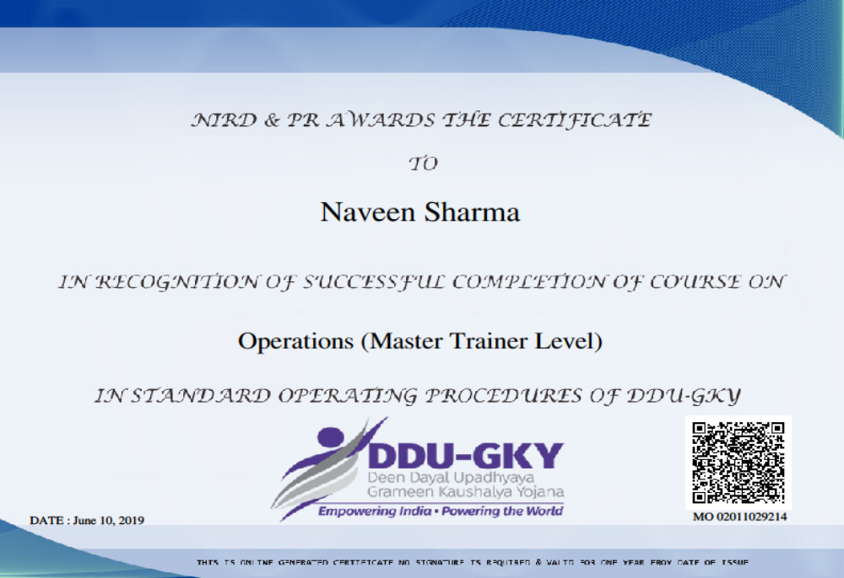
Certificates – ESOP DDUGKY
Professional
 | 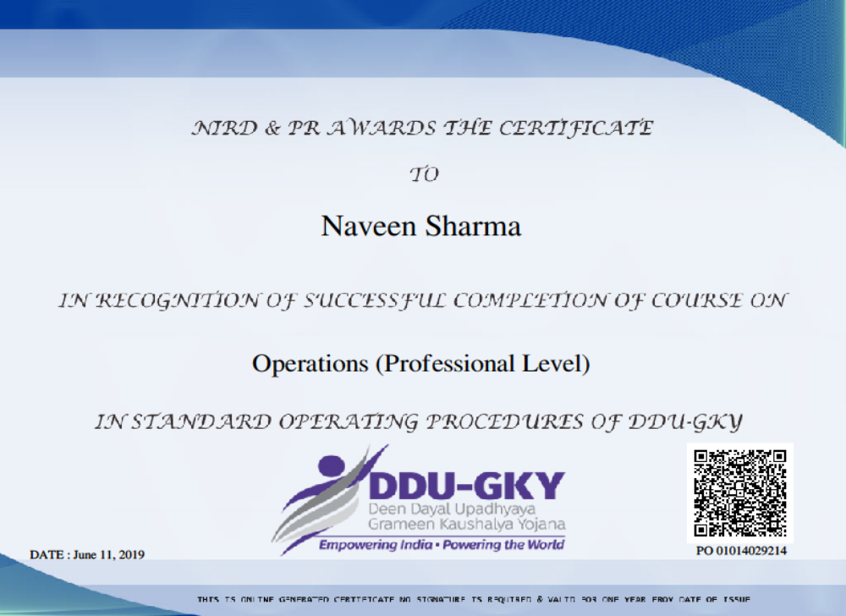

NAVEEN SHARMA
Operations // Quality // Sales // Marketing// Administration

46, South Avenue
Bhopal, MP,462001
8719966609
navin2sharma@yahoo.com
nvcs1972@gmail.com

RESUME

I am constantly looking to solve problems by utilizing the skills that I possess. I especially enjoy those initiatives where I get to lead (or participate) in building something from scratch. I enjoy walking into the unknown and come out as a winner or wiser.
Location Preference: Anywhere
PROFILE SUMMARY
- Result-oriented engineering professional with nearly 17 years’ experience in Direct and Channel Sales, Office and Team Management, Managing Operations and providing quality service while ensuring timely completion of the targets
- Responsible for profit and Loss of my area of operations.
- Expertise in managing Branch operations for reducing churn and enhancing collection which leads to increase in overall profitability.
- Successful in implementing quality standards in different processes of different organizations.
- An effective communicator with excellent relationship management skills and strong analytical, leadership, decision making, problem solving & organizational aptitude

WORK EXPERIENCE
SVG Express Services Pvt. Ltd.
Ratlam as Head Mobilization, Placement and Domain Trainer December 2018 to till date

Ortel Communications Limited
Last Designation: Manager Operations – New Projects at M.P. November 2015 - Oct 2018

Ortel Communications Limited
Last Designation: Manager Operations at various locations of CG October 2011 – April 2015

India Cube Online Deals Private Limited
Last Designation: Manager Quality at Gurgaon Feb 2010 – September 2011

IBM Daksh Business Process Services Pvt. Ltd.
Last Designation: Lead Operations at Gurgaon Oct 2004 – December 2009

Vinayak System Solutions
Last Designation: Self-employed at various locations of MP April 1999 – January 2004

EDUCATION
B.E. (Electronics) Nagpur University.1999

PERSONAL DETAILS
Date of Birth: 5th April 1972
Language Known: Hindi and English

TRAINING ATTENDED
Six Sigma Green Belts

Date – Naveen Sharma

First 30 Day Plan

It is essential to know what is required from me, for that purpose I will sit with my boss to understand his and companies requirements from me.

To understand business will study existing clients and their requirements. Study database of those who are not our clients and find out the reason of failures, if any, to eliminate them.

As it is a new scenario for me I will fix a meeting with all the departments head or responsible person to get information about all the departments and their Links to my work.

Will meet with colleagues and \or subordinates to understand work culture and get involved with them as it is always a team wins.

To meet HR\ Administration to understand written and non written rules.

Thanks
Warm Regards,
Naveen Sharma

46, South Avenue
Bhopal, MP,462001
8719966609
navin2sharma@yahoo.com
nvcs1972@gmail.com

NAVEEN SHARMA
Operations // Quality // Sales // Marketing// Administration// Digital Marketing

