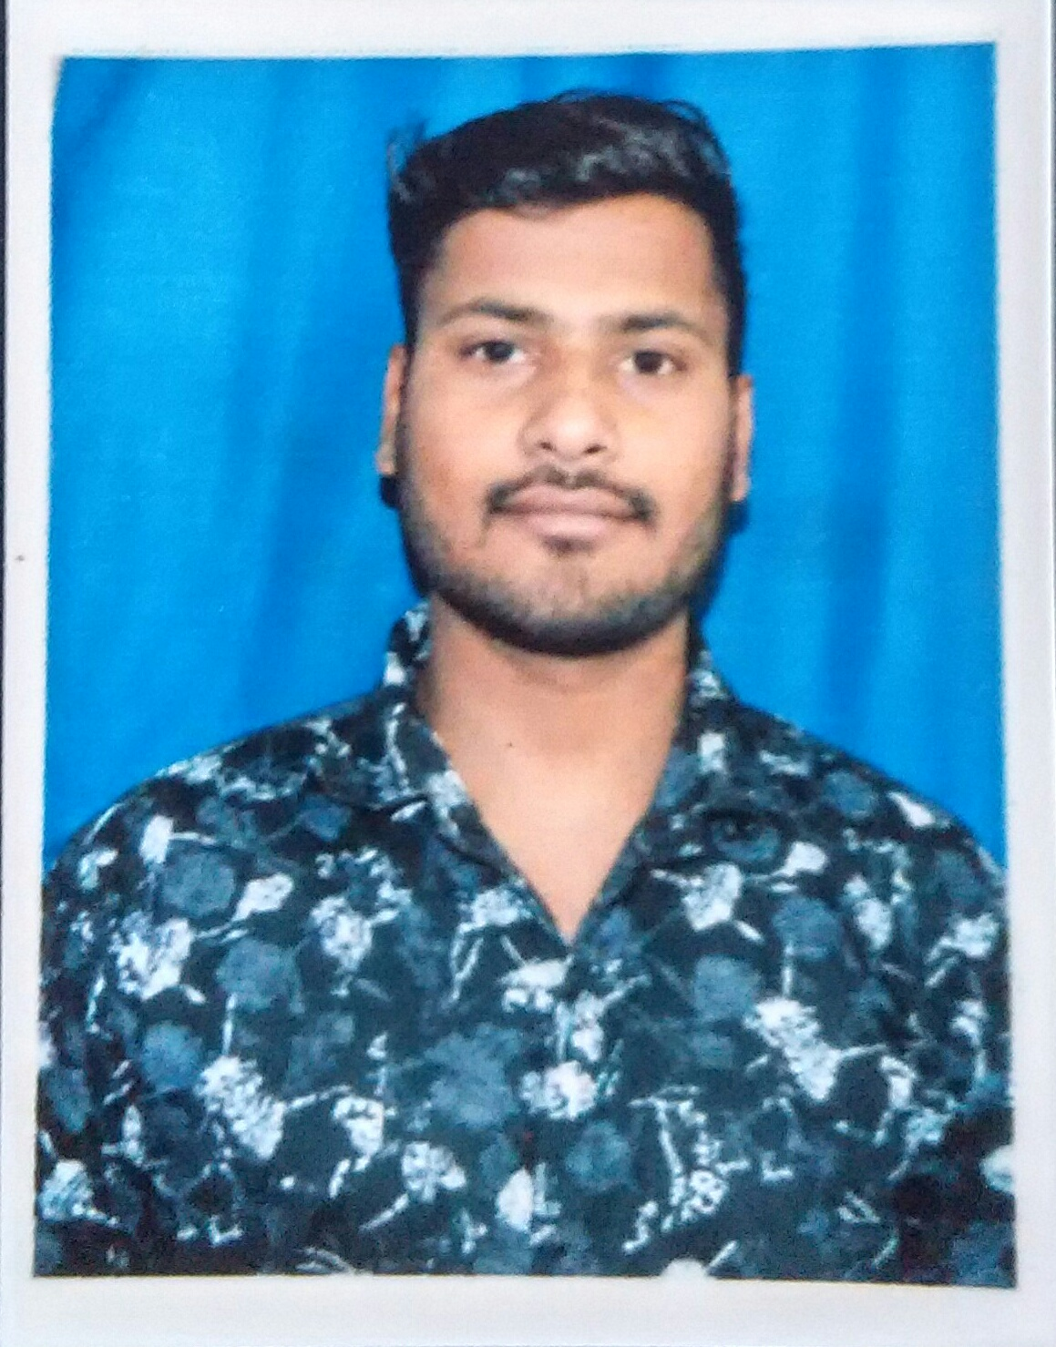
CURRICULUM VITAE

Shakti Singh Rathore
Mob: - 8955696210
Email ID : shaktisr1994@gmail.com
Aadhar Number:- 3287 9735 5924

CAREER OBJECTIVE

Seeking a position as a valuable member of your team that leverages my skills, achievements and ability to lead personal in a direction that provides superior earnings.

ACADEMIC QUALIFICATION

- B.ed
University :- Pandit Deendayal Upadhyaya Shekhawati University, SikerPassing Year :- 2017 (Mathematic-Physics)

- Graduation (B.sc)
University : - Maharishi Dayanand Saraswati University, Ajmer.
Passing Year : - 2015 (Science & Mathematics)

- Sr. Secondary (10+2)
Board. : - Rajasthan Board of Secondary Education, Ajmer, Rajasthan
Passing Year : - 2012 With 62% (Science & Mathematics)

- Secondary
Board : - Rajasthan Board of Secondary Education, Ajmer, Rajasthan
Passing Year : - 2010 With 68%

PROFESSIONAL EXPERIENCE

- I have 4-5 month experience of teaching as a teacher
- I have 3-4 years work experience in computer Operator
- I have also Knowledge of Works on Internet

PROFESSIONAL CERTIFICATE

- Certificate Of Computer Application. & Basic. RS-CIT by VMO University, Siker
- Certificate Of Domestic Data Entry In English by National Skill Development Corporation
- Certificate Of Domestic Data Entry In Hindi by National Skill Development Corporation
- Certificate Of Computer Network by Advanced Institute of Technology & Management
- Certificate Of Business Management by E-learning College
- Certificate Of Accounting & Finance by E-learning College
- Certificate Of Banking & Finance by Lingaya's Lalita Devi Institute of Management & Sciences
- Certificate Of Amazon Elastic Compute Cloud (EC2) by AWS training and certification

SUMMARY OF STRENGTHS

- I can adjust easily according to the situation.
- Hardworking.
- Good Nature.
- Accept challenges

INTERESTS & HOBBIES

- District level player of Handboll Certificate
- Cricket
- Listening song

LANGUAGES KNOWN

Hindi & English

PERSONAL DETAILS

Name : Shakti Singh Rathore
Father’s Name : Sh. Ajay Singh Rathore
Date of Birth : 25st Aug. 1994
Marital status : Unmarried
Nationality : Indian
Gender : Male
Address : Jamado Ka Mohalla ,Old City
Kishangarh, Dist. Ajmer(Raj.)
Pincode-305802
.
.

DECLARATION

I hereby declare that all the information provided by me in this application is actual and correct to the best of my knowledge and belief.

Date:-

(Shakti Singh Rathore)
Place:- Kishangarh

