Bhushan Soni Resume
This Word version preserves the visual content of the PDF by embedding each page as an image.

Page 1
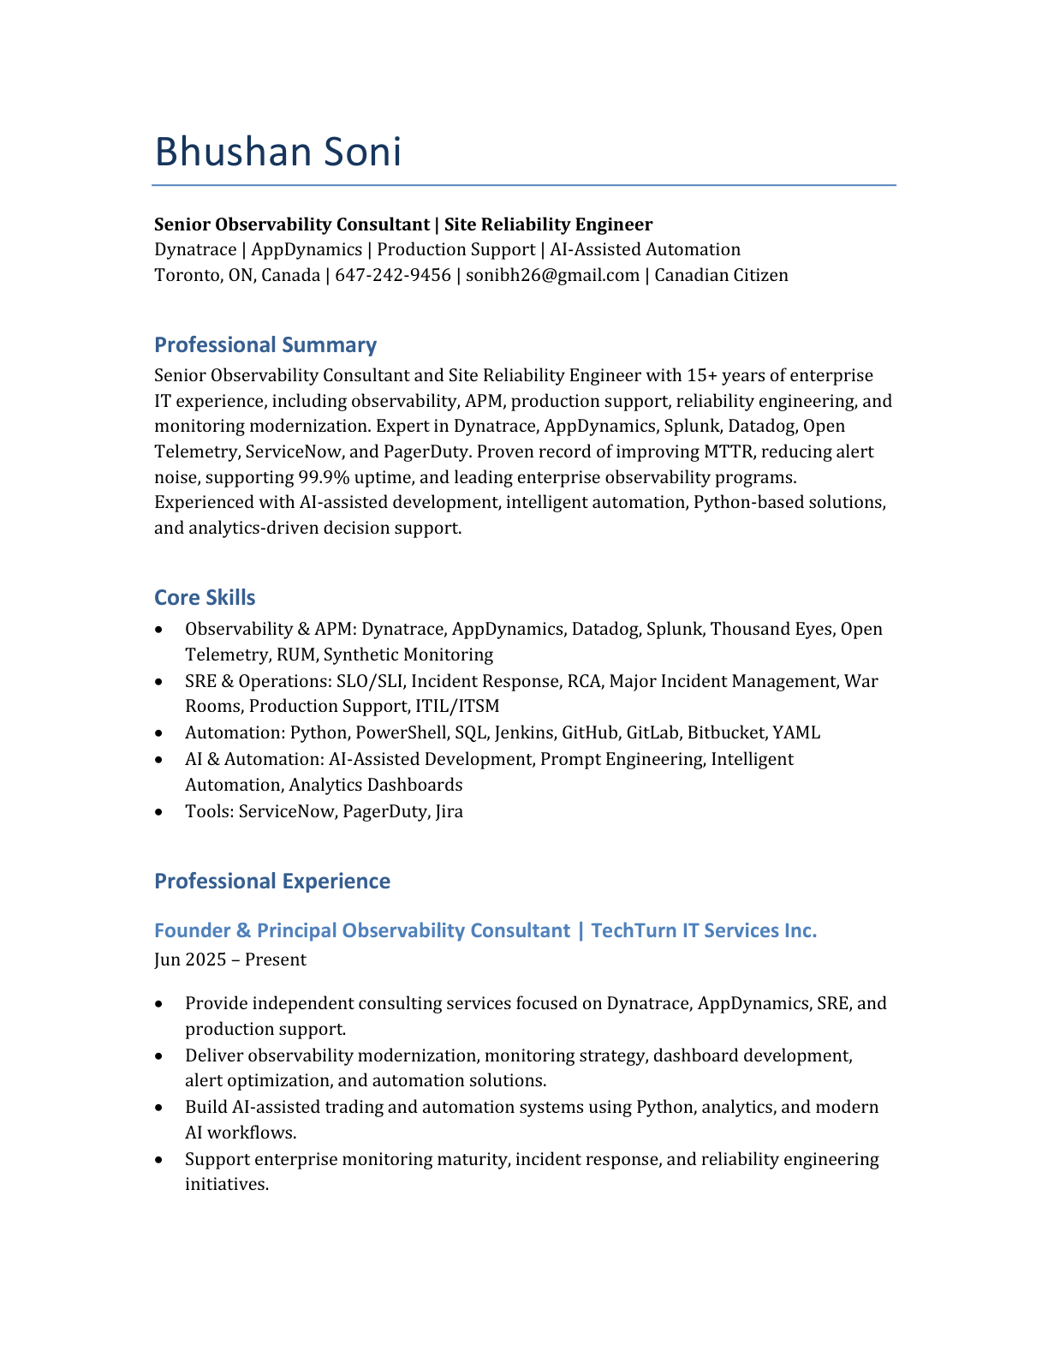

Page 2
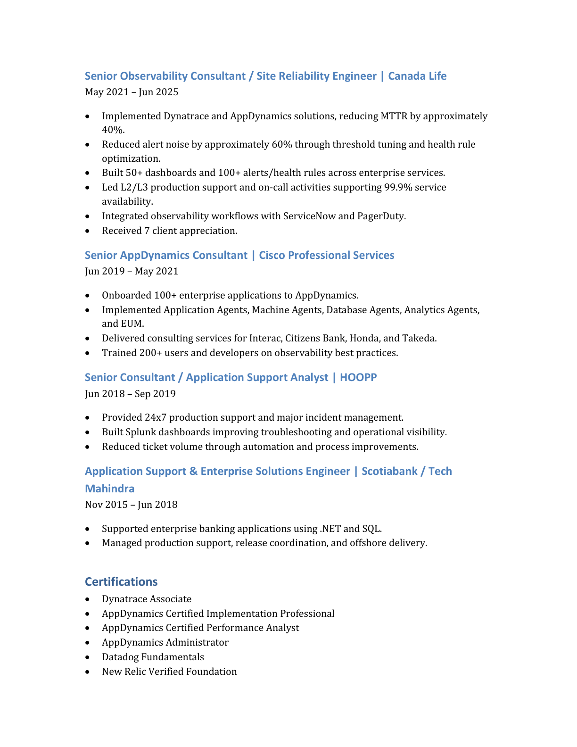

Page 3


