Design of config.bcm unification

Document Information
Rev | Date | Author | Change Description
0.1 | Oct 17, 2023 | zhaohuisun | Draft version
0.2 | Dec 4, 2023 | zhaohuisun | Add approach I
0.3 | Jan 25, 2024 | zhaohuisun | Add use case

Contents
1. Motivation 3
1.1 Background knowledge 3
1.2 Pain points 6
1.3 Use cases 6
2. Design 6
2.1 Original file architecture 6
2.2 New file architecture 10
1. Approach I 10
2. Approach II 16
3. Comparison 22
4. yml formatted config.bcm 22
3. Implementation 24
3.1 Parse original config.bcm files - utility 24
3.2 Generate config.bcm via j2 template 26
4. Test and verification 27
4.1 Unit test 27

Motivation

Background knowledge
We have so many different types of platforms and HardwareSKUs in SONiC so far:
Here is the list of all HardwareSKUs for different Broadcom ASICs.
TD2:
x86_64-dell_s6000_s1220-r0:
Force10-S6000-Q24S32
Force10-S6000-Q20S48
Force10-S6000-Q28S16
Force10-S6000
x86_64-arista_7050_qx32:
Arista-7050-QX32-Flex
Arista-7050-QX32
Arista-7050-Q16S64
x86_64-arista_7050_qx32s:
Arista-7050QX-32S-S4Q31
Arista-7050QX-32S
Arista-7050QX32S-Q32
TD3:
x86_64-dellemc_s5224f_c3538-r0:
DellEMC-S5224f-P-25G
x86_64-dellemc_n3248pxe_c3338-r0:
DELLEMC-N3248PXE
x86_64-dellemc_s5232f_c3538-r0:
DellEMC-S5232f-C8D48
DellEMC-S5232f-P-25G
DellEMC-S5232f-P-10G
DellEMC-S5232f-C32
DellEMC-S5232f-P-100G
x86_64-dellemc_s5212f_c3538-r0:
DellEMC-S5212f-P-25G
x86_64-dellemc_s5296f_c3538-r0:
DellEMC-S5296f-P-10G
DellEMC-S5296f-P-25G
x86_64-dellemc_s5248f_c3538-r0:
DellEMC-S5248f-P-25G
DellEMC-S5248f-P-10G
x86_64-arista_7050sx3_48c8:
Arista-7050SX3-48C8
x86_64-arista_7050sx3_48yc8:
Arista-7050SX3-48YC8
x86_64-arista_7050cx3_32s:
Arista-7050CX3-32S
Arista-7050CX3-32S-D48C8
Arista-7050CX3-32S-C32
TD4:
x86_64-dellemc_z9432f_c3758-r0:
DellEMC-Z9432f-O32
DellEMC-Z9432f-T64C64O8-DPB
x86_64-arista_7050dx4_32s:
Arista-7050DX4-32S
TH:
x86_64-cel_seastone-r0:
Seastone-DX010-50-40
Celestica-DX010-D48C8
Celestica-DX010-C32
Seastone-DX010-50-50-40
Seastone-DX010-25-50
Seastone-DX010-10-50
Seastone-DX010
Seastone-DX010-50
x86_64-dell_s6100_c2538-r0:
Force10-S6100
x86_64-dell_z9100_c2538-r0:
Force10-Z9100
Force10-Z9100-C8D48
Force10-Z9100-C32
x86_64-arista_7060_cx32s:
Arista-7060CX-32S-T96C8
Arista-7060CX-32S-D48C8
Arista-7060CX-32S-C32
Arista-7060CX-32S-Q24C8
Arista-7060CX-32S-Q32
Arista-7060CX-32S
TH2:
x86_64-dellemc_z9264f_c3538-r0:
DellEMC-Z9264f-C64
DellEMC-Z9264f-C8D112
DellEMC-Z9264f-Q64
x86_64-arista_7260cx3_64:
Arista-7260CX3-D96C16
Arista-7260CX3-64
Arista-7260CX3-D108C10
Arista-7260CX3-D108C8
Arista-7260CX3-Q64
Arista-7260CX3-C64
TH3:
x86_64-dellemc_z9332f_d1508-r0:
DellEMC-Z9332f-M-O16C64
DellEMC-Z9332f-O32
DellEMC-Z9332f-C32
x86_64-arista_7060dx4_32:
Arista-7060DX4-C32
Arista-7060DX4-32
x86_64-arista_7060px4_32:
Arista-7060PX4-32
Arista-7060PX4-C64
Arista-7060PX4-O32
TH4:
x86_64-arista_7060px5_64s:
Arista-7060PX5-64S
x86_64-arista_7060dx5_32:
Arista-7060DX5-32-200Gx48-100Gx32
Arista-7060DX5-32
Arista-7060DX5-32-25Gx96-100Gx8-200Gx8
x86_64-arista_7060dx5_64s:
Arista-7060DX5-64S

Currently, each HardwareSKU under each platform has its own config.bcm(SAI initial config file) file which defines all kinds of properties used by SAI (Switch Abstraction Interface).
In this design document, we focus on Broadcom ASIC, not including Mellanox or Cisco or Marvell ASIC (application-specific integrated circuits).

Pain points
Now we have 7 Broadcom ASIC types in sonic-buildimage:
TD2, TD3, TD4, TH, TH2, TH3, TH4
If there is a general change for specific ASIC, we have to change many config.bcm files all at once, across different HardwareSKUs and different platforms. It’s easy to miss some or update incorrectly.
Actually, even config.bcm files are scattered in different HardwareSKU folders, they still share some common properties for the same ASIC type.
In order to manage config.bcm easily and conveniently, config.bcm needs to be unified based on ASIC type for all common parameters and only have port related parameters (HardwareSKU specific) to be in HardwareSKU folder.

Use cases
Based on the scenarios we may face for changes in config.bcm, let’s classify into 3 use cases
- Add or modify a common property for one or more ASICs
- Add or modify a common property for one or more HardwareSKUs
- Add or modify a port related property for one or more HardwareSKUs

We will discuss how to apply these 3 use cases before and after unifying config.bcm.

Design

Original file architecture
Let us take TD2 for example, there are three platforms for TD2:
- device/dell/x86_64-dell_s6000_s1220-r0
- device/arista/x86_64-arista_7050_qx32
- device/arista/x86_64-arista_7050_qx32s

Here is the original file architecture for device/arista/x86_64-arista_7050_qx32:
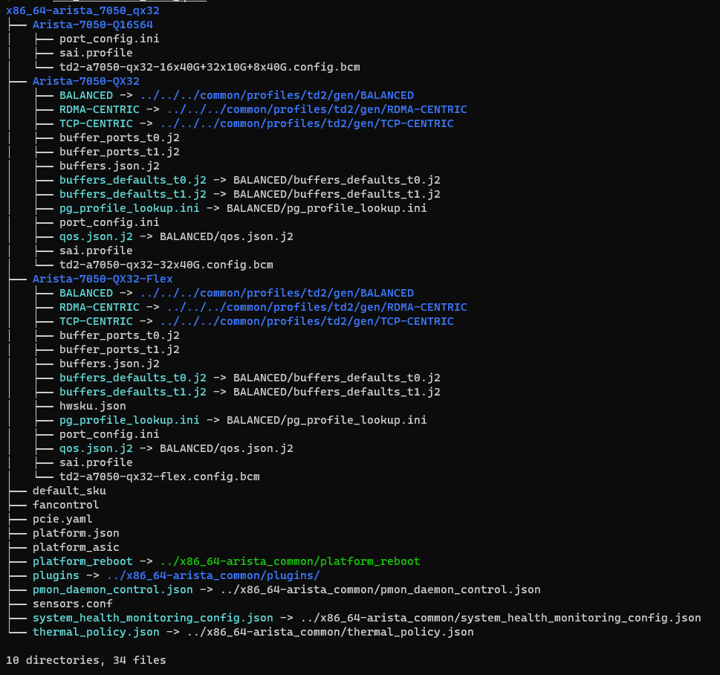

For x86_64-arista_7050_qx32, it has 3 HardwareSKUs:
  - Arista-7050-Q16S64
  - Arista-7050-QX32
  - Arista-7050-QX32-Flex
It has one specific config.bcm file under each HardwareSKU folder.

How to make sure SAI can load its appropriate config.bcm correctly:
- sai.profile
  - Defines which config.bcm will be used in syncd.
  - It’s located in /etc/sai.d/sai.profile in syncd container.
/etc/sai.d/sai.profile points to file /usr/share/sonic/device/arista/x86_64-arista_7050_qx32s/Arista-7050-QX-32S/sai.profile in host.
SAI_INIT_CONFIG_FILE=/usr/share/sonic/hwsku/td2-a7050-q31s4-31x40G-4x10G.config.bcm
SAI_NUM_ECMP_MEMBERS=64

- config.bcm
  - Defines many properties for SAI, both common properties and port related properties.
  - It is in /usr/share/sonic/hwsku in syncd container, which is mounted from /usr/share/sonic/device/x86_64-arista_7050_qx32s/Arista-7050-QX-32S in host

In config.bcm, it defines different properties, such as ALPM, parity and other phy/serdes paramterers.
# ALPM enable
l3_alpm_enable=2
ipv6_lpm_128b_enable=1
l2_mem_entries=32768
l3_mem_entries=16384
# disables bcmALPMDH (ALPM distributed hitbit) thread. This thread is purely for debug purpose
l3_alpm_hit_skip=1
# Disable Counting ACL Drop towards interface RX_DRP counter
sai_adjust_acl_drop_in_rx_drop=1
# From old config file
os=unix
higig2_hdr_mode=1

# Parity
parity_correction=1
parity_enable=1
stat_if_parity_enable=0

# l2 thread related config vars
l2xmsg_hostbuf_size=8192
l2xmsg_mode=1
bcm_num_cos=10
bcm_stat_interval=2000000
lls_num_l2uc=12
max_vp_lags=0
miim_intr_enable=0
mmu_lossless=0
module_64ports=0
stable_size=0x2000000
tdma_timeout_usec=5000000
tslam_timeout_usec=15000000
cdma_timeout_usec=15000000
dma_desc_timeout_usec=15000000

###############################
serdes_fiber_pref=1
###############################
mdio_output_delay=0x0d
###############################
xgxs_lcpll_xtal_refclk=1
tdma_intr_enable=1
tslam_intr_enable=1
table_dma_enable=1

arl_clean_timeout_usec=15000000
bcm_stat_flags=1
bcm_stat_jumbo.0=9236

pbmp_oversubscribe.0=0x1fffffffffffffffffffffffffe
pbmp_xport_xe.0=0x1fffffffffffffffffffffffffe
phy_an_c37_1.0=3
phy_an_c37_5.0=3
phy_an_c37_9.0=3
phy_an_c37_13.0=3
phy_an_c37_17.0=3
phy_an_c37_21.0=3
phy_an_c37_25.0=3
phy_an_c37_29.0=3
phy_an_c37_33.0=3
phy_an_c37_37.0=3

How to apply use cases
If we need to apply the previous 3 use cases with current file architecture:
- Add or modify a common property for one or more ASICs
  - Find out all HardwareSKUs for these ASICs
  - Check each HardwareSKU’s sai.profile and find out every config.bcm file
  - Add or modify the common property in those config.bcm files
  - The number of changed number files: The number of HardwareSKUs for these ASICs
- Add or modify a common property for one or more HardwareSKUs
  - Find out required HardwareSKUs’ sai.profile files
  - Check every config.bcm file in those sai.profiles
  - Add or modify the common property in those config.bcm files
  - The number of changed number files: The number of required HardwareSKUs
- Add or modify a port related property for one or more HardwareSKUs
  - Find out required HardwareSKUs’ sai.profile files
  - Check every config.bcm file in those sai.profiles
  - Add or modify the port related property in those config.bcm files
  - The number of changed number files: The number of required HardwareSKUs

New file architecture
For managing config.bcm easily, we will use j2 template to generate the config.bcm, one config.bcm.j2 for one ASIC type. config.bcm.j2 is the original j2 template for all final config.bcm files of different HardwareSKUs for one ASIC type.
In fact, config.bcm.j2 template is already used for x86_64-arista_7050cx3_32s and x86_64-arista_7260cx3_64.

In our design, config.bcm.j2 has two parts:
- The first part of j2 file has common properties, it will have condition checks to set it accordingly for different HwSkus.

- The second part indicates which port.config.bcm file will be included for each HwSku. port.config.bcm file contains port related properties, which are fixed and specific for each HwSkus.
Those properties start with port_/serdes_/phy_/portmap/xgxs_tx/xgxs_rx etc normally in this
port.config.bcm file.

So, all hardwareSKUs of one ASIC type share one j2 file, the condition check will decide which property will be used for each HardwareSKU. Each config.bcm.j2 under every HwSku is linked to the common config.bcm.j2 for specific ASIC.

We have two different approaches to implement it depending on whether cross venders or not.

Approach I
This method is to apply one common config.bcm.j2 file for one type of ASIC across different manufacturers.
- Comon config.bcm.j2
Create a new config.bcm.j2 file under device/common/profile folder for each ASIC type.
We have 7 ASIC types that need to be handled, so 7 new config.bcm.j2 files for these 7 ASIC types.
- Link it to config.bcm.j2 for each HardwareSKU
Each config.bcm.j2 for every HardwareSKU is linked to the same config.bcm.j2 under this ASIC type’s common/profile folder.
- port.config.bcm files
Each HardwareSKU still has its own port related config.bcm file which is located at the same position with original config.bcm file

File architecture changes
Still take TD2 for example, file infrastructure changes:
- Before:
Each HardwareSKU has its own specific config.bcm file.
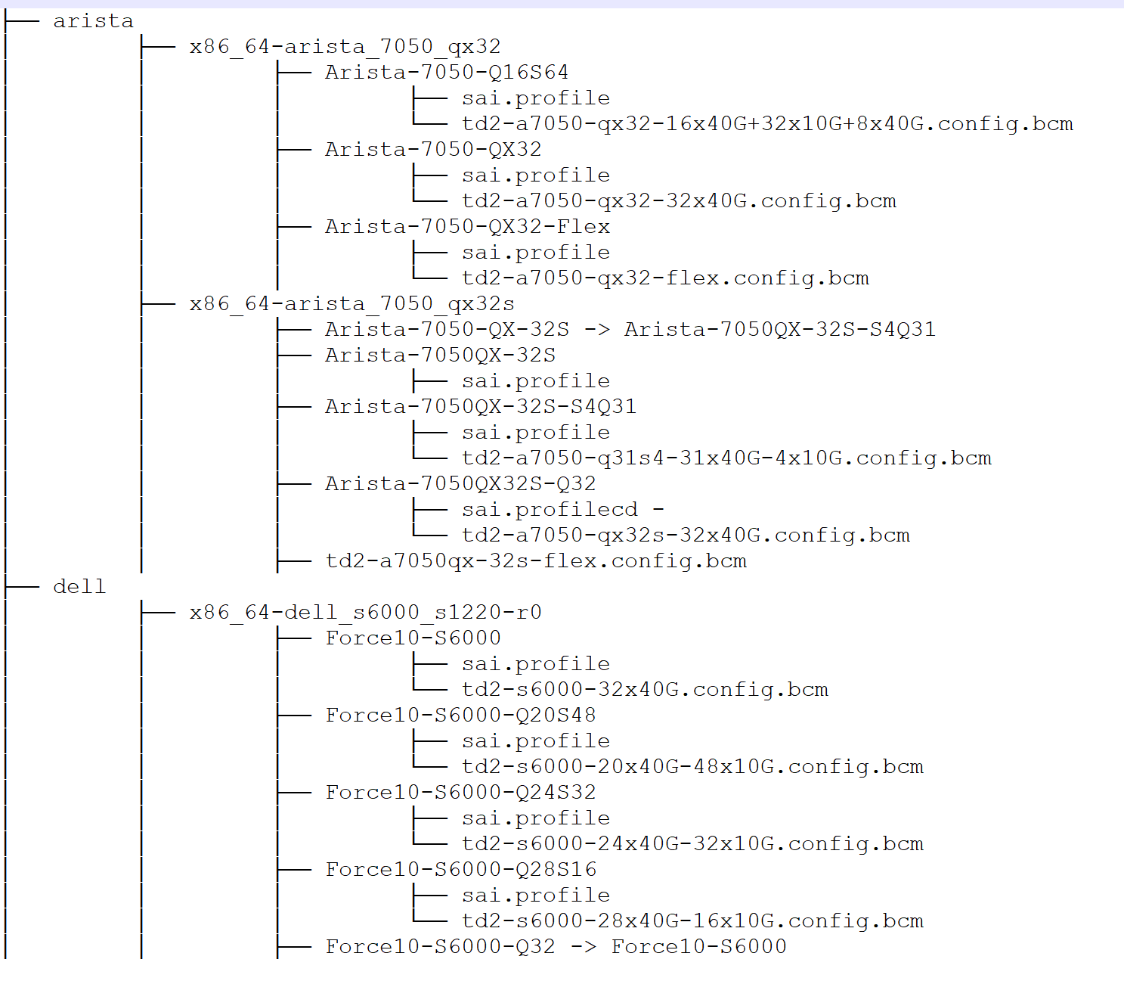

- After:
Every HardwareSKU has a common config.bcm.j2 file which points to device/common/profile/td2/config.bcm.j2.
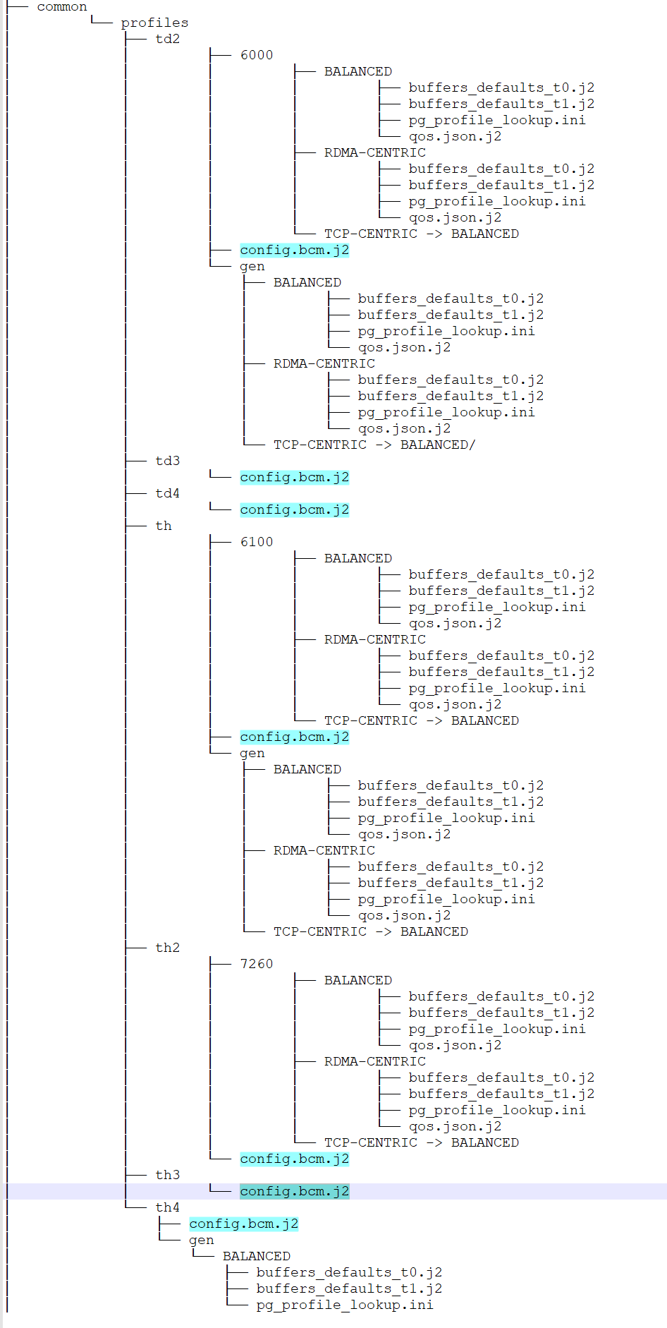

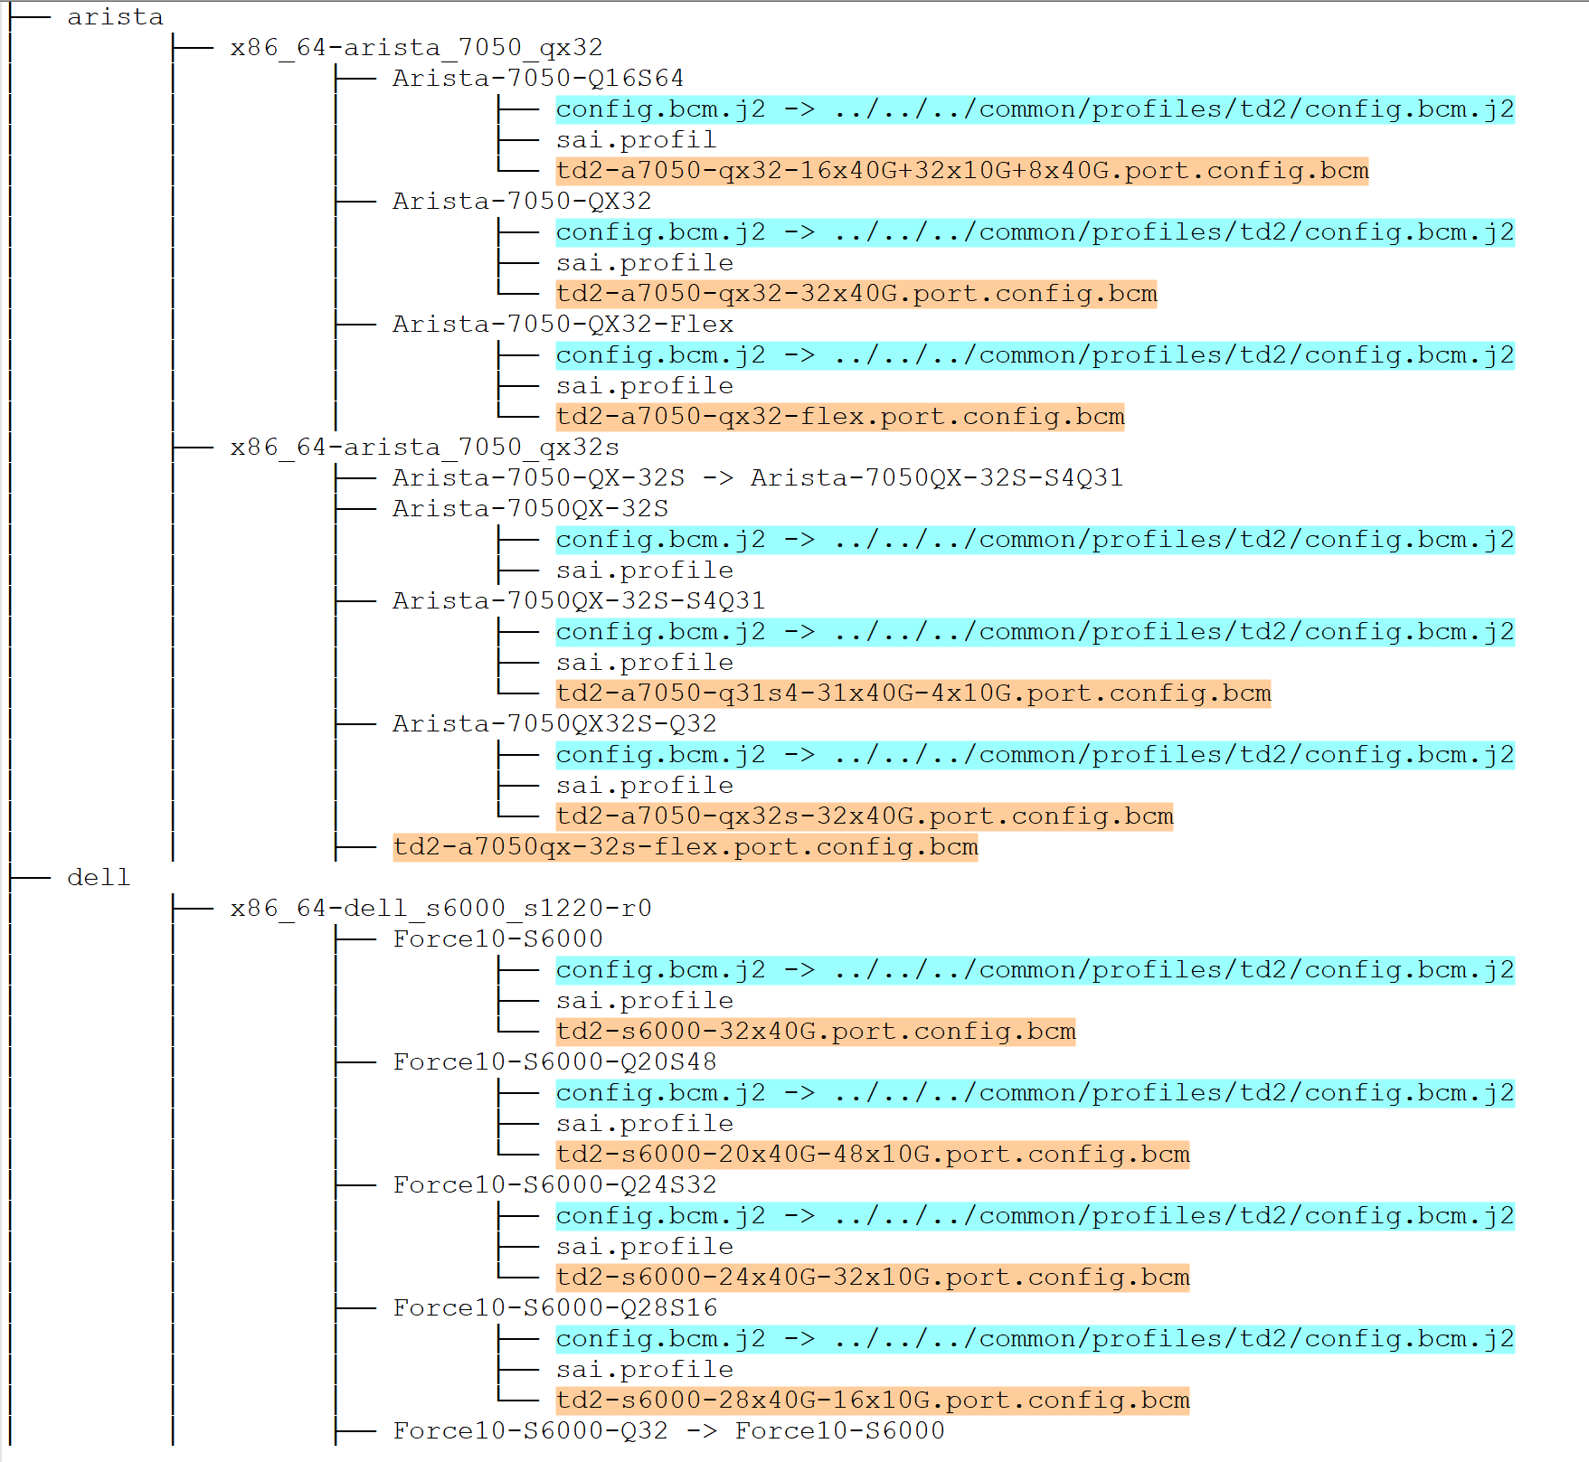

Config.bcm.j2 example
There are quite common variables in it, here is the content:

###First part###
{# Construct config.bcm to include common properties per specific device metadata requirement #}
{%- set td2 _common_1 = '' -%}
{%- set td2 _common_2 = '' -%}
{%- set td2 _common_3 = '' -%}
{%- set td2 _common_4 = '' -%}
{%- set pbmp_xport_xe = '' -%}

{%- if DEVICE_METADATA is defined and DEVICE_METADATA['localhost'] is defined and DEVICE_METADATA['localhost']['hwsku'] is defined -%}
{%- if DEVICE_METADATA['localhost']['hwsku'] in ['Arista-7050-QX32-Flex', 'Arista-7050-QX32', 'Arista-7050-Q16S64'] -%}
{%- set td2 _common_1 = '
load_firmware.0=2
pbmp_oversubscribe=0x1fffffffffffffffffffffffffe
xgxs_lcpll_xtal_refclk.0=1
mdio_output_delay.0=0x0d
serdes_sgmii_m=0
xgxs_lcpll_xtal_refclk.1=1
xgxs_lcpll_xtal_refclk.2=1
xgxs_lcpll_xtal_refclk.3=1
tslam_dma_enable.2=1
tslam_dma_enable.3=1
table_dma_enable.0=1
table_dma_enable.1=1
table_dma_enable.2=1
table_dma_enable.3=1' -%}
{%- endif %}
{%- if DEVICE_METADATA['localhost']['hwsku'] in ['Arista-7050-QX32'] -%}
{%- set pbmp_xport_xe = '
pbmp_xport_xe.0=0x1fffffffe' -%}
{%- endif %}
{%- if DEVICE_METADATA['localhost']['hwsku'] in ['Arista-7050-QX32-Flex', 'Arista-7050-Q16S64', 'Arista-7050QX-32S', 'Arista-7050QX-32S-S4Q31', 'Arista-7050-QX-32S', 'Arista-7050QX32S-Q32'] -%}
{%- set pbmp_xport_xe = '
pbmp_xport_xe.0=0x1fffffffffffffffffffffffffe' -%}
{%- endif %}
{%- if DEVICE_METADATA['localhost']['hwsku'] in ['Force10-S6000-Q24S32', 'Force10-S6000-Q20S48', 'Force10-S6000-Q28S16', 'Force10-S6000', 'Arista-7050-QX32', 'Arista-7050-Q16S64', 'Arista-7050QX-32S-S4Q31', 'Arista-7050-QX-32S', 'Arista-7050QX32S-Q32'] -%}
{%- set td2_common_2 = '
l3_alpm_hit_skip=1
sai_adjust_acl_drop_in_rx_drop=1' -%}
{%- endif %}
{%- if DEVICE_METADATA['localhost']['hwsku'] in ['Arista-7050QX-32S', 'Arista-7050QX-32S-S4Q31', 'Arista-7050-QX-32S', 'Arista-7050QX32S-Q32'] -%}
{%- set td2_common_3 = '
tslam_timeout_usec=15000000
cdma_timeout_usec=15000000
dma_desc_timeout_usec=15000000
mdio_output_delay=0x0d
table_dma_enable=1
pbmp_oversubscribe.0=0x1fffffffffffffffffffffffffe' -%}
{%- endif %}
{%- if DEVICE_METADATA['localhost']['hwsku'] in ['Arista-7050QX-32S-S4Q31', 'Arista-7050-QX-32S'] -%}
{%- set td2_common_4 = '
arl_clean_timeout_usec=15000000
bcm_stat_flags=1
bcm_stat_jumbo.0=9236' -%}
{%- endif %}
{%- endif %}

# common properties for all HwSKUs
l3_alpm_enable=2
ipv6_lpm_128b_enable=1
l2_mem_entries=32768
l3_mem_entries=16384
os=unix
higig2_hdr_mode=1
parity_correction=1
parity_enable=1
stat_if_parity_enable=0
bcm_num_cos=10
bcm_stat_interval=2000000
l2xmsg_hostbuf_size=8192
l2xmsg_mode=1
lls_num_l2uc=12
max_vp_lags=0
miim_intr_enable=0
mmu_lossless=0
schan_intr_enable=0
stable_size=0x2000000
tdma_timeout_usec=5000000

# common properties for different HwSKUs
{{ td2_common_1 }}
{{ td2_common_2 }}
{{ td2_common_3 }}
{{ td2_common_4 }}
{{ pbmp_xport_xe }}

###Second part###
{%- if DEVICE_METADATA is defined and DEVICE_METADATA['localhost'] is defined and DEVICE_METADATA['localhost']['hwsku'] is defined -%}
{%- if DEVICE_METADATA['localhost']['hwsku'] in ['Force10-S6000-Q24S32'] -%}
{%- include '/usr/share/sonic/hwsku/td2-s6000-24x40G-32x10G.port.config.bcm' %}
{%- endif %}
{%- if DEVICE_METADATA['localhost']['hwsku'] in ['Force10-S6000-Q20S48'] -%}
{%- include '/usr/share/sonic/hwsku/td2-s6000-20x40G-48x10G.port.config.bcm' %}
{%- endif %}
{%- if DEVICE_METADATA['localhost']['hwsku'] in ['Force10-S6000-Q28S16'] -%}
{%- include '/usr/share/sonic/hwsku/td2-s6000-28x40G-16x10G.port.config.bcm' %}
{%- endif %}
{%- if DEVICE_METADATA['localhost']['hwsku'] in ['Force10-S6000'] -%}
{%- include '/usr/share/sonic/hwsku/td2-a7050-qx32-32x40G+8x100G.port.config.bcm' %}
{%- endif %}
{%- if DEVICE_METADATA['localhost']['hwsku'] in ['Arista-7050-Q16S64'] -%}
{%- include '/usr/share/sonic/hwsku/td2-s6000-32x40G.port.config.bcm' %}
{%- endif %}
{%- if DEVICE_METADATA['localhost']['hwsku'] in ['Arista-7050-Q16S64'] -%}
{%- include '/usr/share/sonic/hwsku/td2-a7050-qx32-16x40G+32x10G+8x40G.port.config.bcm' %}
{%- endif %}
{%- if DEVICE_METADATA['localhost']['hwsku'] in ['Arista-7050-QX32-Flex'] -%}
{%- include '/usr/share/sonic/hwsku/td2-a7050-qx32-flex.port.config.bcm' %}
{%- endif %}
{%- if DEVICE_METADATA['localhost']['hwsku'] in ['Arista-7050-QX32'] -%}
{%- include '/usr/share/sonic/hwsku/td2-a7050-qx32-32x40G.port.config.bcm' %}
{%- endif %}
{%- if DEVICE_METADATA['localhost']['hwsku'] in ['Arista-7050QX-32S'] -%}
{%- include '/usr/share/sonic/hwsku/td2-a7050-qx32-32x40G+8x100G.port.config.bcm' %}
{%- endif %}
{%- if DEVICE_METADATA['localhost']['hwsku'] in ['Arista-7050QX-32S-S4Q31', 'Arista-7050-QX-32S'] -%}
{%- include '/usr/share/sonic/hwsku/td2-a7050-q31s4-31x40G-4x10G.port.config.bcm' %}
{%- endif %}
{%- if DEVICE_METADATA['localhost']['hwsku'] in ['Arista-7050QX-32S'] -%}
{%- include '/usr/share/sonic/platform/td2-a7050qx-32s-flex.port.config.bcm' %}
{%- endif %}
{%- if DEVICE_METADATA['localhost']['hwsku'] in ['Arista-7050QX32S-Q32'] -%}
{%- include '/usr/share/sonic/hwsku/td2-a7050-qx32s-32x40G.port.config.bcm' %}
{%- endif %}
{%- endif %}

How to apply use cases
If we need to apply the previous 3 use cases after this approach:
- Add or modify a common property for one or more ASICs
  - Find out config.bcm.j2 for these ASICs
  - Add or modify the common property in config.bcm.j2
  - The number of changed number files: The number of config.bcm.j2 files for ASICs
- Add or modify a common property for one or more HardwareSKUs
  - Find out required HardwareSKUs’ config.bcm.j2 files
  - Add or modify the common property in those config.bcm.j2
  - The number of changed number files: The number of config.bcm.j2 files for required HardwareSKUs
- Add or modify a port related property for one or more HardwareSKUs
  - Find out config.bcm.j2 for required HardwareSKUs
  - Find out port related config.bcm files for required HardwareSKUs in config.bcm.j2
  - Add or modify the port related property in port related config.bcm
  - The number of changed number files: The number of required HardwareSKUs

Approach II
This method is to separate venders, different config.bcm.j2 files for different manufacturers.
One common config.bcm.j2 for one ASIC type of one manufacturer.

Generally speaking, keep Dell’s TD2 hardwareSKUs separate from Arista’s TD2 hardwareSKUs.

Still take TD2 for reference, the common j2 file is td2-7050-qx32.config.bcm.j2, which will be used for 2 Arista platforms, that is to say, for their all 7 HardwareSKUs.

file architecture changes
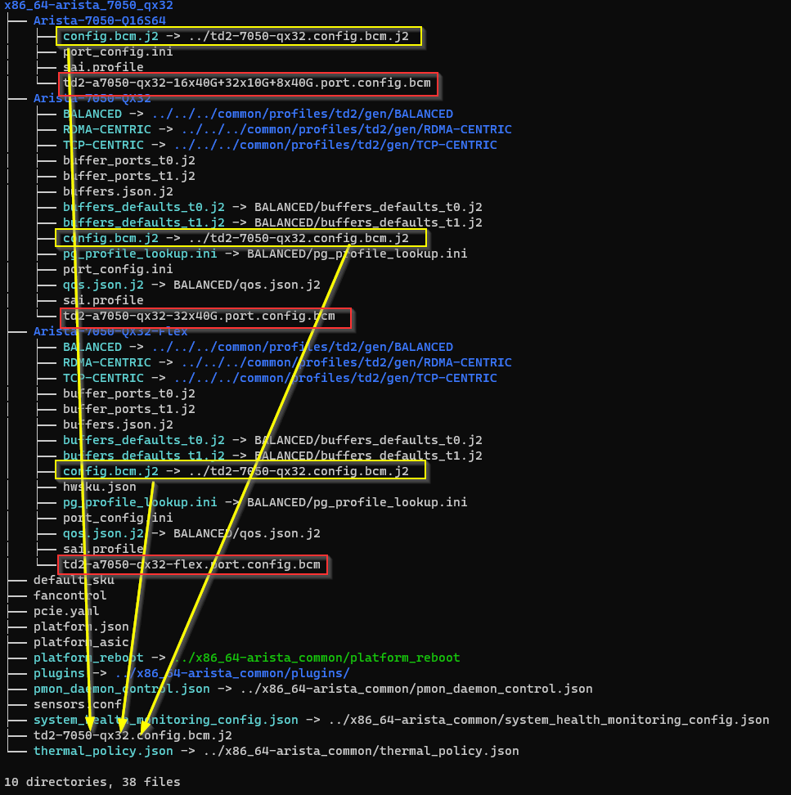
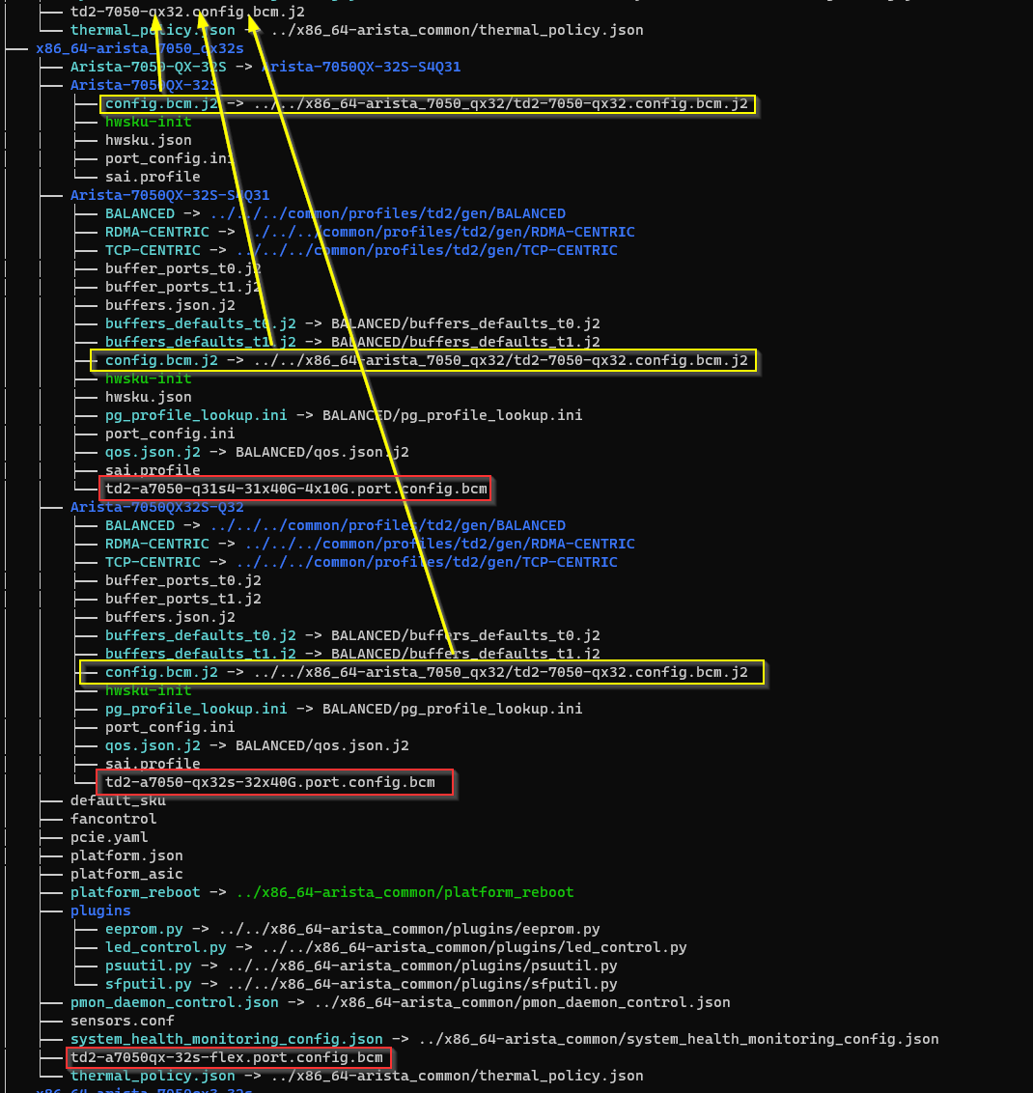
We can see the comparison clearly from the following graphs.
- Before:
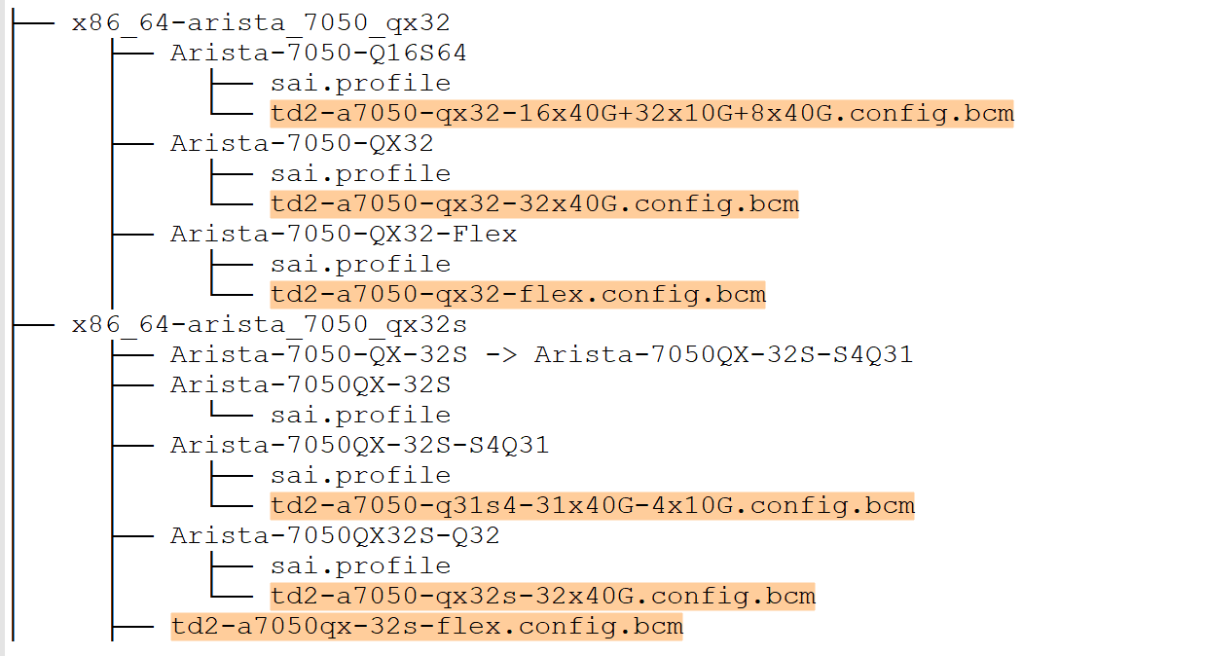
- After:
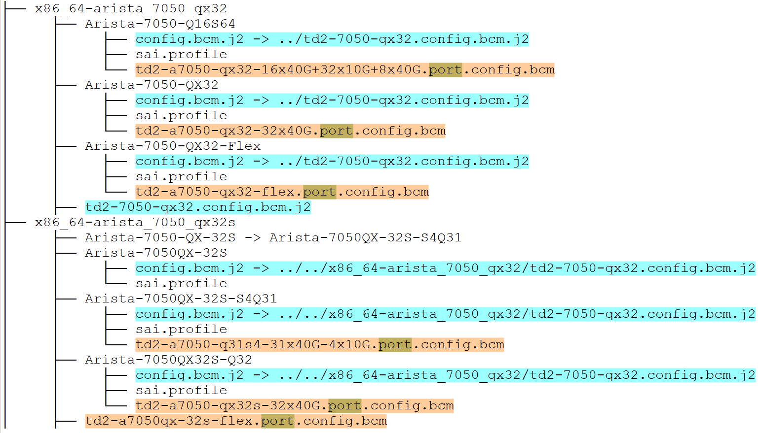

config.bcm.j2 example
There are quite common variables in it, here is the content:

###First part###
{# Construct config.bcm to include commom properties per specific device metadata requirement #}
{%- set td2_7050_qx32_common_1 = '' -%}
{%- set td2_7050_qx32_common_2 = '' -%}
{%- set td2_7050_qx32_common_3 = '' -%}
{%- set td2_7050_qx32_common_4 = '' -%}
{%- set pbmp_xport_xe = '' -%}

{%- if DEVICE_METADATA is defined and DEVICE_METADATA['localhost'] is defined and DEVICE_METADATA['localhost']['hwsku'] is defined -%}
{%- if DEVICE_METADATA['localhost']['hwsku'] in ['Arista-7050-QX32-Flex', 'Arista-7050-QX32', 'Arista-7050-Q16S64'] -%}
{%- set td2_7050_qx32_common_1 = '
load_firmware.0=2
pbmp_oversubscribe=0x1fffffffffffffffffffffffffe
xgxs_lcpll_xtal_refclk.0=1
mdio_output_delay.0=0x0d
serdes_sgmii_m=0
xgxs_lcpll_xtal_refclk.1=1
xgxs_lcpll_xtal_refclk.2=1
xgxs_lcpll_xtal_refclk.3=1
tslam_dma_enable.2=1
tslam_dma_enable.3=1
table_dma_enable.0=1
table_dma_enable.1=1
table_dma_enable.2=1
table_dma_enable.3=1' -%}
{%- endif %}
{%- if DEVICE_METADATA['localhost']['hwsku'] in ['Arista-7050-QX32'] -%}
{%- set pbmp_xport_xe = '
pbmp_xport_xe.0=0x1fffffffe' -%}
{%- endif %}
{%- if DEVICE_METADATA['localhost']['hwsku'] in ['Arista-7050-QX32-Flex', 'Arista-7050-Q16S64', 'Arista-7050QX-32S', 'Arista-7050QX-32S-S4Q31', 'Arista-7050-QX-32S', 'Arista-7050QX32S-Q32'] -%}
{%- set pbmp_xport_xe = '
pbmp_xport_xe.0=0x1fffffffffffffffffffffffffe' -%}
{%- endif %}
{%- if DEVICE_METADATA['localhost']['hwsku'] in ['Arista-7050-QX32', 'Arista-7050-Q16S64', 'Arista-7050QX-32S-S4Q31', 'Arista-7050-QX-32S', 'Arista-7050QX32S-Q32'] -%}
{%- set td2_7050_qx32_common_2 = '
l3_alpm_hit_skip=1
sai_adjust_acl_drop_in_rx_drop=1' -%}
{%- endif %}
{%- if DEVICE_METADATA['localhost']['hwsku'] in ['Arista-7050QX-32S', 'Arista-7050QX-32S-S4Q31', 'Arista-7050-QX-32S', 'Arista-7050QX32S-Q32'] -%}
{%- set td2_7050_qx32_common_3 = '
tslam_timeout_usec=15000000
cdma_timeout_usec=15000000
dma_desc_timeout_usec=15000000
mdio_output_delay=0x0d
table_dma_enable=1
pbmp_oversubscribe.0=0x1fffffffffffffffffffffffffe' -%}
{%- endif %}
{%- if DEVICE_METADATA['localhost']['hwsku'] in ['Arista-7050QX-32S-S4Q31', 'Arista-7050-QX-32S'] -%}
{%- set td2_7050_qx32_common_4 = '
arl_clean_timeout_usec=15000000
bcm_stat_flags=1
bcm_stat_jumbo.0=9236' -%}
{%- endif %}
{%- endif %}

# common properties for all HwSKUs
l3_alpm_enable=2
ipv6_lpm_128b_enable=1
l2_mem_entries=32768
l3_mem_entries=16384
os=unix
higig2_hdr_mode=1
parity_correction=1
parity_enable=1
stat_if_parity_enable=0
l2xmsg_hostbuf_size=8192
l2xmsg_mode=1
bcm_num_cos=10
bcm_stat_interval=2000000
lls_num_l2uc=12
max_vp_lags=0
miim_intr_enable=0
mmu_lossless=0
module_64ports=0
schan_intr_enable=0
stable_size=0x2000000
tdma_timeout_usec=5000000
serdes_fiber_pref=1
xgxs_lcpll_xtal_refclk=1
tdma_intr_enable=1
tslam_intr_enable=1

# common properties for different HwSKUs
{{ td2_7050_qx32_common_1 }}
{{ td2_7050_qx32_common_2 }}
{{ td2_7050_qx32_common_3 }}
{{ td2_7050_qx32_common_4 }}
{{ pbmp_xport_xe }}

###Second part###
{%- if DEVICE_METADATA is defined and DEVICE_METADATA['localhost'] is defined and DEVICE_METADATA['localhost']['hwsku'] is defined -%}
{%- if DEVICE_METADATA['localhost']['hwsku'] in ['Arista-7050-Q16S64'] -%}
{%- include '/usr/share/sonic/hwsku/td2-a7050-qx32-16x40G+32x10G+8x40G.port.config.bcm' %}
{%- endif %}
{%- if DEVICE_METADATA['localhost']['hwsku'] in ['Arista-7050-QX32-Flex'] -%}
{%- include '/usr/share/sonic/hwsku/td2-a7050-qx32-flex.port.config.bcm' %}
{%- endif %}
{%- if DEVICE_METADATA['localhost']['hwsku'] in ['Arista-7050-QX32'] -%}
{%- include '/usr/share/sonic/hwsku/td2-a7050-qx32-32x40G.port.config.bcm' %}
{%- endif %}
{%- if DEVICE_METADATA['localhost']['hwsku'] in ['Arista-7050QX-32S'] -%}
{%- include '/usr/share/sonic/hwsku/td2-a7050-qx32-32x40G+8x100G.port.config.bcm' %}
{%- endif %}
{%- if DEVICE_METADATA['localhost']['hwsku'] in ['Arista-7050QX-32S-S4Q31', 'Arista-7050-QX-32S'] -%}
{%- include '/usr/share/sonic/hwsku/td2-a7050-q31s4-31x40G-4x10G.port.config.bcm' %}
{%- endif %}
{%- if DEVICE_METADATA['localhost']['hwsku'] in ['Arista-7050QX-32S'] -%}
{%- include '/usr/share/sonic/platform/td2-a7050qx-32s-flex.port.config.bcm' %}
{%- endif %}
{%- if DEVICE_METADATA['localhost']['hwsku'] in ['Arista-7050QX32S-Q32'] -%}
{%- include '/usr/share/sonic/hwsku/td2-a7050-qx32s-32x40G.port.config.bcm' %}
{%- endif %}
{%- endif %}

How to apply use cases
If we need to apply the previous 3 use cases after this approach:
- Add or modify a common property for one or more ASICs
  - Find out config.bcm.j2 for these ASICs’ different venders HardwareSKUs
  - Add or modify the common property in config.bcm.j2
  - The number of changed number files: The number of these ASICs
- Add or modify a common property for one or more HardwareSKUs
  - Find out required HardwareSKUs’ config.bcm.j2 files
  - Add or modify the common property in those config.bcm.j2
  - The number of changed number files: The number of required HardwareSKUs’ ASIC
- Add or modify a port related property for one or more HardwareSKUs
  - Find out config.bcm.j2 for required HardwareSKUs
  - Find out port related config.bcm files for required HardwareSKUs in config.bcm.j2
  - Add or modify the port related property in port related config.bcm
  - The number of changed number files: The number of required HardwareSKUs

Comparison
Methods | Pros | Cons
Current | A change for one specific HardwareSKU is simple  Granularity is hwSKU | Lots of config.bcm files needs to be updated for one common property
Approach I | Granularity is ASIC  One config.bcm.j2 per ASIC  Only one file change for common property | A big code change for implementation  Need logic in config.bcm.j2
Approach II | A smaller granularity than approach I | More config.bcm.j2 files

- Genera speaking, Approach I is better than Approach II. It moves config.bcm.j2 to common/profiles folder which already saves other common configuration files too.
- A single change for common property could only ask for one single change in config.bcm.j2 file under common/profiles folder, it meets our original requirements.
- Approach II is a smaller change than Approach I, limiting the change scope for one manufacturer one time.
We will use Approach I as final design in the following sections.

yml formatted config.bcm
For TD4 and TH4, config.bcm is using yml formatted config.
Yml file is naturally separated into global and ports parts.
We can just move bcm_device global and device DEVICE_CONFIG configuration into common config.bcm.j2 file, others are remained as port.config.bcm file.
Taking device/dell/x86_64-dellemc_z9432f_c3758-r0/DellEMC-Z9432f-T64C64O8-DPB/td4-z9432f-32x400G.config.yml for example:
---
bcm_device:
0:
global:
l2_table_default_view: 1
pktio_mode: 1
vlan_flooding_l2mc_num_reserved: 0
shared_block_mask_section: uc_mc
ctr_evict_enable: 0
uat_mode: 1
uft_mode: 4
sai_brcm_sonic_acl_enhancements: 1
sai_tunnel_support: 1
multi_network_groups: 1
sai_field_group_auto_prioritize: 1
sai_modify_hash_flexdigest: 1
sai_fast_convergence_support: 1
...
---
device:
0:
DEVICE_CONFIG:
# CORE CLOCK FREQUENCY
CORE_CLK_FREQ: CLK_1350MHZ
# PP CLOCK FREQUENCY
PP_CLK_FREQ: CLK_1350MHZ
VARIANT: DNA_4_9_5_0
...
---
device:
0:
PC_PM_CORE:
?
PC_PM_ID: 1
CORE_INDEX: 0
: # Same as PM_ID_0
RX_LANE_MAP: 0x05471326
TX_LANE_MAP: 0x53016724
RX_POLARITY_FLIP: 0x44
TX_POLARITY_FLIP: 0x56
RX_POLARITY_FLIP_AUTO: 0
TX_POLARITY_FLIP_AUTO: 0
RX_LANE_MAP_AUTO: 0
TX_LANE_MAP_AUTO: 0
...
Apply the same rules as legal config.bcm, but using separate ways to extract common attributes.
- Create the common config.bcm.j2 under common/profiles/td4 or common/profiles/th4
- Move bcm_device global and device DEVICE_CONFIG in config.bcm.yml into config.bcm.j2
- Rename original config.bcm.yml file to port.config.bcm.yml, the content is remained part of config.bcm.yml
- config.bcm.j2 combines these two parts together and generate different config.bcm.yml file for different HardwareSKU
- sai.profile indicates to use common config.bcm.yml which is generated in step 4.

Implementation

Parse original config.bcm files - utility
How to extract properties from different config.bcm files?
Since there are so many files involved, manual work is not reliable.
Script is needed to do parse job automatically. There are several steps to parse all config.bcm files under device folder. The following steps are what script will do.
- Classify ASICs for all platforms/HwSkus
- Loop each HwSku for one ASIC
- Parse sai.profile file for every HwSku to get its config.bcm file location
- Parse all config.bcm files for one ASIC type, sperate common properties and port related properties, save this information into excel workbook
  - One sheet to save common property table for all HwSkus
  - In other sheets, there are fixed port related properties for each HwSku, same content with their port.config.bcm file
- Generate config.bcm.j2 according to the common property table, also create soft link files config.bcm.j2 pointing to it for each HwSku
- Generate their port.config.bcm files under corresponding folders based on other hwsku tables
Common propriety table for TD2:
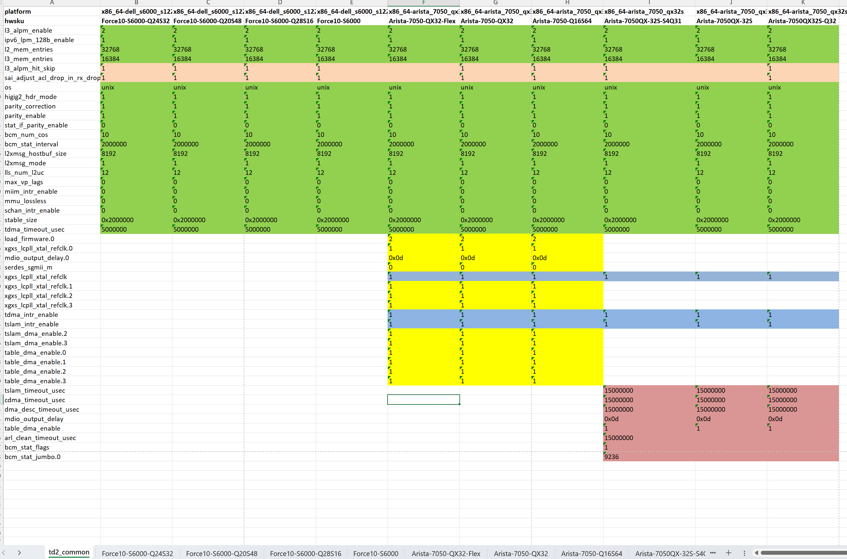
Other port related property table:
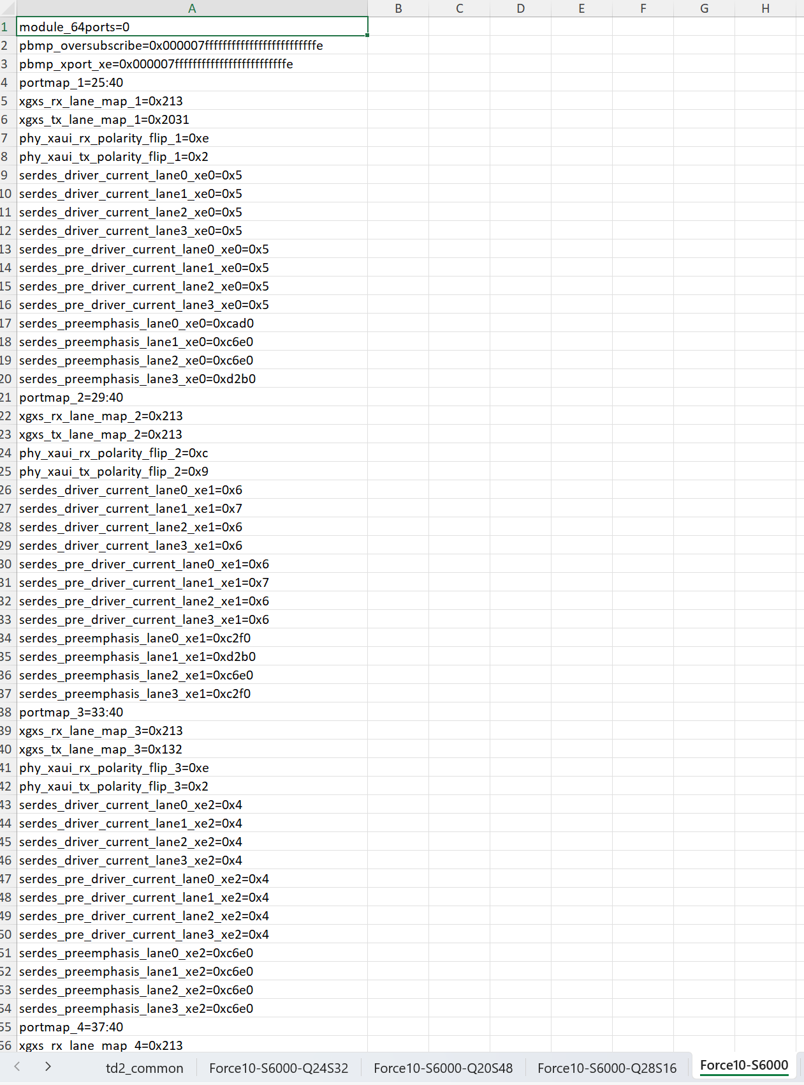
Workbook is a temporary file which is used for debugging.
Script should generate port.config.bcm and config.bcm.j2 directly and automatically.

Generate config.bcm via j2 template
Now these two types of files are ready:
- port.config.bcm files
- config.bcm.j2 file which includes the content of port.config.bcm
The current mechanism supports generating config.bcm from j2 template already.
platform/broadcom/docker-syncd-brcm/start.sh defines that if there is config.bcm.j2, it will call sonic-cfggen to generate /etc/sai.d/config.bcm from j2 template.
start.sh will be executed during syncd booting up.
Here is the code from platform/broadcom/docker-syncd-brcm/start.sh script:
…
if [ -f $HWSKU_DIR/config.bcm.j2 ]; then
sonic-cfggen -d -t $HWSKU_DIR/config.bcm.j2 > /etc/sai.d/config.bcm
fi
…

sai.profile needs to be changed likes this:
SAI_INIT_CONFIG_FILE=/etc/sai.d/config.bcm
SAI_NUM_ECMP_MEMBERS=32

In summary, here are the changes regarding the whole design:
- Generate port.config.bcm file for every HwSku
- Add a common config.bcm.j2 file for all HwSkus of one ASIC type, one config.bcm.j2 per ASIC
- Create config.bcm.j2 for each HwSku and link them to the common config.bcm.j2 file
- Modify sai.profile for every HwSku
When syncd boots up, config.bcm will be generated via sonic-cfggen and located under folder /etc/sai.d/ in syncd container.

Test and verification
For all platforms, there are about 7 ASIC types and dozens of HwSkus.
Even a single wrong property may cause ASIC not to work properly.
So, after implementation, the final config.bcm for every HwSku needs to be verified if it’s same with original one.

Unit test
Unit test is needed after every single change of config.bcm. Ensure each change for config.bcm will be verified in sonic-buildimage repo
Depending on the existing sonic-config-engine unit test framework, write new cases for all new
config.bcm.j2 files.
- Move original config.bcm files to src/sonic-config-engine/tests folder as sample output files for each HardwareSKU
- Create soft link files for config.bcm.j2 under src/sonic-config-engine/tests, pointing them to specific ASIC’s config.bcm.j2 files
- Write new cases for each HardwareSKU in test_j2files.py, compare if the generated config.bcm matches with the original sample output file
- Test every HwSku for all ASICs one by one
- If config.bcm has been modified for new requirements, same config.bcm sample files need to be updated accordingly
For example, if we make a change to modify a common property in TD2 config.bcm.j2 file.
Unit test will fail if you do not update test sample files, because the newly generated config.bcm files for TD2 will be different from their original sample files.
Change the property in each TD2 HardwareSKU sample file, then rerun unit test to see if they are matched.

