OCS data plane topology definition
Date | Author | Comments
July 9, 2025 | Huang Xin, SVT team | Initial draft

1. Purpose
This document defines the topology of the Optical Circuit Switch (OCS) data plane, specifying the physical structure, connectivity and performance parameters to ensure reliable optical signal transmission

2. Scope
This topology definition covers:
- Physical fiber and node layout
- Enable flexible reconfiguration of optical paths (Main objective)
- Provide high-bandwidth, low-latency connectivity

3. Physical Topology Components
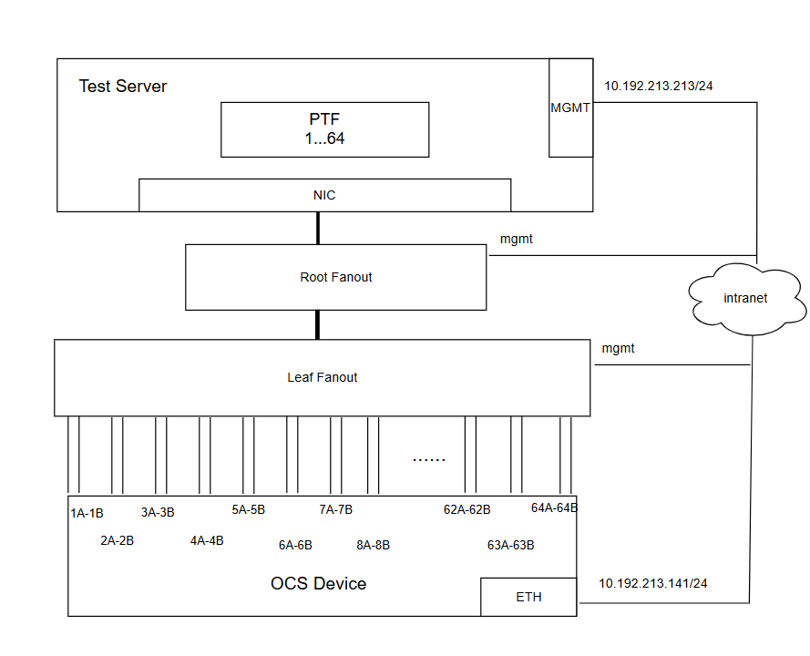

3.1 OCS
- Optical Switch Matrix: 64×64 port configuration

3.2 Endpoint Connections
- Server Connections (Dell R760XS):
  - 2 CPUs each has 24 cores (48 cores);
  - 192G memory (16Gx12);
  - hard disk:960Gx1
  - Mellanox CX6 (NIC)
    - ConnectX-6 DX 100GbE Dual Port
    - ConnectX-6 100GbE Single Port
- Root Fanout:
  - Arista-7260CX3-64
    - 64 ports, 12.8T
    - Supports LACP/LLDP passthrough
    - Supports 802.1Q tunning (QinQ)

- Leaf Fanout:
  - Arista 7060X6-64PE: (2U)
    - 64X800GbE OSFP ports, 2SFP+ports
    - 64 ports 800G, 51.2T
    - Migrate to 320 interfaces
    - Supports LACP/LLDP passthrough
    - Supports 802.1Q tunning (QinQ)

- Network Gateway Connections:
  - Inter-switch links to routers

4.Testing Objectives
- Full mesh capability
  - any-to-any connectivity
  - 64x64 Simultaneous connectivity Test
- Dynamic path provisioning

5. Deploy an OCS Testbed

5.1 Testbed.yaml

5.2 Inventory file

5.3 Variation (host_var setup_environment)

