Audio Alignment with Sonic Visualiser
and the MATCH Vamp Plugin

Requirements
You will need:
- Sonic Visualiser. Get it from http://www.sonicvisualiser.org/
- The MATCH Vamp Plugin. Get it from http://www.vamp-plugins.org/download.html and follow the installation instructions on that page.

Introduction
In this short tutorial, you will load two audio files that contain different recordings of the same piece of music from a Web site into Sonic Visualiser, and align them so that you can compare them in terms of tempo and timing.
The audio files you will use are two recordings of Der Tod und das Mädchen by Franz Schubert provided by the Kings Sound Archive.
Marian Anderson, accompanied by Kosti Vehanen – HMV DA 1550, OLA 1025-6
http://www.kcl.ac.uk/kis/schools/hums/music/ksa/OLA_1025-6.mp3
Karin Branzell, accompanied by Frieder Weissmann – Parlophone E 10744, 2-20440 (from Parlophon P-9817)
http://www.kcl.ac.uk/kis/schools/hums/music/ksa/2-20440.mp3

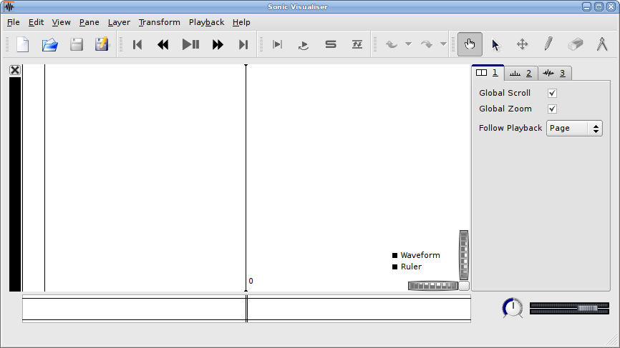
Tutorial
Start Sonic Visualiser. The main window appears like this:
First check that the “align” button is visible in the toolbar. If it is visible, then the MATCH plugin is properly installed.

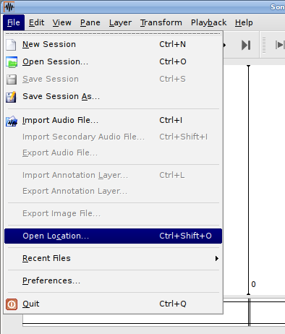
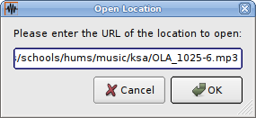
Use File|Open Location to load each of the files in turn from the URLs given above:

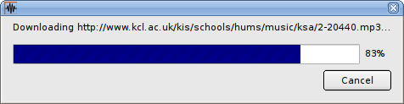

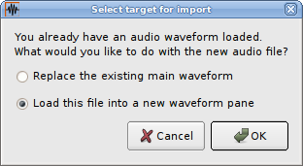
Upon loading the second file a prompt window is displayed, as shown on the right. Select “Load this file into a new waveform pane” and click OK. The two files are displayed in the main window simultaneously, as pictured below.
Click the play/pause button and hear how fearful the two recordings sound in mis-synchrony, as no alignment has yet been performed between the two.

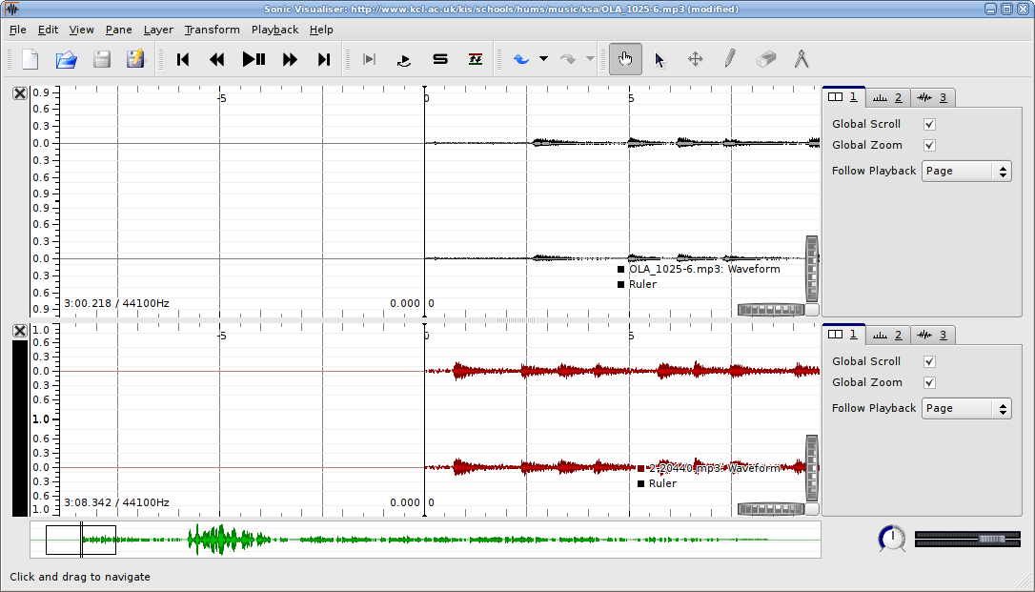

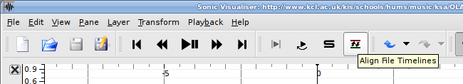
Click the Align button to start alignment. A progress bar is displayed at the bottom-left corner of the lower pane.
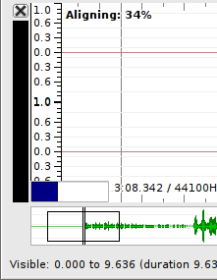
Sonic Visualiser is now running the MATCH audio alignment Vamp plugin. This plugin analyses two recordings to find an alignment path, which associates each moment in one file with a certain moment in the other, so that 1) the alignment preserves temporal order of these moments, and 2) the overall timbral similarity between matched moments is maximized in some way.
Provided the recordings are indeed similar in qualities other than timing, this is likely to produce a sensible tempo alignment between them.
Although the plugin only works on pairs of recordings, Sonic Visualiser can align more than two recordings by aligning them all against a single reference (which is always the recording contained in the file that was loaded first).

Wait for the process to finish.
After the alignment has finished, press Play/Pause again. You will now hear only one of the recordings, and you can change which one is being played by clicking on one of the panes. When you switch from one to the other, you should find that the change happens at the correct point in the recording that you are switching to.

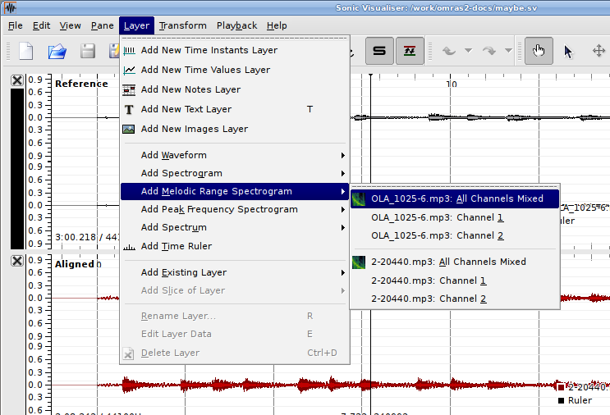
Now, add spectrogram layers to the panes for the two recordings. Use the Layer|Add Melodic Range Spectrogram|OLA_1025.6.mp3 menu item to add spectrogram for the first recording.

Initially, the spectrogram will appear very dark. To brighten it up click the “normalize columns” button next to the scale box. Now the main window should look like the one below.
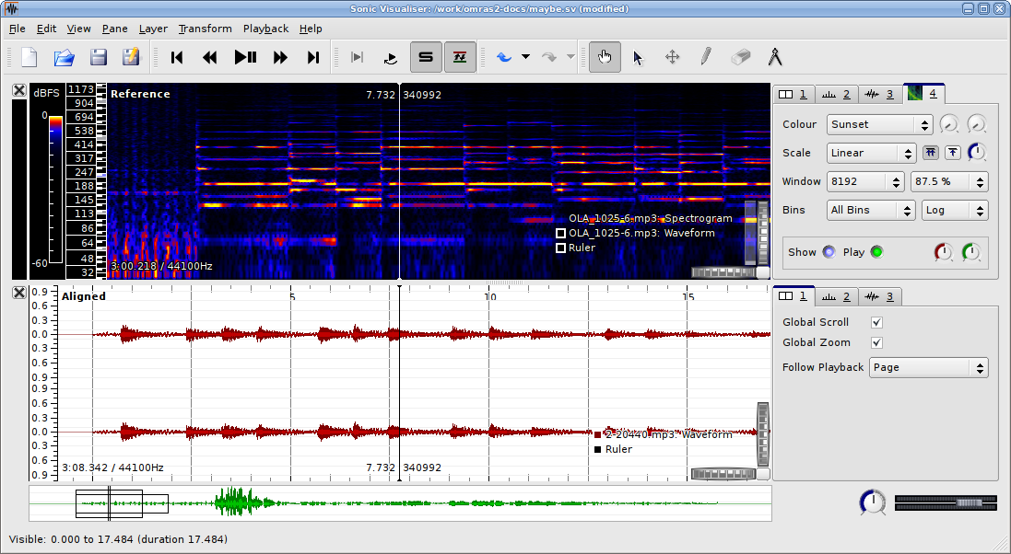
Repeat the last actions for the second recording. (This time use Layer|Add Melodic Range Spectrogram|2-20440.mp3 menu item, rather than Layer|Add Melodic Range Spectrogram|OLA_1025-6.mp3.)
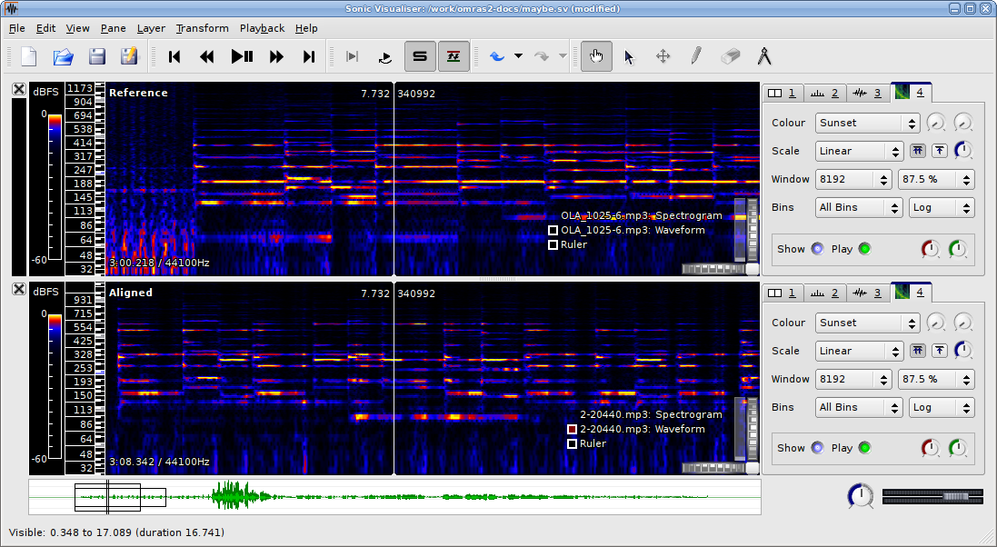
With the two spectrograms in place, it is easier to see where the notes lie in each of the recordings. If you press Play/Pause now, you will see the playback pointers in the two panes moving at different speeds to as to arrive at the notes in each recording at the proper times.

A Note about the MATCH Plugin
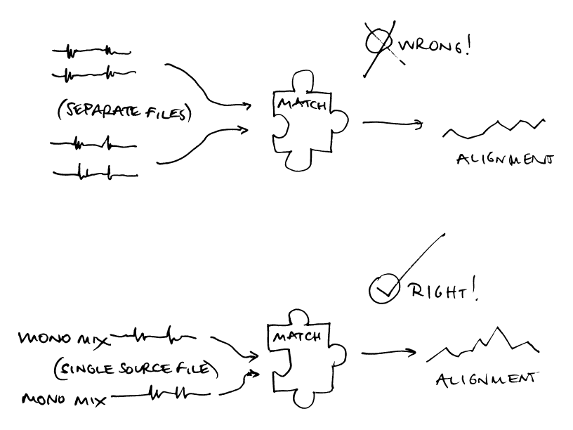
The way the MATCH plugin works internally is to take two channels of audio, each of which represents a single recording (in mono), and to calculate and return an alignment path between them. (Vamp plugins may accept any number of channels as input, but they don't have any understanding of different “audio files”; they can't know whether a two channel input represents a single stereo file or two mono ones. So, this plugin requires that its input always contains two mono recordings.)
It is possible to run this plugin “by hand” in Sonic Visualiser – from the Transform menu, under Analysis by Category|Time|Alignment. However, you would need to have a file loaded that contained one recording (mixed to mono) in each channel. This would need to be done using a separate audio editing program.
Although Sonic Visualiser can run the MATCH plugin appropriately for calculating its own automatic alignments, it doesn't contain any way for the user to provide multiple audio files as a set of individual channels for input to a Vamp plugin.

