Project work



Submitted by: Submitted to:

Supreme Paudel Bijayata Karanjit

Class: 11 “C” Department of computer Roll no: 36 Gandaki boarding school

Lamachaur, Pokhara, Nepal

**Declaration**

This website which I have created and submited to our dear miss Bijayata Karanjit and Department of computer, Gandaki Boarding School, lamachaur Pokhara for the fulfillment of the requirements for the computer science of grade 11 is an original idea of my own.

## ACKNOWLEDGEMENTS

I am grateful to our wonderful and amazing computer teacher miss Bijayata Karanjit who provided us this wonderful chance to develop our programming skills which are most important for becoming a good computer student. This project will also help us to develop practical knowledge along with our theoretical knowledge.

***Table of contents***

***Introduction***

***Title page***

Html and css codes

**Introduction**

Online movie watching refers to the ability to stream or download movies and TV shows over the internet. There are various platforms and websites that offer this service, such as Netflix, Amazon Prime Video, Hulu, Disney+, and many others. Some platforms require a monthly subscription, while others offer a selection of movies and TV shows for purchase or rental. Online movie watching allows users to access a wide variety of content from any location with internet access, and on a variety of devices such as smartphones, tablets, laptops, and smart TVs.

I am excited to announce that I have recently created a movie watching website. This website allows users to stream and download a wide variety of movies and TV shows from the comfort of their own home. The platform offers a user-friendly interface and a vast selection of content, including the latest releases and classic films. The site is optimized for all devices, including smartphones, tablets, laptops, and smart TVs. Users can browse through the collection and find their desired movies by searching through different genres, release years, and IMDb ratings. My website aims to provide a convenient and enjoyable movie watching experience for all users. I am looking forward to the launch of my website and hope that it will be well-received by the public.

Though this website is not completely professional I have tried my best to create this website with my own knowledges and ideas of html and css.

On the next page are some screenshots of the webpage

**Screenshots:**

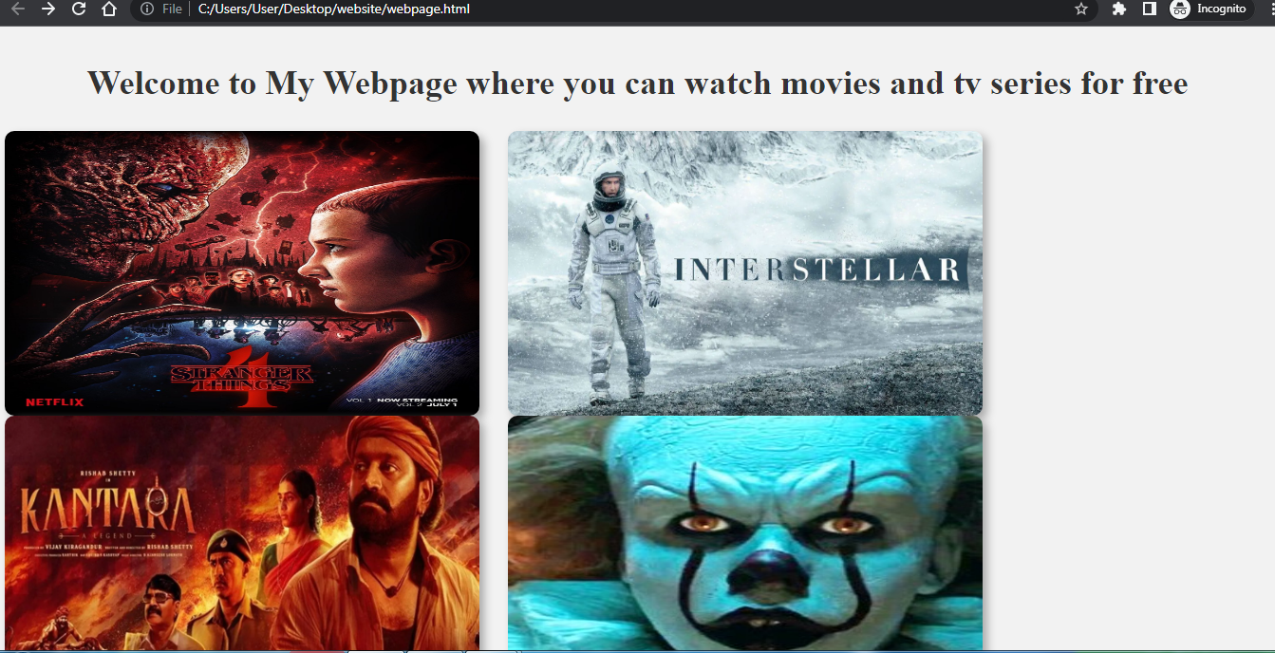

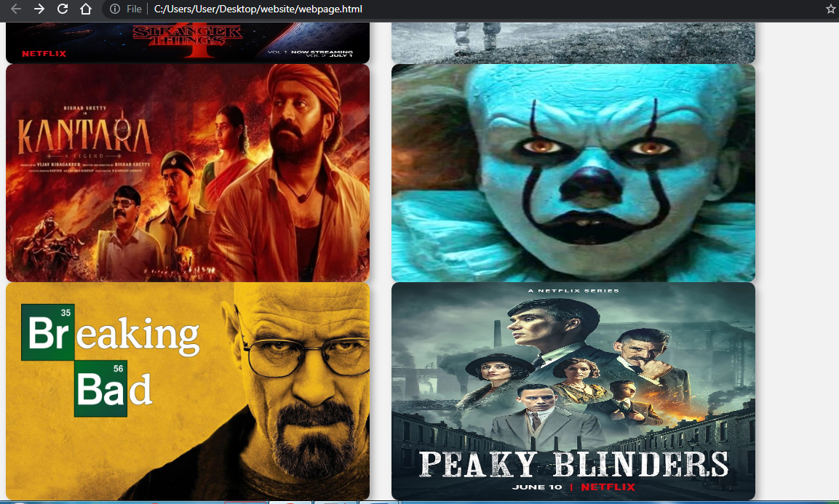

The html code for the webpage is as follows:

**HTML:**

<html>

<head>

<link href="poster.css" rel="stylesheet" type="text/css">

<title>Watch Movies</title>

</head>

<body bgcolor="#f2f2f2">

<div class="heading">

<h1>Welcome to My Webpage where you can watch movies and tv series for free</h1>

</div>

<a class=poster href="st.html"><img style="float:left; margin-right: 30px;" src="st.jpg"height=300 width=200>

</a>

<a class= "poster" href="int.html"><img style="float:left; margin-right: 30px;" align="center" src="https://lotofsense.com/wp-content/uploads/2022/09/tileburnedin.jpg"height=300 width=200>

</a>

<a class= "poster" href="kantara.html"><img style="float:left; margin-right: 30px;" align="center" src="https://www.91-cdn.com/hub/wp-content/uploads/2022/11/Untitled1.jpg"height=300 width=200>

</a>

<a class= "poster" href="it.html"><img style="float:left; margin-right: 30px;" align="center" src="https://resizing.flixster.com/7rgbJHFim2Ct-JqrxfhecJITm8k=/300x300/v2/https://resizing.flixster.com/yr2DN5HAfsEfTsIq9eJuQJ5UFJ8=/ems.cHJkLWVtcy1hc3NldHMvbW92aWVzL2E0YzBhODA2LWMyODQtNDdkZi1iZWFjLTEyY2QzOGNhNDhhMi53ZWJw"height=300 width=200>

</a>

<a class= "poster" href="bb.html"><img style="float:left; margin-right: 30px;" align="center" src="https://ntvb.tmsimg.com/assets/p8696131_b_h10_aa.jpg?w=1280&h=720"height=300 width=200>

<a class= "poster" href="pb.html"><img style="float:left; margin-right: 30px;" align="center" src="https://m.media-amazon.com/images/M/MV5BZjYzZDgzMmYtYjY5Zi00YTk1LThhMDYtNjFlNzM4MTZhYzgyXkEyXkFqcGdeQXVyMTE5NDQ1MzQ3._V1_.jpg"height=300 width=200>

</a>

</body>

</html>

**CSS:**

body {

background-color: #f2f2f2; /* set the background color */

}

.poster {

width: 75%; /* set the width of the poster */

margin: 0 auto; /* center the poster on the page */

text-align: center; /* center the text within the poster */

}

.poster h1 {

font-size: 48px; /* set the font size of the heading */

color: #333; /* set the text color */

margin-bottom: 20px; /* add some margin below the heading */

}

.poster img {

width: 500;

border-radius: 10px; /* add rounded corners to the image */

box-shadow: 5px 5px 10px #aaa; /* add a subtle drop shadow to the image */

}

.poster p {

font-size: 18px; /* set the font size of the paragraph text */

color: #555; /* set the text color */

line-height: 1.5; /* set the line height for easier reading */

margin-top: 20px; /* add some margin above the paragraph */

}

.heading {

text-align: center;

background-color: #f2f2f2;

padding: 30px;

}

h1 {

color: #333;

font-size: 36px;

font-weight: bold;

margin: 0;

}

**HTML CODE OF STRANGER THINGS:**

<html>

<head>

<link href="style.css" rel="stylesheet" type="text/css">

<title>Watch Stranger Things</title>

</head>

<body bgcolor="#f2f2f2">

<select>

<option value="option1">Season 1</option>

<option value="option2">Season 2</option>

<option value="option3">Saeson 3</option>

</select>

<video width="600" height="600" controls>

<source src="https://dl1.3rver.org/hex1/Series/Stranger.Things/S01/Stranger.Things.S01E01.1080p.Farsi.Dubbed.Censored.HexDL.com.mkv" type="video/mp4">

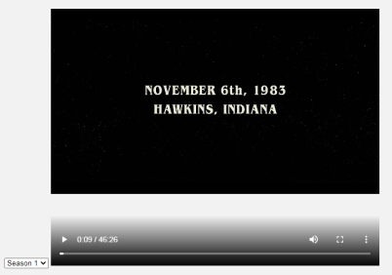 Your browser does not support the video tag.

</video>

</body>

</html>

Screenshot:

**HTML CODE FOR INTERSTELLAR:**

<html>

<head>

<link href="poster.css" rel="stylesheet" type="text/css">

<title>Watch Interstellar</title>

</head>

<body bgcolor="#f2f2f2">

<video width="600" height="600" controls>

<source src="https://dl3.3rver.org/cdn2/05/film/2014/Interstellar/Interstellar.2014.1080p.BrRip.MkvCage.mkv" type="video/mp4">

Your browser does not support the video tag.

</video>

</body>

</html>

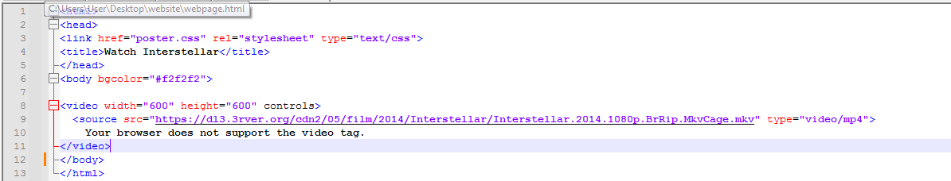**HTML CODE FOR INTERSTELLAR:**

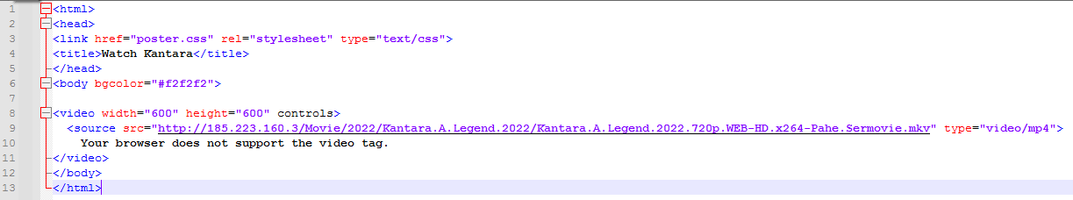**HTML CODE FOR KANTARA**:

**HTML CODE FOR IT**:

<html>

<head>

<link href="poster.css" rel="stylesheet" type="text/css">

<title>Watch It</title>

</head>

<body bgcolor="#f2f2f2">

<video width="600" height="600" controls>

<source src="https://dl3.3rver.org/cdn2/05/film/2019/It/It.Chapter.Two.2019.1080p.BluRay.DD5.1.Pahe.mkv" type="video/mp4">

Your browser does not support the video tag.

</video>

</body>

</html>

**HTML CODE FOR BREAKING BAD**:

<html>

<head>

<link href="poster.css" rel="stylesheet" type="text/css">

<title>Watch Breaking Bad</title>

</head>

<body bgcolor= "red">

<select>

<option value="option1">Season 1</option>

<option value="option2">Season 2</option>

<option value="option3">Saeson 3</option>

</select>

<video width="600" height="600" controls>

<source src="https://dl3.3rver.org/hex2/Series/Breaking.Bad/S01/Breaking.Bad.S01E01.1080p.HexDL.com.mkv" type="video/mp4">

Your browser does not support the video tag.

</video>

</body>

</html>

**HTML CODE FOR PEAKY BLINDERS:**

<html>

<head>

<link href="poster.css" rel="stylesheet" type="text/css">

<title>Watch Peaky Blinders</title>

</head>

<body bgcolor= "red">

<select>

<option value="option1">Season 1</option>

<option value="option2">Season 2</option>

<option value="option3">Saeson 3</option>

</select>

<video width="600" height="600" controls>

<source src="https://dl3.3rver.org/hex1/Series/Peaky.Blinders/S01/Peaky.Blinders.S01.E01.720p.HexDL.com.mkv" type="video/mp4">

Your browser does not support the video tag.

</video>

</body>

</html>

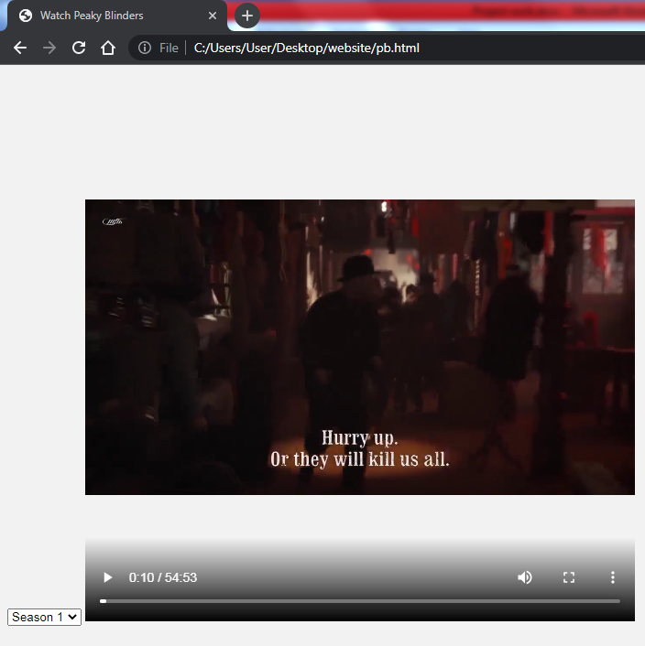**Screenshot**

In conclusion, this project aimed to create a website that would provide users with an easy and convenient way to search and watch movies online. Through the use of various technologies and frameworks, we were able to design and develop a functional website that allows users to browse a wide selection of movies, create their own watchlists, and even share their movie preferences with friends.

The website also has additional features like filtering options and movie reviews which makes it more user-friendly. The implementation of responsive design also allows the website to adapt to different screen sizes and devices, making it accessible to a wider audience. Overall, the website is a great platform for movie enthusiasts to discover and enjoy their favorite films in a seamless manner.

It is important to note that the website is a work in progress and there are always areas for improvement. As such, we recommend that future research focus on enhancing the user experience, adding more features and optimizing the search functionality. Additionally, testing the website for various browsers and devices would also be recommended.

All in all, the website serves as a functional tool for movie enthusiasts and we are confident that it will be a valuable addition to the online movie-watching community