CIKNOW

Introduction
enter introduction text here
Created with the Freeware Edition of HelpNDoc: Single source CHM, PDF, DOC and HTML Help creation

Welcome
Welcome to the C-IKNOW workflow documentation. C-IKNOW is a powerful web-based software tool for social network analysis investigation. It has been designed around real-world problems, and it can store and analyze virtually any type of network data. This documentation provides a basic step-by-step walkthrough of how to get started on a C-IKNOW project, while also offering more advanced support. Additional support can be found in the other documentation items, including the C-IKNOW Worksheet and the C-IKNOW Question-Type Primer.

Cyber-infrastructure Knowledge Networks on the Web (C-IKNOW) is the cyber-infrastructure extension of IKNOW (Inquiring Knowledge Networks on the Web). It is a web-based tool that is used to help communities map, measure, and modify the knowledge and information flow within their networks. C-IKNOW leverages cutting-edge advances in social network theories, automated data collection techniques, advanced network analysis techniques and algorithms to map an individual’s interests and expertise as well as their multidimensional relations with other members and resources within their community. To serve this purpose, C-IKNOW has multiple social network analysis functionality, including data population and a visualization and analytics suite.

C-IKNOW’s data population tools include fully customizable web-administered network surveys and an interface to directly upload virtually any type of network data. An administrator can tailor a survey to his or her own specific needs, and then use C-IKNOW’s contact list to get a complete data set for a network. Since the platform is web-based, administering the survey to the desired network is a very straightforward and time-efficient process. C-IKNOW generates unique login information so that each user can take surveys created on C-IKNOW. With permission, users can also have access to visualization tools in order to personally view and manipulate visualizations of their network.

C-IKNOW’s visualization and analytics suite allows both administrators and users to access visualizations, recommendation tools, and analytical measures for their networks. The visualizations can be physically manipulated to reorganize and reinterpret the network data. Multiple viewing options include ego-networks and node sizing based upon weighted comparative data. Users can also access the C-IKNOW recommender system tools, which combine relational data and digital traces about the community to provide recommendations to users for future network interactions. A recommendation pathway visualization will allow users to explore their recommendations with a dynamic visual aid. Lastly, C-IKNOW can compute all standard network metrics for any desired network or sub-network. C-IKNOW is a work in progress. It is constantly being tailored to incorporate the newest advances in network theory and new features for optimized performance.

Team
C-IKNOW is developed by Guangyao "York" Yao, Yun Huang and Jinling Li in the Science of Networks in Communities (SONIC) research group at Northwestern University. C-IKNOW evolves from I-KNOW, previous contributors include Dan Zink, Mike Chan, Peter Taylor, Dana Serb, Ryan Kanno, Mike Armstrong, Shyam Kurup, Emily Wang, Sean Mason, Jered Wierzbicki, Jeff Tamer, Hank Green, Steven Harper, Nat Bulkley, Andy Don. C-IKNOW development is supported primarily by grants from the National Science Foundation (NSF) and the National Institutes of Health (NIH).
©2009 Noshir Contractor, Science of Networks in communities (SONIC), Northwestern University, Evanston IL
Created with the Freeware Edition of HelpNDoc: Free CHM Help documentation generator

License
license information
Created with the Freeware Edition of HelpNDoc: Easily create HTML Help documents

Getting Started

Created with the Freeware Edition of HelpNDoc: Full featured Help generator

System requirements
C-IKNOW functions across a wide variety of platforms, including Windows, Linux, and Mac. It can be run with standard browsers, such as Firefox, Safari, etc, however there is a system requirement of flash player 10.
Created with the Freeware Edition of HelpNDoc: Full featured Help generator

Getting help
C-IKNOW may encounter technical bugs or problems while performing some of its actions. In the event that a bug is encountered, please check here to see how to correct it. If the bug is not included here, please send an email to Scottgaonkar2012@u.northwestern.edu so that the bug can be investigated and fixed.
Created with the Freeware Edition of HelpNDoc: Easily create Help documents

Concepts
social network theory?
Created with the Freeware Edition of HelpNDoc: Full featured multi-format Help generator

Tutorial

Created with the Freeware Edition of HelpNDoc: Easy CHM and documentation editor

Example Scenario

Created with the Freeware Edition of HelpNDoc: Full featured Help generator

Create New Project

Created with the Freeware Edition of HelpNDoc: Easily create HTML Help documents

Completing the C-IKNOW Worksheet

Created with the Freeware Edition of HelpNDoc: Easy to use tool to create HTML Help files and Help web sites

Login to C-IKNOW Portal

Created with the Freeware Edition of HelpNDoc: Easily create Help documents

Creating a New C-IKNOW Instance

Created with the Freeware Edition of HelpNDoc: Create HTML Help, DOC, PDF and print manuals from 1 single source

Returning to a Specific C-IKNOW Instance

Created with the Freeware Edition of HelpNDoc: Full featured Documentation generator

Initial Configuration

Created with the Freeware Edition of HelpNDoc: Full featured Documentation generator

Data Collection

Created with the Freeware Edition of HelpNDoc: Create HTML Help, DOC, PDF and print manuals from 1 single source

Preparing Nodes

Created with the Freeware Edition of HelpNDoc: Create HTML Help, DOC, PDF and print manuals from 1 single source

Survey Design
C-IKNOW has its origin in data collection via online survey. Survey questions serve as metadata to describe node attributes and relational information we are going to collect via either online survey or direct upload.

Refer to Question Type Guide for detail description of all 19 types of question.
Refer to Worksheet for selecting the right question types for your project.

Next in this tutorial, we will design node attributes and relational questions. To expedite the network construction and demonstrate results quickly, we will upload network data directly.
Created with the Freeware Edition of HelpNDoc: Easy to use tool to create HTML Help files and Help web sites

Upload Node Attributes

Created with the Freeware Edition of HelpNDoc: Free Web Help generator

Upload Relations

Created with the Freeware Edition of HelpNDoc: Single source CHM, PDF, DOC and HTML Help creation

Data Derivation
Derive attributes and relational data
Created with the Freeware Edition of HelpNDoc: Free help authoring environment

Data Analysis

Created with the Freeware Edition of HelpNDoc: Easily create HTML Help documents

Analytics

Created with the Freeware Edition of HelpNDoc: Free HTML Help documentation generator

Recommendations

Created with the Freeware Edition of HelpNDoc: Easily create Web Help sites

Reporting

Created with the Freeware Edition of HelpNDoc: Free help authoring environment

C-IKNOW Manager Interface

Created with the Freeware Edition of HelpNDoc: Free Web Help generator

Obtain an account

Created with the Freeware Edition of HelpNDoc: Free PDF documentation generator

Create Project

Created with the Freeware Edition of HelpNDoc: Easy CHM and documentation editor

Visit Project

Created with the Freeware Edition of HelpNDoc: Free Web Help generator

View Project Details

Created with the Freeware Edition of HelpNDoc: Easily create CHM Help documents

Restart Project

Created with the Freeware Edition of HelpNDoc: Single source CHM, PDF, DOC and HTML Help creation

Update Project

Created with the Freeware Edition of HelpNDoc: Full featured Help generator

Copy Project

Created with the Freeware Edition of HelpNDoc: Full featured Documentation generator

Disable/Enable Project

Created with the Freeware Edition of HelpNDoc: Free help authoring environment

Delete Data/Project

Created with the Freeware Edition of HelpNDoc: Easily create Help documents

C-IKNOW Interface

Created with the Freeware Edition of HelpNDoc: Easily create Help documents

Administration

Created with the Freeware Edition of HelpNDoc: Free PDF documentation generator

Preferences

Created with the Freeware Edition of HelpNDoc: Easily create HTML Help documents

Nodes

Created with the Freeware Edition of HelpNDoc: Full featured Documentation generator

Survey Design

Created with the Freeware Edition of HelpNDoc: Easily create PDF Help documents

Labels

Created with the Freeware Edition of HelpNDoc: Easily create PDF Help documents

Derivation

Created with the Freeware Edition of HelpNDoc: Free HTML Help documentation generator

Derive Relation By Product

Created with the Freeware Edition of HelpNDoc: Full featured Documentation generator

Import/Export

Created with the Freeware Edition of HelpNDoc: Full featured Help generator

Recommender Configuration

Created with the Freeware Edition of HelpNDoc: Full featured Documentation generator

Membership

Created with the Freeware Edition of HelpNDoc: Easily create Web Help sites

Groups

Created with the Freeware Edition of HelpNDoc: Full featured multi-format Help generator

Roles

Created with the Freeware Edition of HelpNDoc: Free Web Help generator

Invitation

Created with the Freeware Edition of HelpNDoc: Easily create Web Help sites

Password

Created with the Freeware Edition of HelpNDoc: Easily create PDF Help documents

More

Created with the Freeware Edition of HelpNDoc: Easy to use tool to create HTML Help files and Help web sites

Visualization Color Settings

Created with the Freeware Edition of HelpNDoc: Full featured Help generator

Gmap

Created with the Freeware Edition of HelpNDoc: Free CHM Help documentation generator

Survey

Created with the Freeware Edition of HelpNDoc: Create HTML Help, DOC, PDF and print manuals from 1 single source

TaggingGame

Created with the Freeware Edition of HelpNDoc: Free HTML Help documentation generator

VisualAnalytics

Created with the Freeware Edition of HelpNDoc: Free PDF documentation generator

Ego Network

Created with the Freeware Edition of HelpNDoc: Free HTML Help documentation generator

Custom Network

Created with the Freeware Edition of HelpNDoc: Easy to use tool to create HTML Help files and Help web sites

Charting

Created with the Freeware Edition of HelpNDoc: Free help authoring environment

Saved Visualization

Created with the Freeware Edition of HelpNDoc: Easily create PDF Help documents

Recommendations

Created with the Freeware Edition of HelpNDoc: Free help authoring environment

Resource

Created with the Freeware Edition of HelpNDoc: Easy CHM and documentation editor

Team Assembly

Created with the Freeware Edition of HelpNDoc: Easily create Help documents

Reporting

Created with the Freeware Edition of HelpNDoc: Easily create CHM Help documents

Individual Node Report

Created with the Freeware Edition of HelpNDoc: Free Web Help generator

System Report

Created with the Freeware Edition of HelpNDoc: Single source CHM, PDF, DOC and HTML Help creation

C-IKNOW Visualizer Interface
The visualization tool is one of CIKNOW’s core functions. It rapidly generates high definition network maps and offers a variety of tools to manipulate the visualization.
Nodes: | Nodes are shown as rounded-rectangles that are colored based upon either nodetype or attribute or focal node (egonetwork only).
Edges: | Edges are the lines that connect nodes to one-another. The relations of the edges can be direct relations, undirect relations, or mutual relations. The arrows tell which way the relations go (if the visualization is for a directed graph).
Legend: | The legend is on the right hand of the window. In the legend, it will tell you which colors signify which node properties and which edges are which relation.
Top Bar: | The top bar has a number of options to manipulate or change the available visualization. Below is a description of these features.
Created with the Freeware Edition of HelpNDoc: Free PDF documentation generator

Open/Save Network

Created with the Freeware Edition of HelpNDoc: Full featured Help generator

For Online Visualizer

Created with the Freeware Edition of HelpNDoc: Easily create Web Help sites

Save Graph
The online Visualizer allows you to save specific networks as well as visualizations for future use. From the "File" menu, click the menuItem "Save Graph Data..", you will get a small window like this:

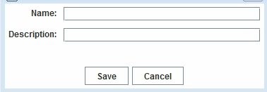

The saved network can be accessed under the Saved Visualization tab under Visual Analytics.
Created with the Freeware Edition of HelpNDoc: Free HTML Help documentation generator

For Standalone Visualizer

Created with the Freeware Edition of HelpNDoc: Easily create PDF Help documents

Open Graph File
Currently, the visualizer only supports C-IKNOW data format. In the future, it will support GraphML and DL format.
Created with the Freeware Edition of HelpNDoc: Free CHM Help documentation generator

Save Graph Data
Save specific networks as well as visualizations in the client server for future use.
Created with the Freeware Edition of HelpNDoc: Free HTML Help documentation generator

Save Graph Image
The visualizer can automatically capture the graph image and legend of the network image.
Created with the Freeware Edition of HelpNDoc: Easily create Help documents

Layout
CI-KNOW Visualizer implements several standard and customized layouts. Circle layout positions nodes in the network as a circle. It helps to show the well-connected networks. Clustering layout help to show which nodes are well-connected with each other and which nodes are not closely connected with the group.

RadialTree layout computes a radial layout based on a single root node and displays the subsequent depth levels as a tree. It displays how far the other nodes are to the root.
Created with the Freeware Edition of HelpNDoc: Single source CHM, PDF, DOC and HTML Help creation

Put Nodes in Circle
Click the icon in the toolbar; this command organizes the nodes into a circular configuration.
Created with the Freeware Edition of HelpNDoc: Free HTML Help documentation generator

Randomly Scatter Nodes
Click the icon in the toolbar; this command randomly scatters the nodes.
Created with the Freeware Edition of HelpNDoc: Easily create HTML Help documents

Automatically Cluster Network
This function clusters the network based either on separating existing components or by clustering around the largest component.
If you click the button in the toolbar, the visualization will show the default view--"Structural View"-- to cluster the components around the largest component.
It is possible, however, to choose this manually by using the "Automatically Cluster Network" menuItem from the "Layout" Menu.

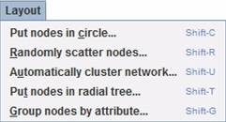

By clicking the menuItem, a dialog box will be generated and you can choose either "Component view" or "Structural view". Component view spreads the components throughout the window by using as much of the space as possible. Structural view places one large component in the middle, and it occupies most of the space. The rest of the components are placed in the periphery, circled around the large central component. Changing the distance between two nodes effects the visualization. A bigger distance preset makes it easier to see the structure of the network, while a shorter distance makes it easier to see the components.

Created with the Freeware Edition of HelpNDoc: Free HTML Help documentation generator

Put Nodes in a Radial Tree
By clicking the icon, all other nodes will be arranged around a selected focal node in the middle of the visualization.

To perform this layout, you must first select a node as the root node, after you select a node, this node will be highlighted.

Created with the Freeware Edition of HelpNDoc: Create HTML Help, DOC, PDF and print manuals from 1 single source

Group Nodes by Attribute
By pressing the icon, all nodes will be grouped based upon their colored attribute.
If you do not want to see all the groups, you can choose which groups you want to show from the generated dialog box.

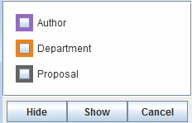
Created with the Freeware Edition of HelpNDoc: Easily create HTML Help documents

Edit Network
This section provides a series of functions which allow the user to generate a sub-network graph based on node/edge filtering, selected nodes, and ego-centered Networks.
Users may explore the connections between individuals associated with the concept by either eliminating or showing selected node/link types associated with the individuals, or by only hiding/displaying
the selected nodes/links. Ego-centered Networks can be generated by selecting all neighbors of a target node within certain distance. Users also have the opportunity to restore the network to the original network.
Created with the Freeware Edition of HelpNDoc: Full featured Documentation generator

Hide Selected Nodes
Click the icon in the toolbar; this command will remove the selected node(s) from the visualization.

See Node Selection and Deselection to learn how to select your desired node(s).

Created with the Freeware Edition of HelpNDoc: Full featured Documentation generator

Show Selected Nodes
Click the icon in the toolbar; now only selected nodes will appear in the visualization.

See Node Selection and Deselection to learn how to select your desired node(s).

Created with the Freeware Edition of HelpNDoc: Full featured multi-format Help generator

Hide Isolated Node(s)
By clicking the icon in the toolbar, all isolated nodes will be removed.

Created with the Freeware Edition of HelpNDoc: Free PDF documentation generator

Hide/Show Selected Node Type/Attribut
By clicking the icon in the toolbar, a dialog box will be displayed.

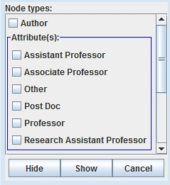

From this dialog box, you can select which node type(s) or attribute(s) you want to be hiding or showing in the visualization.

Created with the Freeware Edition of HelpNDoc: Free HTML Help documentation generator

Hide/Show Selected Edge Type
By clicking the icon in the toolbar, a dialog box will be displayed.

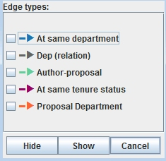

From this dialog box, you can select which edge type(s) you want to be hiding or showing in the visualization.

Created with the Freeware Edition of HelpNDoc: Easily create Web Help sites

Limit Edge Strengths
This function is used to filter edges with desired strength. By clicking the icon in the toolbar,
a dialog box will be displayed.

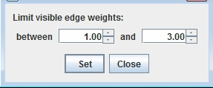

From this dialog box, you can set the range of strengths and filter the edges by this range.

Created with the Freeware Edition of HelpNDoc: Easily create Web Help sites

Show All Nodes and Edges
By clicking the icon in the toolbar, all nodes and edges will be shown. Each node will be located where is was last displayed on the screen.
Created with the Freeware Edition of HelpNDoc: Easy CHM and documentation editor

Reset to the Saved Network
This function allows you to return to your saved network. The command button for this function is

Note: This button will only be available when you open a saved network!
Created with the Freeware Edition of HelpNDoc: Create HTML Help, DOC, PDF and print manuals from 1 single source

Display Options
This section provides a series of display options for a network. The quality of the node/link can be described by its size and shape.
Created with the Freeware Edition of HelpNDoc: Easy to use tool to create HTML Help files and Help web sites

Fit Graph to Screen
Clicking the icon in the toolbar, will expand/shrink the graph to fit the visualization window.

Created with the Freeware Edition of HelpNDoc: Easily create Web Help sites

Minimize Nodes
The button toggles node size; clicking it once removes labels and shows the visualization as a set of points. Clicking it a second time undoes these changes.

Created with the Freeware Edition of HelpNDoc: Free PDF documentation generator

Show Node Image
If a node has an image, click the button to display the node with both its image and label.

Note: this button will only be available when there is a node containing image somewhere in the network.

Created with the Freeware Edition of HelpNDoc: Free HTML Help documentation generator

Node Shape By NodeType/Attribute
By clicking the icon in the toolbar, a node can be displayed by a different kind of shape. Each shape represents one nodeType or one attribute.
Created with the Freeware Edition of HelpNDoc: Full featured multi-format Help generator

Resize Node By NodeType/Attribute
A node attribute's value can be captured by the size of the node. Currently, the radius of the circle represents the value of an attribute, while the height and width of the rectangle represent an attribute separately.
By clicking the icon in the toolbar, a dialog box will be displayed.

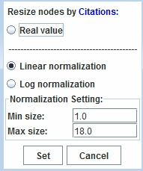

From the above dialog box, you can set the range of the radius based on a real value, a linear nomalized value, or a log nomalized value.

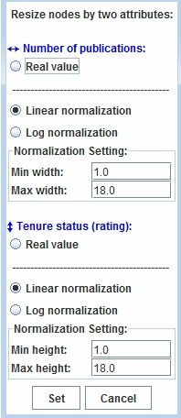

From the above dialog box, you can set the range of height and the range of width for rectangles based on a real value, a linear nomalized value, or a log nomalized value.

Created with the Freeware Edition of HelpNDoc: Free HTML Help documentation generator

Show/Hide Label
The button toggles labels for nodes; clicking it once shows labels and clicking it a second time undoes these changes. By default, you can show/hide all nodes in the network. If you want to display the label(s) for only some of the nodes, please select your desired node(s) first, then click this button.

See Node Selection and Deselection to learn how to select your desired node(s).

Created with the Freeware Edition of HelpNDoc: Free PDF documentation generator

Node Depth
Press ctrl and select two nodes in the network. Then select the option to show all nodes connected to those two nodes at the specified depth.

Created with the Freeware Edition of HelpNDoc: Full featured multi-format Help generator

Show Edge Strengths
Clicking on will toggle numbers corresponding to the edge strength on top of all edges. Clicking it once shows the strength number and clicking it a second time undoes these changes. Binary relations will always have a strength of 1.0

Note: This button will only be available when you open a saved network!

Created with the Freeware Edition of HelpNDoc: Free help authoring environment

Edge thickness by Weight
The weight of a relation can be shown by the thickness of the edge. By clicking the icon in the toolbar, a dialog box will be displayed.

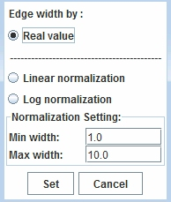

From the above dialog box, you can set the range of the thickness for edges based on a real value, a linear nomalized value, or a log nomalized value.

Created with the Freeware Edition of HelpNDoc: Full featured Help generator

View
This section provides different kinds of zooming and moving functions. Clicking on one of the buttons will trigger a cursor, which is used in the graph screen to perform whatever function you want.Clicking the same button in the tool bar will return you to the zooming/moving cursor.
Created with the Freeware Edition of HelpNDoc: Free HTML Help documentation generator

Zoom to a Selection
The button triggers the zoom cursor. Click and drag the mouse: this allows you to select a rectangular region of the screen. Once the mouse is released, the highlighted rectangular region will be enlarged to fit the screen.

Created with the Freeware Edition of HelpNDoc: Full featured Help generator

Zoom in on Edges
The button triggers the "Zoom in on Edges" cursor. Click anywhere in the visualization to take a closer look at the selected area. Edges will appear longer.

Created with the Freeware Edition of HelpNDoc: Free HTML Help documentation generator

Zoom out on Edges
The button triggers the "Zoom out on Edges" cursor, which can be used by clicking anywhere in the visualization to move further away. Edges will appear shorter.

Created with the Freeware Edition of HelpNDoc: Free HTML Help documentation generator

Zoom in on Graph
The button triggers the "Zoom in on Graph" cursor. Click this button to zoom in on both nodes and edges.

Created with the Freeware Edition of HelpNDoc: Easily create Web Help sites

Zoom out on Graph
The button triggers the "Zoom out on Graph" cursor. Click this button to zoom out on both nodes and edges.

Created with the Freeware Edition of HelpNDoc: Full featured multi-format Help generator

Move Graph
The button transforms the cursor into a hand, allowing the user to move the graph inside the visualization pane.

Created with the Freeware Edition of HelpNDoc: Easy CHM and documentation editor

Other Functions
This section provides a series of important functions that cannot be performed by any of the toolbar buttons.
Created with the Freeware Edition of HelpNDoc: Single source CHM, PDF, DOC and HTML Help creation

Search for a Node
Use the search bar to find a specific node in a cluttered network. The bar is in the bottom right-hand corner of the interface.

Use either Ctrl + F or mouse click to focus in the search field. Type in the Node Label you are looking for, and it will select the node in the interface.

Created with the Freeware Edition of HelpNDoc: Free help authoring environment

Node Filtering by Depth
1. Right click on a desired node. You will see the following:

a. A drop down menu will appear with multiple options
b. Ties related to the selected node will become colored. The colors correspond to the type of link. Outgoing links are red,incoming links are green, and mutual links are blue.

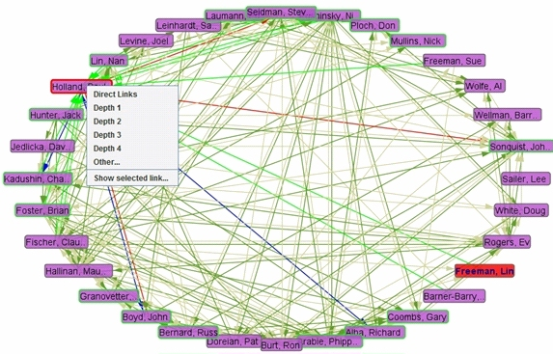

2. Use the menu to navigate the options you would like to select:

Click on the desired depth (originating from that node) to show a smaller version of the original network based around this focal node. If you would like a depth greater than 4, click on ‘Other’ and specify a larger number.

Created with the Freeware Edition of HelpNDoc: Single source CHM, PDF, DOC and HTML Help creation

Filter Relation Typ
Filter Relations Based upon one Node

Right click on a desired node. You will see a drop down menu as shown in Node Filtering by Depth. To filter by incoming, outgoing, mutual,
or undirected links, click on ‘Show Selected Link.’ This window below will appear. Check the ties you would like to show and click 'Show'. The network will be filtered accordingly.

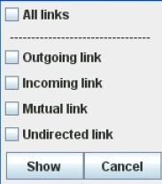

Filter Relations Based upon multiple Nodes

Select multiple desired nodes (see Node Selection and Deselection). Right click on one of the nodes, the window
below will appear. Choose to filter all links, mutual links, or undirected links, then click on ‘Show’.

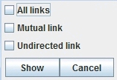

Created with the Freeware Edition of HelpNDoc: Full featured multi-format Help generator

Change Color
Click on a legend image on the legend pane, the window below will appear for you to select a desired color.

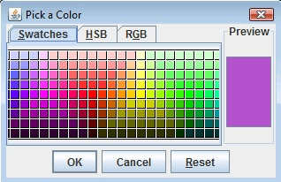

Click the OK button, the color of nodes/edges for this type will be automatically changed to your selected color.

Created with the Freeware Edition of HelpNDoc: Full featured multi-format Help generator

Node Selection and Deselection
Select one Node: just click the node you want to select.

Select multiple Nodes one by one: Hold "Ctrl" key and select nodes one by one.

Select multiple Nodes by rectangular area: Click and drag the mouse, you can select a rectangular area of the screen. All the nodes inside the area will be selected.

Deselect node(s): Click any blank space on the screen to release the selected node(s).

Created with the Freeware Edition of HelpNDoc: Easily create CHM Help documents

Hide Edge
Any edge(s) between two nodes can be hidden. <b>Right</b> clicking on an edge between two nodes triggers the following small window:

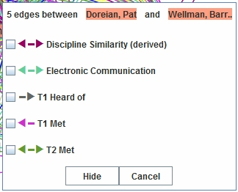

Select the edge(s) you want to hide, then click the "Hide" button.

Created with the Freeware Edition of HelpNDoc: Free PDF documentation generator

Node Profiles
For the online Visualizer, it is possible to double click on a specific node to see all its unique attributes. You will see a screen similar to the following:

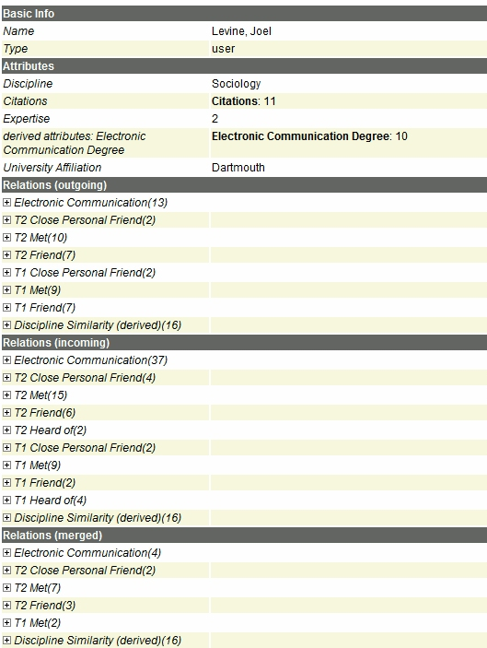

Created with the Freeware Edition of HelpNDoc: Easy to use tool to create HTML Help files and Help web sites

Edge Profiles
For the online Visualizer, if you click on an edge between two nodes, you will see a screen similar to the following:

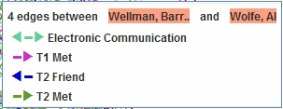

Click on an edge, you will see a screen that shows all edges and their unique attribute information:

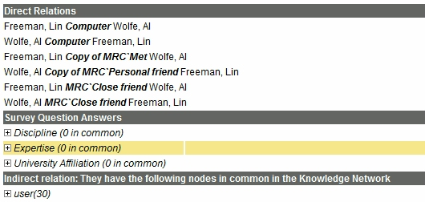

Created with the Freeware Edition of HelpNDoc: Easily create HTML Help documents

Recommendation
CIKNOW’s recommendation tools use network data to provide algorithm-based recommendations for both resource discovery and team assembly. The Resource function allows a user to query a complete list of recommended pathways to any other node or attribute in the network. The Team Assembly function allows a user to assemble a team from nodes in the network based upon specified node attributes and relational characteristics.
This section provides functions for recommendation network visualization. You may see the buttons on the right side of the toolbar like 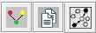 if the recommendation network is based on Node Type. The buttons will be 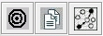 if the recommendation network is based on Attribute.
Created with the Freeware Edition of HelpNDoc: Free PDF documentation generator

Recommendation Based on Node Type
Click the button, a recommendation layout will be displayed like this:

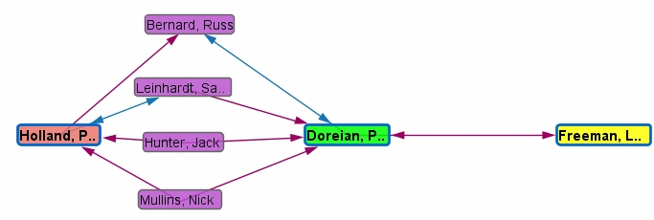

The node colored red is the "requestor" of the recommendation, the node colored green is the "recommendation" and the node colored yellow is the "target" of the recommendation.

If you want to see paths with one more step between the "requestor" and the "recommendation" as well as between the "recommendation" and the "target", click the button.

Created with the Freeware Edition of HelpNDoc: Easy CHM and documentation editor

Recommendation Based on Attribute
Click the button, a recommendation layout will be displayed similar to this:

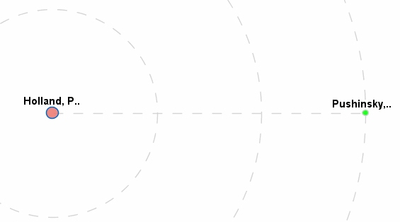

The bigger node colored red is the "requestor" of the recommendation, the node colored green is the "recommendation". The dotted circles indicate how many steps from the requestor to the recommendation. The straight dotted line means there is no direct recommended relations, but only not recommended relations between the requestor and the recommendation.

When mouse hovers over the dotted line, the not recommended relations will be displayed as following:

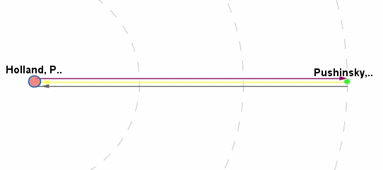

We can see, for this case, there are three direct relations between requestor and the recommendation, but those relations are not recommended. To see the recommended relations between the requestor and the recommendation, hover or click the recommendation node (green node), and you will get the visualization as following.

Click any blank space on the screen and you will be back to the dotted line.

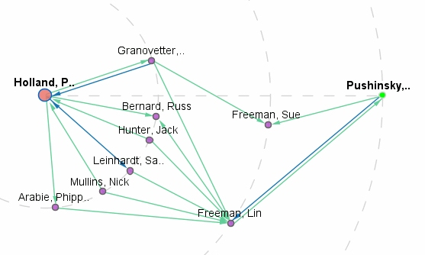

All the paths from requestor to recommendation are by way of intermediary nodes. If you want to show more than one recommendation network on the same screen, just select the recommendation node
you want. See <a href="other.html#Selection">Node Selection and Deselection </a> to learn how to select your desired node(s).

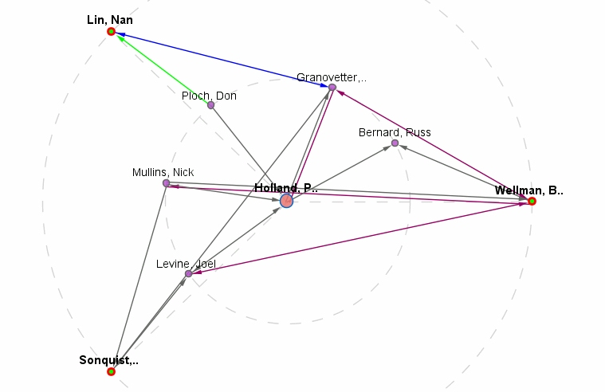

The above shows all the recommended relations for three recommendations at the same screen.

The visualizer also provides a function to see relations which are not recommended, click the button to do so.

Created with the Freeware Edition of HelpNDoc: Full featured multi-format Help generator

Recommendation Description
The button triggers a window the describes why this node is recommended. The contents of this description are similar to this:

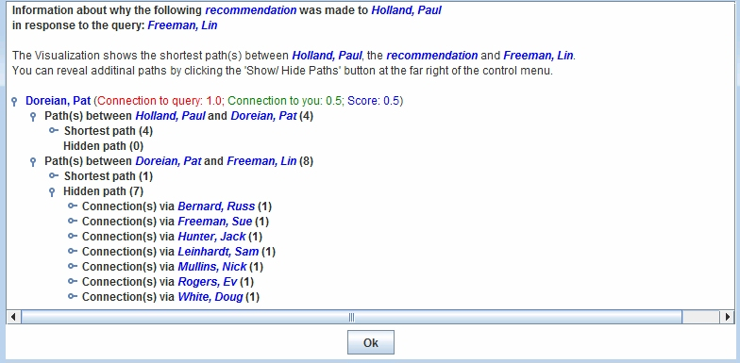
Created with the Freeware Edition of HelpNDoc: Full featured multi-format Help generator

Appendix

Created with the Freeware Edition of HelpNDoc: Easily create PDF Help documents

Troubleshooting

Created with the Freeware Edition of HelpNDoc: Easy CHM and documentation editor

Worksheet

Created with the Freeware Edition of HelpNDoc: Create HTML Help, DOC, PDF and print manuals from 1 single source

Question Type Guide

Created with the Freeware Edition of HelpNDoc: Single source CHM, PDF, DOC and HTML Help creation

