G.O.D. (God of Duality)
Team Choreopower - Christian Arca, Mark Aversa, Aaron Cooper, Ryan Michaels, Eujain Ting
January 21, 2009
Last Updated: February 10, 2009

High Concept

Overview
The following section describes the High Concept of G.O.D. This includes the key features, target audience, marketability, and goals of the title. The High Concept document is also available on it’s own however, is produced here to put the GDD into context.

Story
In the game universe there exists a powerful god that the players control. The god was too powerful for the universe to handle, thus tearing the universe into two parallel universes. Consequently, the god was split as well. Slowly, the two parallel universes are drifting apart. Trying to regain overwhelming power, the selfish god is trying to reunite the universes to once again be whole. To try and stop the god, priests and their minions are attacking the god any chance they get.
If the god does not bring the universes back together fast enough, they will be too far separated. When the god split, each part became a separate consciousness both vying for power. Unfortunately, to regain full power, one most conquerer and absorb the other. The only time they can attempt to conquerer each other is when the universe is whole again. Racing the clock, both are trying to bring the universes back together piece by piece.

Player Experience
G.O.D. is a side scrolling platformer which uses co-op in a unique manner. Players exist within the same time and space, however, in a parallel universe to each other. Actions which partake in each parallel universe directly affects each player’s universe. To progress through the level, players are required to work co-operatively to solve puzzles. While solving the puzzles, enemies will be trying to stop their progress. The players are given a limited, but realistic, time to complete each level. Without co-op the players will remain in a “hold” state where neither player may progress through the level, therefore, emphasizing co-op. During gameplay, players will have the ability to “portal” to another player’s parallel universe. While portal'ed, the timer for level completion will increase in speed. At the end of each stage the players will then engage in a one on one combat for a limited time. The winner of this battle will gain a specific power up.
Gameplay will be linear in nature, leaving the player with one goal to achieve, which is progress through the level. The main emphasis will be on the gameplay experience of a player and providing an enjoyable experience through the linear path. The introduction of co-op will serve as an “emergent” factor of the game, where players are surprised by their partner’s actions, and of course their physical communication outside of the game.
G.O.D.’s gameplay builds on short fast-paced action gameplay combined with intervals of puzzle solving, and intense co-op action. The co-op game mechanic which allows for level progression will act as a tension builder throughout gameplay. Where each player must aid each other but are still pitted against each other, thus creating a tension which builds up as the game progresses.

Player Combat Experience
The player combat experience of G.O.D. is meant to be high in intensity and chaotic, as the main goal of the player is to progress through the level co-operatively. The combat will consist of a player attacking with their equipped weapon and will focus on close quarter melee combat, giving the player an intimate combat experience. Jumping is a key component of movement and battling. The player will be agile with wall jumping and double jumping. Combat for the most part will remain simple and straight forward and will play into providing part of the whole experience which is G.O.D.

Title Goals

Create A Unique Platformer Experience
There have been many innovative platformers and side scrollers throughout the year. Whether it be Braid, or Castle Crashers. With G.O.D. we are looking to bring a unique platformer experience by including co-operative gameplay and creating a unique experience with the inclusion of a juxtaposition pitting the player against their co-operative partner which they have aided throughout the entirety of the gameplay. In short, this platformer will include elements of gameplay that are of slightly radical game design and the “old school” of platformers such as Mario.

Create A Marketable Title
A great idea is great, a great idea that can sell is better. Developing a title costs money and you need to cover that cost, and make a profit. Therefore, one of the goals for this title is to make it marketable so that it can sell. By using a very simple combat system and including co-op this can persuade players to experience the game with another player and feel less intimidated due to the shared player experience. Furthermore, the art will appeal to a vast audience rather than a limited sci-fi tech audience, or horror audience.

Key Features

Universe Traveling
Players will have the ability to travel between both universes in which they exist, the universes being separated by the split screen co-op.

Split Screen Co-Op
Throughout gameplay the game screen will be split into two equal portions where players will exist in two unique worlds within parallel universes of each other.

Target Audience
G.O.D. is aimed for players in the 13 - 35 age range consisting of both males and females. Additionally, the target audience includes both the casual and hardcore market due to the style of gameplay. Specifically, our target audience are players whom are familiar with the platform genre and enjoy short series of games which may be played for both a short or extended amount of time.
Furthermore, it also attracts those players whom might be familiar with the puzzler genre and are comfortable with the logical gameplay of puzzlers but whom have not tried out platformers due to their lack of “skill” within platformers. G.O.D. allows for both the platformer and puzzler genre to come together seamlessly attracting players whom enjoy both genres but may feel they aren’t “good enough” to play the platformer or puzzler genre specifically.
The title will appeal to customers across different gamer types.
Platform Gamer: G.O.D. will appeal to gamers who enjoy platformers and enjoy progressing through a level by using the environment of a level. Therefore appealing to fans of titles such as: Mario, LEGO franchise, Kirby: Canvas Curse, and Sonic.
Co-Op Gamer: Because of the title’s ability to accommodate for Co-Op gaming, it will draw gamers which enjoy experiencing a game and collaborating with other players. Players which enjoy titles such as: Castlevania: Portrait of Ruin, LEGO franchise, Children of Mana, and Advance Wars: Days of Ruin which all feature Co-Op on the Nintendo DS.

Competition
Kirby Canvas Curse: This title has been critically acclaimed as one of the best platformers on the NDS. Additionally, the branding for Kirby has been well established into a very familiar and recognizable character throughout the years therefore making this game very “attractive” to a vast audience. Furthermore, Kirby Canvas Curse sets the bar for stylus drawing navigation of a character as well as implementing character “puzzling” which consists of having a character be navigated in a particular path so that they may overcome certain logistic puzzles and or obstacles.
Donkey Kong Jungle Climber: Donkey Kong Jungle Climber is a side scrolling platformer where players are the beloved Donkey Kong and must climb from platform to platform. Donkey Kong is a well established character within the Nintendo family and therefore is attractive to a vast audience as well. DK: Jungle Climber also uses mini-games as a game mechanic to unlock progress throughout normal gameplay which provides a nice variety in gameplay for players.
New Super Mario Bros: New Super Mario Bros is another installment within the Mario franchise. It continues on it’s success of the original platformer with new levels, and some new features. Of all the titles, Mario - as is known everywhere - is a very well established character whom essentially sells himself. The success of this title is unprecedented within the Nintendo DS platform.

Core Game

The following section describes a description and the definition of what composes the core of G.O.D.

Universe Traveling

Overview
Players may transport to their co-op partners universe at any time during gameplay. This allows them to aid a player when being swarmed with enemies as well as assist in co-operative challenges which the player is faced with. The act of portal'ing places the player in the same position they were, just in the parallel universe. When portal'ing back, the same translation is true. To portal into the others player's universe, both players must be within a certain distance of each other. When both players exist in the same universe, the camera no longer pans. The screen is fixed until both players are in their respective universes. While both players are in the same universe (on the same screen), the timer for level completion speeds up. This speed increase forces the players to choose wisely when it is more advantageous to solve a puzzle on their own screen or on both screens.

Traveling
Players will go through the following steps when traveling to their player’s universe:
- Hold X button to charge up traveling.
  - During charge, the player’s avatar will have a glow which increases until the traveling has occurred.
  - The glow will serve as a shield from enemies which they cannot pass therefore, allowing the player to travel in high action sequences.
- Player avatar appears on their partner’s level.
  - Upon appearing on their partner’s level, the game timer will increase in speed.
  - The player appears at the same coordinates in the other universe from which they left.
- To travel back, the player again presses the X button to begin charging.
  - Once the player has charged up enough, they will go back to their universe.
  - The player will be transported to the position they are in, in the parallel universe, in their own universe.
  - Clock will resume normal speed.

Split Screen Co-Op

Overview
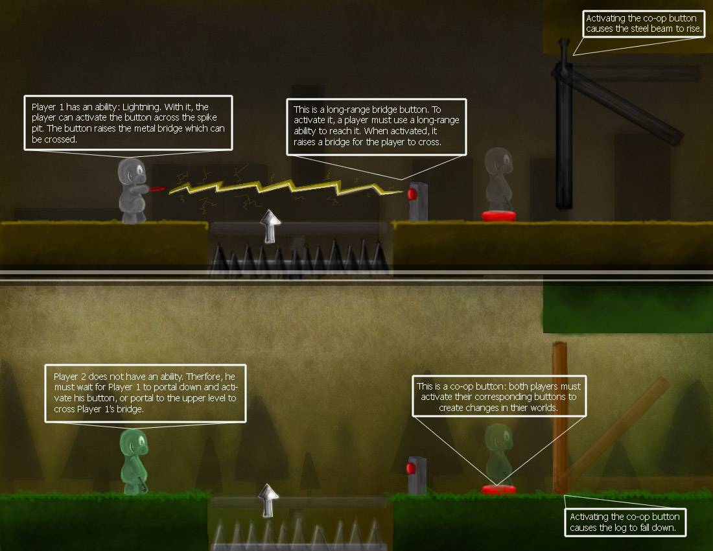
Throughout gameplay the game screen will be split into two equal portions where players will exist in two unique worlds within parallel universes of each other. Actions within a player’s parallel universe have the ability to change the world within the other player’s universe. Therefore, resulting in co-operative gameplay to enable progress throughout levels. Players may also use universe traveling as explained above to travel through parallel universes. Without the assistance of a player’s co-operative partner they will not hold the ability to progress throughout levels. The split screen is a strict and distinct boundary defining two different spaces.

Level Description
Each level will consist of a series of obstacles, puzzles, and enemies. At the end of every level, there is a puzzle that reunites that portion of the world the players are traveling through. Once the final puzzle is solved, both screens fuse together to form a full screen arena. The arena is then for battling to gain the new power.
The layout of the level will be nearly identical for both players. When playing through the level, each player is in their own parallel universe and the universes are effectively the same. The discrepancies between the levels will be their overall artistic theme and sections of puzzles. To enhance the puzzles, sometimes players will have different objects describing a puzzle thus making that portion of the level look different. Within some of the puzzles, objects affecting one universe will cause the same or similar change in the parallel universe.

Level Interaction
During gameplay, both players will encounter different elements particular to each player’s universe. Therefore, this allows for players to know when a particular entity within their split screen of the co-op has the ability to be interacted with or not. For example, if the top player lives in a more organic environment such as a forest that is always lush the bottom player would exist in a universe with a bare skeleton of a tree in a forest which is not as lush and a bit more bare. If the bottom player were to come across a lush pine tree this is definitely something which should not belong in their universe, they know that this environment is inter-actable and will allow them to perform actions on the entity to invoke the co-op game mechanics. Objects like this will cause a change to occur to the objects in both universes.

Types of Puzzles
The types of co-op “puzzles” will have players moving objects that exist within both universes to access different areas of the level.
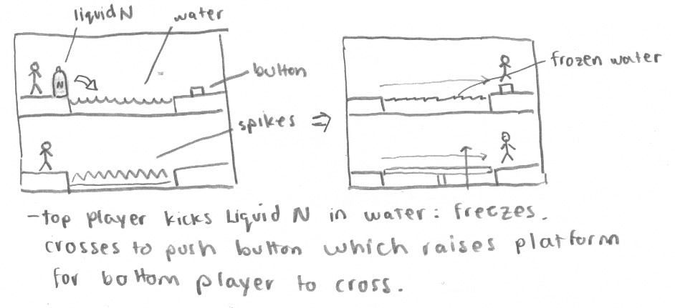
Examples
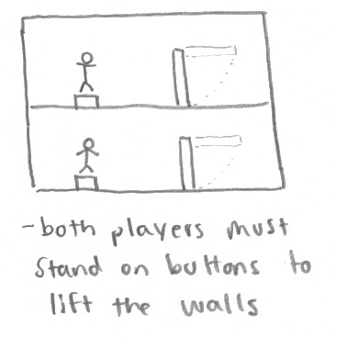
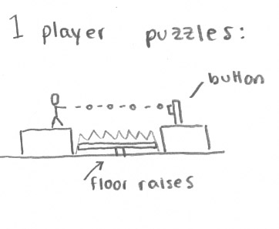
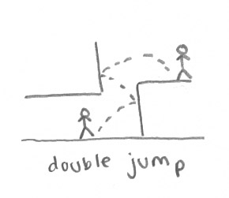
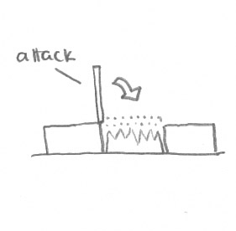

Battle Arena
The players will be in an open arena to fight. The players will strictly be fighting each other. Players can jump, use their normal attacks, or power ups to hurt their opponent. There will be a time limit on the battle and once time is up, the player inflicting the most damage will gain a power up.

Organic vs. Urban / Industrial Levels
Levels will be mirror images of each other. Therefore, this will decrease the need to create two separate level designs for the two levels within the game. The following assets will make up the majority of the levels:
- Trees - Skyscrapers
- Birds - Fighter Jets
- Rocks - Steel Crates
- Bridges - Logs (Such as if there was a lock that was brought down so one could travel across it.
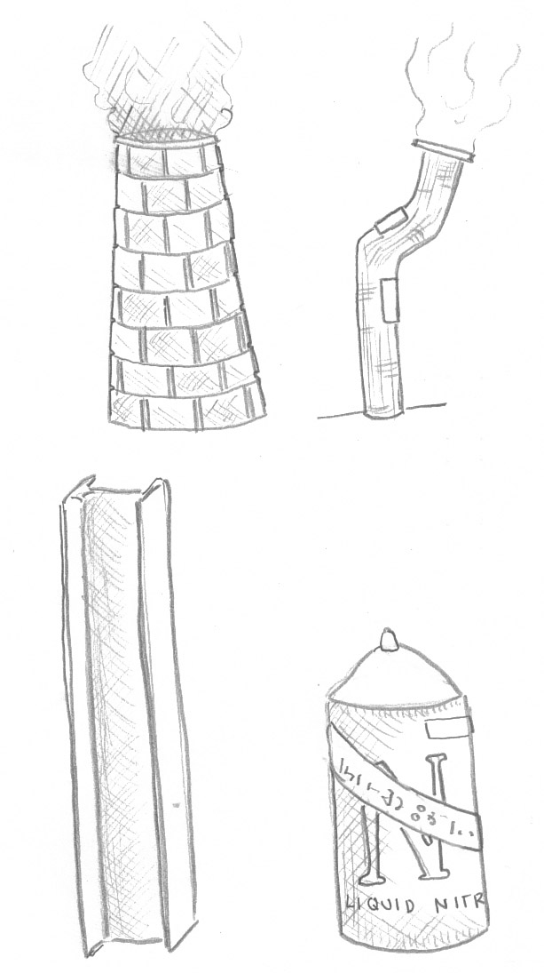
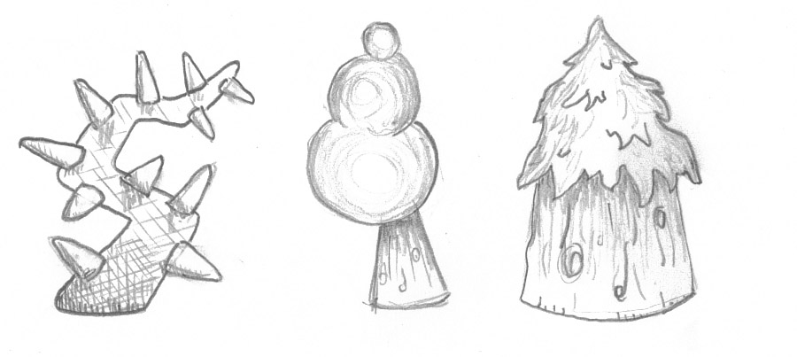

Gameplay

Co-Op Character Existence
During Co-Op both players must be alive for the game to continue. Each player has a certain amount of life and falling into traps or being beaten by enemies will cause death. When one player dies the game will proceed into a fail state. Therefore, if a player does not aid another player during times of low health points, and allows the other player to die, the game will proceed to a fail state.

Level Progression
Players will use entities within the levels to unlock the progression of the level. Therefore, pushing a tree to cross a river, activating a switch so a platform raises, etc... If players do not co-operate they will not be able to reach the goal state at the end of each level.

Goal States
Within each level, there will be a goal state at then end of the level which players must achieve. This will be marked by a final puzzle. Once the goal state is reached, the players enter an arena and battle for a power. When battling, the players 'hurt' each other, but cannot die. There is a limited time that the players battle. The player to inflict the most damage will gain the power-up. When entering the next level, the players health are restored to full. The only way to progress through the game is to reach the goal state of each level which will then unlock and power-up, the next level, and additional story content.
Characters

Overview
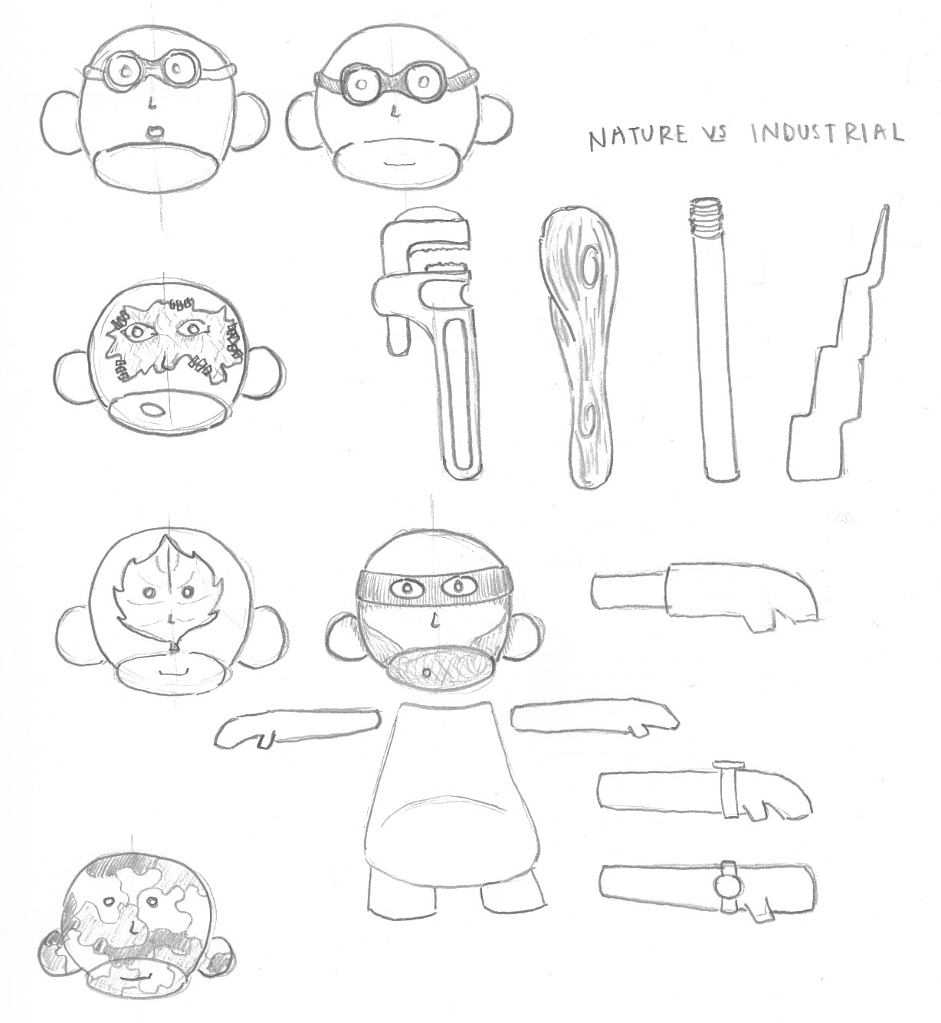
Players will have the option to choose from four different characters. Each of these characters will have the same model, but however be textured differently to differentiate each character. The textures will also stay very similar for characters to give a sense of familiarity and unity amongst players. The emotion we would like to evoke is that players are co-operative partners, much like siblings that are very much alike but with different personalities, therefore a different color skin rather than a different texture.

Player Character
- Class: Player Character
  - Overview: The player character will be an “average” of both the brute and agile drone enemy characters.
  - Attacks
    - Side Slash - The player may slash a character. This will perform a quick attack in the form of a “slash” in front of the character. The amount of time to complete a slash will be: .5 seconds. Per each attack, 15 points of damage will be done. Therefore resulting in a DPS of 30.
    - Upward Slash – This will perform a strong overhand attack in the form of a “slash”. The amount of time to complete an upward slash will be: 0.5 seconds. Per each attack, 30 points of damage will be done.
  - Health: The player’s health will be a total of 100 hit points. Health will be shown via textures on the player’s model. Therefore, visible bruising, bleeding, etc.. will be textures which will be swapped in during combat. The player will flash critically when near death.
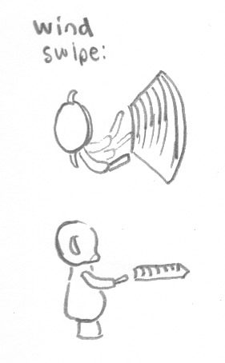
  - Speed: The player’s speed will be 1.

Power-Ups
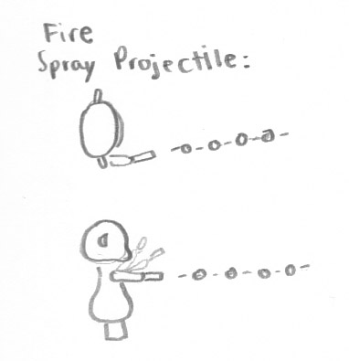
Fire – This attack emits a fireball from the weapon that travels linearly in front of the player. When the fireball hits an object, it disappears. There is a cool down of X seconds.
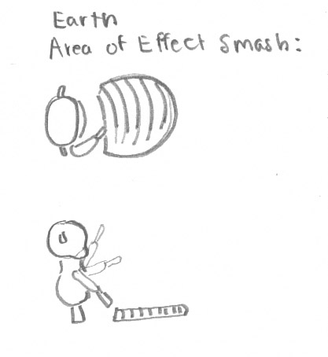
Earth – The earth attack is a smash to the ground that provides an area of effect damage on the ground within a radius of Y around the player. There is a cool down of X seconds.
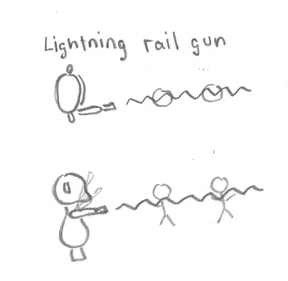
Wind – The wind power affects an area slightly beyond the reach of the sword. It increases the attack distance of a swing. There is a cool down of X seconds.
Lightning – Lightning shots a beam from the sword that travels straight hurting any enemy in its path. Lightning goes through as many enemies as it encounters. It has a cool down of X seconds.
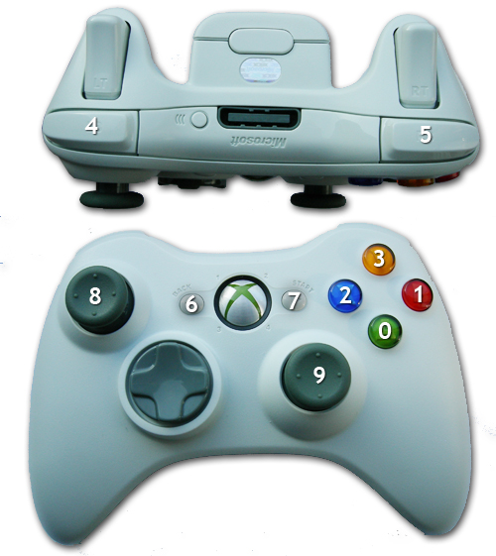
Controller Layout

Overview
0 - Jump (A Button)
1 – Use Power-Up (B Button)
2 - Universal Traveling (X Button)
3 – Cycle Through Power-Ups (Y Button)
4 – Slash Upward (Left Trigger)
5 - Slash In Front (Right Trigger)
7 - Pause (Start Button)
8 - Horizontal Movement & Z Movement (Left Joystick)

Enemy Characters
- Class: Melee Brute
  - Overview: The Melee Brute character will be a “heavier” version of the base player model which will perceive to have weight with added texture.
  - Attack: The melee brute will carry a heavier weapon which they will use in one fashion to attack the enemy. This will be in the form of an overhand slam. Each attack will deal 20 points of damage to a player’s HP. Their attack will take 2 seconds to complete.
  - Health: The melee brute will be the strongest of the enemy characters and therefore will have an additional half of a player’s health added on to their hit point total. Therefore, since the player has 100HP their total hit points is 150.
  - Speed: The melee brute will be the slowest and heaviest of the enemy characters. Therefore their speed will be half of the player’s character. Therefore speed is .5 rather than 1.

- Class: Agile Drone
  - Overview: The agile drone character is a much weaker, but a quicker version where their strength is in numbers and quickness.
  - Attack: Their weapon will be small and agile giving them the ability to perform very quick attacks. Therefore, this should probably be in the form of a slash. Each attack will deal 5 points of damage to a player’s HP. Their attack will take .2 seconds to complete.
  - Health: The agile drone will be the weakest of the enemy characters and therefore will have half of a player’s health. Therefore, since the player has 100HP their total hit points is 50.
  - Speed: The agile drone will be the quickest and most agile of the enemy characters. Therefore their speed will be increased by half of the player’s character. Therefore speed is 1.5 rather than 1.

Character Inspiration
