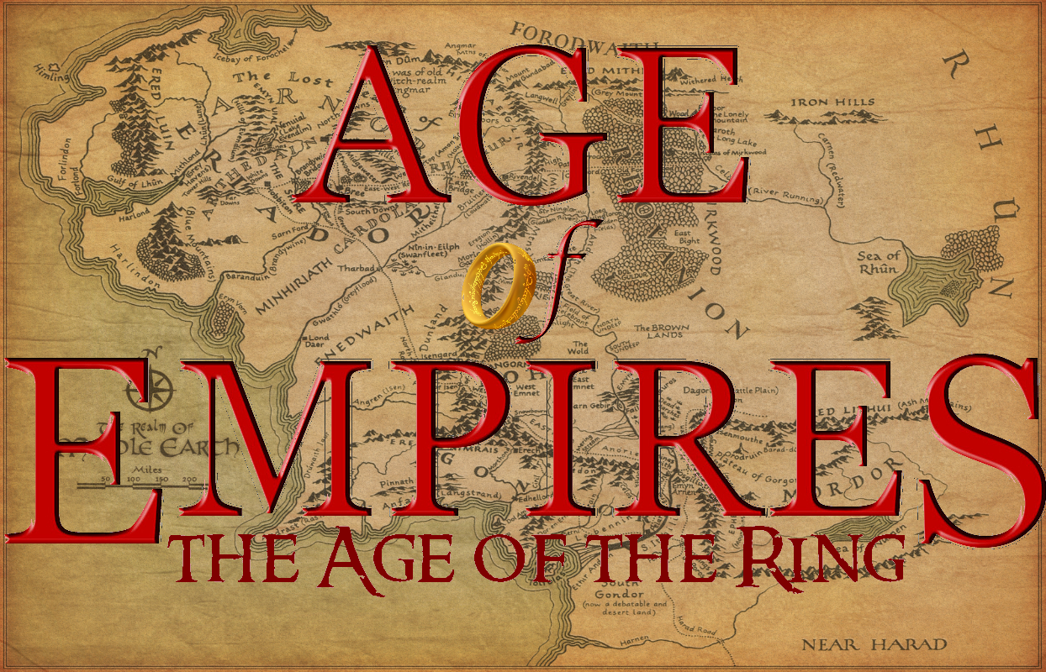
Unofficial Expansion Pack Mod
Age of Empires and The Rise of Rome Expansion are © and owned completely by Microsoft Corporation.
Age of Empires and The Rise of Rome Expansion were developed by Ensemble Studios.
No copyright infringement is intended. This mod is always free.

Requirements: Age of Empires: The Rise of Rome,
UPatch HD 1.1 r2 or later

“Version C” is the fourth released version of the Age of The Ring mod.
“sonictimm” is the modder who conceived and put together this mod using many resources from others, including:

ART Used with Permission
Single Player background "Concerning Hobbits"; Scenario Editor menu background "Minas Tirith"; Achievements Screen "Mordor"; by Joe Gilronan http://joegilronanlordoftherings.blogspot.com

MultiPlayer background "Battle for Ring" by Gökberk Kaya (gkb3rk on DeviantArt, http://gkb3rk.deviantart.com)

Old defeat Screen background "Lost Battle 2" by Ingrid Nedrehagen (in93 on DeviantArt, http://in93.deviantart.com)

Victory Screen background "So I found my llotr soundtrack..." by Stjepan Šejić (nebezial on DeviantArt, http://nebezial.deviantart.com )

J.R.R. Tolkien drew the “Middle-Earth Map” that is used in the main menu and in the logo. High-res image courtesy of Don's Maps.
Resizing, orientation, recoloring, formatting, and visual editing of all images done by sonictimm with some Photoshop help from Le Gamer.

M.E. Scenario map, Hobbit Hole, and four new wonders adapted from images and models by Weta New Zealand.

Scenarios
“Middle Earth” and “Blank_Middle Eath” Scenarios by sonictimm.

Age of The Ring Campaign by sonictimm
Tested by sonictimm.

MUSIC
Composed Stephen Rippy and Howard Shore.
Arrangements:
♫MovieThemes.net for most arrangements of Lord of The Rings music. Visit the site at http://moviethemes.net/index.html. Site maintained by Millennium Music. Thanks for the free midis!
♫Stephen Rippy for all Rise of Rome, Age of Empires, and Age of Empires 2 Demo/The Conquerers Demo songs
♫Freemidi.org for “Far Over Misty Mountains Cold”
♫Sonictimm for “AoTR VICTORY”

video
Intro for Middle Earth Scenario by sonictimm, footage © New Line Cinema

Programs used to help make this mod include:
rord, a genie editor by Scenario TC based on one by Ykkrosh
Advanced Genie Editor 3, by Keisari Tapsa, Apre, and Estian Nifo with help from other fine folk at Age of Kings Heaven
Turtle Pack, a graphical editing tool by Ruralist
Resource Hacker, a tool by Angus Johnson

Also, Thanks to
NicoliII for inspiring this mod,
My great friends who helped test this mod online,
The entire Age of Empires Heaven community including epd999, Highwing, Chab, AOE_Scout, Suppiluliuma, Phatfish, Basse, HolyMario, Mahazona, and anterior2.

Thanks to Tony Goodman, Bruce Shelley and all the rest at Ensemble Studios for a great game that stands the test of time.
Thanks to Tolkien himself, Peter Jackson, and others responsible for making Middle Earth such a wonderful fantasy.

Special thanks to all those involved in the creation of tools used for this project, including Advanced Genie Editor, Turtle Pack, Paint.NET, PaletteMaker, rord, AOESpeed Editor, Resource Hacker, Resource Editor, and Campaign Editor. Check them out on AOE Heaven, AoK Heaven, and across the internet.

And a very special thanks to aoe_scout, the creator of UPatch HD.

Age of Empires and all related properties are © Microsoft Corporation.
The Lord of The Rings © J.R.R. Tolkien, films © New Line Cinema.

All properties belong solely to their respective owners. No copyright infringement is intended.

