🚂

Train Rails plugin

For Unreal Engine 5.03 and newer

TrainRails is an all-in-one solution for adding Trains & Railroads to your project.

Easily set up custom railroad paths using splines and set trains to drive along.
Bundled Graphics & Sound for a modern diesel train with customizable colors.

Quick Start

After importing Train Rails into your project, there should be a folder at “Content/TrainRails” with several subfolders.
Navigate to TrainRails/BP and find “BP_TrainRails_Photoreal_RailsOnly”
Drag BP_TrainRails_Photoreal_RailsOnly into your level and place it on the ground.
TrainRails contains a Spline Component. There should be a square coming out on one side.
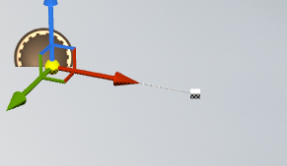
Right click on the square and choose “Duplicate Spline Point.” Use the Gizmo to move the new Spline Point to another location far away from the original.
Right click on the spline point and duplicate it again. Move the next spline point to another new location. This spline will become a railroad when the game starts.
WARNING: Be careful not to make sharp turns on the path, as trains will look silly going around sharp turns.
For more help working with Splines: https://docs.unrealengine.com/4.27/en-US/BuildingWorlds/BlueprintSplines/HowTo/EditSplineComponentInEditor/
Locate BP_Train in the TrainRails folder and drag it anywhere into the level.
Select BP_Train and change the following properties:
- [Cars] Car Count = 3
- [Cars] Car Type = BP_Boxcar_Realistic
- [Cars] Engine Type = BP_EngineCar_Realistic
- [Rails] Rails = BP_TrainRails_Photoreal_RailsOnly (this should match the Train Rails BP you placed in the level earlier)
The BP_Train you placed should now show the correct realistic Engine & Boxcars
Press “Play” to play the scene in-editor.
The Rails should have spawned in along Rails_BP’s spline.
The train should start at the beginning of the rail and begin moving.
🎉 Congratulations, you have a train! 🎉
Now try changing the Train’s Desired Speed, Engine Start Position on Rail, Car Count, and the Loop Around Rail settings.

Blueprints Overview: Movement & Logic

TrainRails

Trains move along rails. These are rails.

Change the RailMesh variable to change the mesh used for rails.
- It is recommended you make a child class of BP_TrainRails_Base for each rail type
- Make sure all materials on the mesh enable “Used with Spline Meshes” 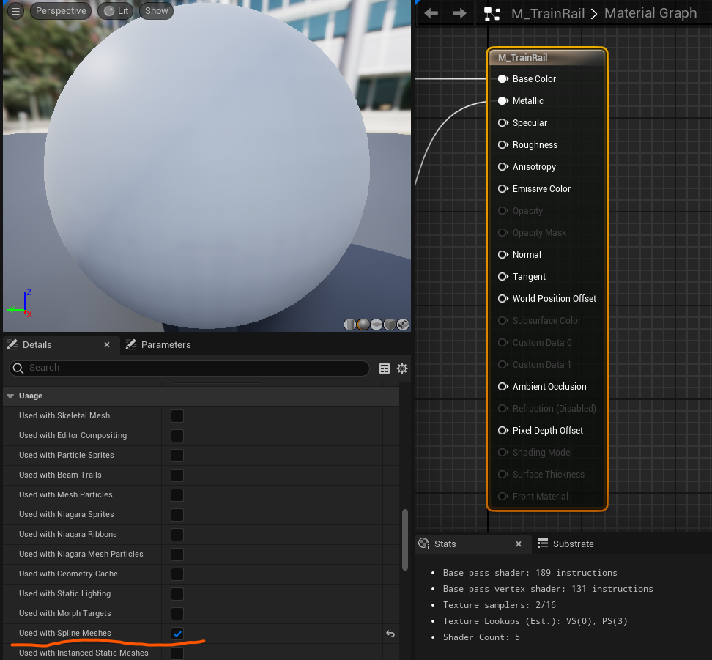
- The origin of your mesh must be its center
- The mesh will be stretched and deformed along the spline. If it does not have enough subdivisions, it may look choppy.
On BeginPlay, TrainRails will go over all spline points and connect them with spline meshes

Included variants:
- BP_TrainRails_Base – Has simplistic Placeholder rails. Parent class of other rails, so be careful when changing logic in this class.
- BP_TrainRails_Photoreal_RailsOnly – Child of TrainRails Base with Realistic railroad tracks that line up with the ground.
- BP_TrainRails_Photoreal_GravelBed – In addition to realistic rails, this blueprint also includes a raised gravel bed beneath the rails.

Train
BP_Train is the glue that holds everything else together.
A Train has an Engine and Cars. There will be one instance of the Engine at the front of the train, and as many Cars as you want following it. Both the Engine and Cars must derive from the BP_TrainCar class.
The Construction Script calls a function called GenerateTrain, which spawns the Engine and all the Cars as child actors.
Every tick, UpdateCarPositions is called. This uses the Train’s DesiredSpeed and previous Position on the rail to calculate new positions for the Engine and all cars.

Some Useful Public Variables:
- Movement
  - Desired Speed – How fast should the train go
  - Loop Around Rail – If the train gets to the end, should it teleport back to the beginning of the current rail?
- Positioning
  - Space Between Cars – How much space between the back of one car and the front of another?
  - Engine Start Position – How far along the rail should the Engine start?
- Cars
  - Car Count – How many cars to spawn AFTER the Engine
  - Car Type – Class for Cars
  - Engine Type – Class for Engine
- Rails
  - Rails – Which instance of BP_TrainRails (or derived class) should the train move along?

Train Cars

TODO Explain Color changing stuff

All train cars and engines are based on BP_TrainCar.
You can make Child Blueprint Classes of BP_TrainCar to add your own cars & engines.
It is generally not recommended to edit BP_TrainCar, because any change will affect all train cars and engines, including the built-in ones. Consider making child classes instead.
A Realistic Box Car is included in this plugin.
Train Car’s position is updated by the BP_Train.
Additionally, there are several moving parts being updated on a Train Car:
- The Front and Back Bogeys (wheel sets) are rotated based on the angle of the track
- As on real train, the car’s rotation is set based on the Bogey locations
- Couplers at the front and back pivot towards the next car in line, if applicable.
- Wheels rotate based on train speed

Essential Components, Functions, Variables
- WheelsFront and WheelsBack are the origin for the car’s Front and Back set of wheels. In a realistic train, these are used as the roots for each Bogey.
- Front/Back Attachment – Where should the next / previous car attach
- Front/Back Coupler Pivot – Used as the root for coupler rotation. Couplers between train cars rotate to keep the cars connected.

- ApplyColor – Input the Primary and Secondary colors for train car paint. If supported (such as on the Realistic Diesel Engine & Realistic Boxcar), the engine or car’s paint will change color to match. The default can be set using Variables.
- ReleaseToPhysics – Experimental function to stop moving this car along the track and let physics take over. Great for train crashes or general chaos. Not fully tested, there may be issues!

- Wheel Speed Multiplier – Wheels of different sizes should spin at different rates. Customize this rate so that the wheels rotate at the right rate. Wheel rotation rate is calculated by DesiredSpeed * Wheel Speed Multiplier
- OffsetAboveRails – How high above the rails this actor’s should be. Ensure it is not too low or floating too high.
- MaxKosherDesiredSpeed – Used for calculating how fast this train is moving as a Percentage. Primarily used for Audio.

Engines
Engines are BP_TrainCar s with different audio & visuals.
There is a BP_EngineCar_Placeholder that demonstrates how wheels can be set up on a custom car.

Train Pieces used for Realistic Diesel Engine

Visuals
Engine
Parts

Bogey
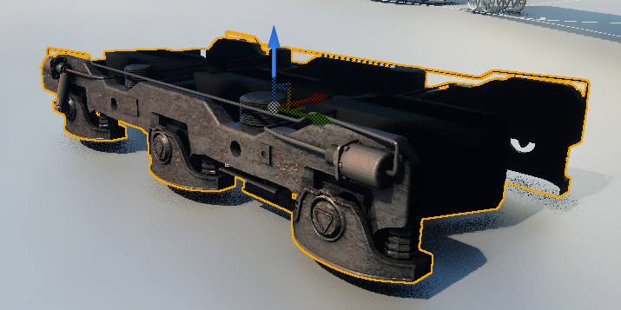
Pivot point must be at the center of the Bogey.
Attach Bogey mesh to the WheelsFront/WheelsBack Component.

Wheels
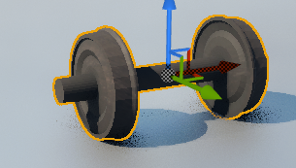
Pivot point for the wheels must be at their center so that the wheels can rotate properly.
Make sure to properly assign wheels by overriding the SetupWheels function so they can be spun properly.

Modern Diesel Engine Assembly
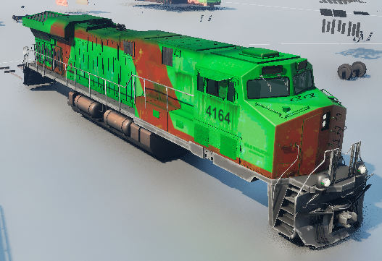

Couplers
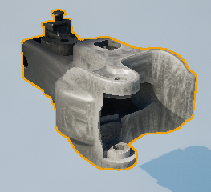
Ensure their pivots are placed where they would be in real life so that they can pivot properly as the train turns.
Attach it to the Front CouplerPivot & BackCouplerPivot component.

Placeholder Engine & TrainCar
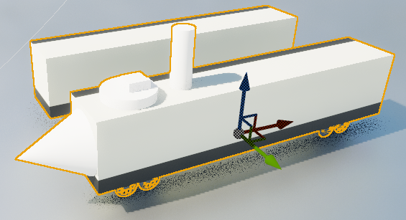
These works of modern art exist as simplistic placeholders.
They can be used for test situations that will not appear in your game, or as base classes for custom car & engine types.

Adding Your Own Train

To add another realistic train car or engine,

FILL THIS IN AS I INTEGRATE THE BOXCAR

used for test situations that will not appear in your game, or as base classes for custom car &

