CyberNews – Project Summary
Individual project · Module 1 · Built with Flask, SQLite, Jinja2, CSS and JavaScript

What my website does
CyberNews is a website that puts cybersecurity news in one place. When you open it you see a dashboard
with three featured stories, a grid of article cards, and a list of categories. You can search and filter
the news by category, source and date, and the results change straight away without the page reloading.
You can click any card to read the full article page.
If you make an account, you can bookmark articles and find them again on "My bookmarks".
If you are the admin, you also get an admin dashboard where you can add, edit and delete articles,
import real headlines from The Hacker News RSS feed, read contact messages, and look at a login audit log.
To be honest about the content: the 12 articles that come with the project are **sample stories I wrote
myself** with made-up companies (Contoso, Northwind, Fabrikam). They have a yellow "Sample" badge, and the
source links only go to the news sites' home pages. The real headlines come in with the RSS import button.

Main features
- Page structure with header, navigation, main content and footer (one shared base.html layout)
- News dashboard with featured stories and article cards
- Categories, live search, and filters by source, date and category
- Individual article pages
- Dynamic content: JavaScript fetch() loads JSON from my Flask API (/api/articles)
- Flask backend with about 20 routes
- SQLite database with 5 tables: users, articles, bookmarks, login_audit, messages
- Forms: register, login, add/edit article, contact
- Login, logout and sessions
- Two roles: user and admin, checked with my own @admin_required decorator
- Bookmarks, login audit log, RSS import, contact messages
- Works on phones (tested at 390 px wide)
- 19 automatic tests with pytest, plus a curl security check script

Technologies
Part | What I used
Backend | Python 3, Flask 3
Templates | Jinja2 (comes with Flask)
Database | SQLite with Python's built-in sqlite3 module
Security | Werkzeug password hashing, Flask-WTF CSRF protection
Frontend | HTML, CSS (grid + flexbox + media queries), plain JavaScript (fetch)
Extra | feedparser for The Hacker News RSS feed
Testing | pytest, curl, headless Chrome for screenshots
Version control | git

Architecture
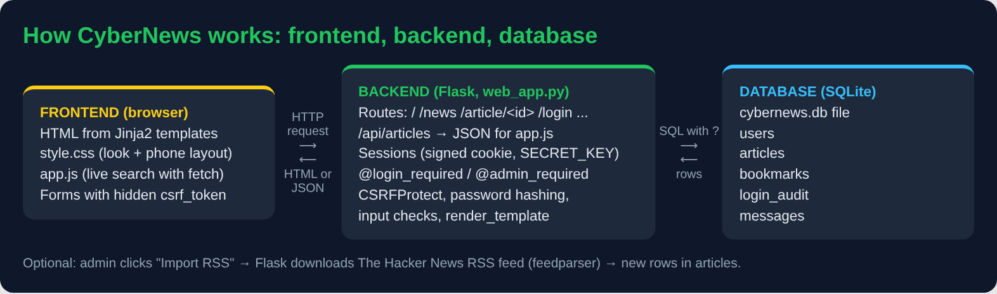
FRONTEND (browser) BACKEND (Flask) DATABASE (SQLite)
┌──────────────────────┐ ┌──────────────────────────┐ ┌──────────────────┐
│ HTML from templates │ --> │ routes in web_app.py │ --> │ cybernews.db │
│ style.css │ HTTP│ sessions + roles │ SQL │ users │
│ app.js (fetch) │ <-- │ CSRF, hashing, checks │ <-- │ articles │
│ forms + csrf_token │HTML/│ /api/articles -> JSON │rows │ bookmarks │
└──────────────────────┘JSON └──────────────────────────┘ │ login_audit │
│ messages │
└──────────────────┘
In simple words: the browser asks for a page. Flask finds the right route, checks who you are
(session) and what you are allowed to do (role), asks the database for the data with a safe SQL query,
and puts the data into a template. The browser gets HTML back. For live search, app.js asks for JSON
instead of HTML and builds the cards itself.

Security measures
- Passwords are hashed with generate_password_hash. Even I can't read them in the database.
- SQL injection: every query uses ? placeholders. Typing ' OR 1=1 -- in the search just finds 0 articles.
- XSS: Jinja2 autoescapes everything, my JavaScript uses textContent instead of innerHTML,
and article links must start with http:// or https:// (so no javascript: links).
- CSRF: Flask-WTF puts a secret token in every form. A POST without it gets 400.
- Roles: normal users get 403 Forbidden on every admin page, even if they type the address.
- Secret key comes from the SECRET_KEY environment variable, not from the code.
- Session safety: cookie is HttpOnly and SameSite=Lax, and the session is cleared on login.
- Login audit log records successful logins, failed logins, logouts and new accounts.
- Same error for "wrong username" and "wrong password", so nobody can find out which usernames exist.
- Debug mode is off unless I switch it on, so the debugger can't be used by others.

What challenged me
- Sessions and roles. Hiding the Admin link from normal users is easy, but I learned that hiding a link
is not security, because anyone can type /admin in the address bar. The real check has to be on the
server, so I wrote the @admin_required decorator and tested it with a normal account.
- CSRF tokens. With CSRFProtect switched on, every POST form needs the hidden token, including small
ones like Log out, Bookmark and Delete. I also had to switch CSRF on in the right order, so the
"security check failed" page still shows who is logged in.
- Jinja macros. My filter drop-downs were empty because imported macros don't see template variables
by default. I fixed it with import ... with context, and I added a test so it can't break again.
- JavaScript and safety together. Building cards with innerHTML would have been shorter, but it would
have let a bad title run as code. I used textContent instead.

What I'm proud of
- The live search: you type and the cards change instantly, and it still works without JavaScript.
- The security tests: I tried SQL injection, XSS, missing CSRF tokens and a normal user on admin pages
on my own app, and every attack failed the way it should.
- The audit log, because it shows a failed login in red, like a small version of what a SOC analyst looks at.
- Keeping it honest: sample content is clearly labelled, and real news only comes from the RSS feed.

Next steps
- Rate limiting / lock the account after many failed logins
- Password reset and changing your own password
- Comments or reactions on articles
- Pagination when there are many articles
- Deploy online with HTTPS (for example with gunicorn behind a web server)
- Automatic RSS import every hour instead of a button

Links
- Project repository: (my GitHub link goes here)
- AI prototype screenshots: (added separately)
- Final website screenshots: screenshots/ folder

