Meet Patel – 23CP054

Meet Patel – 23CP054
3CP08 – Design Engineering Report
NotesHub -
A Git-Inspired Version-Controlled Knowledge Management System

Table of Contents
ABSTRACT 1
INTRODUCTION 2
PROBLEM STATEMENT 3
NEED STATEMENT 3
OBJECTIVES 3
LITERATURE REVIEW 4
PROPOSED SOLUTION 4
SubjectNotes 4
Notes 4
Snapshot-Based Versioning 4
Restore Mechanism 4
Linking 5
Forking 5
SYSTEM ARCHITECTURE 5
DATABASE DESIGN 5
ER DIAGRAM 6
IMPLEMENTATION DETAILS 8
WORKING MECHANISM 8
Creating a Note 8
Updating a Note 8
Restoring a Note 8
RESULTS 9
LIMITATIONS 9
CONCLUSION 9
REFERENCES 9

ABSTRACT
In the modern academic environment, students manage study material across multiple platforms such as messaging applications, PDFs, online tools, and physical notebooks. This fragmentation leads to difficulty in organization, revision, and knowledge tracking.
GitForNotes is a version-controlled academic note management system inspired by Git principles. The system introduces snapshot-based versioning, restore functionality, conceptual linking, and structured containers called SubjectNotes. Built using Spring Boot and PostgreSQL, the system ensures modularity, scalability, and data integrity.
The project emphasizes system design and structured knowledge modeling rather than simple note storage.

INTRODUCTION
Academic knowledge management remains largely unstructured. Most note-taking tools overwrite content without maintaining revision history. Students frequently lose previous versions of notes or struggle to track how their understanding evolves.
This project aims to design a structured, version-aware knowledge management system that:
- Tracks the evolution of notes
- Prevents accidental data loss
- Connects related concepts
- Provides safe editing through restore mechanisms
The system applies software engineering design principles to academic workflows.

PROBLEM STATEMENT
Students face the following challenges:
- Study material scattered across multiple platforms
- No centralized control
- No structured version tracking
- Difficulty revising earlier versions
- No linking between related concepts
- Manual re-organization before examinations
Existing solutions lack academic versioning and structured knowledge evolution.

NEED STATEMENT
Students require a structured system that organizes academic content, tracks revisions safely, and allows interlinking of concepts to enhance learning and revision efficiency.

OBJECTIVES
The primary objectives of this project are:
- To design a centralized academic note management system
- To implement snapshot-based versioning
- To provide restore functionality
- To enable conceptual linking between notes
- To design a scalable relational database architecture
- To develop a modular backend system

LITERATURE REVIEW
Existing note-taking tools such as Notion, OneNote, and Obsidian provide structured note storage but lack:
- Immutable version history
- Git-like restore mechanism
- Academic-specific revision tracking
Version control systems like Git maintain history using snapshot-based storage. This project adapts version control principles for academic knowledge management.

PROPOSED SOLUTION
NotesHub introduces the following core components:

SubjectNotes
Containers similar to repositories that group notes by subject or topic.

Notes
Individual conceptual units stored within SubjectNotes.

Snapshot-Based Versioning
Each update creates a new immutable version rather than overwriting content.

Restore Mechanism
Restoring an older version creates a new version without deleting history.

Linking
Notes can reference other notes to create structured conceptual relationships.

Forking
Users can duplicate public SubjectNotes for independent modification.

SYSTEM ARCHITECTURE
The system follows a layered architecture:
→ Frontend Layer (React)
→ Spring Boot REST API
→ Service Layer
→ Data Access Layer
→ PostgreSQL Database
Design Principles Applied:
- Separation of concerns
- Modularity
- Data integrity
- Scalability

DATABASE DESIGN
The database is implemented using PostgreSQL.
Key Entities:
- Users
- SubjectNotes
- Notes
- NoteVersions
- NoteLinks
- Tags (future extension)
- Sources (future extension)
Snapshot Storage Strategy
Notes are divided into:
- Metadata table (notes)
- Immutable content snapshots (note_versions)
This ensures safe editing and complete revision history.

ER DIAGRAM
The ER diagram illustrates relationships between:
- Users and SubjectNotes
- SubjectNotes and Notes
- Notes and NoteVersions
- Self-referencing SubjectNotes for forking
- Many-to-many linking via NoteLinks

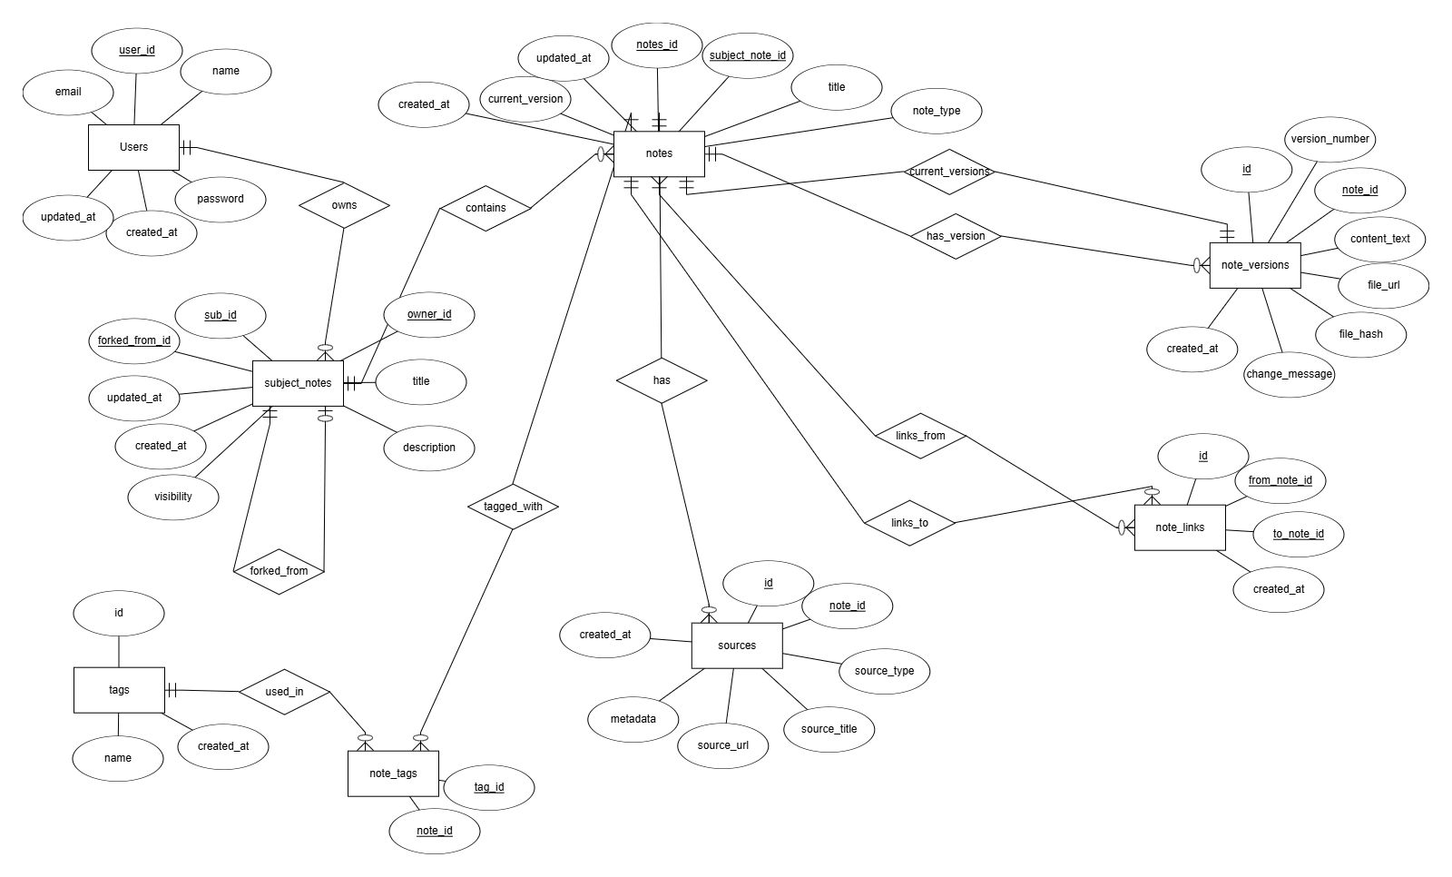

IMPLEMENTATION DETAILS
Technologies Used:
- Java 21
- Spring Boot
- Spring Data JPA
- PostgreSQL
- REST API architecture
Key Design Decisions:
- UUID primary keys for scalability
- Snapshot-based storage
- Unidirectional relationships for MVP stability
- DTO-based API responses

WORKING MECHANISM

Creating a Note
A new note is created within a SubjectNote. An initial version (v1) is stored.

Updating a Note
A new version is created. Previous versions remain unchanged.

Restoring a Note
The selected older version content is copied into a new version. No previous data is deleted.
This ensures immutability and auditability.

RESULTS
The implemented MVP successfully demonstrates:
- Version tracking
- Restore functionality
- Note linking
- Structured container-based organization
- Stable backend architecture

LIMITATIONS
- No real-time collaboration
- No advanced search
- No AI integration
- Limited frontend features (MVP focus)

CONCLUSION
GitForNotes transforms traditional note-taking into an evolving knowledge management system. By integrating version control principles into academic workflows, the system ensures data integrity, structured revision, and conceptual interconnection.
The modular architecture provides a scalable foundation for future enhancements.

REFERENCES
- Git Documentation – https://git-scm.com/docs
- Spring Boot Official Documentation – https://spring.io
- PostgreSQL Official Documentation – https://www.postgresql.org
- Design Thinking Methodology Resources

