***Abstract: The purpose of this project is to reduce the number of thefts happening around us. As thefts are increasing day by day security is becoming a major concern nowadays. In this project we will make a digital door lock system with keypad using [Arduino Uno](https://electrosome.com/arduino-uno/" \o "Arduino Uno" \t "_blank). It will open your door only when the right password is entered and it will start beeping when a wrong password is entered.It is also possible to change the password as per the choice of the user.***

1. **INTRODUCTION**

In this project the main aim is to generate a password based door lock system for which we have used arduinouno which as a atmelatmegamicrcontrolleralong with some other peripherals devices.Along with arduino other components used are (16\*2) lcd display and (4\*4) keypad .

1. **REQUIREMENTS:**

Hardware:

1. A +5V power supply
2. Arduino Uno
3. Servo Motor (any rating)
4. 4×4 Keypad &16×2
5. Breadboard (not mandatory)
6. Connecting wires

Software:

1. Arduino IDE
2. Arduiono Software
3. **FUNCTIONING OF EACH COMPONENT**

* **Arduinouno**: The **Arduino Uno** is a microcontroller board based on the ATmega328. Arduino is an open-source, prototyping platform and its simplicity makes it ideal for  hobbyists to use as well as professionals. The Arduino Uno has 14 digital input/output pins (of which 6 can be used as PWM outputs), 6 analog inputs, a 16 MHz crystal oscillator, a USB connection, a power jack, an ICSP header, and a reset button. It contains everything needed to support the microcontroller; simply connect it to a computer with a USB cable or power it with a AC-to-DC adapter or battery to get started.

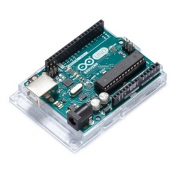

* **Lcd display**: LCD (Liquid Crystal Display) screen is an electronic display module and find a wide range of applications. A 16x2 LCD display is very basic module and is very commonly used in various devices and circuits. These modules are preferred over [seven segments](http://www.engineersgarage.com/content/seven-segment-display) and other multi segment [LED](http://www.engineersgarage.com/content/led)s. The reasons being: LCDs are economical; easily programmable; have no limitation of displaying special & even [custom characters](http://www.engineersgarage.com/microcontroller/8051projects/create-custom-characters-LCD-AT89C51) (unlike in seven segments), [animations](http://www.engineersgarage.com/microcontroller/8051projects/display-custom-animations-LCD-AT89C51) and so on.A **16x2 LCD** means it can display 16 characters per line and there are 2 such lines. In this LCD each character is displayed in 5x7 pixel matrix. This LCD has two registers, namely, Command and Data.

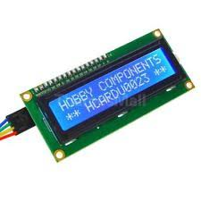

* **4×4 keypad**: Keypads are used in all types of devices, including cell phones, fax machines, microwaves, ovens, door locks, etc. They’re practically everywhere. Tons of electronic devices use them for user input.So knowing how to connect a keypad to a microcontroller such as an Arduino is very valuable for building many different types of commercial products.

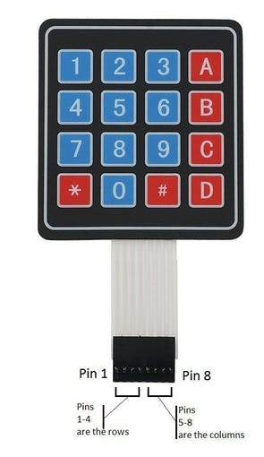

1. **CIRCUIT DIAGRAM**

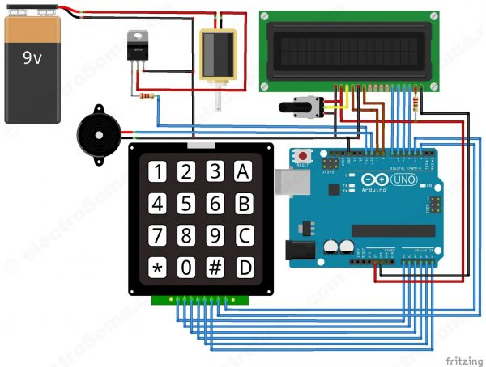

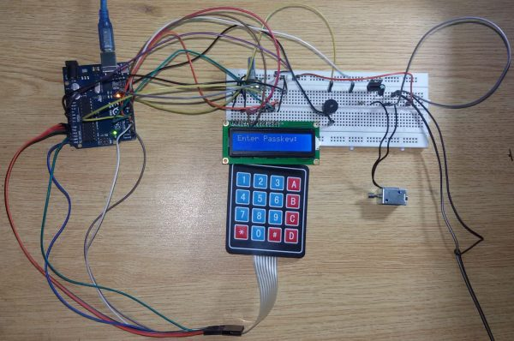

1. **WORKING AND CONSTRUCTION**

* **Construction:**

First of all, we will make the connection to the 4×4 Keypad. For connecting the keypad with the Arduino we are using both analog and digital pins. We used analog pins since we need more that 14 digitals pins for this project. If you are using Arduino Mega, then there is no need to use analog pins. Connect first six pins of keypad to analog pins A0 ~ A5 of Arduino and remaining two to digital pins 3 and 2.

To connect the push pull solenoid with the Arduino, we will have to use external power because it requires 6 ~ 12V to operate and much more current than the Arduino can provide. So to do that, we will use TIP120 NPN [transistor as a switch](https://electrosome.com/transistor-as-a-switch/)/driver and a DC power source which can provide 6 ~ 12V. The NPN transistor will switch ON when we will give HIGH to its base. So, connect its first pin (which is the base pin) to the pin 11 through to a 1KΩ resistor, second pin (which is the collector pin) to the negative wire of push pull solenoid and third pin (which is the emitter pin) to the ground. Now connect the positive of power supply to the positive wire of solenoid and the negative of power supply to the ground.

Now connect the positive wire of buzzer to the pin 10 of Arduino and negative wire to the ground.

* **Working:**

In this project, we have used EEPROM in the Arduino to store the password in it. The default password stored in it will be ‘1234’. When we enter a password, it will match it with the password stored in the Arduino EEPROM. If it is correct, then it will show ‘Passkey Accepted’ and the push pull solenoid will come in low state (Door Unlocked). If the password is wrong, then it will show ‘Access Denied’. During this condition the buzzer will start beeping and the push pull solenoid will remain in the high state (Door Locked). The buzzer will also beep once when any key is pressed.

For changing the passkey, we have to press ‘#’. When we press ‘#’, it will ask forcurrent passkey. If we enter the correct password it will ask for new passkey and will save it in the EEPROM.

1. **BILL OF MATERIAL**

|  |  |  |  |  |
| --- | --- | --- | --- | --- |
| **Sr.no** | **Component**  **name** | **No.of unit** | **Price of 1 unit** | **Total** |
| 1 | Arduinouno | 1 | 400 | 400 |
| 2 | 16×2 lcd display | 1 | 115 | 115 |
| 3 | 4×4 keypad | 1 | 95 | 95 |
| 4 | Jumper wires | 15 | 5 | 75 |
| 5 | potentiometer | 1 | 20 | 20 |
| 6 | resisters | 5 | 1 | 5 |
| 7 | buzzer | 1 | 50 | 50 |
|  | **TOTAL** |  |  | **940** |

1. **FUTURE SCOPE**

* We can send this data to a remote location using mobile or internet.

•We can add fingerprint sensor so entry will be allowed for the authorized person using their fingerprints.

•We can add fire, wind and LPG sensors so that in case of accident, the doors will automatically open.

1. **CONCLUSION**

* Such security systemsare used in the places where we need more security. It can also used to secure lockers and other protective doors. The system comprises a number keypad and the keypads are connected to the 8 bit microcontroller of the arduino.
* The microcontroller of arduino continuously monitor the keypad and if somebody enters the password it will check the entered password with the password which was stored in the memory and if it they are same then the microcontroller will switch on the corresponding device. The system will allow the person who knows the password and it will not allow those who don’t know the password.

1. **BIBLIOGRAPHY**

* http://www.edgefxkits.com/password-based-circuit- breaker
* http://www.edgefxkits.com/remote-password- operated-load-control-by-android-applications
* www.keil.com
* www.electronicshub.org
* www.atmel.com
* Fundamentals of Embedded Software: Where C and Assembly Meet by Lewis Daniel Web .