Event-binding

Step 1 : create angular project

Step 2 : use command ng g component demo

Step 3 : app.component.html

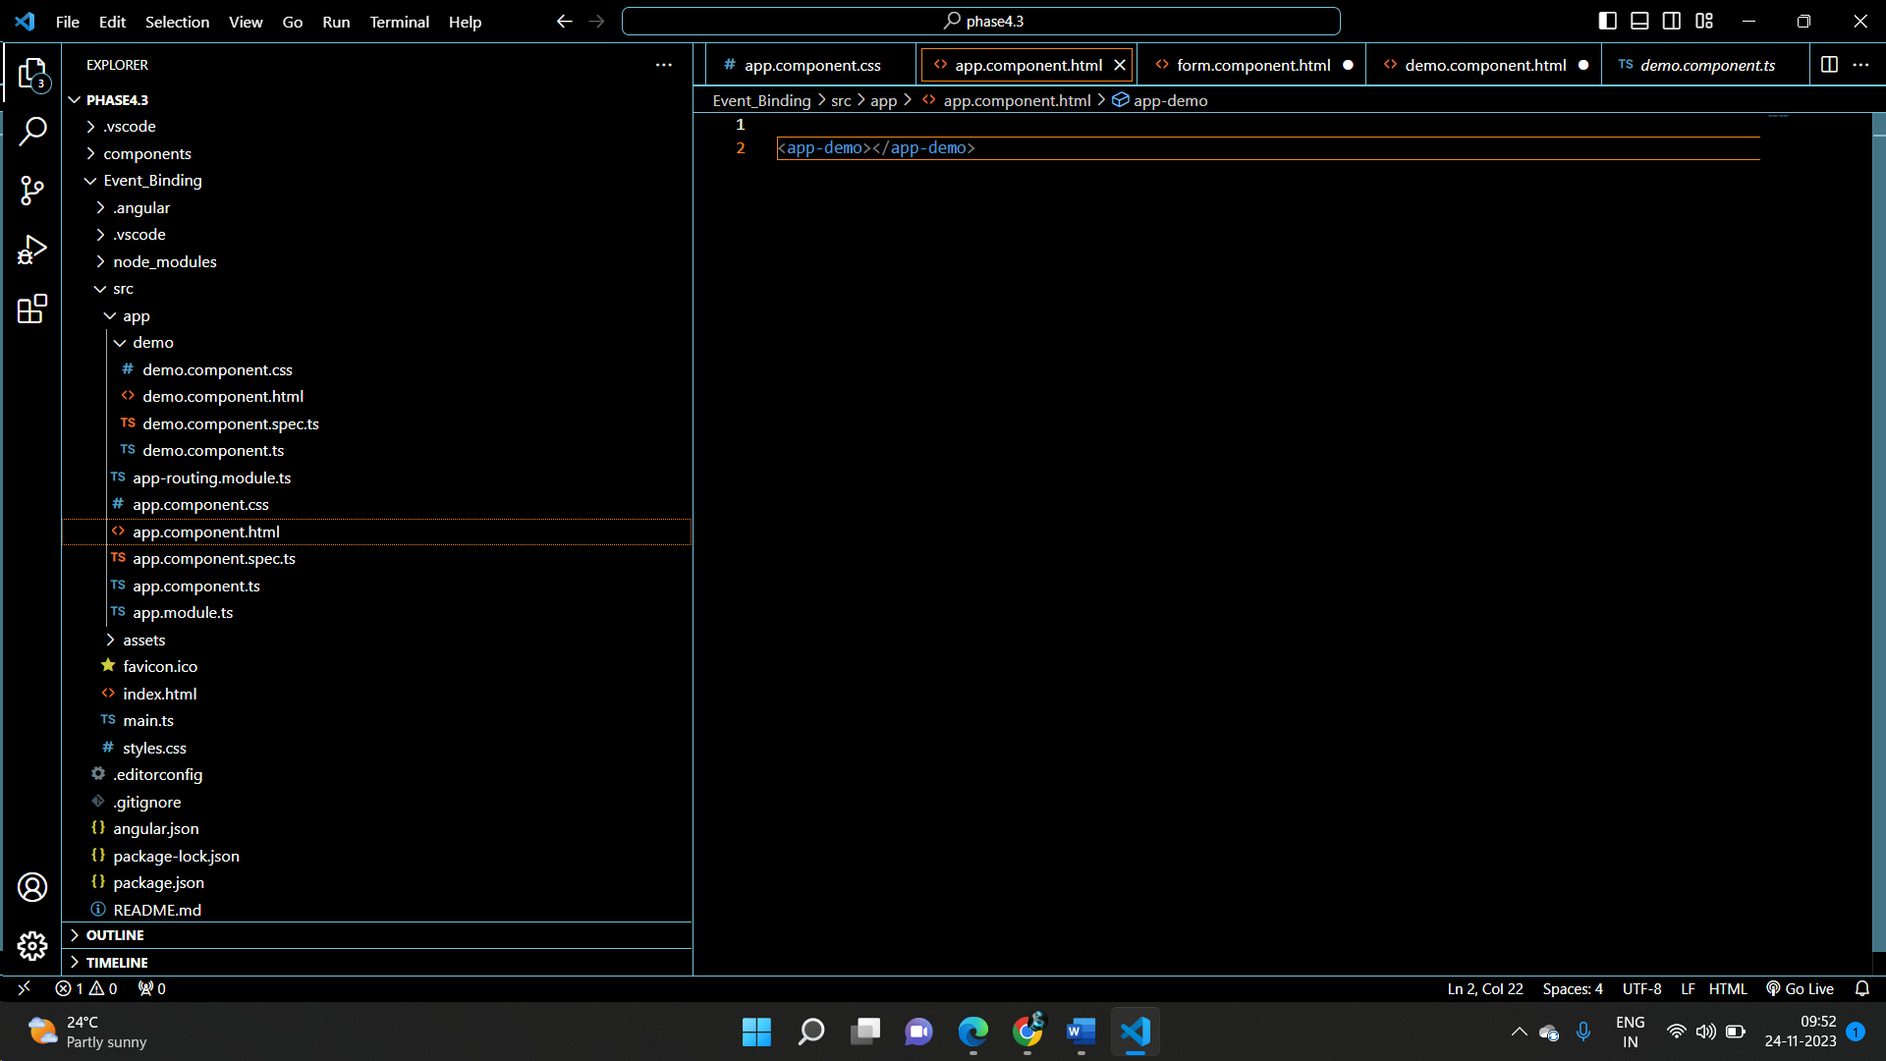

Step 4

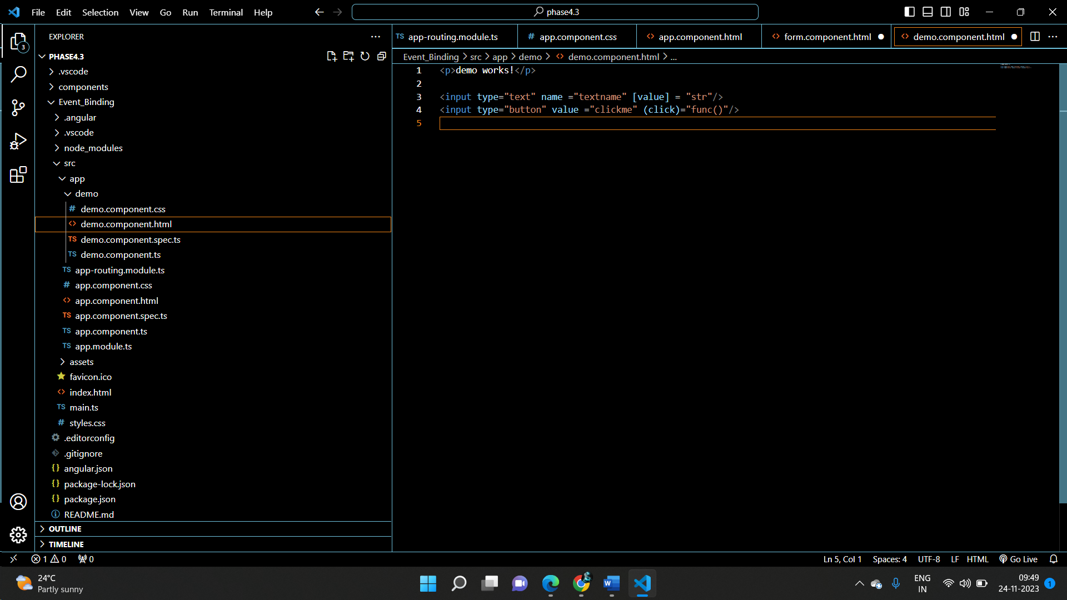

Step 5:

Demo.component.ts

import { Component } from '@angular/core';

@Component({

  selector: 'app-demo',

  templateUrl: './demo.component.html',

  styleUrls: ['./demo.component.css']

})

export class DemoComponent {

str : string ="sonika";

func():void{

  this.str="shetty";

}

}