Property-binding

Step 1 : create angular project

Step 2 : use command ng g component product

Step 3 : app.component.html

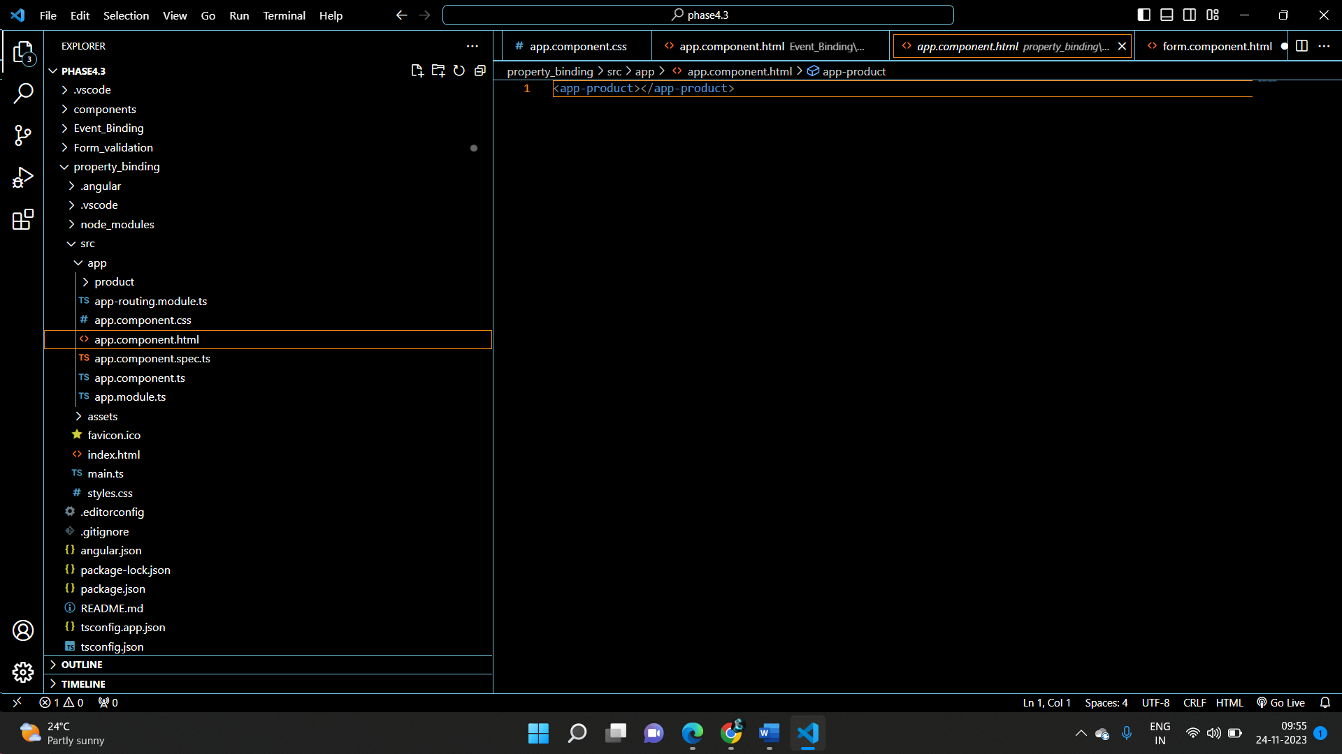

Step 4 :product.component.html

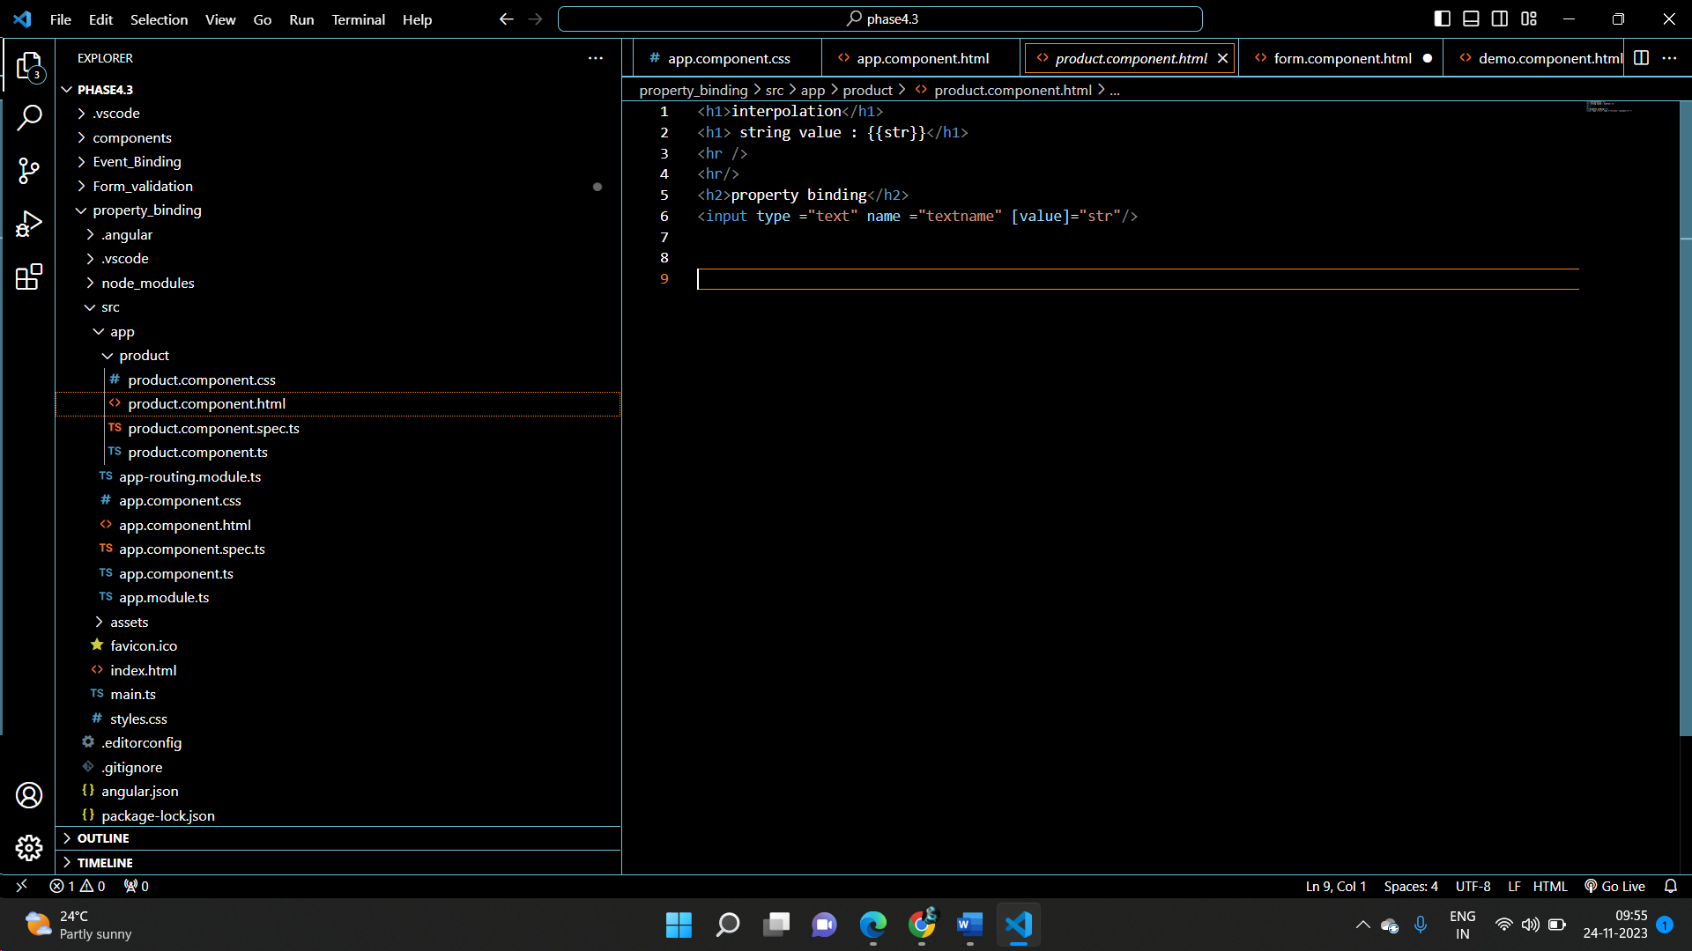

Step 5:product.component.ts

