Two-way-binding

Step 1 : create angular project

Step 2 : use command ng g component demo

Step 3 : app.component.html

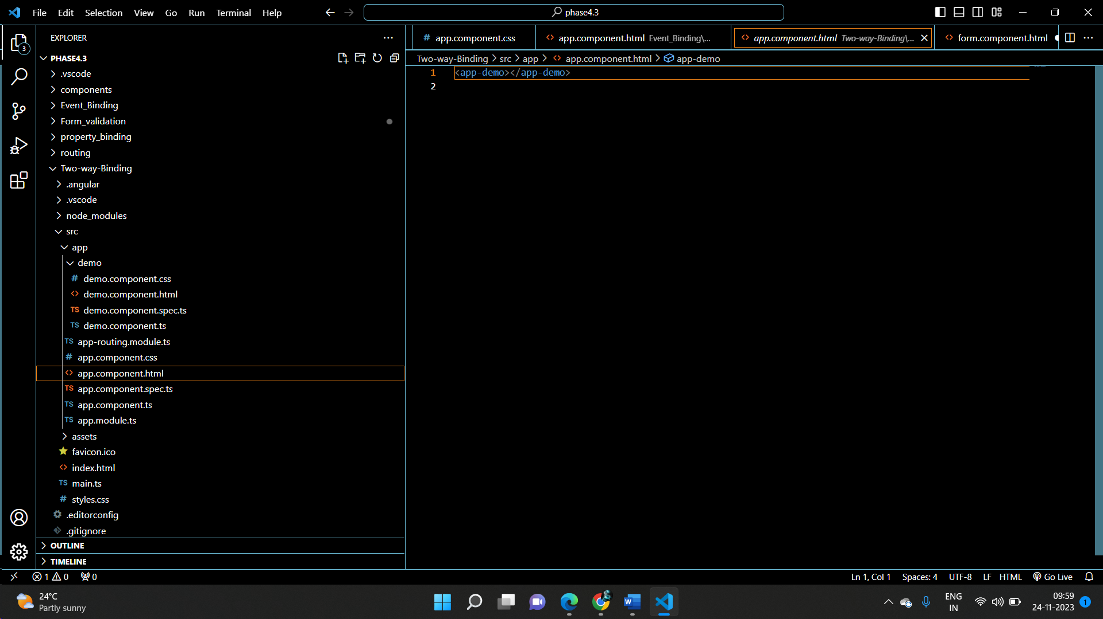

Step 4 : demo.component.html

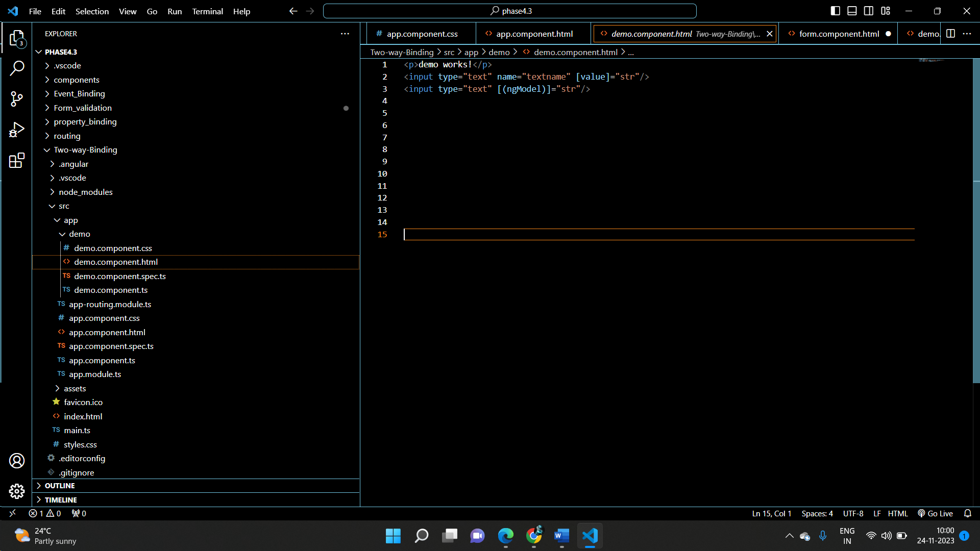

Step5 : demo.component.ts

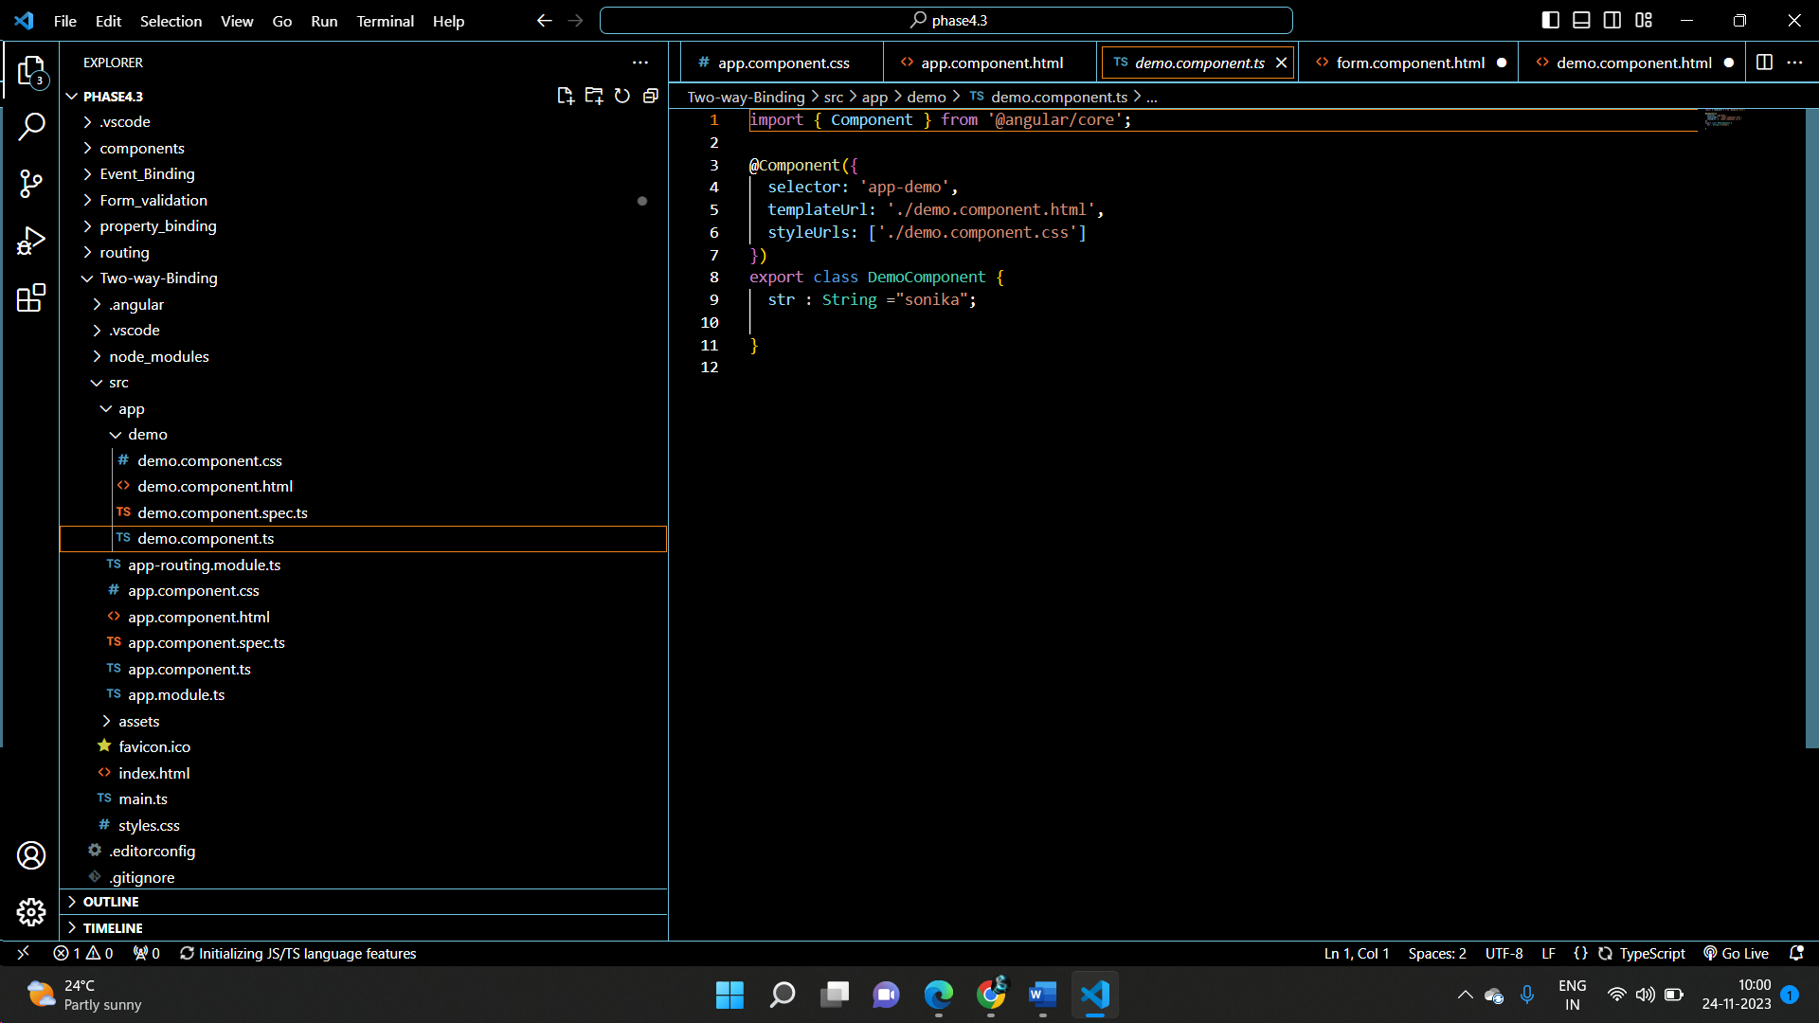

Step 6 :app.module.ts

import { NgModule } from '@angular/core';

import { BrowserModule } from '@angular/platform-browser';

import { FormsModule} from '@angular/forms';

import { AppRoutingModule } from './app-routing.module';

import { AppComponent } from './app.component';

import { DemoComponent } from './demo/demo.component';

@NgModule({

  declarations: [

    AppComponent,

    DemoComponent

  ],

  imports: [

    BrowserModule,

    AppRoutingModule,

    FormsModule

  ],

  providers: [],

  bootstrap: [AppComponent]

})

export class AppModule { }