TRIBHUVAN UNIVERSITY
INSTITUTE OF ENGINEERING (IOE)
PASHCHIMANCHAL CAMPUS
DEPARTMENT OF CIVIL ENGINEERING

Lamachaur-16, Pokhara

Mini Project on Water Supply
(Rupa Rural Municipality, Kaski)

Prepared by:
Sonika Dhungana
(Roll no- PAS078BCE129)

Submitted to:
Er. Sunil Rakhal
Department of Civil Engineering, WRC
Date: 2081/04/

CONTENTS
INTRODUCTION 3
OBJECTIVE OF THE PROJECT 3
GENERAL DETAILS OF PROJECT AREA 3
PRELIMINARY DATA…….…………………………………………………………………6
WATER DEMAND 6
Population status 6
Domestic Demand (DD) 7
Livestock Demand (LD) 7
Commercial Demand (CD) 7
Fire Demand (FD) 8
Municipal Demand (MD) and Loss and Wastage Demand (LW)………………………..…8
Total Demand (TD) 8
SOURCE OF WATER SUPPLY 9
INTAKE 9
PIPE DESIGN: INTAKE TO TREATMENT PLANT……………………………………….10
WATER TREATMENT 11
Screening………………………………………………………………………………..…13
Sedimentation 13
Sedimentation with coagulation and flocculation……………………………..……….....14
Filtration…….…………………………………………………………………………….15
Disinfection……………………………………………………………………………….17
Clear Water Reservoir 17
DISTRIBUTION SYSTEM 18
Service Reservoirs 18
Pipe Design 21
Diameter of pipes 24
CONCLUSION………………………………………………………………………………25

INTRODUCTION
Water is the most important requirement for human life to exist. Two thirds of the earth’s surface is covered by water and the human body consists of 75% of it. Water is a must essential thing in our day-to-day life as it is involved in every activity like cooking, agriculture, industrial processes, firefighting and many other recreational processes. The significance of water extends beyond daily needs, as the very development of human settlements has historically hinged on proximity to reliable water sources. This principle holds true for urban centers and rural communities alike, highlighting the necessity of effective water supply systems.

OBJECTIVE OF THE PROJECT
This report of the water supply project is prepared to supply safe and wholesome drinking water to the people residing in ward no 5 and 6 of Rupa Gaunpalika. It contains a general outline and designs of the whole water supply system using the area’s own natural resource, thus ensuring access to safe water to improve their quality of life and sanitation.

GENERAL DETAILS OF PROJET AREA:
Rupa Rural Municipality (Rupa Gaupalika) is a Gaupalika in Kaski District in Gandaki Province of Nepal. On 12 March 2017, the government of Nepal implemented a new local administrative structure, in which VDCs have been replaced with municipal and Village Councils. Rupa is one of these 753 local units. It has been divided into 7 wards and has an area of 94.8 km².
Rupa experiences a subtropical highland climate, which is characterized by moderate temperatures and distinct seasonal variations. The average annual temperature ranges between 15°C to 25°C (59°F to 77°F). Humidity levels are high during the monsoon season due to heavy rainfall, in other seasons, humidity is relatively moderate. The region's climatic conditions, characterized by a heavy monsoon season and a mild winter, create challenges in ensuring consistent water supply throughout the year.
This is the water supply project targeted at two of the wards of the Rupa, ward no 5 and ward no 6. The total area of the project is 35.34 km², ward no 5 having 16.79 km² and ward no 6 having 18.55 km². With reference to population and housing census 2021, 5590 people are residing in Rupa rural municipality wards 5 and 6 combined. Population density is 157 and the average household size is 4.12.

As per the National Census,2021:
Total population = 5590, Ward no 5 has a population of 2199 and ward no 6 has a population of 3391.
Ward no | Households | Main source of drinking water
 |  | Tap/piped water (within premises) | Tap/piped water (outside premises) | Tubewell / handpump | Covered well / Kuwa | Uncovered well / Kuwa | Spout water | River /stream | Jar / bottle | Others
5 | 603 | 397 | 179 | 0 | 1 | 6 | 15 | 3 | 0 | 2
6 | 739 | 677 | 30 | 1 | 1 | 27 | 1 | 0 | 0 | 2
Total | 1342 | 1074 | 209 | 1 | 1 | 33 | 16 | 3 | 0 | 4

Despite the presence of natural water sources such as rivers and springs, the current water supply infrastructure is inadequate to meet the growing demands of the community. During dry seasons, water is less, which makes it hard to provide a steady and fair supply of water.

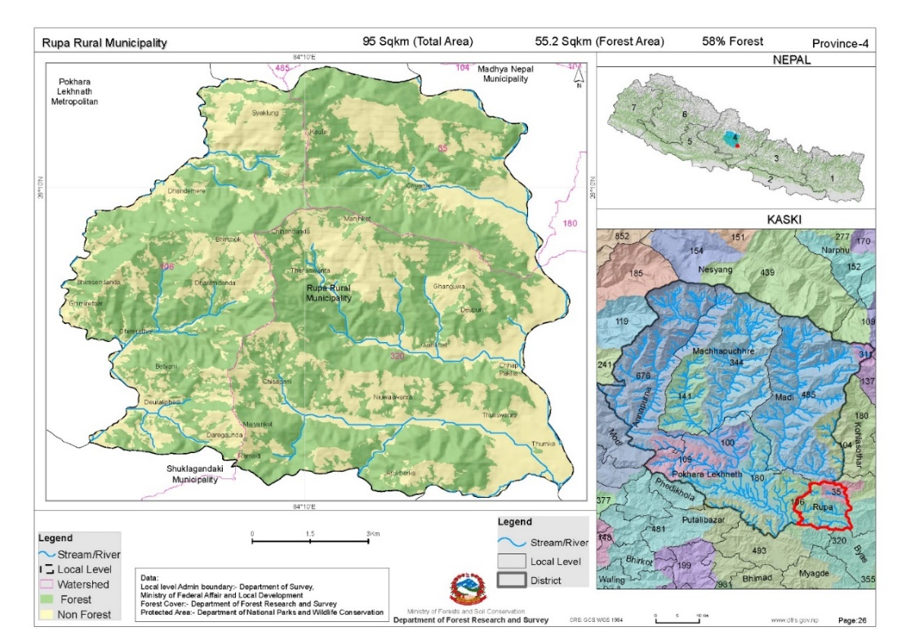 - Figure = Location of Rupa Rural Municipality in Nepal.
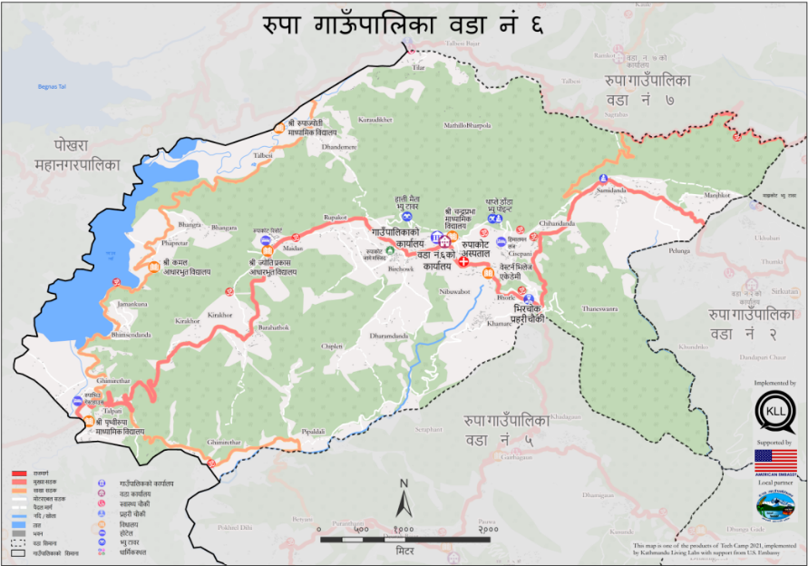

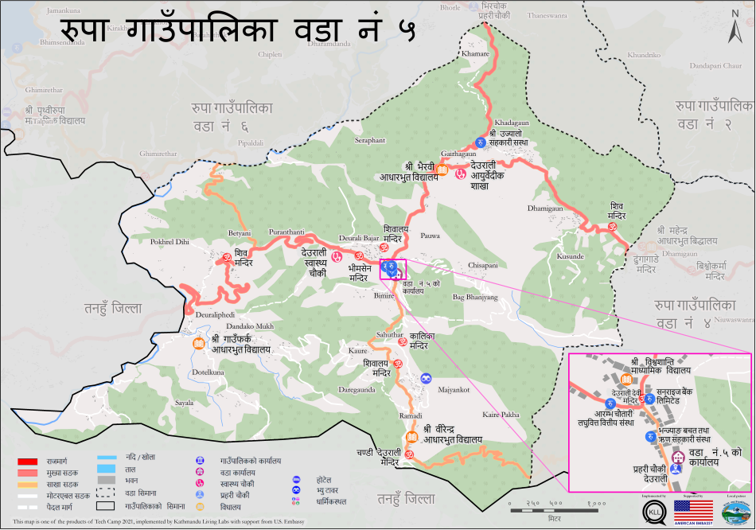

- Figure = Wards No 5 and 6, projected area for water supply

PRELIMINARY DATA
Survey year: 2024 AD
Base Period: 2 yrs.
Design year: 2041 AD
Design Period: 15 yrs

WATER DEMAND
Population:
(Source: CBS)
Census Year (AD) | Population | Increase in population | Percentage increase (%) | Decrease in percentage increase (%)
2001 | 4981
2011 | 5331 | 350 | 7.02 %
2021 | 5590 | 259 | 4.8 % | 2.22 %

Average decrease in percentage increase in population per decade =r’ = 2.22 %
n= 2 (from 2021 to 2041)
Percentage increase in population in last decade= r_{t} =4.8 %
By using changing rate of increase method,
The prospective population at the end of the year 2041 is given by
P₂₀₄₁ = P₂₀₂₁ * (1+(r_{t}-r’) / 100)¹ * (1+ (r_{t}-2*r’) / 100)²
= 5590* (1 + (4.8-2.22)/100) * (1+(4.8-2*2.22)/100)²
= 5755
Hence, the population by the end of 2041 is 5755.

1 ) Domestic Demand (DD)
Consumption in litres per capita per day = 65 lpcd
DD = P₂₀₄₁*65
DD = 5755*65
DD = 374075 lpd = 374.075 m³/day

2 ) Livestock Demand (LD)
(Source: CBS)
Size of animals | Number of animals | Consumption per day | Demand (m³/day)
Large | 2357 | 45 l / animal / day | 106.065
Medium | 5371 | 20 l / animal / day | 107.42
Small | 15274 | 20 l / 100 animals / day | 3.054
Total | 23002 |  | 216.539 m³/day

20% of DD = 0.2 * 374.075 = 74.815 m³/day
Taking the minimum of two values, LD = 74.815 m³/day

3 ) Commercial Demand (CD)
(Source: CBS, rural municipality office)
Item | Number | Consumption | Demand (m³/day)
Day Scholars | 853 | 10 lpcd | 8.53
Offices | 3 | 700 l / day/ office | 2.1
Hospital with beds | 1(15 beds) | 500l/bed/day | 7.5
Health clinics | 2 | 2500l/day | 5
Hotel with beds | 3(142 beds) | 200l / bed/day | 28.4
Hotel without beds/ Restaurants | 11 | 500l/day | 5.5
Total |  |  | 57.03

Hence, CD = 57.03 m³/day.

4 ) Public / Municipal Demand (PD)
Public demand is taken into consideration for the fact that there are few public parks and some public view spots around the area.
PD = 5 % of TD (Let the total demand (TD) be ‘x’)
= 0.05 x

5 ) Fire Demand (FD)
The overall fire risk and incidence rates in Rupa are low. The infrastructure for firefighting is not developed. Hence, being practical / cost-effective, 5 % of total demand is taken for fire demand.
FD =5 % of TD
= 0.05 x

6 ) Loss and Wastage Demand (LW)
LW = 15 % of TD
= 0.15 x

Total Demand (TD)
DD + LD + CD + FD + PD+ LW = TD
374.075 + 74.815 + 57.03 + 0.15 x + 0.05 x + 0.05 x = x
Therefore, x = 674.56 m³/day = Total demand
= 0.674 million litres per day
= 28106.67 litres/hr
= 28.1 m³/hr

SOURCE OF WATER SUPPLY
Anpu Khola
Anpu Khola is a river that flows through Rupa Rural Municipality. The river flows through various settlements, majorly in between the projected wards providing a vital water resource for the region. It provides essential water for irrigation, domestic use, and livestock. The river also contributes significantly to the area’s biodiversity, supporting various aquatic species and plant life along its banks.
Fed by several smaller streams and rivers originating from the hills such as Ghatre khola, Sakhar khola and Kanardi khola, the flow of Anpu Khola is sustained, which continues its journey downstream, and eventually merges with the Seti Gandaki. The flow of Anpu Khola varies seasonally, with higher volumes during the monsoon and lower levels in the dry season. Despite this, it can ensure a reliable water supply for the community.

INTAKE
Intake location: 28° 07’ 58.74’’ N, 84° 07’49.96’’ E
Intake Elevation: 634 m from sea level. Type: River Intake
Intake design:
1.Intake Tower Design
Intake tower type = Wet intake tower type with Coarse Screen
Dimensions:
- Height: From reservoir base to above HFL Base Width: 3m Top Width: 2m
2. Inlet Openings
- Number of Openings: 2 at different levels.
- Opening Size: For a flow rate (Q) of 0.0078 m³/s:
  - Assume Velocity (V): 1 m/s (reasonable for intake structure to avoid excessive velocity that can cause erosion).
  - Area (A): A=QV= 0.0078 =0.0078 m²
  - Diameter of Circular Opening (D): A=πD²/4 D=0.099 m = 100 mm
  - Each opening should have a diameter of about 100 mm.
3. Screens/Trash Racks
- Vertical Bar: 10 mm Bar Spacing: 20 mm
- Screen Area: For a flow rate of 0.0078 m³/s:
  - Assume Velocity Through Screen (Vs): 0.15 m/s (to avoid clogging and ensure smooth flow).
  - Screen Area (As): As=QVs=0.052 m² Height of screen = 50 cm
  - No. of bars = Length / (10 mm + 20 mm) = (104) / 30 = 4
4. Control Gates/Valves
- Gate Type: sluice gates or butterfly valves.
- Gate Size: Should match the size of the inlet openings, 100 mm in diameter.
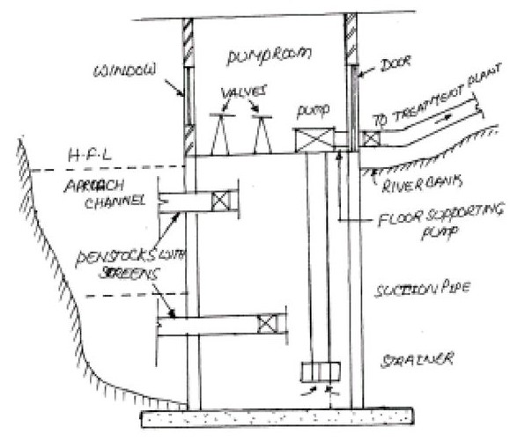 Figure = River Intake (Source : Slideplayer.com)

PIPE DESIGN: From intake to treatment plan
Flow type = Gravity
Location of treatment plant: 28° 7'55.21"N, 84° 7'45.41"E
R.L of Intake = 634 m
R.L of treatment plant = 614 m
Distance between intake and treatment plant (D)= 120 m
Residual head=10 m
Discharge(Q)= 0.0078 m³/s
Allowable Head loss= H_{La} = 634-614-10= 10m
Material used = Steel (for better long-term reliability and durability)
So, C= 140
We know, From Hazen Williams Equation,
H_{L}= 10.68 * L * Q^{1.85}
d^{4.87} C^{1.85}
Therefore, d = 0.0695386 m = 69.539 mm
Nearest standard size available = NPS 3:
Outside Diameter (OD): 88.9 mm, Wall Thickness (WT): 5.49 mm
Hence, inside dia = d = 88.9 mm - 2 * 5.49 mm = 77.92 mm is taken.

Actual head Loss (H_{L}) = 10.68 * 120 * 0.0078^{1.85}
(77.92 * 10⁻³)^{4.87} 120^{1.85}
= 5.7452 m
Residual Head loss = 634 - 614 – 5.745 = 14.255m ≥ 10m. Hence, OK
Velocity, V= Q = 4 * Q = 4 * 0.0078 = 1.635 m/s, between 0.3 and 3 m/s. Hence, OK
A π d² π * 0.07792²

Conclusion:
We are using a steel pipe with a diameter of 77.92 mm to conduct water from intake at elevation of 634 m to treatment plant at elevation of 614 m from sea level.

WATER TREATMENT
Natural water contains various types of impurities. Water treatment is a process of making the water suitable for the intended purpose by removing the impurities present in water. The figure below gives the typical schematic layout of a water treatment plant for treating surface water.

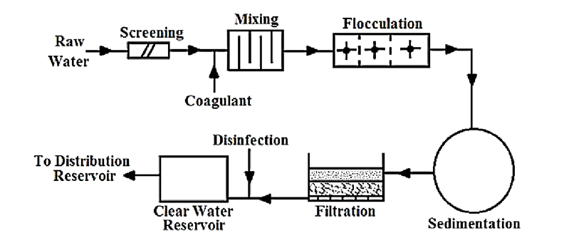
Fig- Schematic Layout of Water Treatment Plant
Source: WATER SUPPLY ENGINEERING Prof.Dr. Bhagwan Ratna Kansakar
The treatment procedures for this water supply project are described below:

1) Screening
Bar Screens have already been in the intake, so further screening in the treatment plant is not necessary. This treatment plant is designed to handle water that has already been pre-screened, focusing on further purification processes to meet water quality standards.

2 ) Sedimentation
Sedimentation tank design:
Design Type- Continuous flow type-Horizontal flow tank- rectangular tank with longitudinal flow
Design Materials- bricks or concrete
Average quantity of water to be treated per day = 674.56 m³
Q=0.0078m³/s
Taking detention period of 3 hours. (T)
Capacity of the settling tank = C = Q * T
= 0.0078 * 3 *60 *60
= 84.24 m³

If the length, breadth and depth of the tank are L, B, H respectively, then
L * B * H = 84.24---------------(i)
Assume the velocity of flow in tank as 60 mm/minute.
Length of the tank is given by L = velocity of flow * Detention period
= (60/1000) *3*60
= 10.8m
Fron equation (i), we get
10.8 * B * H = 84.24 m²
B* H = 7.79 m²
Assuming the water depth in tank as 2m, we get
B=7.79/2 = 3.9 m
As a check on the design, the surface overflow rate (S.O.R) is computed as
S.O.R = Q/BL
= 674.56/ (3.895*10.8)
= 16.035 m³/day/m² which is within the permissible limit.
Providing an extra depth of 0.5 m for sludge storage and 0.5m for freeboard,
Total depth = 2 + 0.5 + 0.5 = 3m

Conclusion:
Tank Shape: Rectangular
Dimensions:
- Length: 10.8 meters
- Width: 3.9 meters
- Depth: 3 meters
Volume: 84.24 m³
Detention Time: 3 hours
Inlet: Diffuser or baffle system for even distribution.
Outlet: Located opposite the inlet.
Sludge Management: Sloped bottom for collection and access for cleaning, Assume a 2% slope.

3) Sedimentation with Coagulation and Flocculation
The raw water sourced from Anpu Khola and local streams exhibits high turbidity, especially during the monsoon season. So. Coagulation must be implemented to ensure the delivery of clean and safe drinking water.
Coagulant - alum (aluminum sulphate)
Mixing device- Horizontal end type mixing basin with baffle walls
The usual dosage varies from 5mg/l to 30 mg/l, with 14 mg/l being average. Continuous monitoring will be conducted to adjust dosages based on incoming water quality. Jar test is done to determine the optimum amount.
Quantity of water to be treated = 674560 litre / day, if 14 mg/l is used,
Quantity of alum required per day = 14 x 674560 mg = 9.44 kg
Following this, the water will flow into a flocculation basin where paddle mixers are installed. These mixers will rotate slowly, providing gentle agitation to promote the growth of flocs. The formed flocs will then be removed through sedimentation.

4) Filtration
Filter used = Slow Sand filter

Filter design:
Water demand = 674.56 m³/day = 674560 litre / day
Peak Factor = 1.5
Maximum quantity of water to be treated = 1.5 * 674560 = 1011840 litre/day
Assume filtration rate = 150 litres/hr/m²
Surface Area, As = Q / filtration rate = (1011840 /24) / 150 = 281.07 m².
Providing 2 filter units including 1 standby,
Area of filter = 281.07 m²
Taking L= 2*B,
2 B² = 281.07 So, B = 11.8m
And L = 23.7 m

Section dimensions:
Item | Dimension(m)
Free board | 0.5
Water depth | 1.5
Sand depth | 0.6
Gravel depth | 0.6
Under-drainpipe depth | 0.2
Total depth | 3.4

Conclusion:
No of slow sand filters = 2
Dimensions = 23.7 m x 11.8 m x 3.4 m

Design of Filter media:
Top layer = Sand Thickness = 90 – 100 cm
Effective size = 0.15 to 0.35 mm
Coefficient of uniformity = Cu= 1.3 to 1.7

Likewise, Base layer = Gravel Thickness= 30 – 75 cm
Layering Arrangement:
- Fine Gravel Layer :2-5 mm gravel
- Medium Gravel Layer: 5-15 mm gravel
- Coarse Gravel Layer :15-30 mm gravel

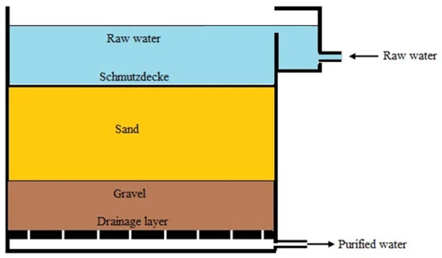 Fig- Slow Sand Filter (Source: mdpi.com)

5) Disinfection
Chlorination will be used as the primary disinfection method. Calcium hypochloride will be applied post-filtration to ensure the water is free from pathogens.
Method: Post-chlorination
Chlorine used: Bleaching powder or Calcium hypochloride (Ca (OCl)₂)

Percentage of available chlorine in bleaching powder = 30% of available chlorine
Dosage of chlorine used = 0.3 mg/l
Quantity of water to be disinfected = 674560 litre / day
So, quantity of Chlorine required per day = (0.3 x 674560) / 10⁶ kg = 0.2 kg per day
Quantity of bleaching powder required = (0.2 * 100) / 30 = 0.67 kg per day

Residual Chlorine Monitoring is done if residual chlorine in the distribution system is generally between 0.2 and 0.5 mg/L. If excess chlorine is present Dechlorination should be done using dechlorination agents like sodium bisulfite or activated carbon.

6) Clear Water Reservoir
The capacity of reservoir of daily water demand = 15 hours.
For a peak factor 1.5, volume of reservoir=42.16m³/hr.*15hr=632.4m³=633m³
taking depth of reservoir(h)= 3m
If length(L)= 2 B,
the dimension of reservoir becomes B= 10.27 m L= 20.54 m
Taking free board as 0.5 m
So, the dimensions will be 20.54 m x 10.27 m x 3.5 m.
A clear water reservoir of the above dimension is made to store the clear water obtained from the treatment of water.
Conclusion:
Capacity = 633 m³ Dimensions = 20.54 m x 10.27 m x 3.5 m.
Shape = Rectangular Material: Reinforced concrete

DISTRIBUTION SYSTEM
System type: Combined Pumped and Gravity system
Supply system: Continuous
Service Reservoirs
For Rupa Rural Municipality's wards 5 and 6, We will have two service reservoirs, one for each ward, to account for the population distribution, varying topography, and water demand.
Service Reservoir for Ward 5: Deurali Reservoir
- Serves the flat terrain and population of Ward 5.
- Location: 28° 7'24.96"N, 84° 8'44.81"E Elevation: 923 m
Service Reservoir for Ward 6: Rupakot Reservoir
- Accounts for varying elevations and larger population of Ward 6.
- Location: 28° 8'49.80"N, 84° 7'40.35"E Elevation: 1063 m

Type = Surface Reservoir, made at high elevation in both wards.

Deurali Reservoir:
For Ward 5, considering peak factor of 1.5, Maximum demand = 398.039 m³ per day.
Volume of the tank = 248.77 m³, capacity to hold our discharge for 15 hours.
Dimensions = 16.6m x 8.3 m x 2.5 m
Calculation of capacity of pump from CWR to Deurali Reservoir:
Number of pumps = 4 (1 on standby)
Running time of pumps = 7 hrs/day
Rate of pumping = 0.0157 m³/sec
Let the pipe be of diameter 154 mm, velocity in the pipe = 0.84 m/s
Quantity of water pumped = 0.0157 *60 * 60 * 7 = 398.039 m³/day
Head loss in pumping to elevated reservoir = (flQ²) / (12.1D⁵)
= (0.02* 1915 *0.0157²) / (12.1*0.1⁵)
= 9 m
Total head to be pumped = 923m−613m + 9m = 319 m
Efficiency of pump (μ) = 0.70
Using pump in series, each of head 80 m max,
Individual pump power required = (q_{(m}³_{/hr)} x ρ_{(kg/m}³₎ x g_{(m}²_{/s)} x h_{(m)}) / (3600000 * μ)
= (16.58 *1000*9.81* 80) / (3600000 * 0.7)
= 5.16 Kw
= 6.92 hp
Diameter of pipe = 154 mm, Steel pipes, Pump Power = 6.92 hp, Pump no = 4(one on standby)

Design of Service Reservoir hourly consumption table
Time  (hr) | Duration (hrs) | Demand  (%) | Demand  (m³) | Cumulative Demand  (m³) | Supply  (m³) | Cumulative Supply  (m³) | Cumulative Surplus  (m³) | Cumulative Deficit  (m³)
5-7 | 2 | 16 | 63.68 | 63.68 | 98.24 | 98.24 | 34.56 | -
7-12 | 5 | 30 | 119.41 | 183.09 | 54.46 | 152.7 | - | 30.39
12-17 | 5 | 14 | 55.72 | 238.81 | 96.58 | 249.28 | 10.47 | -
17-19 | 2 | 30 | 119.411 | 358.221 | 54.46 | 303.74 | - | 54.481
19-5 | 10 | 10 | 39.8 | 398.03 | 94.29 | 398.03 | 0 | -
Total | 24 | 100 | 398.03 |  | 398.03

Here,
Maximum cumulative surplus (MCS) = 34.56 m³
Maximum cumulative deficit (MCD)= 54.481 m³

Therefore,
Capacity of balancing reservoir = MCS + MCD- Total Supply + Total demand
= 34.56 + 54.481
= 89.04 m³

Rupakot Reservoir:
For Ward 6, considering peak factor of 1.5, Maximum demand = 613.801 m³ per day.
Volume of the tank = 383.63 m³, capacity to hold our discharge for 15 hours.
Dimensions = 17.51 m x 8.75 m x 3 m
Calculation of capacity of pump from CWR to Rupakot Reservoir:
Number of pumps = 7 (1 on standby)
Running time of pump = 7 hrs/day Rate of pumping = 0.024 m³/sec
Let the pipe be of diameter 154 mm, velocity in the pipe = 1.288 m/s
Quantity of water pumped = 0.024*60 * 60 * 7 = 613.801 m³/day
Head loss in pumping to elevated reservoir = (flQ²) / (12.1D⁵)
= (0.02* 1701 *0.024²) / (12.1*0.12⁵)
= 18.69 m
Total head to be pumped = 1063 m – 613 m + 18.69 m = 468.69 m
Efficiency of pump (μ) = 0.7
Using pump in series, 5 of head 80 m max and 1 of maximum head 70 m.
pump power required for 80m head = (q_{(m}³_{/hr)} x ρ_{(kg/m}³₎ x g_{(m}²_{/s)} x h_{(m)}) / (3600000 * μ)
= (25.58 *1000*9.81* 80) / (3600000 * 0.7)
= 7.96 Kw = 10.67 hp
Similarly, for 70m head pump = 6.96 kW = 9.33 hp.
Diameter of pipe = 120 mm, Steel pipes, Pump no = 7.

Design of Service Reservoir hourly consumption table
Time  (hr) | Duration  (hr) | Demand  (%) | Demand  (m³) | Cumulative Demand  (m³) | Supply  (m³) | Cumulative Supply  (m³) | Cumulative Surplus  (m³) | Cumulative Deficit  (m³)
5-7 | 2 | 15 | 92.07 | 92.07 | 175.42 | 175.42 | 80.35 | -
7-12 | 5 | 30 | 184.14 | 276.21 | 56.46 | 231.88 | - | 44.33
12-17 | 5 | 15 | 92.07 | 368.28 | 56.46 | 288.34 | - | 79.94
17-19 | 2 | 30 | 184.14 | 552.42 | 150.23 | 438.57 | - | 113.85
19-5 | 10 | 10 | 61.38 | 613.801 | 175.42 | 614 | 0.2 | -
Total | 24 | 100 | 613.801 |  | 614
Here,
Maximum cumulative surplus (MCS) = 80.35 m³
Maximum cumulative deficit (MCD)= 113.85m3
Therefore,
Capacity of balancing reservoir = MCS + MCD- Total Supply + Total demand
= 80.35 + 113.85 – 0.2
= 194 m³
PIPE DESIGN:

SN | Reservoir | Pipelines | Population | Demand  (m^3/day) | Distance of  nodes | Elevation
1) | Deurali  (923 m) | Betyani - Dotelkuna | 1176 | 209.03 - 60 | 1376m - 950m | 781m -721m
 |  | Khadgaun | 1023 | 129.1 | 1736 m | 900 m
2) | Rupakot  (1063 m) | Bhirchowk- Chisapani | 2645 | 200.6 -202.2 | 1781m-1150m | 1020m - 992m
 |  | Rupakot Locality | 745 | 201 | 573m | 994m

Deurali-Betyani-Dotelkuna
Deurali- Betyani:
Elevation Difference = 142 m, So, we will use Break Pressure Tank ,BPT in the RL 852 m at distance 380m.
Minimum Pressure Required = 10 m

Deurali – BPT 1
Q = 209.03 + 60 = 269.03 m³/day = 0.00311 m³/s.
Allowable Head loss = 923-852 - 10 = 61 m
Distance = L = 380 m
From Hazen Williams Equation, C = 140 for HDPE pipes,
Diameter = d = 0.05 m =50 mm
Actual head loss (H) = 21.65 m
Check for velocity(V)= 1.58 m/s (0.3-3m/s)

Similarly, from BPT 1 to (Betyani)
Allowable Head Loss = 852-781- 10 = 61 m Distance = 996 m
From Hazen Williams Equation, C = 140 for HDPE pipes,
Diameter = d = 0.05 m =50 mm
Actual head loss (H) = 22.85 m
Residual head available= 71 – 22.85 = 48.14m
Check for velocity(V)= 1.58 m/s (0.3-3m/s)

Here, if water is taken from Betyani to dotelkuna, head loss = 781- 724 + 48.14 – 10 =
95.14 m. So, we again use BPT between the intervals. Let, the BPT is in distance 20 m from Betyani node. Then,

Betyani to BPT 2
Q = 60 m³/day = 0.0007 m³/s.
Minimum Pressure Required = 10 m
Allowable Head Loss = 781- 778 + 48.14 – 10 = 41.14 m Distance, L = 20 m
From Hazen Williams Equation, C = 140 for HDPE pipes,
Diameter = d = 0.015 m = 20 mm Actual head loss (H) = 11.66 m
Check for velocity(V)= 2.2 m/s (0.3-3m/s)

BPT 2 – Dotelkuna:
Q = 60 m³/day = 0.0007 m³/s.
Minimum Pressure Required = 10 m
Allowable Head loss = 778- 721 - 10 = 47 m Distance, L = 930 m
From Hazen Williams Equation, C = 140 for HDPE pipes,
Diameter = d = 0.029 m = 32 mm Actual head loss (H) = 29.5 m
Residual head available= 781- 724 – 29.5 = 27.5 m
Check for velocity(V)= 0.8 m/s (0.3-3m/s)

Deurali – Khadgaun:
Q = 129.1 m³/day = 0.0015 m³/s.
Minimum Pressure Required = 10 m
Allowable Head loss = 923 - 900 - 10 = 13 m Distance, L = 1736 m
From Hazen Williams Equation, C = 140 for HDPE pipes,
Diameter = d = 0.0575 m = 60 mm
Actual head loss (H) = 10.56 m
Residual head available= 923 - 900 – 10.56 = 12.44 m
Check for velocity(V)= 0.53 m/s (0.3-3m/s)

Rupakot-Bhirchowk-Chisapani

Rupakot- Bhirchowk
Q = 200.6 + 202.2 = 402.8 m³/day = 0.005 m³/s.
Minimum Pressure Required = 10 m
Allowable Head loss = 1063 – 1020 - 10 = 33 m Distance, L = 1781 m
From Hazen Williams Equation, C = 140 for HDPE pipes,
Diameter = d = 0.08 m = 80 mm
Actual head loss (H) = 24.77 m
Residual head available= 1063 – 1020 – 24.77 = 18.23 m
Check for velocity(V)= 0.99 m/s (0.3-3m/s)

Bhirchowk - Chisapani
Q = 202.2 m³/day = 0.0023 m³/s.
Minimum Pressure Required = 10 m
Allowable Head loss = 1020 – 992 + 18.23 - 10 = 36.23 m Distance, L = 1150 m
From Hazen Williams Equation, C = 140 for HDPE pipes,
Diameter = d = 0.05 m = 50 mm
Actual head loss (H) = 37.5 m which is greater than allowable head loss, so take d = 60 mm
Then, head loss (H) = 15.43 m
Residual head available= 1020 – 992 + 18.23 – 15.43 = 30.8 m
Check for velocity(V)= 0.81 m/s (0.3-3m/s)

Rupakot- Rupakot Locality
Q = 201 m³/day = 0.0023 m³/s.
Minimum Pressure Required = 10 m
Allowable Head loss = 1063 – 994 - 10 = 59 m Distance, L = 573 m
From Hazen Williams Equation, C = 140 for HDPE pipes,
Diameter = d = 0.039 m = 40 mm
Actual head loss (H) = 55.4 m
Residual head available = 1063 – 994 – 55.4= 13.6 m
Check for velocity(V)= 1.8 m/s (0.3-3m/s)

Distribution system conclusion
Pipeline | Length of Pipe (m) | Diameter (mm)
Rupakot-Rupakot Locality | 573 | 40
Rupakot-Bhirchowk | 1781 | 80
Bhirchowk-Chisapani | 1150 | 60
Deurali-BPT 1 | 380 | 50
BPT 1 - Betyani | 996 | 50
Betyani – BPT 2 | 20 | 20
BPT 2 - Dotelkuna | 930 | 32
Deurali-Khadgaun | 1736 | 60
Table – Distribution and diameter of pipelines

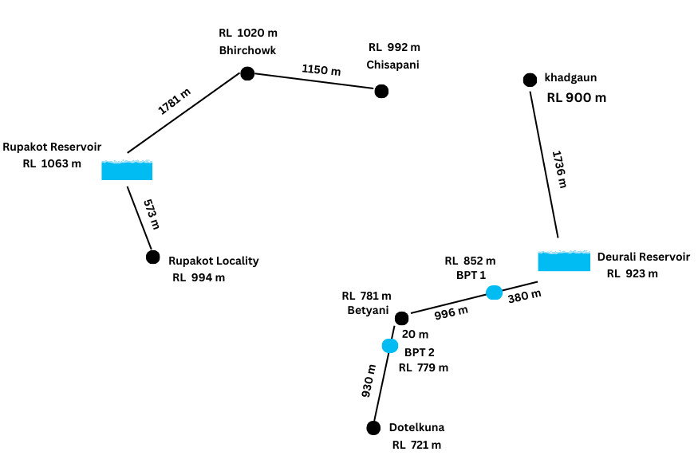 Figure – Visualization of distribution of pipelines
CONCLUSION

The water supply project for Rupa Rural Municipality represents a significant advancement in addressing the critical issue of water scarcity and improving public health standards for the residents of wards 5 and 6. Through the implementation of innovative and sustainable water management solutions, this initiative not only aims to provide a consistent and safe water supply but also to elevate the overall quality of life in the community.
The successful execution of this water supply project will pave the way for a healthier, more prosperous, and resilient Rupa Rural Municipality. It stands as a testament to the potential of collaborative efforts and innovative solutions in overcoming challenges and building a sustainable future for all residents.

