Automated Road Surface Crack and Distress Detection Using YOLOv8 and LiDAR-Based Depth Estimation
Sonika
Computer Science and Engineering (AI & ML)
Lovely Professional University
Phagwara, India
sonikadeshwal567@gmail.com

Abstract—Cracks and potholes make roads unsafe and costly to maintain. Checking them by eye is slow, so I built a system that finds road damage automatically. The system has two parts. First, a YOLOv8s model detects damage in road photos. Second, a LiDAR step measures how deep a pothole is and gives it a severity level. I trained two detectors. The pothole-only detector, trained on 1,243 images, reached a mAP50 of 0.642 on 249 images it had not seen. The five-class detector, trained for 15 epochs on 3,000 images from the RDD2022 dataset, reached a mAP50 of 0.384 on 600 unseen images. For the LiDAR part I used a simulated road with two potholes of known size. RANSAC and DBSCAN found both potholes, the depth was 6 mm too high in each case, the area error was under 7%, and both severity levels were correct. The LiDAR data is simulated because I could not find public road LiDAR with damage labels, so a test on real sensor data is future work.
Keywords—road damage detection, pothole, crack, YOLOv8, LiDAR, point cloud, RANSAC, DBSCAN

I. Introduction
Roads get damaged over time. Cracks appear first, and later potholes form. Damaged roads are unsafe for drivers, and fixing them late costs more money. Most roads are still checked by people who walk or drive along them and rate the damage by eye. This is slow, it depends on who is checking, and it is not always safe for the inspector.
Vehicles that carry cameras and LiDAR sensors can record a whole road network quickly. The problem is that someone then has to find the damage in a very large amount of data. I wanted to automate this step.
Images and LiDAR are good at different things. A photo shows texture and thin cracks, but it gives no depth, and it works badly in shadows or poor light. LiDAR measures distance directly, so it can give the depth of a pothole, but it is weak at very thin cracks. In this work I use each one for what it does best. The image model finds and names the damage, and the LiDAR step measures how serious it is.
My contributions are:
- Two YOLOv8s detectors, one for potholes only and one for five damage classes from RDD2022, both tested on images they did not train on.
- A LiDAR step using RANSAC and DBSCAN that gives the depth, area and severity of each pothole, checked against known values in a simulated scene.
- A notebook that can be run again, and an honest list of the limits of this study.

II. Literature Review
RDD2022 is a road damage dataset from several countries, with a box drawn around each damaged area. Its standard categories are longitudinal crack (D00), transverse crack (D10), alligator crack (D20) and pothole (D40). The YOLO-format copy I used has images from the Czech Republic, India, Japan, Norway, the United States and China, and it labels five class ids [1].
An earlier study collected road images with smartphones fixed inside vehicles and trained deep neural networks to find and classify road damage. It showed that cheap cameras can be used for large-scale road checking [2].
YOLO treats object detection as one regression problem, from image pixels to boxes and class probabilities. This makes it fast enough for real-time use [3].
YOLOv8 is a recent version of this family. It is released through the Ultralytics library with pretrained weights and tools for training and testing, and it is the detector I used [4].
RANSAC fits a model to data that has many outliers. It picks a small random sample, builds a model, counts how many points agree with it, and repeats this to keep the best model. I use it to fit the road plane, even though the damaged points lie away from that plane [5].
DBSCAN groups points that are packed closely together and treats isolated points as noise. It does not need the number of clusters in advance. I use it to separate one pothole from another [6].
The KITTI benchmark gives camera and LiDAR recordings that are matched in time, together with calibration. With calibration, LiDAR points can be projected into the camera image. This is how I plan to join the two parts in future work [7].
For the pothole-only experiment I used a public dataset of 1,243 labelled pothole images in YOLO format [8].
The works above deal with image detection and 3D geometry separately. In this paper I put them in one system and report the results, including where it does not work well.

III. Methodology

A. Flowchart
Fig. 1 shows how the system works. It has two branches. In the image branch, a road photo goes into the YOLOv8s model, which gives boxes and classes. In the LiDAR branch, a road point cloud goes through plane fitting, clustering and a depth rule. Both results go into one report.
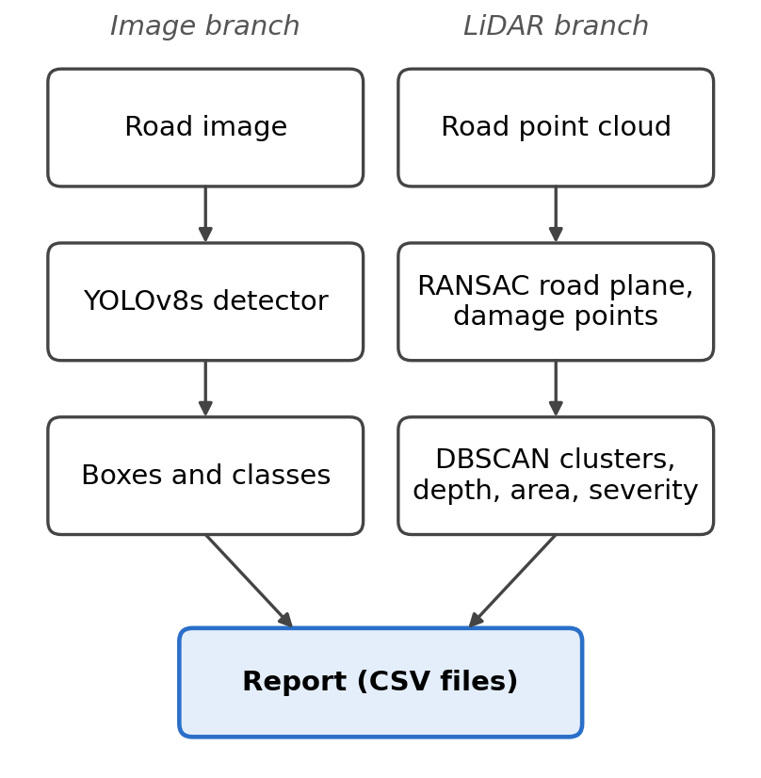
Fig. 1. Flowchart of the road damage detection system.

B. Algorithm
- Load the trained YOLOv8s weights and set the confidence threshold and image size.
- Run the detector on each road image. Keep the boxes above the confidence threshold, with their class and confidence.
- Load the point cloud of the same road section.
- Fit a plane to the points with RANSAC and find each point’s distance from the plane.
- Keep the points that are more than 1.5 cm from the plane. These are the damage points.
- Group the damage points with DBSCAN (eps 0.08 m, at least 8 points). Each cluster is one pothole.
- For each cluster, take the depth as the largest distance from the plane, and the area as the number of points times the area one point covers.
- Give a severity level: LOW below 25 mm, MEDIUM from 25 to 50 mm, HIGH above 50 mm.
- Save the image detections and the LiDAR results as CSV files.

C. Sampling Method
I did not have enough time to train on all of RDD2022, so I used a random sample of 3,000 training images and 600 validation images, chosen with seed 42. Every image had the same chance of being picked. I split the pothole dataset at random into 80% training and 20% validation. I used public datasets because I could not collect road data myself. The sample was not balanced by country or by class, so it may not represent the full dataset. A better plan is a balanced sample and the official test split.

D. Dataset
Experiment A. The public pothole dataset [8] has 1,243 images in YOLO format with one class. I used 994 images for training and 249 for validation. The validation set has 898 pothole boxes.
Experiment B. The YOLO-format RDD2022 data [1] has 26,869 training, 5,758 validation and 5,758 test images. I used 3,000 training and 600 validation images. In my sample, 916 training images and 188 validation images have no damage at all. The validation set has 988 boxes. I did not use the official test split.
The labels use five class ids, 0 to 4, with no names. I named them by looking at example images with their boxes: 0 is longitudinal crack, 1 is transverse crack, 2 is alligator crack, 3 is pothole and 4 is other. I am less sure about the names of classes 3 and 4 than about the first three.
In both experiments I used the same validation images to pick the best model and to report the results, so the scores may be a little higher than they would be on a fresh test set.
TABLE I
Datasets used in the two experiments
Exp. | Source | Train images | Val. images | Classes | Val. boxes
A | Pothole dataset [8] | 994 | 249 | 1 | 898
B | RDD2022 subset [1] | 3,000 | 600 | 5 | 988

E. Model Used
I used YOLOv8s [4], a one-stage detector that predicts boxes and classes in one pass [3]. I started from weights that were already trained on the COCO dataset and fine-tuned them on road images. The image size was 640 and the batch size was 16. The optimizer was chosen automatically by the Ultralytics library. I used the default augmentations (mosaic, colour changes and horizontal flip). Experiment A ran for 30 epochs. Experiment B ran for 15 epochs with early stopping (patience 10). Both ran on a Tesla T4 GPU, and Experiment B took 0.184 hours. I report precision, recall, mAP50 and mAP50-95.

F. LiDAR Depth and Severity Model
I could not find public road LiDAR data with damage labels, so I made a simulated scene. It has 60,000 points spread over a road 10 m long and 4 m wide, with 2 mm of random height noise. I cut two round potholes in it. The first is at (3.0 m, 1.5 m) with radius 0.25 m and depth 60 mm. The second is at (7.0 m, 2.8 m) with radius 0.18 m and depth 30 mm.
I fitted the road plane with RANSAC [5], using 300 tries and an inlier distance of 1 cm. Points more than 1.5 cm from the plane were treated as damage. DBSCAN [6] then grouped these points, so each pothole became one cluster. For each cluster, the depth is the largest distance from the plane, and the area is the number of points times 6.67 cm², which is the area one point covers. I chose the severity limits (25 mm and 50 mm) myself to show the idea. They do not come from a road standard.

IV. Results and Discussion

A. Comparison Table
Table II compares the design of manual inspection, image-only detection and my system. It compares features only, not measured performance. The depth part of my system has been tested only on simulated LiDAR.
TABLE II
Comparison of three approaches
Feature | Manual inspection | Image only | Proposed system
Damage detection | By the inspector | Automatic | Automatic
Damage type | By the inspector | Automatic | Automatic
Depth and area | By hand, slow | Not available | LiDAR (simulated)
Severity | Subjective | Not available | Rule from depth
Poor light | Limited | Limited | Depth not affected by light

B. Detection Accuracy
Table III shows the results on the validation images. The pothole detector scored higher (mAP50 0.642) than the five-class detector (0.384). These two numbers should not be compared directly, because the datasets, the number of classes, the number of epochs and the validation images are all different.
TABLE III
Detection accuracy on validation images
Experiment | Precision | Recall | mAP50 | mAP50-95
A: pothole, 1 class | 0.659 | 0.592 | 0.642 | 0.320
B: RDD2022, 5 classes | 0.480 | 0.412 | 0.384 | 0.184

C. Per-Class Results
Table IV gives the mAP50 of each class in Experiment B. The pothole class (id 3) did best at 0.521. Class 4 did worst at 0.251, and it also has the fewest validation boxes (85). This fits the idea that less data gives lower accuracy, but I did not test it.
TABLE IV
Per-class mAP50, Experiment B
Id | Damage type | Val. boxes | mAP50
0 | Longitudinal crack | 372 | 0.394
1 | Transverse crack | 176 | 0.287
2 | Alligator crack | 185 | 0.464
3 | Pothole | 170 | 0.521
4 | Other | 85 | 0.251

Fig. 2 shows how the training loss and the validation scores changed over the 15 epochs. The mAP50 went from 0.062 after the first epoch to 0.385 after the last one, and it was still going up. So the model had not finished learning. In my two validation runs, the speed was about 5 to 8 ms per image on the T4 GPU.
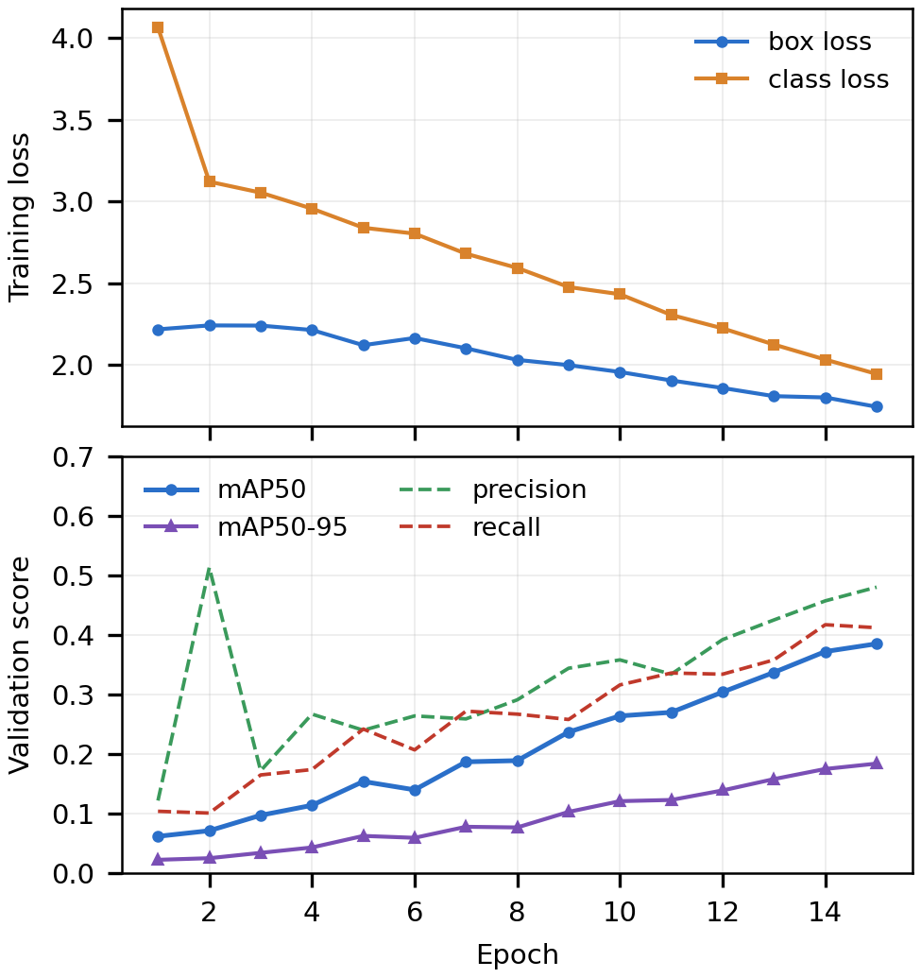
Fig. 2. Training loss and validation scores per epoch, Experiment B (plotted from the training log).

D. LiDAR Depth and Severity
Table V compares the true values of the simulated potholes with the values my method measured. The method found both potholes and made no false clusters. The depth was 6 mm too high for both. The area errors were −3.6% and +6.1%. Both severity levels were correct. Fig. 3 shows the simulated road, where the potholes are the bright patches.
TABLE V
LiDAR results on the simulated scene
Pothole | Depth, true / found (mm) | Area, true / found (cm²) | Severity
1 | 60 / 66 | 1,963 / 1,893 | HIGH
2 | 30 / 36 | 1,018 / 1,080 | MEDIUM

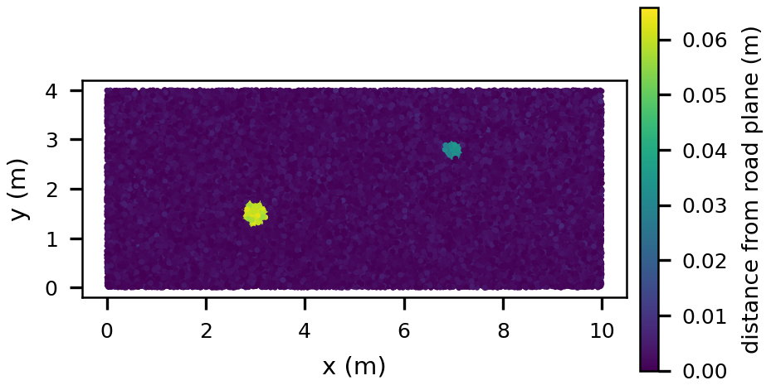
Fig. 3. Simulated road point cloud. The colour shows the distance from the fitted road plane.
The depth is too high because I used the largest distance in each cluster. This picks up the largest noise value, which is about three times the 2 mm noise, so about 6 mm. Using the mean of the deepest 5% of points would probably reduce this error.

E. Qualitative Observations
I also tried the models on a few photos of my own. In one photo with several small potholes far away, the pothole model found only two of them. In a photo with a clear crack, the pothole model found nothing, because it only knows potholes. These were informal checks and I did not measure them.

F. Explanation of Results and Discussion
The pothole model has a recall of 0.592, so it misses about 4 of every 10 potholes. This matches the far-away potholes it missed in my photo. The five-class model is the weaker one, but its mAP50 was still rising when training stopped, so longer training is the easiest way to improve it. The results are not strong yet, but they show that the full idea can work step by step: images find and name the damage, and the point cloud gives the depth and severity.

G. Limitations
- The LiDAR results come from a simulated scene with a flat road and round potholes. They show that the method works, but they say nothing about how it works with a real sensor.
- The image detections and the LiDAR measurements are not joined. The two parts run separately.
- I trained on subsets for a short time, with one run each, so I have no repeated runs or cross-validation.
- The validation images were also used to pick the best model, and I did not test on the official test split.
- The names of classes 3 and 4 come from a few example images and are less certain.
- The severity limits are my own and are not calibrated against a road condition standard.
- I did not measure crack width or length, because the detector gives boxes and not masks.

V. Conclusion and Future Scope
In this work I built a system that detects road damage in images with YOLOv8s and measures pothole depth, area and severity from a point cloud with RANSAC and DBSCAN. The pothole detector reached a mAP50 of 0.642 and the five-class detector reached 0.384 on images they had not trained on. On the simulated road, the LiDAR step found both potholes and gave the right severity to each.
In future work I want to: (1) test the method on real mobile mapping LiDAR; (2) project the LiDAR points into the image using calibration, as in KITTI [7], so that each detected box gets a measured depth; (3) train longer on more of RDD2022 and test on the official test split; (4) use segmentation to measure crack width and length; and (5) set the severity limits from a road condition standard.

References
[1] D. Arya, H. Maeda, S. K. Ghosh, D. Toshniwal and Y. Sekimoto, “RDD2022: A multi-national image dataset for automatic road damage detection,” Geoscience Data Journal, 2024.
[2] H. Maeda, Y. Sekimoto, T. Seto, T. Kashiyama and H. Omata, “Road damage detection and classification using deep neural networks with smartphone images,” Computer-Aided Civil and Infrastructure Engineering, vol. 33, no. 12, pp. 1127–1141, 2018.
[3] J. Redmon, S. Divvala, R. Girshick and A. Farhadi, “You only look once: unified, real-time object detection,” in Proc. IEEE Conf. Computer Vision and Pattern Recognition (CVPR), 2016, pp. 779–788.
[4] G. Jocher, A. Chaurasia and J. Qiu, “Ultralytics YOLOv8,” 2023. [Online]. Available: https://github.com/ultralytics/ultralytics
[5] M. A. Fischler and R. C. Bolles, “Random sample consensus: a paradigm for model fitting with applications to image analysis and automated cartography,” Communications of the ACM, vol. 24, no. 6, pp. 381–395, 1981.
[6] M. Ester, H.-P. Kriegel, J. Sander and X. Xu, “A density-based algorithm for discovering clusters in large spatial databases with noise,” in Proc. KDD, 1996, pp. 226–231.
[7] A. Geiger, P. Lenz, C. Stiller and R. Urtasun, “Vision meets robotics: the KITTI dataset,” International Journal of Robotics Research, vol. 32, no. 11, pp. 1231–1237, 2013.
[8] J. Gala, “pothole-detection,” GitHub repository (public pothole dataset, YOLO format). [Online]. Available: https://github.com/jaygala24/pothole-detection

