Training Evidence Report
YOLOv8s road damage detection: training logs and results
Sonika and Ayush Dobriyal, B.Tech Computer Science and Engineering (AI & ML), Lovely Professional University

1. Summary
We trained two YOLOv8s road damage detectors on a GPU and tested them on images they had not seen during training. The numbers in this report are copied from the training and validation logs of the runs, not typed by hand.
 | Experiment A: pothole | Experiment B: five classes
Data | 1,243 pothole images (public dataset) | 3,000 train + 600 val images from RDD2022
Split | 994 train / 249 validation | 3,000 train / 600 validation
Epochs | 30 | 15
Platform | Google Colab, Tesla T4 GPU | Kaggle, Tesla T4 GPU
Precision | 0.659 | 0.481
Recall | 0.592 | 0.412
mAP50 | 0.642 | 0.385
mAP50-95 | 0.320 | 0.184

2. Experiment B: five-class model on RDD2022 (Kaggle)

2.1 Environment
Item | Value (from the log)
Library | Ultralytics 8.4.197
Python / PyTorch | Python 3.13.15, torch 2.11.0+cu128
GPU | Tesla T4, 14,912 MiB, CUDA:0

2.2 Settings
Setting | Value
Starting weights | yolov8s.pt (pretrained). The log shows 349 of 355 items transferred
Epochs, batch, image size | 15 epochs, batch 16, 640 px, early-stopping patience 10
Optimizer | AdamW, chosen automatically (lr 0.001111)
Mixed precision | On (the AMP check passed)
Augmentation | Defaults: mosaic 1.0, horizontal flip 0.5, colour jitter
Classes | 5 (ids 0 to 4)

2.3 Data and model size
- Training images: 3,000 (916 contain no damage). Validation images: 600 (188 contain no damage). Corrupt images: 0.
- Model: 129 layers, 11,137,535 parameters, 28.7 GFLOPs. The saved best.pt is 22.5 MB.
- Training time: 15 epochs in 0.184 hours (about 11 minutes).

2.4 Result of every epoch
Losses are training losses. Precision, recall and mAP are measured on the 600 validation images after each epoch.
Epoch | Box loss | Class loss | DFL loss | Precision | Recall | mAP50 | mAP50-95
1 | 2.217 | 4.065 | 1.948 | 0.122 | 0.104 | 0.062 | 0.023
2 | 2.241 | 3.121 | 2.000 | 0.513 | 0.101 | 0.071 | 0.025
3 | 2.240 | 3.054 | 2.014 | 0.172 | 0.165 | 0.097 | 0.034
4 | 2.213 | 2.956 | 1.992 | 0.267 | 0.174 | 0.114 | 0.043
5 | 2.120 | 2.839 | 1.924 | 0.240 | 0.242 | 0.154 | 0.063
6 | 2.164 | 2.803 | 2.006 | 0.264 | 0.207 | 0.140 | 0.059
7 | 2.101 | 2.680 | 1.940 | 0.259 | 0.272 | 0.187 | 0.078
8 | 2.030 | 2.593 | 1.907 | 0.291 | 0.267 | 0.189 | 0.077
9 | 1.998 | 2.476 | 1.873 | 0.344 | 0.258 | 0.237 | 0.103
10 | 1.956 | 2.432 | 1.830 | 0.358 | 0.316 | 0.264 | 0.121
11 | 1.904 | 2.305 | 1.788 | 0.334 | 0.336 | 0.270 | 0.123
12 | 1.858 | 2.223 | 1.762 | 0.392 | 0.334 | 0.304 | 0.139
13 | 1.808 | 2.124 | 1.719 | 0.425 | 0.358 | 0.337 | 0.158
14 | 1.800 | 2.032 | 1.703 | 0.457 | 0.417 | 0.372 | 0.175
15 | 1.743 | 1.944 | 1.672 | 0.480 | 0.412 | 0.385 | 0.184

The validation mAP50 rose from 0.062 after epoch 1 to 0.385 after epoch 15, and the training losses fell in the same period. Figure 1 shows the same numbers as curves.
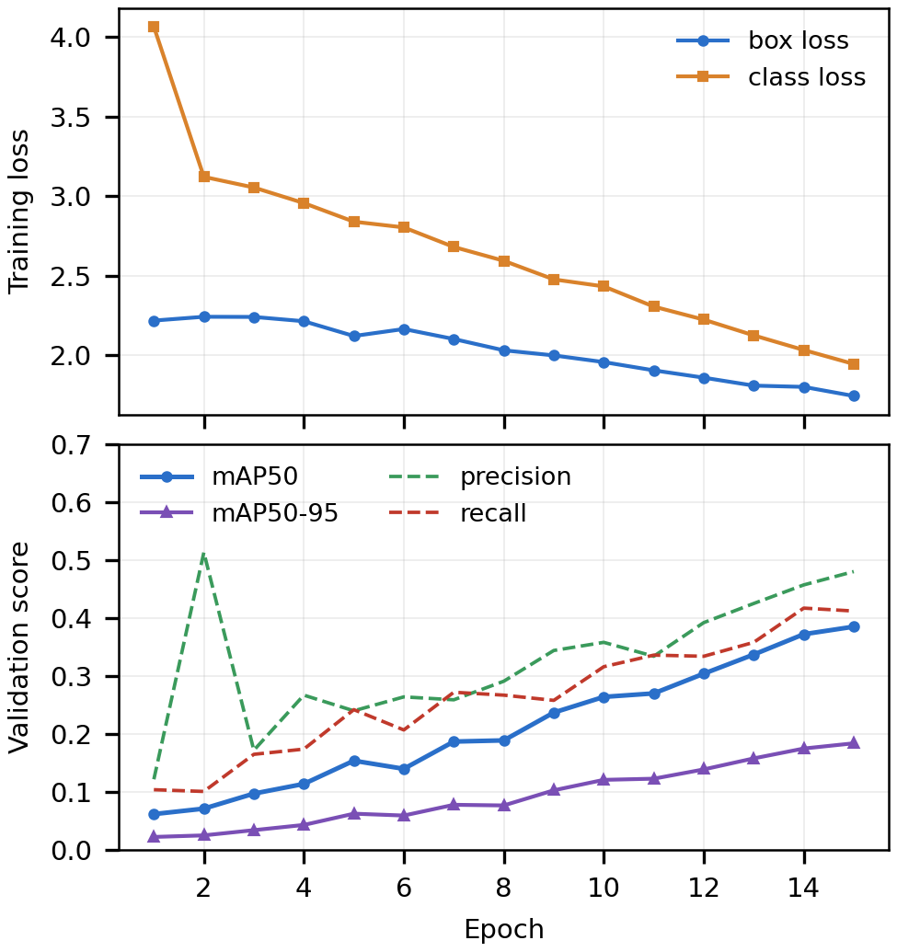
Figure 1. Training loss and validation scores per epoch (plotted from the log above).

2.5 Final validation of the best model
Class | Images | Boxes | Precision | Recall | mAP50 | mAP50-95
0 Longitudinal crack | 206 | 372 | 0.475 | 0.425 | 0.395 | 0.185
1 Transverse crack | 124 | 176 | 0.419 | 0.337 | 0.295 | 0.105
2 Alligator crack | 140 | 185 | 0.523 | 0.427 | 0.464 | 0.225
3 Pothole | 112 | 170 | 0.460 | 0.582 | 0.521 | 0.284
4 Other | 51 | 85 | 0.526 | 0.288 | 0.249 | 0.119
All classes | 600 | 988 | 0.481 | 0.412 | 0.385 | 0.184
Speed on the T4 GPU: 0.3 ms pre-processing, 5.0 ms inference, 1.0 ms post-processing per image. The names of classes 3 and 4 were given from example images and are less certain than the first three.

3. Experiment A: pothole model (Colab)
Item | Value (from the log)
Library / GPU | Ultralytics 8.4.195, Python 3.13.16, torch 2.11.0+cu130, Tesla T4 (14,913 MiB)
Data | 1,243 images split at random 80/20: 994 train, 249 validation (898 pothole boxes)
Settings | yolov8s.pt, 30 epochs, batch 16, 640 px
Model | 72 layers (fused), 11,125,971 parameters, 28.4 GFLOPs
Validation result | Precision 0.659, recall 0.592, mAP50 0.642, mAP50-95 0.320
Speed | 1.8 ms pre-processing, 8.8 ms inference, 2.4 ms post-processing per image

4. LiDAR stage (simulated road)
A simulated road of 60,000 points (10 m by 4 m, 2 mm height noise) with two potholes of known size was processed with RANSAC and DBSCAN.
Pothole | Depth, true / found (mm) | Area, true / found (cm²) | Severity
1 | 60 / 66 | 1,963 / 1,893 | HIGH
2 | 30 / 36 | 1,018 / 1,080 | MEDIUM

5. Notes
- The model file was lost when a Kaggle session ended, so training was repeated with the same settings to get best.pt again. The figures above and in the paper come from the first full run. The repeated run can differ slightly.
- The same validation images were used to choose the best model and to report results, and the official test split was not used. The scores may be a little high.
- The LiDAR data is simulated, because public road LiDAR with damage labels was not available.
- The notebook that produced these results is road_distress_detection.ipynb. Its saved outputs show the same logs.

