Swami Vivekanand College of Engineering Indore

PHYSICS DEPARTMENT



Session: July-Dec2024 LAB MANUALS
Physics (BT-201)

Submitted to: Submitted by
Mr………………… Name: RollNo:

1. Vision and Mission of Physics Department

Vision:


- To build a foundation for excellence and encourage the development of the Institution as a premier Institution by igniting and promoting enthusiasm, interests and passion, in the study of Physics, in professional courses, as a part of curriculum.

Mission:

- M1. To awaken the young minds and discover their talents both in theory and in practical Physics, through dedication to teach, commitment towards students and innovative instructional methods like PPT & Visual Aids

- M2. To support the developmental activities of the College and make the Department vibrant

- M3. To make vital contributions in areas such as faculty, modern labs, and demonstrate a high level of competence in the study of Engineering Physics.

- M4. To organize and sustain efficient operating systems in the Department for realization of our objectives as Institution of eminence and International standards.

- M5. To develop strategy in the Department for improvement

Program Outcomes:

PO1. Engineering knowledge: Apply the knowledge of mathematics, science, engineering fundamentals, and an engineering specialization to the solution of complex engineering problems.

PO2. Problem analysis: Identify, formulate, research literature, and analyze complex engineering problems reaching substantiated conclusions using first principles of mathematics, natural sciences, and engineering sciences.

PO3.Design/development of solutions: Design solutions for complex engineering problems and design system components or processes that meet the specified needs with appropriate consideration for the public health and safety, and the cultural, societal, and environmental considerations.

PO4. Conduct investigations of complex problems: Use research-based knowledge and research methods including design of experiments, analysis and interpretation of data, and synthesis of the information to provide valid conclusions.

PO5. Modern tool usage: Create, select, and apply appropriate techniques, resources, and modern engineering and IT tools including prediction and modeling to complex engineering activities with an understanding of the limitations.

PO6. The engineer and society: Apply reasoning informed by the contextual knowledge to assess societal, health, safety, legal and cultural issues and the consequent responsibilities relevant to the professional engineering practice.


PO7. Environment and sustainability: Understand the impact of the professional engineering solutions in societal and environmental contexts, and demonstrate the knowledge of, and need for sustainable development.

PO8. Ethics: Apply ethical principles and commit to professional ethics and responsibilities and norms of the engineering practice.

PO9. Individual and team work: Function effectively as an individual, and as a member or leader in diverse teams, and in multidisciplinary settings.

PO10. Communication: Communicate effectively on complex engineering activities with the engineering community and with society at large, such as, being able to comprehend and write effective reports and design documentation, make effective presentations, and give and receive clear instructions.

PO11. Project management and finance: Demonstrate knowledge and understanding of the engineering and management principles and apply these to one’s own work, as a member and leader in a team, to manage projects and in multidisciplinary environments.

PO12. Life-long learning: Recognize the need for, and have the preparation and ability to engage in independent and life-long learning in the broadest context of technological change.
.

Course Learning Objectives (CLO)
TheLearningObjectivesofBasicMechanicalEngineeringaresuchthatthestudentwill
CLO1: Understand different types of engineering material, there composition, properties and applications.
CLO2: Understand different types of measuring instruments and production processes.
CLO3: Study and understand fluid properties, its types, Bernoulli’s equation and different type of hydraulic machines.
CLO4: Understand basic concepts of thermodynamics formation of steam and use of steam table.
CLO5: Understand different type of IC engines and Air standard cycles on which the engines work.

Course Outcomes (CO)

At the end of the course, student would be able to
CO1: Know the basic concepts to understand different types of engineering material.
CO2: Use different types of measurement tools.
CO3: Get familiar with basic concepts o f fluid mechanics.
CO4: Know the thermodynamic system, processes and laws and al so the concept of steam formation.
CO5: Getfamiliar with the internal combustion engine end air standard cycles.
CO6: Expected to possess basic understanding
and knowledge about the scope, current and future trends in mechanical engineering.

Program Specific Outcome
PSO – 1: Ability to Develop and implement new ideas on product design and development with the help of modern computer aided tools ,while ensuring best manufacturing practices.
PSO – 2: Ability to apply engineering knowledge and design & analysis tools to solve problems in the domains of structural, thermal and fluid mechanics.
PSO - 3:Engage professionally in industries or as an entrepreneur by applying manufacturing and management practices.

Swami Vivekanand College of Engineering INDEX
Student Practical Evaluation Sheet

S.  No. | Name of Experiment | Date of Experiment | Date of Submiss ion | Marks  Obtained |  | Signature of Student | Signature of Faculty
 |  |  |  | LW(10  Marks) | PQ(10  marks) | Signature of Student | Signature of Faculty
1. | V-I Characteristics Of an LED
2 | Determination Of Wavelength Of Laser Using A Plane Transmission Grating).
3 | To Study And Plot The P-N Junction Diode Characteristics.
4 | To Plot The Characteristics Of A Zener Diode
5 | To Study And Plot The V-I Characteristics Of Solar Cell
6 | Determination Of Planck’s Constant Using Leds.
7 | Energy Band Gap
8 | Bar Pendulum.
9 | To Measure The Numerical Aperture Of An Fiber.
Total marks obtained

Experiment No:1

OBJECT:

To plot the V-I characteristics of an LED

APPARATUS REQUIRED: LED kit, patch chords
.

THEORY:
A light-emitting diode (LED) is a semiconductor light source. LEDs are used as indicator lamps in many devices and are increasingly used for other lighting. Introduced as a practical electronic component in 1962, early LEDs emitted low-intensity red light, but modern versions are available across the visible, ultraviolet, and infrared wavelengths, with very high brightness.
When a light-emitting diode is forward-biased (switched on), electrons are able to recombine with electron holes within the device, releasing energy in the form of photons. This effect is called electroluminescence and the color of the light (corresponding to the energy of the photon) is determined by the energy gap of the semiconductor. LEDs are often small in area (less than 1 mm²), and integrated optical components may be used to shape its radiation pattern. LEDs present many advantages over incandescent light sources including lower energy consumption, longer lifetime, improved physical robustness, smaller size, and faster switching.

PROCEDURE:
- Do the connections as per circuit diagram.
- Adjust the voltage with potentiometer at 0 volt and note the current if any.
- Increase the supply voltage in steps and the corresponding current each time. LED will glow at approximately 1.5 volt.
- Draw the curve between forward voltage and current

.
CIRCUIT DIAGRAM:

v
mA

Circuit Diagram LED in forward biasing

OBSERVATION TABLE:
Least count of ammeter (m A) =
Least count of voltmeter (V) =

S. No. | Voltmeter (V) | Current (m A)

RESULT:

The curve is traced and the glowing point of the LED is =………..
Volts and the maximum glowing point is =……… volts.

PRECAUTIONS:
- LED must be connected in forward biased condition only.
- Connection should be neat and tight.
- Increase voltage by small amounts.
- Do not cross the limit of the meter scale and take readings within the limit.

Experiment No:2

OBJECT: Determination of wavelength of laser using a plane transmission grating.

APPARATUS REQUIRED: Transmission Grating, stand, scale, Laser.

THEORY:
If monochromatic light from semiconductor laser source is allowed to fall on grating, we obtain image of laser along the same direction as well as diffraction spots incident rays in first and second order on both sides. These positions of the central image and the diffraction images are recorded.
The diffraction equation is
(e+d) sinθ = nλ
sinθ = $\frac{nλ}{(e+d) }$
λ = $\frac{(e+d) sinθ }{n}$
Where,
sinθ = angle of inclination
n = order of spectrum
λ = wavelength of source
(e+d) = Grating element= $\frac{2.54}{15000}$

PROCEDURE:

- Set the laser, diffraction grating and scale in one line so that the beam of laser falls on the scale directly.
- The centre spot of is the zero order image of the laser, the first image of both the sides from the centre is the first order image of the laser and further more.
- Move left to the first order spectrum and then to right side and note down the distance.
- Experiment can be repeated for the second order image of the laser.

RAY DIAGRAM:

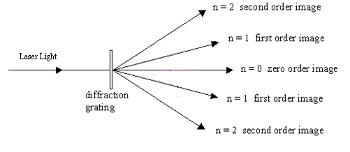

OBSERVATION:

Position of the centre spot =
Position (Distance) of the first order spot from the central spot =
Position (Distance) of the first order spot from the central spot =

CALCULATIONS:
$$λ= \frac{(e+d)}{n}\frac{l}{\sqrt{D^{2}+ l^{2}}}$$
Where,
$λ$ = Wavelength of laser light
(e + d) = Grating element
n = Order of spectrum
l = Distance of the spot to centre spot
D = Distance of the grating to meter scale

RESULT:

Wavelength of first order = A⁰

Wavelength of second order = A⁰

ExperimentNo:3

OBJECT: To study and plot the P-N junction diode characteristics.

APPARATUS REQUIRED: P-N Junction Diode kit, patch chords.

THEORY:

When a P-type crystal is placed in contact with N- type crystal so as to form one piece, the assembly so obtained is called P-N Junction. Due to high concentration of different types of charge carries in the two sections, holes from P region diffuse into N region and vice-versa. In both cases, when an electron meets a hole the two cancel out the effect of each other and as a result a thin layer at the junction becomes devoid of charge carriers. This is called depletion layer.
A junction diode can be biased in following two ways:

- Forward Bias :
When an external d.c. source is connected to the Diode with P- section connected to positive and N- section is connected to negative pole, the junction is aid to be forward biased. In the beginning when the applied forward bias is low, practically no current flows through the junction diode. It is because the potential barrier opposes the applied voltage. As soon as forward bias becomes greater than the potential barrier opposes the applied voltage. As soon as forward bias becomes greater than the potential barrier, the forward current increases linearly.
- Reverse Bias :

When battery is connected to junction diode with P- section connected to negative pole and N- section connected to the positive pole, the junction diode is said to reverse biased. The current flows due to minority charge carriers and hence a micrometer is used to measure the small current.

PROCEDURE:
- According to the circuit diagram, connect all the wires.
- For forward bias vary the current in mill ampere. Take the corresponding reading readings of voltmeter.
- When sufficient readings are taken for taken for forward bias then connect the wires according to circuit diagram of reverse bias.
- Vary the current in micro ampere. Take the corresponding readings of voltmeter.
- Take sufficient readings so that graph is plotted between current and voltage

CIRCUIT DIAGRAM:

V
Ckt Diagram of P-N Junction Diode in forward Bias

V
Ckt Diagram of P-N Junction Diode in reverse Bias

OBSERVATION TABLE:

- Forward Bias:
Least count of ammeter (m A) =
Least count of voltmeter (V) =

S. No. | Voltmeter (V) | Current (m A)

- Reverse Bias :
Least count of micrometer (µA) =
Least count of voltmeter (V) =
S. No. | Voltmeter (V) | Current (µA)

RESULT:
Forward bias and reverse bias characteristics of P-N junction diode has been plotted on the graph.

PRECAUTIONS:

- Connection should be neat and tight.
- Cathode current must not exceed the value specified by manufacturer and should remain constant throughout otherwise the value may get damaged.
- Increase voltage by small amounts.
- Do not cross the limit of the meter scale and take readings within the limit.

ExperimentNo:4

OBJECT: To plot the characteristics of a Zener Diode
.

APPARATUS REQUIRED: Zener Diode kit, patch chord.

THEORY:
In forward biasing the function of Zener diode is just like the function of P-N diode, but in reverse biasing arrangement of Zener Diode, there happens a certain voltage at which current flow increases suddenly. This definite positive voltage is known as Zener Voltage.
PROCEDURE:
- Make the electrical connections with forward biasing as shown in the figure. Adjust the power supply voltage and note the current. Increase the supply and measure the value of current.
- Make the electrical connections with reverse biasing as shown in the figure.
- Now adjust power supply at zero voltage and note the current with millimeter.
- Right from the negative voltage of zener diode increase this negative voltage with gradual steps and note the corresponding current value in millimeter or micrometer. Continue to take the readings till a stage comes when current changes suddenly and get its maximum value. In this position any further change in voltage will produce negligible effect on current value.
CIRCUIT DIAGRAM:

V
Ckt Diagram of Zener Diode in Reverse Bias

OBSERVATION TABLE:

Reverse Bias :
Least count of ammeter (m A) =

Least count of voltmeter (V) =

S. No. | Voltmeter (V) | Current (m A)

RESULT:

Zener Voltage =

PRECAUTIONS:

- Zener Diode must be connected in reverse biased condition only.
- Connection should be neat and tight.
- Increase voltage by small amounts.
- Do not cross the limit of the meter scale and take readings within the limit.

ExperimentNo:5

Aim:- To study and plot the V-I characteristics of Solar Cell

Apparatus Required : Solar cell, voltmeter, ammeter, resistors.

Theory :
Solar cell is basically a solar energy converter. It is a P –N Junction device which converts solar energy in to electric energy.
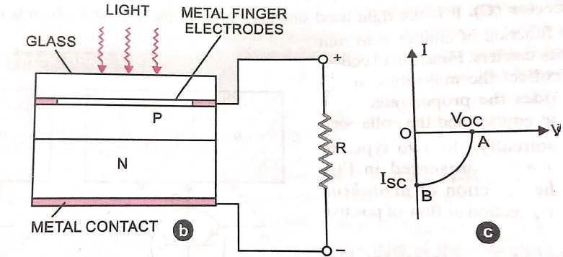

Symbol and construction of solar cell

A solar cell consist of a silicon or gallium arsenide P-N Junction diode packed in a can with glass window on top. The upper layer is P- type semiconductor. It is very thin so that the incident light photons may easily reach the P-N Junction. On the top face of P- layer, the metal finger electrodes are prepared in order to have enough spacing between the fingers for the light to reach the P-N Junction through P- layer. When photons of light fall at the junction, electrons and holes produced move in opposite directions due to junction field. The photo generated electrons move towards n-side of P-N junction. The photo generated holes move towards p- side of p-n junction. They will be collected at the two sides of the junction, giving rise to a photo voltage between the top and bottom metal electrodes. The top metal contact as positive electrode and bottom metal contact acts as negative electrodes. When an external load is connected across metal electrodes a photo current flows.

Procedure:1. Connect the ckt as shown in figure.
2. Exposé the sunlight in solar cell.
3. Note down the reading of voltmeter and ammeter .
4. Vary the load resistance and note the readings for different resistances.
5. Plot the graph between Output voltage vs output current of the solar cell.

OBSERVATION TABLE:

s.No. | Voltage | Current | Resistance

I

o V_{OC} V
A

I_{SC} B

Result: The V-I graph potted.

ExperimentNo:6

OBJECT: Determination of Planck’s Constant using LEDs.

APPARATUS REQUIRED: Planck’s Constant kit, Patch Chords

THEORY: A Light emitting diode conducts a relatively large electric current when sufficient voltage from a power supply is applied across it in the forward direction.
The entire diode is system possessing energy levels. When forward biased, the current is carried by electrons in the higher –energy conduction band of the n- martial and by holes moving in the opposite direction in the lower energy p-material. At the P-N Junction, electrons meet and fall into the oncoming holes. In other words, they undergo a transition from the conduction band to the valence band, giving up a quantum of energy .In an LED type diode, this energy is emitted as a photon in the visible or infrared spectrum.
The entire diode is a system possessing energy levels. When forward Biased the current is carried by electrons in the higher energy conduction band of the N-material and by holes moving in the opposite direction in the lower energy P- material. At the P-N Junction electrons meet and fall into the oncoming hoes. In the words. They undergo a transition from the conduction band to the valence band, giving up a quantum of energy equal to the energy difference between the bands. In applications, the light emitted can be used as a substitute for a small incandescent bulb, for example as an indicator light on an instrument or aaas part of a digital display. The color of the light emitted by an LED is determined during its manufacture by making a choice among materials of minimum forward bias voltage before it will conduct very much current if it is an LED, at least this minimum voltage is required before it will light up. As explained later this turn on voltage is related to the and gap energy
E_{gap} = eV_{turn-on} + ∆ E …………………. (1)

Where ∆ is constant from one LED to another of the same type. Note that if e is the electronic charge, then eV_{turn-on} , represents the energy received from the power supply by each electron crossing the junction. Ince the band-gap energy will be the energy carried away by a photon,
E_{photon} = hf
Equation (1) becomes

hf = eV_{turn-on} + ∆ E …………………...(2)
In this experiment we use Eq. (2) to determine Planck’s constant h. We use several LEDs that emit light of different colors. We measure the turn-on voltage for each, and make a graph of f v/s eV_{turn-on} according to eq. (2) the slope of the graph is Planck’s constant h

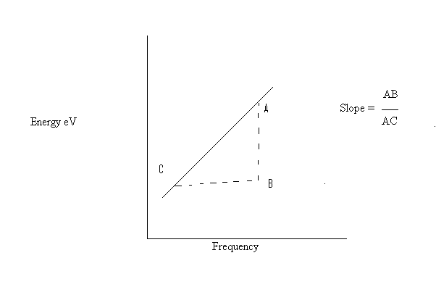
PROCEDURE:

- Connect an LED according to the circuit.
- Slowly increase the forward bias voltage until the diode lights up, with moderate brightness. It may be helpful to observe the ammeter and note the diode current. Record the bias voltage and frequency of the diode.
- Chang the diode and repeat the procedure for other diodes.
- Make a graph of f Horizontal v/s eV Vertical and determine the slope by doing a linear regression. Compare the value of Planck’s constant with the standard value.

OBSERVATION TABLE:

c = 3 × 10⁸ m/s
e = 1.6 × 10⁻¹⁹ C

S. No. | LED | Wavelength λ × 10 ⁻¹⁰ M | Frequency c/ λ | Turn On Voltage | Current
 | Red  Yellow  Green  Blue | 6600  6100  5580  4285

S. No. | LED | Wavelength M (λ) | Frequency c/ λ (Hz) | Turn On Voltage | Energy eV | AB | BC | Slope
 | Red  Yellow  Green  Blue | 6600 × 10 ⁻¹⁰  6100 × 10 ⁻¹⁰  5580 × 10 ⁻¹⁰  4285× 10 ⁻¹⁰

Graph

ExperimentNo:7
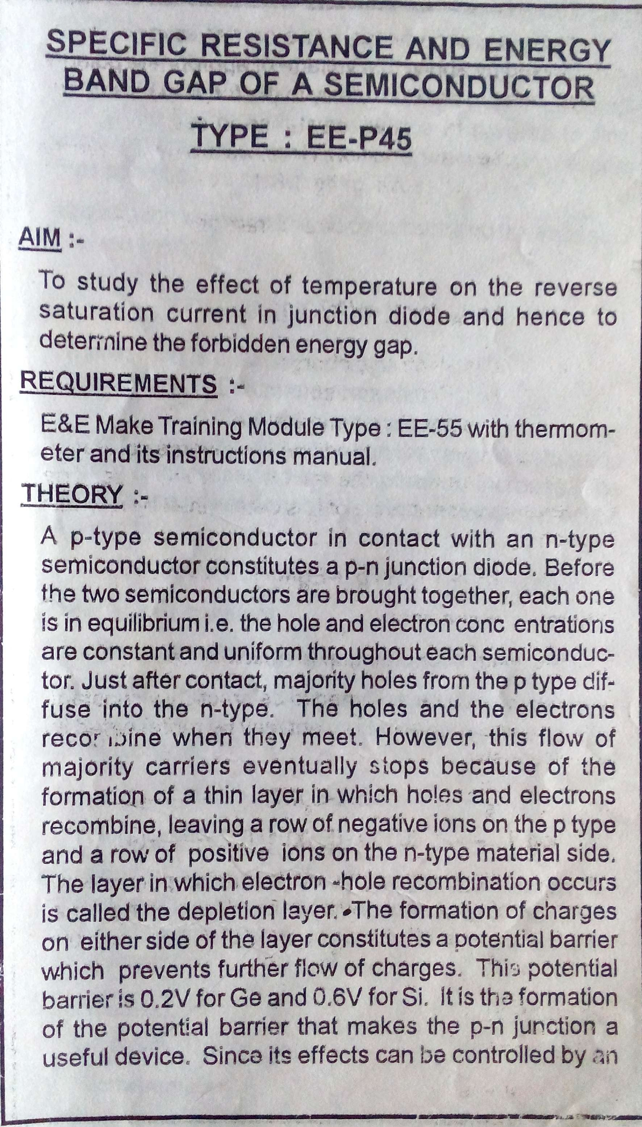

.
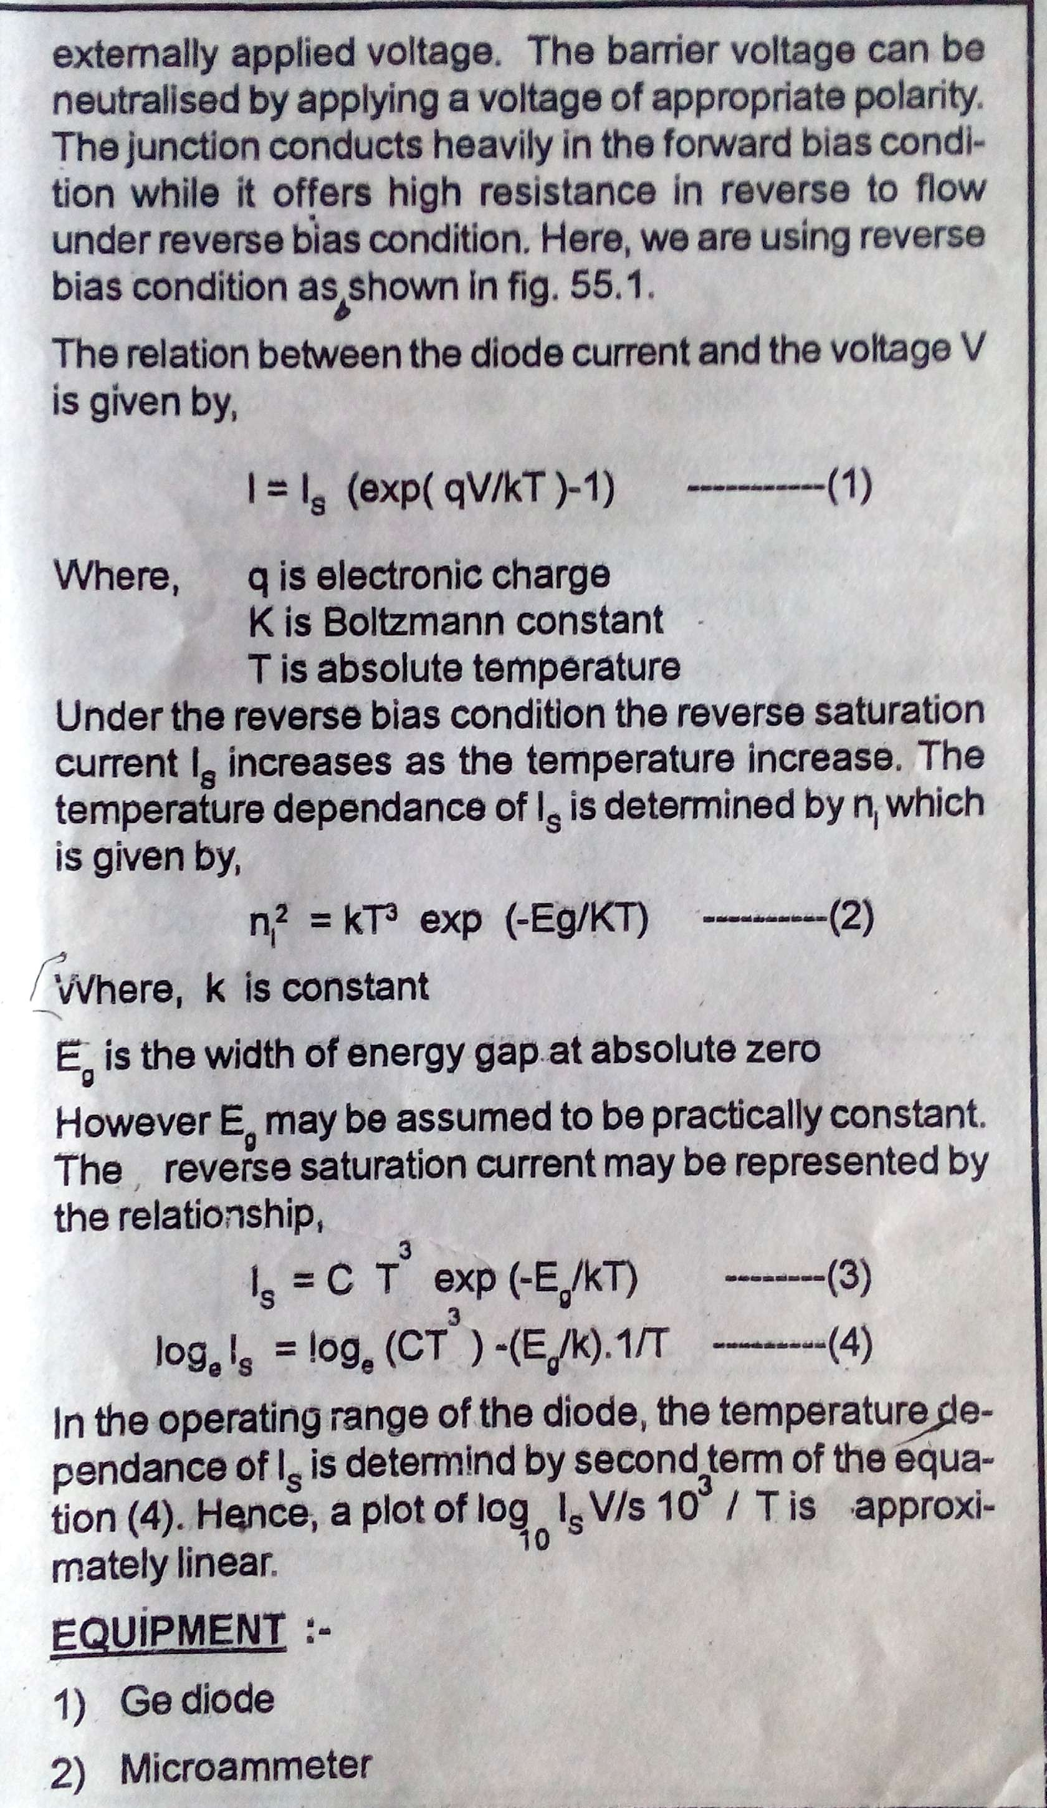
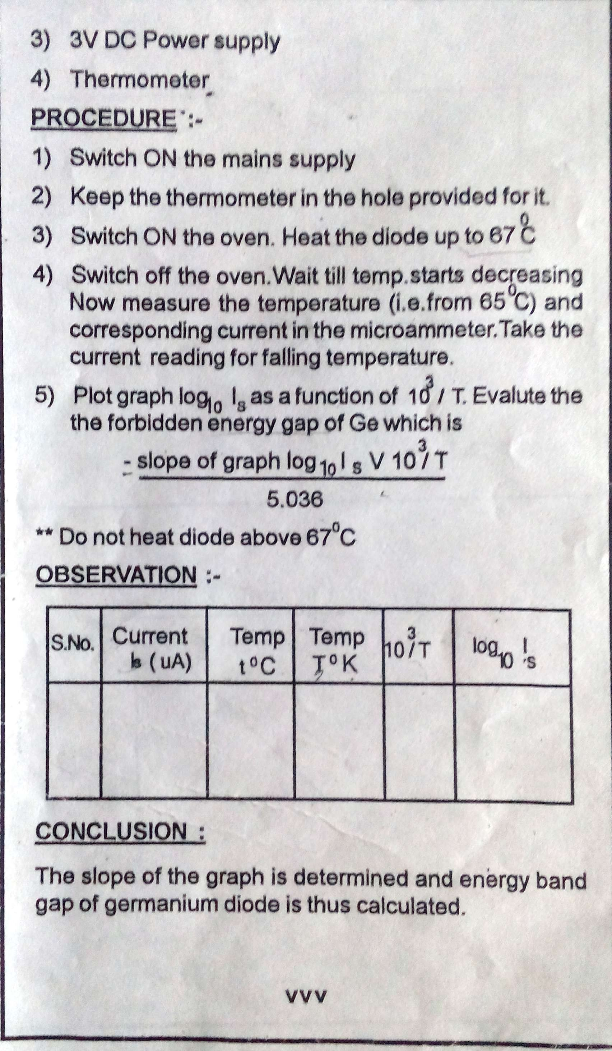

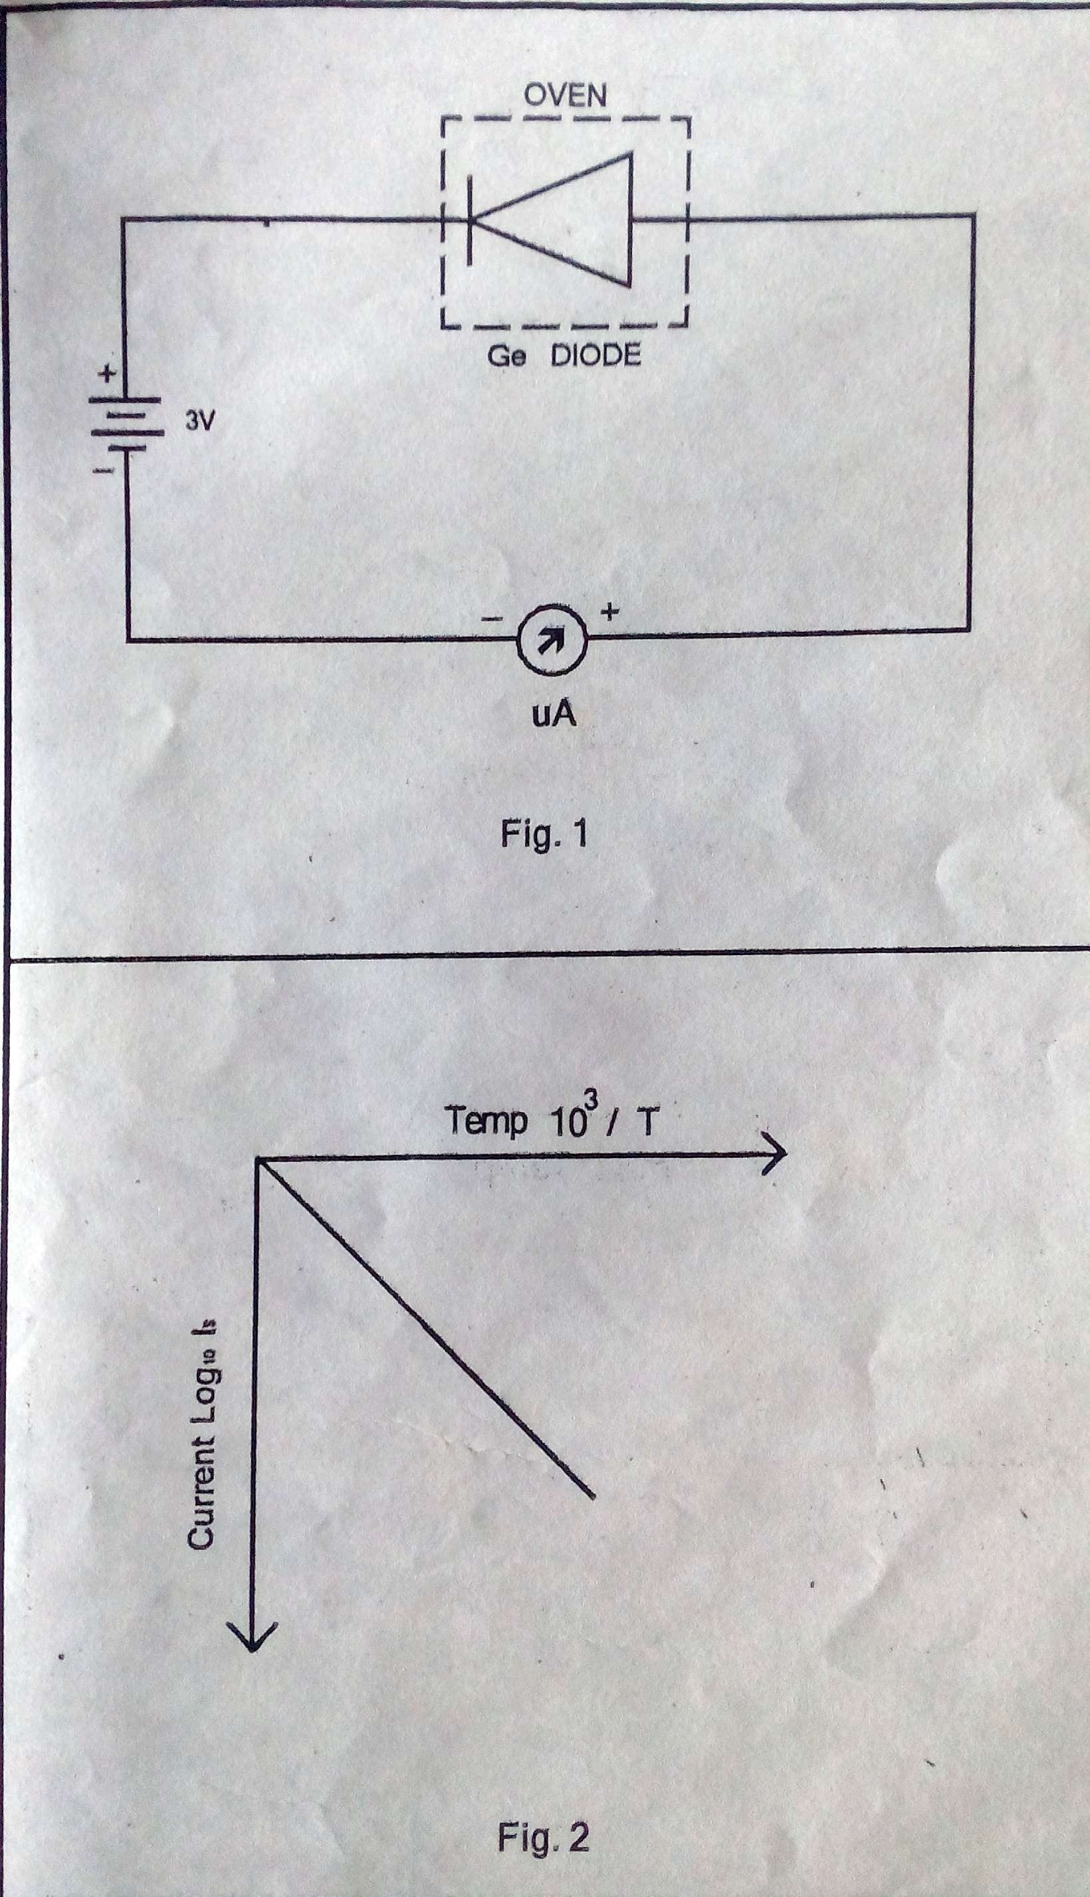

ExperimentNo:8

OBJECT: To determine the value of acceleration due to gravity and radius of gyration using bar pendulum.
Apparatus used: Bar pendulum, stop watch and meter scale.
Formula:
A. The general formula of the time period for bar pendulum is given by following equation:
$g=8 π^{2}\frac{(l_{1}+ l_{2})}{T^{2}}$ (1)

Where l: distance between C.G. and suspension point,
L: distance between suspension and oscillation points, L =$l_{1}+ l_{2}={\frac{k}{l}}^{2}+ l$ ,
g: acceleration due to gravity, T: time period.

B. The time period is minimum when l=±k, in this situation the equation (1) becomes as:

$$T_{min}=2 π\sqrt{\frac{k}{g} }$$
$g=8 π^{2}\frac{k}{T^{2}}$ (2)

where, k: radius of gyration,
T_{min}: minimum time period.
The value of ‘g’ can be calculated using equations (1) and (2).
The values of L, T, k and T_{min} are obtained using graph between T and L for bar pendulum which is shown in following figure.
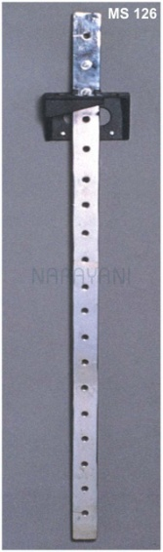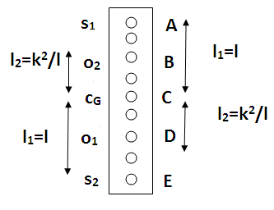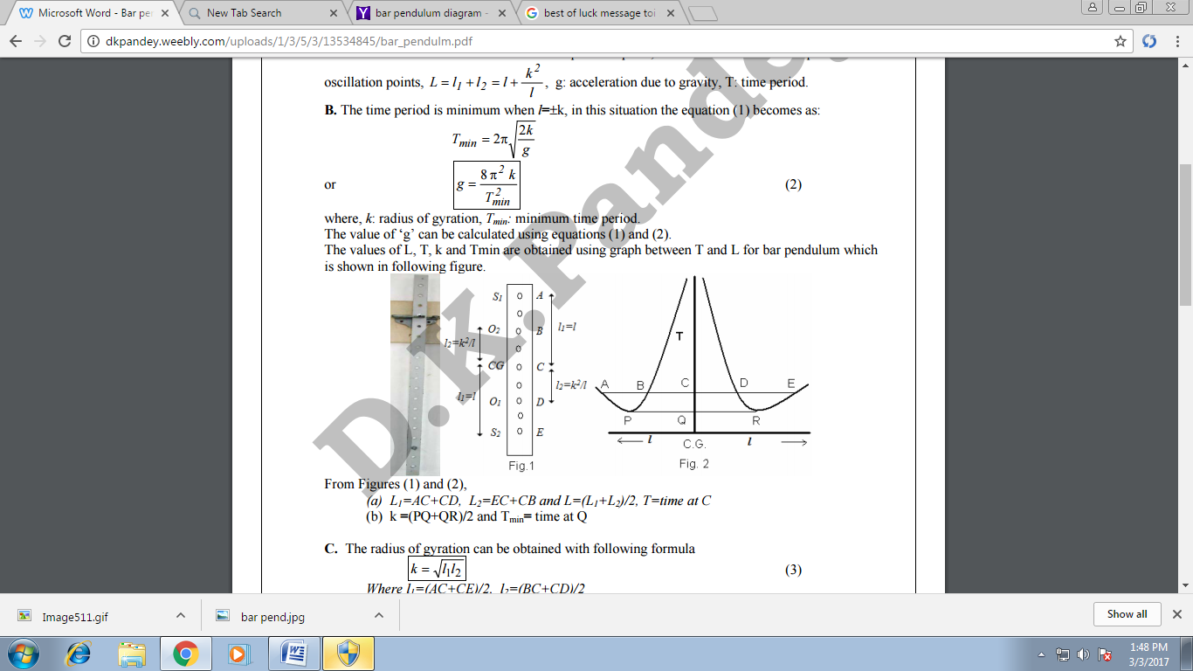

From Figures (1) and (2),
(a) L₁=AC+CD, L₂=EC+CB and L=(L₁+L₂)/2, T=time at C
(b) k =(PQ+QR)/2 and T_{min}= time at Q
C. The radius of gyration can be obtained with following formula
k = $\frac{(l_{1}+ l_{2})}{2}$ (3)
Where l₁=(AC+CE)/2, l₂=(BC+CD)/2

Procedure:
(1) Place the knife-edges at the first hole of the bar.
(2) Suspend the pendulum through rigid support with the knife-edge.
(3) Oscillate the pendulum for small amplitude (θ=3~40 ).
(4) Note the time taken for 20 oscillations and measure the distance of the hole from the C.G. of the bar. (5) Repeat the observations (2)-(4) for knife-edges at first half side holes of bar.
(6) Repeat the process (1)-(5) for the second half side of the bar.
(7) Plot the graph between T and L.
Observations:
1. Least count of the stop watch = ….. sec
2. Least count of the meter scale =…… cm
3. Table for l and T

S. No. | l (cm) | t (time taken for 20 oscillations) | T= t/20
For First half side of the bar
1
2
3
4
5
6

7
8
9
For second half side of the bar
10
11
12
13
14
15
16
17
18

Calculations: from graph,
L=(AD+EB)/2=……………………, T=…………………sec,
k=PR/2=……………………., T_{min}=……………..sec
l₁=(AC+CE)/2=…., l₂=(BC+CD)/2
2. $g_{2}=8 π^{2}\frac{k}{T^{2}}$ 3. g = $\frac{g_{1}+ g_{2}}{2}$ 4. k = $\frac{(l_{1}+ l_{2})}{2}$

Results: The acceleration due to gravity (g) = ……….m/s²
Radius of gyration (k) =………cm (from calculation)
=………cm (from graph)

ExperimentNo:9

OBJECT:
To measure the numerical aperture of the an fiber.
APPARATUS REQUIRED:
He-Ne laser , fiber optic chuck, optical fiber, screen, graph paper, measuring tape.
THEORY:
Numerical aperture (NA) is a basic descriptive characteristic of fibers. It can be thought of as representing the size or “degree or openness” of the input acceptance cone.
Mathematically, numerical aperture is defined as the sine of half angle of the acceptance cone (sin Ѳ)
The light gathering power or flux carrying capacity of a fiber is numerically equal to the sequence of the aperture, which is the ratio between the area of a unit sphere with the acceptance cone and the area of the hemisphere (2 π solid angle). A fiber with numerical aperture of 0.66 has 43% as much as flux carrying capacity as a fiber with a numerical aperture of 1.0 i.e.
$\frac{{0.66}^{2}}{{1.00}^{2}}$ = 0.43
Snell’s law can be used to calculate the maximum angle with in which light will be accepted in to and conducted through a fiber
NA = Sin Ѳ_{a}= (n₁²- n₂²)^{1/2}
Where sin Ѳ is numerical aperture.
n₁and n₂ are the refractive indices of the core and the cladding respectively.
The semi angle Ѳ_{a} of the acceptance core for a step index fiber is determined by the critical angle Ѳ_{c} = sin⁻¹ $\frac{n_{2}}{n_{1}}$ for total internal reflection to take place at core cladding interface. For a ray with incident angle Ѳ< Ѳ_{a} , it undergoes total internal reflection at core cladding interface and is called the guided ray. For incident angle Ѳ > Ѳ_{a} the ray undergoes only partial reflection at core cladding interface and is radiated out into the cladding.

A ray entering the fibre at an angle Ѳ< Ѳ_{a} gets guided through the fiber, and comes out at angles > Ѳ_{a} undergo partial reflections at the core cladding interface and eventually lose all their energy into the cladding.
In a short length of straight fiber, ideally a ray launched at angle Ѳ, at the input end should come out at the output same angle Ѳ from output end. t therefore the far field at the output end will also appear as a cone of semi-angle Ѳ_{a} emerging from the fiber end. It is then simpler to make measurement on this far field to determine the NA of the fiber.

PROCEDURE:

- Mount both the nods of the optical fiber on the fiber optic chucks.
- Couple the light from the He-Ne laser source onto one of the fiber ends using a microscopic objective.
- Place the screen at some distance from the output end (end other than at which light is coupled) of the fiber such that is perpendicular to the axis of the fiber.
- Now move the screen towards or away the output ends of the optical fiber, such that a circular spot is formed on the screen.
- Measure the distance between the output end of the optical fiber and screen, let this be L. also measure the diameter of the circular spot formed on the screen let it be D.
- Use the formula
NA= sin Ѳ_{a} = Sin $\left[\tan^{-1}\left(\frac{D}{2L}\right)\right]$

- Repeat the above procedure for different values of L and D and calculate the average value of NA.
OBSERVATION TABLE:
S.No. | Diameter of the Spot D | Distance between Fibre end and Screen L | $$\tan^{-1}\left(\frac{D}{2L}\right)$$ | Sin$\left[\tan^{-1}\left(\frac{D}{2L}\right)\right]$
1
2
3
4

CALCULATIONS:
Mean Numerical Aperture (NA) = Sin $\left[\tan^{-1}\left(\frac{D}{2L}\right)\right]$
= ……….
Acceptance Angle (Ѳ) = Sin⁻¹ NA= ………..⁰
RESULT:
- NA OF THE GIVEN FIBER=……………….
- Acceptance angle of the fiber=……………⁰
PRECAUTIONS:
- Light should fall on the fiber
- Diameter of the spot should be measured accurately
- Direct viewing of laser light should be avoided.

