SWAMI VIVEKANANDA COLLEGE OF ENGINEERING
DEPARTMENT OF CIVIL ENGINEERING

LAB MANUAL
BASIC CIVIL ENGINEERING & MECHANICS
BT-204

LIST OF EXPERIMENTS
S.NO | NAME OF EXPERIMENT | SCHEDULED DATE | PERFORMED DATE
MATERIAL TESTING
1 | To determine particle size distribution and fineness modulus of course and fine aggregates.
2 | To determine compressive strength of brick.
3 | To determine normal consistency; initial setting time and final setting time of cement sample.
4 | To determine the workability of fresh concrete of given proportions by slump cone test.
SURVEYING
5 | To perform the linear measurement with the help of chain and setting offset using tape in open & closed traverse.
6 | To perform traverse surveying with prismatic compass, check for local attraction and determine corrected bearing and to balance the traverse by Bowditch’s rule
7 | To perform levelling exercise by height of instrument method or rise and fall method.
8 | To measure horizontal and vertical angles in field by using theodolite.
MECHANICS
9 | To verify the law of triangle of forces and Lami’s Theorem
10 | To verify the law of parallelogram of forces.
11 | To verify the law of polygon of forces.

EXPERIMENT-1
AIM: To determine particle size distribution and fineness modulus of course and fine aggregates.
I) Fineness Modulus of fine aggregate

APPARATUS: Standard sieves of size 4.75mm, 2.36mm, 1.18mm, 0.6mm, 0.3mm,0.15mm , mechanical sieve shaker (optional), dry oven and digital weight scale .
THEORY: Fine aggregate means the aggregate which passes through 4.75mm sieve. Fineness modulus of sand (fine aggregate) is an index number which represents the mean size of the particles in sand. It is calculated by performing sieve analysis with standard sieves. The cumulative percentage retained on each sieve is added and divided by 100 gives the value of fine aggregate.
If fineness modulus of fine aggregate is 2.75. It means the average value of aggregate is in between the 2nd sieve and 3rd sieve. It means the average aggregate size is in between 0.3mm to 0.6mm.

Limits of Fineness Modulus
Fineness modulus of fine aggregate varies from 2.0 to 3.5mm. Fine aggregate having fineness modulus more than 3.2 should not considered as fine aggregate. Various values of fineness modulus for different sands are detailed below.
Type of sand | Fineness modulus range
Fine sand | 2.2 – 2.6
Medium sand | 2.6 – 2.9
Coarse sand | 2.9 – 3.2

PROCEDURES:

Sample preparation
Take a sample of fine aggregate in pan and placed it in dry oven at a temperature of 100 – 110ºC. After drying take the sample and note down its weight.

Test Procedure – Fineness Modulus of Sand
- Take the sieves and arrange them in descending order with the largest sieve on top.
- If mechanical shaker is using then put the ordered sieves in position and pour the sample in the top sieve and then close it with sieve plate. Then switch on the machine and shaking of sieves should be done at least 5 minutes.
- If shaking is done by the hands then pour the sample in the top sieve and close it then hold the top two sieves and shake it inwards and outwards, vertically and horizontally. After some time shake the 3rd and 4th sieves and finally last sieves.
- After sieving, record the sample weights retained on each sieve. Then find the cumulative weight retained. Finally determine the cumulative percentage retained on each sieves. Add the all cumulative percentage values and divide with 100 then we will get the value of fineness modulus.
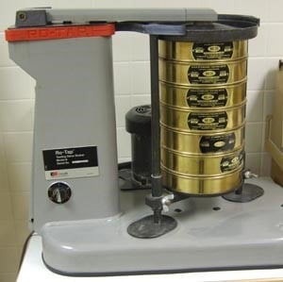

OBSERVATIONS:
The dry weight of sample in gm =
After sieve analysis the values appeared are tabulated below.

Sieve size | Weight retained (g) | Cumulative weight retained(g) | Cumulative percentage weight Retained (%)
4.75mm
2.36mm
1.18mm
0.6mm
0.3mm
0.15mm
Total
Fineness modulus of aggregate = (sum of cumulative % retained) / 100

RESULTS:

II) Fineness Modulus of coarse aggregate
APPARATUS: Standard sieves of size 80mm, 40mm, 20mm, 10mm, 4.75mm, 2.36mm, 1.18mm, 0.6mm, 0.3mm,0.15mm , mechanical sieve shaker (optional), dry oven and digital weight scale .
THEORY: Course aggregate means the aggregate which is retained on 4.75mm sieve when it is sieved through 4.75mm. Fineness modulus of coarse aggregates represents the average size of the particles in the coarse aggregate by an index number. It is calculated by performing sieve analysis with standard sieves.
The cumulative percentage retained on each sieve is added and divided by 100 gives the value of fine aggregate. Higher the aggregate size higher the Fineness modulus hence fineness modulus of coarse aggregate is higher than fine aggregate.
Fineness modulus is the number at which the average size of particle is known when we counted from lower order sieve size to higher order sieve. So, in the calculation of coarse aggregate we need all sizes of sieves.

Limits of Fineness Modulus
Fineness modulus of coarse aggregate varies from 5.5 to 8.0. And for all in aggregates or combined aggregates fineness modulus varies from 3.5 to 6.5. Range of fineness modulus for aggregate of different maximum sized aggregates is given below.

Maximum size of coarse aggregate | Fineness modulus range
20mm | 6.0 – 6.9
40mm | 6.9 – 7.5
75mm | 7.5 – 8.0
150mm | 8.0 – 8.5

PROCEDURES:

Sample preparation
Take a sample of coarse aggregate in pan and placed it in dry oven at a temperature of 100 – 110ºC. After drying take the sample weight to nearest gram.

Test Procedure for Fineness Modulus of Coarse Aggregates
- Arrange the sieves in descending order and put the arrangement on mechanical shaker.
- After proper sieving, record the sample weights retained on each sieve and find out the cumulative weight of retained particles as well as cumulative % retained on each sieve.
- Add all cumulative percentage values and divide the result with 100. Then we get the value of fineness modulus.
OBSERVATIONS:

Dry weight of coarse aggregate in grams =

Values after sieve analysis are as tabulated
Sieve size | Weight retained(g) | Percent weight retained (g) | Cumulative % retained (g)
80mm
40mm
20mm
10mm
4.75mm
2.36mm
1.18mm
0.6mm
0.3mm
0.15mm
 | Sum
Fineness modulus of coarse aggregates = sum (cumulative % retained) / 100

RESULTS:

EXPERIMENT-2
AIM: To determine the compressive strength of the given specimen of bricks.

APPARATUS: Compression testing machine, the compression plate of which shall have ball seating in the form of portion of a sphere center of which coincides with the centre of the plate.

THEORY: Compressive strength test on bricks are carried out to determine the load carrying capacity of bricks under compression. This test is carried out with the help of compression testing machine.
Bricks are generally used for construction of load bearing masonry walls, columns and footings. These load bearing masonry structures experiences mostly the compressive loads. Thus, it is important to know the compressive strength of bricks to check for its suitability for construction.

PROCEDURES:

Sampling of Bricks
Select three bricks randomly. Remove unevenness observed the bed faces of bricks to provide two smooth parallel faces by grinding. Immerse the bricks in water at room temperature for 24 hours, then remove the specimen and drain out any surplus moisture at room temperature.
Fill the frog and all voids in the bed faces flush with cement mortar (1 cement, 1 clean coarse sand of grade 3mm and down). Store it under the damp jute bags for 24 hours filled by immersion in clean water for 3 days. Remove and wipe out any traces of moisture.

Procedure of Compressive Strength Test on Bricks
- Place the specimen with flat face s horizontal and mortar filled face facing upwards between plates of the testing machine.
- Apply load axially at a uniform rate of 14 N/mm² (140 kg/cm²) per minute till failure occurs and note maximum load at failure.
- The load at failure is maximum load at which the specimen fails to produce any further increase in the indicator reading on the testing machine.

OBSERVATIONS:
Compressive Strength of Bricks = Maximum Load at Failure (N)/Average area of bed face (mm²)
The average of result shall be reported.

RESULTS: Average compressive strength of the given bricks =………….. N/mm²

EXPERIMENT-3
AIM: To determine normal consistency; initial setting time and final setting time of cement sample.
I) NORMAL CONSISTENCY OF CEMENT
APPARATUS: Weighing balance of 1000g with accuracy 1g and measuring cylinder of 200ml, VICAT apparatus, VICAT Mould, Glass plate, the plunger of 10mm dia and Hand Trowel.

THEORY: The Consistency of cement test is performed to determine the amount of water content that is to be added in cement to attain Standard consistency or normal consistency of cement. The normal consistency of cement is amount of water added in cement to penetrate the Vicat plunger up to a depth of 5-7mm from the bottom of the Vicat mould or 33-35mmfrom top of the Vicat Mould.
When water is mixed with cement, it starts hydration. Excessive addition of water in cement results in an increase in Water cement ratio & ultimately cement loses its strength when it hardens. If less water is added than required, Cement isn’t properly hydrated and results in loss of strength. The Standard or Normal consistency for Ordinary Portland cement varies between 25-35%. To prepare a mix of cement paste of Standard consistency 25-35% of water is added to cement.

PROCEDURES:
- Take 400g of cement and place it in a bowl or tray.
- Now Assume standard consistency of water is 28% and add the same quantity of water in cement and mix it.
- Mix the paste thoroughly within 3-5 minutes. The time taken to obtain cement paste after adding water is called gauging time.
- Now fill the paste in Vicat mould correctly any excessive paste remained on Vicat mould is taken off by using a trowel.
- Then, place the VICAT mould on Glass plate and see that the plunger should touch the surface of VICAT mould gently.
- Release the Plunger and allow it to sink into the test mould.
- Note down the penetration of the plunger from the bottom of mould indicated on the scale.
- Repeat the same experiment by adding different percentages of water until the reading is in between 5-7mm on the Vicat apparatus scale.
OBSERVATIONS:

RESULTS:

II) INITIAL SETTING TIME AND FINAL SETTING TIME OF CEMENT
APPARATUS: Weighing balance of 1000g with accuracy 1g and Measuring cylinder of 200ml, VICAT apparatus, VICAT Mould, Glass plate, the plunger of 10mm dia and Hand Trowel, stop watch
THEORY: Cement start hydrates when it is mixed with water. In presence of water, cement has a property to achieve strength and get hardened within a short period. So its mandate to place the cement in position before it losing its plasticity. To achieve this, the setting time of cement is calculated. The time from when cement is mixed with water and it continues reacting with water and slowly starts losing its plasticity, to set harden is called Setting time of cement.

INITIAL SETTING TIME
(For Ordinary Portland Cement, The initial Setting Time is 30 minutes.)
The time to which cement can be moulded in any desired shape without losing it strength is called Initial setting time of cement OR
The time at which cement starts hardens and completely loses its plasticity is called Initial setting time of cement. OR
The time available for mixing the cement and placing it in position is an Initial setting time of cement. If delayed further, cement loses its strength.

FINAL SETTING TIME
(For Ordinary Portland Cement, The Final Setting Time is 600 minutes (10hrs))
The time at which cement completely loses its plasticity and became hard is a final setting time of cement.

PROCEDURES:
- Take 400g of cement and place it in a bowl or tray.
- Now add water. Start the stopwatch at the moment water is added to the cement. Water of quantity 0.85P.times (Where P is the Standard consistency of cement) is added and mix is prepared.
- Now fill the mix in Vicat mould. If any excessive paste remained on Vicat mould is taken off by using a trowel.
- Then, place the VICAT mould on non-porous plate (Glass plate) and see that the plunger should touch the surface of VICAT mould gently.
- Release the Plunger and allow it to sink into the test mould.
- Note down the penetration of the plunger from the bottom of mould indicated on the scale.
- Repeat the same experiment at different positions on the mould until the plunger should stop penetrating 5 from the bottom of the mould. The time period elapsed between the moment water is added to the cement and the time, the needle fails to penetrate the mould of 5mm when measured from the bottom of the mould, is the initial setting time of cement.
- Now replace the needle (plunger) by the one with an annular attachment. The cement is assumed as finally set when, upon applying the needle gently to the surface of the test mould, the needle makes an impression therein, while the attachment fails to do so. The time period between the moment water is added to the cement and the time at which needle makes an impression on the surface of the mould, while the attachment fails to do so, is the final setting time of cement.
OBSERVATIONS:

RESULTS:

EXPERIMENT-4
AIM: To determine the workability of fresh concrete of given proportions by slump cone test.
APPARATUS: Mould for slump test, non-porous base plate, measuring scale, temping rod. The mould for the test is in the form of the frustum of a cone having height 30 cm, bottom diameter 20 cm and top diameter 10 cm. The tamping rod is of steel 16 mm diameter and 60cm long and rounded at one end.
THEORY: Concrete slump test is to determine the workability or consistency of concrete mix prepared at the laboratory or the construction site during the progress of the work. Concrete slump test is carried out from batch to batch to check the uniform quality of concrete during construction. The slump is carried out as per procedures mentioned in IS: 1199 – 1959 in India. Generally concrete slump value is used to find the workability, which indicates water-cement ratio, but there are various factors that affect the concrete slump value.

Factors which influence the concrete slump test:
- Material properties like chemistry, fineness, particle size distribution, moisture
content and temperature of cementitious materials. Size, texture, combined grading, cleanliness and moisture content of the aggregates,
- Chemical admixtures dosage, type, combination, interaction, sequence of addition and its effectiveness,
- Air content of concrete,
- Concrete batching, mixing and transporting methods and equipment,
- Temperature of the concrete,
- Sampling of concrete, slump-testing technique and the condition of test equipment,
- The amount of free water in the concrete, and
- Time since mixing of concrete at the time of testing.

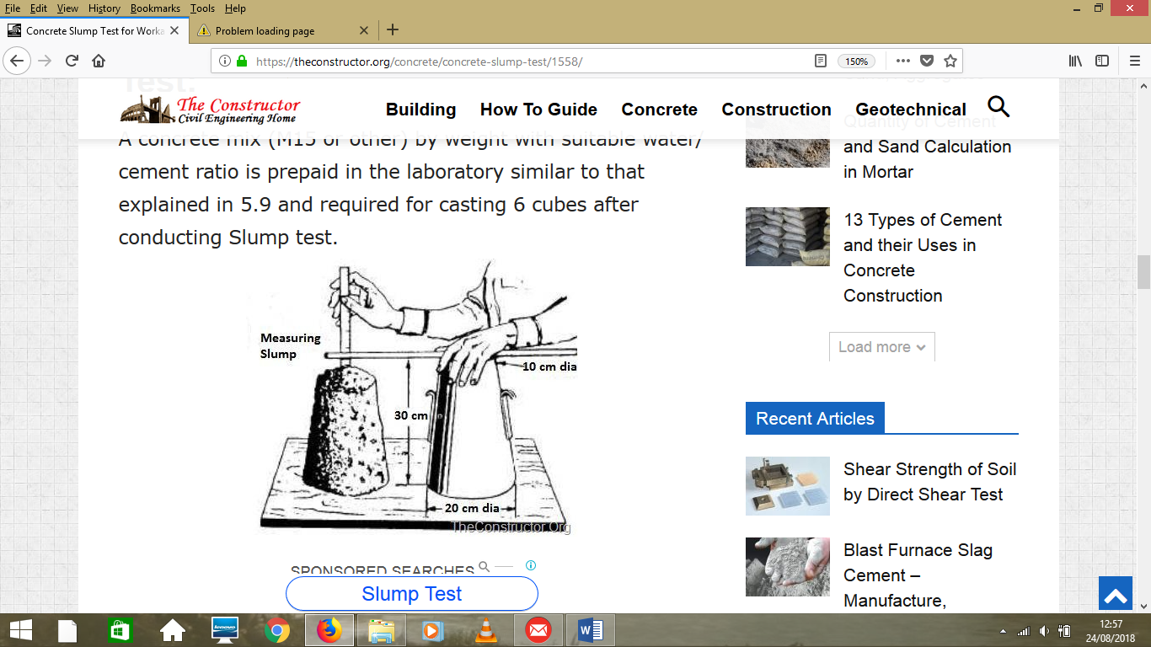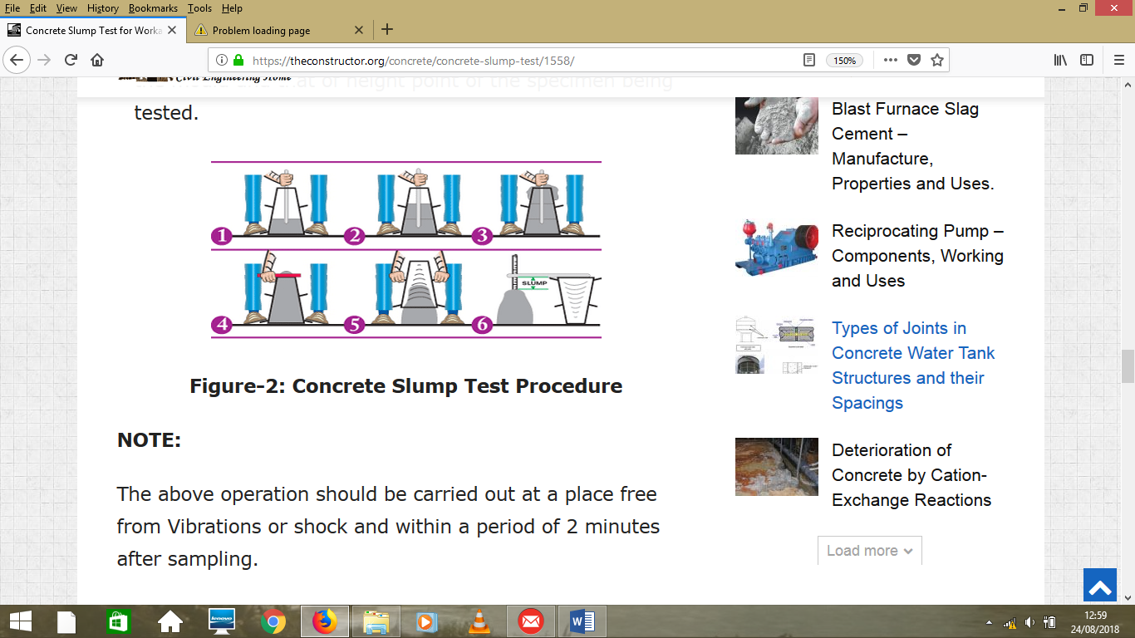
When the slump test is carried out, following are the shape of the concrete slump that can be observed:
- True Slump – True slump is the only slump that can be measured in the test. The measurement is taken between the top of the cone and the top of the concrete after the cone has been removed as shown in figure.
- Zero Slump – Zero slump is the indication of very low water-cement ratio, which results in dry mixes. These type of concrete is generally used for road construction.
- Collapsed Slump – This is an indication that the water-cement ratio is too high, i.e. concrete mix is too wet or it is a high workability mix, for which a slump test is not appropriate.
- Shear Slump – The shear slump indicates that the result is incomplete, and concrete to be retested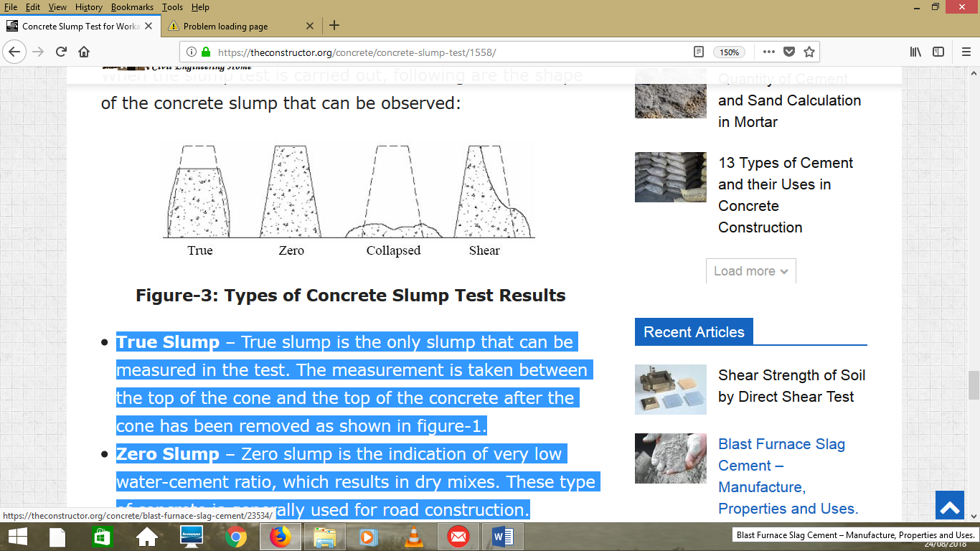
PROCEDURES:
- A concrete mix (M15 or other) by weight with suitable water/ cement ratio is prepaid
- Clean the internal surface of the mould and apply oil.
- Place the mould on a smooth horizontal non- porous base plate.
- Fill the mould with the prepared concrete mix in 4 approximately equal layers.
- Tamp each layer with 25 strokes of the rounded end of the tamping rod in a uniform manner over the cross section of the mould. For the subsequent layers, the tamping should penetrate into the underlying layer.
- Remove the excess concrete and level the surface with a trowel.
- Clean away the mortar or water leaked out between the mould and the base plate.
- Raise the mould from the concrete immediately and slowly in vertical direction.
- Measure the slump as the difference between the height of the mould and that of height point of the specimen being tested.

OBSERVATIONS:
The slump (Vertical settlement) measured shall be recorded in terms of millimetres of subsidence of the specimen during the test.

RESULTS:
Slump for the given sample= _____mm

EXPERIMENT -5
CHAIN SURVEYING (MAPPING BY TAPE)
Objective: Chain (Tape) surveying is the simplest form of detail surveying. In this method the lengths of lines marked on the field are measured, while the details are measured by offsets and ties from these lines. So, this field work aimed to train the student on the following process:
1. Selection of a frame work (chain or base lines) and control points.
2. Direct method of linear measurements (horizontal distance measurement).
3. Setting out right angles (offsets).
4. Determining the direction of any line in the field with respect to magnetic north "bearing".
5. Booking Method.
6. Plotting Method.
Equipments: 2 Tapes, 3 Ranging rods, Arrows/Marker paint, Prism Square, Prismatic Compass Booking Board
Procedure:
1. Make a reconnaissance of the area and select a suitable framework (chain lines) and stations based on the criterion given in Note 1.
2. Measure all the chain (based) lines once in each direction using the direct measurement method.
3. Measure the offsets/or ties from every necessary point on the details to the corresponding base line. Use the procedure explained in Note 2.
4. You may need some measurements on the details (on the building sides…).
5. Measure the bearing of one of the chain lines by using the prismatic compass.
6. Record all the information and measurements properly in the booking papers as explained in Note 4.
7. Make the necessary calculations and corrections.
8. Draw the details in a suitable scale to produce a detailed map of the area. See Note 5.

Note 1: CHAIN LINES & STATIONS SELECTION
To locate a suitable stations and chain lines, a reconnaissance of the area should be undertaken by walking around the area required to be surveyed. Any obstacles should be noticed. The selected stations should produce well formed linked triangles or braced quadrilaterals.
The principles to be considered are:
1. Few long lines should be used.
2. Avoid any obstacles to ranging or chaining.
3. Angles should be > 30º &<120º.
4. Make check lines when possible to detect errors when plotting.
5. The lines should be closed to the details (Avoid long offsets (>10m) and ties.
After selection of the framework you should draw sketch of the area and mark the stations by wooden pegs or marker paints, and give a number for each station.
Note 2: SETTING THE OFFSET
Any point on the details can be related to the chain line by offset or ties:
The pair of ties method depends on taking the measurement of two distances from the point to be surveyed to a traverse line (base line). The offset method is based on taking a perpendicular distance from the point to the survey line (base line).
To set out offsets, a prism square can be used. To locate the point at which a perpendicular from any point on the feature would meet the chain line (say AB) you can follow the following steps:
1. One man should hold the ranging pole at the given point, while the other pole is placed at any point on the chain line AB.
2. The observer holds the instrument and walk along the line AB until he sees both poles coincide in each other. Then the distance to this point along the chain line can be measured beside the length of the perpendicular.
Another method can be used by holding the zero point of the tape at the given point and swinging tape over the chain line and mark the point on the chain line at minimum reading.
NOTE 3: MEASURING THE BEARING OF A LINE
To measure the angle that any line (say AB) makes with the magnetic direction, you can use a prismatic compass. The procedure is as follow:
1. Place the ranging pole vertically at point B.
2. Place the prismatic compass over its tripod at point A and level it using the bubble and screws. 3. Rotate the compass until it is directed to the pole and read the angle. 4. Repeat the whole procedure for point B.
NOTE 4: BOOKING
The field book should be neat and consistent:
1. Each chain line is represented by double line drawn through the corner of the page. 2. Entries start at the bottom of the page. 3. Detail that is on the right-hand side of the line is booked on the right-hand side of the page and vice versa. 4. The lengths from the beginning of the line are written inside the double lines while the offset lengths outside.
NOTE 5: PLOTTING
A. Plot the framework of chain lines by:
1. Draw the longest line according to its bearing.
2. Build up the other chain lines by using beam compasses.
3. Draw the check lines, and if there are any errors, check the drawn lines in the incorrect triangles. (You may need to measure them in the field).
B. Draw the details for each chain line based on offsets and ties information. Then connect these points to get the details.

CLOSED TRAVERSE – CHAIN SURVEY
Aim: To conduct the chain survey closed traverse around a building and plot the existing building.
Equipment and Accessories: Chain, Tape, Arrows, Ranging rods, Cross-staff, Pegs, plumb bob, hammer, field-book, pencils, eraser.
Principle: Traversing is a method of control surveying. Traverse is the framework of survey lines connecting the control points. A series of control points (stations), each one being inter visible with its adjacent stations are chosen. The survey lines joining the control points are called traverse lines. In chain traverse work linear measurements (entire work is done by chain and tape) are taken to establish the lengths and directions of the traverse lines. The offsets necessary to locate the details are taken along the traverse lines in the usual way and recorded in the field-book.
Procedure: It is required to plot the position of a given building (for example the building shown in Fig.7 given above).

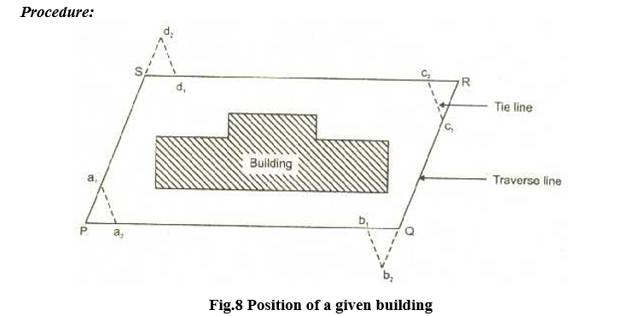
Position of a given building
1. Walk over the area to have the general idea about the main features and boundaries. Then prepare a neat free-hand sketch in the field book called ‘key plan’ which shows the boundaries, main features, positions of chain lines and survey stations. Draw the north direction on the right hand top corner by an arrow pointing vertically upward.
2. With reference to the key plan drawn, mark all the survey stations (for example P, Q, R and S as shown in figure) on the ground using pegs.
3. Range a survey line (say survey line SR) on an any one side of the building.
4. Stretch the chain in true alignment along survey line keeping one end of the chain at the starting station. Fix an arrow at the other end of the chain while it is kept laying on the ground.
5. Walk along the chain line and take either perpendicular offsets or oblique offsets to the corners of the building and to any other feature that is to be included in plan.
6. Record chainages and offsets in the field-book.
7. Repeat the process of chaining and offsetting until you reach the end of survey line.
8. Complete the survey work along the remaining survey lines.
9. At each survey station take tie lines connecting two survey lines and record the measurements in field-book.
Observations and Calculations:
10. The complete record of the chain survey in addition to all the measurements taken in the field should also include, the date of survey, name of the survey site and the names of the surveyors.
11. It is required to draw the plan to a suitable scale. Having chosen a scale obtain the plan dimensions from the field measurements.
Result:
1. Using the data recorded in the field-book prepare a plan of the area surveyed to a suitable scale on an A3 drawing sheet.
2. The plan should be oriented in such a way that the north line points more or less upwards.

EXPERIMENT-6
AIM: To perform traverse surveying with prismatic compass, check for local attraction and determine corrected bearing and to balance the traverse by Bowditch’s rule
APPARATUS: Prismatic compass, ranging rod, chain, tape, peg Tripod stand , small pieces of stones.

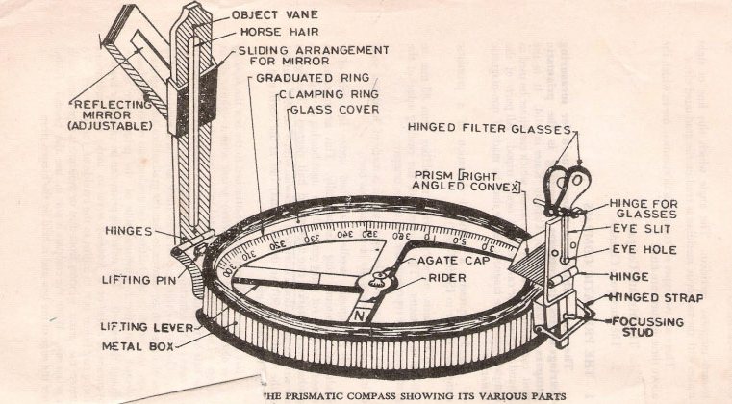

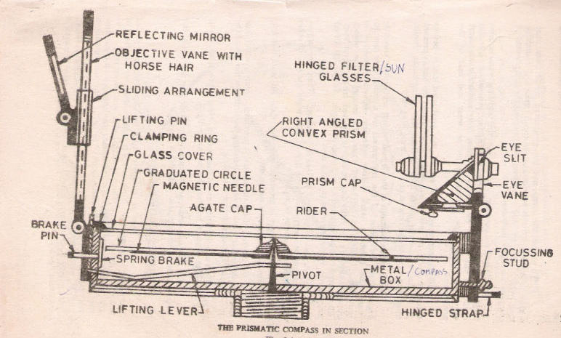

THEORY:
The important parts of compass are:-
1) A box with graduated circle.
2) A magnetic needle
3) A line of sight
When the line of sight is pointed to point, the magnetic needle of compass points towards north (Magnetic meridian). The angle which this line of sight makes with the magnetic meridian is read on graduated circle it is known as magnetic bearing of the line.

There are two types of compasses:-
1) Prismatic compass
2) Surveyor’s compass.

Prismatic Compass:-
Prismatic compass is very valuable instrument. It is usually used for rough survey form measuring bearing and survey lines. The least count of prismatic compass is 30 min. It consists of circular box of 10cm-12 cm dia. of non magnetic material. Pivot is fixed at the centre of box and is made up of hard steel with a Sharp pivot. Graduated aluminium is attached to the needle. It is graduated in clockwise direction from 0°to
360°. The figures are written in inverted. Zero is written at south end and 180° at north end and 270° at the east. Diametrically opposite are fixed to the box. The sighting vane consists of a hinged metal frame in the centre of which is stretched a vertical Horsehair fine silk thread of which is stretched a vertical hair. It presses against a lifting pin which lifts the needle of the pivot and holds it against the glass lid. Thus preventing the wear of the pivot point to damp the oscillations of the needle when about to take reading and to bring to rest quickly, a light spring is brought lifted inside the box. The face of the prism can be folded out the edge of the box when North end is used. Sometime the sighting vanes are provided with a hinge mirror which can be placed upward or downwards on the frame and can be also slided along it if required. The mirror can be made inclined at any angle so that objects which are too high or too low can be sighted directly by reflecting.

BEARING OF LINES: A bearing of a line is a horizontal angle made by the survey line with some reference direction or meridian.
Meridian may be
1) A true meridian
2) A magnetic meridian
3) An arbitrary or assumed meridian

True meridian: The true geographical meridian passing through a point is a line of intersection of earth’s surface by a plane containing north south pole and given point.
They are not parallel to each other at different places.

Magnetic meridian: The direction indicates by a free suspended and a properly balanced magnetic needle free from all other attractive forces. The direction of magnetic meridian can be established with the help of Magnetic compass.

Arbitrary meridian: Any direction is assumed to be the Reference meridian to carry out small survey.

Whole Circle Bearing: In whole circle bearing system, the bearing of a line is always measured clockwise from the north point of the reference meridian towards the line right round the circle. The angle thus measured between the reference meridian and the line is called Whole circle bearing of the line. Angles measured will have value between 0 to 360 degrees.

Conversion of W.C.B. in R.B
CASE | WCB | RB | QUADRANT
1 | 0°-90° | WCB | NE
2 | 90°-180° | 180°-WBC | SE
3 | 180°-270° | WBC-180° | SW
4 | 270°-360° | 360°-WBC | NW

Reduced bearing (R.B): In this system of bearing of a line is measured clockwise or anticlockwise from north or south direction whichever is nearer to the line towards east or west. The concept of reduced bearing facilitates computations in traverse surveying.

Conversion of R.B in W.C.B.
CASE | RB IN QUADRANT | RULE FOR WBC | WCB
1 | NE | WCB | 0°-90°
2 | SE | 180°-RB | 90°-180°
3 | SW | RB+180° | 180°-270°
4 | NW | 360°-RB | 270°-360°

Adjustment of the Prismatic Compass
The compass may be held in hand but for better results it should be fitted at the top of tripod having ball and socket arrangement. The adjustment of a compass is done in the following three steps.
1) Centering: The compass fitted over the tripod is lifted bodily and placed approximately on the station peg by spreading the leg of a tripod equally. The centre of the compass is checked by dropping a small piece of stone from the centre of the bottom of the compass so that it falls on the top of the station peg. A plumb bob may be used to judge the centering either by attaching it with a hook providing at the bottom or otherwise by holding it by hand.
2) Levelling: After the compass is centred, it is levelled by means of ball and socket arrangement so that the graduated circle may swing freely. It can be checked roughly by placing a round pencil on the top of the compass, when the pencil does not move, that is roughly the horizontal position.
3) Focusing the prism: The prism attached is moved up and down so that graduation on the graduated circle should become sharp and clear.

LOCAL ATTRACTION:
Sometimes the magnetic needle does not point towards magnetic North or South. The reason being that the needle may be under the influence of external attractive forces which are produced due to magnetic substances. Thus the deflection of the needle from its original position, due to the presence of some magnetic substances is known as local attraction. To detect local attraction at a particular place, fore and back bearing of each line are taken. Then if difference comes out to be 180° there is no local attraction at either station. On the other hand if the difference is other than 180°, the bearing may be rechecked to find out the discrepancy may not be due to the presence of iron substance near to the compass. If the difference still remains the local attraction exists at one or both the stations.

Elimination of Local attraction:-
1st method: - In this method, the bearing of the other lines are corrected and calculated on the basis of the line which has the difference between its fore bearing and back bearing equal to 180°.
The magnetic of the error is formed due to local attraction by drawing a sketch of observed and correct bearing of the line at each station. The error will be negative when the observed bearing is less than the corrected one and the correction will be positive and vice versa.
If however, there is no such line in which the difference of fore bearing and back bearing is equal to 180°, the correction should be made from the mean value of the bearing of that line in which the difference between the fore and the back bearing is the least. If the bearings are observed in quadrantal system, the correction should be applied in proper direction by drawing a neat sketch roughly.
2ndMethod: - This method is more general as the bearing at a station locally affected may be incorrect but include angles calculated from these bearing will be correct since the amount of the error will be the same for all the bearing observed from that station. Thus starting from the unaffected line and using these included angles the correct bearing of all other lines can be calculated.
Note: - The sum of the internal included angles must be equal to (2n-4) right angles where n=number of sides of a closed traverse.

PROCEDURES:
- Four ranging rods are fixed at different points i.e. A, B, C, D, E etc. such that it should be mutually visible and may be measured easily.
- Measure the distance between them.
- At point A the prismatic compass is set on the tripod Stand, centering and levelling is then properly done.
- The ranging rod at B is ranged through sighting slits and objective vane attached with horse hair and reading on prismatic compass is noted down. It is fore bearing of line AB.
- Then the prismatic compass is fixed at B and ranging rod at C and A are sighted. And reading is taken as forbearing of BC and back bearing of AB.
- Repeat the same procedure at the stations C, D etc.

OBSERVATION & CALCULATIONS:
Station | Line | Observed bearing | Local attraction | Error | Corrected bearing | Included angle

Error = observed bearing –corrected bearing
Check = (2n-4) x 90⁰

RESULTS:

EXPERIMENT-7
AIM: To perform levelling exercise by height of instrument method or rise and fall method.
APPARATUS: Dumpy level, levelling staff
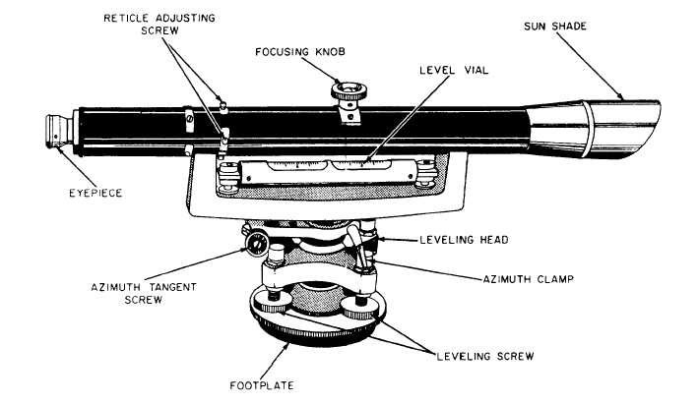
THEORY:
Levelling: The art of determining and representing the relative height or elevation of different object/points on the surface of earth is called levelling. It deals with measurement in vertical plane.
By levelling operation, the relative position of two points is known whether the points are near or far off. Similarly, the point at different elevation with respect to a given datum can be established by levelling.

LEVELLING INSTRUMENTS: The instrument which are directly used for levelling operation are:-
Level, levelling staff
Level: - An instrument which is used for observing staff reading on levelling staff kept over different points after creating a line of sight is called a level.
The difference in elevation between the point then can worked out.
A level essentially consists of the following points:
1) Levelling Heads
2) Limb plate
3) Telescope:
Telescope consists of two tubes, one slide into the other and fitted with lens and diaphragm having cross hairs. it creates a line of sight by which the reading on the staff is taken. The essential parts of a telescope are a) body; b) object glass; c)Eye-piece; d) Diaphragm; e) Ray shade; f) The rack and pinion arrangement; g) Focusing screw h) Diaphragm screw.
4) Bubble tube
5) Tripod stand
Dumpy level:
The dumpy level is simple, compact and stable instrument. The telescope is rigidly fixed to its supports. Hence it cannot be rotated about its longitudinal axis or cannot be removed from its support. The name dumpy is because of its compact and stable construction. The axis of telescope is perpendicular to the vertical axis of the level. The level tube is permanently placed so that its axis lies in the same vertical plane of the telescope but it is adjustable by means of captain head not at one end. The ray shade is provided to protect the object glass. A clamp and slow motion screw are provided in modern level to control the movement of spindle, about the vertical axis. The telescope has magnifying power of about thirty diameters.
The level tube is graduated to 2mm divisions and it has normally a sensitiveness of 20seconds of are per graduation. The telescope may be internally focusing or external focusing type.

Adjustment of the level
The level needs two type of adjustment
1) Temporary adjustment and
2) Permanent adjustment

Temporary adjustments of dumpy level
These adjustments are performed at each set-up the level before taking any observation.
A) Setting up the level: this includes
- Fixing the instrument in the tripod: the tripod legs are well spread on the ground with tripod head nearly level and at convenient height. Fix up the level on the tripod.
- Leg adjustment: Bring all the foot screws of the level in the centre of their run. Fix any two legs firmly into the ground by pressing them with hand and move the third leg to leg to right or left until the main bubble is roughly in the centre. Finally the legs are fixed after centering approximately both bubbles. This operation will save the time required for levelling.
B) Levelling: Levelling is done with the help of foot screws and bubbles. The purpose of levelling is to make the vertical axis truly vertical. The method of levelling the instrument depends upon whether there are three foot screws or four foot screws. In all modern instruments three foot screws are provided and this method only is described
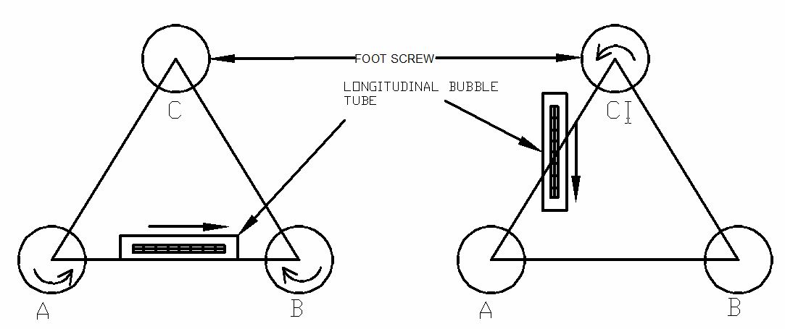

- Place the telescope parallel to pair of foot screws.
- Hold these two foot screw between the thumb and first finger of each hand and turn them uniformly so that the thumbs move either toward each other until the bubble is in centre.
- Turn the telescope through 90°so that it lies over the third foot screw.
- Turn this foot screw only until the bubble is centred.
- Bring the telescope back to its original position without reversing the eye piece and object glass ends.
- Again bring the bubble to the centre of its run and repeat these operation until the bubble remains in the centre of its run in both position which are at right angle to each other.
- Now rotate the instrument through 180°, the bubble should remain in centre provided the instrument is in adjustment, if not it needs permanent adjustment.

C) Focusing the eye piece: To focus the eye piece, hold a white paper in front of the object glass and move the eye piece in or out till the cross hairs are distinctly seen.
Care should be taken that the eye piece is not wholly taken out some times graduation are provided at the eye piece and that one can always remember the particular graduation position to suit his eyes. This will save much time of focusing the eye piece.

D) Focusing the object glass: - Direct the telescope to the levelling staff and on looking through the telescope, turn the focusing screw until the image appears clears and sharp. The image is thus formed inside the plane of cross hairs, Parallax, if any is removed by exact focusing. It may be noted that parallax is completely eliminated when there is no change in staff reading after moving the eye up and down.

Reduced Levels
The system of working out the reduced level of the points from staff reading taken in the field is called as reduced level (R.L) of a point is the elevation of the point with reference to the same datum.

There are two systems of reduced levels
1) The plane of collimation system (Height of instrument method)
2) The Rise and fall system

The plane of collimation system (H.I. method)
In this system, the R.L. of plane of collimation (H.I) is found out for every set-up of the level and then the reduced levels of the points are worked out with the respective plane of collimation as described below.

- Determine the R.L. of plane of collimation for the first set up of the level by adding B.S. to the R.L. of B.M. i.e. (R.L of plane of collimation= R.L. of B.M.+B.S.)
- Obtained the R.L. of the intermediate points and first change point by subtracting the staff readings (I.S. and F.S. from the R.L. of plane of collimation (H.I). (R.L. of a point=R.L of plane of collimation H.I.-I.S or F.S)
- When the instrument is shifted and set up at new position a new plane of collimation is determined by addition of B.S. to the R.L of change point. Thus the levels from two set-ups of the instruments can be correlated by means of B.S. and F.S. taken on C.P.
- Find out the R.L.s of the successive points and the second C.P. by subtracting their staff readings from this plane of collimation R.L.
- Repeat the procedure until all the R.Ls are worked out.

Observation table:-

Station | Reading |  |  | R.L. of plane Collimation (H.I) | Reduced  Level | Remarks
Station | BS | IS | FS | R.L. of plane Collimation (H.I) | Reduced  Level | Remarks

Arithmetical check: The difference between the sum of the back sights and the sum of the fore sights should be equal to the difference between the last and first reduced levels.
i.e. ∑B.S - ∑ F.S.= LAST R.L –FIRST R.L

The Rise and fall system
In this system, there is no need to determine R.L. of plane of collimation .The difference of level between consecutive points are obtained as described in procedure.

PROCEDURES:
- Determine the difference in staff readings between the consecutive points comparing each point after the first with that immediately preceding it.
- Obtained the rise or fall from the difference of their staff reading accordingly to the staff reading at the point is smaller or greater than that of proceeding point.
- Find out the reduced level of each point by adding the rise to or subtracting fall from the R.L. of a proceeding point.

OBSERVATION & CALCULATIONS:
Station | Reading |  |  | RISE | FALL | Reduced  Level | Remarks
Station | BS | IS | FS

Arithmetic check:
The difference between the sum of back sight and the sum of fore Sight= differencebetween the sum of rise and the sum of fall = the difference between the last R.L. and the first R.L.
∑B.S-∑F.S =∑RISE -∑FALL =LAST RL- FIRST RL
Inverted staff reading
When the B.M of staff station is above the line of collimation (or line of sight) the staff is held inverted on the point and reading is taken .This reading being negative is entered in the level field book with minus sign, or to avoid confusion, ‘Staff inverted’ should be written in the remarks column against the entry of the reading.

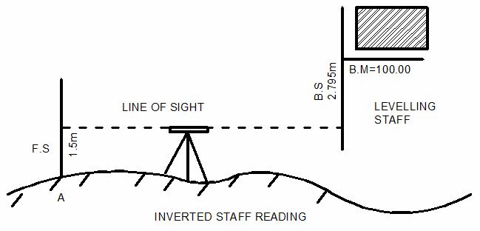

The results are tabulated as below:
BS | IS | FS | HI | RL | REMARK
-2.795 |  | 1.500 | 97.215 | 100.000  95.715 | B.M.Staff  InvertedPoint A

When the reading on the inverted staff is a foresight or intermediate sight .it should also be recorded in field book with minus sign
The R.L. of such points may be worked at as:
R.L. of the point (where the inverted staff is held) =R.L. of H.I +F.S. or I.S.reading

RESULTS:

EXPERIMENT-8
AIM: To measure horizontal and vertical angles in field by using theodolite.
APPARATUS: Theodolite, Ranging rod, pegs
TRANSIT THEODOLITE

THEORY:
Theodolite: Theodolite is the most intricate and accurate instrument used for measurement of horizontal and vertical angles. It consists of telescope by means of which distant objects can be sighted. The telescope has two distinct motions on in the horizontal plane and the other in the vertical plane. The former being measured on a graduated Horizontal vertical circle of two vernier. It is most precise method it is also used for laying of horizontal angles, locating points on line prolonging the survey line establishing the gradient, determination of difference in the elevation setting out curve.
Theodolite is primarily classified as following;
1) Transit theodolite
2) Non-transit theodolite
A theodolite is called transit theodolite when its telescope can be resolved through a complete revolution about its horizontal axis in a vertical plane.
Various parts of transit theodolite
- Telescope: it is an integral part and is mounted on the spindle known as horizontal axis or turn on axis. Telescope is either internal or external focusing type. The telescope is pivoted between the standard at right angles to the horizontal axis. It can be rotated about its horizontal axis in a vertical plane. The telescope is provided with the focusing screw, Clamping screw and tangent screw.
- The leveling head: It supports the main working parts of the instrument and screws on a tripod. The head comprises of two parts
  - A leveling foot screws for leveling the instrument i.e. for marking vertical axis truly vertical.
  - A movable head or centering arrangement for centering the vertical axis accurately over a station point.
- It may consists of circular plates called as upper and lower Parallel plates. The lower parallel plate has a central aperture through which a plumb bob may be suspended. The upper parallel plate or tri branch is supported by means of four or three leveling screws by which the instrument may be leveled.
- To lower plate or screw plate: It carries horizontal circle at its leveled screw.
- It carries a lower clamp screw and tangent screw with the help of which it can be fixed accurately in any desired position.
- The upper plate or vernier plate:- it is attached to inner axis and carries two vernier and at two extremities diametrically opposite.
- Compass: the compass box may be either of circular form or of a rough type. The former is mounted on the vernier plate between the standards while the latter is attached to the underside of the scale or lower plate or screwed to one of the standards. Modern theodolite is fitted with a compass of the tubular type and it is screwed to one of the standards.
- Vertical circle: the vertical circle is rigidly attached to the telescope and moves with it. It is silvered and it is usually divided into four quadrants.
- Index bar or T-frame: the index bar is T shaped and centered on horizontal axis of the telescope in front of the vertical axis. It carries two verniers on the extremities. Its horizontal arms or limbs called the index arm. The vertical leg called the clip or clipping screws at its lower extremity. The index arm and the clipping arm are together known as T-frame.
- Plumb bob: To centre the instrument exactly over a station mark, a plumb bob is suspended from the hook fitted to the bottom of the central vertical axis.
- A lower level circular horizontal metal plate: It carries a circular graduated arc. The lower plate is attached to a vertical metal spindle (outer axis) which works in vertical bearing and a form a part of leveling head. It may be graduated in degree and half degree or a degree 1/3 of degrees .the upper plate carries an index and vernier or micrometer towards fine reading on gradated horizontal circle .the upper plate carries standard use of for supporting the telescope and the spirit level used for leveling the instrument.
- A circular graduated are carried on vertical circle: It is attached to the horizontal axis of the telescope, it is usually divided into 4 quadrants, but in some instruments it is graduated continuously from 0-360°.the graduation in each quadrant are numbered from 0-90°in opposite direction. The subdivisions of vertical circle are similar to those of vertical circle.

Repetition method of measuring Horizontal angles
When it is required to measure horizontal angles with great accuracy as in the case of traverse, the method of repetition may be adopted. In this method the same angle is added several times by keeping the vernier to remain clamped each time at the end of each measurement instead of setting it back to zero when sighting at the previous station. The corrected horizontal angle is then obtained by dividing the final reading by the number of repetitions. Usually six reading, three with face left and three with face right, are taken The average horizontal angle is then calculated.

MESURMENT OF VERTICAL ANGLE
A vertical angle is the angle between the inclined line of sight to an object and the horizontal. It may be an angle of elevation or on angle of depression according as the point is above or below the horizontal plane passing through the trunnion axis of the instrument.
.
PROCEDURES:
  - Measurement of Horizontal angle
- Let LOM is the horizontal angle to be measured where O is the station point fixed on the ground by a peg. Set up the theodolite over the peg ‘o’ and level it accurately.
- Set the horizontal graduated circle vernier A to read zero or 360° by upper clamps crew and slow motion screw. Clamp the telescope to bisect the bottom shoe of the flag fixed at point ‘L’ and tighten the lower clamp. Exactly intersect the centre of the bottom shoe by means of lower slow motion screw. Check that the face of the theodolite should be left and the telescope in normal position.
- Check the reading of the vernier A to see that no slip has occurred .Also see that the plate levels are in the centre of their run. Read the vernier B also.
- Release the upper clamp screw and turn the theodolite clockwise. Bisect the flag bottom shoe fixed at point M by a telescope. Tighten the upper clamp screw and bisect the shoe exactly by means of upper slow motion screw.
- Note the reading on both the vernier to get the approximate value of the angle LOM.
- Release the lower clamp screw and rotate the theodolite anticlockwise azimuth. Bisect again the bottom shoe of the flag at ‘L’ and tighten the lower clamp screw. By means of slow motion screw bisect exactly the centre of the shoe.
- Release now the upper clamp screw and rotate the theodolite clockwise. Bisect the bottom shoe of the flag fixed at M and tighten the upper clamp screw. By means of slow motion screw bisect exactly the centre of the shoe. The vernier readings will be now twice of the angles.
- Repeat the process until the angle is repeated the required number of times (usually3). Add 360° for every complete revaluation to the final reading and divided the total angle by number of repetitions to get the value of angle LOM.
- Change the face of the theodolite the telescope will now be inverted. Repeat the whole process exactly in the above manner and obtain value of angle LOM.
- The average horizontal angle is then obtained by taking the average of the two angles obtained with face left and face right.
- Usually three repetitions face left and three with face right should be taken and the mean angle should be calculated.

  - Measurement of Vertical angle
- Set up the theodolite at station point O and level it accurately with reference to the altitude level.
- Set vertical verniers C and D exactly to zero by using the vertical circle clamp and tangent screw, while the altitude level should remain in the centre of its run. Also the face of the theodolite should be left.
- Release the vertical circle clamp screw and rotate the telescope in vertical plane so as to bisect the object M. tighten the vertical circle clamp and exactly bisect the object by slow motion screw.
- Read both verniers C and D. the mean of the two readings gives the value of the required angle.
- Similar observation may be made with other face. The average of the two values thus obtained gives the value of the required angle which is free from instrumental errors.
- Similarly the angle of depression can be measured following the above steps.

To measure the vertical angle between two points L and M
- Sometimes it is required to measure vertical angle between two points L and M. There can be three possibilities.
  - One point is above the line of sight and the other is below the line of sight the angle LOM as shown in fig will be equal to (<P +<Q )
  - Both the points are above the line of sight. Then the angle LOM= <P -<Q
  - Both the points are below the line of sight, then the angle LOM= <P -<Q (Refer Fig 3)
- To measure the angle between two points L and M proceed as follows
  - Set the theodolite at station point O and accurately level it.
  - Bisect the flag at L as explained already and take the reading on the verniers C and D. Calculate the mean angle.
  - Bisect the flag at M as before and take the reading on the verniers C and D. Calculate the mean angle.
  - The sum or difference of these angles will give the value of the vertical angle between points L and M as shown in the figure (4)

OBSERVATION & CALCULATIONS:
  - Measurement of Horizontal angle
S.No. | Instrument Station | Shifted to | Face left readings |  |  | Mean Horizontal angle | Remark
S.No. | Instrument Station | Shifted to | Vernier  C  0,I,II | Vernier  D  0,I,II | Total angle | Mean Horizontal angle | Remark
 | O | L
 |  | M

S.No. | Instrument Station | Shifted to | Face right readings |  |  | Mean Horizontal angle | Remark
S.No. | Instrument Station | Shifted to | Vernier  C  0,I,II | Vernier  D  0,I,II | Total angle | Mean Horizontal angle | Remark
 | O | L
 |  | M

  - Measurement of Vertical angle
S.No. | Instrument Station | Shifted to | Face left readings |  |  | Vertical angle | Remark
S.No. | Instrument Station | Shifted to | Vernier  C  0,I,II | Vernier  D  0,I,II | Mean angle | Vertical angle | Remark
 | O | P
 | (+ ve) | L
 | (- ve) | M

S.No. | Instrument Station | Shifted to | Face right readings |  |  | Vertical angle | Remark
S.No. | Instrument Station | Shifted to | Vernier  C  0,I,II | Vernier  D  0,I,II | Mean angle | Vertical angle | Remark
 | O | P
 | (+ ve) | L
 | (- ve) | M

RESULTS:
The average horizontal angle is found to be
The average value of vertical is found to be

EXPERIMENT-9
AIM: To verify the law of triangle of forces and Lami’s Theorem

APPARATUS: Gravesend’s apparatus Board fixed with pulley, drawing sheet, weights, plain mirror strip, strings, pencil & eraser, protector
THEORY:
Law of Triangle of forces states that “If three coplanar, concurrent forces are in equilibrium, the forces can be represented in magnitude and direction by the sides of triangle drawn in such a way that the sides of triangle are parallel to the forces taken in order”.
This law can also be stated as: If two forces acting on a particle represented in magnitude and direction by the two sides of the triangle taken in order then their resultant will be given by the third side of the triangle taken in opposite direction.

LAMI’S THEOREM: This theorem was given by a Great Mathematician “Bernard Lamy”, and the name was coined Lami’s theorem. According to this theorem, when three coplanar, concurrent and non-co-linear forces act on a body which is in equilibrium then the magnitude of each force is proportional to the sine of angle between other two forces.
This theorem can be proved by the sine law.
(A/Sin α) = (B/Sin β) = (C/ Sin γ)
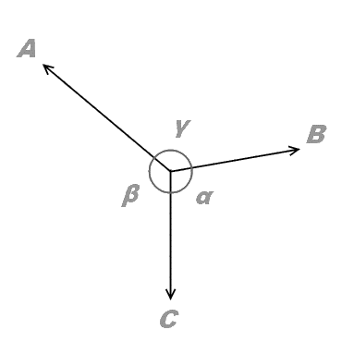
Also we can solve it by triangle law.
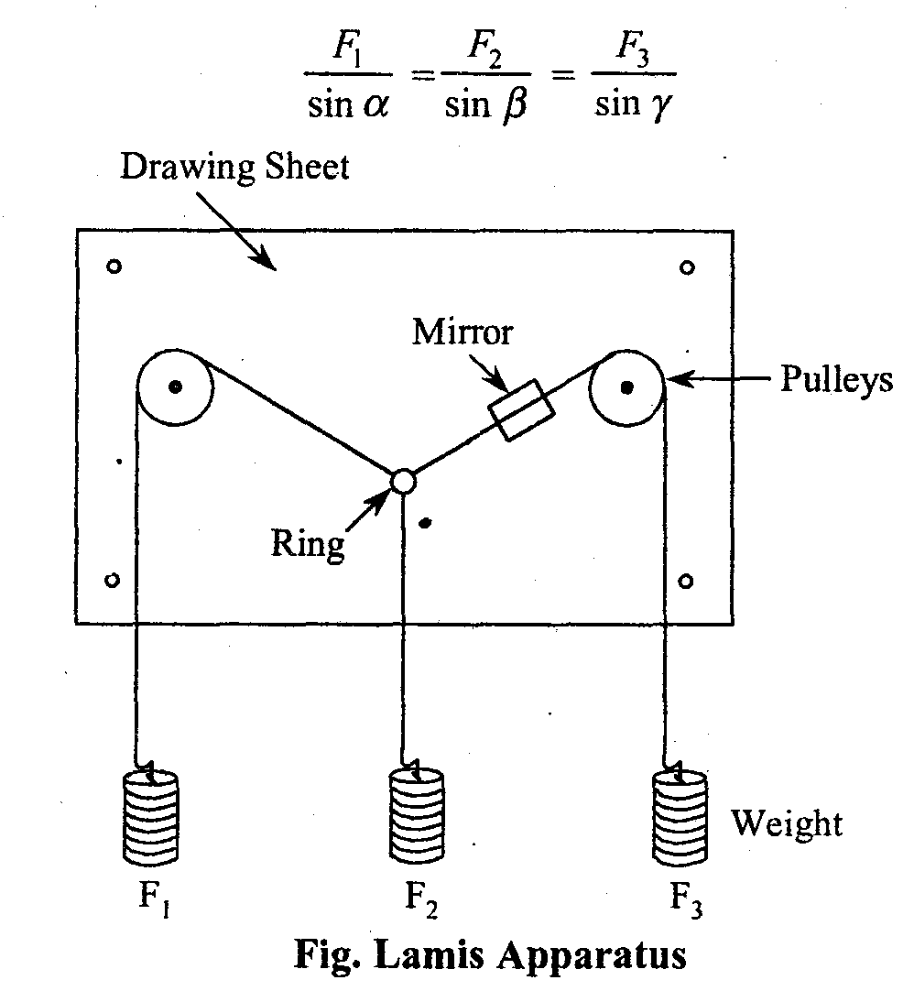
PROCEDURES:
- Take two wire apparatus and fix drawing sheet on the board.,
- Connect the hanger at the end of each string and hang the given weight on the pivot provided.
- Note down the reading of the two spring balances and weight F₂ so that equilibrium condition is achieved.
- Mark the position of strings on the drawing sheet using mirror after equilibrium condition is reached.
- Note down magnitudes of weight F₁, F₂ and F₃ in the table.
- Remove the sheet and construct space and vector diagram.
- Repeat the above procedure for various sets of readings.
- Measure magnitude of resultant force R graphically for verification of triangle law.
- Measure the angle α, β, and γ for verification of Lami’s theorem.

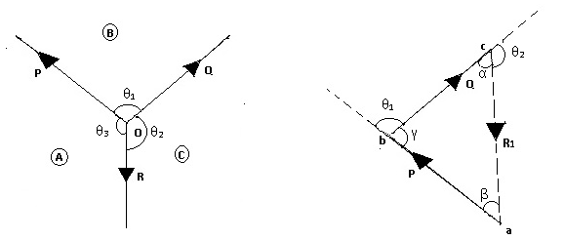
(a) Space diagram (b) Vector diagram

OBSERVATION & CALCULATIONS:
Law of Triangle of Forces
S.No. | Experimental Force F₁  Kg | Experimental Force F₂  kg | Experimental Force F₃  kg | Graphical Force F₃’ | % error  F₃ –F’₃ x100  F₃
1.
2.
3.
4.
5.

Lami`s Theorem
S. No. | Observed |  |  | Observed |  |  | Analytical |  | % error
S. No. | Force F₁ | Force F₂ | Force F₃ | Angle α | Angle β | Angle γ | F’₁ | F’₂ | F₁ –F’₁ x100  F₁ | F₂ –F’₂ x100  F₂
1.
2.
3.
4.
5.

RESULTS:
- Law of triangle of forces- ________________(Verified /Not verified)

- For ____ sets of observations, the observed percentage error is _______

- Lami’s Theorem of forces- ________________(Verified /Not verified)

- For ____ sets of observations, the observed percentage error is _________

PRECAUTIONS:
- Pulleys should be smooth.
- Place the weights gently.
- Fix the drawing Sheet properly.
- Weights of hanger should be taken into consideration.
- Parallax should be removed to mark the position of string.
- Proper scale should be chosen.

EXPERIMENT-10
AIM: To verify the law of parallelogram of forces.

APPARATUS: Gravesend’s apparatus Board fixed with pulley, drawing sheet, weights, plain mirror strip, strings, pencil & eraser, protector
THEORY:
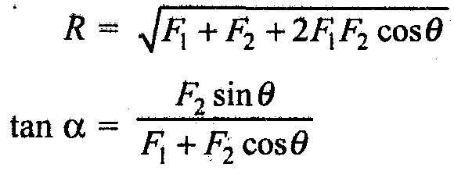
If two force F1 and F2 acting on a particle, be represented in magnitude and direction by the two adjacent sides of a parallelogram, then their resultant (R) is represented by the diagonal of the parallelogram ,Magnitude and direction of the resultant force is given by:

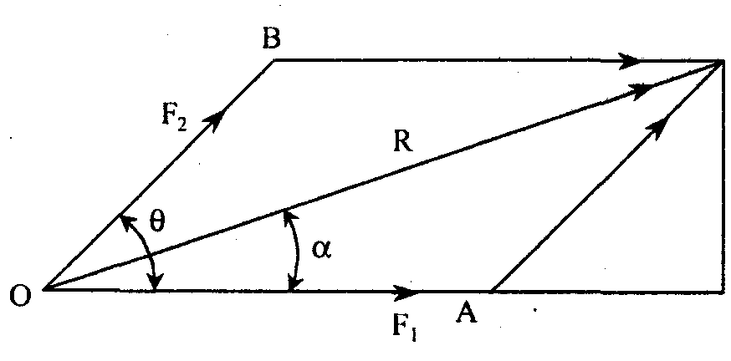
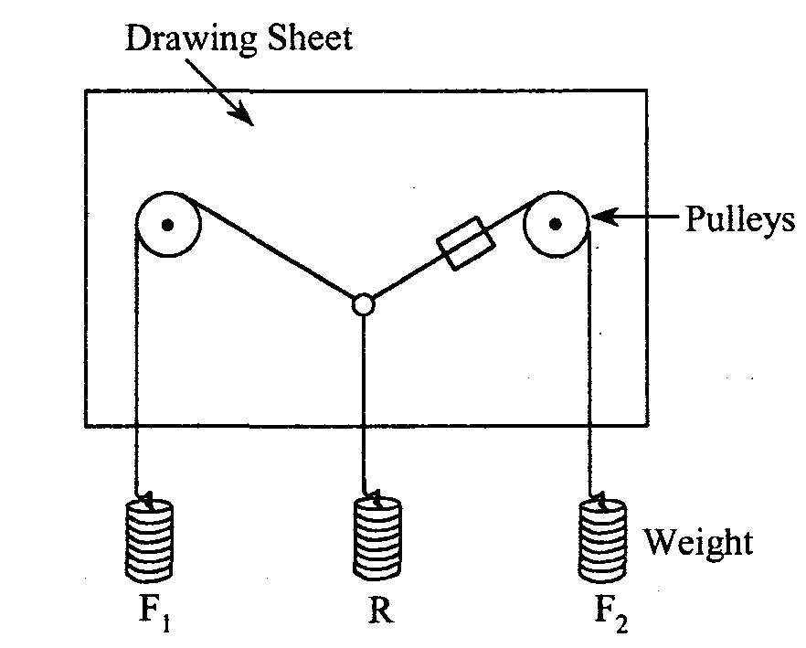

PROCEDURES:
- Take two wire apparatus and fix drawing sheet on the board.
- Connect the hanger at the end of each string and hang the giving weight on the pivot provided.
- Note down the reading of two weights F₁ and F₂&weight R so that equilibrium condition is achieved.
- Mark the position of strings on the drawing sheet using mirror after equilibrium condition is reached.
- Note down magnitudes of weight F₁, F₂, R and measure angle ϴ and α.
- Repeat the above procedure for various sets of readings in the table.
- Repeat the above procedure for various sets of readings.
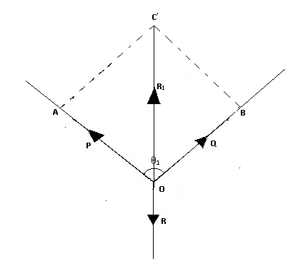
OBSERVATION & CALCULATIONS:

S. No. | Observed Forces |  |  | Observed Angles |  | Analytical values |  | % error
S. No. | F₁ | F₂ | R | θ | α | α’ | R’ | R’ – R x 100  R’ | α’ – αx100  α’
1.
2.
3.
4.

RESULTS:
    - Law of Parallelogram of Forces- ________________(Verified /Not verified)

    - For ____ sets of observations, the observed percentage error is ___________

PRECAUTIONS:
- Pulleys should be smooth.
- Place the weights gently.
- Fix the drawing Sheet properly.
- Weights of hanger should be taken into consideration.
- Parallax should be removed to mark the position of string.
- Proper scale should be chosen.

EXPERIMENT-11
AIM: To verify the law of polygon of forces.

APPARATUS: Universal force table, Strings, Weights, Hangers, drawing sheets
THEORY:
Polygon law:
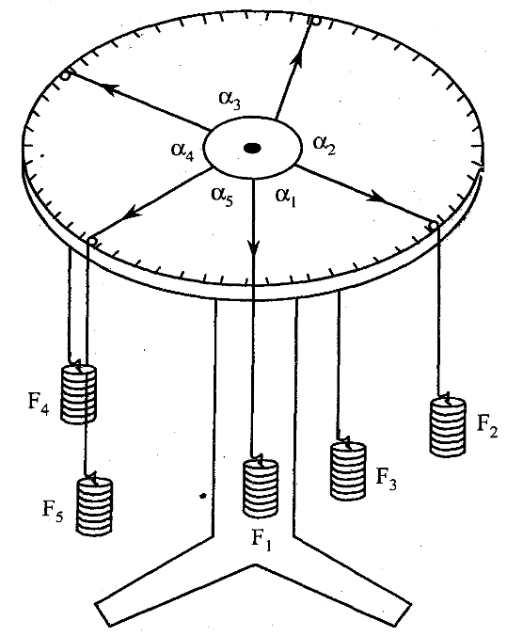
This law states that “if a number of coplanar, concurrent forces Is represented in magnitude and direction by the sides of a polygon taken in order then their resultants represented in magnitude and direction by the closing side of the polygon but in opposite order”.

PROCEDURES:
    - Draw the thread over the pulley and connect the hangers at one end of string whose other end is connected to the circular ring.
    - Add suitable weights in each hanger till the ring is in centre and apply load in the thread in such a way that all the forces are in equilibrium.
    - Mark the position of thread with the help of mirror on paper and join all the points.
    - Measure the angles between the strings and read the values of the corresponding weights.
    - Draw the vector diagram and calculate the percentage error.
    - Repeat the experiment for minimum five sets.

OBSERVATION & CALCULATIONS:
S. No | Experimental Angles |  |  |  |  | Experimental weights |  |  |  |  | Graphical |  | Percentage error
S. No | α₁ | α₂ | α₃ | α₄ | α₅ | F₁ | F₂ | F₃ | F₄ | F₅ | F₅’ | α₅’ | F₅ - F₅’ x 100  F₅ | α ₅ - α ₅’ x 100  α ₅
1.
2.
3.
4.
5.

RESULTS:
- Law of Polygon of Forces- ________________(Verified /Not verified)

- For ____ sets of observations, the observed percentage error is ____________

Precaution:
- Pulleys should be smooth.
- Place the weights gently.
- Plotting should be done carefully.
- Clean the apparatus carefully.
- The ring should be at centre for equilibrium position.

