UML diagrams

# Use case

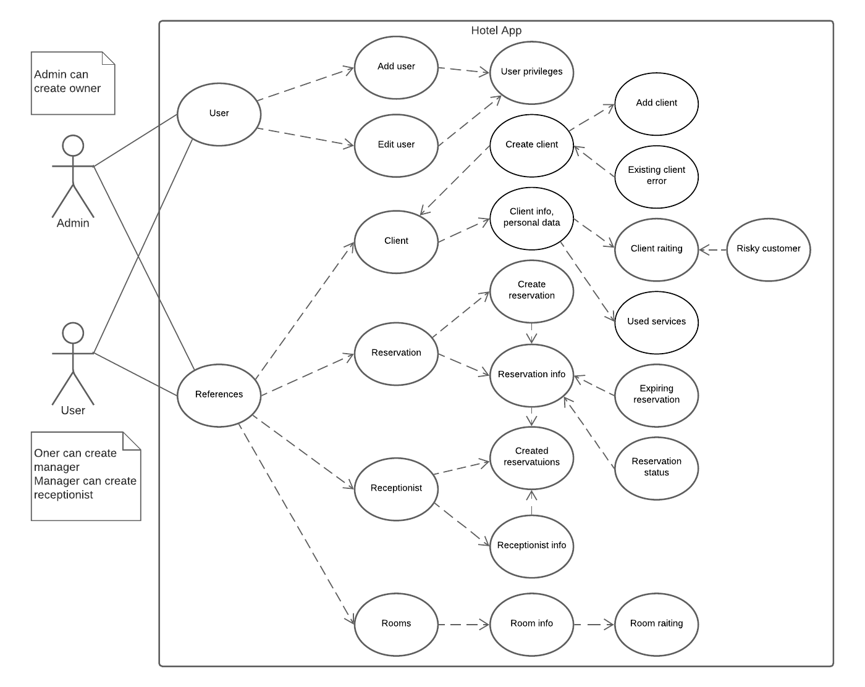

# Sequence diagram