[Дата]

Веселин Николов

Проект по Бази данни

Задание № 11

# Задание

## Да се проектира и реализира база от данни за **МУЗИКАЛЕН МАГАЗИН**, която да съхранява следната информация:

1. *Стока (CD, DVD, Blue-Ray, и др.)* – вид, година, наименование, изпълнител, жанр, музикална компания, единична цена.
2. *Клиент* – име, адрес и телефон.
3. *Служител* – име, позиция, телефон.
4. *Продажби* – клиент, служител, дата на продажба, стоки, брой.

## Правила:

* Всеки клиент може да закупи повече от една стока.
* Всяка стока е от един: вид, жанр, изпълнител, компания.

## Базата данни трябва да е **нормализирана** и да позволява:

1. **Въвеждане и корекция** на данни.
2. **Търсене на CD, DVD** по: вид, изпълнител, жанр, година, музикална компания.
3. **Справки** за:
   * Продажби на служител, подредени по дата.
   * Последните 5 продажби на стоки, подредени по служител.
   * Закупени стоки от клиент, подредени по вид и дата.
   * Закупени стоки за период, подредени по клиенти и дати.

# Data modeler

## Logical model

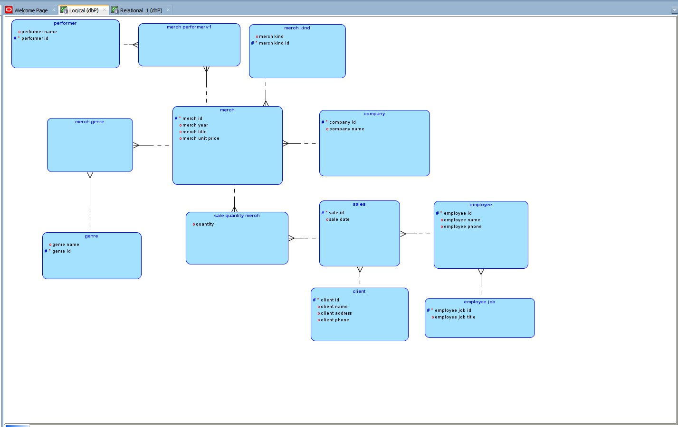

## Relational model

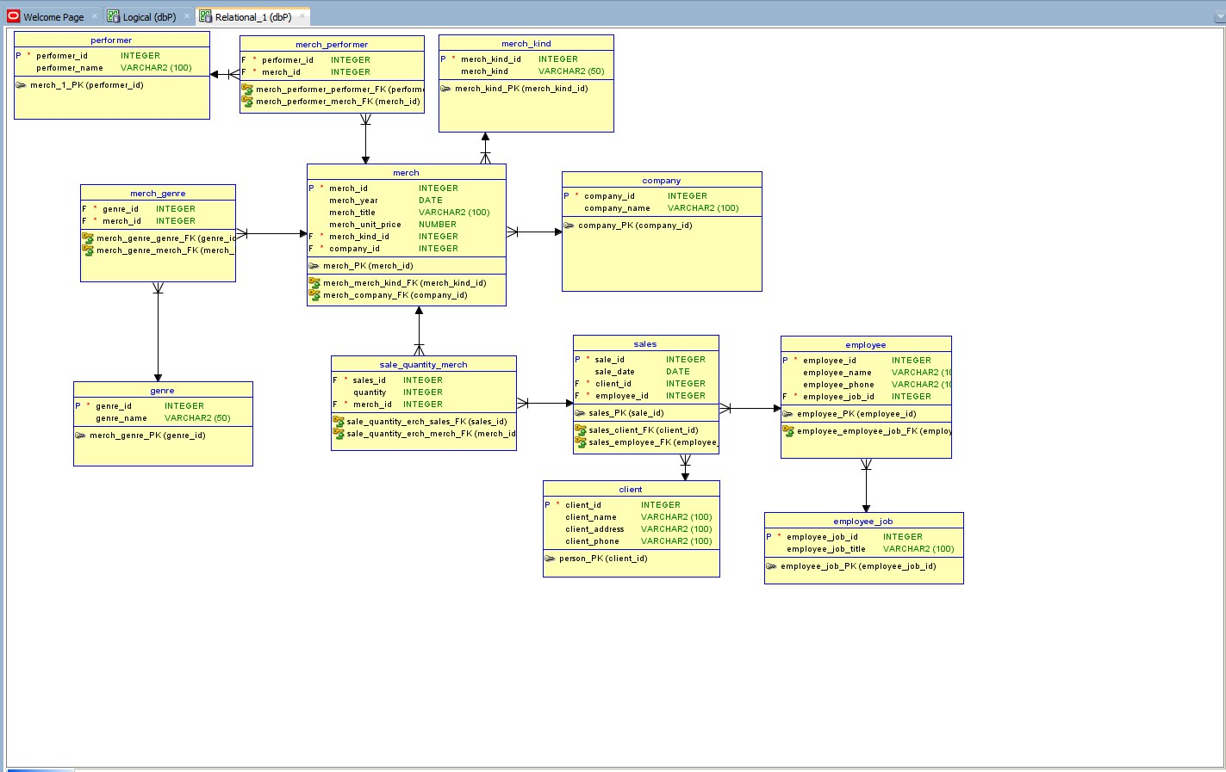

# Създаване на таблици

Пълният код на заданието може да намерите на този линк: https://github.com/sonikvvv/Project-for-DB

**CREATE** **TABLE** sales (  
 sale_id INTEGER **NOT** NULL,  
 sale_date DATE,  
 client_id INTEGER **NOT** NULL,  
 employee_id INTEGER **NOT** NULL  
);

# Въвеждане на информация в таблиците

Пълният код на заданието може да намерите на този линк: https://github.com/sonikvvv/Project-for-DB

**insert** **all**   
 **into** merch_kind (merch_kind_id, merch_kind) **VALUEs**(1, 'CD')  
 **into** merch_kind (merch_kind_id, merch_kind) **VALUEs**(2, 'DVD')   
 **into** merch_kind (merch_kind_id, merch_kind) **VALUEs**(3, 'Blue-Ray')   
 **into** merch_kind (merch_kind_id, merch_kind) **VALUEs**(4, 'Plate')  
**select** 1 **from** dual;

# Търсене

## Създаване на отделна таблица

**create** **table** search_in_merch **as**  
**with** search_merch **as**  
(  
 **select**  
 m.merch_id,  
 m.merch_title,  
 m.merch_year,  
 m.merch_unit_price,  
 mk.merch_kind,  
 g.genre_name,  
 **LISTAGG**(p.performer_name, ',') **within** **group** (**order** **by** p.performer_name) **as** performers,  
 c.company_name  
 **from** merch m  
 **join** merch_genre mg **on** mg.merch_id = m.merch_id  
 **join** genre g **on** g.genre_id = mg.genre_id  
 **join** company c **on** m.company_id = c.company_id  
 **join** merch_performer mp **on** m.merch_id = mp.merch_id  
 **join** performer p **on** mp.performer_id = p.performer_id  
 **join** merch_kind mk **on** m.merch_kind_id = mk.merch_kind_id  
 **group** **by** m.merch_id, m.merch_title, m.merch_year, m.merch_unit_price, mk.merch_kind,   
 c.company_name, g.genre_name  
 **order** **by** m.merch_id  
)  
**select**   
 s.merch_id,  
 s.merch_title,  
 s.merch_year,  
 s.merch_unit_price,  
 s.merch_kind,  
 **LISTAGG**(s.genre_name, ',') **within** **group** (**order** **by** s.genre_name) **as** genres,  
 s.performers,  
 s.company_name  
**from** search_merch s  
**group** **by** s.merch_id, s.merch_title, s.merch_year, s.merch_unit_price, s.merch_kind,   
s.performers, s.company_name;s.performers, s.company_name;

## Заявки за търсене и резултати

### По изпълнител – value = mc

**select** *   
**from** search_in_merch  
**where** (merch_kind = 'CD' **or** merch_kind = 'DVD')  
 **and** **lower**(company_name) **like** **lower**('%&value%');



### По жанр – value = op

**select** *  
**from** search_in_merch  
**where** (merch_kind = 'CD' **or** merch_kind = 'DVD')  
 **and** **lower**(genres) **like** **lower**('%&value%');



### По година – value = 1981-10-1

**select** *  
**from** search_in_merch  
**where** (merch_kind = 'CD' **or** merch_kind = 'DVD')  
 **and** merch_year **like** **to_date**('&value', 'YYYY-MM-DD');



### По музикална компания – value = mc

**select** *   
**from** search_in_merch  
**where** (merch_kind = 'CD' **or** merch_kind = 'DVD')  
 **and** **lower**(company_name) **like** **lower**('%&value%');



# Справки

## Продажби на служител, подредени по дата- value = 5

**select**  
 s.sale_id,  
 s.sale_date,   
 s.client_id,  
 e.employee_name,  
 e.employee_id  
**from** sales s  
**join** EMPLOYEE e **on** e.employee_id = s.employee_id  
**where** e.employee_id = &employee_id  
**group** **by** e.employee_name, s.sale_id, s.sale_date, s.client_id, e.employee_id  
**order** **by** e.employee_name **DESC**, s.sale_date **DESC**;

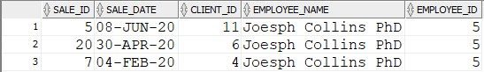

## Последните 5 продажби на стоки, подредени по служител

### Продажби подредени по дата.

select s.sale_id, s.sale_date, s.client_id, e.employee_name  
from sales s  
join employee e on s.employee_id = e.employee_id  
**order** by sale_date DESC;

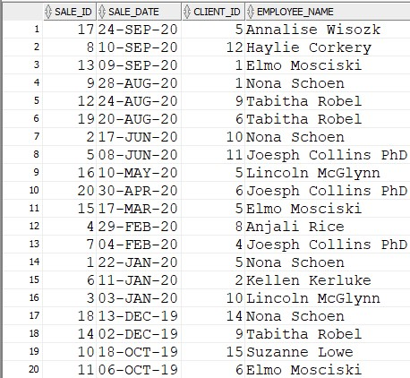

### Последните 5 продажби на стоки

**select** *   
**from**  
(  
 **select** s.sale_id, s.sale_date, s.client_id, e.employee_name  
 **from** sales s  
 **join** employee e **on** s.employee_id = e.employee_id  
 **order** **by** sale_date **DESC**  
)  
**where** ROWNUM <= 5  
**order** **by** 4 **ASC**;

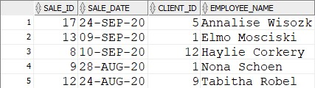

## Закупени стоки от клиент, подредени по вид и дата – value = 4

**select**  
 s.sale_id,  
 s.sale_date,  
 c.client_name,  
 c.client_phone,  
 m.merch_id,  
 m.merch_title,  
 mk.merch_kind,  
 m.merch_unit_price  
**from** sales s  
**join** sale_quantity_merch sqm **on** s.sale_id = sqm.sales_id  
**join** **client** c **on** c.client_id = s.client_id  
**join** merch m **on** m.merch_id = sqm.merch_id  
**join** merch_kind mk **on** mk.merch_kind_id = m.merch_kind_id  
**where** c.client_id = &client_id  
**order** **by** mk.merch_kind **ASC**, s.sale_date **DESC**;

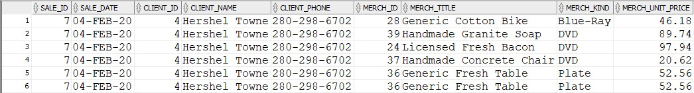

## Закупени стоки за период, подредени по клиенти и дати 1.1.2020 -20.4.2020

**select**  
 s.sale_id,  
 s.sale_date,  
 c.client_name,  
 c.client_phone,  
 m.merch_id,  
 m.merch_title,  
 mk.merch_kind,  
 m.merch_unit_price  
**from** sales s  
**join** sale_quantity_merch sqm **on** s.sale_id = sqm.sales_id  
**join** **client** c **on** c.client_id = s.client_id  
**join** merch m **on** m.merch_id = sqm.merch_id  
**join** merch_kind mk **on** mk.merch_kind_id = m.merch_kind_id  
**where**   
 (s.sale_date >= **to_date**('&from_date', 'DD.MM.YYYY')) **and**  
 (s.sale_date <= **to_date**('&to_datee', 'DD.MM.YYYY'))  
**order** **by** s.sale_date **DESC**, c.client_name;

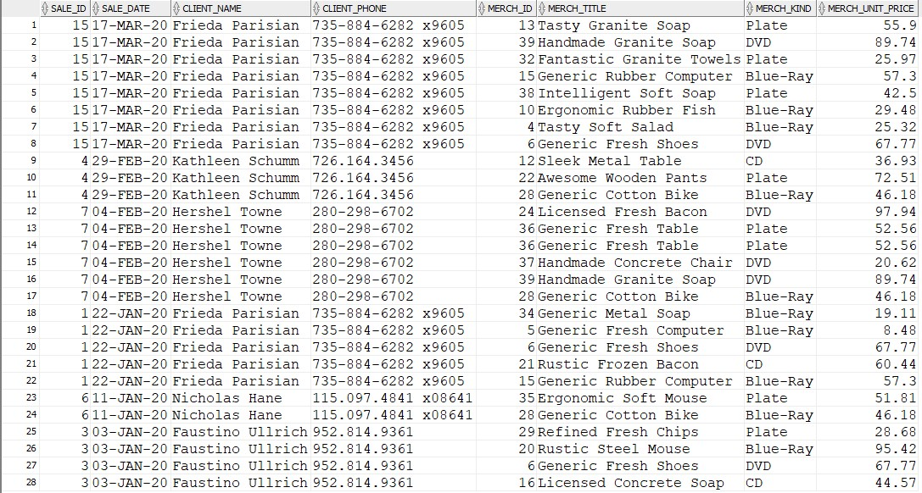

# PL/SQL

## Sequences

**create** **SEQUENCE** client_seq  
    **start** **with** 16   
    **INCREMENT** **by** 1  
NOCACHE **ORDER**;  
   
**create** **SEQUENCE** company_seq  
    **start** **with** 21   
    **INCREMENT** **by** 1  
NOCACHE **ORDER**;  
   
**create** **SEQUENCE** employee_seq  
    **start** **with** 11   
    **INCREMENT** **by** 1  
NOCACHE **ORDER**;  
  
**create** **SEQUENCE** employee_job_seq  
    **start** **with** 11   
    **INCREMENT** **by** 1  
NOCACHE **ORDER**;  
  
**create** **SEQUENCE** genre_seq  
    **start** **with** 15   
    **INCREMENT** **by** 1  
NOCACHE **ORDER**;  
   
**create** **SEQUENCE** merch_seq  
    **start** **with** 40   
    **INCREMENT** **by** 1  
NOCACHE **ORDER**;  
   
**create** **SEQUENCE** merch_genre_seq  
    **start** **with** 102   
    **INCREMENT** **by** 1  
NOCACHE **ORDER**;  
   
**create** **SEQUENCE** merch_kind_seq  
    **start** **with** 5   
    **INCREMENT** **by** 1  
NOCACHE **ORDER**;  
   
**create** **SEQUENCE** merch_performer_seq  
    **start** **with** 60  
    **INCREMENT** **by** 1  
NOCACHE **ORDER**;  
   
**create** **SEQUENCE** performer_seq  
    **start** **with** 16  
    **INCREMENT** **by** 1  
NOCACHE **ORDER**;  
   
**create** **SEQUENCE** sale_quantity_merch_seq  
    **start** **with** 99  
    **INCREMENT** **by** 1  
NOCACHE **ORDER**;  
   
**create** **SEQUENCE** sales_seq  
    **start** **with** 21  
    **INCREMENT** **by** 1  
NOCACHE **ORDER**;

## Triggers

**create** **TRIGGER** client_trig  
    **before** **insert** **on** **CLIENT**  
    **for** **EACH** **ROW**  
    **WHEN** (new.client_id **is** null)  
    **begin** :new.client_id := vesko.CLIENT_SEQ.NEXTVAL;  
**end**;  
  
**create** **TRIGGER** company_trig  
    **before** **insert** **on** company  
    **for** **EACH** **ROW**  
    **WHEN** (new.company_id **is** null)  
    **begin** :new.company_id := vesko.company_seq.NEXTVAL;  
**end**;  
  
**create** **TRIGGER** employee_trig  
    **before** **insert** **on** employee  
    **for** **EACH** **ROW**  
    **WHEN** (new.employee_id **is** null)  
    **begin** :new.employee_id := vesko.employee_seq.NEXTVAL;  
**end**;  
  
**create** **TRIGGER** employee_job_trig  
    **before** **insert** **on** employee_job  
    **for** **EACH** **ROW**  
    **WHEN** (new.employee_job_id **is** null)  
    **begin** :new.employee_job_id := vesko.employee_job_seq.NEXTVAL;  
**end**;  
  
**create** **TRIGGER** genre_trig  
    **before** **insert** **on** genre  
    **for** **EACH** **ROW**  
    **WHEN** (new.genre_id **is** null)  
    **begin** :new.genre_id := vesko.genre_seq.NEXTVAL;  
**end**;  
  
**create** **TRIGGER** merch_trig  
    **before** **insert** **on** merch  
    **for** **EACH** **ROW**  
    **WHEN** (new.merch_id **is** null)  
    **begin** :new.merch_id := vesko.merch_seq.NEXTVAL;  
**end**;  
  
**create** **TRIGGER** merch_genre_trig  
    **before** **insert** **on** merch_genre  
    **for** **EACH** **ROW**  
    **WHEN** (new.merch_genre_id **is** null)  
    **begin** :new.merch_genre_id := vesko.merch_genre_seq.NEXTVAL;  
**end**;  
  
**create** **TRIGGER** merch_kind_trig  
    **before** **insert** **on** merch_kind  
    **for** **EACH** **ROW**  
    **WHEN** (new.merch_kind_id **is** null)  
    **begin** :new.merch_kind_id := vesko.merch_kind_seq.NEXTVAL;  
**end**;  
  
**create** **TRIGGER** merch_performer_trig  
    **before** **insert** **on** merch_performer  
    **for** **EACH** **ROW**  
    **WHEN** (new.merch_performer_id **is** null)  
    **begin** :new.merch_performer := vesko.merch_performer_seq.NEXTVAL;  
**end**;  
  
**create** **TRIGGER** performer_trig  
    **before** **insert** **on** performer  
    **for** **EACH** **ROW**  
    **WHEN** (new.performer_id **is** null)  
    **begin** :new.performer_id := vesko.performer_seq.NEXTVAL;  
**end**;  
  
**create** **TRIGGER** sale_quantity_merch_trig  
    **before** **insert** **on** sale_quantity_merch  
    **for** **EACH** **ROW**  
    **WHEN** (new.sale_quantity_merch_id **is** null)  
    **begin** :new.sale_quantity_merch_id := vesko.sale_quantity_merch_seq.NEXTVAL;  
**end**;  
  
**create** **TRIGGER** sales_trig  
    **before** **insert** **on** sales  
    **for** **EACH** **ROW**  
    **WHEN** (new.sales_id **is** null)  
    **begin** :new.sales_id := vesko.sales_seq.NEXTVAL;  
**end**;

## Procedures

### Insert

**CREATE** **OR REPLACE** **PROCEDURE** insert_into_client  
    (  
        v_client_name client.client_name%TYPE,  
        v_client_adress client.client_address%TYPE,  
        v_client_phone client.client_phone%TYPE  
    )  
    **AS**  
    **BEGIN**  
        **INSERT** **INTO** client (client_name, client_address, client_phone)  
        **Values** (v_client_name,v_client_adress, v_client_phone);  
**END**;  
  
**CREATE** **OR REPLACE** **PROCEDURE** insert_into_company  
    (  
        v_company_name company.company_name%TYPE  
    )  
    **AS**  
    **BEGIN**  
        **INSERT** **INTO** company(company_name)  
        **Values** (v_company_name);  
**END**;  
  
**CREATE** **OR REPLACE** **PROCEDURE** insert_into_employee_job  
    (  
        v_employee_job_title employee_job.employee_job_title%TYPE  
    )  
    **AS**  
    **BEGIN**  
        **INSERT** **INTO** employee_job(employee_job_title)  
        **Values** (v_employee_job_title);  
**END**;  
  
**CREATE** **OR REPLACE** **PROCEDURE** insert_into_employee  
    (  
        v_employee_name employee.employee_name%TYPE,  
        v_employee_job_id employee.employee_job_id%TYPE,  
        v_employee_phone employee.employee_phone%TYPE  
    )  
    **AS**  
    **BEGIN**  
        **INSERT** **INTO** employee (employee_name, employee_phone, employee_job_id)  
        **Values** (v_employee_name, v_employee_job_id, v_employee_phone);  
**END**;  
  
**CREATE** **OR REPLACE** **PROCEDURE** insert_into_genre  
    (  
        v_genre_name genre.genre_name%TYPE  
    )  
    **AS**  
    **BEGIN**  
        **INSERT** **INTO** genre(genre_name)  
        **Values** (v_genre_name);  
**END**;  
  
**CREATE** **OR REPLACE** **PROCEDURE** insert_into_merch_kind  
    (  
        v_merch_kind merch_kind.merch_kind%TYPE  
    )  
    **AS**  
    **BEGIN**  
        **INSERT** **INTO** merch_kind(merch_kind)  
        **Values** (v_merch_kind);  
**END**;  
  
**CREATE** **OR REPLACE** **PROCEDURE** insert_into_performer  
    (  
        v_performer_name performer.performer_name%TYPE  
    )  
    **AS**  
    **BEGIN**  
        **INSERT** **INTO** performer(performer_name)  
        **Values** (v_performer_name);  
**END**;  
  
**CREATE** **OR REPLACE** **PROCEDURE** insert_into_sales  
    (  
        v_sale_date sales.sale_date%TYPE,  
        v_client_id sales.client_id%TYPE,  
        v_employee_id sales.employee_id%TYPE  
    )  
    **AS**  
    **BEGIN**  
        **INSERT** **INTO** sales(sale_date, client_id, employee_id)  
        **Values** (v_sale_date, v_client_id, v_employee_id);  
**END**;  
  
**CREATE** **OR REPLACE** **PROCEDURE** insert_into_sqm  
    (  
        v_sales_id sale_quantity_merch.sales_id%TYPE,  
        v_quantity sale_quantity_merch.quantity%TYPE,  
        v_merch_id sale_quantity_merch.merch_id%TYPE  
    )  
    **AS**  
    **BEGIN**  
        **INSERT** **INTO** sale_quantity_merch(sales_id, quantity, merch_id)  
        **Values** (v_sales_id, v_quantity, v_merch_id);  
**END**;  
  
**CREATE** **OR REPLACE** **PROCEDURE** insert_into_merch_perf  
    (  
        v_performer_id merch_performer.performer_id%TYPE,  
        v_merch_id merch_performer.merch_id%TYPE  
    )  
    **AS**  
    **BEGIN**  
        **INSERT** **INTO** merch_performer(performer_id, merch_id)  
        **Values** (v_performer_id, v_merch_id);  
**END**;  
  
**CREATE** **OR REPLACE** **PROCEDURE** insert_into_merch_genre  
    (  
        v_genre_id merch_genre.genre_id%TYPE,  
        v_merch_id merch_genre.merch_id%TYPE  
    )  
    **AS**  
    **BEGIN**  
        **INSERT** **INTO** merch_genre(genre_id, merch_id)  
        **Values** (v_genre_id, v_merch_id);  
**END**;  
  
**CREATE** **OR REPLACE** **PROCEDURE** insert_into_merch  
    (  
        v_merch_year merch.merch_year%TYPE,  
        v_merch_title merch.merch_title%TYPE,  
        v_merch_unit_price merch.merch_unit_price%TYPE,  
        v_merch_kind_id merch.merch_kind_id%TYPE,  
        v_company_id merch.company_id%TYPE  
    )  
    **AS**  
    **BEGIN**  
        **INSERT** **INTO** merch(merch_year, merch_title, merch_unit_price, merch_kind_id, company_id)  
        **Values** (v_merch_year, v_merch_title, v_merch_unit_price, v_merch_kind_id, v_company_id);  
**END**;

#### Резултати

Преди insert procedure:

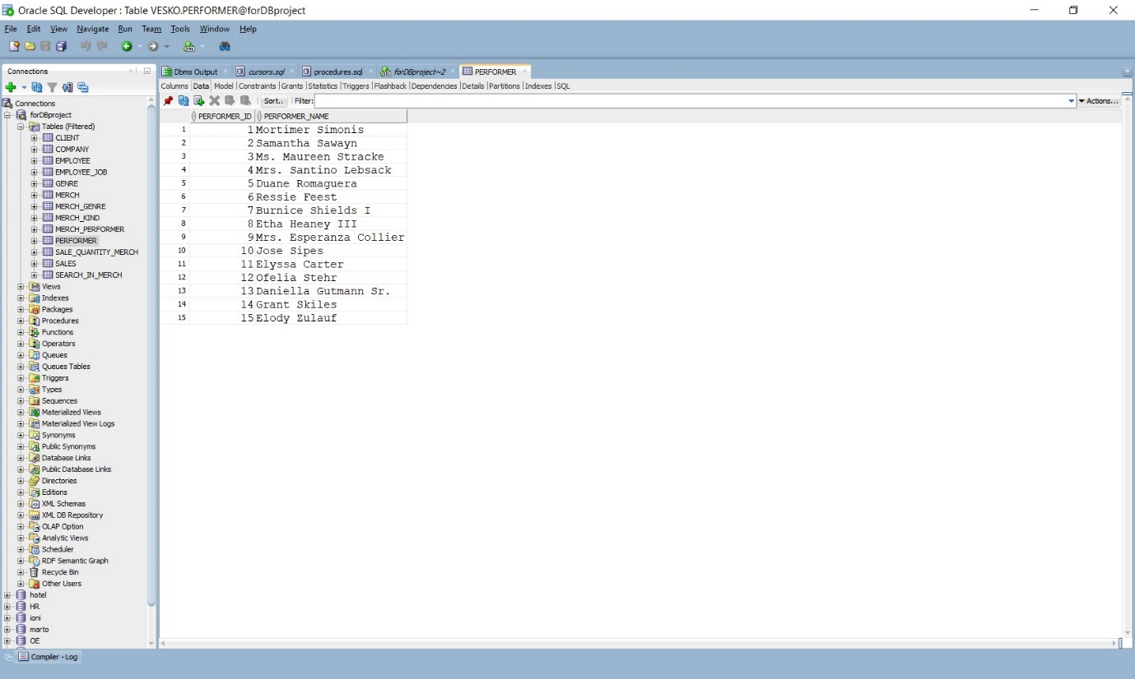

Заявка:

**begin**  
 insert_into_performer('New Performer');  
**end**;

След insert procedure:

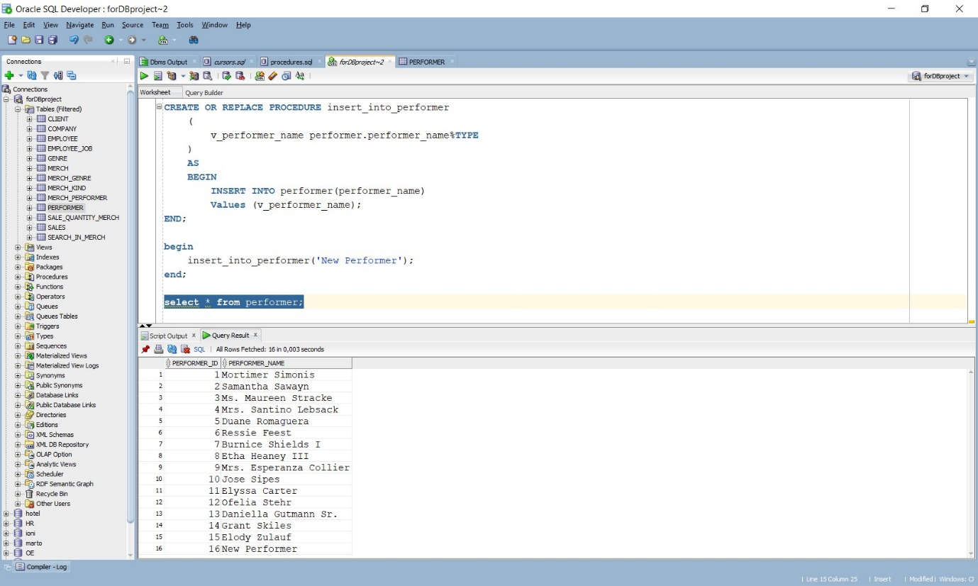

### Update

**CREATE** **OR REPLACE** **PROCEDURE** update_in_search_by_id  
    (  
        v_search_id SEARCH_IN_MERCH.MERCH_ID%TYPE,  
        v_merch_title SEARCH_IN_MERCH.MERCH_TITLE%TYPE  
    )  
    **AS**  
    **BEGIN**  
        **update** SEARCH_IN_MERCH **set** MERCH_TITLE = v_merch_title  
            **where** MERCH_ID = v_search_id;  
**END**;

Преди Update procedure:

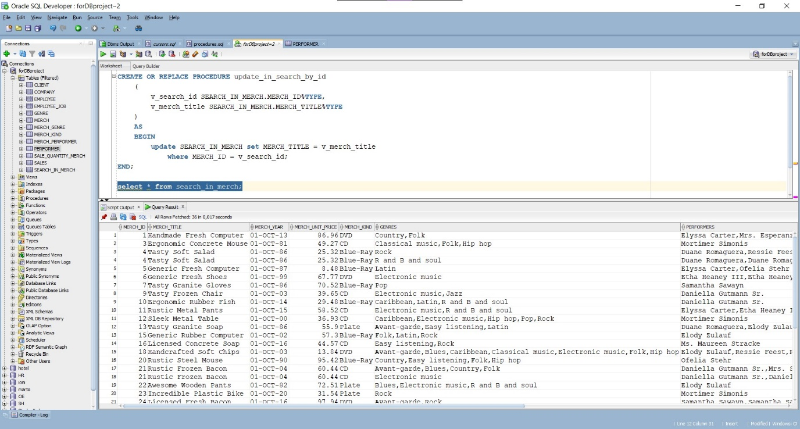

След Update procedure: 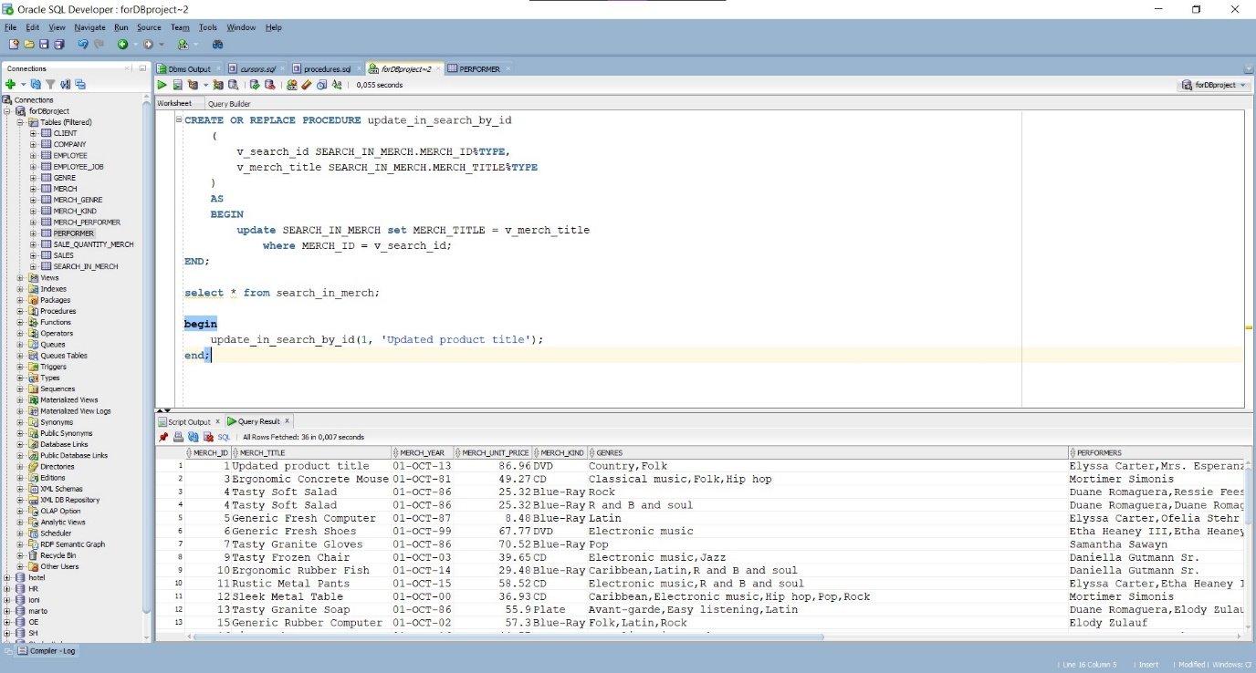

### Delete

**CREATE** **OR REPLACE** **PROCEDURE** delete_in_search_by_id  
    (  
        v_search_id SEARCH_IN_MERCH.MERCH_ID%TYPE  
    )  
    **AS**  
    **BEGIN**  
        **DELETE** **FROM** SEARCH_IN_MERCH  
            **where** MERCH_ID = v_search_id;  
**END**;

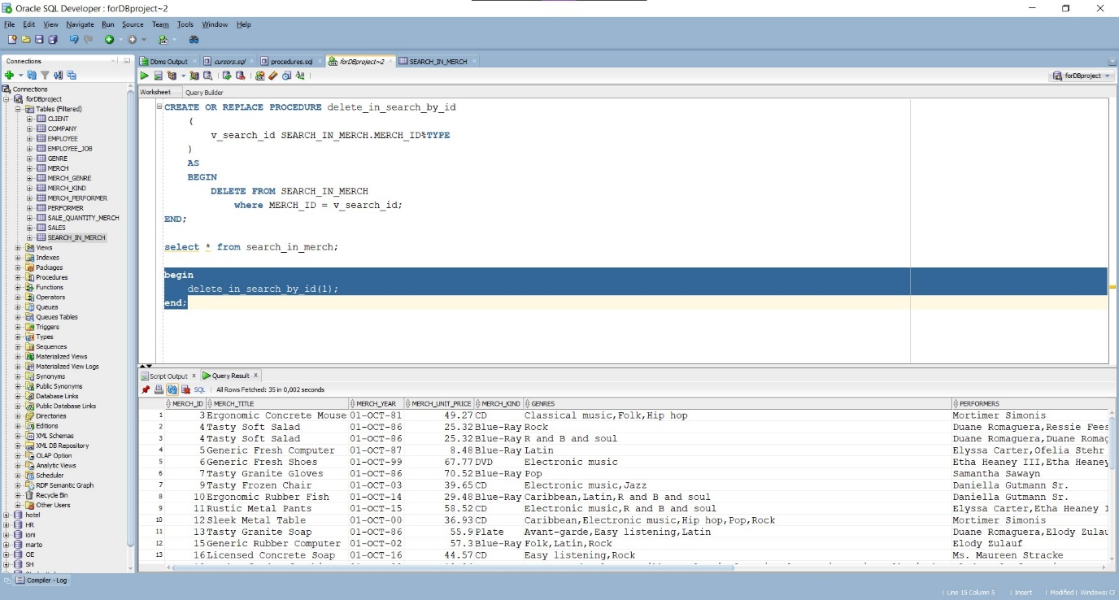

# Cursors

## Продажби на служител, подредени по дата.

**create** **or replace** **PROCEDURE** SalesByEmpDate(v_empl_id Number)  
**is**   
    **cursor** cursor_select **is**  
    **select**  
        s.sale_id,  
        s.sale_date,   
        s.client_id,  
        e.employee_name,  
        e.employee_id  
    **from** sales s  
    **join** EMPLOYEE e **on** e.employee_id = s.employee_id  
    **where** e.employee_id = v_empl_id  
    **group** **by** e.employee_name, s.sale_id, s.sale_date, s.client_id, e.employee_id  
    **order** **by** e.employee_name **DESC**, s.sale_date **DESC**;  
      
    v_sale_id       sales.SALE_ID%type;  
    v_sale_date     sales.SALE_DATE%type;  
    v_client_id     CLIENT.CLIENT_ID%TYPE;  
    v_employee_name EMPLOYEE.EMPLOYEE_NAME%TYPE;  
    v_employee_id   EMPLOYEE.EMPLOYEE_ID%TYPE;  
      
    **begin**  
        **open** cursor_select;  
        **loop** **fetch** cursor_select **into**   
            v_sale_id,  
            v_sale_date,  
            v_client_id,  
            v_employee_name,  
            v_employee_id;  
        **exit** **when** cursor_select%notfound;  
            DBMS_OUTPUT.PUT_LINE  
                (  
                    'Sale ID => ' || v_sale_id || ' sale date => ' || v_sale_date ||  
                    ' client id => ' || v_client_id || ' employee name => ' || v_employee_name ||  
                    ' employee id => ' || v_employee_id  
                );  
        **end** **loop**;  
        **close** cursor_select;  
    **end** SalesByEmpDate  
;  
  
--exec SalesByEmpDate(3);

## Последните 5 продажби на стоки, подредени по служител.

**create** **or replace** **PROCEDURE** last5sales(v_empl_id Number)  
**is**   
 **cursor** cursor_select **is**  
 **select** *   
 **from**  
 (  
 **select** s.sale_id, s.sale_date, s.client_id, e.employee_name  
 **from** sales s  
 **join** employee e **on** s.employee_id = e.employee_id  
 **order** **by** sale_date **DESC**  
 )  
 **where** ROWNUM <= 5  
 **order** **by** 4 **ASC**;  
   
 v_sale_id sales.SALE_ID%type;  
 v_sale_date sales.SALE_DATE%type;  
 v_client_id CLIENT.CLIENT_ID%TYPE;  
 v_employee_name EMPLOYEE.EMPLOYEE_NAME%TYPE;  
   
 **begin**  
 **open** cursor_select;  
 **loop** **fetch** cursor_select **into**   
 v_sale_id,  
 v_sale_date,  
 v_client_id,  
 v_employee_name;  
 **exit** **when** cursor_select%notfound;  
 DBMS_OUTPUT.PUT_LINE  
 (  
 'Sale ID => ' || v_sale_id || ' sale date => ' || v_sale_date ||  
 ' client id => ' || v_client_id || ' employee name => ' || v_employee_name  
 );  
 **end** **loop**;  
 **close** cursor_select;  
 **end** last5sales  
;  
  
--exec last5sales(1);

## Закупени стоки от клиент, подредени по вид и дата.

**create** **or replace** **PROCEDURE** SalesByClientID(v_cl_id Number)  
**is**   
    **cursor** cursor_select **is**  
    **select**  
        s.sale_id,  
        s.sale_date,  
        c.client_id,  
        c.client_name,  
        c.client_phone,  
        m.merch_id,  
        m.merch_title,  
        mk.merch_kind,  
        m.merch_unit_price  
    **from** sales s  
    **join** sale_quantity_merch sqm **on** s.sale_id = sqm.sales_id  
    **join** client c **on** c.client_id = s.client_id  
    **join** merch m **on** m.merch_id = sqm.merch_id  
    **join** merch_kind mk **on** mk.merch_kind_id = m.merch_kind_id  
    **where** c.client_id = v_cl_id  
    **order** **by** mk.merch_kind **ASC**, s.sale_date **DESC**;  
      
    v_sale_id SALES.SALE_ID%TYPE;  
    v_sale_date  SALES.SALE_DATE%TYPE;  
    v_client_id CLIENT.CLIENT_ID%TYPE;  
    v_client_name CLIENT.CLIENT_NAME%TYPE;  
    v_client_phone CLIENT.CLIENT_PHONE%TYPE;  
    v_merch_id MERCH.MERCH_ID%TYPE;  
    v_merch_title MERCH.MERCH_TITLE %TYPE;  
    v_merch_kind MERCH_KIND.MERCH_KIND%TYPE;  
    v_merch_unit_price MERCH.MERCH_UNIT_PRICE%TYPE;  
      
    **begin**  
        **open** cursor_select;  
        **loop** **fetch** cursor_select **into**           
            v_sale_id,  
            v_sale_date,  
            v_client_id,  
            v_client_name,  
            v_client_phone,  
            v_merch_id,  
            v_merch_title,  
            v_merch_kind,  
            v_merch_unit_price;  
        **exit** **when** cursor_select%notfound;  
            DBMS_OUTPUT.PUT_LINE  
                (  
                    'Sale ID => ' || v_sale_id || ' sale date => ' || v_sale_date ||  
                    ' client id => ' || v_client_id || ' client name => ' || v_client_name ||  
                    ' client phone N => ' || v_client_phone || ' merch id => ' || v_merch_id ||  
                    ' merch title => ' || v_merch_title || ' merch kind => ' || v_merch_kind ||  
                    ' merch unit price => ' || v_merch_unit_price  
                );  
        **end** **loop**;  
        **close** cursor_select;  
**end** SalesByClientID;  
  
--exec SalesByClientID(2);

## Закупени стоки за период, подредени по клиенти и дати.

**create** **or replace** **PROCEDURE** SalesByDate(v_from_date varchar2, v_to_date varchar2)  
**is**   
    **cursor** cursor_select **is**  
    **select**  
        s.sale_id,  
        s.sale_date,  
        c.client_name,  
        c.client_phone,  
        m.merch_id,  
        m.merch_title,  
        mk.merch_kind,  
        m.merch_unit_price  
    **from** sales s  
    **join** sale_quantity_merch sqm **on** s.sale_id = sqm.sales_id  
    **join** client c **on** c.client_id = s.client_id  
    **join** merch m **on** m.merch_id = sqm.merch_id  
    **join** merch_kind mk **on** mk.merch_kind_id = m.merch_kind_id  
    **where**   
        (s.sale_date >= to_date(v_from_date, 'DD.MM.YYYY')) **and**  
        (s.sale_date <= to_date(v_to_date, 'DD.MM.YYYY'))  
    **order** **by** s.sale_date **DESC**, c.client_name;  
      
    v_sale_id SALES.SALE_ID%TYPE;  
    v_sale_date  SALES.SALE_DATE%TYPE;  
    v_client_name CLIENT.CLIENT_NAME%TYPE;  
    v_client_phone CLIENT.CLIENT_PHONE%TYPE;  
    v_merch_id MERCH.MERCH_ID%TYPE;  
    v_merch_title MERCH.MERCH_TITLE %TYPE;  
    v_merch_kind MERCH_KIND.MERCH_KIND%TYPE;  
    v_merch_unit_price MERCH.MERCH_UNIT_PRICE%TYPE;  
      
    **begin**  
        **open** cursor_select;  
        **loop** **fetch** cursor_select **into**           
            v_sale_id,  
            v_sale_date,  
            v_client_name,  
            v_client_phone,  
            v_merch_id,  
            v_merch_title,  
            v_merch_kind,  
            v_merch_unit_price;  
        **exit** **when** cursor_select%notfound;  
            DBMS_OUTPUT.PUT_LINE  
                (  
                    'Sale ID => ' || v_sale_id || ' sale date => ' || v_sale_date ||  
                    ' client name => ' || v_client_name ||  
                    ' client phone N => ' || v_client_phone || ' merch id => ' || v_merch_id ||  
                    ' merch title => ' || v_merch_title || ' merch kind => ' || v_merch_kind ||  
                    ' merch unit price => ' || v_merch_unit_price  
                );  
        **end** **loop**;  
        **close** cursor_select;  
**end** SalesByDate;  
  
--exec SalesByDate('1.1.2020', '20.4.2020');

## Търсене на CD, DVD:

### По музикална компания

**create** **or replace** **PROCEDURE** search_by_company(valuess varchar2)  
**is**   
    **cursor** cursor_select **is**  
    **select**  
        merch_id,  
        merch_title,  
        merch_year,  
        merch_unit_price,  
        merch_kind,  
        genres,  
        performers,  
        company_name  
    **from** search_in_merch  
    **where** (merch_kind = 'CD' **or** merch_kind = 'DVD')  
        **and** lower(company_name) **like** lower('%'||valuess||'%');  
      
    v_merch_id          search_in_merch.MERCH_ID%TYPE;  
    v_merch_title       search_in_merch.MERCH_TITLE%TYPE;  
    v_merch_year        search_in_merch.MERCH_YEAR%TYPE;  
    v_merch_unit_price  search_in_merch.MERCH_UNIT_PRICE%TYPE;  
    v_merch_kind        search_in_merch.MERCH_KIND%TYPE;  
    v_genres            search_in_merch.GENRES%TYPE;  
    v_performers        search_in_merch.PERFORMERS%TYPE;  
    v_company_name      search_in_merch.COMPANY_NAME%TYPE;  
      
    **begin**  
        **open** cursor_select;  
        **loop** **fetch** cursor_select **into**           
            v_merch_id,  
            v_merch_title,  
            v_merch_year,  
            v_merch_unit_price,  
            v_merch_kind,  
            v_genres,  
            v_performers,  
            v_company_name;  
        **exit** **when** cursor_select%notfound;  
            DBMS_OUTPUT.PUT_LINE  
                (  
                    'Merch ID => ' || v_merch_id || ' title => ' || v_merch_title ||  
                    ' year => ' || v_merch_year || ' unit price => ' || v_merch_unit_price ||  
                    ' kind => ' || v_merch_kind || ' genres => ' || v_genres ||  
                    ' performers => ' || v_performers || ' company => ' || v_company_name  
                );  
        **end** **loop**;  
        **close** cursor_select;  
**end** search_by_company;  
  
--exec search_by_company('mc');

### По име на продукт

**create** **or replace** **PROCEDURE** search_by_m_title(valuess varchar2)  
**is**   
    **cursor** cursor_select **is**  
    **select**  
        merch_id,  
        merch_title,  
        merch_year,  
        merch_unit_price,  
        merch_kind,  
        genres,  
        performers,  
        company_name  
    **from** search_in_merch  
    **where** (merch_kind = 'CD' **or** merch_kind = 'DVD')  
        **and** lower(merch_title) **like** lower('%'||valuess||'%');  
      
    v_merch_id          search_in_merch.MERCH_ID%TYPE;  
    v_merch_title       search_in_merch.MERCH_TITLE%TYPE;  
    v_merch_year        search_in_merch.MERCH_YEAR%TYPE;  
    v_merch_unit_price  search_in_merch.MERCH_UNIT_PRICE%TYPE;  
    v_merch_kind        search_in_merch.MERCH_KIND%TYPE;  
    v_genres            search_in_merch.GENRES%TYPE;  
    v_performers        search_in_merch.PERFORMERS%TYPE;  
    v_company_name      search_in_merch.COMPANY_NAME%TYPE;  
      
    **begin**  
        **open** cursor_select;  
        **loop** **fetch** cursor_select **into**           
            v_merch_id,  
            v_merch_title,  
            v_merch_year,  
            v_merch_unit_price,  
            v_merch_kind,  
            v_genres,  
            v_performers,  
            v_company_name;  
        **exit** **when** cursor_select%notfound;  
            DBMS_OUTPUT.PUT_LINE  
                (  
                    'Merch ID => ' || v_merch_id || ' title => ' || v_merch_title ||  
                    ' year => ' || v_merch_year || ' unit price => ' || v_merch_unit_price ||  
                    ' kind => ' || v_merch_kind || ' genres => ' || v_genres ||  
                    ' performers => ' || v_performers || ' company => ' || v_company_name  
                );  
        **end** **loop**;  
        **close** cursor_select;  
**end** search_by_m_title;  
  
--exec search_by_m_title('resh');

### По жанр

**create** **or replace** **PROCEDURE** search_by_genre(valuess varchar2)  
**is**   
    **cursor** cursor_select **is**  
    **select**  
        merch_id,  
        merch_title,  
        merch_year,  
        merch_unit_price,  
        merch_kind,  
        genres,  
        performers,  
        company_name  
    **from** search_in_merch  
    **where** (merch_kind = 'CD' **or** merch_kind = 'DVD')  
        **and** lower(genres) **like** lower('%'||valuess||'%');  
      
    v_merch_id          search_in_merch.MERCH_ID%TYPE;  
    v_merch_title       search_in_merch.MERCH_TITLE%TYPE;  
    v_merch_year        search_in_merch.MERCH_YEAR%TYPE;  
    v_merch_unit_price  search_in_merch.MERCH_UNIT_PRICE%TYPE;  
    v_merch_kind        search_in_merch.MERCH_KIND%TYPE;  
    v_genres            search_in_merch.GENRES%TYPE;  
    v_performers        search_in_merch.PERFORMERS%TYPE;  
    v_company_name      search_in_merch.COMPANY_NAME%TYPE;  
      
    **begin**  
        **open** cursor_select;  
        **loop** **fetch** cursor_select **into**           
            v_merch_id,  
            v_merch_title,  
            v_merch_year,  
            v_merch_unit_price,  
            v_merch_kind,  
            v_genres,  
            v_performers,  
            v_company_name;  
        **exit** **when** cursor_select%notfound;  
            DBMS_OUTPUT.PUT_LINE  
                (  
                    'Merch ID => ' || v_merch_id || ' title => ' || v_merch_title ||  
                    ' year => ' || v_merch_year || ' unit price => ' || v_merch_unit_price ||  
                    ' kind => ' || v_merch_kind || ' genres => ' || v_genres ||  
                    ' performers => ' || v_performers || ' company => ' || v_company_name  
                );  
        **end** **loop**;  
        **close** cursor_select;  
**end** search_by_genre;  
  
--exec search_by_genre('op');

### По изпълнител

**create** **or replace** **PROCEDURE** search_by_perf(valuess varchar2)  
**is**   
    **cursor** cursor_select **is**  
    **select**  
        merch_id,  
        merch_title,  
        merch_year,  
        merch_unit_price,  
        merch_kind,  
        genres,  
        performers,  
        company_name  
    **from** search_in_merch  
    **where** (merch_kind = 'CD' **or** merch_kind = 'DVD')  
        **and** lower(performers) **like** lower('%'||valuess||'%');  
      
    v_merch_id          search_in_merch.MERCH_ID%TYPE;  
    v_merch_title       search_in_merch.MERCH_TITLE%TYPE;  
    v_merch_year        search_in_merch.MERCH_YEAR%TYPE;  
    v_merch_unit_price  search_in_merch.MERCH_UNIT_PRICE%TYPE;  
    v_merch_kind        search_in_merch.MERCH_KIND%TYPE;  
    v_genres            search_in_merch.GENRES%TYPE;  
    v_performers        search_in_merch.PERFORMERS%TYPE;  
    v_company_name      search_in_merch.COMPANY_NAME%TYPE;  
      
    **begin**  
        **open** cursor_select;  
        **loop** **fetch** cursor_select **into**           
            v_merch_id,  
            v_merch_title,  
            v_merch_year,  
            v_merch_unit_price,  
            v_merch_kind,  
            v_genres,  
            v_performers,  
            v_company_name;  
        **exit** **when** cursor_select%notfound;  
            DBMS_OUTPUT.PUT_LINE  
                (  
                    'Merch ID => ' || v_merch_id || ' title => ' || v_merch_title ||  
                    ' year => ' || v_merch_year || ' unit price => ' || v_merch_unit_price ||  
                    ' kind => ' || v_merch_kind || ' genres => ' || v_genres ||  
                    ' performers => ' || v_performers || ' company => ' || v_company_name  
                );  
        **end** **loop**;  
        **close** cursor_select;  
**end** search_by_perf;  
  
--exec search_by_perf('moni');

### По година

**create** **or replace** **PROCEDURE** search_by_year(valuess varchar2)  
**is**   
    **cursor** cursor_select **is**  
    **select**  
        merch_id,  
        merch_title,  
        merch_year,  
        merch_unit_price,  
        merch_kind,  
        genres,  
        performers,  
        company_name  
    **from** search_in_merch  
    **where** (merch_kind = 'CD' **or** merch_kind = 'DVD')  
        **and** merch_year **like** to_date(valuess, 'YYYY-MM-DD');  
      
    v_merch_id          search_in_merch.MERCH_ID%TYPE;  
    v_merch_title       search_in_merch.MERCH_TITLE%TYPE;  
    v_merch_year        search_in_merch.MERCH_YEAR%TYPE;  
    v_merch_unit_price  search_in_merch.MERCH_UNIT_PRICE%TYPE;  
    v_merch_kind        search_in_merch.MERCH_KIND%TYPE;  
    v_genres            search_in_merch.GENRES%TYPE;  
    v_performers        search_in_merch.PERFORMERS%TYPE;  
    v_company_name      search_in_merch.COMPANY_NAME%TYPE;  
      
    **begin**  
        **open** cursor_select;  
        **loop** **fetch** cursor_select **into**           
            v_merch_id,  
            v_merch_title,  
            v_merch_year,  
            v_merch_unit_price,  
            v_merch_kind,  
            v_genres,  
            v_performers,  
            v_company_name;  
        **exit** **when** cursor_select%notfound;  
            DBMS_OUTPUT.PUT_LINE  
                (  
                    'Merch ID => ' || v_merch_id || ' title => ' || v_merch_title ||  
                    ' year => ' || v_merch_year || ' unit price => ' || v_merch_unit_price ||  
                    ' kind => ' || v_merch_kind || ' genres => ' || v_genres ||  
                    ' performers => ' || v_performers || ' company => ' || v_company_name  
                );  
        **end** **loop**;  
        **close** cursor_select;  
**end** search_by_year;  
  
--exec search_by_year('1981-10-1');

### Изпълнение на процедурите и резултат:

**exec** SalesByEmpDate(3);  
**exec** last5sales(1);  
**exec** SalesByClientID(2);  
**exec** SalesByDate('1.1.2020', '20.4.2020');  
**exec** search_by_company('tter');  
**exec** search_by_m_title('resh');  
**exec** search_by_genre('op');  
**exec** search_by_perf('moni');  
**exec** search_by_year('1981-10-1');

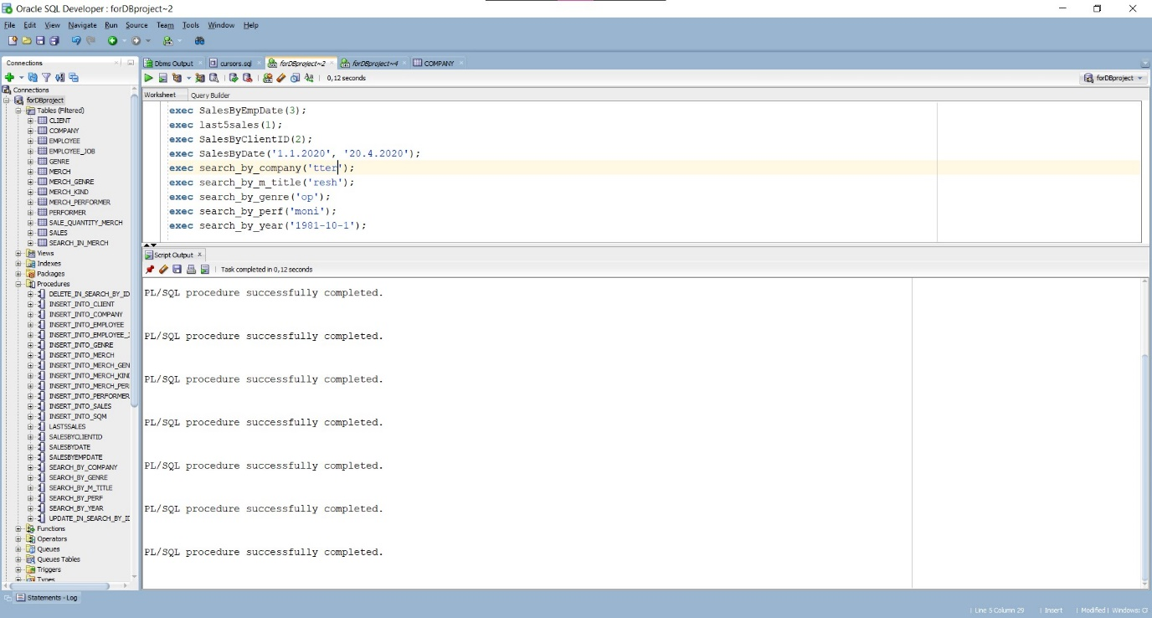

Резултат: