DIGITAL FORENSIC EXAMINATION REPORT

NIST Samsung Galaxy S6 Mobile Forensic Case
Evidence- and Artifact-Centric Examination Report

Device | Samsung Galaxy S6 (SM-G920A / G920A)
Evidence type | Physical acquisition / raw block image
Primary image | blk0_sda.bin
Primary analysis tool | Autopsy 4.23.1
Acquisition context | NIST IR 8412 mobile forensic case study
Report basis | Artifacts recovered and screenshots examined during the investigation
Investigator | Lakshita Soni

Prepared as an examination record — findings are organized by forensic artifact and investigative workflow.

1. Scope and Examination Objective
The examination was done on an image of a Samsung Galaxy S6. This device was part of the NIST mobile forensic case study. The goal of this report is to show what artifacts were actually found during the investigation. It also aims to keep the order and logic of the process clear. For that reason the evidence is grouped by category. The report does not follow the 24 NIST questions. Instead it focuses on presenting the findings in a way.
- Primary evidence examined: blk0_sda.bin.
- Primary forensic platform: Autopsy 4.23.1.
- Manual artifact inspection was required because the ALEAPP processing attempt produced essentially no parsed artifacts for this image.
- Where an observation is not fully proven by the artifact shown, it is explicitly described as an inference or limitation rather than presented as fact.

2. Evidence Identification and Integrity
The physical image examined was the raw block image extracted from the Cellebrite/UFED acquisition package.
Image file | blk0_sda.bin
Image format | Raw block image
Acquisition block count | 31,240,192 blocks
SHA-256 | 7B5EF155A6E07AD4D5C67FAA65F715552CDB4D5CDA2E8C45B8104E0F63A84EB4

The SHA-256 value above was checked against the acquisition metadata. The NIST publication has a display error, in one spot; the acquisition metadata value was used for the integrity record.

3. Initial File-System Examination
The autopsy tool saw the image and showed the Android file system, inside the image and volume structure. The important evidence was found in the Android data/system/application folders. This made it possible to look at system files, app databases, web history, messages and settings.
- Android volume examined: /img_blk0_sda.bin/vol_vol20/
- Key evidence areas included /system, /data, application-specific directories, and parsed Data Artifacts.
- The examination relied on both Autopsy artifact parsing and direct file/content inspection.

4. System, Account and Device Configuration Artifacts

4.1 Android user profile
The Android user profile was examined under the system user configuration. The recovered XML contained the user display name <b>jd tester</b>.
Artifact location: /system/users/0.xml
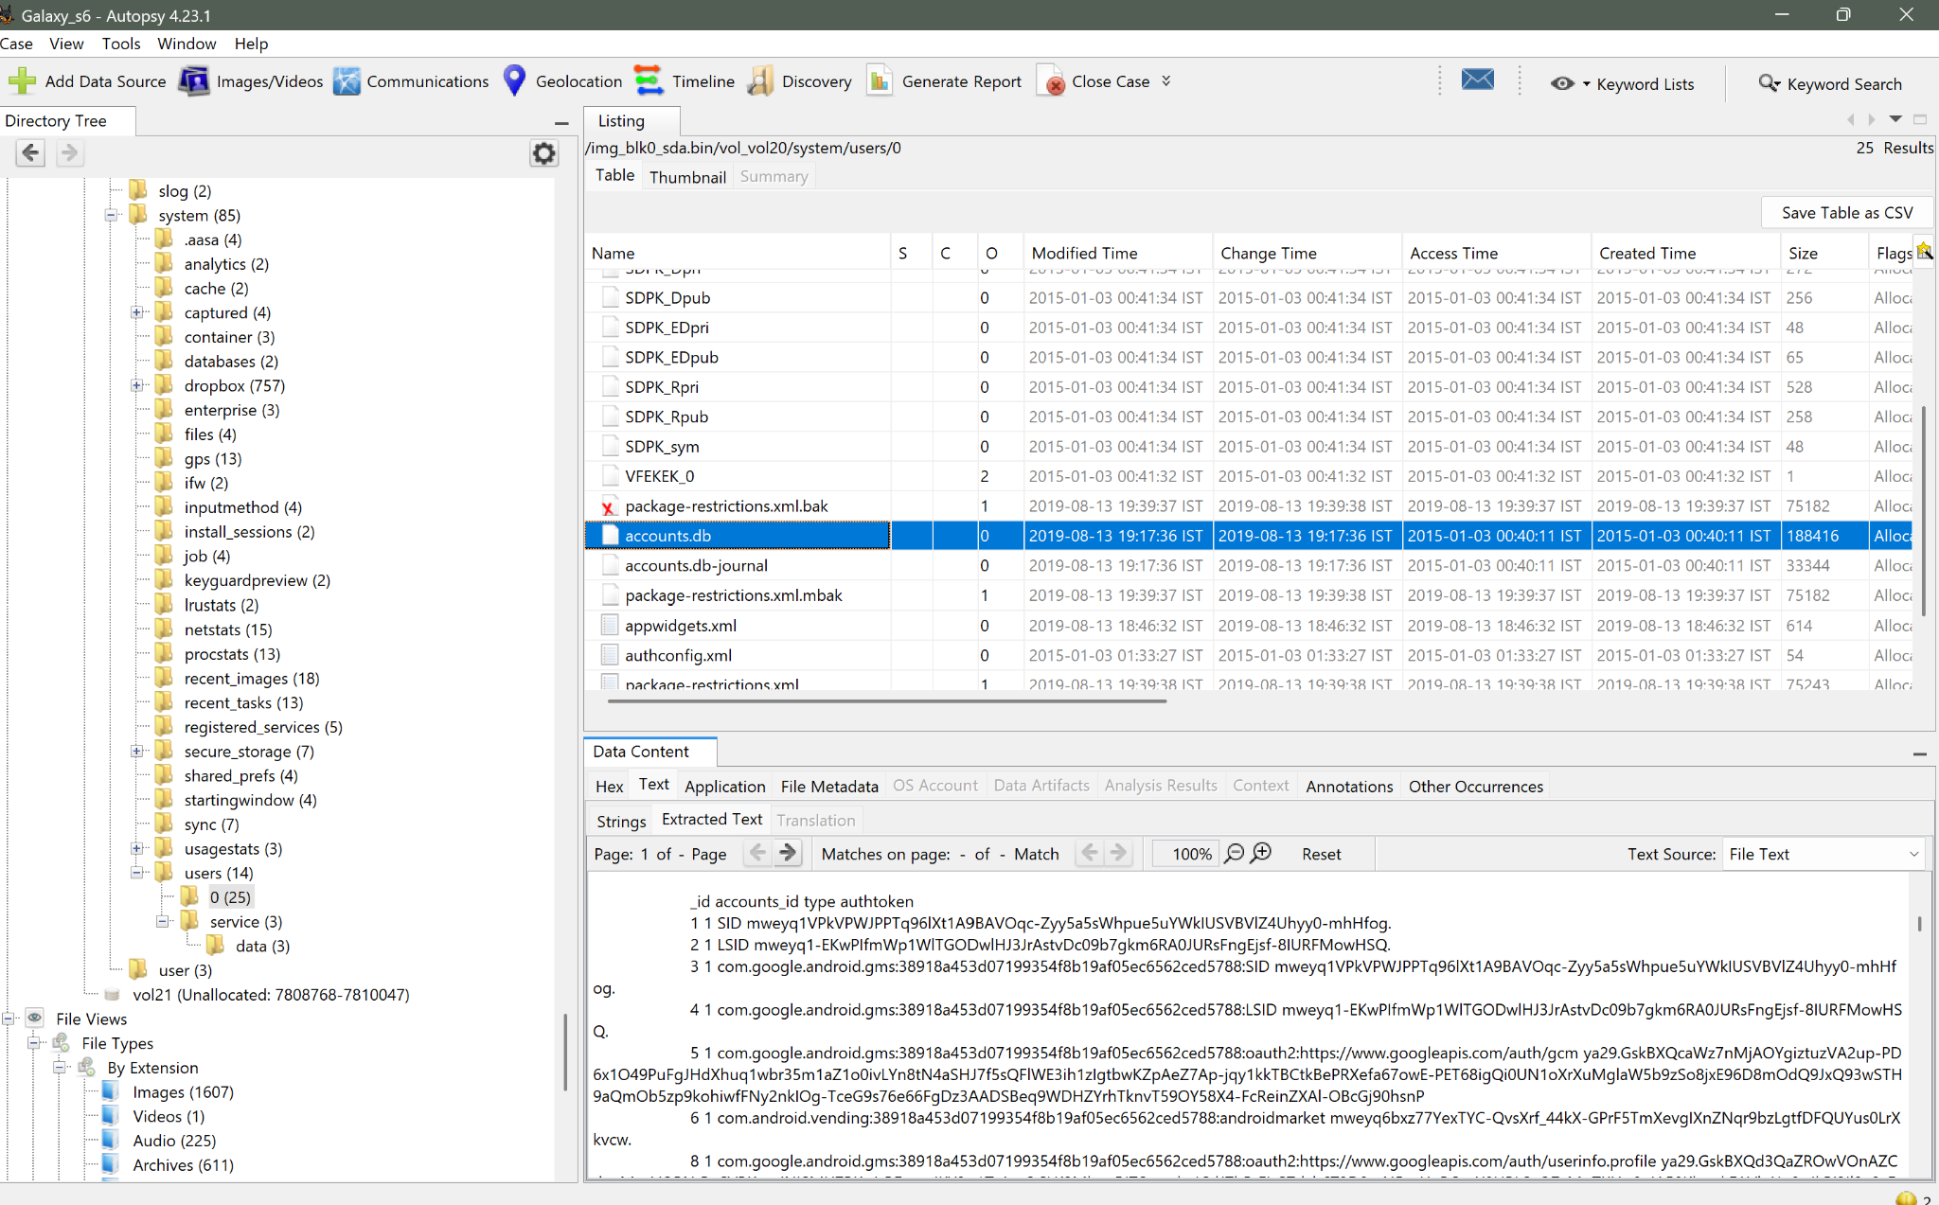
Figure 1. Autopsy examination of the Android /system/users/0 area and associated account database content.

4.2 Device time-zone configuration
I examined the Android system property persist.sys.timezone. The stored value was <b>America/New_York</b> which establishes the device‑configured time zone that the system uses to interpret timestamps.
Artifact: /data/property/persist.sys.timezone

4.3 Authentication / gesture artifact
A 20-byte gesture.key file was recovered from the Android system directory. The artifact is associated with the Android pattern-lock credential mechanism. The raw hexadecimal content observed was:
70 AA A1 63 3B 89 CC 64 C3 80 6C EF D4 79 35 57 64 11 AF A9
Artifact location: /system/gesture.key
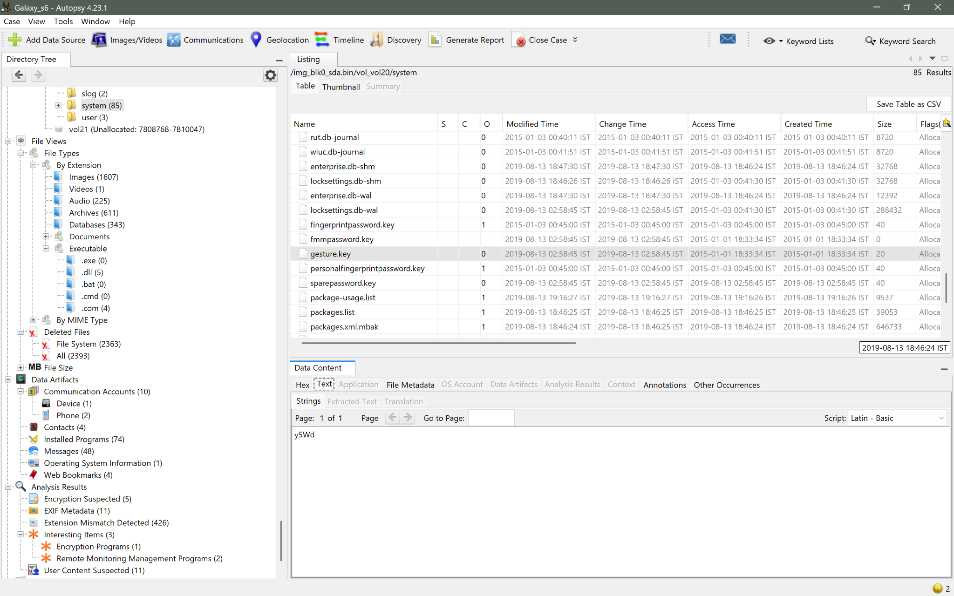
Figure 2. Autopsy showing gesture.key within /system and its recovered hexadecimal content.

5. Image Metadata and Geolocation Evidence
The media file 20190809_120201.jpg was examined through image metadata. The recovered metadata included a Samsung SM-G920A device identifier, a creation timestamp of 2019-08-09 12:02:01 IST, and GPS coordinates 36.15055555555556, -95.94777777777779. These coordinates correspond to Tulsa, Oklahoma.
File | 20190809_120201.jpg
Timestamp observed | 2019-08-09 12:02:01 IST
Latitude | 36.15055555555556
Longitude | -95.94777777777779
Geographic interpretation: Tulsa, Oklahoma.

6. Wireless Network Artifacts
The Wi-Fi configuration artifact was reviewed for distinct access-point records. Eight distinct Wi-Fi access points were identified in the recovered configuration data. Examples observed during examination included attwifi and Hilton Honors HGI.
Finding: 8 distinct Wi-Fi access points logged in the examined artifact.

7. Communications and Contact Artifacts

7.1 WhatsApp communication database
WhatsApp records were recovered from msgstore.db. The communication set contained messages associated with a potentially illegal transaction and provided a link between the device and the WhatsApp account represented by 19182360870@s.whatsapp.net.
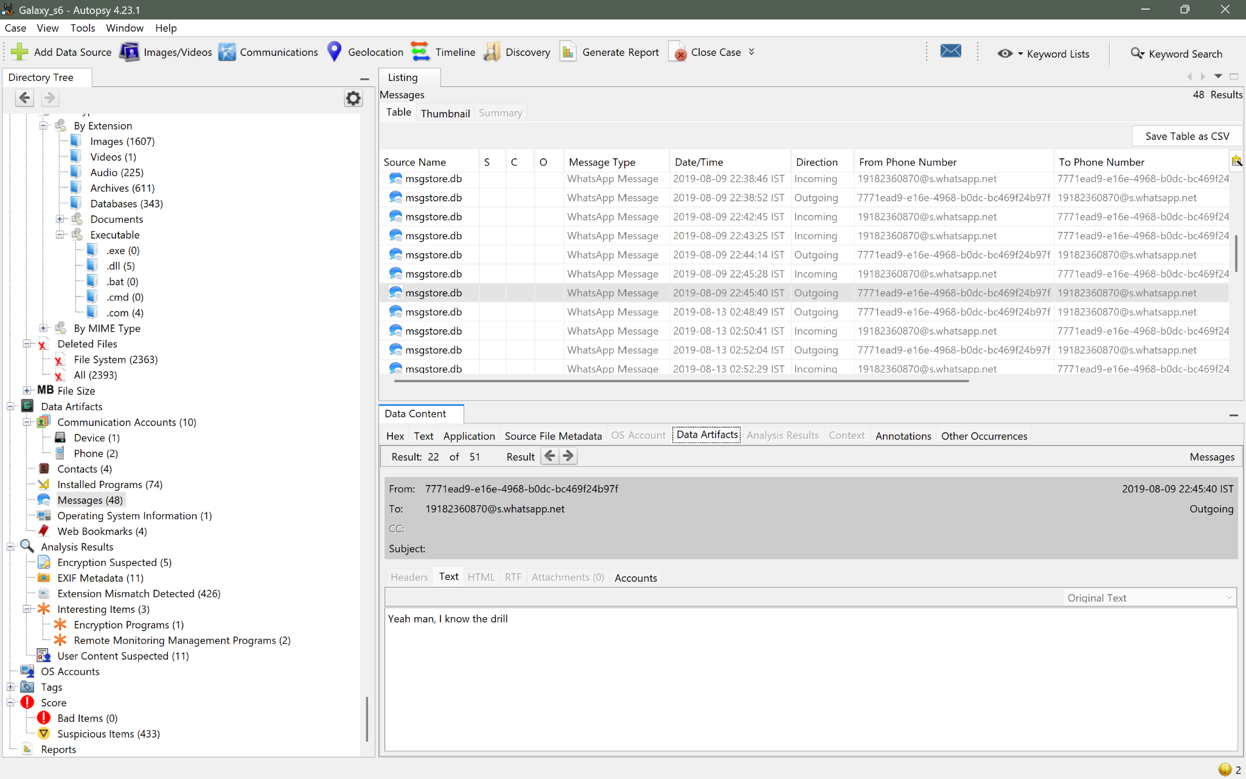
Figure 4. Autopsy WhatsApp message listing showing messages exchanged with the recovered WhatsApp account.
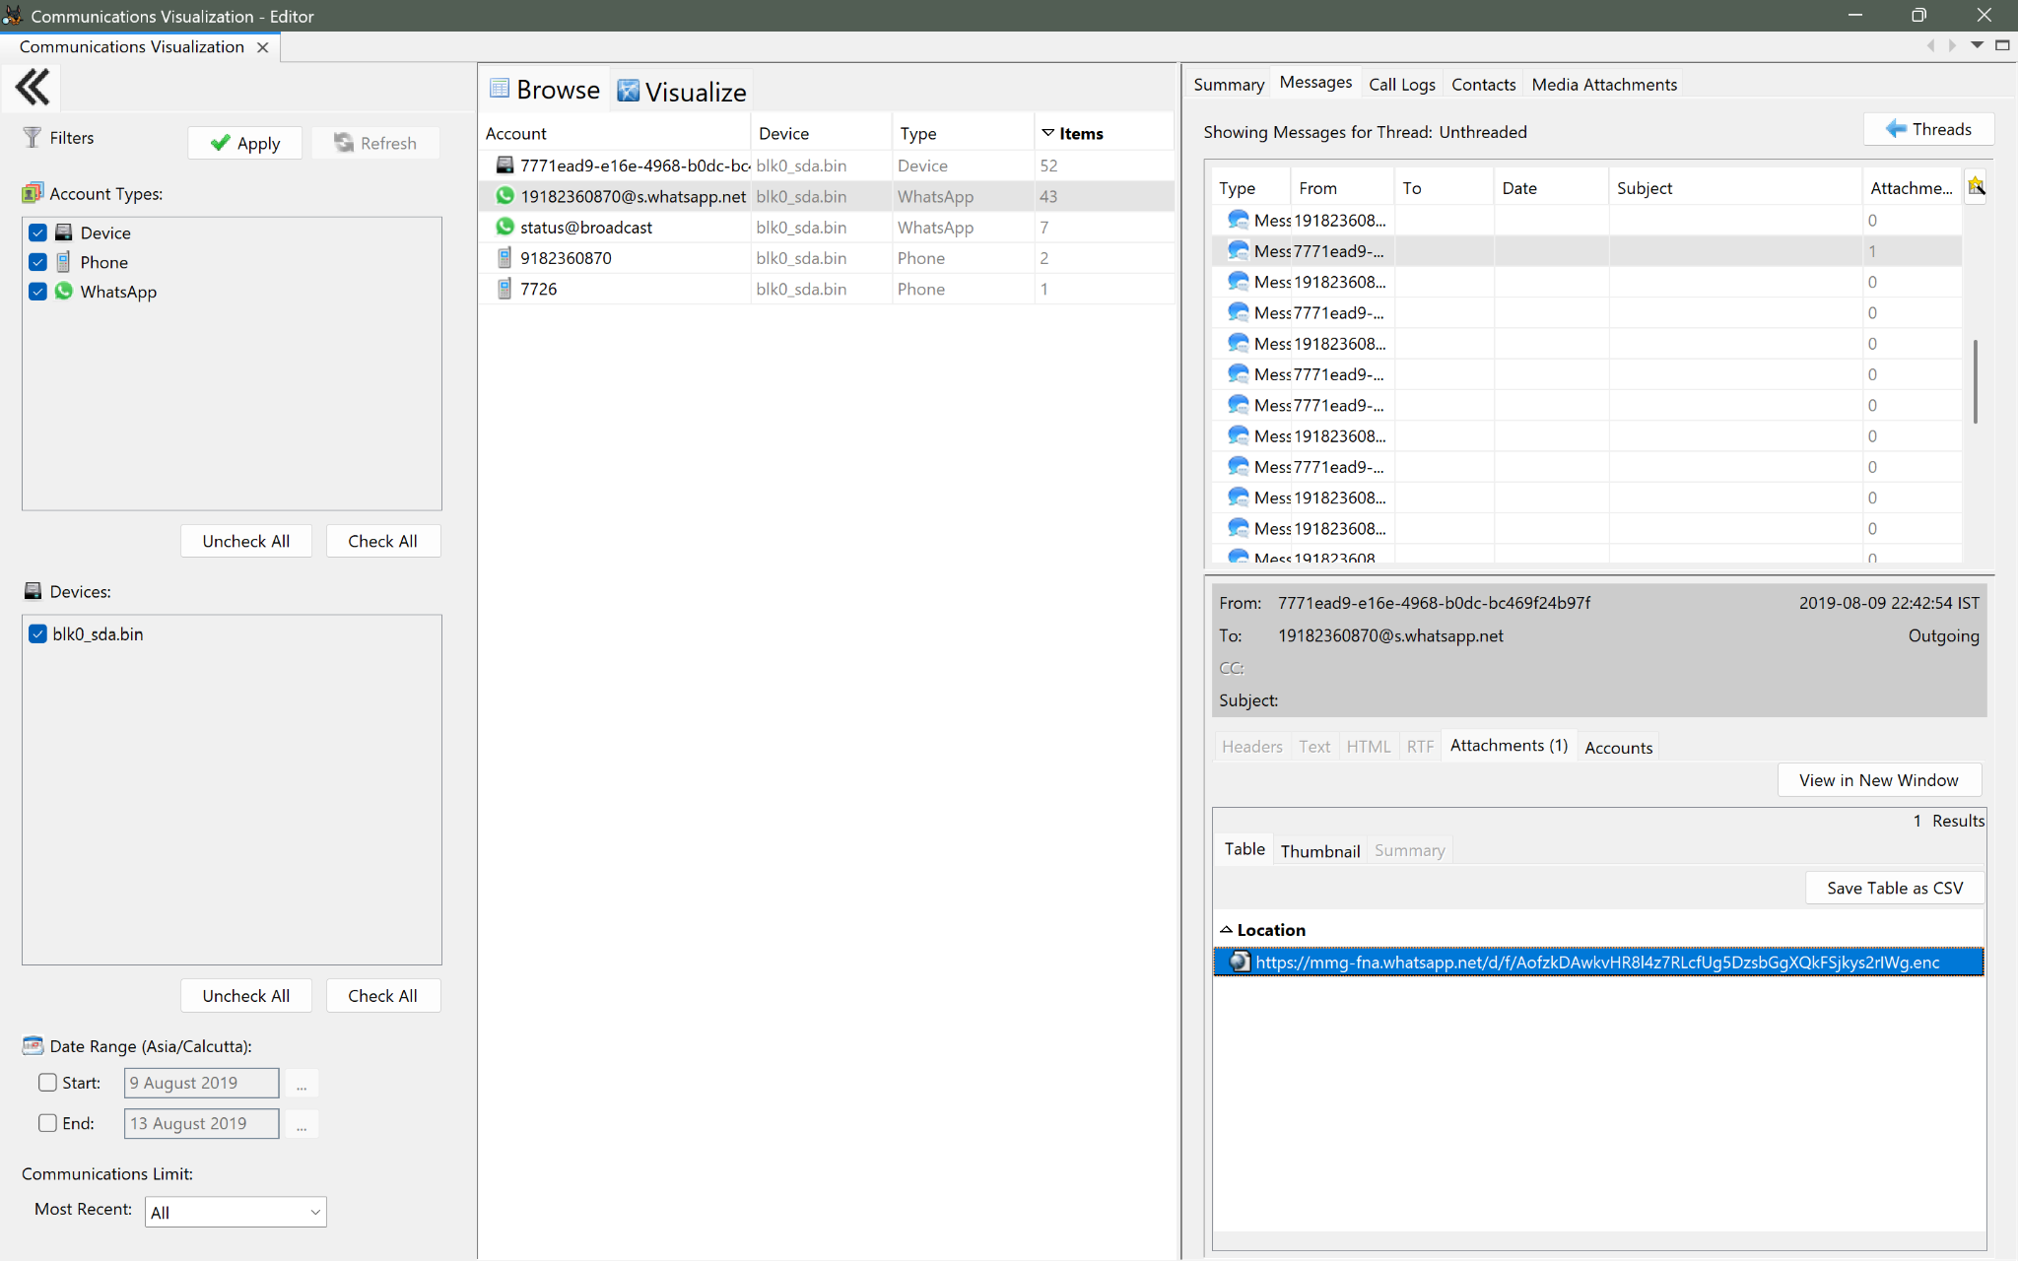
Figure 5. Autopsy Communications Visualization showing the recovered WhatsApp, phone, and device communication accounts.

7.2 Contact correlation
The contacts database linked the recovered phone number 9182360870 to the contact name Olve. The same number was also represented in Autopsy communications artifacts.
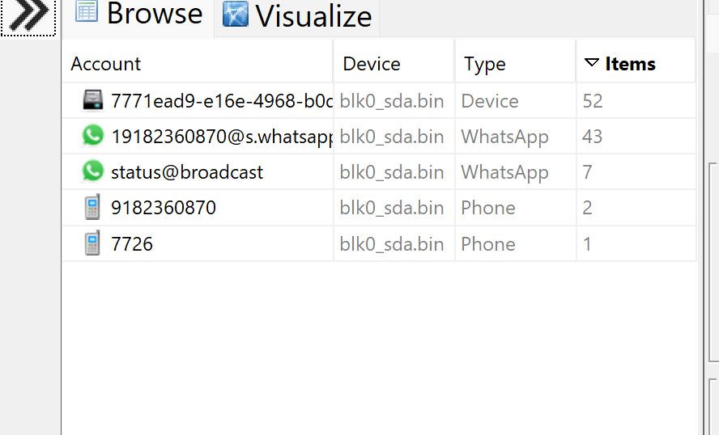
Figure 6. Autopsy communication-account view showing the phone number 9182360870.
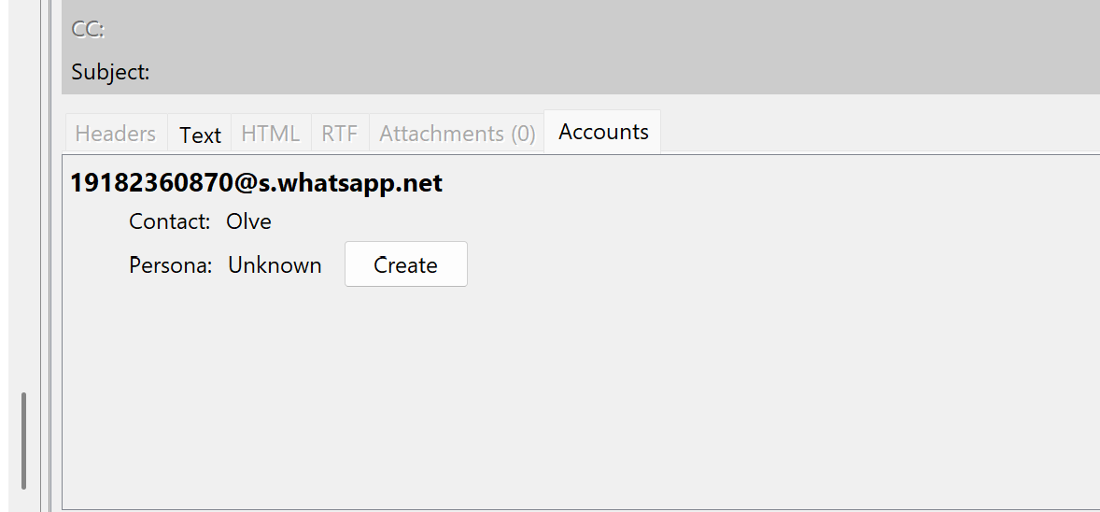
Figure 7. Autopsy contact/communication detail showing the recovered WhatsApp account associated with contact Olve.
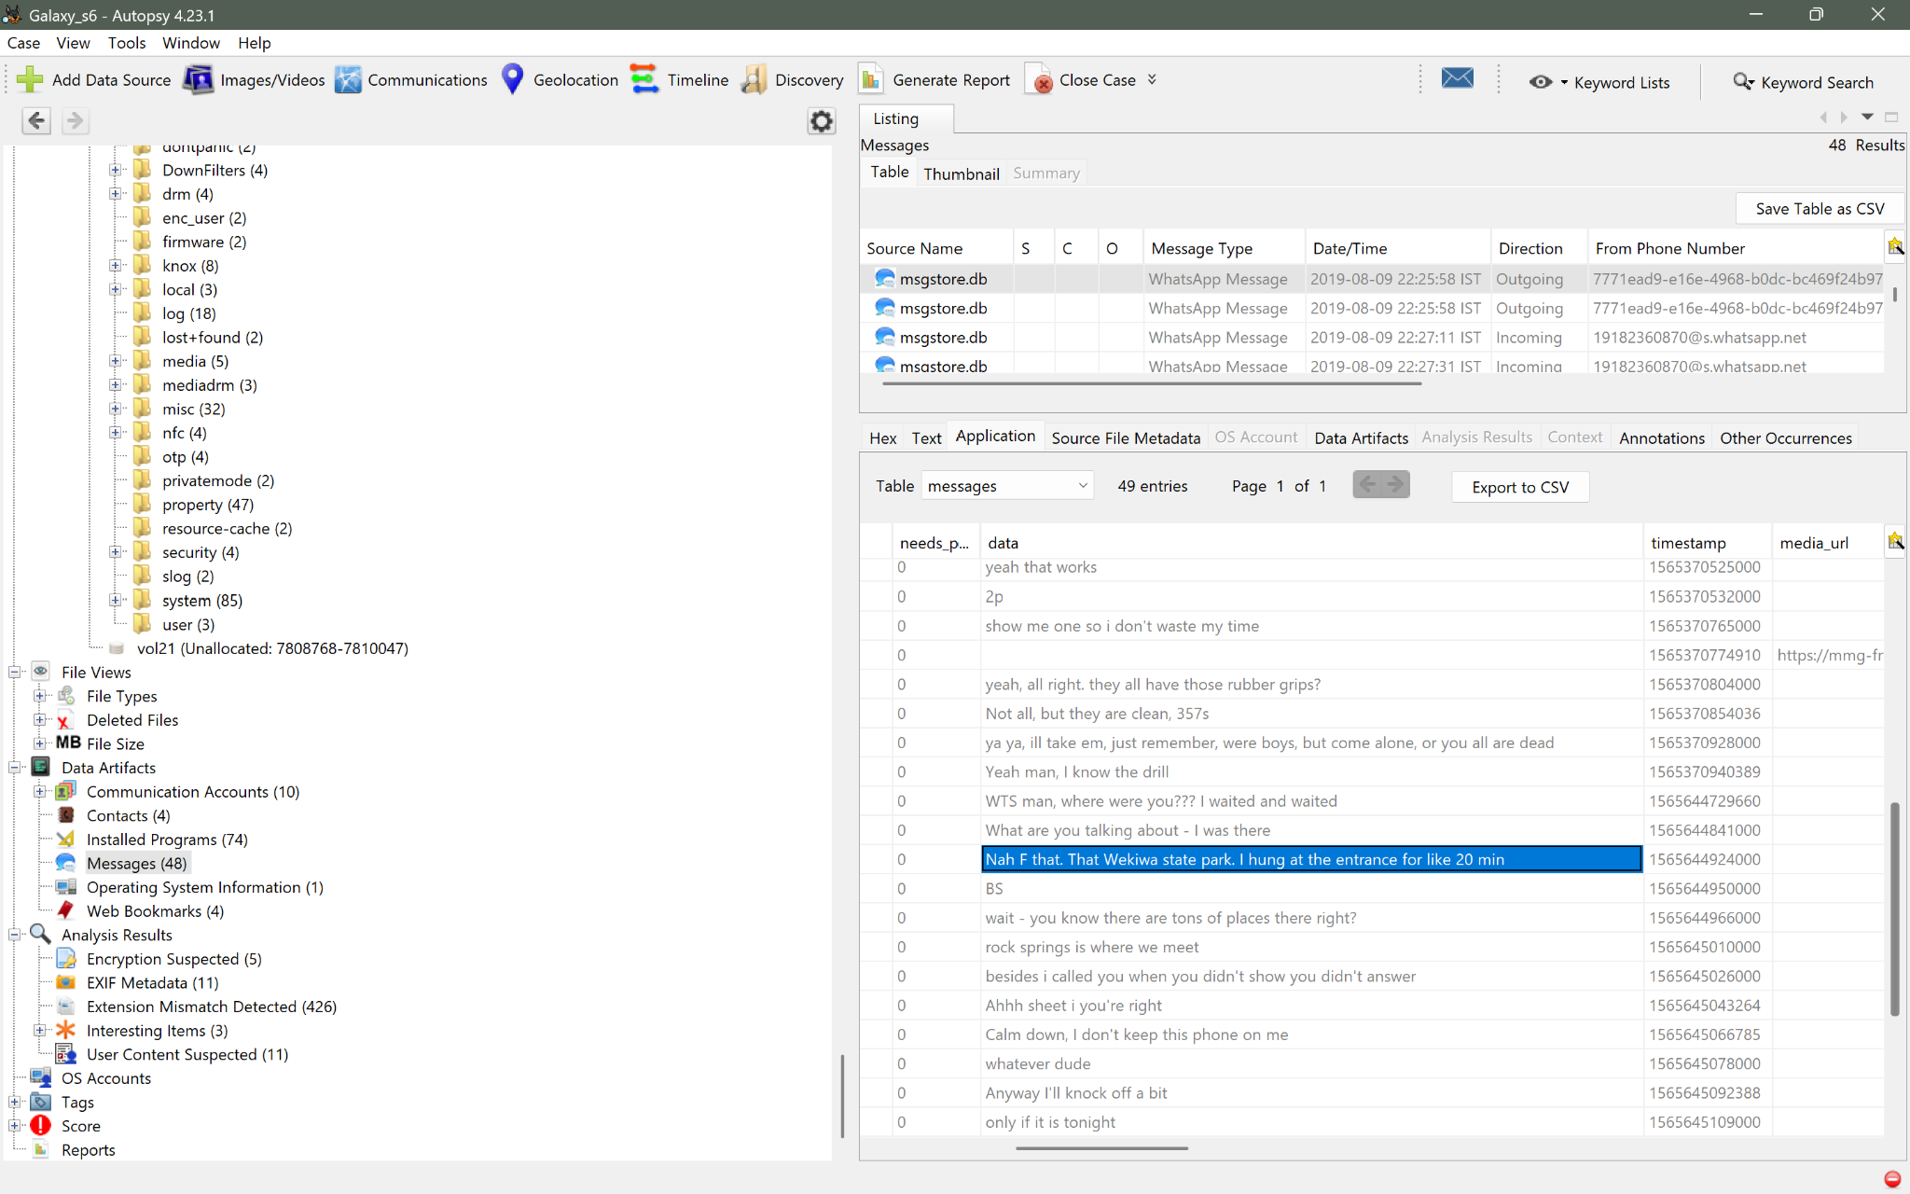
Figure 8. Autopsy WhatsApp message content containing contextual discussion about a meeting location.
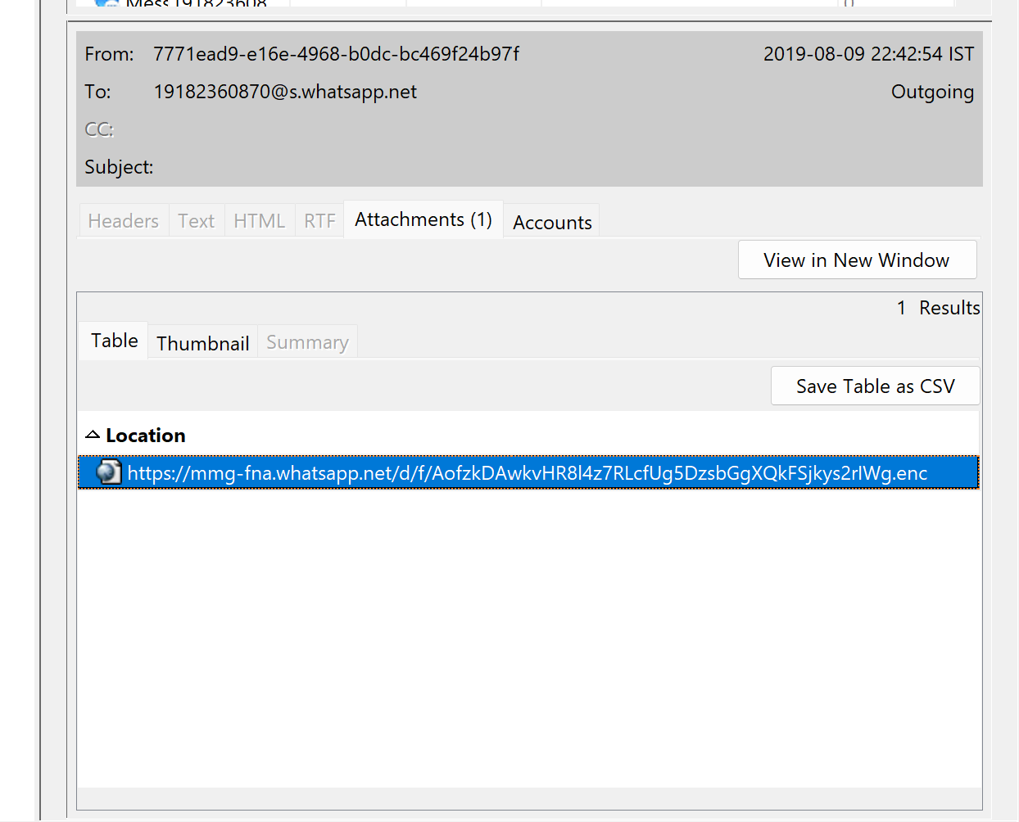
Figure 9. Autopsy WhatsApp message showing an outgoing message with one location attachment.

I see that the location attachment shows that a location was shared through WhatsApp. The conversation, around the location also talks about where the participants would meet. This supports the meeting-location part of the scenario.. Do not overstate it as proof of a specific route unless a dedicated navigation or route artifact is found.

8. Browser and Web-Activity Artifacts

8.1 Chrome history and search activity
Chrome history was examined in the folder /data/com.android.chrome/app_chrome/Default. The History database contained Google searches. The searches that mattered were firearm-related price queries and drug-price queries, including variants like "price, for sig pistols
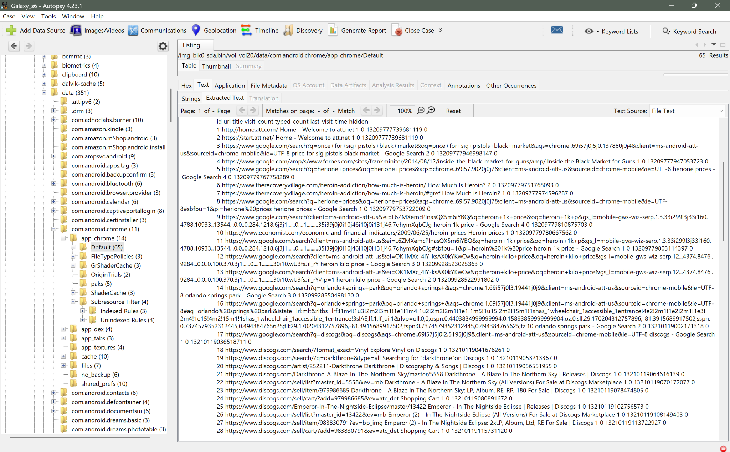
Figure 10. Autopsy Chrome history content showing recovered Google searches and visit timestamps.
The same Chrome history also contained searches for 'orlando springs park'. Two relevant raw Chrome timestamps were converted from Chrome/WebKit time (microseconds since 1601-01-01 UTC):
Raw last_visit_time | UTC | America/New_York
13209928550498120 | 2019-08-10 16:35:50.498120 UTC | 2019-08-10 12:35:50.498120 PM EDT
13210119002171318 | 2019-08-12 21:30:02.171318 UTC | 2019-08-12 17:30:02.171318 / 5:30:02 PM EDT
These two timestamps correspond to the two 'orlando springs park' history entries visible in the examined Chrome data.

9. Tor Browser and Onion-Network Artifacts

9.1 Tor service state
Tor Browser artifacts were located under the org.torproject.torbrowser application. The Tor service state file contained an explicit generation timestamp:
# Tor state file last generated on 2019-08-09 14:55:23 local time
LastWritten 2019-08-09 14:55:23
This establishes a Tor state-file generation/last-written time of 2019-08-09 14:55:23 local time. The investigation used the 2:55 PM value when relating this artifact to the NIST scenario.

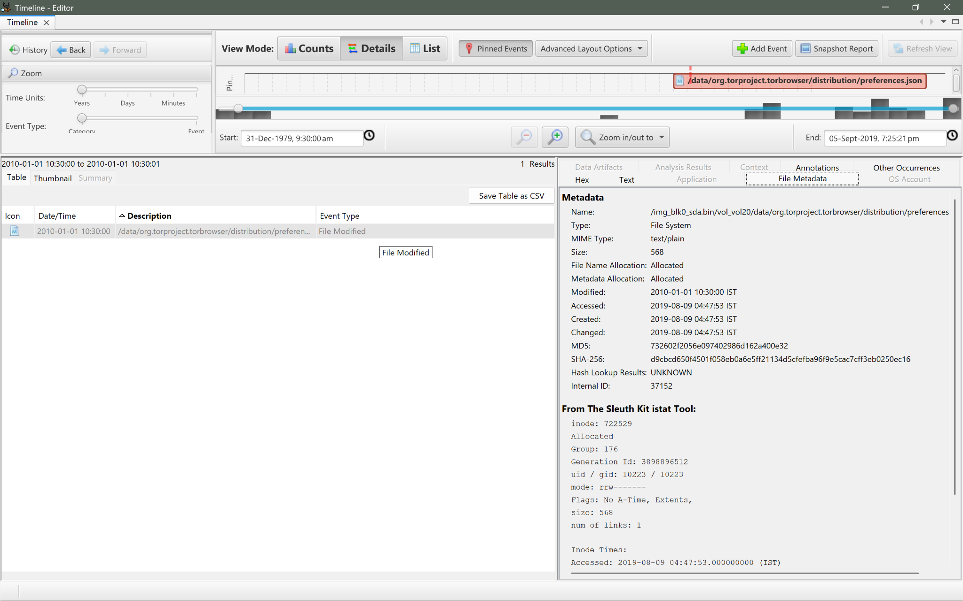
Figure 12. Autopsy Timeline view showing Tor Browser distribution/preferences activity.
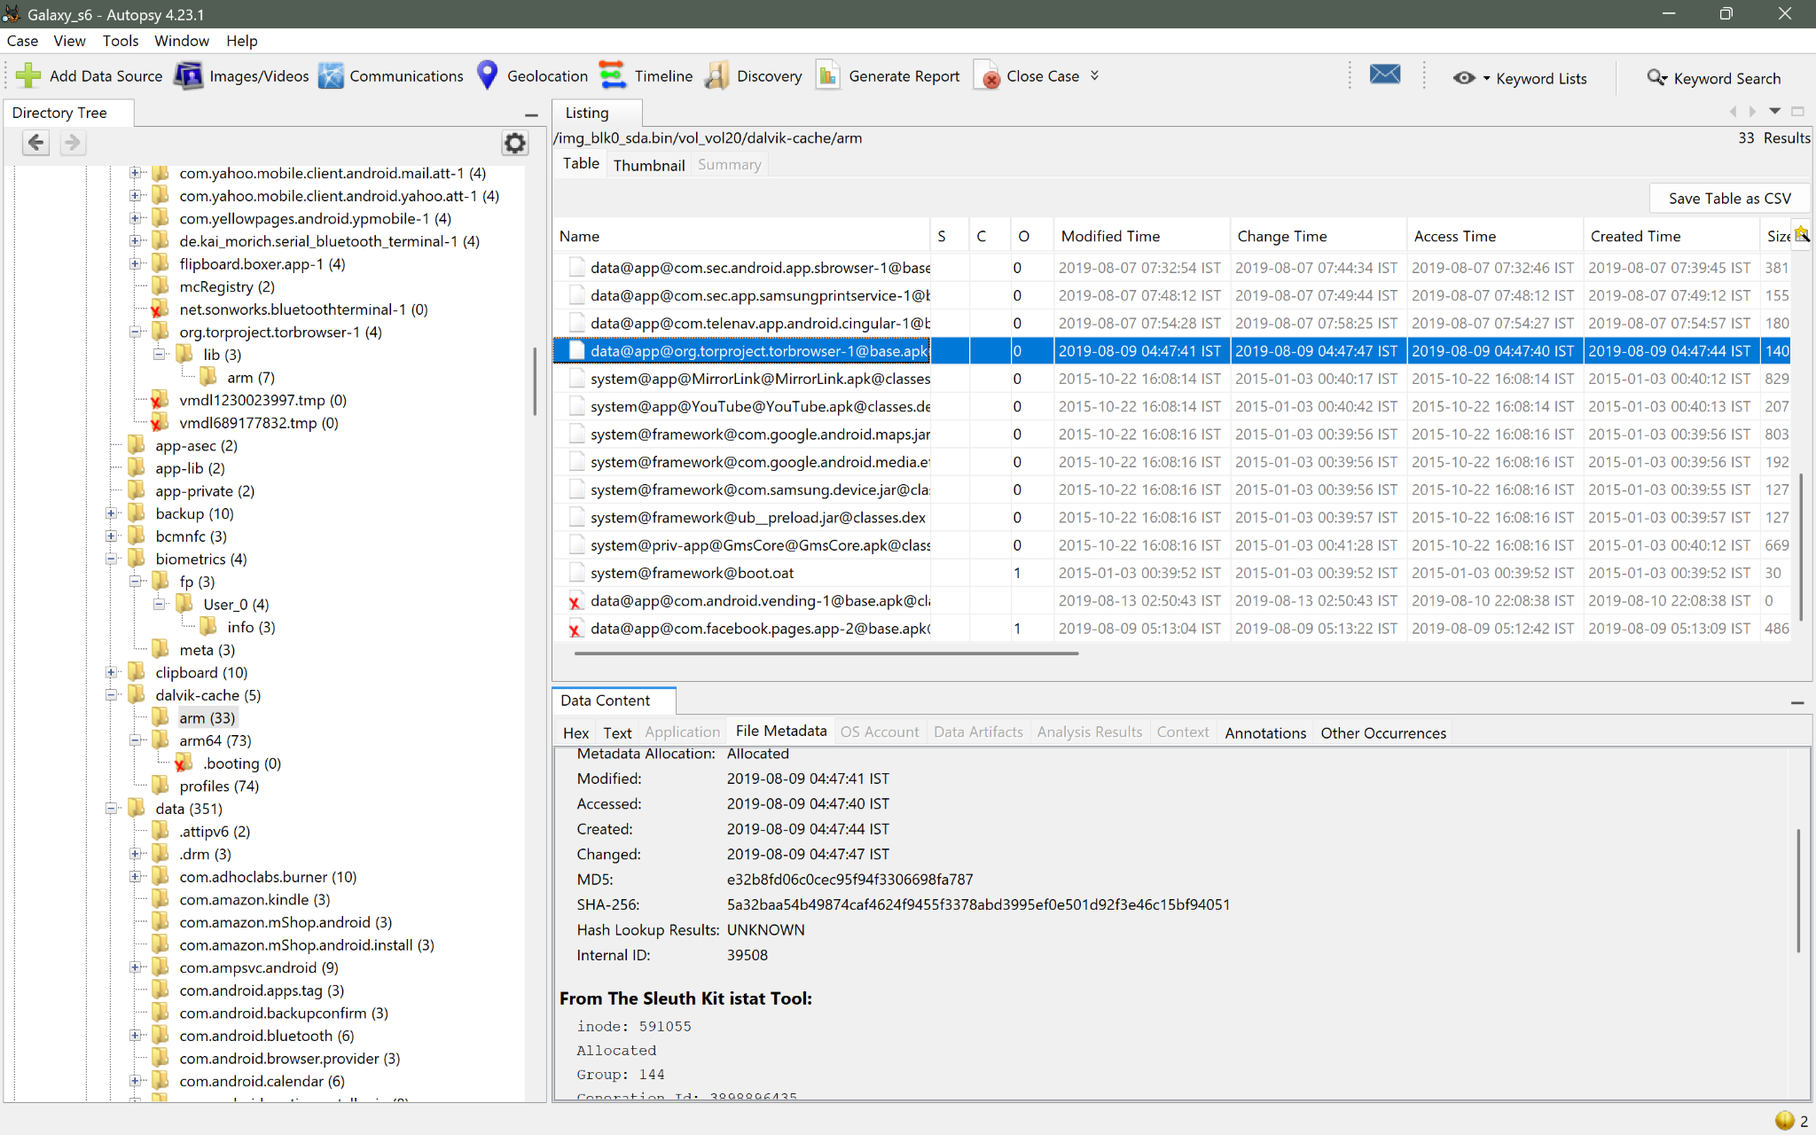
Figure 13. Autopsy file-system view of the Tor Browser application libraries.

9.2 Deep-web directory/listing website
Tor/Firefox-related recovered strings contained a clear reference to www.deepwebsiteslinks.com and a corresponding onion address. This artifact was used to associate the browsing activity with a site providing links/listings to deep-web markets.
Recovered domain: www.deepwebsiteslinks.com

10. Bluetooth and Vehicle-Related Artifacts
Bluetooth application preferences and device records were examined. The phone's own Bluetooth adapter was recorded as 3c:bb:fd:6a:00:32, while a remote device named 'Uconnect 1C4RDHAG7HC690071' was recovered.
[Screenshot not available in working copy: 6d53d3a1-c11b-451e-af8b-998fbd13377c.png]
The Uconnect remote-device record contained the Bluetooth MAC address <b>00:54:AF:68:D4:F4</b>. This MAC address is directly supported by the Bluetooth artifact.
Remote device: Uconnect 1C4RDHAG7HC690071
Bluetooth MAC: 00:54:AF:68:D4:F4
Important forensic qualification: the string 1C4RDHAG7HC690071 was recovered as part of the Uconnect device name. It was not independently validated in this examination as a dedicated VIN field. The separate VIN candidate question therefore remains unresolved from the evidence currently documented.

11. Google Drive / Google Docs Artifacts
Google Drive application data was located under the account directory associated with jd.cvult@gmail.com. The cello.db items table contained two records: a 'My Drive' folder and a 'Getting started' PDF.
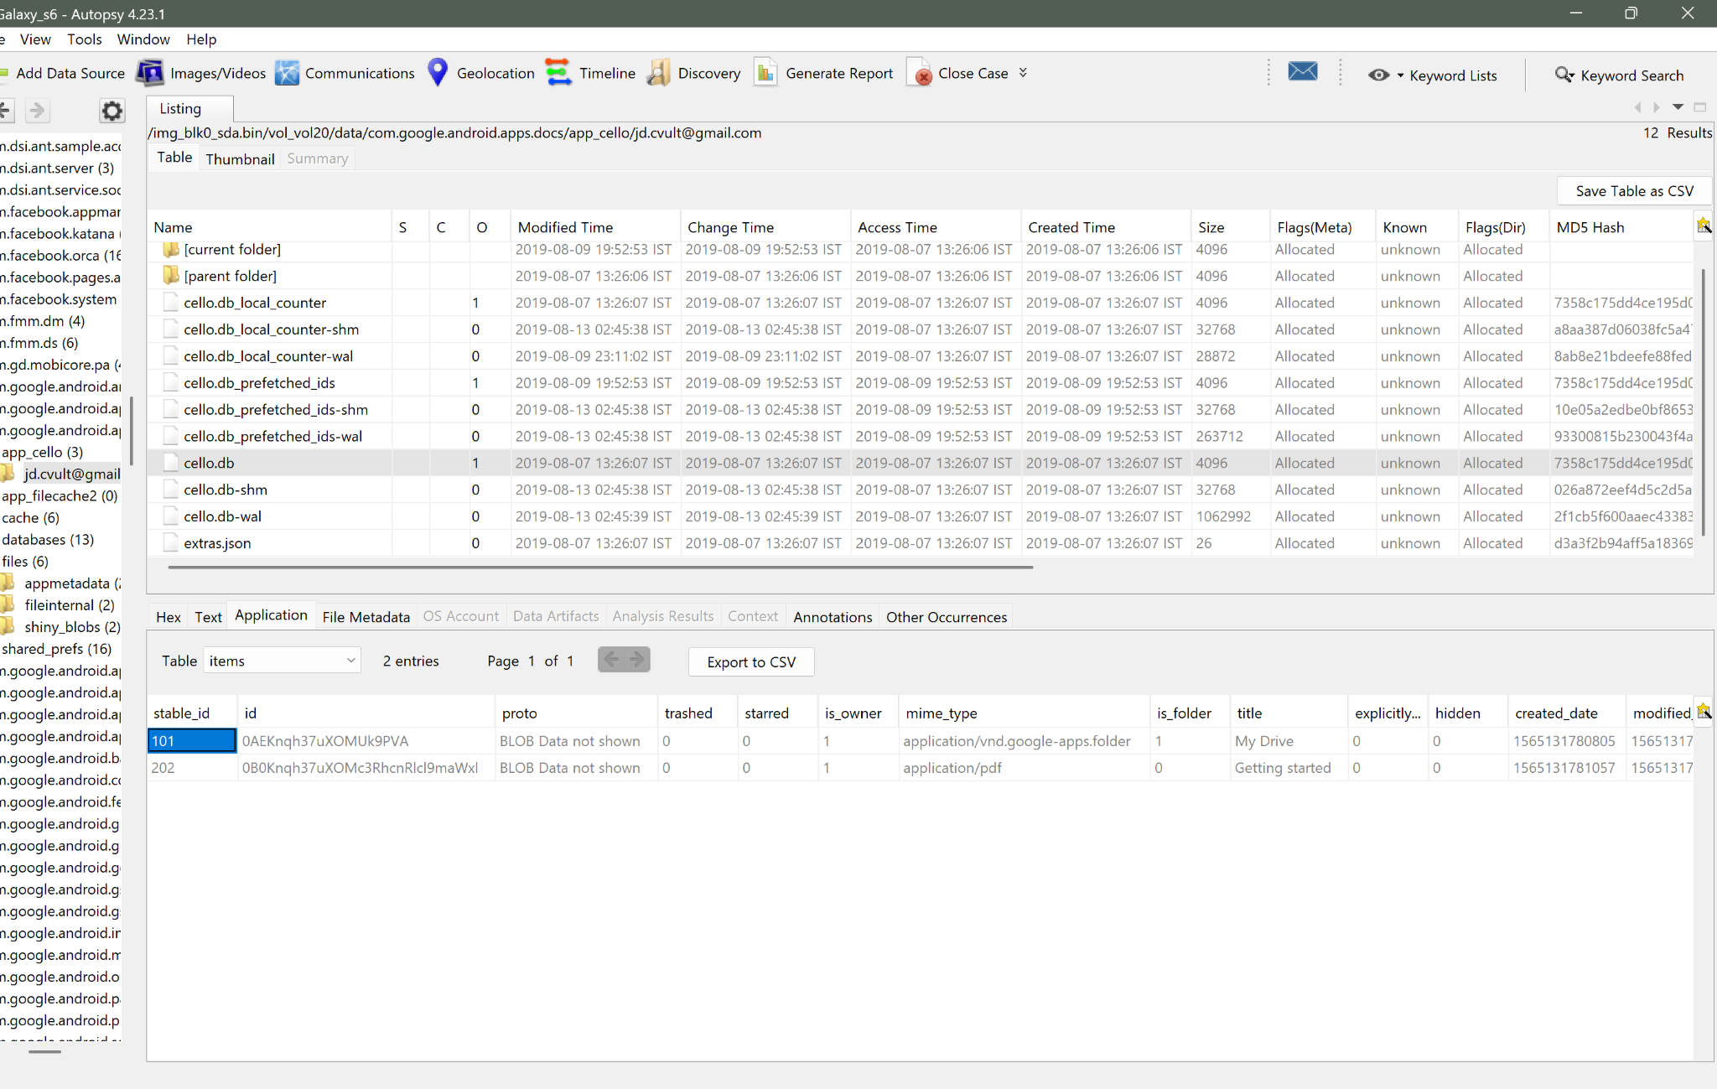
Figure 16. Autopsy Google Drive application data showing the jd.cvult@gmail.com account directory and two stored items.
The Drive application configuration also contained settings associated with binary download capability. These configuration values establish that the application supported download functionality, but configuration alone does not prove that the user actually downloaded a specific file.

12. Extraction and Parsing Limitations
An ALEAPP-based parsing attempt was performed during the examination. Processing completed, but the relevant modules returned essentially zero parsed artifacts/file counts. As a result, the examination was continued manually in Autopsy using direct file-system navigation, database inspection, and raw artifact content.
- ALEAPP: processing completed but artifact output was effectively empty for the examined image.
- Autopsy: successfully exposed the raw image and allowed direct inspection of application/system artifacts.
- The parsing limitation should not be interpreted as proof that the original Cellebrite acquisition was corrupt.
- Manual verification of artifacts was therefore essential for this case.

13. Consolidated Artifact Findings
The following summary records the findings established during the investigation. It intentionally does not use the NIST question numbering.
Artifact category | Recovered artifact / path | Finding | Evidence status
Image integrity | blk0_sda.bin | SHA-256: 7B5EF155A6E07AD4D5C67FAA65F715552CDB4D5CDA2E8C45B8104E0F63A84EB4 | Directly verified
Android user profile | /system/users/0.xml | jd tester | Directly observed
Time-zone configuration | /data/property/persist.sys.timezone | America/New_York | Directly observed
Authentication | /system/gesture.key | 20-byte Android gesture-key artifact recovered | Directly observed
Image metadata | 20190809_120201.jpg | GPS coordinates correspond to Tulsa, Oklahoma | Directly observed + geographic interpretation
Wi-Fi | Wi-Fi configuration artifact | 8 distinct access points | Directly observed
Messaging | WhatsApp msgstore.db | Potentially illegal-transaction discussion recovered | Directly observed
Contact correlation | contacts2.db / WhatsApp account | 9182360870 associated with contact Olve | Directly observed
Location sharing | WhatsApp message attachment | Location attachment shared in conversation | Directly observed
Chrome | Chrome History | Drug/firearm price searches and Orlando Springs Park searches | Directly observed
Tor | app_torservice/.tor/state | State file last generated 2019-08-09 14:55:23 local | Directly observed
Deep-web browsing | Tor/Firefox-related records | www.deepwebsiteslinks.com reference recovered | Directly observed
Bluetooth | Bluetooth remote-device record | Uconnect MAC 00:54:AF:68:D4:F4 | Directly observed
Vehicle identifier | Uconnect device name | 1C4RDHAG7HC690071 embedded in device name; VIN not independently validated | Unresolved as VIN
Google Drive | cello.db | Account jd.cvult@gmail.com; My Drive and Getting started PDF entries | Directly observed
Drive download capability | Google Drive configuration | Download-related configuration present; actual user download not proven | Limited / not conclusive

14. Current Unresolved / Not Fully Proven Items
- The specific VIN requested by the scenario has not been independently established from a dedicated VIN artifact. The Uconnect device name contains 1C4RDHAG7HC690071, but this is not being treated as a verified VIN.
- The application associated with the deleted Chrome/search term remains unresolved from the evidence currently documented.
- The country represented by the Instagram envelope return address has not been directly established from a screenshot/artifact in this report.
- The exact set of Instagram search terms and the full shopping-cart contents require direct artifact verification before being treated as proven findings.
- A Google Drive download is not proven solely by the presence of download-enabled configuration settings.

15. Conclusion

The Samsung Galaxy S6 physical image provided a lot of user, communication, browser, Tor, Bluetooth, location and cloud-application evidence when looked at directly through Autopsy. The important things found include the Android user name, device time-zone setting, authentication artifact, geotagged photograph, Wi-Fi history, WhatsApp communications and contact correlation, browser searches, Tor state information, deep-web site reference Bluetooth connection, with a Uconnect device and Google Drive account/application data.

This report keeps the investigation as a centric forensic record. Findings are written based on the strength of the evidence that's available right now and things that are not yet solved are kept apart instead of being turned into conclusions that are not supported.

Appendix A — Screenshot Register
Figure 1: Android /system/users/0 area — 14eb321e-3190-4312-b0e2-74972d18ab3c.png
Figure 2: gesture.key — 3ca1f72e-e313-477f-aa10-0a3b3f7aa7d6.png
Figure 3: Android system/application directory — 3a0be90e-1ee3-4385-808b-83a23df86726.png
Figure 4: WhatsApp messages — c7388774-c319-44ea-922a-40814f7a9e82.png
Figure 5: Communications Visualization — 7eaca4e1-d06e-45dc-9538-091ad58a569c.png
Figure 6: Phone communication account — 3354fde0-d104-4be0-9bbf-fbb2e30ad377.png
Figure 7: Olve / WhatsApp account — 574acf57-4475-419d-8cec-7e1f3dba36ed.png
Figure 8: WhatsApp meeting-location context — 08975ca8-e5b4-4bc0-b79d-275259cebec6.png
Figure 9: WhatsApp location attachment — 211fab7a-8005-4e30-bc2c-39a94b57c7ea.png
Figure 10: Chrome History — 27cb0a59-689c-4566-b7dd-ec3379a1db85.png
Figure 11: Tor state directory — c8be4fe5-4ded-4402-86f3-7c8777014bcf.png
Figure 12: Autopsy Timeline — dd95fa00-b3b1-434c-9a02-87198bc37404.png
Figure 13: Tor Browser libraries — c017e9f4-3e1c-4490-8383-05fbc7fb096d.png
Figure 14: Tor temporary artifact — 688c7f3b-ac59-4164-be06-e5274932686f.png
Figure 15: Bluetooth preferences — 6d53d3a1-c11b-451e-af8b-998fbd13377c.png
Figure 16: Google Drive / cello.db — ffc291ef-6279-40c7-bc98-53ebf3cc731d.png

