SEO

<https://ads.google.com/>

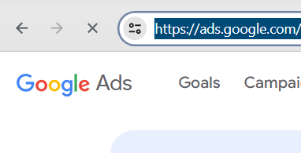

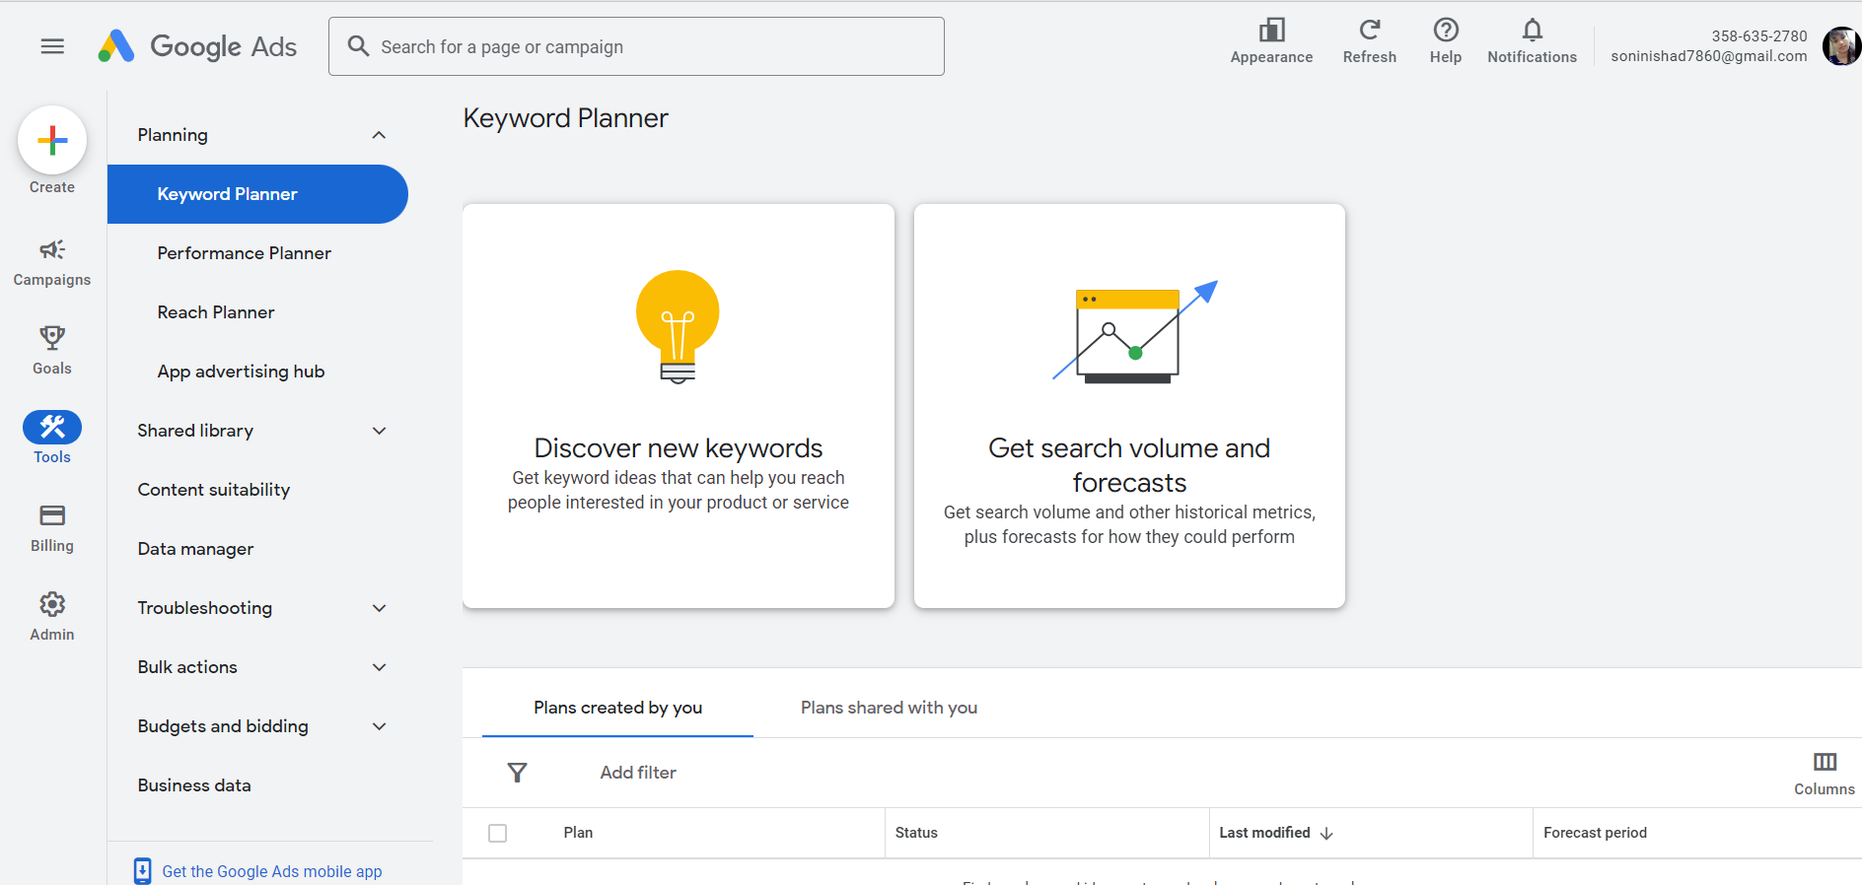

Meta ADD

* Sponsers add , called

Tools

* https://clarity.microsoft.com/