COMPUTER GRAPHICS LAB

1. Write C++/Java program to draw line using DDA and Bresenham‘s algorithm. Inherit pixel class and Use function overloading.

2. Write C++/Java program to draw circle using Bresenham‘s algorithm. Inherit pixel class.

3. Write C++/Java program for line drawing using DDA or Bresenhams algorithm with patterns such as solid, dotted, dashed, dash dot and thick.

4.Write C++/Java program to draw the following pattern using any Line drawing algorithms

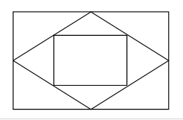

5.Write C++/Java program to draw inscribed and Circumscribed circles in the triangle as shown as an example below. (Use any Circle drawing and Line drawing algorithms)

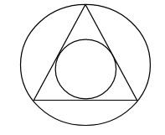

6. Write C++/Java program to generate fractal patterns by using Koch curves.

7. Write C++/Java program to generate Hilbert curve using concept of fractals

8. Write C++/Java program to draw 2-D object and perform following basic transformations,
a) Scaling
b) Translation
c) Rotation
Use operator overloading.

9. Write C++/Java program to implement reflection of2-D object about X axis, Y axis and about X=Y axis. Also rotate object about arbitrary point given by user.

10. Write C++/Java program to implement translation, sheer, rotation and scaling transformations on equilateral triangle and rhombus.

11. Write C++/Java program to draw any object such as flower, waves using any curve generation techniques

