**Private AI**

1. Installing [olama](https://ollama.com/download/windows) for windows/Mac

2. now install the llama in the terminal  
 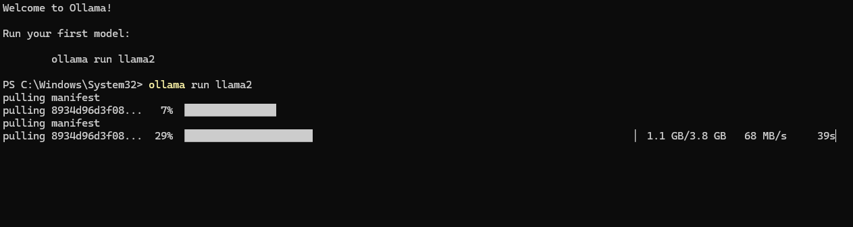

3.Running the first question and testing the AI

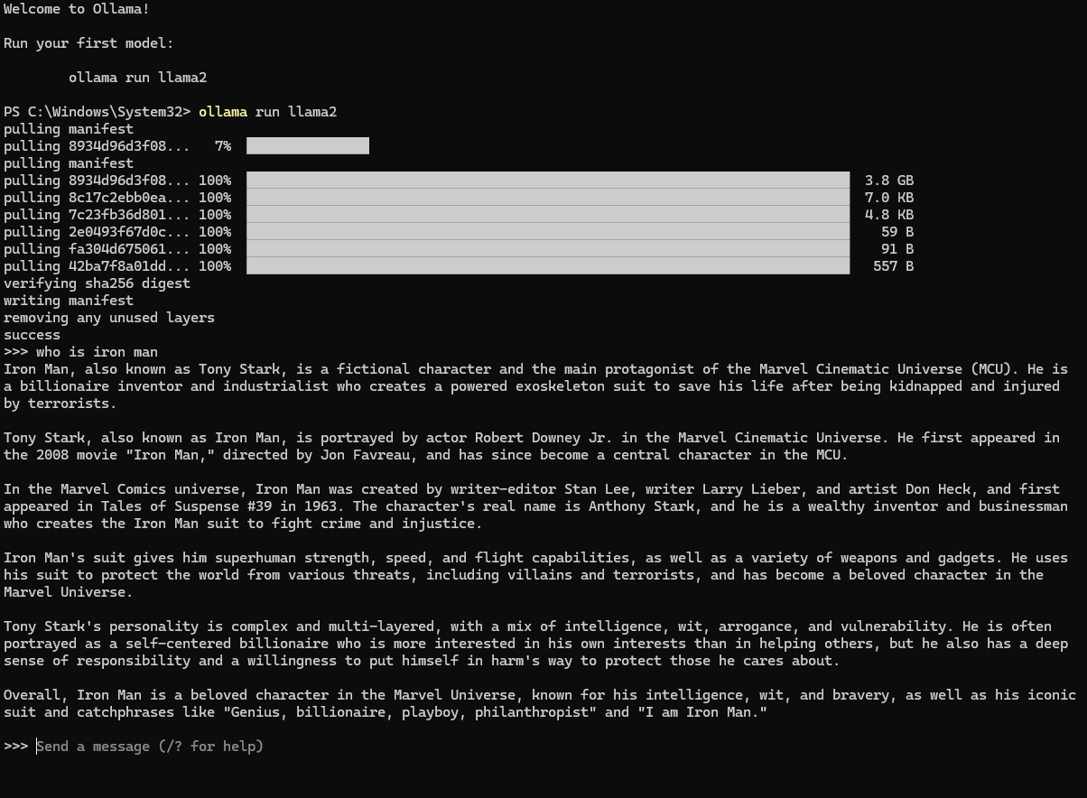  
  
The better the GPU the faster the AI responds (M-series macbook runs really good)

4. Proceeding with **Fine tuning  
  
Installing poetry**(Invoke-WebRequest -Uri <https://install.python-poetry.org/> -UseBasicParsing).Content | py -

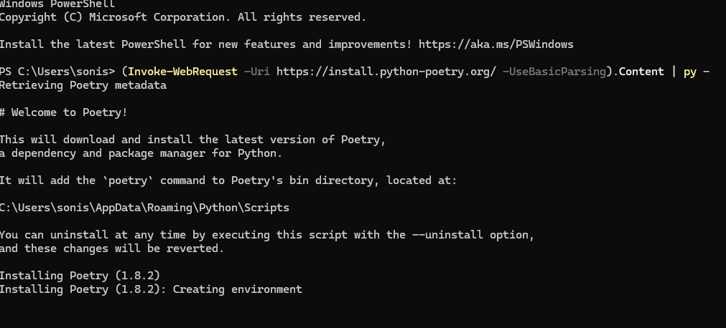  
  
add the path  
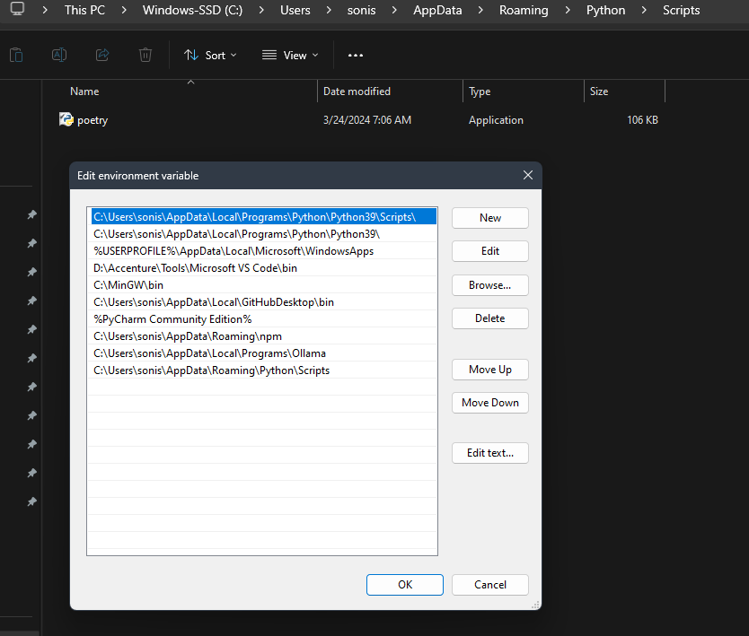

5. now check for poetry version  


6. Run as administrative and run the below command  
Invoke-WebRequest -UseBasicParsing -Uri "https://raw.githubusercontent.com/pyenv-win/pyenv-win/master/pyenv-win/install-pyenv-win.ps1" -OutFile "./install-pyenv-win.ps1"; &"./install-pyenv-win.ps1"

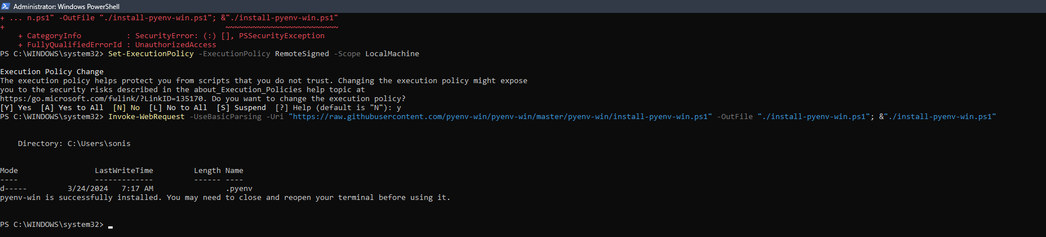

7.Now clone the repository  
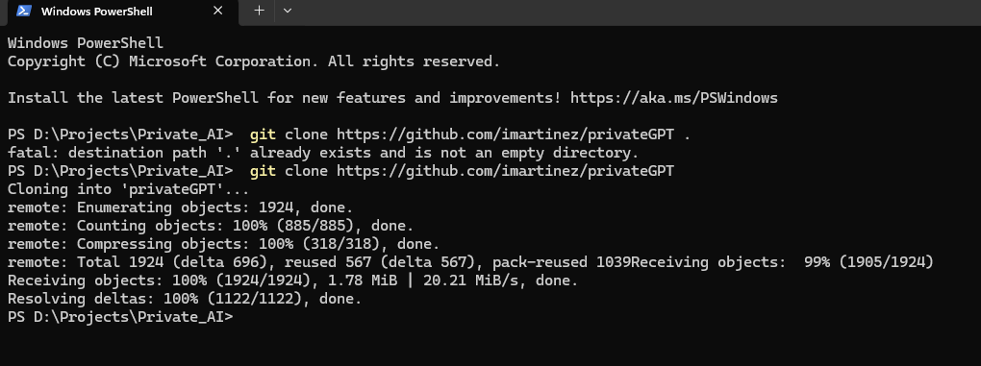

8. changing the Python version

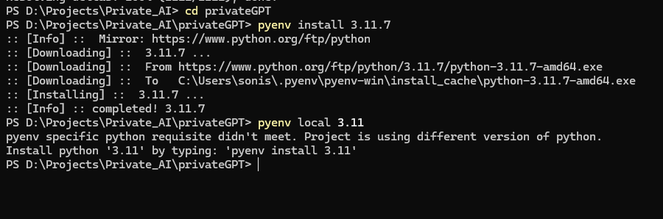

9. Install Chocolate as administrator  
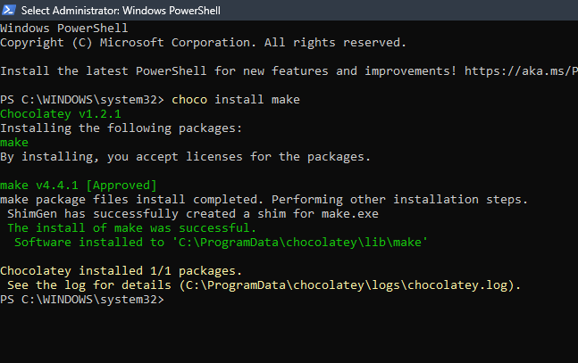

10. Pulling manifest : ollama pull nomic-embed-textollama pull nomic-embed-text  
  
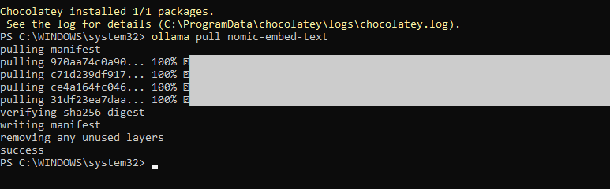

11. Run the python command: (Invoke-WebRequest -Uri https://install.python-poetry.org/ -UseBasicParsing).Content | py -  
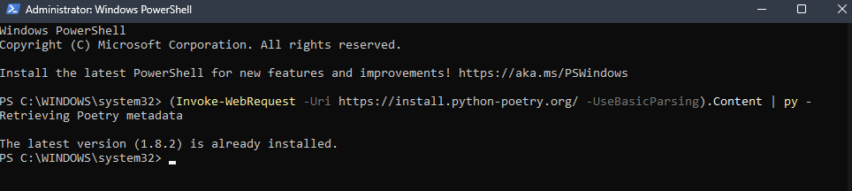

12. pyenv install 3.11.7  
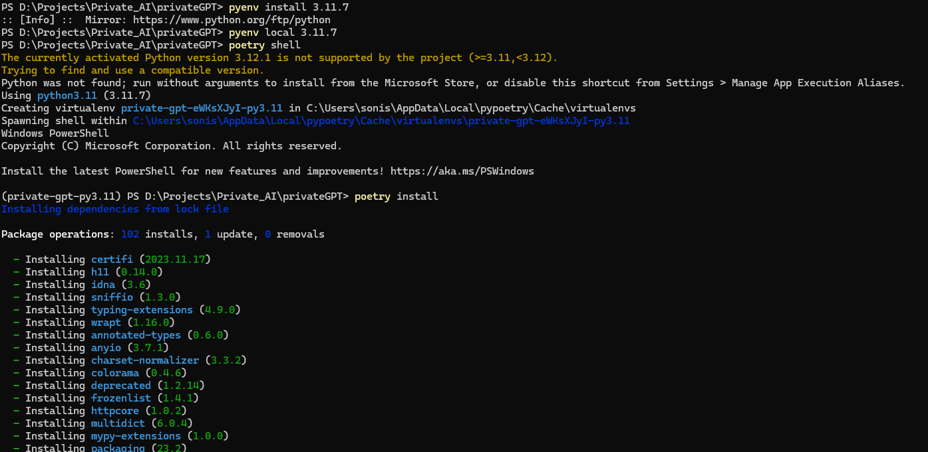

13. poetry install --extras "ui llms-ollama embeddings-ollama vector-stores-qdrant"  
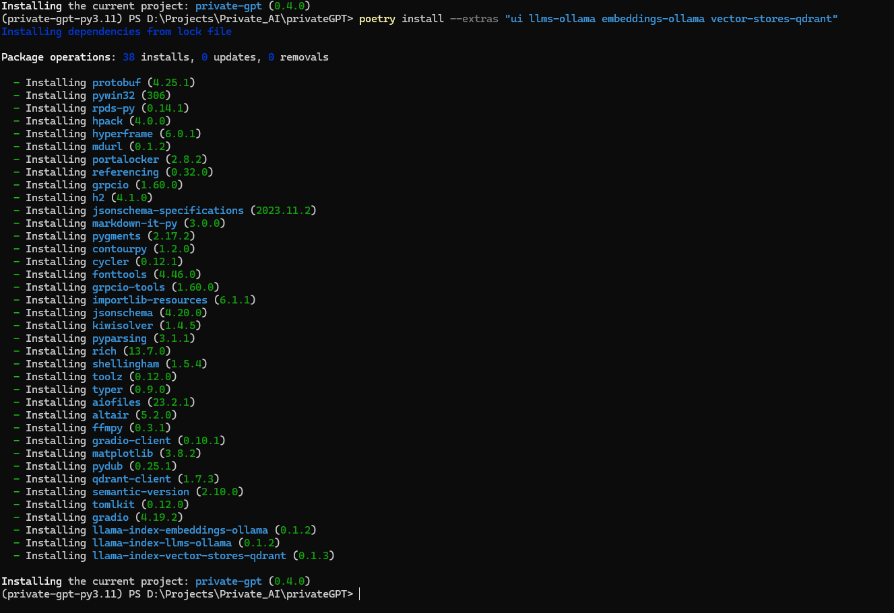

14. make run command  
http://localhost:8001/  
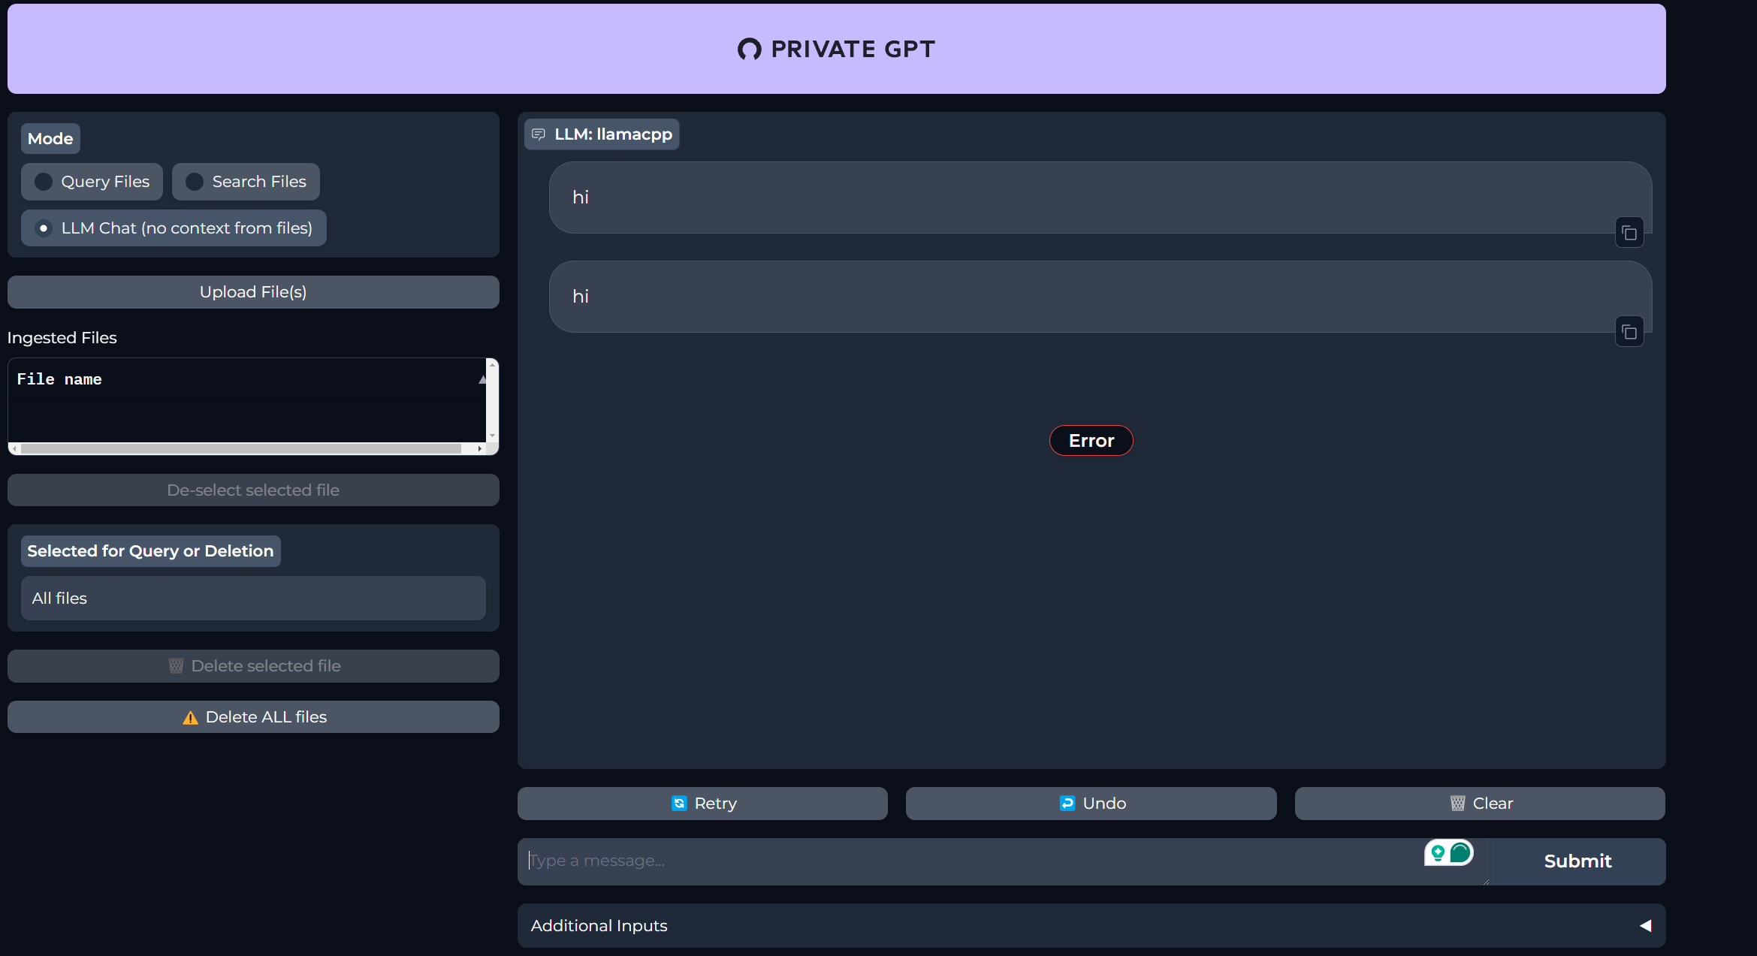

15.Poetry shell and Poetry install  
  
16. How to start   
 $env:PGPT_PROFILES="ollama"   
 make run

