1.

First, the admin should log in first to be able to register the faculty/students since admin has the power to control the system.

2.

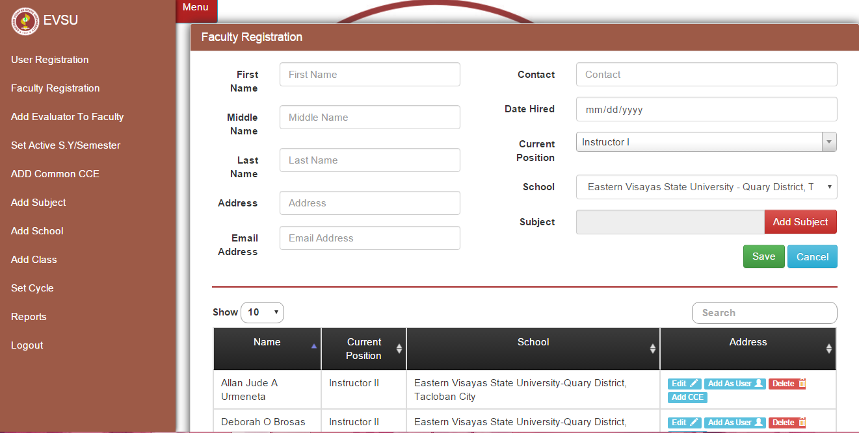

Fill in all the blanks that needs information above to complete the registration.

3.

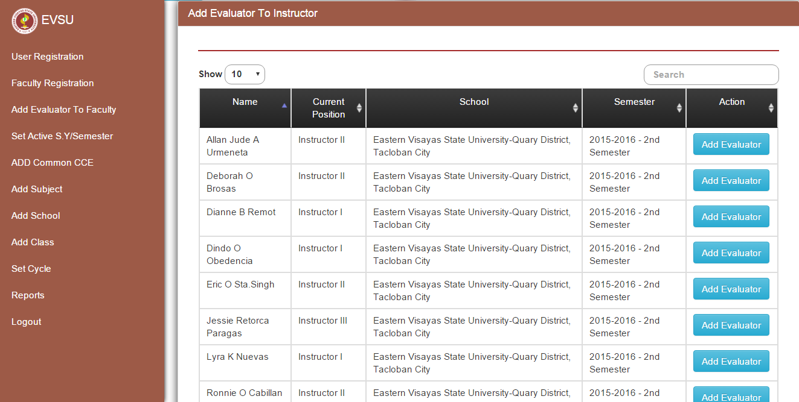

After that you can click the Button Add Evaluator and to start evaluation you should log in the user.

4.

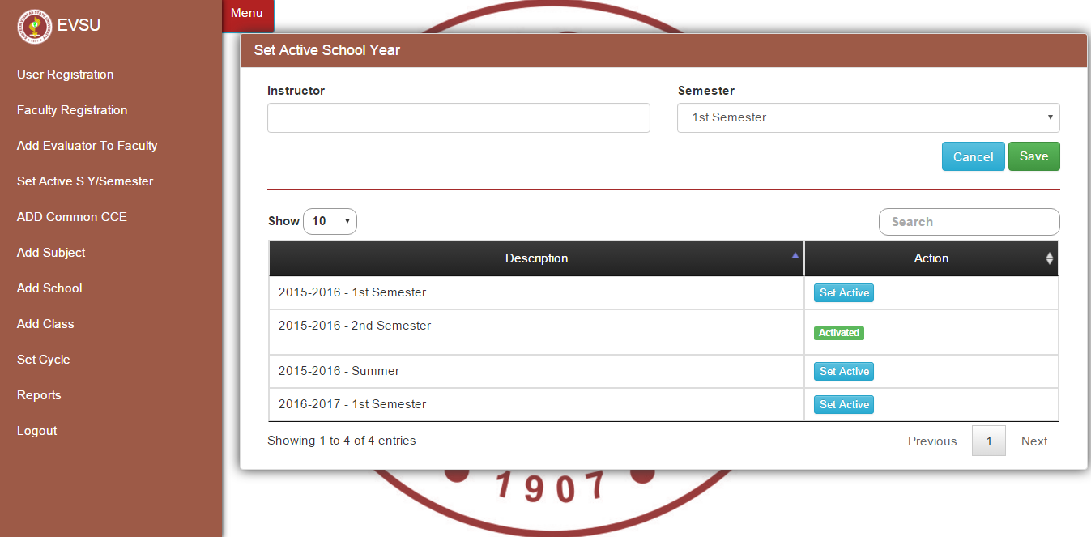

Set the Active or current School Year to avoid confusion.

5. 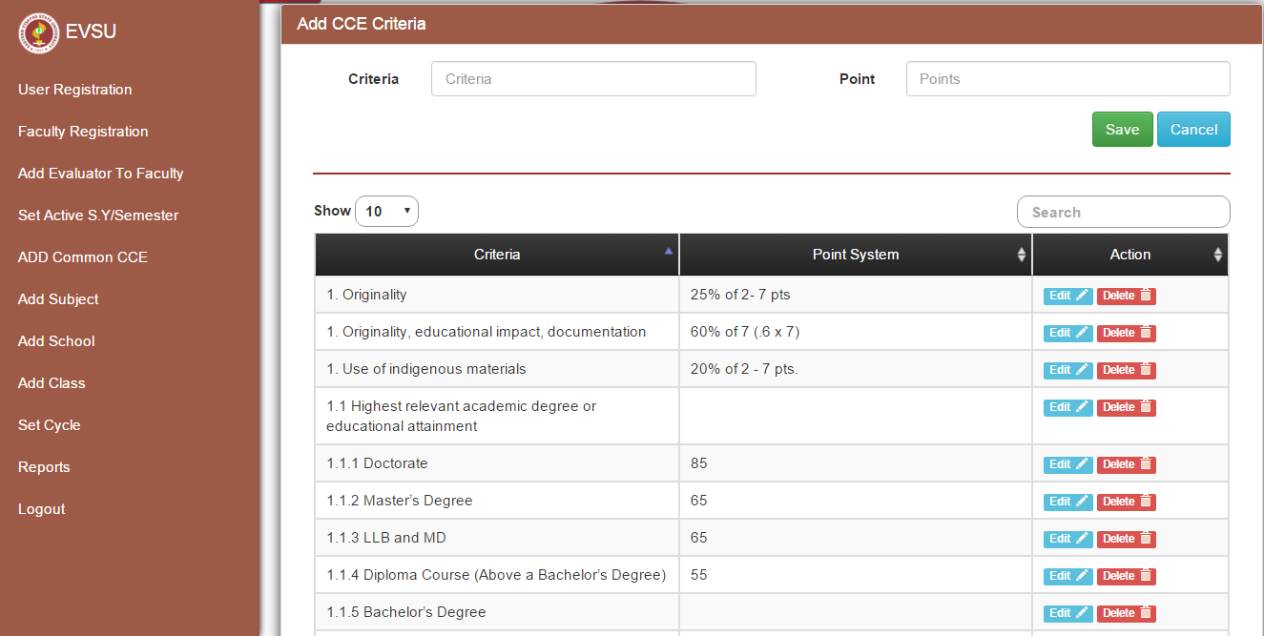

Adding CCE Criteria by just entering the Criteria and their corresponding points and click Save. It can be edited if there will be some errors or it can also be deleted.

6.

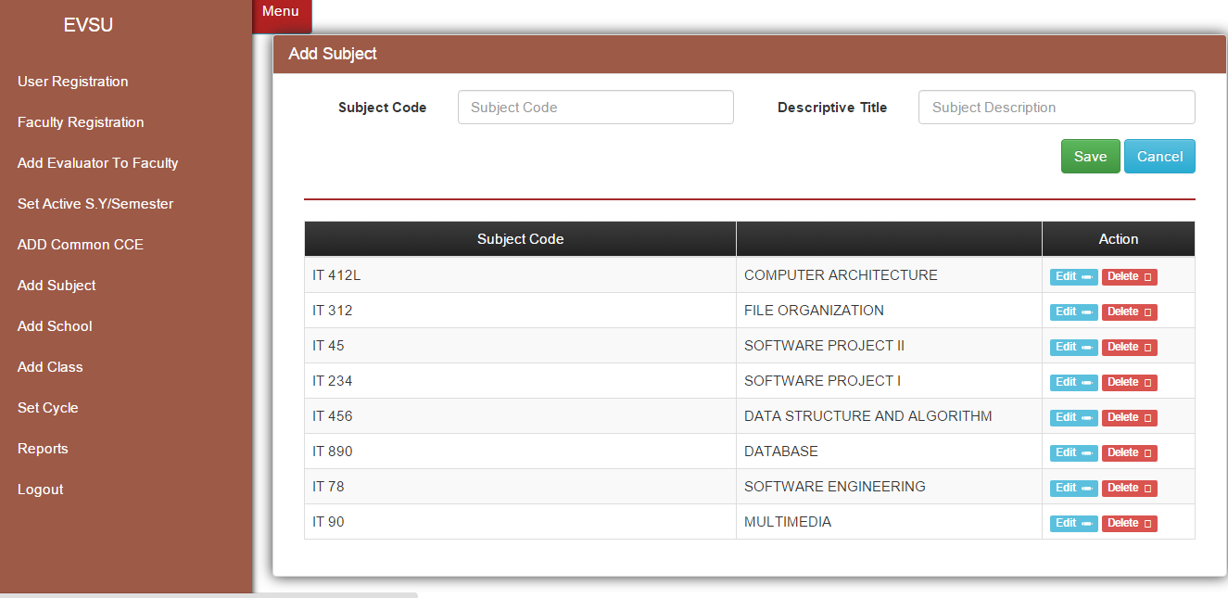

Adding Subject by entering the Subject Code and the Descriptive Title and click Save.

7.

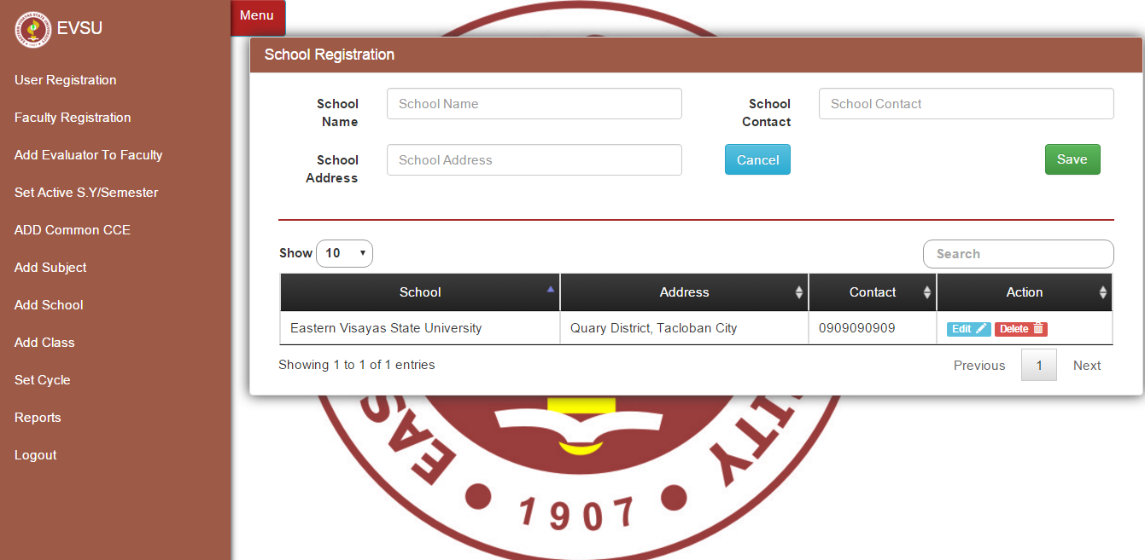

School Registration entering the School Name, School Address, School Contact and click Save.

8.

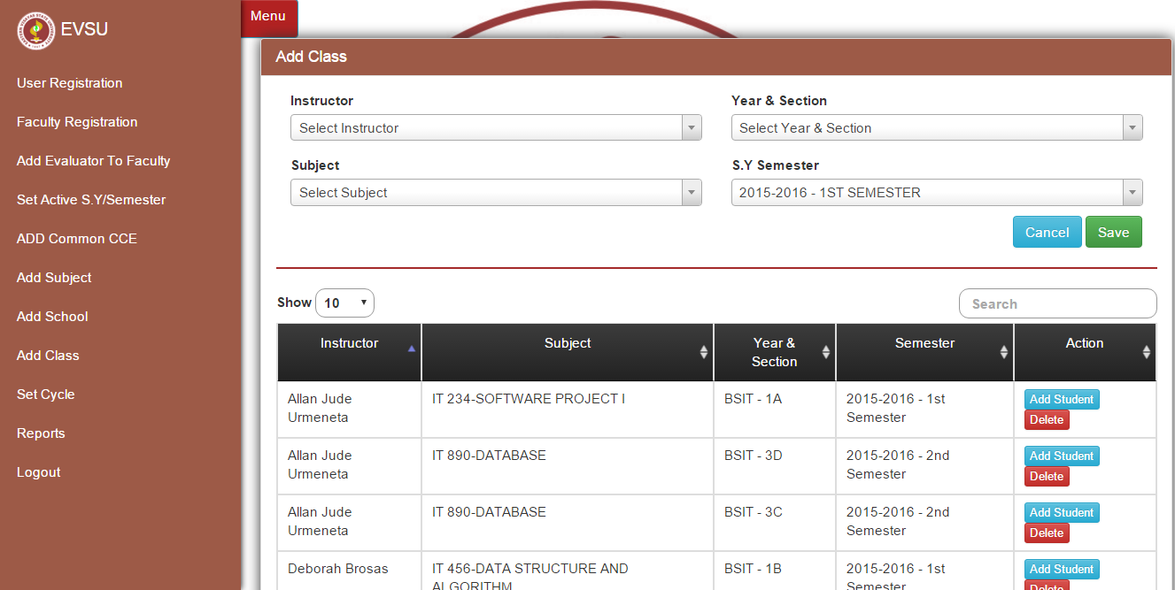

Adding Class, Entering the instructor, Subject, Year and Section, School Year semester and click Save.

9.

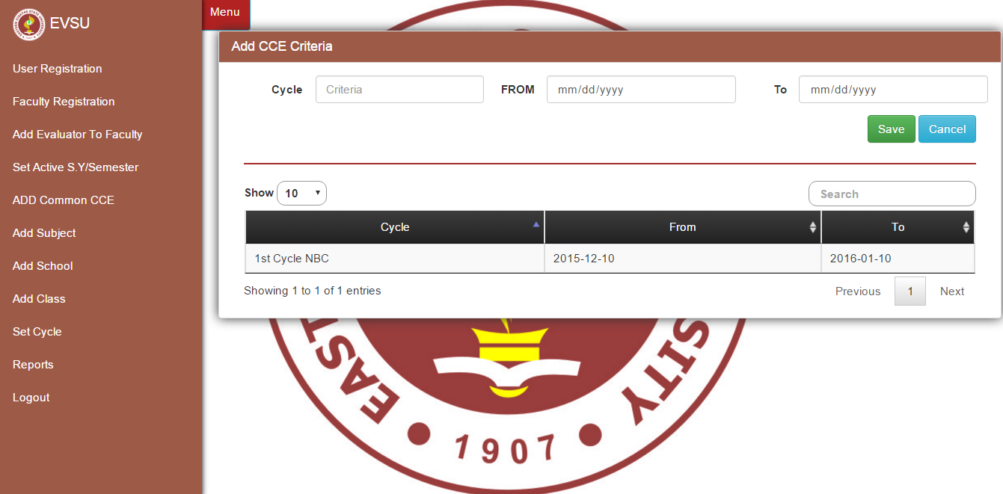

Add CCE Criteria, enter criteria, and the activated rating period and click save.

10.

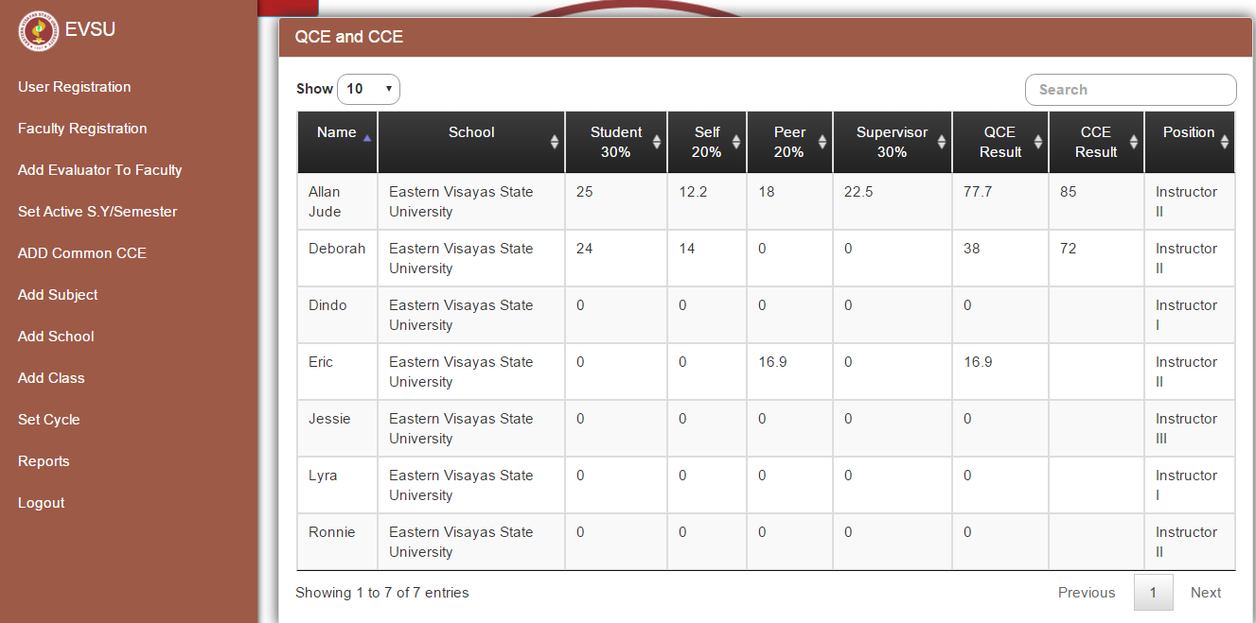

REPORTS, it can be seen here the QCE and CCE Reports result and their position.