**Objective**: Identify the hotspots of human wildlife conflicts geographically due to urbanization and the goal is to identify the urban and forest boundaries touching each other.

1. Upload the West Bengal shapefile in Google Earth Engine(GEE) via assets tab. Files in Dissolve_WB

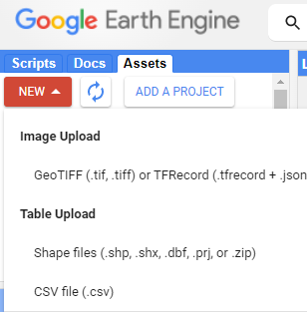

2. Import the file to code editor as shown below

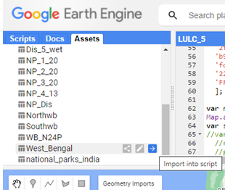

3. Copy the code from LULC_5.txt to GEE code editor. Code has reading sentinel 2 satellite collection of images for an year and use filter for cloud free image in that year, clippling the cloud free image according to the West Bengal shapefile, Training supervised cart classification on collected data and created a new land use land cover (LULC) layer.

4. Create point geometry and assign classes in settings, manually collect the training data and import the data to code editor

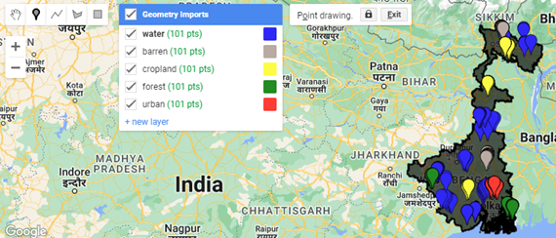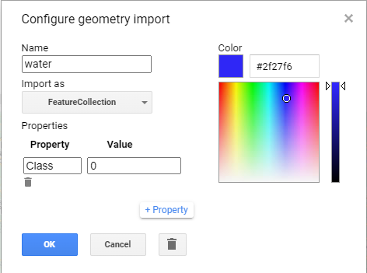

5. Run the code and run the task to export the classified tiff image to Google drive. File is LULC_5.tif

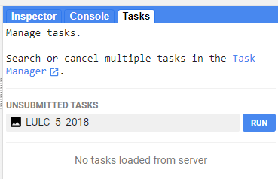

6. Load the classified tiff file into Arcgis pro and convert it to vector data by using raster to polygon tool. Files in LULC_vector

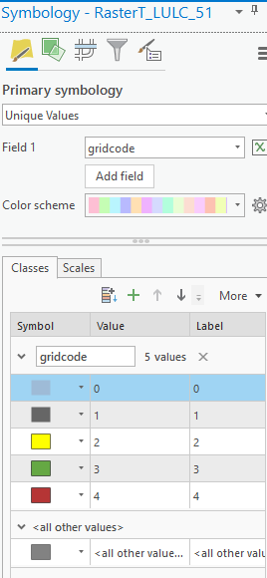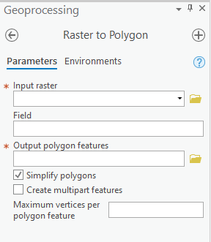

7. Change the symbology to the corresponding colors for classes

8. Clip the vector according to the boundary of West Bengal shapefile by

clip tool. Files in LULC_clip

9. Filter by urban and forest and save them as separate vector files

Files in Urban and Forest respectively

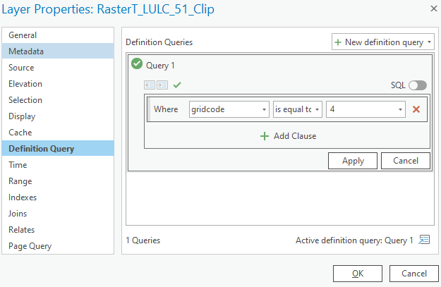

10. By using Select by Location tool to filter only polygons of urban and forest touching each other with a line segment and save them separately. Files in Urban_touches and Forest_touches repectively

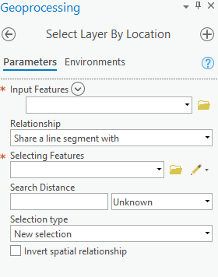

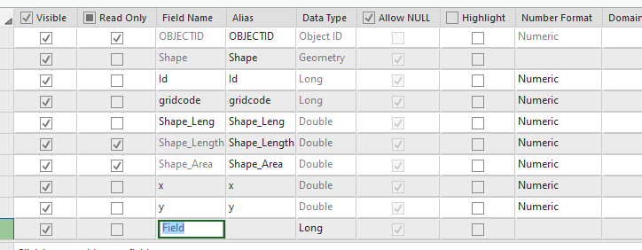11. The forest polygons from above, take polygons from median to q3 to eliminate the outliers (not proper metric can be changed). Files in Forest_filter

12. Calculate the centroids of those polygons by creating new fields x,y in attribute table

13. Calculate the geometry of created x, y fields and assign to coordinates

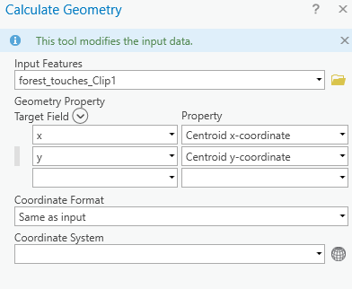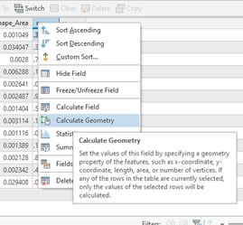

14. Clip the forest polygons according to boundaries of north and south regions by using clip tool. Files are in NorthWB, SouthWB, forest_touches_Clip_north, forest_touches_Clip_south respectively

15. Export the above result layers as tables. Files in locations_north, locations_south respectively

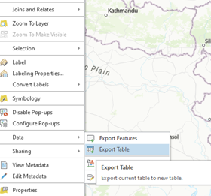

16. Display the XY coordinates on to map from the exported table. Files in locations_north_XY, locations_south_XY respectively

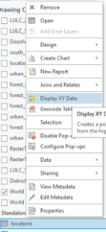

**Analysis for National Parks in India:**

1. Using webscrapping and geopandas extracted national park locations. Files in National_parks

2. Load the National park csv into arcgis pro and Load the India map shape files - IND_adm.

3.Using select by location tool filter the district polygons contains the national park locations from csv table in arcgis pro. Files in NP_Districts.

4. Upload and import this NP_Districts shapefile in GEE and same steps as above shown for west bengal except skip 4 step(instead of manual collection of training data reading from GEE datasets - <https://developers.google.com/earth-engine/datasets/catalog/MODIS_006_MCD12Q1>) and in step 3 copy script from NP.txt

**Other Data :**

India map shapefiles with including Pakistan and China occupied kashmir - India_kashmir_districts, India_kashmir