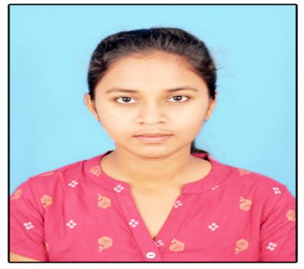

**Soniya Choppadandi**

Student

## My Contact

GMail:so n i y a c h o p p a d a n d i [@gmail.com](mailto:jeldidivya@gmail.com)

LinkedIn : https://[www.linkedin.com/in/soniya-](http://www.linkedin.com/in/soniya-) choppadandi-2799b2270

Phone:8688854717

Address: Chegyam , Jagitial[Dist], Telangana-505416.

## Soft Skills

Problem Soving Skills Team Work

Good Listener Slow Learner

**Programming Languages**

C-Intermediate Python-Basic Java-Beginner

## Education Background

**2020-2024**

*b.Tech in Computer Science with 6.7 CGPA.*

RGUKT,Basar.

**2018-2020**

PUC(Pre University Course) with 8.0 CGPA

RGUKT,Basar.

**2018**

SSC(Secondary School Certificate) with 9.7 CGPA

ZPHS.Chegyam.

# Objective

To associate with an organization which progress dynamically and gives me chance to enhance skills and be a part of the team that excels and works towards the growth of the organization.

# Profile

**Father Name:** Rajanarsaiah **Mother Name:** Laxmi

**Occupation:** Farmer

**Siblings:** Elder brother and sister

## Habits

Reading Books Watching TV Playing indoor games

## Languages Known

Telugu English(Basic)

* Hindi(Basic)

## Declaration

I,Soniya Choppadandi here by declare that the above mentioned information is true to the best of my knowledge and belief.

**Place:** Karimnagar

**Date:** 0 1 -June-2023

Ch.Soniya

SIGNATURE