# **Chi-Square Analysis for Survived People and Class –**

For the following bar graph, X-axis has ‘Age’ variable and Y-axis has ‘Class’ variable.

Now, consider the following code -

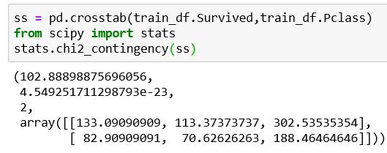

The following code displays the value for chi-square analysis.

H0: Survived people and Class are independent to each other.

Ha: Survived people and Class are not independent to each other

χ2 = ∑((f - e)2 / e

χ2 = 102.8889

DF = (r-1) (c-1)

DF = 2

And therefore DP = 7.81

Hypothesis Result – Since, χ2 is bigger than the decision point, we have enough evidence to reject the null hypothesis.

We conclude that, Survived people and Class are not significantly independent to each other.