High-Level Architecture

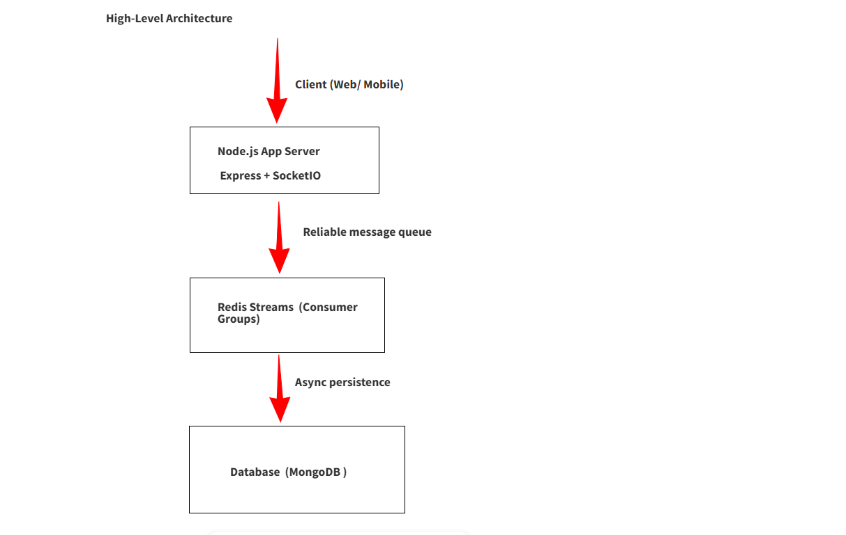

Chat Room Flow Diagram (Step-by-Step)
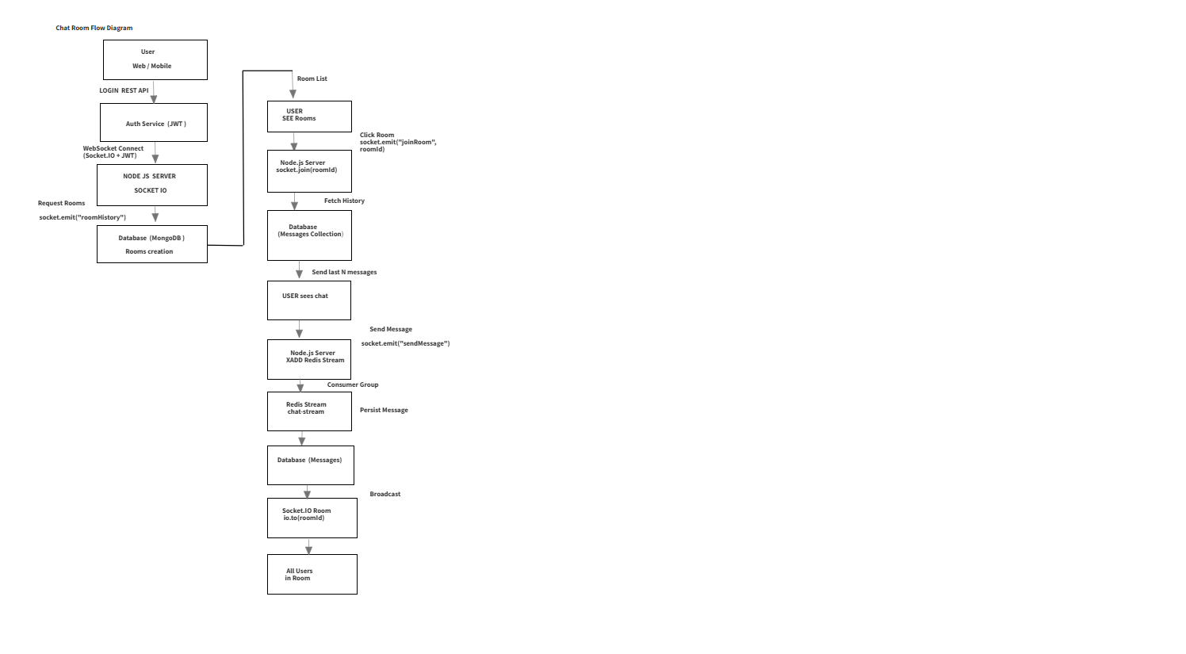

Simplified Flow

Login
↓
Socket Connect (JWT)
↓
Load Rooms
↓
Join Room
↓
Load Chat History
↓
Send Message
↓
Redis Stream
↓
Database
↓
Broadcast to Room

