**SONIYA KAMBLE – Assignment 2**

1. **Mention the difference between block elements and inline elements. Also give examples for the same.**

In HTML and CSS, elements are generally categorized into two types based on their display behavior: block elements and inline elements.

### **Block Elements**

#### **Characteristics:**

1. **Display Behavior**: Block elements take up the full width available, pushing other elements to the next line. They start on a new line and stack vertically.
2. **Box Model**: They respect all four sides of the box model (margin, border, padding, and content) and can have width and height specified.
3. **Use Case**: Typically used for larger sections of a webpage, such as headers, paragraphs, and divs.

#### **Examples:**

* <div>: A generic container for grouping content.
* <p>: Represents a paragraph of text.
* <h1>, <h2>, <h3>, etc.: Header elements, with <h1> being the highest level.
* <ul>, <ol>, <li>: Unordered and ordered lists, and list items.
* <header>, <footer>, <section>, <article>, <aside>: Semantic elements for structuring a document.

<div>

<h1>Welcome to My Website</h1>

<p>This is a paragraph of text.</p>

</div>

### **Inline Elements**

#### **Characteristics:**

1. **Display Behavior**: Inline elements do not break the flow of content. They only take up as much width as necessary and do not force line breaks.
2. **Box Model**: They only respect the horizontal padding and margins. Vertical margins and heights are usually not applied.
3. **Use Case**: Typically used for smaller pieces of content that should be contained within block-level elements, such as text formatting and links.

#### **Examples:**

* <span>: A generic inline container for styling a part of text.
* <a>: Represents a hyperlink.
* <strong>, <em>: Used to give importance and emphasis to text, respectively.
* <img>: Embeds an image in the page.
* <br>: Inserts a line break.

<p>This is a <strong>bold</strong> and <em>italicized</em> text with a <a href="#">link</a>.</p>

1. **What is the difference between bold tag and strong tag.**

The <b> (bold) tag and the <strong> tag both make text appear bold in an HTML document, but they serve different purposes and have different implications, especially in terms of semantics and accessibility.

### **<b> Tag (Bold Tag)**

#### **Purpose:**

1. **The <b> tag is used purely for visual styling. It renders text in a bold typeface, but it does not convey any additional meaning or importance about the content.**

**<p>This is a <b>bold</b> text.</p>**

### **<strong> Tag (Strong Tag)**

#### **Purpose:**

1. **The <strong> tag is used to indicate that the enclosed text is of strong importance or has a special emphasis. By default, this text is also displayed in bold, but it carries semantic meaning.**

**<p>This is a <strong>strong</strong> text.</p>**

1. **Design a Web page as shown below.**

* Output

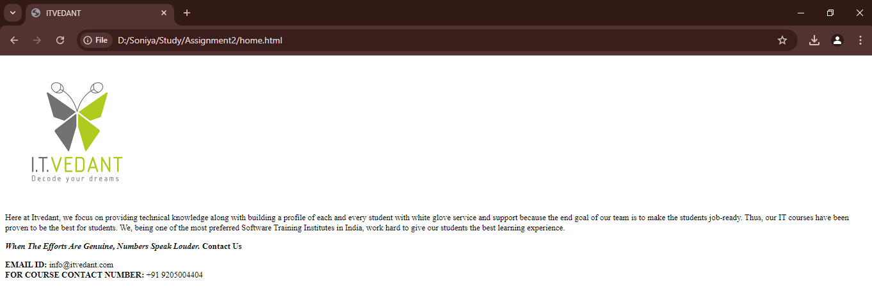

* home.html - Code

<html lang="en">

<head>

<meta charset="UTF-8">

<meta name="viewport" content="width=device-width, initial-scale=1.0">

<title>ITVEDANT</title>

</head>

<body style="font-family: monotype corsiva; font-size: small;">

<a href="https://www.itvedant.com/" target="_blank">

<img src="itvedant.png" />

</a>

<p>

Here at Itvedant, we focus on providing technical knowledge along with building a profile of each and every student with white glove service and support because the end goal of our team is to make the students job-ready. Thus, our IT courses have been proven to be the best for students. We, being one of the most preferred Software Training Institutes in India, work hard to give our students the best learning experience.

</p>

<p style="text-transform: capitalize; font-weight: bold;">

<i>When the Efforts are genuine, Numbers speak louder.</i> Contact Us

</p>

<span>

<b>EMAIL ID: </b>info@itvedant.com <br />

<b>FOR COURSE CONTACT NUMBER: </b>+91 9205004404

</span>

</body>

</html>

1. **Design Web page as shown Below.**

* Output

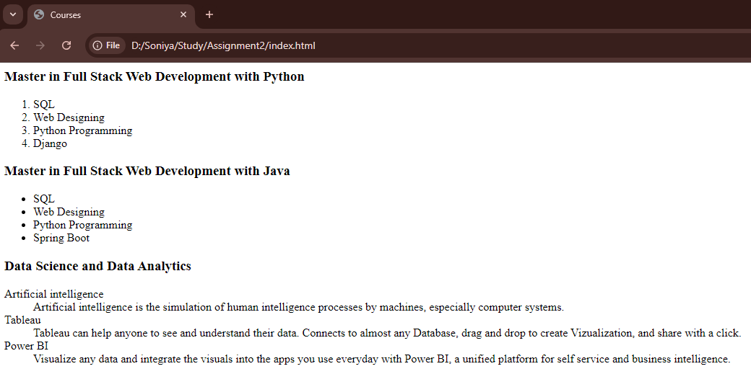

* index.html - Code

<html lang="en">

<head>

<meta charset="UTF-8">

<meta name="viewport" content="width=device-width, initial-scale=1.0">

<title>Courses</title>

</head>

<body>

<h3>Master in Full Stack Web Development with Python</h3>

<ol>

<li>SQL</li>

<li>Web Designing</li>

<li>Python Programming </li>

<li>Django</li>

</ol>

<h3>Master in Full Stack Web Development with Java</h3>

<ul>

<li>SQL</li>

<li>Web Designing</li>

<li>Python Programming </li>

<li>Spring Boot</li>

</ul>

<h3>Data Science and Data Analytics</h3>

<dl>

<dt>Artificial intelligence</dt>

<dd>

Artificial intelligence is the simulation of human intelligence processes by machines, especially computer systems.

</dd>

<dt>Tableau</dt>

<dd>

Tableau can help anyone to see and understand their data. Connects to almost any Database, drag and drop to create Vizualization, and share with a click.

</dd>

<dt>Power BI</dt>

<dd>

Visualize any data and integrate the visuals into the apps you use everyday with Power BI, a unified platform for self service and business intelligence.

</dd>

</dl>

</body>

</html>

1. **What is the use of target attribute in anchor tag?**

The target attribute in the <a> (anchor) tag specifies where to open the linked document or resource. It controls the behavior of the link when it is clicked, determining whether the linked content should open in the same window, a new tab, or a specific frame.

* **target="_self":** Opens in the same window or frame (default behavior).

<a href="https://www.example.com" target="_self">Visit Example</a>

* **target="_blank":** Opens in a new window or tab.

<a href="https://www.example.com" target="_blank">Visit Example</a>

* **target="_parent":** Opens in the parent frame.

<a href="https://www.example.com" target="_parent">Visit Example</a>

* **target="_top":** Opens in the full browser window, breaking out of any frames.

<a href="https://www.example.com" target="_top">Visit Example</a>

* **Custom Frame Name:** Opens in a named frame or window.

<a href="https://www.example.com" target="myFrame">Visit Example</a>

1. **What is the use of alt attribute in image tag?**

The alt attribute in the <img> tag is used to provide alternative text for an image. This text serves several important purposes:

* **Accessibility**
* **Context for Non-Loading Images**
* **SEO (Search Engine Optimization)**
* **Improved User Experience**

<img src="logo.png" alt="Company Logo">