**SONIYA KAMBLE – Assignment 3**

1. **What is the difference between semantic and non-semantic elements. Explain it with example.**

* In HTML, semantic elements are those that clearly describe their meaning in a human- and machine-readable way, both for the browser and developers. They tell both the browser and the developer what kind of content is inside them. However, non-semantic elements do not convey any information about their content.

### **Semantic Elements**

1. These elements define the structure and the purpose of the content in the document. They help search engines and assistive technologies like screen readers understand the content better, improving accessibility and SEO.
2. Examples of semantic elements:
3. <header>: Defines the header section of a document.
4. <nav>: Represents a section with navigation links.
5. <article>: Specifies independent, self-contained content.
6. <section>: Defines a section in a document.
7. <footer>: Represents the footer of a document or a section.

#### ***Example:***

<header>

<h1>Website Title</h1>

<nav>

<ul>

<li><a href="#home">Home</a></li>

<li><a href="#about">About</a></li>

<li><a href="#contact">Contact</a></li>

</ul>

</nav>

</header>

<section>

<article>

<h2>Blog Post Title</h2>

<p>This is a blog post content.</p>

</article>

</section>

<footer>

<p>&copy; 2024 Website Name</p>

</footer>

In this example, elements like <header>, <nav>, <article>, <section>, and <footer> are semantic, clearly indicating their roles.

### **Non-Semantic Elements**

These elements do not describe the content meaningfully. They are typically used for styling or layout purposes, and they don't convey any structural meaning to the content.

#### ***Examples of non-semantic elements:***

* <div>: A generic container for content.
* <span>: Used to group inline elements.

#### ***Example:***

<div>

<span>Website Title</span>

<div>

<a href="#home">Home</a>

<a href="#about">About</a>

<a href="#contact">Contact</a>

</div>

</div>

In this case, the <div> and <span> elements are used purely for structure or layout, without providing any additional meaning about the content.

#### ***Key Differences***

* Semantic elements provide meaning to the structure and content (e.g., <header>, <nav>, <footer>).
* Non-semantic elements are used mainly for layout or styling without providing any meaning (e.g., <div>, <span>).

1. **Create a table and add content inside it as shown by using the appropriate formatting tags.**

* Output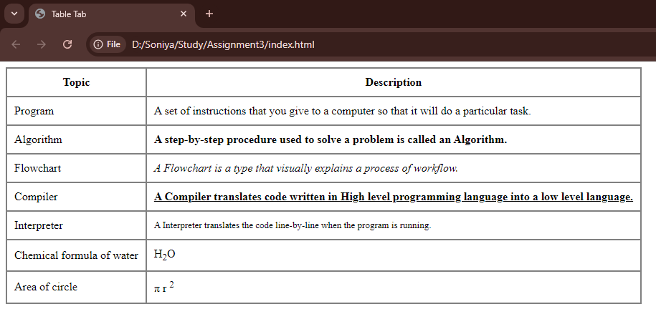
* Html Code:

<html lang="en"></html>

<head>

<meta charset="UTF-8">

<meta name="viewport" content="width=device-width, initial-scale=1.0">

<title>Table Tab</title>

</head>

<body>

<table style="border-collapse: collapse; border-spacing: 10px; border: 2px solid grey;" cellsp>

<thead>

<tr>

<th style="border: 2px solid grey;padding: 10px;">Topic</th>

<th style="border: 2px solid grey;padding: 10px;">Description</th>

</tr>

</thead>

<tbody>

<tr>

<td style="border: 2px solid grey;padding: 10px;">

Program

</td>

<td style="border: 2px solid grey;padding: 10px;">

A set of instructions that you give to a computer so that it will do a particular task.

</td>

</tr>

<tr>

<td style="border: 2px solid grey;padding: 10px;">

Algorithm

</td>

<td style="font-weight: bold; border: 2px solid grey;padding: 10px;">

A step-by-step procedure used to solve a problem is called an Algorithm.

</td>

</tr>

<tr>

<td style="border: 2px solid grey;padding: 10px;">

Flowchart

</td>

<td style="font-style: italic; border: 2px solid grey;padding: 10px;">

A Flowchart is a type that visually explains a process of workflow.

</td>

</tr>

<tr>

<td style="border: 2px solid grey;padding: 10px;">

Compiler

</td>

<td style="text-decoration: underline;font-weight: bold;border: 2px solid grey;padding: 10px;">

A Compiler translates code written in High level programming language into a low level language.

</td>

</tr>

<tr>

<td style="border: 2px solid grey;padding: 10px;">

Interpreter

</td>

<td style="font-size: small;border: 2px solid grey;padding: 10px;">

A Interpreter translates the code line-by-line when the program is running.

</td>

</tr>

<tr>

<td style="border: 2px solid grey;padding: 10px;">

Chemical formula of water

</td>

<td style="border: 2px solid grey;padding: 10px;">

H<sub>2</sub>O

</td>

</tr>

<tr>

<td style="border: 2px solid grey;padding: 10px;">

Area of circle

</td>

<td style="border: 2px solid grey;padding: 10px;">

&pi; r <sup>2</sup>

</td>

</tr>

</tbody>

</table>

</body>

</html>

**2. Design Sign Up form as shown Below.**

* Output:

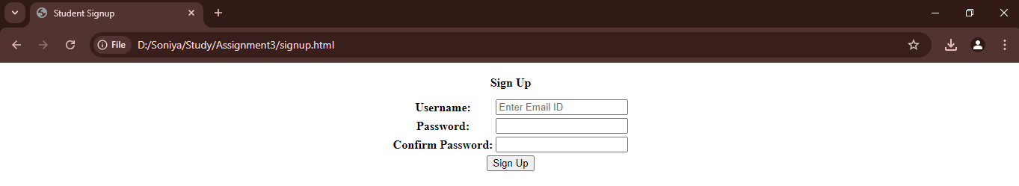Html Code:

<html lang="en"></html>

<head>

<meta charset="UTF-8">

<meta name="viewport" content="width=device-width, initial-scale=1.0">

<title>Student Signup</title>

</head>

<body>

<form method="POST" enctype="multipart/form-data">

<table align="center">

<caption style="caption-side: top; font-weight: bold; margin: 10px; text-align: center; ">Sign Up</caption>

<tbody>

<tr>

<th align="center"><label for="email">Username: </label></th>

<td>

<input type="email" id="email" placeholder="Enter Email ID" required>

</td>

</tr>

<tr>

<th align="center"><label for="password"></label>Password: </label></th>

<td>

<input type="password" id="password" required>

</td>

</tr>

<tr>

<th align="center"><label for="cpassword"></label>Confirm Password: </label></th>

<td>

<input type="password" id="cpassword" required>

</td>

</tr>

<tr>

<th align="center" colspan="2">

<input type="submit" id="submit" value="Sign Up">

</th>

</tr>

</tbody>

</table>

</form>

</body>

</html>

**3. Design a Sign In Page as shown Below.**

* Output:

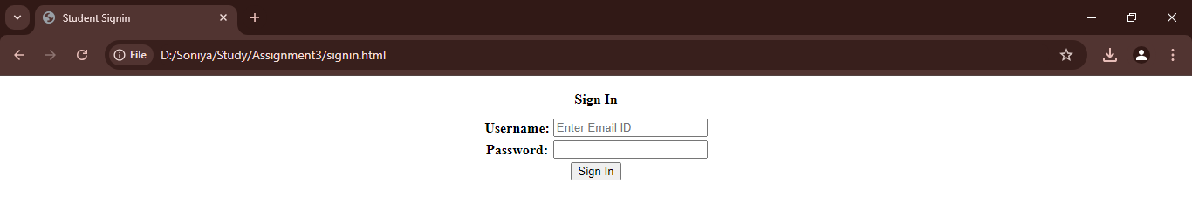

* Html Code:

<html lang="en"></html>

<head>

<meta charset="UTF-8">

<meta name="viewport" content="width=device-width, initial-scale=1.0">

<title>Student Signin</title>

</head>

<body>

<form method="POST" enctype="multipart/form-data">

<table align="center">

<caption style="caption-side: top; font-weight: bold; margin: 10px; text-align: center; ">Sign In</caption>

<tbody>

<tr>

<th align="center"><label for="email">Username: </label></th>

<td>

<input type="email" id="email" placeholder="Enter Email ID" required>

</td>

</tr>

<tr>

<th align="center"><label for="password"></label>Password: </label></th>

<td>

<input type="password" id="password" required>

</td>

</tr>

<tr>

<th align="center" colspan="2">

<input type="submit" id="submit" value="Sign In">

</th>

</tr>

</tbody>

</table>

</form>

</body>

</html>

**4. Create a Profile Page as shown in the image.**

* Output:

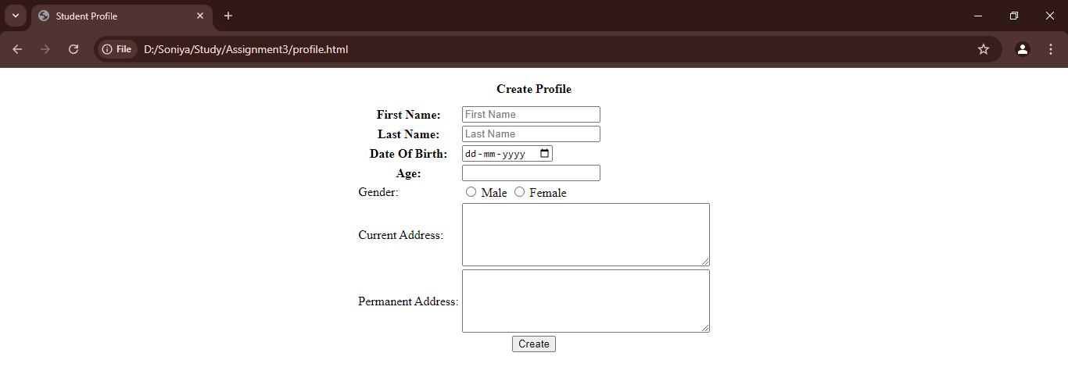

* Html Code:

<html lang="en"></html>

<head>

<meta charset="UTF-8">

<meta name="viewport" content="width=device-width, initial-scale=1.0">

<title>Student Profile</title>

</head>

<body>

<form method="POST" enctype="multipart/form-data">

<table align="center">

<caption style="caption-side: top; font-weight: bold; margin: 10px; text-align: center; ">Create Profile</caption>

<tbody>

<tr>

<th align="center"><label for="fname">First Name: </label></th>

<td>

<input type="text" id="fname" placeholder="First Name" required>

</td>

</tr>

<tr>

<th align="center"><label for="lname">Last Name: </label></th>

<td>

<input type="text" id="lname" placeholder="Last Name" required>

</td>

</tr>

<tr>

<th align="center"><label for="dob">Date Of Birth: </label></th>

<td>

<input type="date" id="dob" name="dob" required />

</td>

</tr>

<tr>

<th align="center"><label for="age">Age: </label></th>

<td>

<input type="number" id="age" required>

</td>

</tr>

<tr>

<td><label for="gender">Gender: </label></td>

<td><input type="radio" id="male" name="gender" value="M" required /> <label for="male"> Male </label>

<input type="radio" id="female" name="gender" value="F" required /> <label for="female"> Female </label>

</td>

</tr>

<tr>

<td><label for="c_add">Current Address:</label></td>

<td><textarea name="c_add" id="c_add" cols="40" rows="5"></textarea></td>

</tr>

<tr>

<td><label for="p_add">Permanent Address:</label></td>

<td><textarea name="p_add" id="p_add" cols="40" rows="5"></textarea></td>

</tr>

<tr>

<th align="center" colspan="2">

<input type="submit" id="submit" value="Create">

</th>

</tr>

</tbody>

</table>

</form>

</body>

</html>