**SONIYA KAMBLE – Assignment 7**

1. **Design a responsive ecommerce webpage similar to the image shown below.**
   * Index.html code

<html lang="en">

<head>

<meta charset="UTF-8">

<meta name="viewport" content="width=device-width, initial-scale=1.0">

<title>ITCART</title>

<link href="assets/css/bootstrap.min.css" rel="stylesheet" />

<link href="assets/css/style.css" rel="stylesheet" />

<link rel="stylesheet" href="https://cdn.jsdelivr.net/npm/bootstrap-icons@1.11.3/font/bootstrap-icons.min.css">

</head>

<body>

<script src="assets/js/bootstrap.min.js"></script>

<script src="assets/js/bootstrap.bundle.min.js"></script>

<nav class="navbar navbar-expand-sm bg-dark navbar-dark fixed-top">

<div class="container-fluid">

<a class="navbar-brand active" href="index.html">ITCART</a>

<button class="navbar-toggler" type="button" data-bs-toggle="collapse" data-bs-target="#navbarSupportedContent" aria-controls="navbarSupportedContent" aria-expanded="false" aria-label="Toggle navigation">

<span class="navbar-toggler-icon"></span>

</button>

<div class="collapse navbar-collapse" id="navbarSupportedContent">

<ul class="navbar-nav me-auto mb-2 mb-lg-0">

<li class="nav-item">

<a class="nav-link active" aria-current="page" href="index.html">Home</a>

</li>

<li class="nav-item">

<a class="nav-link" href="about.html">About Us</a>

</li>

<li class="nav-item">

<a class="nav-link" href="contact.html">Contact</a>

</li>

<li class="nav-item dropdown">

<a class="nav-link dropdown-toggle" href="#" id="navbarDropdown" role="button" data-bs-toggle="dropdown" aria-expanded="false">

Account

</a>

<ul class="dropdown-menu" aria-labelledby="navbarDropdown">

<li><a class="dropdown-item" href="login.html">Login</a></li>

<li><a class="dropdown-item" href="register.html">Register</a></li>

</ul>

</li>

</ul>

<form class="d-flex pt-2">

<input class="form-control me-2" type="search" placeholder="Search" aria-label="Search">

<button class="btn btn-primary" type="submit">Search</button>

</form>

</div>

</div>

</nav>

<!--Header End-->

<!--Main content start-->

<div class="container mt-4">

<div class="row">

<!-- Vertical Menu -->

<div class="col-md-3">

<h5 id="home-tab" href="#home">Categories Available</h5>

<hr>

<ul class="nav flex-column">

<li class="nav-item">

<a class="nav-link active" id="laptop-tab" href="#laptop">Laptops</a>

</li>

<li class="nav-item">

<a class="nav-link active" id="pc-tab" href="#pc">Personal Computers</a>

</li>

<li class="nav-item">

<a class="nav-link active" id="tabs-tab" href="#tabs">Tablet</a>

</li>

<li class="nav-item">

<a class="nav-link active" id="headphone-tab" href="#headphone">Headphones</a>

</li>

</ul>

</div>

<!-- Content Section -->

<div class="col-md-9">

<div class="tab-content">

<!-- Home Content -->

<div class="tab-pane fade show active" id="home">

<span><h5>India's leading and trusted tech paradise -</h5></span> <span><h4>ITCART</h4></span>

<p>This year’s nasscom's Strategic Review report focuses on the theme “Priming for a ‘No Normal’ Future” and explores details about the Indian tech industry’s resilience and growth in the wake of global uncertainty and how the industry strengthened its position as a trusted global technology leader over the past two years.

The report analyses in detail the major trends, segments and strategies that defined and further strengthened the fundamentals of the technology industry in FY2023. Key emerging tech bets which are at an inflection point of commercial adoption are also explored based on investment and IP focus. The report has crisp fact sheets on the industry’s value proposition that hinges upon a diverse ecosystem, young and high-quality talent pool, excellent physical and digital infrastructure, vibrant domestic market, and strong Government support.

However, the VUCA world continues to exist, and we are witness to a “No Normal Future”. Therefore, while enterprises may continue to focus on digital transformation, cost takeout and optimization requirements are also in demand given the macro environment. The final chapter discusses in details, the playbook to thrive in a “No Normal” future.</p>

</div>

<!-- Home Content -->

<div class="tab-pane fade" id="laptop">

<h2>Laptops</h2>

<p>Welcome to the homepage. Here is some introductory content.</p>

</div>

<!-- About Content -->

<div class="tab-pane fade" id="pc">

<h2>Personal Computers</h2>

<p>This is the about section. Learn more about us here.</p>

</div>

<!-- Services Content -->

<div class="tab-pane fade" id="tabs">

<h2>Tablet</h2>

<p>Here are the services we offer.</p>

</div>

<!-- Contact Content -->

<div class="tab-pane fade" id="headphone">

<h2>Headphones</h2>

<p>Get in touch with us through the contact page.</p>

</div>

</div>

</div>

</div>

<div class="row pt-4">

<!-- Vertical Menu -->

<div class="col-md-3">

<h5 id="rv-tab" href="#rv">Reviews</h5>

<hr>

<ul class="nav flex-column">

<li class="nav-item">

<a class="nav-link" id="srv-tab" href="#srv">For Services</a>

</li>

<li class="nav-item">

<a class="nav-link" id="prod-tab" href="#prod">For Products</a>

</li>

<li class="nav-item">

<a class="nav-link" id="cons-tab" href="#cons">For Consultation</a>

</li>

</ul>

</div>

<!-- Content Section -->

<div class="col-md-9">

<div class="tab-content">

<!-- Reviews Content -->

<div class="tab-pane fade show" id="rv">

Reviews

</div>

<!-- For Services Content -->

<div class="tab-pane fade" id="srv">

For Services

</div>

<!-- For Products Content -->

<div class="tab-pane fade" id="prod">

For Products

</div>

<!-- For Consultation Content -->

<div class="tab-pane fade" id="cons">

For Consultation

</div>

</div>

</div>

</div>

</div>

<!--Main content end-->

<!--Footer start-->

<nav class="navbar fixed-bottom navbar-light bg-light">

<div class="col-3 bd-highlight"></div>

<div class="col-3 bd-highlight">

<h6>ITVEDANT EDUCATION PVT LTD:</h6></br>

<b>3<sup>rd</sup> floor, Korem Mall,</br>

Near Toyota Showroom</br>

Road No 22, Wagle Estate</br>

Thane-West</b>

</div>

<div class="col-3 bd-highlight">

<h6>Quick Link</h6></br>

<b><a href="index.html" style="text-decoration: none;">Home</a></b></br>

<b><a href="about.html" style="text-decoration: none;">About Us</a></b></br>

<b><a href="#" style="text-decoration: none;">Courses</a></b></br>

<b><a href="#" style="text-decoration: none;">Placements</a></b></br>

</div>

<div class="col-3 bd-highlight">

<h6>Connect us</h6></br>

<i class="bi bi-facebook p-2"></i></br>

<i class="bi bi-instagram p-2"></i></br>

<i class="bi bi-linkedin p-2"></i></br>

<i class="bi bi-twitter p-2"></i></br>

</div>

</nav>

<!--Footer end-->

</div> <!--Container Div-->

</body>

</html>

* Output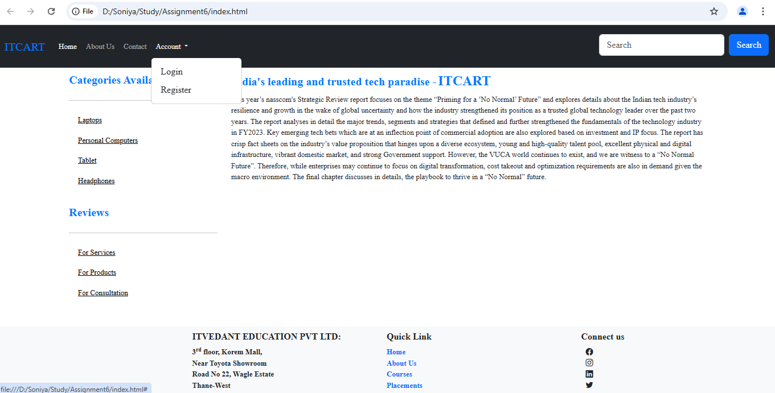

1. **Create. a Registration page and Login Page with respect to previous assignment as shown in below image.**

***Login Page:***

* + Index.html code

<html lang="en">

<head>

<meta charset="UTF-8">

<meta name="viewport" content="width=device-width, initial-scale=1.0">

<title>Login - Nykaa.com - Buy Cosmetics Products & Beauty Products Online in India at Best ..nykaa.com</title>

<link href="assets/css/bootstrap.min.css" rel="stylesheet" />

<link href="assets/css/style.css" rel="stylesheet" />

<link rel="stylesheet" href="https://cdn.jsdelivr.net/npm/bootstrap-icons@1.11.3/font/bootstrap-icons.min.css">

</head>

<body>

<script src="assets/js/bootstrap.min.js"></script>

<script src="assets/js/bootstrap.bundle.min.js"></script>

<nav class="navbar navbar-expand-sm bg-dark navbar-dark fixed-top">

<div class="container-fluid">

<a class="navbar-brand active" href="index.html">ITCART</a>

<button class="navbar-toggler" type="button" data-bs-toggle="collapse" data-bs-target="#navbarSupportedContent" aria-controls="navbarSupportedContent" aria-expanded="false" aria-label="Toggle navigation">

<span class="navbar-toggler-icon"></span>

</button>

<div class="collapse navbar-collapse" id="navbarSupportedContent">

<ul class="navbar-nav me-auto mb-2 mb-lg-0">

<li class="nav-item">

<a class="nav-link active" aria-current="page" href="index.html">Home</a>

</li>

<li class="nav-item">

<a class="nav-link" href="about.html">About Us</a>

</li>

<li class="nav-item">

<a class="nav-link" href="contact.html">Contact</a>

</li>

<li class="nav-item dropdown">

<a class="nav-link dropdown-toggle" href="#" id="navbarDropdown" role="button" data-bs-toggle="dropdown" aria-expanded="false">

Account

</a>

<ul class="dropdown-menu" aria-labelledby="navbarDropdown">

<li><a class="dropdown-item" href="login.html">Login</a></li>

<li><a class="dropdown-item" href="register.html">Register</a></li>

</ul>

</li>

</ul>

<form class="d-flex pt-2">

<input class="form-control me-2" type="search" placeholder="Search" aria-label="Search">

<button class="btn btn-primary" type="submit">Search</button>

</form>

</div>

</div>

</nav>

<!--Header End-->

<!--Main content start-->

<div class="container">

<div class="row">

<div class="col-md-4 shadow mt-4 mx-auto">

<center><h4>Login</h4></center>

<form>

<div class="mb-3">

<label for="Input1" class="form-label">Username:</label>

<input type="email" class="form-control" id="Input1" placeholder="Enter Username">

</div>

<div class="mb-3">

<label for="Input2" class="form-label">Password:</label>

<input type="password" class="form-control" id="Input2">

</div>

<div class="mb-3">

<input type="submit" class="btn btn-primary" id="Input3" value="Login">

</div>

<div class="mb-3">

<span>Not a user? <a href="register.html">Register</a></span>

</div>

</form>

</div>

</div>

</div>

<!--Footer start-->

<nav class="navbar fixed-bottom navbar-light bg-light">

<div class="col-3 bd-highlight"></div>

<div class="col-3 bd-highlight">

<h6>ITVEDANT EDUCATION PVT LTD:</h6></br>

<b>3<sup>rd</sup> floor, Korem Mall,</br>

Near Toyota Showroom</br>

Road No 22, Wagle Estate</br>

Thane-West</b>

</div>

<div class="col-3 bd-highlight">

<h6>Quick Link</h6></br>

<b><a href="index.html" style="text-decoration: none;">Home</a></b></br>

<b><a href="about.html" style="text-decoration: none;">About Us</a></b></br>

<b><a href="#" style="text-decoration: none;">Courses</a></b></br>

<b><a href="#" style="text-decoration: none;">Placements</a></b></br>

</div>

<div class="col-3 bd-highlight">

<h6>Connect us</h6></br>

<i class="bi bi-facebook p-2"></i></br>

<i class="bi bi-instagram p-2"></i></br>

<i class="bi bi-linkedin p-2"></i></br>

<i class="bi bi-twitter p-2"></i></br>

</div>

</nav>

<!--Footer end-->

</div> <!--Container Div-->

</body>

</html>

* + Output

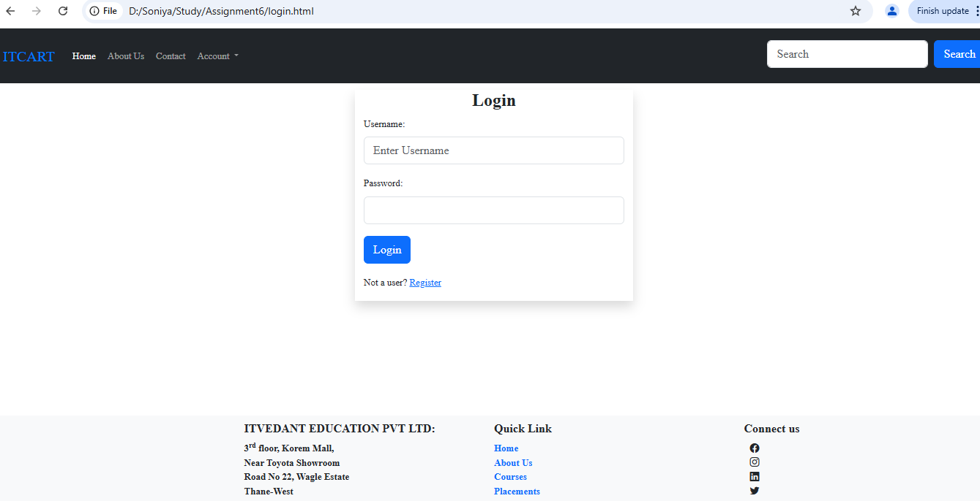

***Registration Page:***

* + Index.html code

<html lang="en">

<head>

<meta charset="UTF-8">

<meta name="viewport" content="width=device-width, initial-scale=1.0">

<title>Registration - Nykaa.com - Buy Cosmetics Products & Beauty Products Online in India at Best ..nykaa.com</title>

<link href="assets/css/bootstrap.min.css" rel="stylesheet" />

<link href="assets/css/style.css" rel="stylesheet" />

<link rel="stylesheet" href="https://cdn.jsdelivr.net/npm/bootstrap-icons@1.11.3/font/bootstrap-icons.min.css">

</head>

<body>

<script src="assets/js/bootstrap.min.js"></script>

<script src="assets/js/bootstrap.bundle.min.js"></script>

<nav class="navbar navbar-expand-sm bg-dark navbar-dark fixed-top">

<div class="container-fluid">

<a class="navbar-brand active" href="index.html">ITCART</a>

<button class="navbar-toggler" type="button" data-bs-toggle="collapse" data-bs-target="#navbarSupportedContent" aria-controls="navbarSupportedContent" aria-expanded="false" aria-label="Toggle navigation">

<span class="navbar-toggler-icon"></span>

</button>

<div class="collapse navbar-collapse" id="navbarSupportedContent">

<ul class="navbar-nav me-auto mb-2 mb-lg-0">

<li class="nav-item">

<a class="nav-link active" aria-current="page" href="index.html">Home</a>

</li>

<li class="nav-item">

<a class="nav-link" href="about.html">About Us</a>

</li>

<li class="nav-item">

<a class="nav-link" href="contact.html">Contact</a>

</li>

<li class="nav-item dropdown">

<a class="nav-link dropdown-toggle" href="#" id="navbarDropdown" role="button" data-bs-toggle="dropdown" aria-expanded="false">

Account

</a>

<ul class="dropdown-menu" aria-labelledby="navbarDropdown">

<li><a class="dropdown-item" href="login.html">Login</a></li>

<li><a class="dropdown-item" href="register.html">Register</a></li>

</ul>

</li>

</ul>

<form class="d-flex pt-2">

<input class="form-control me-2" type="search" placeholder="Search" aria-label="Search">

<button class="btn btn-primary" type="submit">Search</button>

</form>

</div>

</div>

</nav>

<!--Header End-->

<!--Main content start-->

<div class="container">

<div class="row">

<div class="col-md-4 shadow mt-4 mx-auto">

<center><h4>Registration</h4></center>

<form>

<div class="mb-3">

<label for="Input1" class="form-label">Username:</label>

<input type="text" class="form-control" id="Input1" placeholder="Enter Username">

</div>

<div class="mb-3">

<label for="Input2" class="form-label">Username:</label>

<input type="email" class="form-control" id="Input2" placeholder="Enter a valid email address">

</div>

<div class="mb-3">

<label for="Input3" class="form-label">Password:</label>

<input type="password" class="form-control" id="Input3">

</div>

<div class="mb-3">

<label for="Input4" class="form-label">Confirm Password:</label>

<input type="password" class="form-control" id="Input4">

</div>

<div class="mb-3">

<input type="submit" class="btn btn-primary" id="Input5" value="Register">

</div>

<div class="mb-3">

<span>Already user? <a href="login.html">Login</a></span>

</div>

</form>

</div>

</div>

<!--Footer start-->

<nav class="navbar fixed-bottom navbar-light bg-light">

<div class="col-3 bd-highlight"></div>

<div class="col-3 bd-highlight">

<h6>ITVEDANT EDUCATION PVT LTD:</h6></br>

<b>3<sup>rd</sup> floor, Korem Mall,</br>

Near Toyota Showroom</br>

Road No 22, Wagle Estate</br>

Thane-West</b>

</div>

<div class="col-3 bd-highlight">

<h6>Quick Link</h6></br>

<b><a href="index.html" style="text-decoration: none;">Home</a></b></br>

<b><a href="about.html" style="text-decoration: none;">About Us</a></b></br>

<b><a href="#" style="text-decoration: none;">Courses</a></b></br>

<b><a href="#" style="text-decoration: none;">Placements</a></b></br>

</div>

<div class="col-3 bd-highlight">

<h6>Connect us</h6></br>

<i class="bi bi-facebook p-2"></i></br>

<i class="bi bi-instagram p-2"></i></br>

<i class="bi bi-linkedin p-2"></i></br>

<i class="bi bi-twitter p-2"></i></br>

</div>

</nav>

<!--Footer end-->

</div> <!--Container Div-->

</body>

</html>

* + Output

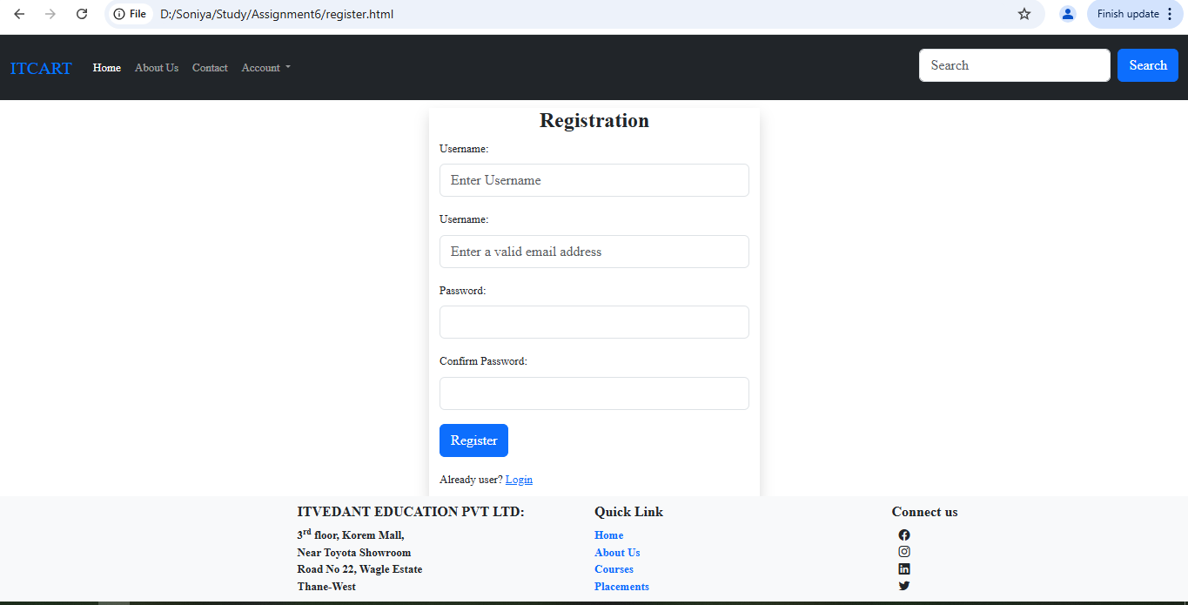

1. **Design the following footer by using bootstrap as shown in the below image.**
   * FooterHTML code

<!--Footer start-->

<nav class="navbar fixed-bottom navbar-light bg-light">

<div class="col-3 bd-highlight"></div>

<div class="col-3 bd-highlight">

<h6>ITVEDANT EDUCATION PVT LTD:</h6></br>

<b>3<sup>rd</sup> floor, Korem Mall,</br>

Near Toyota Showroom</br>

Road No 22, Wagle Estate</br>

Thane-West</b>

</div>

<div class="col-3 bd-highlight">

<h6>Quick Link</h6></br>

<b><a href="index.html" style="text-decoration: none;">Home</a></b></br>

<b><a href="about.html" style="text-decoration: none;">About Us</a></b></br>

<b><a href="#" style="text-decoration: none;">Courses</a></b></br>

<b><a href="#" style="text-decoration: none;">Placements</a></b></br>

</div>

<div class="col-3 bd-highlight">

<h6>Connect us</h6></br>

<i class="bi bi-facebook p-2"></i></br>

<i class="bi bi-instagram p-2"></i></br>

<i class="bi bi-linkedin p-2"></i></br>

<i class="bi bi-twitter p-2"></i></br>

</div>

</nav>

<!--Footer end-->

* + Output

