Program 7:

<?php

$last_visited_time=time();

setcookie('last_visited',$last_visited_time,tim e()+3600);

if(isset($_COOKIE['last_visited']))

{ $last_visited=$_COOKIE['last_visited']; date_default_timezone_set("Asia/Kolkata");

$current_time=date('y-m-d H:i:s'); else

{ $last_visited_date="unknown"; } ?>

<!DOCTYPE html>

<html>

<head>

<title>COLLEGE HOMEPAGE</title>

<style> body {

background-color: #ef6; margin:0; }

.header1 { display:flex; color: white;

background-color: grey; padding: 5px; }

ul { display:flex; }li { list-style:none; padding:0 15px; }

.headlist {

text-decoration:none; font-size:20px; }

.mainclass { background-

image:url("https://getmyuni.azureedge.net/co llege-image/big/psg-college-of-arts-and- science-psgcas-coimbatore.jpg");

background-repeat:no_repeat; background-size:cover;

height:630px; text-align:center;

} .lastvisit { color:red; }

.contact{

text-align:left; padding-left: 15px; padding-top: 15px;

}

.Footerdetails{ background-color:yellow; height:50px;

}

</style>

</head>

<body>

<header class="header1">

<img

src="https://ecampus.psgtech.ac.in/Images/P SG.png">

<h3><marquee behavior="alternate">PSG COLLEGE OF ARTS &

SCIENCE</marquee></h3>

<nav>

<ul>

<li><a class="headlist" href="login.php" style="color:yellow">Admissions</a></li>

<li><a class="headlist" href="#"

style="color:yellow">Home</a></li>

<li><a class="headlist" href="#"

style="color:yellow">Programs</a></li>

<li><a class="headlist" href="#"

style="color:yellow">Exams</a></li>

<li><a class="headlist" href="#"

style="color:yellow">Placement</a></li>

<li><a class="headlist" href="#"

style="color:yellow">About</a></li>

</ul>

</nav>

</header>

<main class="mainclass">

<br><br>

<h2>WELCOME TO PSG COLLEGE OF ARTS & SCIENCE</h2>

<p><b>Explore our wide range of academic progress, state_of_the_art facilities and

diverse students community.</b></p>

<p class="lastvisit"><b><em>Your last visited on this page on <?php echo $current_time;

?></em></b></p>

<audio autoplay loop>

<source src="background_music.mp3" type="audio/mpeg">

Your browser does not support the audio element.

</audio>

<img src="animated_logo.gif" alt="College Logo" width="150">

</main>

<div class="Footerdetails">

<p class="contact"> Contact:04212485678

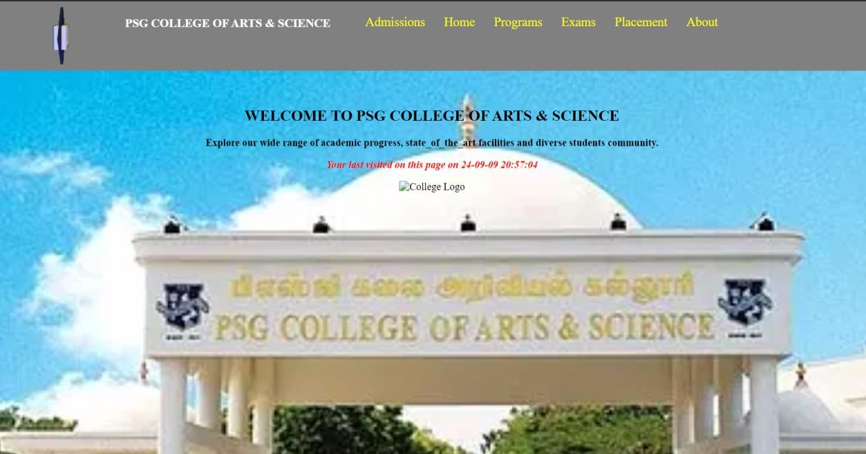

<?php

date_default_timezone_set("Asia/Kolkata");

$lastVisited = date("Y-m-d H:i:s");

?>

<!DOCTYPE html>

<html>

<head>

<title>PSG College of Arts & Science</title>

<style>

body {

margin: 0;

font-family: Arial, sans-serif;

}

.navbar {

background-color: #555;

padding: 10px;

color: white;

}

.navbar a {

color: yellow;

margin: 0 15px;

text-decoration: none;

}

.navbar a:hover {

color: white;

}

.content {

text-align: center;

padding: 20px;

}

img {

width: 80%;

max-width: 700px;

margin-top: 20px;

}

</style>

</head>

<body>

<div class="navbar">

<strong>PSG COLLEGE OF ARTS & SCIENCE</strong>

<a href="index.php">Home</a>

<a href="about.php">About</a>

<a href="programmes.php">Programs</a>

<a href="exams.php">Exams</a>

<a href="placement.php">Placement</a>

</div>

<div class="content">

<h2>WELCOME TO PSG COLLEGE OF ARTS & SCIENCE</h2>

<p>Explore our wide range of academic programs, state-of-the-art facilities and diverse student community.</p>

<p style="color: red;">Your last visited on this page on <?php echo $lastVisited; ?></p>

<img src="college.jpg" alt="College Logo">

</div>

</body>

</html>

**Sample about.php**

<!DOCTYPE html>

<html>

<head>

<title>About - PSG College</title>

</head>

<body>

<div class="navbar">

<strong>PSG COLLEGE OF ARTS & SCIENCE</strong>

<a href="index.php">Home</a>

<a href="about.php">About</a>

<a href="programmes.php">Programs</a>

<a href="exams.php">Exams</a>

<a href="placement.php">Placement</a>

</div>

<div class="content">

<h2>About Us</h2>

<p>PSG College of Arts & Science was established in 1947. It is an autonomous institution affiliated with Bharathiar University...</p>

</div>

</body>

</html>