JAR GROWTH INTERN ASSIGNMENT
Sales Performance & Business Insights Report

Submitted By
Sunidhi Shinde
Tools & Technologies Used
- Python
- Pandas
- Matplotlib
- Microsoft Excel
- Microsoft Word
Submission Date
20 July 2026

Table of Contents
- Question 1 – Sales Performance Analysis
  - Part 1 – Sales & Profitability Analysis
  - Part 2 – Target Achievement Analysis
  - Part 3 – Regional Performance Analysis
- Question 2 – Jar App Exploration
- Question 3 – Business Opportunities
- Conclusion

Question 1
Part 1 – Sales and Profitability Analysis
Objective
The objective of this analysis is to understand the company's sales performance across different product categories. The analysis focuses on identifying high-performing categories, measuring profitability, and providing business recommendations based on the available sales data.

Summary Table
(Insert the summary table generated from Python here. It is better to create it as a Word table instead of pasting console output.)
Category | Total Sales | Average Profit | Profit Margin (%)
Clothing | 139054 | 11.76 | 8.03
Electronics | 165267 | 34.07 | 6.35
Furniture | 127181 | 9.46 | 1.81

Key Findings
Top Performing Category
Clothing
The Clothing category achieved the highest profit margin among all categories. Although Electronics generated higher overall sales, Clothing produced better profitability, making it the strongest performing category from a business perspective.
Underperforming Category
Furniture
Furniture generated the lowest profit margin. While the category contributes to total sales, its profitability is comparatively low. This indicates opportunities to improve pricing strategy, supplier costs, or operational efficiency.

Category-wise Total Sales

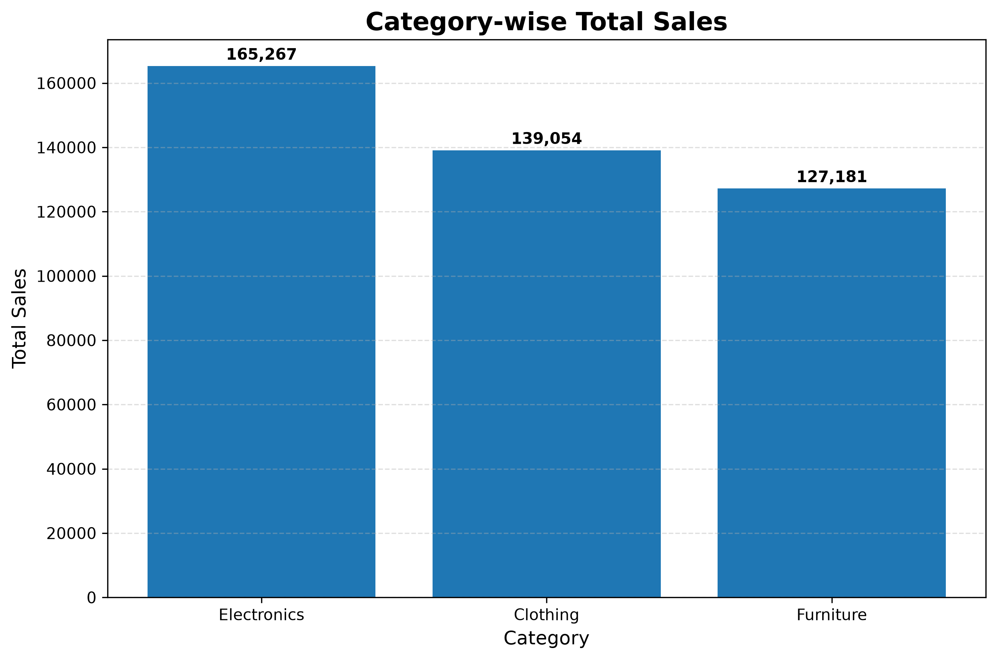

Business Insights
The analysis reveals several important business observations:
- Electronics generated the highest total sales, indicating strong customer demand.
- Clothing delivered the highest profit margin, making it the most profitable category.
- Furniture showed the weakest profitability and requires improvement.
- Increasing inventory for Clothing could improve overall revenue.
- Reviewing Furniture pricing and operational costs may increase profitability.
- Improving Electronics profit margin can further strengthen business performance.

Part 1 Conclusion
The category analysis highlights that sales volume and profitability are not always the same. While Electronics drives the highest revenue, Clothing contributes the strongest profit margin. Business decisions should therefore consider both sales and profitability when planning future growth.

Question 1
Part 2 – Target Achievement Analysis
Objective
The objective of this analysis is to evaluate monthly sales targets for the Furniture category and identify trends in target growth over time.

Monthly Target Summary
Metric | Result
Highest Increase Month | Jul-2026
Highest Increase (%) | 1.89%
Highest Decrease Month | Apr-2026
Highest Decrease (%) | -11.86%
Average Monthly Target | 11,075

Furniture Monthly Target Trend

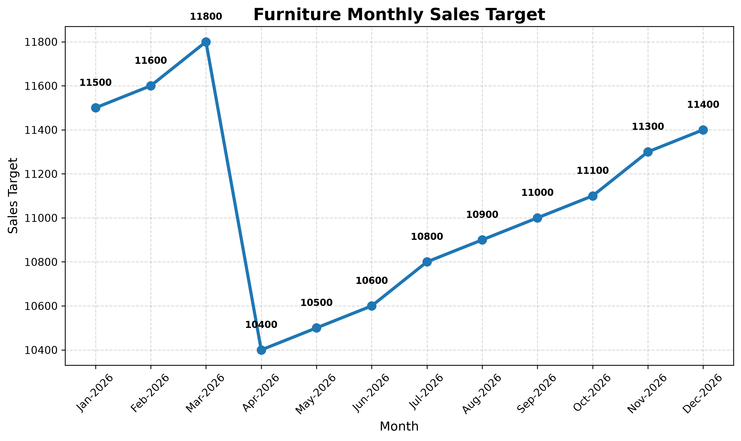

Business Insights
The target analysis provides valuable information about the company's planning strategy.
- Monthly sales targets increase gradually over time.
- The highest month-over-month growth occurred in July 2026.
- April 2026 experienced the largest decline in monthly target growth.
- Overall target planning appears stable and consistent.
- Seasonal demand should be considered while defining future targets.
- Historical performance should be used to create more realistic sales goals.

Part 2 Conclusion
The target trend demonstrates that the company follows a steady growth strategy. Continuous monitoring of monthly performance will help improve forecasting accuracy and support better business planning.

Question 1
Part 3 – Regional Performance Analysis
Objective
The purpose of this analysis is to evaluate sales performance across different states, identify the strongest and weakest regions, and recommend strategies for business improvement.

Regional Performance Summary

State | Order Count | Total Sales | Average Profit
Madhya Pradesh | 101 | 105140 | 16.33
Maharashtra | 90 | 95348 | 21.30
Rajasthan | 32 | 21149 | 16.99
Gujarat | 27 | 21058 | 5.34
Punjab | 25 | 16786 | -10.15

Regional Sales Performance

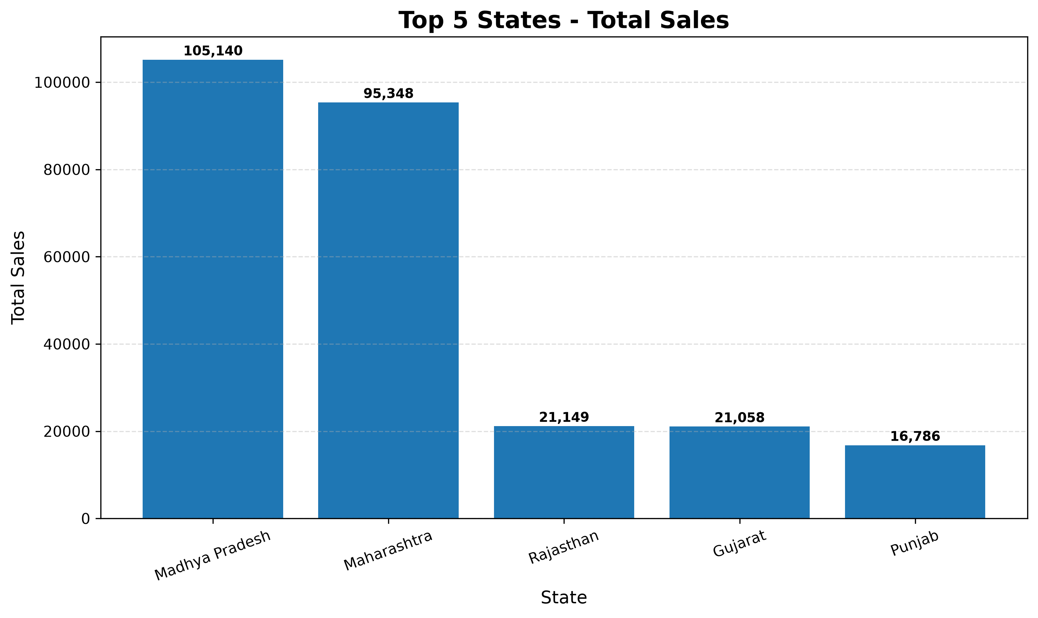

Key Findings
- Madhya Pradesh generated the highest total sales among all selected states.
- Maharashtra maintained strong profitability despite slightly lower sales.
- Rajasthan delivered stable overall performance.
- Gujarat requires improvement in average profitability.
- Punjab recorded the lowest sales and negative average profit.

Business Recommendations
Based on the analysis, the following recommendations are suggested:
- Continue investing in high-performing states such as Madhya Pradesh and Maharashtra.
- Improve pricing strategies and operational efficiency in Punjab.
- Strengthen regional marketing campaigns based on customer demand.
- Optimize inventory allocation according to regional sales performance.
- Monitor profitability regularly to support data-driven decision making.

Part 3 Conclusion
Regional analysis shows significant differences in business performance across states. Focusing on profitable regions while improving weaker markets can help increase overall business growth.

Question 2 – Jar App Exploration
Objective
The objective of this section is to evaluate the Jar application from a user's perspective by identifying its strengths and suggesting practical improvements that can enhance the overall user experience.

About the Jar App
Jar is a micro-saving and digital gold investment platform designed to help users build a saving habit through small daily investments. The application automatically rounds up transactions and invests the spare change in digital gold, making investing simple and accessible for beginners.

Top 5 Features I Liked
1. Simple and User-Friendly Interface
The application has a clean and easy-to-use interface. Navigation is straightforward, making it suitable even for first-time users who have little or no investment experience.

2. Automatic Savings
One of the best features is automatic saving. Instead of requiring users to invest manually every day, the app automatically saves small amounts from daily transactions. This makes saving effortless and encourages financial discipline.

3. Digital Gold Investment
The option to invest in digital gold with very small amounts is an excellent feature. It allows users to start investing without needing a large amount of money.

4. Easy Payment Integration
The application offers a smooth payment process through UPI and other digital payment methods. This makes deposits and investments fast, secure, and convenient.

5. Clear Investment Tracking
Users can easily monitor their savings, investments, and portfolio performance through simple dashboards and visual summaries. This helps users understand their financial progress over time.

Top 5 Improvements I Would Recommend
1. More Investment Options
Currently, the application focuses mainly on digital gold. Adding investment options such as mutual funds, fixed deposits, ETFs, or recurring investment plans would provide users with greater flexibility.

2. Better Financial Insights
The application could offer personalized spending analysis, saving trends, and AI-powered recommendations to help users make better financial decisions.

3. Goal-Based Savings
Users should be able to create financial goals such as buying a vehicle, planning a vacation, or building an emergency fund. Progress tracking toward these goals would make saving more engaging.

4. Educational Content
Adding beginner-friendly articles, short videos, and investment tips would help users improve their financial knowledge and make informed investment decisions.

5. Personalized Notifications
Instead of sending generic reminders, the app could provide personalized notifications based on users' spending habits, savings goals, and investment activity.

Overall Feedback
Overall, I found Jar to be an excellent application for beginners who want to develop a regular saving habit without investing large amounts. The app is simple, easy to use, and provides a smooth investment experience. By introducing additional investment options, personalized financial insights, and goal-based saving features, the application could become even more valuable for a wider range of users.

Question 3 – Business Opportunities for Jar
Objective
The purpose of this section is to propose new business opportunities that can help Jar increase user engagement, improve customer retention, and create additional revenue streams.

Proposed Business Idea
AI-Based Smart Savings and Financial Planning Assistant
I propose introducing an AI-powered financial assistant that helps users automatically plan their savings based on their income, spending habits, and financial goals.
Instead of simply investing spare change into digital gold, the assistant would analyze users' financial behavior and recommend personalized saving strategies.

How It Would Work
The AI assistant would:
- Analyze monthly income and expenses.
- Track spending patterns automatically.
- Predict future expenses using historical data.
- Suggest personalized daily or monthly savings amounts.
- Recommend suitable investment options based on user preferences.
- Send intelligent reminders to help users stay on track with their financial goals.

Key Features
1. Smart Budget Planning
The system would automatically categorize expenses and provide suggestions to improve spending habits.

2. Personalized Saving Goals
Users could create multiple financial goals such as purchasing a vehicle, planning a holiday, buying a laptop, or building an emergency fund. The AI would recommend the required monthly savings for each goal.

3. AI Investment Recommendations
Based on the user's financial profile, the assistant could recommend investment options such as digital gold, mutual funds, recurring deposits, or fixed deposits.

4. Monthly Financial Health Report
Users would receive an easy-to-understand monthly report summarizing income, expenses, savings, investments, and financial progress.

5. Smart Notifications
The application could send personalized reminders such as:
- "You are close to achieving your savings goal."
- "Your spending this month is higher than usual."
- "Investing ₹100 today will help you reach your target faster."
These notifications would encourage consistent saving behavior.

Benefits for Users
- Better financial planning.
- Improved saving habits.
- Personalized investment guidance.
- Clear visibility into financial progress.
- Increased confidence in managing personal finances.

Benefits for Jar
- Higher user engagement.
- Improved customer retention.
- Increased investment activity.
- Stronger customer satisfaction.
- Opportunity to introduce premium subscription services in the future.

Implementation Strategy
The feature can be introduced in three phases:
Phase 1: AI-based spending analysis and budgeting.
Phase 2: Goal-based savings with personalized recommendations.
Phase 3: Advanced AI investment suggestions and automated financial reports.
This phased approach would allow Jar to gradually introduce new functionality while continuously collecting user feedback and improving the overall experience.

Conclusion
Jar has already made investing simple through digital gold and automatic savings. By introducing an AI-powered financial planning assistant, the platform can evolve into a more comprehensive personal finance solution. This feature would improve user experience, encourage long-term financial discipline, and strengthen Jar's competitive position in the digital finance market.

Final Conclusion
This assignment involved analyzing sales performance using Python and Pandas, evaluating the Jar application from a user perspective, and proposing a business enhancement idea.
Through data analysis, important insights were identified regarding product profitability, monthly targets, and regional sales performance. The Jar app review highlighted both its strengths and areas for improvement, while the proposed AI-based financial planning assistant demonstrates how technology can create additional value for both users and the business.
Overall, this assignment reflects analytical thinking, problem-solving ability, and the practical application of data analysis to support business decision-making.

