**Exp No: 3 Date:**

**VIRTUALIZATION**

**INSTALLATION OF VIRTUAL MACHINE IN VIRTUAL BOX**

**AIM:**

To configure a Virtual Machine using Virtual Box and Launch to execute a simple program using C.

**PROCEDURE:**

1. Launch a Virtual Box

2. Create new virtual machine

3. Customize the set-up

4. Set username and password

5. Browse for .iso file of an operating system

6. Configure the hardware capacity

7. Finish and power on the VM

8. Install C, PYTHON OR JAVA Compiler and execute a simple program.

**OUTPUT:**

The virtual machine of Ubuntu OS was created using a virtual box. Ubuntu virtual machine running in Virtual Box.

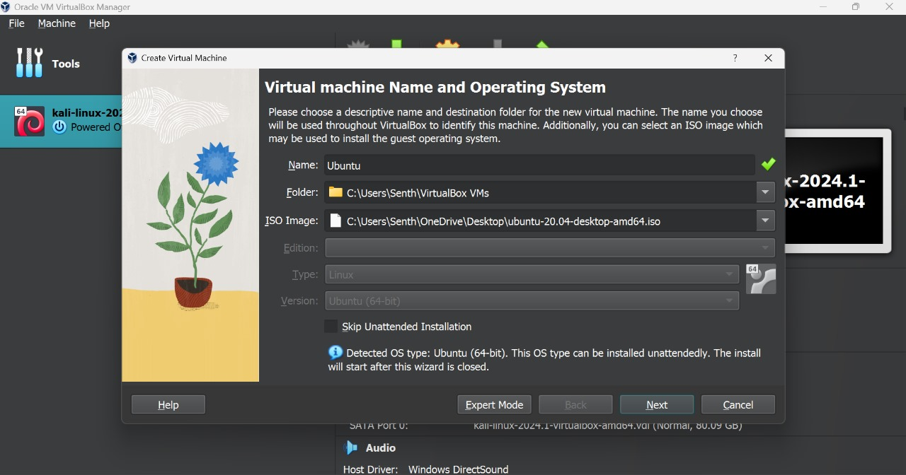

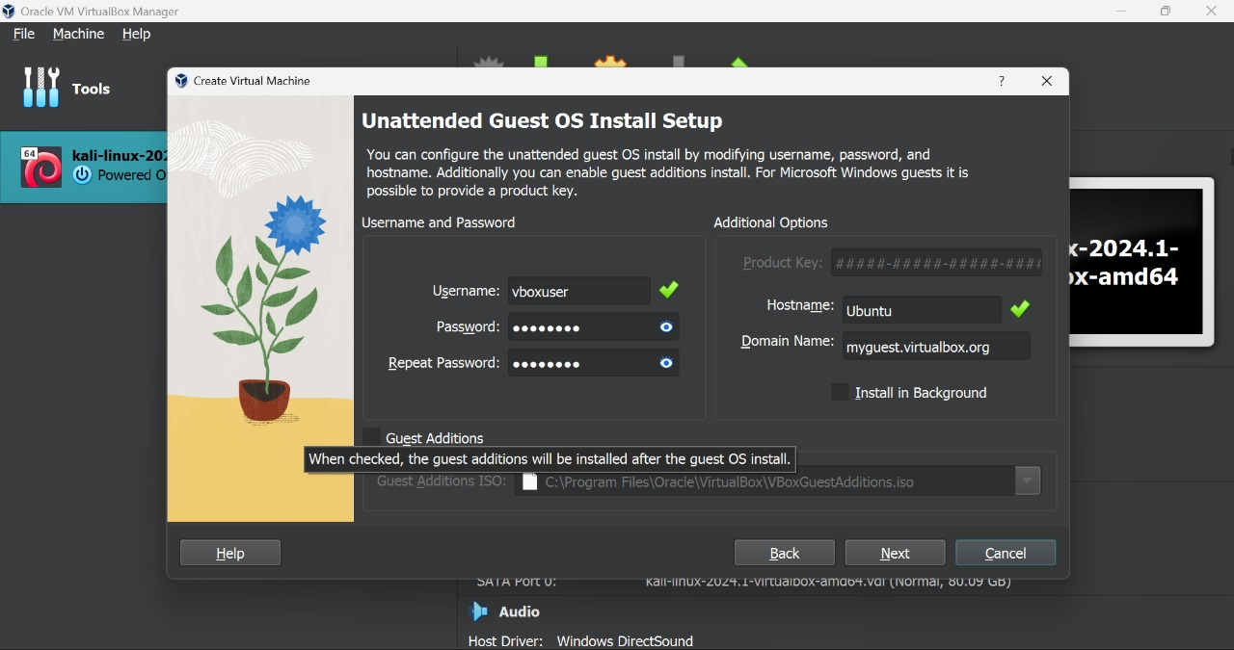

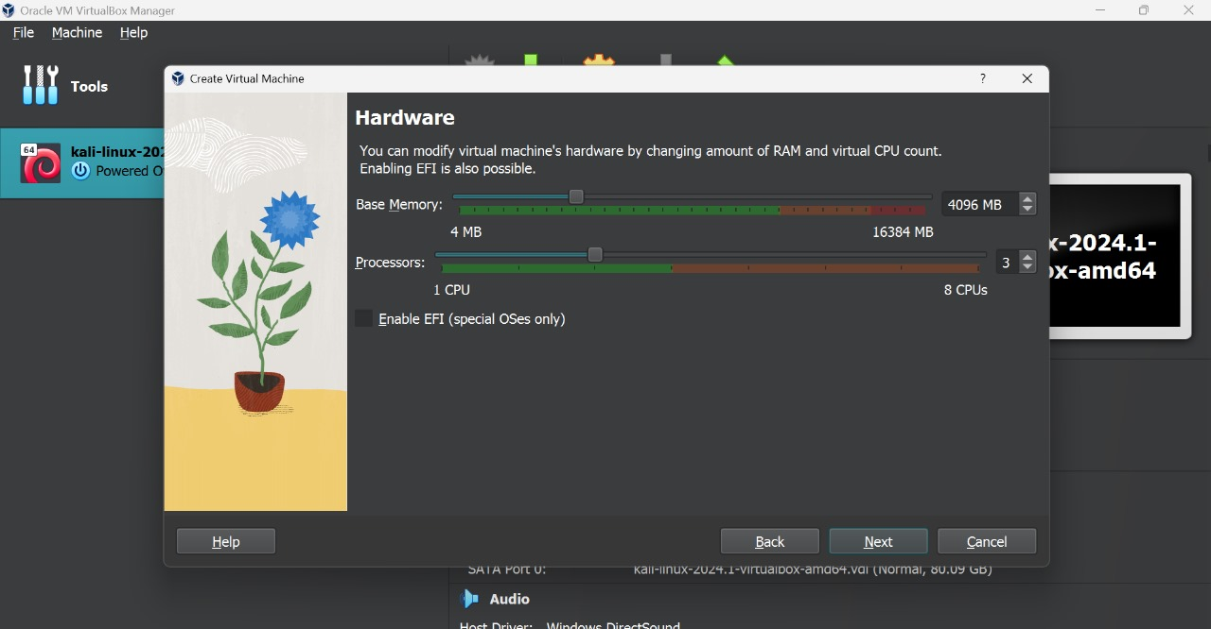

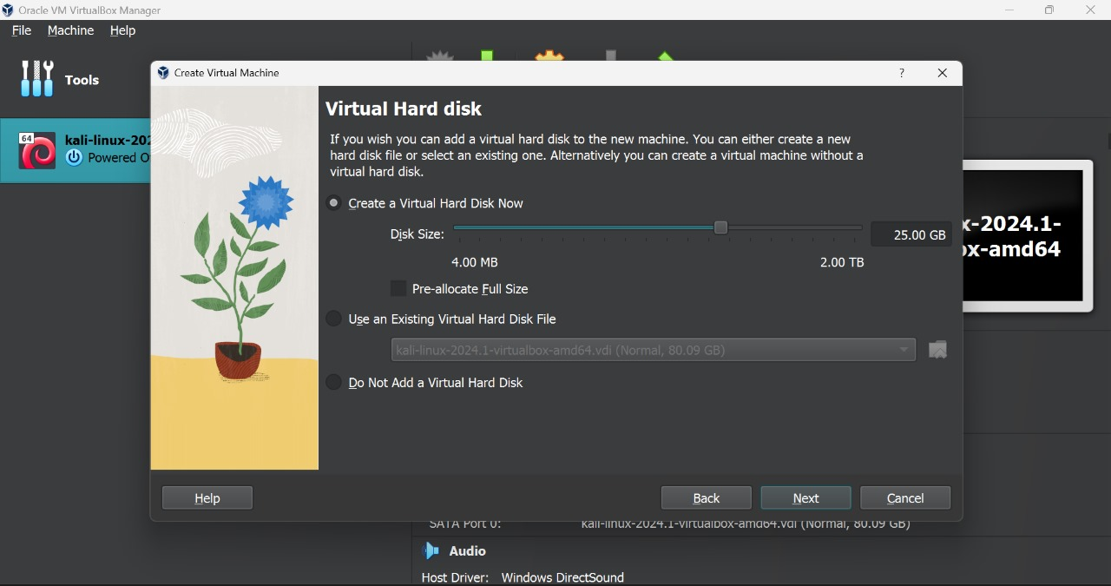

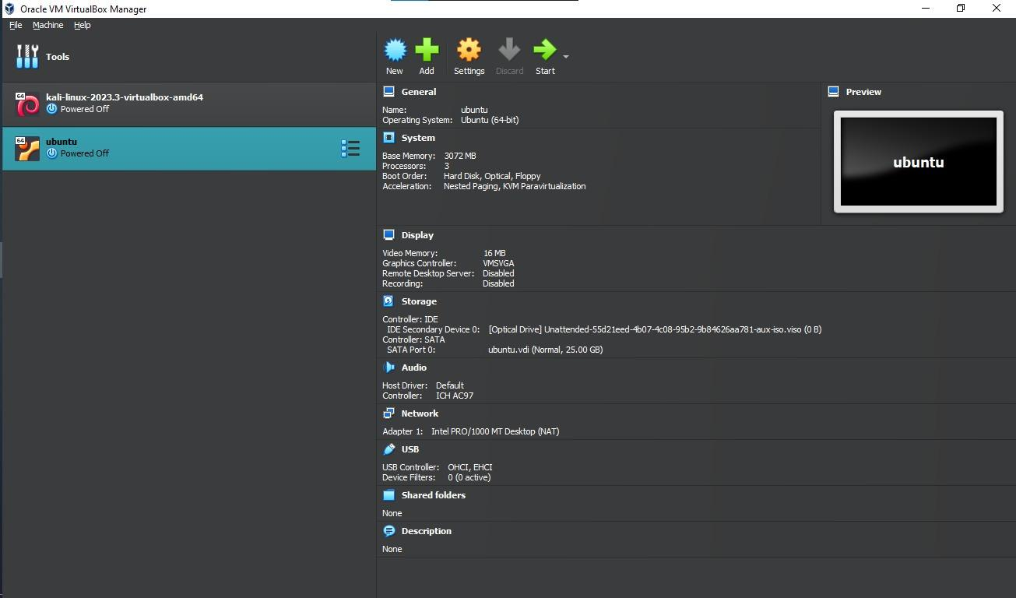

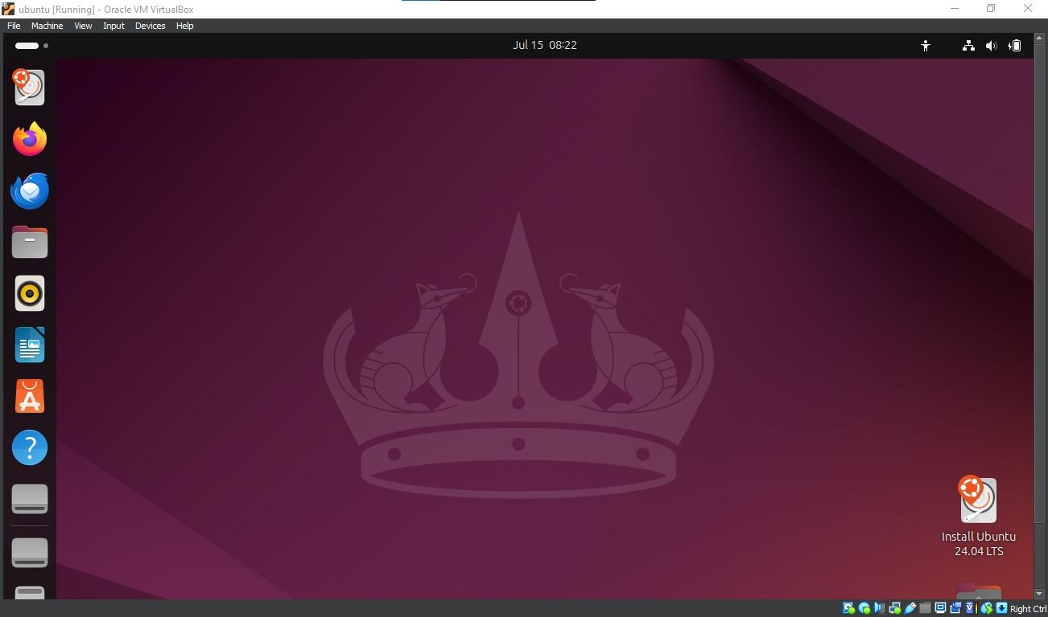

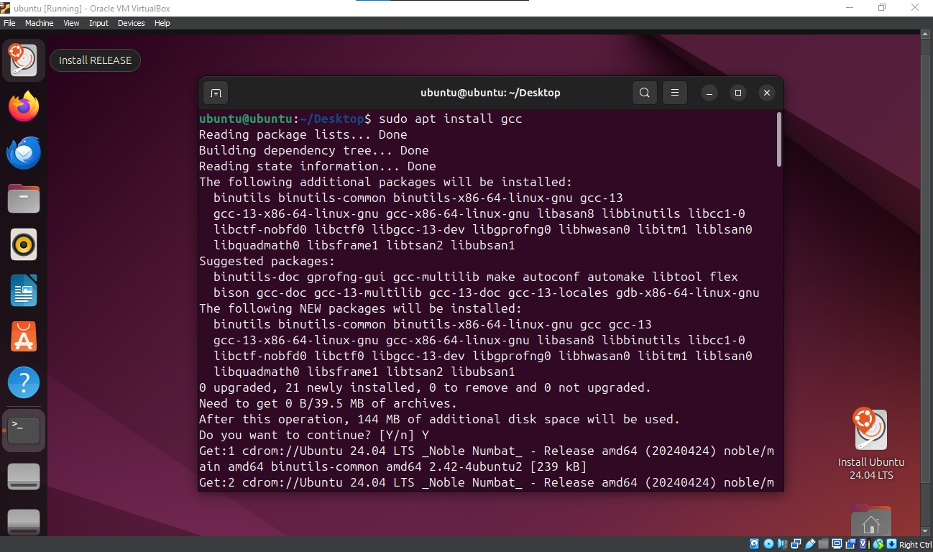

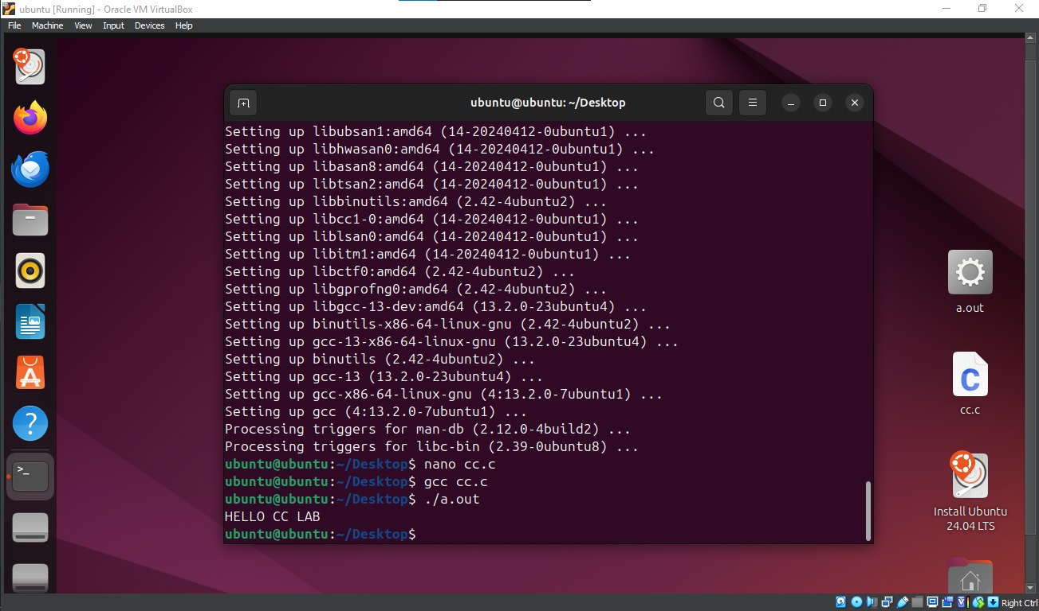

cc.c

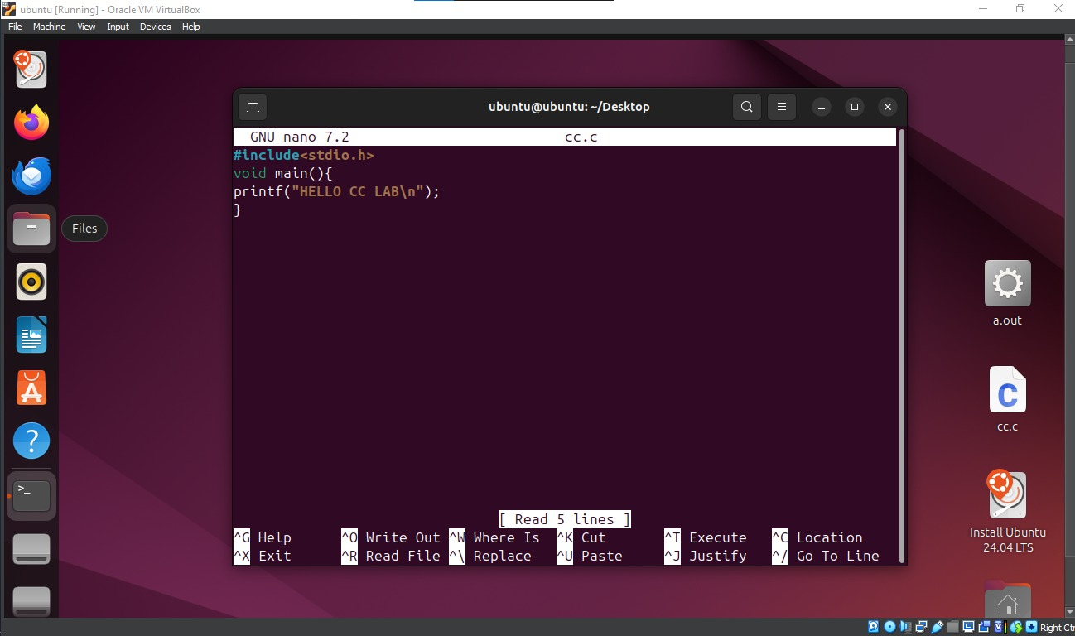

**RESULT:**

Thus a virtual machine is configured using Virtual box and a simple C program is executed successfully.

5